**Keerthika Devi S**

**21BCE1811**

**Assignment 1**

**TASK 1**

Create a pandas dataframe (DataFrame name as 'df') with numpy random values (4 features and 4 observation)

**CODE:**

import pandas as pd

import numpy as np

# Set the random seed for reproducibility

np.random.seed(42)

# Create a dictionary with random values

data = {

'Feature1': np.random.rand(4),

'Feature2': np.random.rand(4),

'Feature3': np.random.rand(4),

'Feature4': np.random.rand(4)

}

df = pd.DataFrame(data)

# Print the DataFrame

print(df)

OUTPUT:

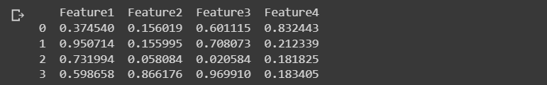

**TASK 2**

Rename the task - 1 'df' dataframe column names to 'Random value 1', 'Random value 2', 'Random value 3' & 'Random value 4

**CODE:**

import pandas as pd

import numpy as np

np.random.seed(42)

data = {

'Feature1': np.random.rand(4),

'Feature2': np.random.rand(4),

'Feature3': np.random.rand(4),

'Feature4': np.random.rand(4)

}

df = pd.DataFrame(data)

# Rename the columns

df.rename(columns={

'Feature1': 'Random value 1',

'Feature2': 'Random value 2',

'Feature3': 'Random value 3',

'Feature4': 'Random value 4'

}, inplace=True)

# Print the DataFrame

print(df)

OUTPUT:

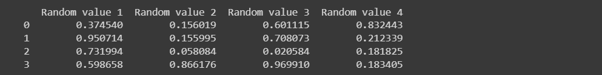

**TASK 3**

Find the descriptive statistics of the 'df' dataframe

**CODE:**

import pandas as pd

import numpy as np

np.random.seed(42)

data = {

'Feature1': np.random.rand(4),

'Feature2': np.random.rand(4),

'Feature3': np.random.rand(4),

'Feature4': np.random.rand(4)

}

df = pd.DataFrame(data)

df.rename(columns={

'Feature1': 'Random value 1',

'Feature2': 'Random value 2',

'Feature3': 'Random value 3',

'Feature4': 'Random value 4'

}, inplace=True)

print(df)

**OUTPUT:**

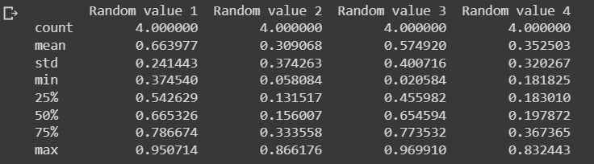

**TASK 4**

Check for the null values in 'df' and find the data type of the columns.

**CODE:**

import pandas as pd

import numpy as np

# Set the random seed for reproducibility

np.random.seed(42)

# Create a dictionary with random values

data = {

'Random value 1': np.random.rand(4),

'Random value 2': np.random.rand(4),

'Random value 3': np.random.rand(4),

'Random value 4': np.random.rand(4)

}

df = pd.DataFrame(data)

null_values = df.isnull().sum()

data_types = df.dtypes

# Print null values and data types

print("Null Values:\n", null_values)

print("\nData Types:\n", data_types)

**OUTPUT:**

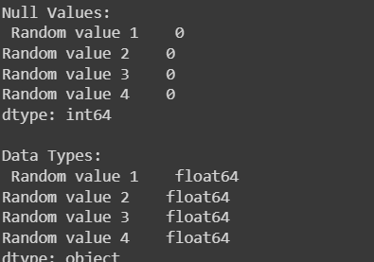

**TASK 5**

Display the 'Random value 2' & 'Random value 3' columns with location method and index location method.

**CODE:**

import pandas as pd

import numpy as np

# Set the random seed for reproducibility

np.random.seed(42)

# Create a dictionary with random values

data = {

'Random value 1': np.random.rand(4),

'Random value 2': np.random.rand(4),

'Random value 3': np.random.rand(4),

'Random value 4': np.random.rand(4)

}

# Create a DataFrame

df = pd.DataFrame(data)

# Display using .loc[] with column names

column_names = ['Random value 2', 'Random value 3']

columns_loc = df.loc[:, column_names]

print("Using .loc[] with column names:\n", columns_loc)

# Display using .iloc[] with column indices

column_indices = [1, 2]

columns_iloc = df.iloc[:, column_indices]

print("\nUsing .iloc[] with column indices:\n", columns_iloc)

**OUTPUT:**

