**MASTAN SHAREEF**

**21BAI1879**

|  |  |  |  |  |  |  |  |  |  |
| --- | --- | --- | --- | --- | --- | --- | --- | --- | --- |
| |  | | --- | | import matplotlib.pyplot as plt |   import numpy as np import pandas as pd import seaborn as sb | | | | | | | | |
| from google.colab import drive drive.mount('/content/drive') | | | | | | |  |  |
|  | | | | | | |  |  |
| df = pd.read_csv("/content/drive/MyDrive/AIML Course/car_crashes.csv")  df.head() | | | | | | |  |  |
|  | **total** | **speeding** | **alcohol** | **not_distracted** | **no_previous** | **ins_premium** | **ins_losses** | **ab** |

1. 18.8 7.332 5.640 18.048 15.040 784.55 145.08
2. 18.1 7.421 4.525 16.290 17.014 1053.48 133.93
3. 18.6 6.510 5.208 15.624 17.856 899.47 110.35
4. 22.4 4.032 5.824 21.056 21.280 827.34 142.39
5. 12.0 4.200 3.360 10.920 10.680 878.41 165.63

**

**

df.tail()

**total speeding alcohol not_distracted no_previous ins_premium ins_losses a**

1. 12.7 2.413 3.429 11.049 11.176 768.95 153.72
2. 10.6 4.452 3.498 8.692 9.116 890.03 111.62
3. 23.8 8.092 6.664 23.086 20.706 992.61 152.56
4. 13.8 4.968 4.554 5.382 11.592 670.31 106.62
5. 17.4 7.308 5.568 14.094 15.660 791.14 122.04

**

**

sb.scatterplot(x = "total", y = "speeding", data = df)

<

Axes: xlabel='total', ylabel='speeding'

>

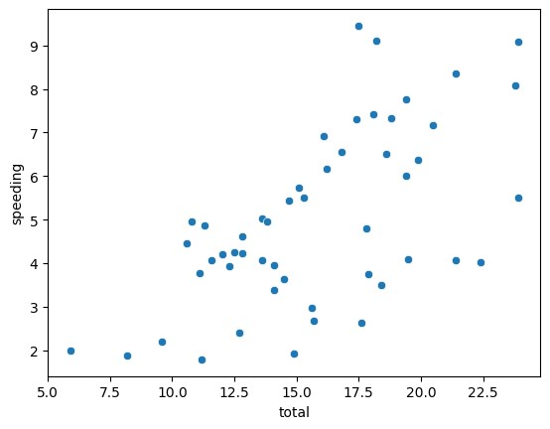

<

Axes: xlabel='alcohol', ylabel='speeding'

>

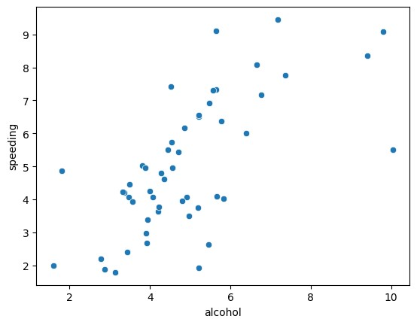

sb.scatterplot

(

x =

"alcohol"

,

y =

"speeding"

,

data = df

)

sb.lineplot(x = "speeding", y = "ins_losses", data = df) <Axes: xlabel='speeding', ylabel='ins_losses'>

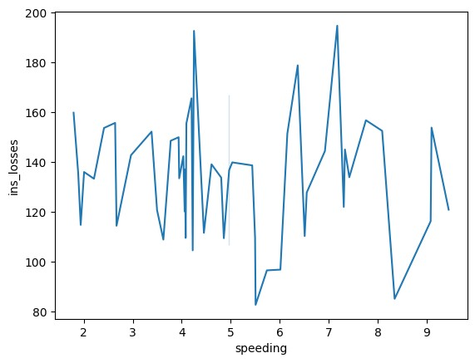

<

Axes: xlabel='alcohol', ylabel='total'

>

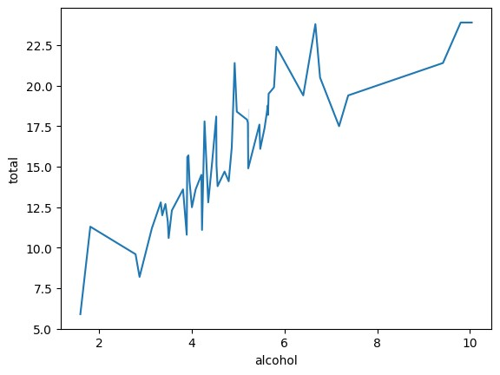

sb.lineplot

(

x =

"alcohol"

,

y =

"total"

,

data = df

)

sb.lineplot(x = "no_previous", y = "total", data = df)

<

Axes: xlabel='no_previous', ylabel='total'

>

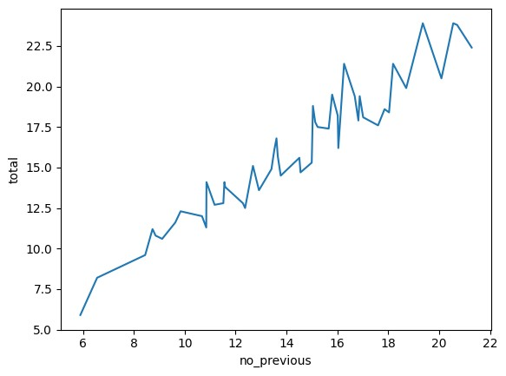

<

Axes: xlabel='ins_premium', ylabel='total'

>

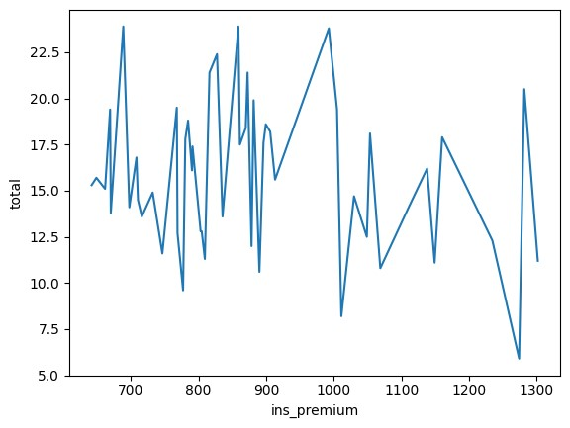

sb.lineplot

(

x =

"ins_premium"

,

y =

"total"

,

data = df

)

sb.lineplot(x = "ins_losses", y = "total", data = df)

<

Axes: xlabel='ins_losses', ylabel='total'

>

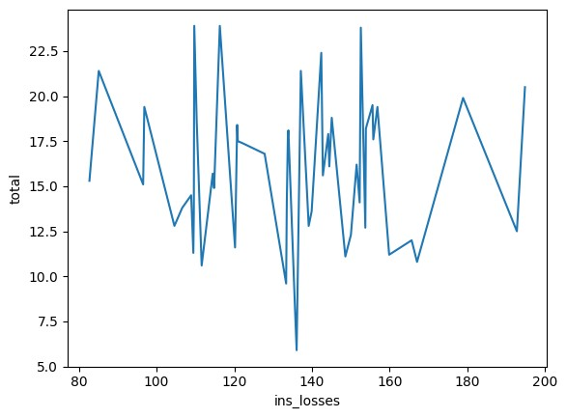

<

Axes: xlabel='total', ylabel='abbrev'

>

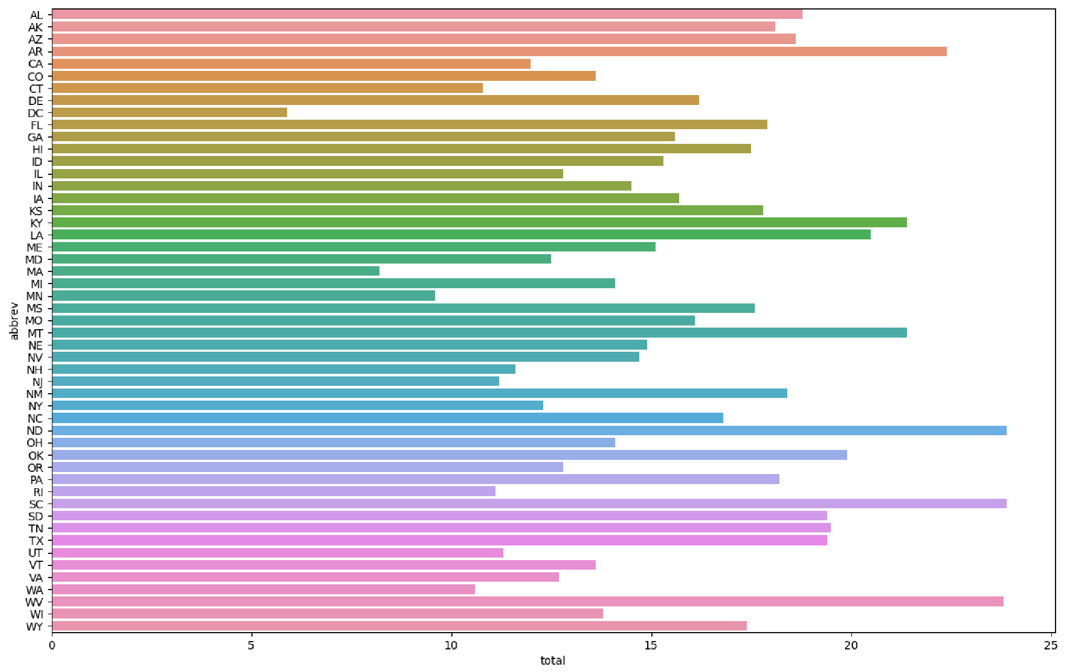

plt.subplots

(

figsize=

(

16

,

10

))

sb.barplot

(

data = df

,

x =

'total'

,

y =

'abbrev'

)

sb.scatterplot(x = "total", y = "speeding", data = df, hue = 'alcohol')

<

Axes: xlabel='total', ylabel='speeding'

>

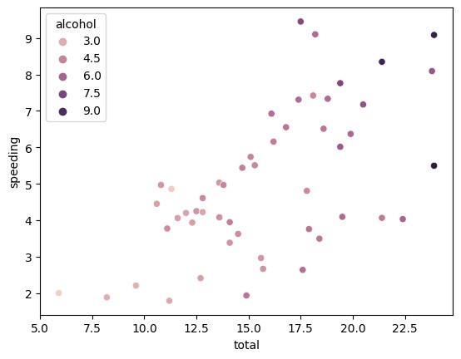

<

Axes: xlabel='total', ylabel='not_distracted'

>

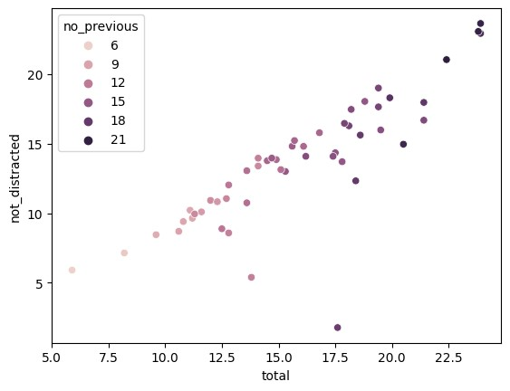

sb.scatterplot

(

x =

"total"

,

y =

"not_distracted"

,

data = df

,

hue =

'no_previous'

)

sb.scatterplot(x = "total", y = "speeding", data = df, hue = 'ins_premium')

<

Axes: xlabel='total', ylabel='speeding'

>

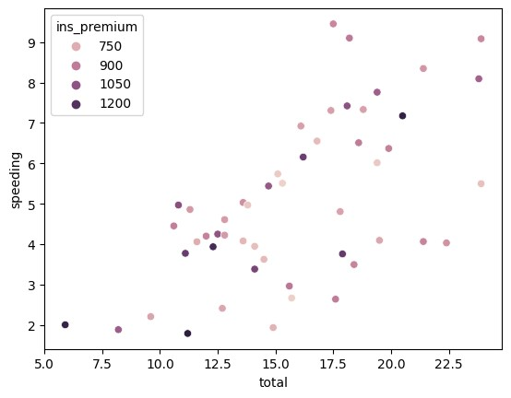

<

Axes: xlabel='ins_losses', ylabel='speeding'

>

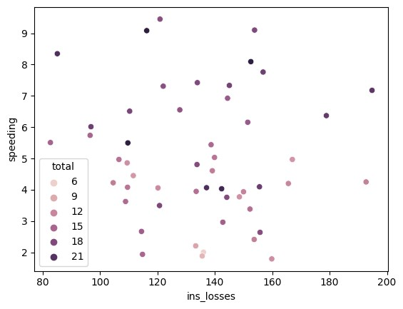

sb.scatterplot

(

x =

"ins_losses"

,

y =

"speeding"

,

data = df

,

hue =

'total'

)

sb.jointplot(x = 'total', y = 'alcohol', data = df) <seaborn.axisgrid.JointGrid at 0x7b8bb0e43550>

sb.jointplot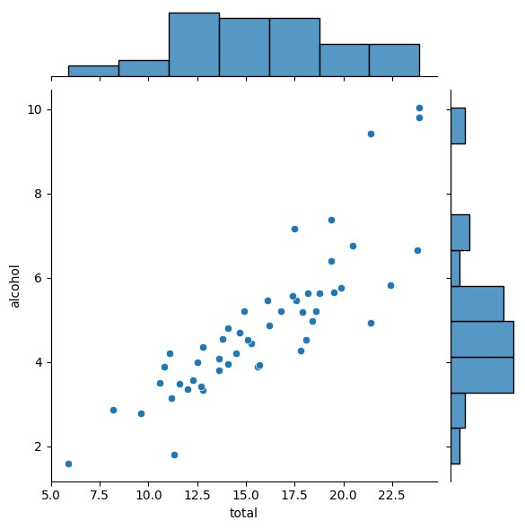(x = 'total', y = 'speeding', data = df)

<seaborn.axisgrid.JointGrid at 0x7b8bb0e436a0>

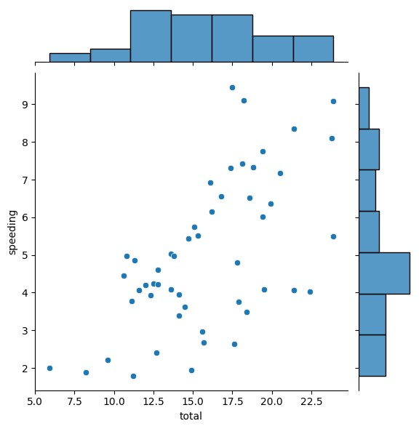

<

seaborn.axisgrid.JointGrid at 0x7b8bb

0d79330>

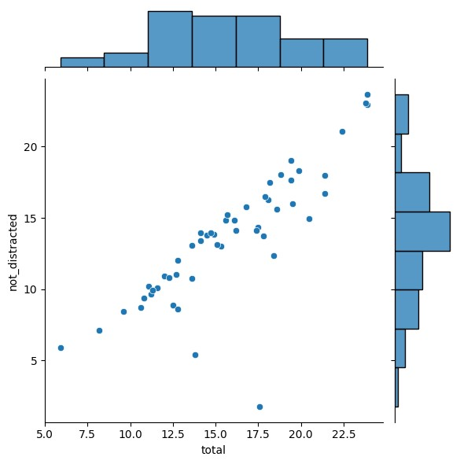

sb.jointplot

(

x =

'total'

,

y =

'not_distracted'

,

data = df

)

sb.jointplot(x = 'total', y = 'no_previous', data = df) <seaborn.axisgrid.JointGrid at 0x7b8bb0dcc700>

sb.jointplot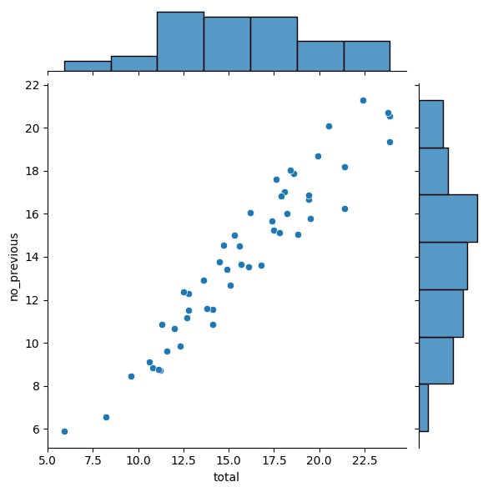(x = 'ins_losses', y = 'ins_premium', data = df)

<seaborn.axisgrid.JointGrid at 0x7b8bb0985090>

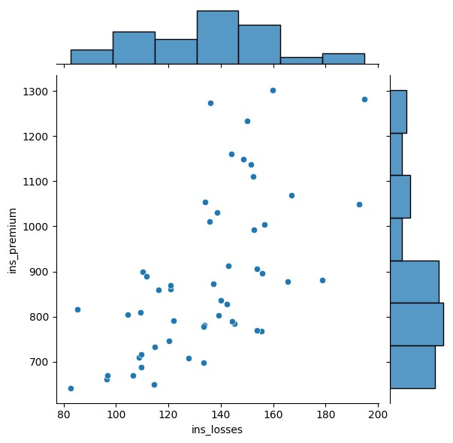

<

seaborn.axisgrid.JointGrid at 0x7b8bb0985de

0>

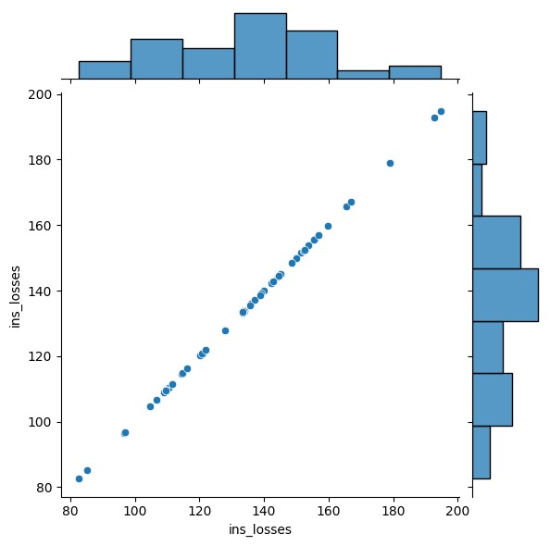

sb.jointplot

(

x =

'ins_losses'

,

y =

'ins_losses'

,

data = df

)

corr = df.corr()

<ipython-input-31-45893e33df67>:1: FutureWarning: The default value of numeric_only i corr = df.corr()

**

**

sb.heatmap(corr, annot = True)

<Axes: >

sb.pairplot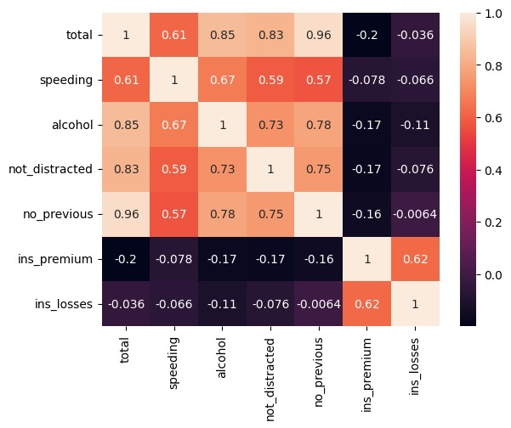(df)

<seaborn.axisgrid.PairGrid at 0x7b8bafff7e50>

Colab paid product

[s](https://colab.research.google.com/signup?utm_source=footer&utm_medium=link&utm_campaign=footer_links)

-

Cancel contracts her

[e](https://colab.research.google.com/cancel-subscription)

