Name- Shashibhushan Das

Reg No.- 21BCE0515

**ASSIGNMENT-3**

**1. Introduction to SOC**

A Security Operations Center (SOC) is a pivotal component of an organization's cybersecurity strategy. Its primary purpose is to safeguard the organization's digital assets, sensitive data, and infrastructure from a wide array of cyber threats and security incidents. Below are key aspects of a SOC:

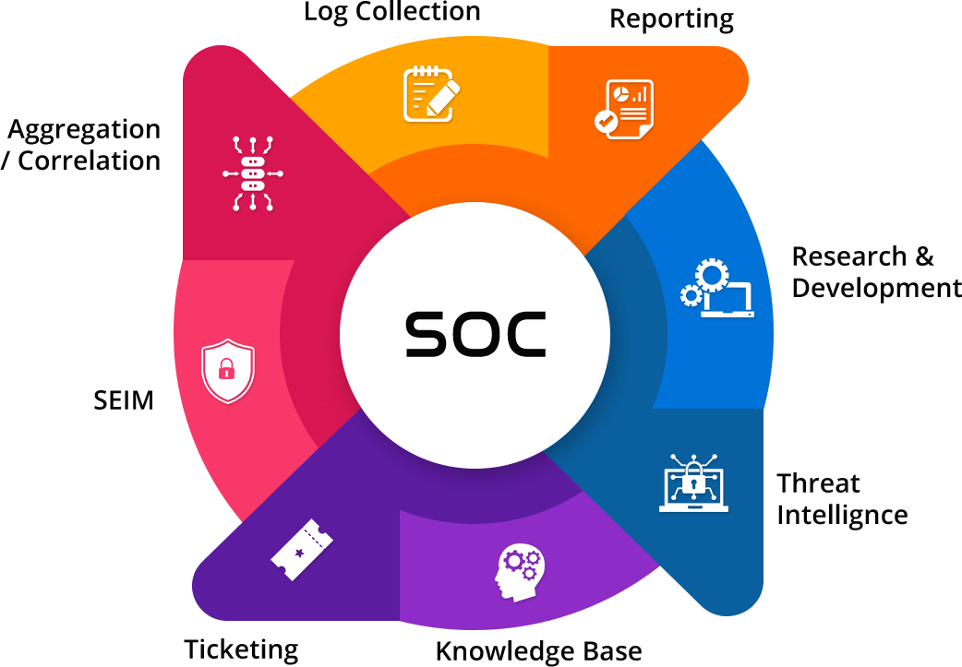

**Purpose:**

* Threat Monitoring: SOC is responsible for continuous monitoring of an organization's network, systems, and applications for suspicious activities, vulnerabilities, or security breaches.
* Incident Detection and Response: When security incidents are detected, the SOC team investigates, analyzes, and responds to them promptly. This includes identifying the nature and severity of the incident, containing it, and mitigating the damage.
* Proactive Defense: SOC proactively seeks to strengthen an organization's security posture by identifying weaknesses, assessing risks, and implementing security measures to prevent future incidents.
* Compliance and Reporting: SOCs also play a role in ensuring compliance with industry regulations and internal security policies. They generate reports, maintain logs, and provide evidence of adherence to security standards.

**Key Functions:**

* Monitoring and Analysis: SOC analysts continuously monitor incoming security events and data logs to identify abnormal patterns or indicators of compromise.
* Incident Response: SOC teams use incident response procedures to contain, mitigate, and recover from security incidents. They may work with other teams such as IT and legal departments.
* Threat Intelligence: SOC leverages threat intelligence feeds to stay updated on emerging threats, tactics, and vulnerabilities.
* Vulnerability Management: Identifying and patching vulnerabilities in software and hardware is essential to reducing the attack surface.
* Forensics and Investigations: Analyzing incidents to determine the cause, extent, and impact, which can aid in legal actions and prevention.
* Security Awareness and Training: Promoting security awareness among employees is vital in preventing security breaches caused by human error.

**Role in Cybersecurity Strategy:**

A SOC plays a central role in an organization's cybersecurity strategy by providing real-time threat visibility and rapid incident response. It acts as the frontline defense, reducing the time it takes to detect and mitigate threats, thus minimizing the potential damage and financial losses associated with security incidents.

**2. SIEM Systems**

Security Information and Event Management (SIEM) systems are crucial components of modern cybersecurity infrastructure. They collect, aggregate, correlate, and analyze security data from various sources across an organization to provide a unified view of the security landscape. Here's why SIEM is essential:

**Importance in Modern Cybersecurity**:

* Centralized Data Collection: SIEM systems gather data from diverse sources, such as firewalls, antivirus software, network appliances, and servers, creating a centralized repository for security data.
* Real-time Monitoring: SIEMs enable real-time monitoring of security events, allowing organizations to detect and respond to threats as they happen.
* Threat Detection: Advanced analytics and correlation capabilities help identify patterns and anomalies indicative of security threats or breaches.
* Compliance and Reporting: SIEMs assist in compliance efforts by automating log management and generating compliance reports.
* Incident Response: SIEM tools facilitate incident response by providing alerts and actionable insights for security teams.

**3. QRadar Overview**

IBM QRadar is a powerful SIEM solution that offers a range of features and capabilities:

**Key Features:**

* Log and Event Collection: QRadar collects and aggregates log and event data from various sources, including network devices, servers, applications, and cloud services.
* Real-time Monitoring: It provides real-time visibility into an organization's security posture, helping detect threats as they occur.
* Advanced Analytics: QRadar uses machine learning and behavioral analytics to identify unusual patterns and potential security incidents.
* Incident Investigation: The platform supports comprehensive incident investigation with tools for forensic analysis and threat hunting.
* Automation and Orchestration: QRadar can automate response actions to quickly mitigate threats and reduce manual workload.
* Threat Intelligence Integration: It integrates with external threat intelligence feeds to enhance threat detection.
* Cloud and On-Premises Deployment: QRadar offers deployment options to cater to the organization's preferences and requirements.

**Benefits:**

* Efficient Threat Detection: QRadar's advanced analytics and real-time monitoring capabilities enable organizations to detect threats quickly.
* Reduced False Positives: Machine learning algorithms reduce false positives by distinguishing between benign and malicious activities.
* Improved Incident Response: Automated response actions and detailed investigation tools streamline incident response efforts.
* Compliance Assistance: QRadar assists in meeting compliance requirements by collecting, storing, and reporting on relevant security data.
* Scalability: It can scale to accommodate the needs of both small and large organizations.

**4. Use Cases**

Here are real-world use cases for IBM QRadar in a SOC:

* Detecting Insider Threats: QRadar can monitor user activities and detect unusual behavior patterns, helping identify insider threats like data exfiltration or unauthorized access.
* Phishing Detection: By analyzing email logs and network traffic, QRadar can identify phishing attempts and block malicious emails, preventing potential breaches.
* Zero-Day Threat Detection: QRadar's behavior analytics can identify zero-day threats by detecting abnormal activities that signature-based detection systems may miss.
* Malware Detection: It can analyze files and network traffic for signs of malware infections, enabling rapid containment and removal.
* Anomaly Detection: QRadar can discover anomalies in network traffic, user behavior, or system activities, signaling potential security incidents.
* Compliance Reporting: QRadar simplifies the process of collecting and reporting security data, making it easier for organizations to meet regulatory compliance requirements.

In conclusion, a SOC, SIEM systems like IBM QRadar, and their integration play a crucial role in modern cybersecurity. They provide proactive threat detection, rapid incident response, and compliance support to protect an organization's digital assets effectively.