Task 6

**What is SQLMAP ?**

SQLMap is an open-source penetration testing tool that automates the process of detecting

and exploiting SQL injection vulnerabilities in web applications. SQL injection is a common

type of security vulnerability that occurs when an attacker can manipulate a web application's

SQL query by injecting malicious SQL code.

SQLMap is designed to help security professionals and ethical hackers identify and fix such

vulnerabilities in web applications before malicious hackers can exploit them.

To show the functionality of sqlmap ,I will be showing its implementation on vulnweb.com :

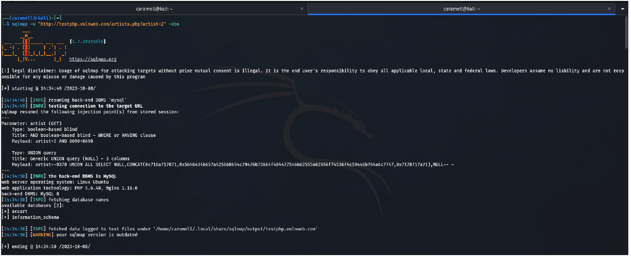

Using the command, we first found out that there are two databases namely,acuart and

information_schema.

**We will be checking the contents of acuart database.**

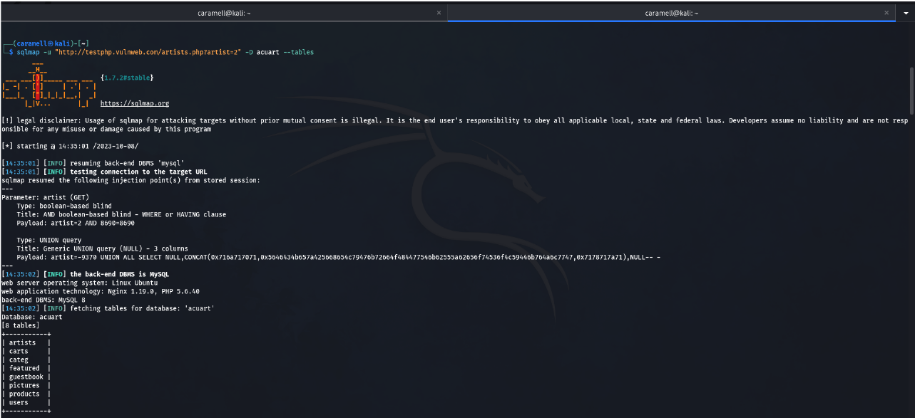

After the checking we found out that there were 8 tables.

Now I will be looking into the users table in acuart database.

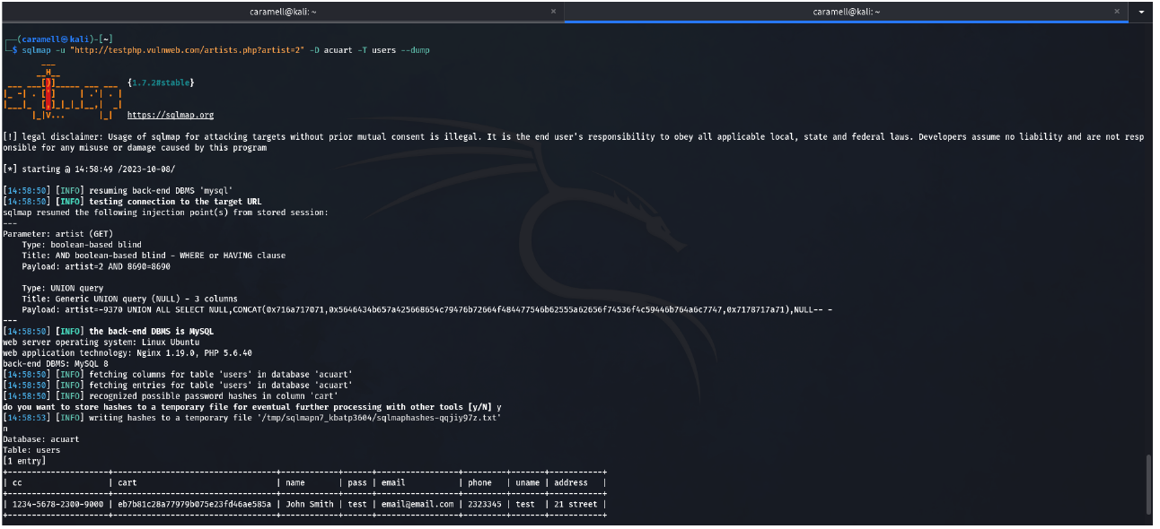

After the execution of the command ,we find out that there is 1 user with the name “John

Smith” and pass as “test”.

**We will be checking the contents of information_schema database now.**

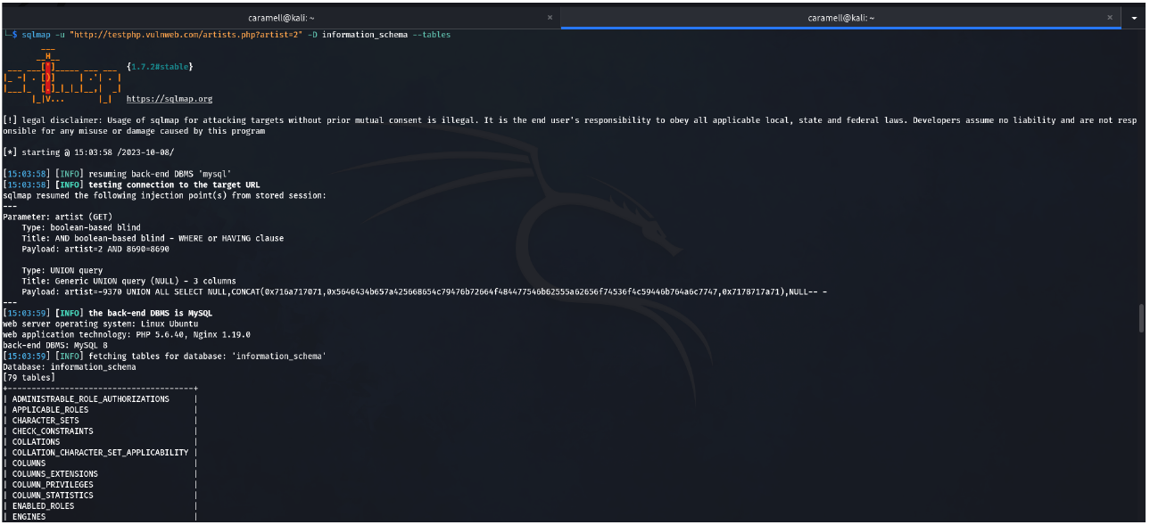

After the execution of command we found out that there were 79 tables.

I am looking into the ENGINES to found out something useful :

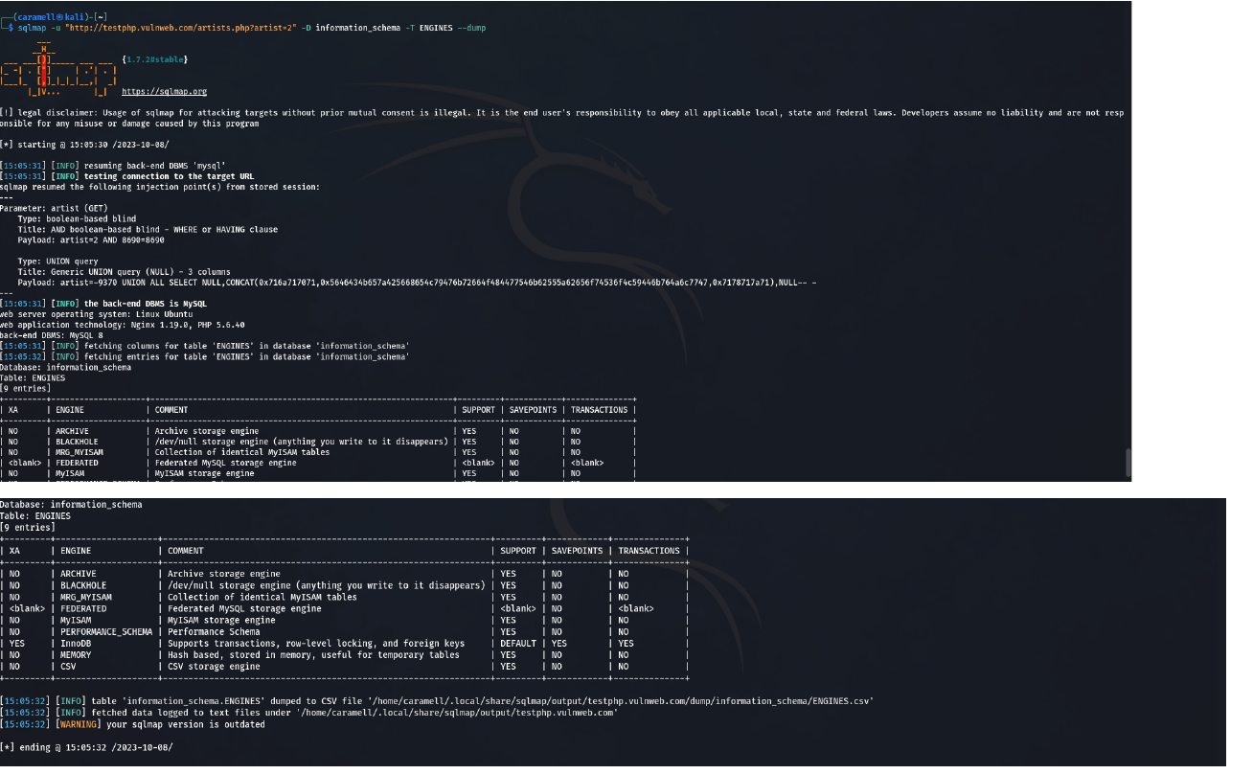

We get the total info about the engines. This info can be really useful if we go into depth and

analyze it.