Task 7

**Local Security Policy:**

A Local Security Policy, often referred to as Local Security Policy Settings or Local Security Policies, serves as a set of configurations and parameters applicable to a specific computer or device running a Windows operating system. These configurations are designed to assist administrators and users in creating and sustaining a secure computing environment at the local level. Exclusive to Windows-based systems, Local Security Policies wield control over various facets of system security.

One of the key components of Local Security Policies is the assignment of User Rights. This entails specifying which users or groups possess particular privileges on the local machine. For instance, it dictates who has the right to log on locally, shut down the system, or alter system time.

Another critical facet is the Security Options, which encapsulate a wide array of settings governing different security-related behaviors on the local device. This encompasses policies related to passwords, account lockouts, and auditing.

Account Policies constitute a pivotal category that outlines the regulations governing user account management on the local system. These policies encompass settings dictating password complexity, expiration, and the threshold for account lockouts.

Furthermore, Local Policies encompass settings pertaining to audit policies, user rights assignment, and security options. They afford administrators the capability to configure auditing for specific events, oversee user permissions, and manage diverse security settings at the local level.

In the realm of Event Logs, administrators are granted the ability to determine how Windows event logs are handled. This includes specifying the maximum log size, policies for log retention, and log behavior.

In contemporary Windows versions, Advanced Audit Policy Configuration provides a more intricate level of control over auditing settings compared to conventional audit policies.

Additionally, administrators can apply security settings to the Windows Registry, thereby governing access and permissions for specific registry keys and values.

It is crucial to discern that while Local Security Policies are tailored for individual machines, Group Policy serves as a broader mechanism for managing and enforcing policies across multiple computers within an Active Directory domain. Local Security Policies prove invaluable for fortifying standalone computers or those not integrated into a domain, as well as for configuring specific security parameters that may not be regulated by domain-wide policies. Nevertheless, in an enterprise setting, administrators often lean on Group Policy to centrally oversee security settings across numerous systems efficiently. The "Local Security Policy" MMC (Microsoft Management Console) snap-in is the tool employed to access and configure Local Security Policies on a Windows system. It is imperative to exercise caution when adjusting security settings, as misconfigurations may lead to security vulnerabilities or system complications. Always ensure a comprehensive understanding of the implications of the changes being made and meticulously document them.

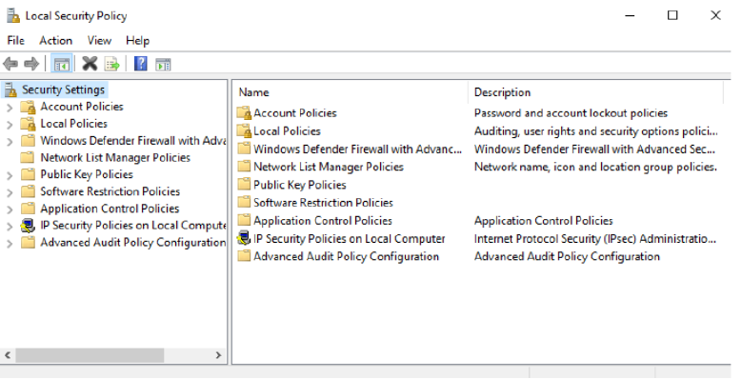

**WinCollect:**

A standalone deployment of IBM Security QRadar WinCollect software denotes an independent instance of the software that operates autonomously and is not integrated into a larger IBM QRadar SIEM (Security Information and Event Management) setup. In this context, "standalone" signifies that WinCollect is exclusively utilized for the purpose of gathering and transmitting log and event data from Windows-based systems to an alternate destination, such as a log management system, a SIEM other than QRadar, or a centralized log repository.

WinCollect possesses several vital functionalities:

Log Collection: Its primary role is to gather log and event data produced by Windows-based devices and applications, encompassing event logs, system logs, and application logs.

Normalization: WinCollect is adept at standardizing and formatting the collected log data into a uniform structure suitable for analysis by the SIEM system. This process of normalization simplifies the correlation and analysis of log data originating from diverse sources.

Forwarding: After normalizing the log and event data, WinCollect proceeds to forward it to IBM Security QRadar, where it can be scrutinized for security incidents, compliance monitoring, and reporting purposes.

Real-time Data Collection: WinCollect is capable of collecting log data in real-time, ensuring that security events and incidents are promptly detected and analyzed.

Agent-Based Collection: It employs agent software installed on Windows systems to collect and transmit log data. These agents can be configured to gather logs from various sources, including the Windows Event Log, custom application logs, and more.

Log Filtering: Administrators have the ability to configure WinCollect to filter log data based on specific criteria. This reduces noise and ensures that only pertinent events are sent forward to the SIEM.

Log Rotation and Retention: WinCollect is equipped to manage log rotation and retention policies, guaranteeing that log data is retained for the requisite duration in accordance with compliance requirements.

Secure Data Transfer: WinCollect employs secure methods to transfer log data to the QRadar SIEM system, ensuring the confidentiality and integrity of the data during transit.

Configuration Management: Administrators can centrally oversee the configuration of WinCollect agents, simplifying the process of scaling log collection across a large number of Windows devices.

Integration with QRadar: WinCollect is engineered to seamlessly integrate with IBM Security QRadar. This integration provides a streamlined approach to incorporating Windows log and event data into an organization's overarching security monitoring and incident response strategy.

