Assignment 2:

Kali Linux is a popular penetration testing and ethical hacking distribution that comes with a wide range of security and penetration testing tools. Here are 10 Kali Linux tools along with brief explanations of their purposes and steps on how to implement them:

1. **Nmap (Network Mapper):**

Purpose: Nmap is a powerful network scanning tool used to discover devices and services on a network.

Implementation:

Open a terminal in Kali Linux.

Run the following command to scan a target IP address or range: nmap target

Result: Nmap provides a detailed report of open ports, services, and OS information for the scanned target.

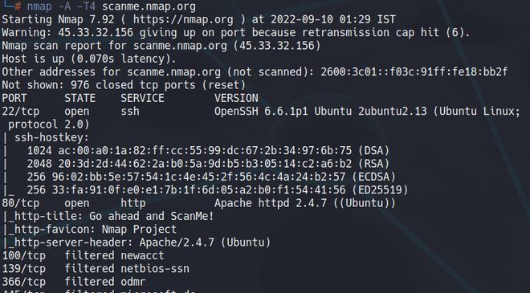

1. **Wireshark:**

Purpose: Wireshark is a network protocol analyzer for capturing and inspecting data packets on a network.

Implementation:

Launch Wireshark from the Kali Linux applications menu.

Select a network interface to capture packets.

Result: Wireshark displays captured packets in real-time, allowing you to analyze network traffic and diagnose issues.

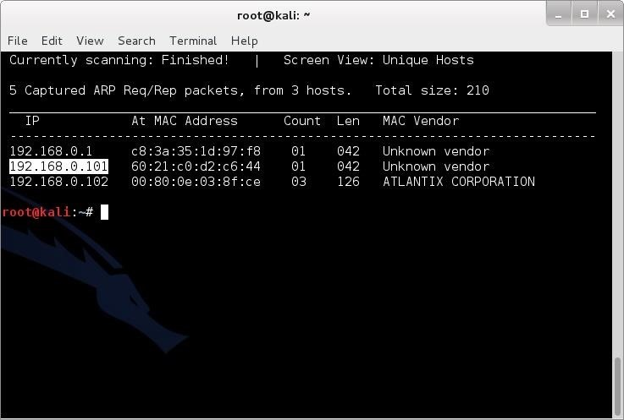

1. **Metasploit Framework:**

Purpose: Metasploit is a powerful penetration testing framework used for exploiting vulnerabilities in systems and applications.

Implementation:

Open a terminal and run msfconsole to start Metasploit.

Use modules to search for and exploit vulnerabilities.

Result: Metasploit helps identify vulnerabilities and assess the security of a target system.

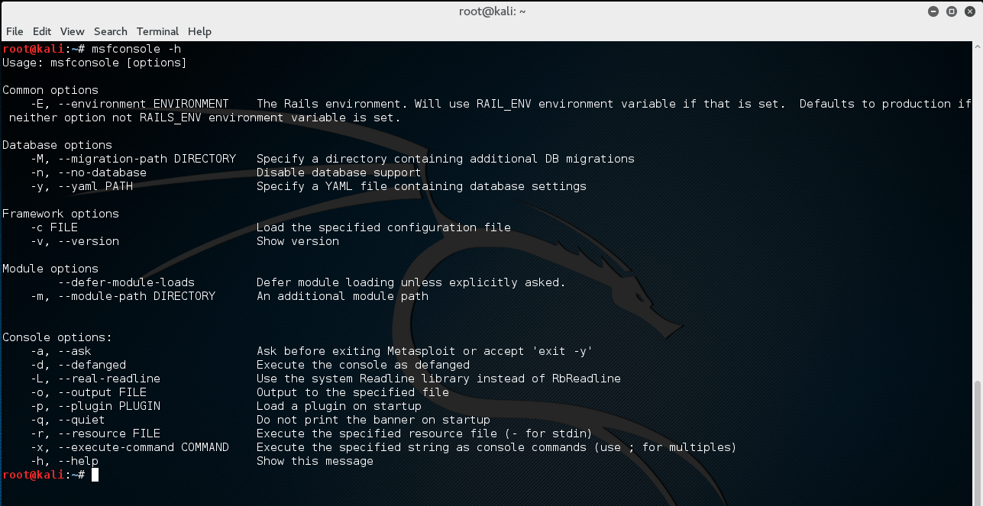

1. **Burp Suite:**

Purpose: Burp Suite is a web vulnerability scanner and proxy tool for web application security testing.

Implementation:

Launch Burp Suite from the Kali Linux applications menu.

Configure your browser to use Burp Suite as a proxy.

Result: Burp Suite intercepts and analyzes HTTP requests and responses, allowing you to identify and exploit web application vulnerabilities.

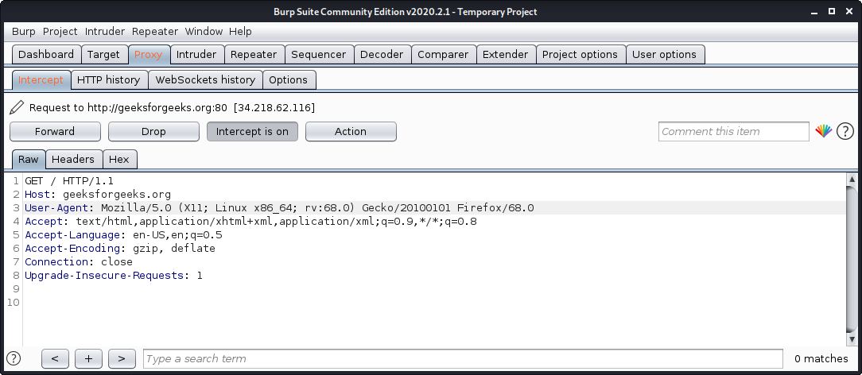

1. **Aircrack-ng**:

Purpose: Aircrack-ng is a tool for assessing Wi-Fi network security by cracking WEP and WPA/WPA2 keys.

Implementation:

Open a terminal and run commands like airmon-ng to put your Wi-Fi adapter in monitor mode.

Use airodump-ng to capture Wi-Fi traffic.

Result: Aircrack-ng helps identify weak Wi-Fi security and can recover Wi-Fi passwords.

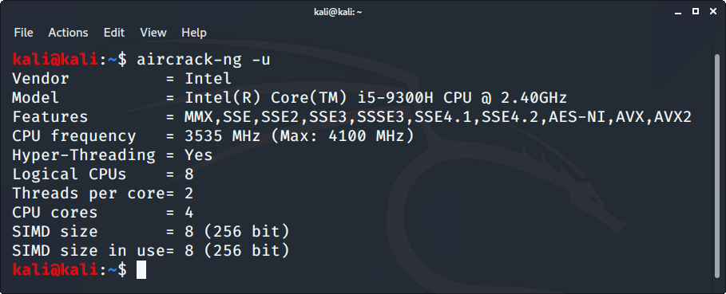

1. **John the Ripper:**

Purpose: John the Ripper is a password cracking tool for various encryption formats.

Implementation:

Open a terminal and use the john command to specify the target file.

Result: John the Ripper attempts to crack password hashes and recover plaintext passwords.

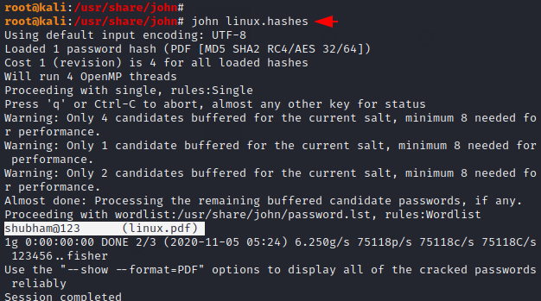

1. **Hydra:**

Purpose: Hydra is a brute-force password cracking tool used to crack remote authentication services.

Implementation:

Open a terminal and use the hydra command with the appropriate flags and target information.

Result: Hydra performs password brute-forcing attacks against various services, such as SSH, FTP, and web forms.

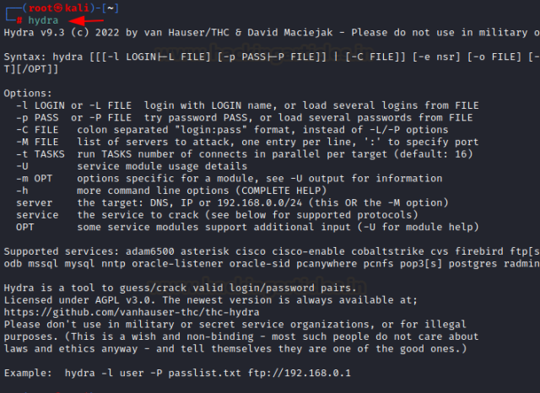

1. **Nikto:**

Purpose: Nikto is a web server vulnerability scanner that checks for known vulnerabilities and misconfigurations.

Implementation:

Open a terminal and run nikto -h target to scan a web server.

Result: Nikto generates a report detailing potential web server vulnerabilities and security issues.

1. **Gobuster:**

Purpose: Gobuster is a directory and file brute-forcing tool used to discover hidden resources on web servers.

Implementation:

Run gobuster dir -u URL -w wordlist in the terminal to start the scan.

Result: Gobuster reveals hidden directories and files on a web server, aiding in information gathering and potential attack vectors.

1. **Sqlmap:**

Purpose: Sqlmap is a powerful tool for automated SQL injection and database penetration testing.

Implementation:

Open a terminal and run sqlmap -u URL to test a web application for SQL injection vulnerabilities.

Result: Sqlmap identifies and exploits SQL injection vulnerabilities, allowing you to extract data from databases