TASK-14

Metasploitable 2 Exploit

PORT 8080 JAVA:

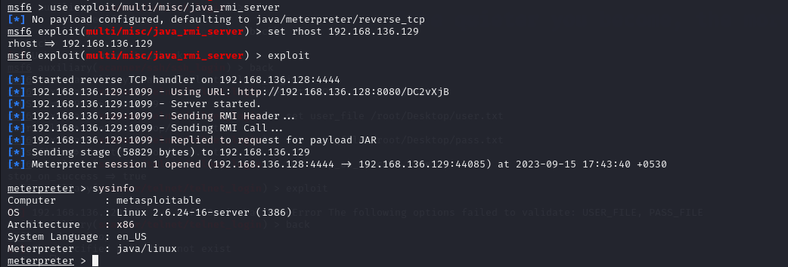

PORT 5432 Postgres:

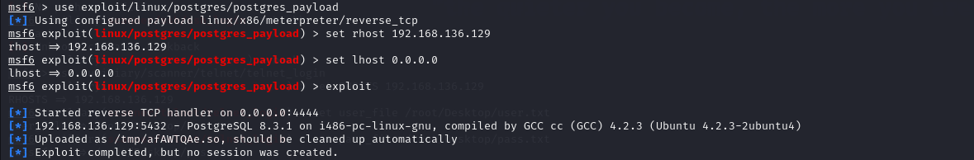

PORT 36255:

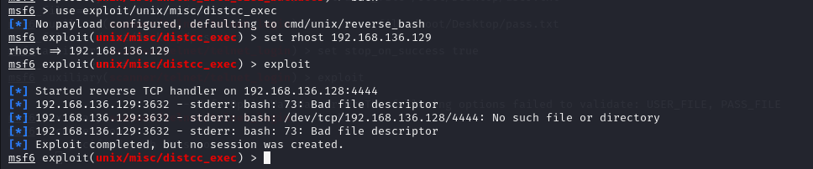

PORT 5900 Virtual Network Computing:

