TASK-7

Gathering info on a website using OSINT Framework

Website Name: Zomato.com

OSINT Framework

1.Username

Available in Facebook, slack, YouTube, Twitter, Blogger, Twitch, TikTok, Reddit, Ebay, Pinterest, Blogger, GitHub, Tumblr.

2.Email Address

3.Domain

Address: 13.250.82.200,13.228.169.233

Amazon Data services Singapore

AS: AS16509

Site ownership verification

Adobe sign: 6a09126310927f379735c2b7d09e1928

AWS: 3ufcI9pD6ZqyPNibcDPmG70sgJIGL96bhztrM07aetY=

Annual Reports

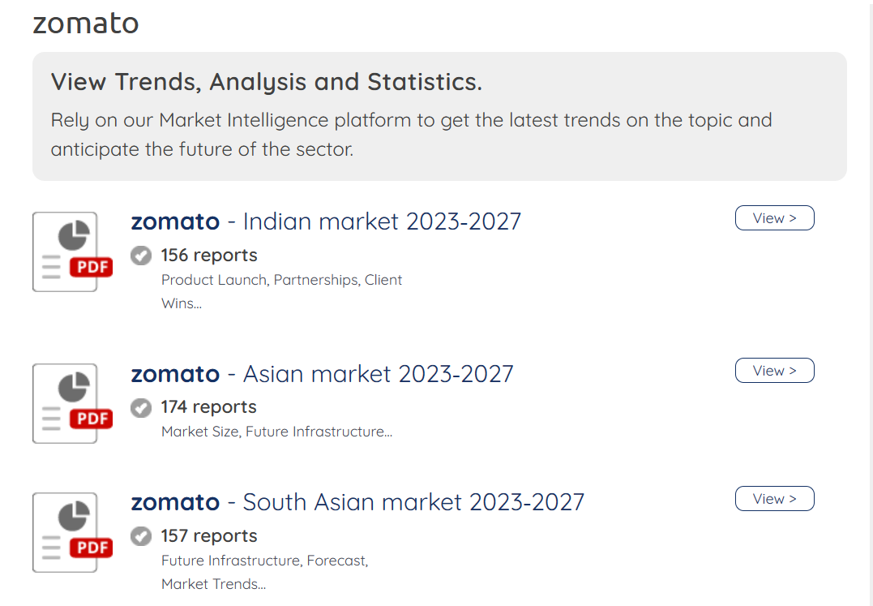

Company Profile

