**The Importance and Implementation of Local Security Policy**

**Introduction**

In today's interconnected world, safeguarding sensitive data and maintaining the security of computer systems is paramount. Local Security Policy (LSP) serves as a critical component of an organization's overall security strategy. This one-page document aims to elucidate why we use LSP and how it is effectively implemented to protect against potential threats.

**Why Use Local Security Policy?**

**Granular Control**: LSP provides granular control over the security settings of individual computers, allowing administrators to define specific security measures tailored to their organization's needs.

**Protection Against Unauthorized Access**: It acts as a first line of defense against unauthorized access to computer resources, ensuring that only authorized users have access to system files and functions.

**Preventing Malware and Viruses**: LSP helps prevent the execution of malicious code, thereby mitigating the risk of malware and viruses compromising the system.

**User Accountability**: It enforces user authentication and password policies, making users accountable for their actions and reducing the likelihood of security breaches due to weak passwords.

**Auditing and Compliance**: LSP facilitates auditing and compliance efforts by allowing organizations to monitor and record security-related events, aiding in the identification of security breaches and ensuring adherence to regulatory requirements.

**How to Use Local Security Policy**

**Accessing LSP**: On Windows systems, Local Security Policy can be accessed through the Local Security Policy Management Console (secpol.msc) or by running "Local Security Policy" in the Control Panel. On Linux systems, it is typically configured through the /etc/security/ directory.

**User Account Policies**: Define and enforce password policies, account lockout policies, and Kerberos policies to secure user accounts. Ensure strong password requirements, password expiration, and account lockout thresholds are configured.

**Security Options**: Configure settings such as account logon policies, user rights assignment, and security options to limit system vulnerabilities and control user access to specific resources.

**Audit Policies**: Enable auditing for relevant events to track user activities and security-related events. Define which events to audit, where to store audit logs, and establish a regular review process for these logs.

**Local Policies**: Establish local policies such as interactive logon settings, access permissions, and user rights to secure the local system and limit potential attack vectors.

**Security Updates**: Ensure that the system is regularly updated with security patches and updates to address known vulnerabilities.

**Regular Review**: Continuously review and update LSP settings to adapt to changing security threats and organizational needs.

**Employee Training**: Train employees on LSP policies and best practices for maintaining system security, including password management and recognizing potential security threats.

**Conclusion**

Local Security Policy plays a pivotal role in safeguarding an organization's computer systems. By providing granular control, preventing unauthorized access, and ensuring compliance with security standards, LSP serves as a foundational element in an organization's overall security posture. Properly configuring and maintaining LSP is essential to mitigating risks and protecting sensitive data. Therefore, organizations should prioritize the implementation and ongoing management of Local Security Policy as part of their broader security strategy.

**Introduction to Burp Suite**

Priyanshu Srivastav

21BAI1233

VIT Chennai

**What is Burp Suite?**

Burp Suite is a leading web application security testing tool developed by PortSwigger, a UK-based cybersecurity company. It is widely used by security professionals, penetration testers, and web developers to identify and address security vulnerabilities in web applications. Burp Suite provides a comprehensive set of features and tools designed to assess the security of web applications, APIs, and various online services.

**Why Burp Suite?**

1. Web Application Security Testing:

One of the primary reasons for using Burp Suite is its effectiveness in identifying and mitigating web application security vulnerabilities. It allows security professionals to simulate real-world attacks on web applications, helping organizations proactively secure their online assets.

2. User-Friendly Interface:

Burp Suite offers an intuitive and user-friendly interface, making it accessible to both seasoned security experts and newcomers. Its well-organized dashboard and detailed documentation make it easy to get started and navigate through the tool's various features.

3. Extensibility:

One of the standout features of Burp Suite is its extensibility. Users can enhance its capabilities through the use of extensions, known as Burp Extensions. These extensions can be written in multiple programming languages, allowing users to tailor the tool to their specific needs and workflows.

4. Active and Passive Scanning:

Burp Suite can actively scan web applications for vulnerabilities such as SQL injection, cross-site scripting (XSS), and more. It also offers passive scanning capabilities, monitoring application traffic for vulnerabilities in real-time without actively sending malicious requests.

5. Detailed Reporting:

After scanning and testing, Burp Suite provides detailed reports that highlight identified vulnerabilities, their severity, and recommendations for remediation. This feature is crucial for communicating security issues to development teams for prompt resolution.

**Key Features of Burp Suite**

1. Proxy Server:

Burp Suite includes a powerful proxy server that allows users to intercept and modify HTTP requests and responses. This feature is invaluable for understanding how a web application works and for manually testing various security aspects.

2. Spidering:

Burp Suite's spidering capability enables the automated exploration of a web application, identifying all accessible pages and endpoints. This is essential for creating an accurate map of the application and ensuring comprehensive testing.

3. Intruder:

The Intruder tool in Burp Suite automates the process of launching brute force and dictionary attacks against web applications. Security professionals can use it to identify weak authentication mechanisms and other vulnerabilities.

4. Repeater:

The Repeater tool allows for manual testing and modification of individual HTTP requests. It is instrumental in identifying vulnerabilities that may not be apparent during automated scanning.

5. Sequencer:

Burp Suite's Sequencer tool helps analyze the quality of randomness in tokens and session identifiers. This is crucial for detecting vulnerabilities related to insecure random number generation.

6. Collaborator:

The Collaborator tool assists in identifying out-of-band vulnerabilities by providing a unique domain name for each interaction with a target application. It helps discover vulnerabilities that may not be immediately evident through standard scanning.

**Advanced Features and Conclusion**

1. Automation and Integration:

Burp Suite can be integrated into the CI/CD pipeline and automated testing processes, allowing for continuous security testing of web applications. This ensures that security is considered throughout the development lifecycle.

2. Support for Various Protocols:

While primarily focused on HTTP and HTTPS, Burp Suite also supports testing for other web-related protocols like WebSocket and RESTful APIs. This makes it a versatile tool for assessing a wide range of web services.

3. Regular Updates and Community Support:

PortSwigger continually updates Burp Suite to address emerging threats and vulnerabilities. The tool has a robust user community, and security professionals often share knowledge, extensions, and tips through forums and online communities.

**Conclusion:**

In summary, Burp Suite is a powerful and versatile web application security testing tool that offers a wide range of features to help identify and address security vulnerabilities. Its user-friendly interface, extensibility, and support for various protocols make it a preferred choice for security professionals and organizations seeking to protect their web applications from cyber threats. Regular updates and community support ensure that Burp Suite remains at the forefront of web application security testing.

**Top 10 OWASP vulnerabilities in websites**

**And how to fix them**

*Priyanshu Srivastav*

*21BAI1233*

*AI for Cyber Security with IBM Qrador*

1. **Broken Access Control**

Access control systems are intended to ensure that only legitimate users have access to data or functionality. Vulnerabilities in the broken access control category include any issue that allows an attacker to bypass access controls or that fails to implement the principle of least privilege. For example, a web application might allow a user to access another user’s account by modifying the provided URL.

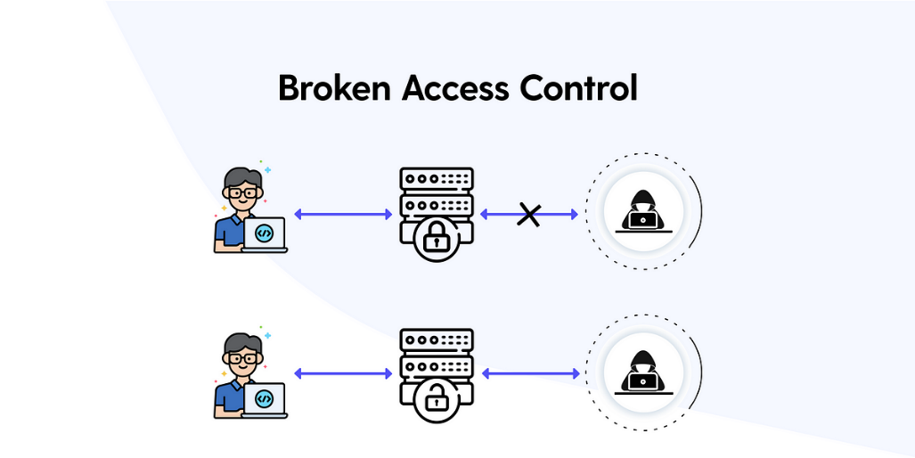

**How to fix it:**

1. Continuous Inspection and Testing Access Control:

Efficient continuous testing and inspecting the access control mechanism is an effective way to detect the newer vulnerabilities and correct them as soon as possible.

2. Deny Access By Default:

Design access control in such a way that not everyone can get access to the resources and functionalities unless it is intended to be publicly accessible. You can apply JIT (Just-in-Time) access, which helps to remove the risks associated with standing privileges.

3. Limiting CORS Usage:

CORS (Cross-Origin Resource Sharing) protocol provides a controlled way to share cross-origin resources. The implementation of the CORS relies on the Hypertext Transfer Protocol (HTTP) headers used in the communication between the client and the target application. When CORS protocol is misconfigured, it makes it possible for a domain to be controlled by a malicious party to send requests to your domain.

4. Enable Role-based Access Control:

This is a widely used access control mechanism. According to this, users are given permissions based on their roles. Instead of identifying each user individually, users are assigned to a group of roles, this way the struggle of IT support and administration can be reduced, and operational efficiency will be maximized.

5. Enable Permission-Based Access Control:

This is an access control method, where the authorization layer checks if the user has permission to access particular data or to perform a particular action, typically by checking if the user’s roles have this permission or not.

1. **Cryptographic Failures**

Cryptographic algorithms are invaluable for protecting data privacy and security; however, these algorithms can be very sensitive to implementation or configuration errors. Cryptographic failures include a failure to use encryption at all, misconfigurations of cryptographic algorithms, and insecure key management. For example, an organization might use an insecure hash algorithm for password storage, fail to salt passwords, or use the same salt for all stored user passwords.

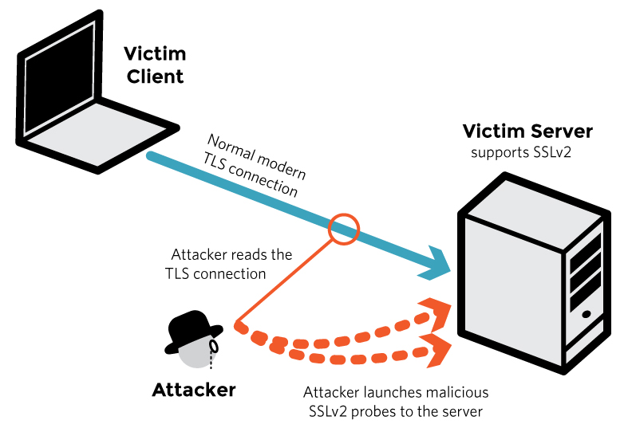

**How to fix it:**

1. Choose Strong Algorithms: Select well-established and robust cryptographic algorithms that are widely recognized and have undergone thorough security analysis. Avoid using weak or deprecated algorithms that are known to be vulnerable.

2. Implement Proper Key Management: Ensure secure key generation, storage, and distribution. Use strong random number generators for key generation and employ secure key storage mechanisms, such as hardware security modules (HSMs), to protect keys from unauthorized access.

3. Keep Software Up to Date: Regularly update your software, frameworks, and cryptographic libraries to ensure you have the latest security patches. Stay informed about any vulnerabilities or weaknesses discovered in cryptographic implementations and promptly apply updates.

4. Validate and Test Implementations: Thoroughly test and validate your cryptographic implementations to ensure they function correctly and securely. Use established testing methodologies, such as fuzzing or penetration testing, to identify any potential weaknesses or vulnerabilities

5. Follow Best Practices and Standards: Adhere to established cryptographic best practices and standards when designing and implementing secure systems. Rely on widely accepted cryptographic protocols and avoid rolling out custom protocols unless you have the necessary expertise and resources for extensive review and analysis.

**3. Injection**

Injection vulnerabilities are made possible by a failure to properly sanitize user input before processing it. This can be especially problematic in languages such as SQL where data and commands are intermingled so that maliciously malformed user-provided data may be interpreted as part of a command. For example, SQL commonly uses single (‘) or double (“) quotation marks to delineate user data within a query, so user input containing these characters might be capable of changing the command being processed.

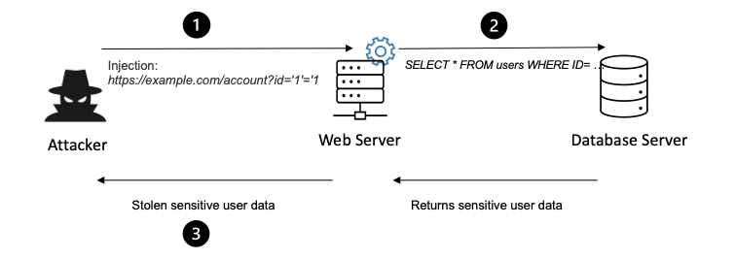

**How to fix it:**

1. Input Validation and Parameterized Queries: Implement strong input validation by validating and sanitizing user input on the server side. Use parameterized queries or prepared statements in database interactions to separate code logic from user input, preventing malicious input from being executed as commands.

2. Use Whitelisting Approach: Apply a whitelisting approach to input validation, where only known safe values or patterns are allowed, rejecting all other inputs. This helps prevent injection attacks by strictly controlling the types and formats of expected input.

3. Avoid Dynamic Query Building: Avoid constructing SQL queries dynamically by concatenating user input. Instead, use ORM (Object-Relational Mapping) frameworks or query builders that provide built-in protections against injection attacks.

4. Secure Database Configuration: Configure database permissions and access controls properly, ensuring that the application's database user has the least privilege required. Restrict database user permissions to prevent unauthorized access or modification of data.

5. Secure Coding Practices: Train developers on secure coding practices and educate them about the risks of injection vulnerabilities. Encourage the use of secure coding frameworks and libraries that have built-in protections against injection attacks.

**4. Insecure Design**

Vulnerabilities can be introduced into software during the development process in a couple of different ways. While many of the vulnerabilities on the OWASP Top Ten list deal with implementation errors, this vulnerability describes failures in design that undermine the security of the system. For example, if the design for an application that stores and processes sensitive data does not include an authentication system, then a perfect implementation of the software as designed will still be insecure and fail to properly protect this sensitive data.

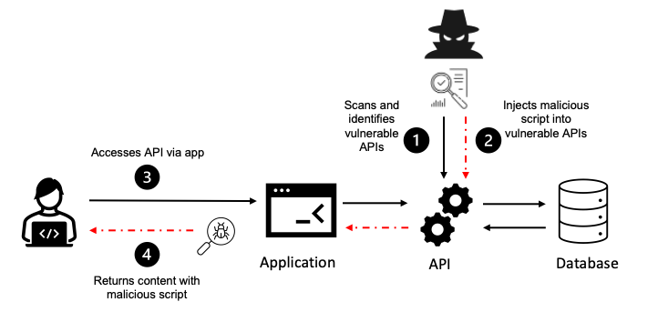

**How to fix it:**

1. Threat Modeling: Perform a thorough threat modeling exercise to identify potential security risks and vulnerabilities early in the design phase. Consider the application's architecture, data flow, trust boundaries, and potential attack vectors. This will help you understand the potential security risks and make informed design decisions.

2. Secure Architecture: Design a secure architecture that incorporates security controls at each layer of the application. Apply security principles such as defense-in-depth and least privilege. Use proven architectural patterns and frameworks that enforce security controls, such as the Model-View-Controller (MVC) pattern.

3. Secure Data Management: Ensure secure handling of sensitive data. Implement strong encryption techniques for data in transit and at rest. Use secure protocols such as HTTPS/TLS for data transmission. Employ proper data access controls, authentication mechanisms, and secure storage practices.

4. Access Control and Authorization: Implement robust access control mechanisms to enforce proper authentication and authorization. Apply the principle of least privilege, granting users only the necessary permissions to perform their intended actions. Use role-based access control (RBAC) or attribute-based access control (ABAC) to manage user permissions effectively

5. Secure Input Validation: Implement strict input validation to prevent common vulnerabilities such as injection attacks or cross-site scripting (XSS). Validate and sanitize user input on the server side, following secure coding practices, and avoid relying solely on client-side validation.

**5. Security Misconfiguration**

In addition to its design and implementation, the security of an application is also determined by how it is configured. A software manufacturer will have default configurations for their applications, and the users may also enable or disable various settings, which can improve or impair the security of the system. Examples of security misconfigurations could include enabling unnecessary applications or ports, leaving default accounts and passwords active and unchanged, or configuring error messages to expose too much information to a user.

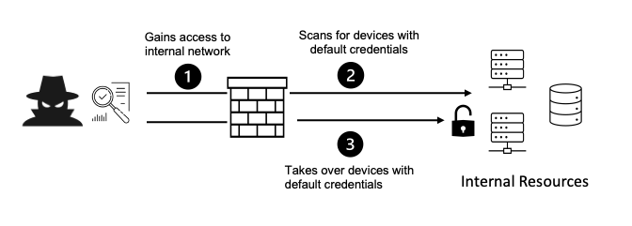

**How to fix it:**

1. Secure Default Configurations: Review and modify default configurations of your web server, application framework, and components. Default configurations often have unnecessary services enabled or weak security settings. Disable or configure them securely to minimize potential vulnerabilities.

2. Patch and Update Regularly: Keep all software, frameworks, libraries, and plugins up to date with the latest security patches and updates. Vulnerabilities in outdated software versions are often exploited by attackers. Establish a process to regularly check for updates and apply them promptly.

3. Secure Server and Network Configurations: Configure your server and network settings securely. Disable unnecessary services, ports, or protocols that are not required for the application's functionality. Implement proper firewall rules, network segmentation, and intrusion detection systems to protect against unauthorized access.

4. Strong Authentication and Access Controls: Implement strong authentication mechanisms, such as multi-factor authentication (MFA), to ensure that only authorized users can access the application. Enforce secure password policies, account lockouts, and session timeouts. Implement proper access controls to restrict privileged operations or sensitive data access to authorized users.

5. Error Handling and Logging: Ensure that error messages do not disclose sensitive information and follow secure coding practices for error handling. Implement detailed logging mechanisms to capture relevant security events and incidents. Regularly review and analyze logs to detect and respond to security incidents promptly.

**6. Vulnerable and Outdated Components**

Supply chain vulnerabilities have emerged as a major concern in recent years, especially as threat actors have attempted to insert malicious or vulnerable code into commonly used libraries and third-party dependencies. If an organization lacks visibility into the external code that is used within its applications — including nested dependencies — and fails to scan it for dependencies, then it may be vulnerable to exploitation. Also, a failure to promptly apply security updates to these dependencies could leave exploitable vulnerabilities open to attack. For example, an application may import a third-party library that has its own dependencies that could contain known exploitable vulnerabilities.

**7. Identification and Authentication Failures**

Many applications and systems require some form of identification and authentication, such as a user proving their identity to an application or a server providing a digital certificate verifying its identity to a user when setting up a TLS-encrypted connection. Identification and authentication failures occur when an application relies upon weak authentication processes or fails to properly validate authentication information. For example, an application that lacks multi-factor authentication (MFA) might be vulnerable to a credential stuffing attack in which an attacker automatically tries username and password combinations from a list of weak, common, default, or compromised credentials.

**8. Software and Data Integrity Failures**

The Software and Data Integrity Failures vulnerability in the OWASP Top 10 list addresses weaknesses in the security of an organization’s DevOps pipeline and software update processes similar to those that made the SolarWinds hack possible. This vulnerability class includes relying on third-party code from untrusted sources or repositories, failing to secure access to the CI/CD pipeline, and not properly validating the integrity of automatically applied updates. For example, if an attacker can replace a trusted module or dependency with a modified or malicious version, then applications that are built with that dependency could run malicious code or be vulnerable to exploitation.

**9. Security Logging and Monitoring Failures**

Security Logging and Monitoring Failures is the first of the vulnerabilities that are derived from survey responses and has moved up from the tenth spot in the previous iteration of the list. Many security incidents are enabled or exacerbated by the fact that an application fails to log significant security events or that these log files are not properly monitored and handled. For example, an application may not generate log files, may generate security logs that lack critical information, or these log files may only be available locally on a computer, making them only useful for investigation after an incident has been detected. All of these failures degrade an organization’s ability to rapidly detect a potential security incident and to respond in real-time.

**10. Server-Side Request Forgery**

Server-side request forgery (SSRF) is unusual among the vulnerabilities listed in the OWASP Top Ten list because it describes a very specific vulnerability or attack rather than a general category. SSRF vulnerabilities are relatively rare; however, they have a significant impact if they are identified and exploited by an attacker. The Capital One hack is an example of a recent, high-impact security incident that took advantage of an SSRF vulnerability.

SSRF vulnerabilities can exist when a web application does not properly validate a URL provided by a user when fetching a remote resource located at that URL. If this is the case, then an attacker exploiting the vulnerability can use the vulnerable web application to send a request crafted by the attacker to the indicated URL. This allows the attacker to bypass access controls, such as a firewall, which would block direct connections from the attacker to the target URL but is configured to provide access to the vulnerable web application.

**Top 10 Hackers in the world**

**What is hacking?**

Computer hacking is the act of identifying and exploiting system and network vulnerabilities in order to obtain unauthorized access to those systems. Not all hacking is malicious. White hat hackers may work in cyber security or as software engineers and testers seeking out vulnerabilities in order to fix them. Black hat hackers operate with malicious intent. That said, there is a large grey area populated by political activists and hackers who wear both hats

1. **Kevin Mitnick (Black Hat hacker)**

A seminal figure in American hacking, Kevin Mitnick got his career start as a teen. In 1981, he was charged with stealing computer manuals from Pacific Bell. In 1982, he hacked the North American Defense Command (NORAD), an achievement that inspired the 1983 film [*War Games*](https://www.imdb.com/title/tt0086567/?ref_=nv_sr_srsg_0). In 1989, he hacked Digital Equipment Corporation's (DEC) network and made copies of their software. Because DEC was a leading computer manufacturer at the time, this act put Mitnick on the map. He was later arrested, convicted and sent to prison. During his conditional release, he hacked Pacific Bell's voicemail systems.

Throughout his hacking career, Mitnick never exploited the access and data he obtained. It's widely believed that he once obtained full control of Pacific Bell's network simply to prove it could be done. A warrant was issued for his arrest for the Pacific Bell incident, but Mitnick fled and lived in hiding for more than two years. When caught, he served time in prison for multiple counts of wire fraud and computer fraud.

Although Mitnick ultimately went white hat, he may be part of the both-hats grey area. According to [Wired](https://www.wired.com/2014/09/kevin-mitnick-selling-zero-day-exploits/), in 2014, he launched "Mitnick's Absolute Zero Day Exploit Exchange," which sells unpatched, critical software exploits to the highest bidder.

1. **Anonymous(Grey hat hacker)**

Anonymous got its start in 2003 on [4chan message boards](https://en.wikipedia.org/wiki/4chan) in an unnamed forum. The group exhibits little organization and is loosely focused on the concept of social justice. For example, in 2008 the group took issue with the Church of Scientology and begin disabling their websites, thus negatively impacting their search rankings in Google and overwhelming its fax machines with all-black images. In March 2008, a group of "Anons" marched passed Scientology centers around the world wearing the now-famous Guy Fawkes mask. As noted by [The New Yorker](https://www.newyorker.com/magazine/2014/09/08/masked-avengers), while the FBI and other law enforcement agencies have tracked down some of the group's more prolific members, the lack of any real hierarchy makes it almost impossible to identify or eliminate Anonymous as a whole.

1. **Adrian Lamo(Grey hat hacker)**

In 2001, 20-year-old Adrian Lamo used an unprotected content management tool at Yahoo to modify a Reuters article and add a fake quote attributed to former Attorney General John Ashcroft. Lamo often hacked systems and then notified both the press and his victims. In some cases, he'd help clean up the mess to improve their security. As [Wired](http://www.wired.com/2010/05/lamo/) points out, however, Lamo took things too far in 2002, when he hacked The New York Times' intranet, added himself to the list of expert sources and began conducting research on high-profile public figures. Lamo earned the moniker "The Homeless Hacker" because he preferred to wander the streets with little more than a backpack and often had no fixed address.

1. **Albert Gonzalez(Black hat hacker)**

According to the New York Daily News, Gonzalez, dubbed "soupnazi," got his start as the "troubled pack leader of computer nerds" at his Miami high school. He eventually became active on criminal commerce site Shadowcrew.com and was considered one of its best hackers and moderators. At 22, Gonzalez was arrested in New York for debit card fraud related to stealing data from millions of card accounts. To avoid jail time, he became an informant for the Secret Service, ultimately helping indict dozens of Shadowcrew members.

During his time as a paid informant, Gonzalez continued his in criminal activities. Along with a group of accomplices, Gonzalez stole more than 180 million payment card accounts from companies including OfficeMax, Dave and Buster's and Boston Market. [The New York Times Magazine](https://www.nytimes.com/2010/11/14/magazine/14Hacker-t.html) notes that Gonzalez's 2005 attack on US retailer TJX was the first serial data breach of credit information. Using a basic SQL injection, this famous hacker and his team created back doors in several corporate networks, stealing an estimated $256 million from TJX alone. During his sentencing in 2015, the federal prosecutor called Gonzalez's human victimization "unparalleled."

1. **Matthew Bevan and Richard Pryce(Grey hat hacker)**

Matthew Bevan and Richard Pryce are a team of British hackers who hacked into multiple military networks in 1996, including Griffiss Air Force Base, the Defense Information System Agency and the Korean Atomic Research Institute (KARI). Bevan (Kuji) and Pryce (Datastream Cowboy) have been accused of nearly starting a third world war after they dumped KARI research onto American military systems. Bevan claims he was looking to prove a UFO conspiracy theory, and according to the [BBC](http://news.bbc.co.uk/2/hi/technology/4761985.stm), his case bears resemblance to that of Gary McKinnon. Malicious intent or not, Bevan and Pryce demonstrated that even military networks are vulnerable.

1. **Jeanson James Ancheta(Grey hat hacker)**

Jeanson James Ancheta had no interest in hacking systems for credit card data or crashing networks to deliver social justice. Instead, Ancheta was curious about the use of bots—software-based robots that can infect and ultimately control computer systems. Using a series of large-scale "[botnets](https://www.kaspersky.com/resource-center/threats/botnet-attacks)," he was able to compromise more than 400,000 computers in 2005. According to [Ars Technica](https://arstechnica.com/uncategorized/2006/05/6789-2/), he then rented these machines out to advertising companies and was also paid to directly install bots or [adware](https://www.kaspersky.com/resource-center/threats/adware-pornware-riskware) on specific systems. Ancheta was sentenced to 57 months in prison. This was the first time a hacker was sent to jail for the use of botnet technology.

1. **Michael Calce(White hat hacker)**

In February 2000, 15-year-old Michael Calce, also known as "Mafiaboy," discovered how to take over networks of university computers. He used their combined resources to disrupt the number-one search engine at the time: Yahoo. Within one week, he'd also brought down Dell, eBay, CNN and Amazon using a [distributed-denial-of-service (DDoS)](https://www.kaspersky.com/resource-center/threats/ddos-attacks) attack that overwhelmed corporate servers and caused their websites to crash. Calce's wake-up call was perhaps the most jarring for cyber crime investors and internet proponents. If the biggest websites in the world—valued at over $1 billion—could be so easily sidelined, was any online data truly safe? It's not an exaggeration to say that the development of cyber crime legislation suddenly became a top government priority thanks to Calce's hack.

1. **Kevin Poulsen(Black hat hacker)**

In 1983, a 17-year-old Poulsen, using the alias Dark Dante, hacked into ARPANET, the Pentagon’s computer network. Although he was quickly caught, the government decided not to prosecute Poulsen, who was a minor at the time. Instead, he was let off with a warning.

Poulsen didn’t heed this warning and continued hacking. In 1988, Poulsen hacked a federal computer and dug into files pertaining to the deposed president of the Philippines, Ferdinand Marcos. When discovered by authorities, Poulsen went underground. While he was on the run, Poulsen kept busy, hacking government files and revealing secrets. According to his [own website](https://www.kingpin.cc/about/), in 1990, he hacked a radio station contest and ensured that he was the 102nd caller, winning a brand new Porsche, a vacation, and $20,000.

Poulsen was soon arrested and barred from using a computer for three years. He has since converted to white hat hacking and journalism, writing about cyber security and web-related socio-political causes for [Wired](https://www.wired.com/author/kevin-poulsen/), The Daily Beast and his own blog Threat Level. Paulson also teamed with other leading hackers to work on various projects dedicated to social justice and freedom of information. Perhaps most notably, working with Adam Swartz and Jim Dolan to develop the open-source software SecureDrop, initially known as DeadDrop. Eventually, Poulsen turned over the platform, which enabled secure communication between journalists and sources, to the Freedom of Press Foundation.

1. **Jonathan James(Grey hat hacker)**

Using the alias cOmrade, Jonathan James hacked several companies. According to the [New York Times](https://www.nytimes.com/2000/09/23/us/youth-sentenced-in-government-hacking-case.html), what really earned James attention was his hack into the computers of the United States Department of Defense. Even more impressive was the fact that James was only 15 at the time. In [an interview with PC Mag](https://www.pcmag.com/archive/qa-hackings-boy-wonder-212515), James admitted that he was partly inspired by the book *The Cuckoo’s Egg*, which details the hunt for a computer hacker in the 1980s. His hacking allowed him to access over 3,000 messages from government employees, usernames, passwords and other sensitive data.

James was arrested in 2000 and was sentenced to a six months house arrest and banned from recreational computer use. However, a probation violation caused him to serve six months in jail. Jonathan James became the youngest person to be convicted of violating cyber crime laws. In 2007, TJX, a department store, was hacked and many customer’s private information were compromised. Despite a lack of evidence, authorities suspect that James may have been involved.

In 2008, James committed suicide by gunshot. According to the [Daily Mail](https://www.dailymail.co.uk/news/article-2262831/Revealed-Aaron-Swartz-prosecutor-drove-hacker-suicide-2008-named-cyber-crime-case.html), his [suicide note](https://www.dailymail.co.uk/news/article-2262831/Revealed-Aaron-Swartz-prosecutor-drove-hacker-suicide-2008-named-cyber-crime-case.html) stated, “I have no faith in the 'justice' system. Perhaps my actions today, and this letter, will send a stronger message to the public. Either way, I have lost control over this situation, and this is my only way to regain control.”

1. **ASTRA(Black hat hacker)**

This hacker differs from the others on this list in that he has never been publicly identified. However, according to [the Daily Mail](https://www.dailymail.co.uk/news/article-2262831/Revealed-Aaron-Swartz-prosecutor-drove-hacker-suicide-2008-named-cyber-crime-case.html), some information has been released about ASTRA. Namely that he was apprehended by authorities in 2008, and at that time he was identified as a 58-year-old Greek mathematician. Reportedly, he had been hacking into the Dassault Group, for almost half a decade. During that time, he stole cutting edge weapons technology software and data which he then sold to 250 individuals around the world. His hacking cost the Dassault Group $360 million in damages. No one knows why his complete identity has never been revealed, but the word 'ASTRA' is a Sanskrit word for 'weapon'.

* TCP Port 20 (FTP - File Transfer Protocol - Data):

Vulnerabilities: Data leakage, unauthorized access, FTP bounce attacks, plaintext transmission of data.

* TCP Port 21 (FTP - File Transfer Protocol - Control):

Vulnerabilities: Weak authentication, FTP bounce attacks, plaintext transmission of credentials, FTP command injection.

* TCP Port 22 (SSH - Secure Shell):

Vulnerabilities: Weak passwords, brute force attacks, SSH protocol vulnerabilities, insecure SSH configurations.

* TCP Port 23 (Telnet):

Vulnerabilities: Weak or default credentials, plaintext transmission of data, command injection, session hijacking.

* TCP Port 24 (Priv-mail - any private mail system):

Vulnerabilities: Specific vulnerabilities depend on the private mail system in use.

* TCP Port 25 (SMTP - Simple Mail Transfer Protocol):

Vulnerabilities: Email spoofing, SMTP relay abuse, open mail relays, unauthorized email access, email flooding.

* TCP/UDP Port 53 (DNS - Domain Name System):

Vulnerabilities: DNS cache poisoning, DNS spoofing, DDoS attacks, zone transfer attacks, DNS amplification attacks.

* UDP Port 69 (TFTP - Trivial File Transfer Protocol):

Vulnerabilities: Insecure file transfers, lack of authentication, potential for unauthorized access.

* TCP Port 80 (HTTP - Hypertext Transfer Protocol):

Vulnerabilities: Cross-site scripting (XSS), SQL injection, directory traversal, server misconfigurations, insecure authentication mechanisms.

* TCP Port 110 (POP3 - Post Office Protocol version 3):

Vulnerabilities: Weak or default credentials, plaintext transmission of credentials, unauthorized email access.

* UDP Port 123 (NTP - Network Time Protocol):

Vulnerabilities: NTP amplification attacks, DDoS attacks, time manipulation attacks, server misconfigurations.

* TCP Port 143 (IMAP - Internet Message Access Protocol):

Vulnerabilities: Weak or default credentials, plaintext transmission of credentials, unauthorized email access.

* TCP Port 443 (HTTPS - Hypertext Transfer Protocol Secure):

Vulnerabilities: SSL/TLS vulnerabilities, certificate issues, weak ciphers, man-in-the middle attacks, phishing attacks.

**Non top 10 Web vulnerabilities**

1. Cross-Site Script Inclusion (XSSI): XSSI vulnerabilities occur when an attacker can include untrusted content from a different domain into a web application. This can lead to cross-site scripting (XSS) attacks or information disclosure.

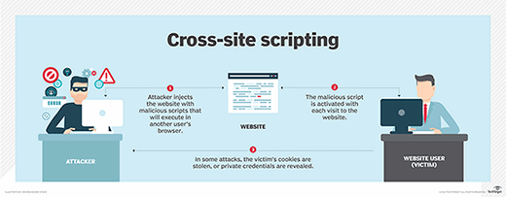

2. Clickjacking: Clickjacking involves tricking users into clicking on a malicious element disguised as a legitimate one on a webpage. This can lead to unintended actions performed by the user, such as unknowingly liking a post or sharing sensitive information.

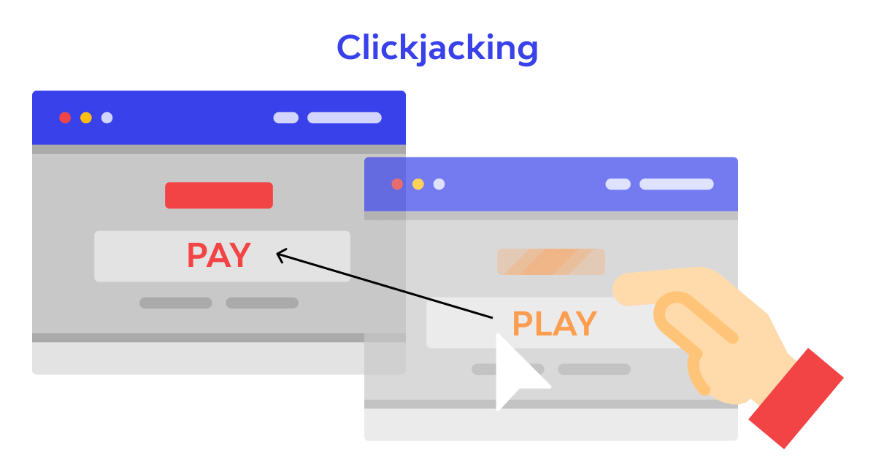

3. Cross-Site Printing: Cross-Site Printing attacks occur when an attacker abuses the browser's print functionality to print arbitrary content. This can lead to the disclosure of sensitive information or the manipulation of printed documents.

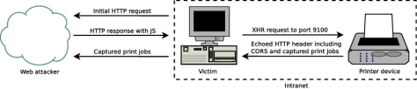

4. Predictable Resource Location: Predictable resource location vulnerabilities occur when sensitive resources, such as files or directories, have predictable or easily discoverable URLs. This can allow attackers to directly access or manipulate sensitive information.

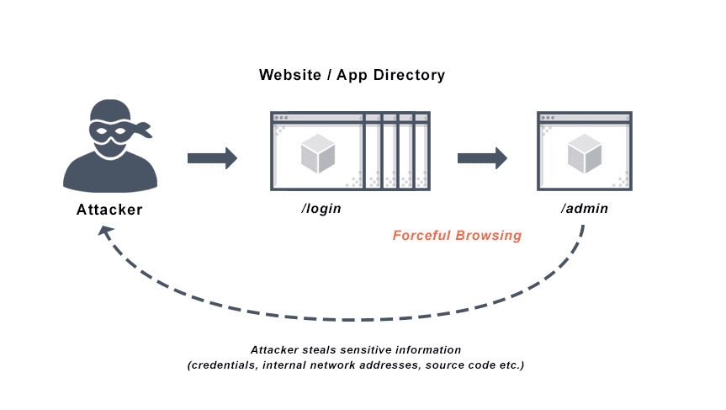

5. Security Through Obscurity: Relying on security through obscurity involves using secrecy or hidden mechanisms as the primary means of protection. This can lead to vulnerabilities being overlooked and exploited once the underlying mechanisms are discovered.



6. HTTP Parameter Pollution (HPP): HPP vulnerabilities occur when multiple values are assigned to the same parameter, causing conflicts or unexpected behavior in the application. This can lead to data corruption, privilege escalation, or bypassing security controls.

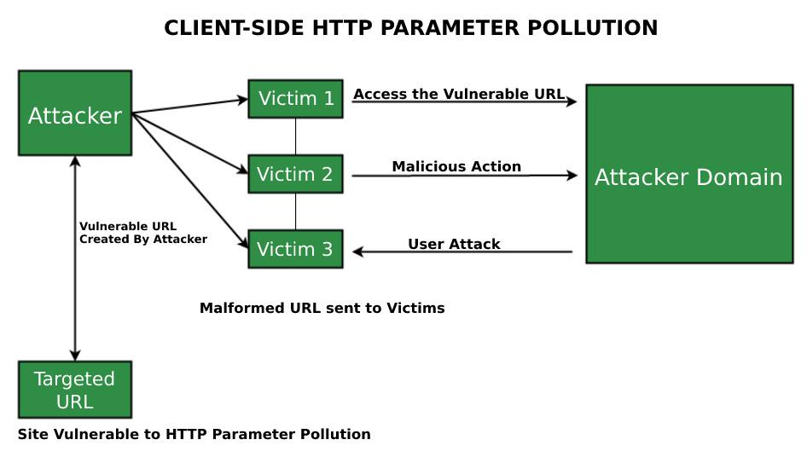

7. Unvalidated File Upload: Unvalidated file upload vulnerabilities allow users to upload arbitrary files to a web application without proper validation. This can lead to the execution of malicious code, denial of service, or unauthorized access to the server.

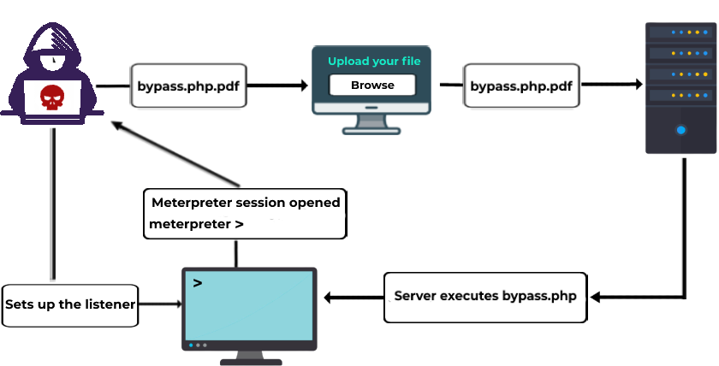

8. Insecure Cross-Origin Resource Sharing (CORS): CORS vulnerabilities occur when a web application improperly configures cross-origin resource sharing, allowing unauthorized domains to access sensitive data or perform privileged actions.

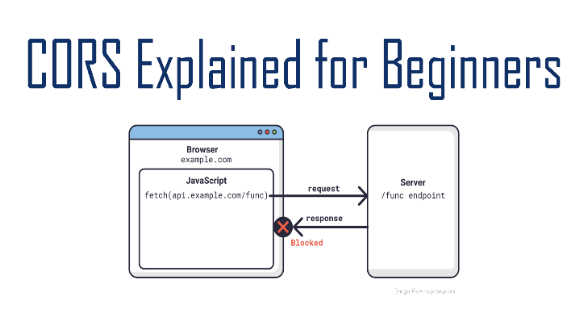

9. HTTP Response Splitting: HTTP response splitting vulnerabilities occur when an attacker can manipulate the application's HTTP response header, leading to cache poisoning, session hijacking, or injection attacks.

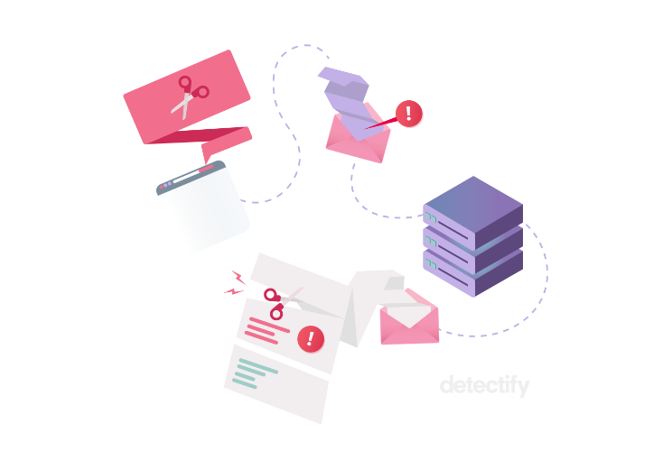

10. Content Spoofing: Content spoofing involves manipulating the content displayed to users, making it appear as if they are interacting with a legitimate website or application. This can lead to phishing attacks or the theft of sensitive information.

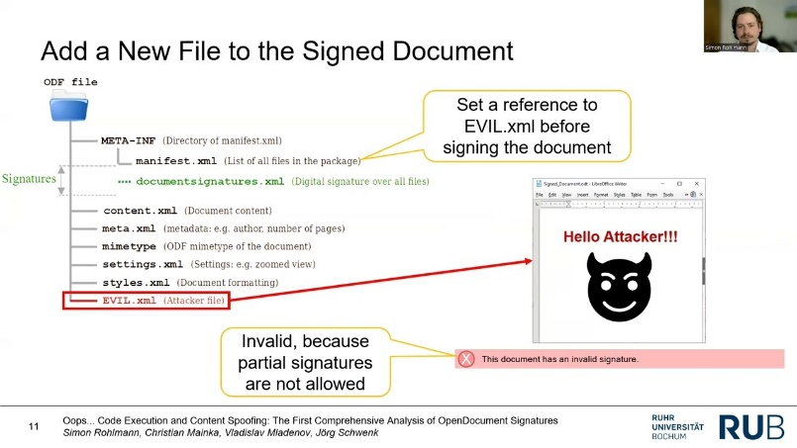

While these vulnerabilities may not always make it to the top 10 lists, they can still pose significant risks to web applications. It is important to employ secure coding practices, perform regular security assessments, and stay informed about emerging vulnerabilities to protect against a wide range of threats.

Here are 10 common web server attacks:

1. Distributed Denial of Service (DDoS): In a DDoS attack, multiple compromised systems flood the target server with a massive amount of traffic, overwhelming its resources and causing it to become unavailable to legitimate users.

2. SQL Injection: This attack involves exploiting vulnerabilities in a web application's database layer. Attackers inject malicious SQL code into user input fields, tricking the server into executing unintended database commands that can reveal sensitive information or manipulate the database.

3. Cross-Site Scripting (XSS): XSS attacks occur when attackers inject malicious scripts into web pages viewed by other users. These scripts can be used to steal sensitive information, hijack user sessions, or deface websites.

4. Cross-Site Request Forgery (CSRF): In a CSRF attack, an attacker tricks a victim into unknowingly executing unwanted actions on a web application. This is done by exploiting the trust between the user's browser and the target server, leading to unauthorized actions being performed on behalf of the user.

5. Remote File Inclusion (RFI): RFI attacks involve exploiting vulnerabilities in a web application to include remote files, often from external servers controlled by the attacker. This can allow the attacker to execute arbitrary code on the server, leading to unauthorized access or system compromise.

6. Server-Side Request Forgery (SSRF): In an SSRF attack, an attacker manipulates a vulnerable web application to make requests to internal resources or external systems that the server has access to. This can be used to bypass security restrictions, scan internal networks, or exploit vulnerable services.

7. Directory Traversal: This attack aims to access files and directories outside of the intended web server directory structure. By manipulating input parameters, attackers can navigate to restricted areas and potentially retrieve sensitive information or execute arbitrary code.

8. Brute Force Attacks: In a brute force attack, an attacker systematically attempts all possible combinations of usernames and passwords to gain unauthorized access to a web server. This attack relies on weak or easily guessable credentials.

9. Server Misconfiguration: Server misconfigurations can expose sensitive information or provide unauthorized access to attackers. Examples include leaving default credentials unchanged, enabling unnecessary services, or not applying security patches.

10. Zero-Day Exploits: Zero-day exploits target vulnerabilities that are unknown to the vendor or have no official patch available. Attackers exploit these vulnerabilities before they are discovered and patched, gaining unauthorized access to web servers.

It's important for organizations to implement strong security measures, regularly update software and applications, and perform security audits to mitigate the risk of these attacks.

Basic

1. Inventory and Control of Hardware Assets

Actively manage (inventory, track, and correct) all hardware devices on the network so that only authorized devices are given access, and unauthorized and unmanaged devices are found and prevented from gaining access.

2. Inventory and Control of Software Assets

Actively manage (inventory, track, and correct) all software on the network so that only authorized software is installed and can execute, and that unauthorized and unmanaged software is found and prevented from installation or execution.

3. Continuous Vulnerability Management

Continuously acquire, assess, and take action on new information in order to identify vulnerabilities, remediate, and minimize the window of opportunity for attackers.

4. Controlled Use of Administrative Privileges

The processes and tools used to track/control/prevent/correct the use, assignment, and configuration of administrative privileges on computers, networks, and applications.

5. Secure Configuration for Hardware and Software on Mobile Devices, Laptops, Workstations and Servers

Establish, implement, and actively manage (track, report on, correct) the security configuration of mobile devices, laptops, servers, and workstations using a rigorous configuration management and change control process in order to prevent attackers from exploiting vulnerable services and settings

6. Maintenance, Monitoring and Analysis of Audit Logs

Collect, manage, and analyze audit logs of events that could help detect, understand, or recover from an attack.

**Foundational**

7. Email and Web Browser Protections

Minimize the attack surface and the opportunities for attackers to manipulate human behavior though their interaction with web browsers and email systems.

8. Malware Defenses

Control the installation, spread, and execution of malicious code at multiple points in the enterprise, while optimizing the use of automation to enable rapid updating of defense, data gathering, and corrective action.

9. Limitation and Control of Network Ports, Protocols, and Services

Manage (track/control/correct) the ongoing operational use of ports, protocols, and services on networked devices in order to minimize windows of vulnerability available to attackers

10. Data Recovery Capabilities

The processes and tools used to properly back up critical information with a proven methodology for timely recovery of it

11. Secure Configuration for Network Devices, such as Firewalls, Routers and Switches

Establish, implement, and actively manage (track, report on, correct) the security configuration of network infrastructure devices using a rigorous configuration management and change control process in order to prevent attackers from exploiting vulnerable services and settings

12. Boundary Defense

Detect/prevent/correct the flow of information transferring networks of different trust levels with a focus on security-damaging data

13. Data Protection

The processes and tools used to prevent data exfiltration, mitigate the effects of exfiltrated data, and ensure the privacy and integrity of sensitive information

14. Controlled Access Based on the Need to Know

The processes and tools used to track/control/prevent/correct secure access to critical assets (e.g., information, resources, systems) according to the formal determination of which persons, computers, and applications have a need and right to access these critical assets based on an approved classification

15. Wireless Access Control

The processes and tools used to track/control/prevent/correct the security use of wireless local area networks (WLANs), access points, and wireless client systems

16. Account Monitoring and Control

Actively manage the life cycle of system and application accounts - their creation, use, dormancy, deletion - in order to minimize opportunities for attackers to leverage them.

**Organizational**

17. Implement a Security Awareness and Training Program

For all functional roles in the organization (prioritizing those mission-critical to the business and its security), identify the specific knowledge, skills and abilities needed to support defense of the enterprise; develop and execute an integrated plan to assess, identify gaps, and remediate through policy, organizational planning, training, and awareness programs

18. Application Software Security

Manage the security life cycle of all in-house developed and acquired software in order to prevent, detect, and correct security weaknesses.

19. Incident Response and Management

Protect the organization’s information, as well as its reputation, by developing and implementing an incident response infrastructure (e.g., plans, defined roles, training, communications, management oversight) for quickly discovering an attack and then effectively containing the damage, eradicating the attacker’s presence, and restoring the integrity of the network and systems

20. Penetration Tests and Red Team Exercises

Test the overall strength of an organization’s defense (the technology, the processes, and the people) by simulating the objectives and actions of an attacker

Kali Linux Tools List

List of Kali Linux Tools and Description of Each

* **Nmap -** Nmap, a network discovery and security auditing tool, is another frequently used tool. There are options that notify every open port on the target. The Nmap ("Network Mapper") tool is used in active reconnaissance to discover not only the live systems but also gaps in the system. This versatile tool is well supported and one of the best in the hacking community. Nmap is available for all operating systems and includes a graphical user interface. It is used to identify network flaws.
* **Amass** - is a command line open-source tool that helps information security professionals to perform network mapping of attack surfaces and perform external asset discovery using open source information gathering and active reconnaissance techniques.
* **SpiderFoot** - is an intelligence automation tool based on *open-source intelligence***(OSINT).** Its purpose is to automate gathering intelligence about a specific target, which could be *an IP address, domain name, hostname, network subnet, ASN,* or *person's name.*
* **Maltego** - is an open source intelligence and forensics application. It will offer you timeous mining and gathering of information as well as the representation of this information in a easy to understand format. This package replaces previous packages matlegoce and casefile.
* **ike-scan** - discovers IKE hosts and can also fingerprint them using the retransmission backoff pattern. ike-scan does two things: a) Discovery: Determine which hosts are running IKE. This is done by displaying those hosts which respond to the IKE requests sent by ike-scan.
* **Nikto** - is an Open Source software written in Perl language that is used to scan a web-server for vulnerability that can be exploited and can compromise the server. It can also check for outdated version details of 1200 servers and can detect problems with specific version details of over 200 servers. It comes packed with many features
* **Lynis** is probably one of the most complete tools available for cybersecurity compliance (e.g. PCI, HIPAA, SOx), testing, system hardening, and system auditing. That’s why it’s included in this Kali Linux tools list.

Given its immense capabilities, Lynis also serves as a great vulnerability scanner and penetration testing platform.

* **Fierce** is a great tool for network mapping and port scanning. It can be used to discover non-contiguous IP space and hostnames across networks.

It's similar to Nmap and Unicornscan, but unlike those, Fierce is mostly used for specific corporate networks.

Once the penetration tester has defined the target network, Fierce will run several tests against the selected domains to retrieve valuable information that can be used for later analysis and exploitation.

* **WPScan** is recommended for auditing your WordPress installation security. By using WPScan you can check if your WordPress setup is vulnerable to certain types of attacks, or if it's exposing too much information in your core, plugin or theme files.

This WordPress security tool also lets you find any weak passwords for all registered users, and even run a brute force attack against it to see which ones can be cracked.

WPScan receives frequent updates from the wpvulndb.com WordPress vulnerability database, which makes it a great software for up-to-date WP security.

* **Wireshark** is an open source multi-platform network analyzer that runs Linux, OS X, BSD, and Windows.

It's especially useful for knowing what's going on inside your network, which accounts for its widespread use in government, corporate and education industries.

It works in a similar manner as tcpdump, but Wireshark adds a great graphical interface that allows you to filter, organize and order captured data so it takes less time to analyze. A text-based version, called tshark, is comparable in terms of features.

* **John the Ripper** is a multi-platform cryptography testing tool that works on Unix, Linux, Windows and MacOS. It allows system administrators and security penetration testers to launch brute force attacks to test the strength of any system password. It can be used to test encryptions such as DES, SHA-1 and many others.

Its abilities to change password decryption methods are set automatically, depending on the detected algorithm.

Licensed and distributed under the GPL license, it's a free tool available for anyone who wants to test their password security.

* **THC Hydra** is a free hacking tool licensed under AGPL v3.0, widely used by those who need to brute force crack remote authentication services.

As it supports up to more than 50 protocols, it's one of the best tools for testing your password security levels in any type of server environment.

It also provides support for most popular operating systems like Windows, Linux, Free BSD, Solaris and OS X.

* **Metasploit** Framework is a Ruby-based platform used to develop, test and execute exploits against remote hosts. It includes a full collection of security tools used for penetration testing, along with a powerful terminal-based console — called msfconsole — which allows you to find targets, launch scans, exploit security flaws and collect all available data.

Available for Linux and Windows, MSF is probably one of the most powerful security auditing tools freely available for the infosec market.

* **Yersinia** is a security network tool that allows you to perform L2 attacks by taking advantage of security flaws in different network protocols.

This tool can attack switches, routers, DHCP servers and many other protocols. It includes a fancy GTK GUI, ncurses-based mode, is able to read from a custom configuration file, supports debugging mode and offers to save results in a log file.

**WinCollect and Standalone WinCollect: Enhancing Log Management and Security Intelligence**

**Introduction**

In the ever-evolving landscape of cybersecurity, effective log management is paramount. IBM Security's WinCollect, a powerful log collection tool, plays a pivotal role in gathering and analyzing logs from various sources. This document provides an in-depth exploration of WinCollect and its standalone variant, shedding light on their features, benefits, and deployment scenarios.

**WinCollect: An Overview**

WinCollect is a robust log collection agent developed by IBM Security, designed to gather logs from multiple sources and forward them to a central repository for analysis and correlation. It is a crucial component of IBM Security's QRadar SIEM (Security Information and Event Management) solution. WinCollect is renowned for its versatility, scalability, and seamless integration with various log sources, making it a valuable tool for organizations seeking to enhance their cybersecurity posture.

**Features of WinCollect**

**1. Log Source Flexibility**

WinCollect supports a wide range of log sources, including Windows, Linux, Unix, network devices, and applications. This flexibility ensures comprehensive coverage of an organization's IT environment.

**2. Real-time Log Collection**

It offers real-time log collection, ensuring that security events are promptly captured and forwarded to the SIEM system for analysis. This capability enables swift incident response and threat detection.

**3. Efficient Log Compression and Transmission**

WinCollect optimizes log transmission by compressing and encrypting logs before forwarding them to the central repository. This reduces network bandwidth usage and enhances data security.

**4. Scalability**

The solution can scale to accommodate the log volume of even the largest organizations. It allows for centralized management of multiple WinCollect agents, simplifying log collection in complex, multi-site environments.

**5. Predefined Log Source Support**

WinCollect includes predefined log source configurations for many common devices and applications, simplifying the setup process and reducing the risk of misconfiguration.

**6. Custom Log Source Configuration**

For unique or proprietary log sources, WinCollect offers the flexibility to create custom log source configurations, ensuring compatibility with virtually any log-generating system.

**## Standalone WinCollect**

Standalone WinCollect refers to a deployment scenario in which WinCollect agents are used independently, without integration with IBM QRadar SIEM. This configuration is particularly relevant for organizations that require standalone log collection and analysis capabilities, but do not necessarily need the full SIEM functionality.

**Use Cases for Standalone WinCollect**

**1. Small and Medium-sized Businesses (SMBs)**

SMBs with limited resources may opt for Standalone WinCollect to meet their log collection and security monitoring needs without the complexity and cost associated with a full SIEM solution.

**2. Log Source Normalization**

Standalone WinCollect can serve as a log source normalization tool, aggregating logs from diverse sources and forwarding them in a standardized format to other security tools or storage systems.

**3. Compliance and Auditing**

Organizations seeking compliance with regulatory standards, such as PCI DSS or HIPAA, can deploy Standalone WinCollect to collect and retain logs for auditing purposes.

**4. Security Event Detection**

While not a full SIEM solution, Standalone WinCollect can still aid in detecting security events and anomalies within an organization's network by providing real-time log collection and analysis.

**Benefits of Standalone WinCollect**

**1. Cost-Efficiency**

Standalone WinCollect offers a cost-effective solution for log collection and management, making it accessible to organizations with budget constraints.

**2. Simplified Deployment**

The deployment of Standalone WinCollect is typically simpler and faster than implementing a full SIEM solution, allowing organizations to get up and running quickly.

**3. Tailored Log Management**

Organizations can configure Standalone WinCollect to meet their specific log collection and analysis needs, providing a tailored solution.

**4. Log Retention**

Standalone WinCollect helps organizations meet compliance requirements by collecting and retaining logs for auditing and reporting purposes.

**Conclusion**

WinCollect, in its various deployment scenarios, is a valuable tool for organizations looking to enhance their log management and security intelligence capabilities. Whether integrated with IBM QRadar SIEM or deployed as Standalone WinCollect, this versatile solution provides flexibility, scalability, and efficient log collection, contributing to a stronger cybersecurity posture. Organizations should carefully assess their requirements and resources to determine the most suitable deployment approach, ensuring they get the most out of WinCollect's capabilities to protect their digital assets and maintain compliance.

**TASK 9**

Nmap (Network Mapper) is a powerful open-source tool used for network discovery and security auditing. It's commonly used for scanning networks, identifying open ports, detecting services running on those ports, and more. Below is a cheat sheet of common Nmap commands and their associated port numbers:

1. Basic Nmap Scan:

- Syntax: `nmap [target]`

- Example: `nmap 192.168.1.1`

2. Scan a Range of Ports:

- Syntax: `nmap -p [port-range] [target]`

- Example: `nmap -p 80-100 192.168.1.1`

3. Scan All Ports (Full Port Scan:

- Syntax: `nmap -p- [target]`

- Example: `nmap -p- 192.168.1.1`

4. Scan Specific Ports:

- Syntax: `nmap -p [ports] [target]`

- Example: `nmap -p 22,80,443 192.168.1.1`

5. Scan for UDP Services:

- Syntax: `nmap -sU [target]`

- Example: `nmap -sU 192.168.1.1`

6. Operating System Detection:

- Syntax: `nmap -O [target]`

- Example: `nmap -O 192.168.1.1`

7. Service Version Detection:

- Syntax: `nmap -sV [target]`

- Example: `nmap -sV 192.168.1.1`

8. Script Scanning:

- Syntax: `nmap -sC [target]`

- Example: `nmap -sC 192.168.1.1`

9. Aggressive Scanning (Faster, but noisier):

- Syntax: `nmap -A [target]`

- Example: `nmap -A 192.168.1.1`

10. Save Output to a File:

- Syntax: `nmap -oN [filename] [target]`

- Example: `nmap -oN scan_results.txt 192.168.1.1`

11. Scan Multiple Targets:

- Syntax: `nmap [target1] [target2] ...`

- Example: `nmap 192.168.1.1 192.168.1.2`

12. Exclude Hosts from Scan:

- Syntax: `nmap --exclude [target] [other-target]`

- Example: `nmap --exclude 192.168.1.2 192.168.1.0/24`

Here are some common port numbers to memorize:

- **SSH**: 22

- **HTTP**: 80

- **HTTPS**: 443

- **FTP**: 21

- **SMTP**: 25

- **POP3**: 110

- **IMAP**: 143

- **DNS**: 53

- **Telnet**: 23

- **SFTP**: 22 (commonly used with SSH)

- **MySQL**: 3306

- **PostgreSQL**: 5432

- **RDP (Remote Desktop Protocol)**: 3389

- **VNC (Virtual Network Computing)**: 5900

- **HTTP Proxy**: 8080