Project Design Phase-II

Data Flow Diagram & User Stories

|  |  |
| --- | --- |
| Date | 21 October 20223 |
| Team ID |  |
| Project Name | Visualizing and Predicting Heart Diseases with an Interactive Dash Board |
| Maximum Marks | 4 Marks |

Data Flow Diagrams:

A Data Flow Diagram (DFD) is a traditional visual representation of the information flows within a system. A neat and clear DFD can depict the right amount of the system requirement graphically. It shows how data enters and leaves the system, what changes the information, and where data is stored.

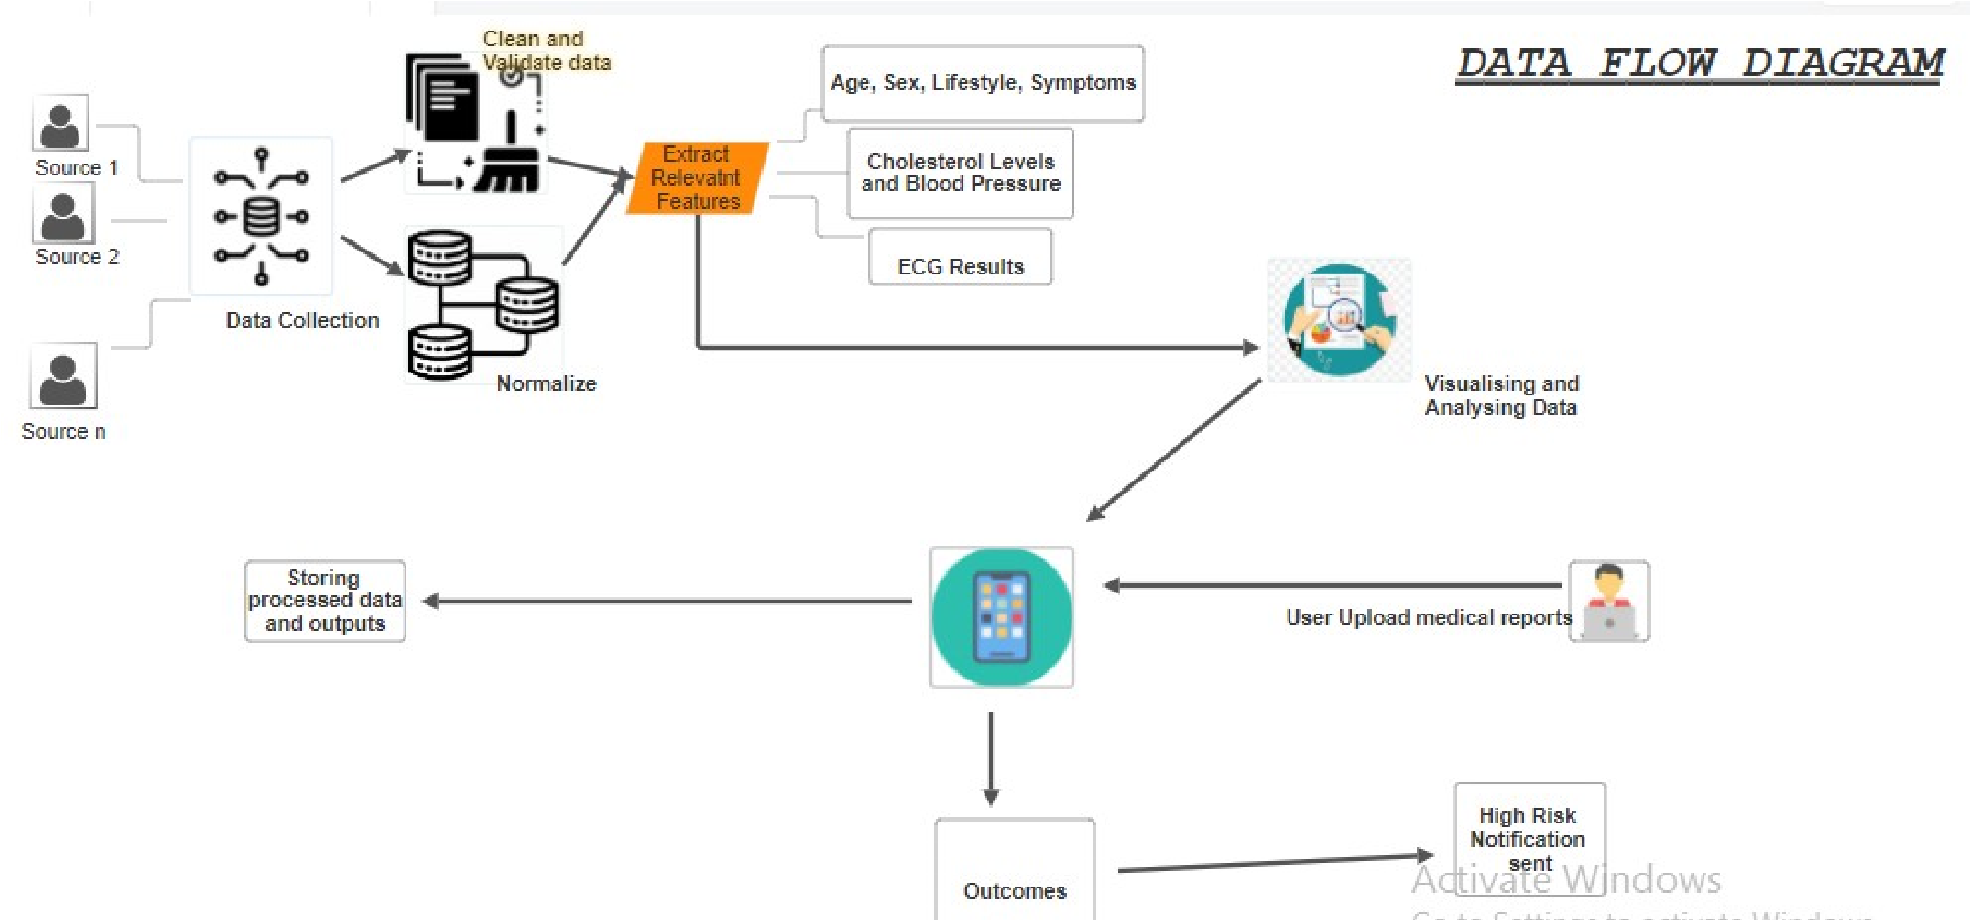

User Stories

Use the below template to list all the user stories for the product.

|  |  |  |  |  |  |  |
| --- | --- | --- | --- | --- | --- | --- |
| User Type | Functional  Requirement  (Epic) | User Story Number | User Story / Task | Acceptance criteria | Priority | Release |
| Patient  (Mobile user) | Registration | USD-1 | As a patient, I can create an account by providing my name, age, gender, and contact information. | I can see my health information after registration | High | Sprint-1 |
|  |  | USD-2 | As a patient, I can upload my medical history and test results during registration. | I can access my uploaded medical records. | High | Sprint-1 |
|  | Login | USD-3 | As a patient, I can log into my account using my email and a secure password. |  | High | Sprint-1 |
|  | Dashboard | USD-4 | As a patient, I can view my personalized health dashboard with vital signs and recommended actions. | The dashboard displays real-time heart rate, blood pressure, and ECG data. | High | Sprint-2 |
|  |  |  |  |  |  |  |
| Doctor (Web user) | Registration | USD-5 | As a doctor, I can register by providing my medical license details and contact information. | I can access the patient records. | High | Sprint-1 |
|  | Login | USD-6 | As a doctor, I can log in using my email and a secure password. |  | High | Sprint-1 |
|  | View Patient Records | USD-7 | As a doctor, I can view a patient's medical history and diagnostic data for analysis. | I can view patient data, including ECG reports and medical history. | High | Sprint-2 |
|  |  |  |  |  |  |  |
| Administrator | User Management | USD-8 | As an administrator, I can manage user accounts by adding, modifying, or deleting user profiles. | I can maintain the integrity of the user database. | High | Sprint-1 |
|  | Access Control | USD-9 | As an administrator, I can set role-based access controls, ensuring only authorized personnel can view or modify patient records. | I can restrict access to sensitive patient data. | High | Sprint-2 |