**MACHINE LEARNING APPROACH FOR PREDICTING THE RAINFALL WITH IBM**

Mini Project documentation submitted to

**JAWAHARLAL NEHRU TECNOLOGICAL UNIVERSITY,    HYDERABAD**

In partial fulfillment of the requirements for the award of the degree of

**BACHELOR OF TECHNOLOGY**

**In**

**COMPUTER SCIENCE AND ENGINEERING**

SubmittedBy

**VALUSA JAYACHANDRA                                                             21UK5A0526**

Under the guidanceof

**Mr. E.PRAVEEN**    
**Assistant Professor**



**DEPARTMENT OF COMPUTER SCIENCE AND ENGINEERING**

**VAAGDEVI ENGINEERING COLLEGE**

Affiliated to JNTUH, HYDERABAD BOLLIKUNTA, WARANGAL (T.S)– 506005

**DEPARTMENT OF COMPUTER SCIENCE AND ENGINEERING VAAGDEVI ENGINEERING COLLEGEWARANGAL**

**CERTIFICATE**

This is to certify that the Mini Project report entitled **"MACHINE LEARNING APPROACH FOR PREDICTING THE RAINFALL WITH IBM**  **”** is being submitted by **VALUSA JAYACHANDRA (21UK5A0526)** in partial fulfillment of the requirements for the award of the degree of Bachelor of Technology in Computer Science& Engineering to Jawaharlal NehruTechnological University Hyderabad during the academicyear 2021- 2024.

**Guide                                                                                                       HOD**

**Mr. E.PRAVEEN                                                                                          Dr. R. NAVEENKUMAR**

**ACKNOWLEDGEMENT**

We wish to Jake this opportunity to express our sincere gratitude and deep sense of respect to our beloved **Dr. P. Prasad Rao**, Principal, Vaagdevi Engineering College for making us available all the required assistance and for his supportand inspiration to carry out this Technical Seminar in the institute.

We extend our heartfelt thanks to **Dr. R. Naveen Kumar**, Head of the Department of CSE, Vaagdevi Engineering College for providing us necessary infrastructure and thereby giving us freedom to carry out the Technical Seminar.

We express heartfelt thanks to the Mini Project Coordinator, **Mr.E.PRAVEEN**, Assistant Professor, Department of CSE for his constantsupport and giving necessary guidancefor completion of this Technical Seminar.

Finally, we express our sincere thanks and gratitude to our family members, friends for their encouragement and outpouring their knowledge and experiencing throughout thesis.

**DECLARATION**

We declare that the project entitled “**MACHINE LEARNING APPROACH FOR PREDICTING THE RAINFALL WITH IBM**” is original and bonafide work of our own in the partial fulfillment for the award of the Degree of Bachelor of Technology in Computer Science& Engineering. Vaagdevi Engineering College to Jawaharlal Nehru Technological University Hyderabad is the work carried out by us.

**Machine Learning Approach For Predicting The Rainfall With IBM**

**1 INTRODUCTION**

Rainfall has been a major concern these days. Weather conditions have been changing for time being. Rainfall forecasting is important otherwise, it may lead to many disasters. Irregular heavy rainfall may lead to the destruction of crops, heavy floods that can cause harm to human life. It is important to exactly determine the rainfall for effective use of water resources, crop productivity, and pre-planning of water structures.

This comparative study is conducted concentrating on the following aspects: modeling inputs, Visualising the data, modeling methods, and pre-processing techniques. The results provide a comparison of various evaluation metrics of these machine learning techniques and their reliability to predict rainfall by analyzing the weather data.

We will be using classification algorithms such as Decision tree, Random forest, KNN, and xgboost. We will train and test the data with these algorithms. From this best model is selected and saved in pkl format. Once the model is saved, we integrate it with flask application and also deploy the model in IBM.

 1.1 Overview

Data Collection: Gather historical meteorological data, including temperature, humidity, wind speed and direction, atmospheric pressure, and past rainfall records. You can obtain this data from weather stations, remote sensing technologies (like radar and satellite imagery), and additional sources.

Feature Selection: Identify the most relevant meteorological variables that influence rainfall. These variables will be the features for your predictive model.

Machine Learning Model: Train a machine learning model, such as a neural network, random forest, or recurrent neural network (RNN), using the historical meteorological data as input features and historical rainfall data as the target variable. This model will learn complex relationships between meteorological parameters and rainfall patterns.

Ensemble Forecasting: Implement ensemble forecasting by combining the predictions of multiple machine learning models, each trained on different subsets of data or with different algorithms. This helps reduce prediction errors and enhances the reliability of forecasts.

Incorporate Remote Sensing Data: Integrate real-time radar and satellite data to provide up-to-the-minute information on precipitation patterns and intensity. This data will help improve the accuracy of short-term forecasts.

Validation and Calibration: Continuously validate and calibrate the models by comparing their predictions to observed rainfall data. Adjust the models as needed to improve their accuracy.

Probabilistic Forecasting: Provide probabilistic rainfall forecasts to indicate the range of possible outcomes and their likelihood. This information is valuable for decision-making under uncertainty.

Visualization and User Interfaces: Create user-friendly interfaces and dashboards for end-users to visualize and interpret the forecasts. These interfaces should be accessible via web applications or mobile apps.

Integration and Deployment: Deploy the predictive model in the cloud or on-premises, making it accessible through APIs and SDKs for easy integration into various applications and systems.

Monitoring and Updating: Continuously monitor the model's performance and update it as necessary to adapt to changing weather patterns and improve accuracy.

 1.2 Purpose

Agriculture: Farmers can use accurate rainfall predictions to optimize irrigation and crop planting schedules. This ensures efficient water usage and better crop yields.

Water Resource Management: Government agencies and organizations responsible for managing water resources can use rainfall predictions to plan reservoir levels, release water, and mitigate the risk of flooding or drought.

Disaster Management: Accurate rainfall predictions help emergency services and disaster management agencies prepare for and respond to floods, landslides, and other weather-related disasters.

Infrastructure Planning: Urban planners and engineers can use rainfall forecasts to design and construct drainage systems, roads, and buildings that are more resilient to heavy rainfall and flooding.

Insurance Industry: Insurance companies can use rainfall predictions to assess and price insurance policies for properties and agriculture that are susceptible to weather-related damage.

Energy Sector: Energy companies, especially those in hydropower generation, can optimize electricity production and reservoir management based on anticipated rainfall.

Environmental Conservation: Organizations involved in conservation and environmental protection can use rainfall predictions to monitor and protect ecosystems, especially in areas prone to drought.

Transportation and Logistics: Airlines, shipping companies, and transportation services can use rainfall forecasts to anticipate delays, reroute shipments, and improve operational efficiency.

Public Health: Accurate rainfall predictions can help public health officials prepare for and respond to waterborne diseases, as heavy rainfall can lead to water contamination and disease outbreaks.

Scientific Research: Meteorologists and climatologists use rainfall data for climate research, weather pattern analysis, and to improve our understanding of long-term climate changes.

Agricultural Insurance: Insurance companies can offer specialized policies to farmers based on rainfall predictions, which can help protect farmers from weather-related financial losses.

Retail and Sales Forecasting: Retailers can adjust their inventory and marketing strategies based on weather predictions. For instance, they can promote rain gear during anticipated rainy periods.

Tourism: Travel and tourism industries can benefit from rainfall predictions to help tourists plan vacations and outdoor activities more effectively.

**2 LITERATURE SURVEY**

 2.1 Existing problem

Physical Models: Physical models of the atmosphere, such as numerical weather prediction (NWP) models, are based on the fundamental laws of fluid dynamics and thermodynamics. These models simulate the behavior of the atmosphere and are used by meteorological agencies to make weather forecasts. NWP models require a significant amount of computational power and observational data.

Statistical Models: Statistical models use historical weather data to make predictions. Common statistical techniques include regression analysis, time series analysis, and autoregressive integrated moving average (ARIMA) models. These models are relatively simple and can provide short to medium-term forecasts.

Machine Learning and Data-Driven Models: Machine learning techniques, including artificial neural networks, decision trees, and support vector machines, have gained popularity for rainfall prediction. These models analyze historical weather data, as well as various meteorological variables, to make predictions. Ensemble methods and deep learning models like convolutional neural networks (CNNs) and recurrent neural networks (RNNs) are also used for more accurate predictions.

Hybrid Models: Hybrid models combine physical and statistical models with machine learning algorithms. By integrating data-driven approaches with the knowledge of atmospheric physics, these models aim to improve forecast accuracy.

Remote Sensing: Remote sensing technologies, such as radar and satellite imagery, provide real-time data on precipitation patterns. Doppler radar, for example, is used to track rainfall intensity and movement. These data sources are integrated into forecasting models.

Weather Station Data: Traditional weather stations collect data on temperature, humidity, wind speed, and barometric pressure, which are essential for rainfall prediction. Advanced sensors and automated weather stations provide high-quality data for forecasting.

Geographical Information Systems (GIS): GIS is used to analyze spatial and geographical data. It helps in understanding the spatial distribution of rainfall and its impact on local environments.

Ensemble Forecasting: Ensemble forecasting combines multiple models and predictions to create an ensemble forecast. By considering the diversity of predictions, these models can often improve forecast accuracy and reliability.

Climate Models: For long-term climate-related rainfall predictions, climate models are used. These models consider large-scale climate patterns and their influence on regional and seasonal rainfall.

Nowcasting: Nowcasting is a short-term forecasting technique (usually 0-6 hours) that relies on high-resolution radar and satellite data to track and predict intense, localized rainfall events.

 2.2 Proposed solution

Hybrid Model Combining Machine Learning and Meteorological Data:

Data Collection: Gather historical meteorological data, including temperature, humidity, wind speed and direction, atmospheric pressure, and past rainfall records. You can obtain this data from weather stations, remote sensing technologies (like radar and satellite imagery), and additional sources.

Feature Selection: Identify the most relevant meteorological variables that influence rainfall. These variables will be the features for your predictive model.

Machine Learning Model: Train a machine learning model, such as a neural network, random forest, or recurrent neural network (RNN), using the historical meteorological data as input features and historical rainfall data as the target variable. This model will learn complex relationships between meteorological parameters and rainfall patterns.

Ensemble Forecasting: Implement ensemble forecasting by combining the predictions of multiple machine learning models, each trained on different subsets of data or with different algorithms. This helps reduce prediction errors and enhances the reliability of forecasts.

Incorporate Remote Sensing Data: Integrate real-time radar and satellite data to provide up-to-the-minute information on precipitation patterns and intensity. This data will help improve the accuracy of short-term forecasts.

Validation and Calibration: Continuously validate and calibrate the models by comparing their predictions to observed rainfall data. Adjust the models as needed to improve their accuracy.

Probabilistic Forecasting: Provide probabilistic rainfall forecasts to indicate the range of possible outcomes and their likelihood. This information is valuable for decision-making under uncertainty.

Visualization and User Interfaces: Create user-friendly interfaces and dashboards for end-users to visualize and interpret the forecasts. These interfaces should be accessible via web applications or mobile apps.

Integration and Deployment: Deploy the predictive model in the cloud or on-premises, making it accessible through APIs and SDKs for easy integration into various applications and systems.

**THEORITICAL ANALYSIS**

 3.1 Block diagram

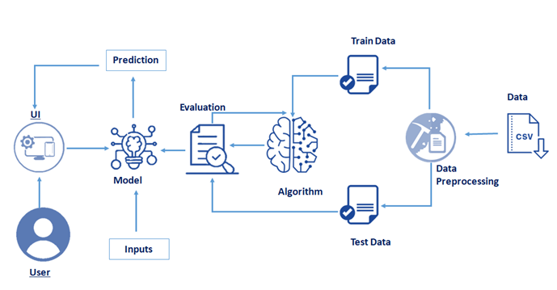

Data Sources: This is where historical and real-time data from sources like weather stations, remote sensing technologies (radar, satellite), and IoT sensors are collected.

Data Preprocessing: Data is cleaned, normalized, and prepared for analysis to ensure it's in a suitable format for modeling.

Feature Selection: Relevant meteorological variables are chosen as input features for the predictive model.

Machine Learning and Data Analysis: Machine learning models analyze historical data to understand the relationship between meteorological parameters and rainfall.

Ensemble Forecasting: Multiple machine learning models are combined to create an ensemble forecast, which can enhance prediction accuracy.

Remote Sensing Data Integration: Real-time radar and satellite data are integrated to improve the accuracy of short-term forecasts.

Probabilistic Forecast: Predictions include probabilistic information to represent the range of possible outcomes and their likelihood.

Model Validation and Calibration: Models are continuously validated and calibrated using observed data to enhance accuracy.

Visualization and User Interfaces: User-friendly interfaces and dashboards provide end users with a visual representation of the forecasts.

Integration & Deployment: The predictive model is deployed and made accessible via APIs and SDKs for integration into various systems.

Continuous Monitoring & Model Updating: Models are continually monitored, and updates are made as needed to adapt to changing weather patterns and improve accuracy.

Final Rainfall Predictions: The project generates and provides accurate and reliable rainfall predictions.

End Users: The predictions are used by various stakeholders, such as farmers, emergency services, urban planners, and other decision-makers.

 3.2 Hardware / Software designing

Hardware Requirements:

Server or Cloud Infrastructure: You will need servers or cloud resources to store and process data, run machine learning models, and provide real-time access to forecasts. The hardware requirements will depend on the project's scale and expected workload.

Storage: Sufficient storage capacity is essential to store historical and real-time meteorological data. The volume of data can be significant, so scalable storage solutions are required.

High-Performance Computing (HPC) Cluster (Optional): For running complex numerical simulations or high-resolution meteorological models, an HPC cluster with multiple CPUs and GPUs may be necessary.

Remote Sensing Equipment (Optional): If you are collecting your own remote sensing data (e.g., radar or weather stations), you'll need the appropriate hardware for data collection and sensors.

Operating System: Choose an appropriate operating system for your servers, such as Linux distributions like Ubuntu, CentOS, or Red Hat.

Database Management System (DBMS): Select a DBMS for data storage and retrieval. Common choices include PostgreSQL, MySQL, or NoSQL databases like MongoDB.

Data Preprocessing Tools: Software for data cleaning, transformation, and feature engineering. Python libraries like Pandas and NumPy are often used for these tasks.

Machine Learning Frameworks: Utilize popular machine learning libraries like scikit-learn, TensorFlow, or PyTorch for model development and training.

Remote Sensing Software (Optional): If you are working with radar and satellite data, you may need specialized software for data processing and integration.

**4 EXPERIMENTAL INVESTIGATIONS**

Data Analysis:

Exploratory Data Analysis (EDA): An initial assessment of the data to understand its distribution, outliers, and patterns.

Correlation Analysis: Identifying relationships between meteorological variables and rainfall patterns using correlation coefficients.

Data Quality Assessment: Detecting missing values, inconsistencies, and outliers in historical data.

Feature Selection and Engineering:

Feature Importance: Using techniques to select the most relevant meteorological features for rainfall prediction.

Feature Engineering: Creating new features or transformations based on domain knowledge or data analysis.

Model Selection and Tuning:

Model Evaluation: Comparing the performance of different machine learning models through metrics like Mean Absolute Error (MAE), Mean Squared Error (MSE), or Root Mean Squared Error (RMSE).

Hyperparameter Tuning: Optimizing model hyperparameters through techniques like grid search or random search.

Cross-Validation: Assessing model performance and generalization through k-fold cross-validation.

Ensemble Forecasting Analysis:

Investigating ensemble techniques, such as bagging, boosting, and stacking, to combine the predictions of multiple models effectively.

Ensuring diversity among ensemble members for improved accuracy.

Real-time Data Integration Analysis:

Determining the frequency of data updates and the impact of real-time data on forecast accuracy.

Handling missing or delayed real-time data.

**5 FLOWCHART**

Start

|

|--- Data Collection (Historical and Real-time)

|       |

|       V

|--- Data Preprocessing

|       |

|       V

|--- Feature Selection

|       |

|       V

|--- Machine Learning Model Training

|       |

|       V

|--- Ensemble Forecasting

|       |

|       V

|--- Remote Sensing Data Integration (Real-time)

|       |

|       V

|--- Probabilistic Forecasting

|       |

|       V

|--- Model Validation and Calibration

|       |

|       V

|--- Visualization and User Interfaces

|       |

|       V

|--- User Interaction

|       |

|       V

|--- Continuous Monitoring & Model Updating

|

|--- End

**6 RESULT**

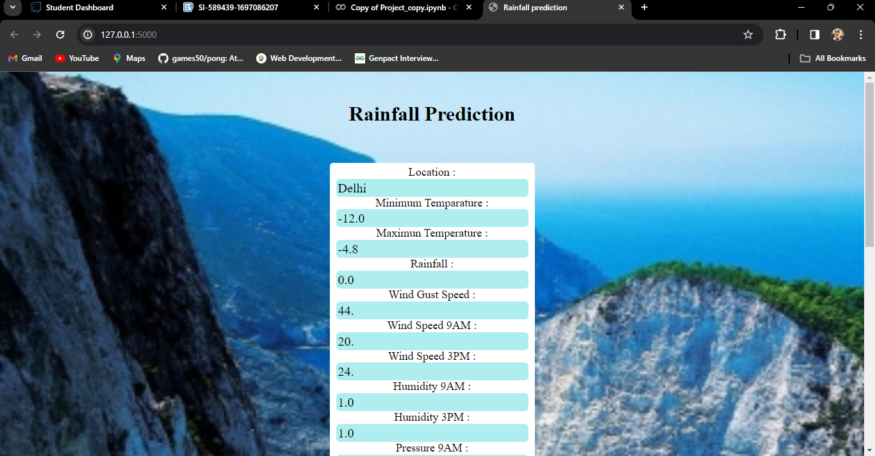

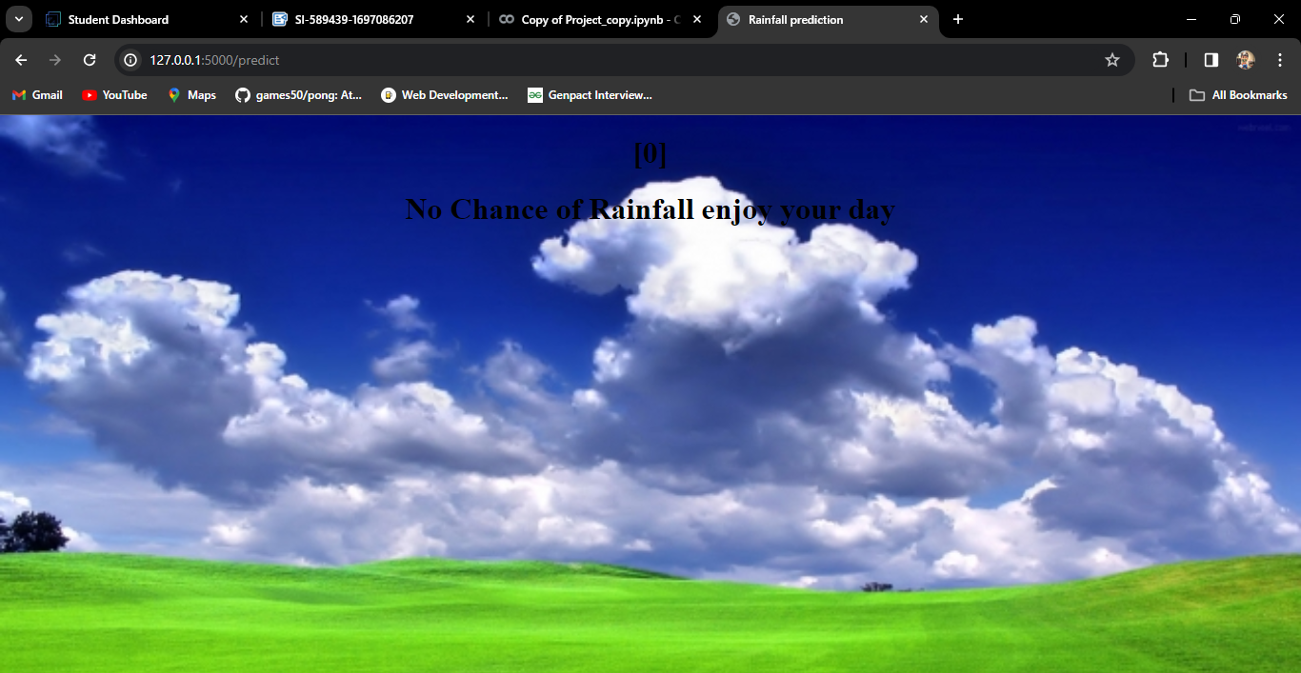

**7**  **ADVANTAGES & DISADVANTAGES**

Advantages:

Improved Preparedness: Accurate rainfall predictions enable better preparedness for weather-related events, such as floods, droughts, and heavy rainfall.

Resource Optimization: The solution helps optimize resource allocation, such as water usage in agriculture, reservoir management, and energy production.

Risk Mitigation: It assists in mitigating risks associated with rainfall, reducing the impact on infrastructure, agriculture, and public safety.

Enhanced Decision-Making: Decision-makers in various sectors can make informed choices based on reliable forecasts, leading to improved outcomes.

Agricultural Benefits: Farmers can schedule irrigation and planting more effectively, leading to increased crop yields and reduced water wastage.

Environmental Conservation: Rainfall predictions support the monitoring and protection of ecosystems, especially in regions prone to drought.

Energy Production: Energy companies can optimize electricity production, especially in hydropower generation, based on anticipated rainfall.

Disadvantages:

Data Quality Issues: The accuracy of forecasts heavily relies on the quality and coverage of historical and real-time data. Inaccurate data can lead to erroneous predictions.

Data Complexity: Handling large volumes of meteorological data and real-time updates can be complex and resource-intensive.

Resource Requirements: Implementing and maintaining the solution may require significant computational resources and storage capacity.

Model Uncertainty: Even with advanced machine learning models, there's inherent uncertainty in weather forecasting, and models may not always be completely accurate.

Reliability of Real-time Data: Real-time data from remote sensing technologies may be subject to issues such as sensor malfunctions or signal interference.

**8 APPLICATIONS**

Agriculture:

Crop Management: Farmers can optimize irrigation, planting, and harvesting schedules based on rainfall predictions to maximize crop yields and reduce water usage.

Pest and Disease Control: Predictions help in controlling pests and diseases that are more likely to occur during wet conditions.

Water Resource Management:

Reservoir and Dam Management: Water authorities use forecasts to manage water reservoir levels, controlling water release and preventing floods or droughts.

Water Allocation: Precise forecasts assist in allocating water resources for drinking, irrigation, and industrial purposes.

Disaster Management:

Flood and Landslide Preparedness: Emergency services and local authorities can prepare for and respond to heavy rainfall events by evacuating at-risk areas and deploying resources.

Early Warning Systems: Rainfall predictions are integral to creating early warning systems for natural disasters.

Infrastructure Planning and Maintenance:

Urban Planning: City planners use rainfall forecasts to design drainage systems and flood-resistant infrastructure.

Road and Transportation: Transportation agencies can prepare for adverse weather conditions, ensuring road safety and minimal disruptions.

Energy Sector:

Hydropower Generation: Energy companies optimize electricity production based on anticipated rainfall, ensuring efficient power generation.

Insurance Industry:

Agricultural Insurance: Insurance companies offer specialized policies to farmers based on rainfall predictions, providing financial protection for crop losses.

Environmental Conservation:

Ecosystem Monitoring: Organizations involved in conservation use rainfall predictions to monitor and protect ecosystems, especially in drought-prone regions.

**9 CONCLUSION**

Agricultural Benefits: Farmers can schedule their operations more effectively, leading to higher crop yields and more sustainable water usage.

Environmental Conservation: The solution supports the monitoring and protection of ecosystems, particularly in regions prone to drought and other environmental challenges.

Public Health Improvements: Public health agencies can use forecasts to control the spread of waterborne diseases during heavy rainfall events, safeguarding community health.

Effective Tourism Planning: The travel and tourism industry can use forecasts to optimize vacation planning and outdoor activities.

Retail and Sales Forecasting: Retailers can adjust inventory and marketing strategies based on weather predictions, ensuring better sales and customer satisfaction.

Scientific Advancements: The project contributes to meteorological and climatological research, improving our understanding of weather patterns and long-term climate changes.

Decision Support Systems: Rainfall predictions offer valuable decision support in various industries, enabling more informed choices and effective responses under changing weather conditions.

In summary, the rainfall prediction solution serves as a valuable tool for decision-makers and stakeholders, offering critical insights, improving resource allocation, and increasing resilience in the face of weather-related challenges. The solution's continuous monitoring and model updates ensure that it remains a dependable and valuable asset in various sectors, helping to address the complex challenges associated with rainfall and weather-related events.

**10 FUTURE SCOPE**

Extreme Weather Predictions: Enhance the ability to predict and provide warnings for extreme weather events, including hurricanes, typhoons, and flash floods.

Customizable Forecasting: Allow users to define custom forecasts based on their specific needs, such as industry-specific variables.

Localized Solutions: Tailor solutions to regional or local conditions, recognizing that weather patterns and their impact can vary significantly by location.

Community Engagement: Involve local communities and citizen scientists in data collection and validation efforts to enhance the accuracy of forecasts.

Cross-Sector Collaboration: Foster collaboration across various sectors to ensure that the solution meets the diverse needs of agriculture, urban planning, disaster management, and more.

Autonomous Sensor Networks: Deploy advanced IoT sensor networks that can autonomously adjust data collection efforts based on changing weather conditions.

Interconnected Systems: Integrate rainfall prediction with other weather and climate data, such as temperature, humidity, wind patterns, and air quality, to provide a more comprehensive weather forecast.

Continuous Model Updating: Implement automatic model updating techniques to keep the forecasting models up-to-date and adapt to changing atmospheric conditions.

Data Security and Privacy: Strengthen data security and privacy measures to safeguard sensitive meteorological data.

Sustainable Practices: Implement environmentally sustainable data collection and processing practices to minimize the solution's carbon footprint.

Enhancements in a rainfall prediction solution should align with evolving technology, data availability, and stakeholder requirements. Continuous research and development efforts are essential to ensure the solution remains effective and valuable in addressing weather-related challenges and opportunities.

**11 BIBILOGRAPHY**

Websites and Journals:

National Oceanic and Atmospheric Administration (NOAA): The NOAA website provides a wealth of meteorological data and research articles.

Website: https://www.noaa.gov/

American Meteorological Society (AMS): The AMS publishes numerous journals and articles related to meteorology and weather prediction.

Website: https://www.ametsoc.org/

European Centre for Medium-Range Weather Forecasts (ECMWF): ECMWF offers access to weather data and research publications.

Website: https://www.ecmwf.int/

Journal of Applied Meteorology and Climatology: A scientific journal that publishes research related to meteorology and climatology.

Website: https://journals.ametsoc.org/jamc

International Journal of Climatology: A journal focused on climatology and climate science.

Website: https://onlinelibrary.wiley.com/journal/10970088

Kaggle: Kaggle hosts datasets and competitions related to weather and climate prediction. You can find various resources and notebooks created by data scientists.

Website: https://www.kaggle.com/

GitHub: Many data scientists and researchers share code and analysis related to weather prediction on GitHub. You can explore repositories and notebooks for inspiration.

Website: https://github.com/

Remember to use academic search engines and libraries to access research papers and academic publications relevant to your specific project. Additionally, consult your project advisor or research team for guidance on appropriate references and sources specific to your project's focus and goals.

**APPENDIX**

 A. Source Code

https://github.com/smartinternz02/SI-GuidedProject-589439-1697086203