 

Internship project report on

**IBM Cognos Power HR and People Analytics Dashboard**

SUBMITTED BY:



KOMAL S ROKHADE 4BD19CS401

AKSHATHA S P 4BD19CS400

YAMINI NIHARIKHA 4BD18CS122

THOTA VEDA SREE 4BD18CS118

DEPARTMENT OF COMPUTER SCIENCE AND ENGINEERING

BAPUJI INSTITUTE OF ENGINEERING AND TECHNOLOGY DAVANGERE

ACADEMIC YEAR: 2021-2022

**CONTENTS**

**CHAPTERS PAGE NO’S**

1. **INTRODUCTION 01**
   1. Overview
   2. Purpose
2. **LITERATURE SURVEY 02**
   1. Existing Problem
   2. Proposed Solution
3. **THEORETICAL ANALYSIS 02-03**
   1. Hardware and Software Design
4. **EXPERIMENTAL INVESTIGATIONS 03-04**
   1. Overview
   2. User Interface
5. **FLOWCHART 04-05**
6. **RESULT 06-08**
7. **ADVANTAGES AND DISADVANTAGES 09**
8. **APPLICATIONS 09**
9. **CONCLUSION 10**
10. **FUTURE SCOPE 10**

**CHAPTER 1**

* 1. **OVERVIEW**

**INTRODUCTION**

Analytics is the interpretation of data pattern that assist decision- making and performance improvement. HR analytics is defined as the process of measuring the impact of HR metrics, such as time to hire and retention rate on business performance. IBM Cognos Analytics integrates reporting, modeling, analysis, exploration, dashboards, stories, and event management so you can understand your organization's data, and make effective business decisions. A dashboard helps you to monitor events or activities at a glance by providing key insights and analysis about your data on one or more pages or screens. In this project, we visualize, analyze and gain most of the insights by creating a dashboard.

# PURPOSE

In certain situations, report consumers would like to analyze combinations of disparate facts in the context of some common dimensional attributes rather than treat each fact independently in a sub query and then merge the results together. The latter is what IBM Cognos Analytics does when perform a multi-fact query and is referred to by IBM Cognos as a "stitch query". IBM Cognos Analytics provides templates that contain predefined designs and grid lines for easy arrangement and alignment of the visualizations.

Having a powerful engine that can provide you with deep insights and automate things like planning, budgeting, and forecasting can help you to take your organization to the next level. By enabling you to create a single source of truth and visibility to all your data, which is also able to scale the same robust planning across your organization will help connect each different line of business at your organization

**CHAPTER 2**

**LITERATURE SURVEY**

# EXISTING SYSTEM

Watson-powered BI solution can do it all: clean and connect your data, create stunning [data visualizations](https://www.ibm.com/analytics/data-visualization), and show you where your business is today while helping predict what will happen tomorrow.

IBM Business Analytics is a solution that is easy to use by all employees regardless of their specialty. With this solution you can be confident that your organization is empowered to make smarter decisions and take better actions to drive your business forward across every stage.

Data has always been considered a great weapon, and Analytics is the means by which this information can take shape. By building a solid and governed analytics foundation with a layer in cognitive and machine learning, your organization will be able to zoom in on the right information which might otherwise be hidden.

# PROPOSED SYSTEM

Cognos Analytics with Watson takes BI a step further with AI capabilities that not only bring an accurate, trusted and complete picture of your business, but forecast what’s coming in the future, predict outcomes and explain why they may happen.

**CHAPTER 3**

**THEORETICAL ANALYSIS**

# HARDWARE AND SOFTWARE DESIGNING

**HARDWARE DESIGNING:**

The hardware required for the development of this project is:

* + - Processor : Intel® CoreTM i5-9300H
    - Processor speed : 2.4GHz
    - RAM Size : 8 GB DDR
    - System Type : X64-based processor

**SOFTWARE DESIGNING:**

The software required for the development of this project is:

* + - Desktop GUI : Anaconda Navigator
    - Operating System : Windows 10(and other higher version)
    - Front end : HTML,CSS,JAVASCRIPT
    - Programming Language : PYTHON
    - Cloud Computing Service : IBM Cloud Servics

**CHAPTER 4**

**EXPERIMENTAL ANALYSIS**

# ANALYSIS OR INVESTIGATION MADE WHILE WORKING

With Cognos Analytics you are able access raw data as easy to understand insights and trends, taking your organization’s knowledge levels and decision-making abilities to another level. You can even create and easily share system-recommended visualizations, reduce the time needed for data preparation through automation and built-in intelligence, as well as pose questions about your data and receive intelligent responses, with the natural language-powered assistant.

**4.2 ARCHITECTURE**

HR analytics is a methodology for creating insights on how investments in human capital assets contribute to the success of four principal outcomes: (a) generating revenue, (b) minimizing expenses, (c) mitigating risks, and (d) executing strategic plans. This is done by applying statistical methods to integrated HR, talent management, financial, and operational data.

IBM Cognos Analytics provides dashboards and stories to communicate your insights and analysis. You can assemble a view that contains visualizations such as a graph, chart, plot, table, map, or any other visual representation of data. Explore powerful visualizations of your data in IBM Cognos Analytics and discover patterns and relationships that impact your business. A dashboard helps you to monitor events or activities at a glance by providing key insights and analysis about your data on one or more pages or screens.

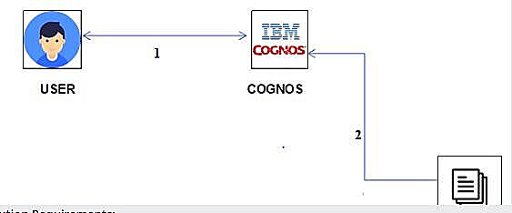

**Figure: Architecture of IBM Cognos Analytic**

**CHAPTER 5**

**WORKFLOW**

If you're new to dashboards and stories, review the following steps to understand the general workflow to create a view.

* + 1. Click, and click Dashboard.
    2. Select a template. Cognos Analytics provides templates that contain predefined layouts and grid lines for easy arrangement and alignment of the visualizations in a view.
    3. Add visualizations to your view in one or more of the following ways:
* If you know the type of visualization you want to use, select the visualization type and then add columns to it.
* If you know the data that you want to see, but are not sure about how to present it, click and add a source to the Selected sources pane. Then, drag columns onto the canvas. Cognos Analytics displays them in the appropriate visualization.
* Drag your collected visualizations from the My pins panel to quickly build a story.
  + 1. Limit the data that is displayed by filtering in one or more of the following ways:
* You can filter individual visualizations or on all visualizations in the view.
* You can even filter on a column that is not displayed in the visualization by using a context filter.
* You can select a specific value or a range of values.
  + 1. Enhance your view and draw attention to visualizations by adding media, web pages, images, shapes, and text.
    2. Personalize your view by changing the theme. You can choose from default, light, or dark themes. You can also customize specific visualization properties such as fill and border color, and opacity.
    3. Create more meaningful or complex visualizations by adding columns to an existing visualization. Drag another column onto a visualization and it changes to match the new data added.
    4. You can undo and redo your last actions in succession. The ability to undo and redo previous actions is available until you close the view.
    5. Test the view.

**CHAPTER 6**

**RESULT**

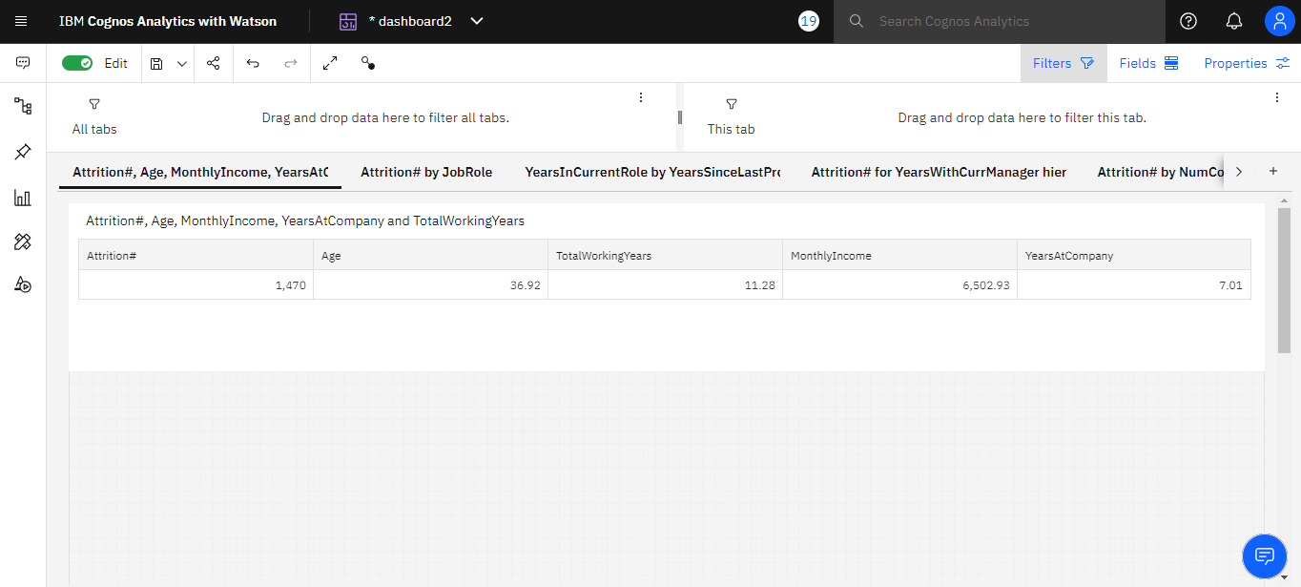

**Fig 6.1: This figure shows the Analyzing Age, Total Working Years, Attrition, Years At Company And Monthly Income.**

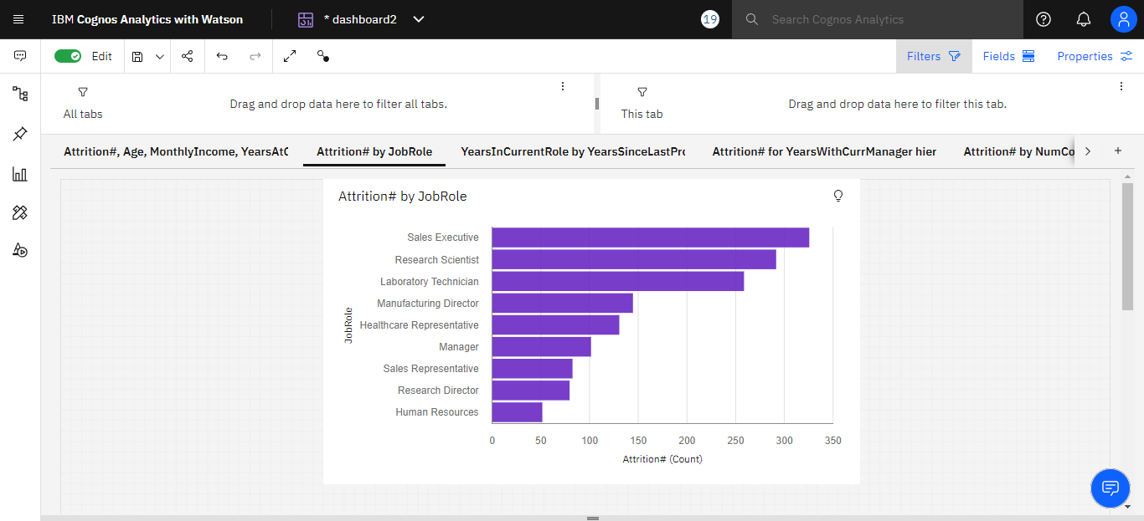

**Fig 6.2: This figure shows the visualize attrition with respect to job role as a bar chart**

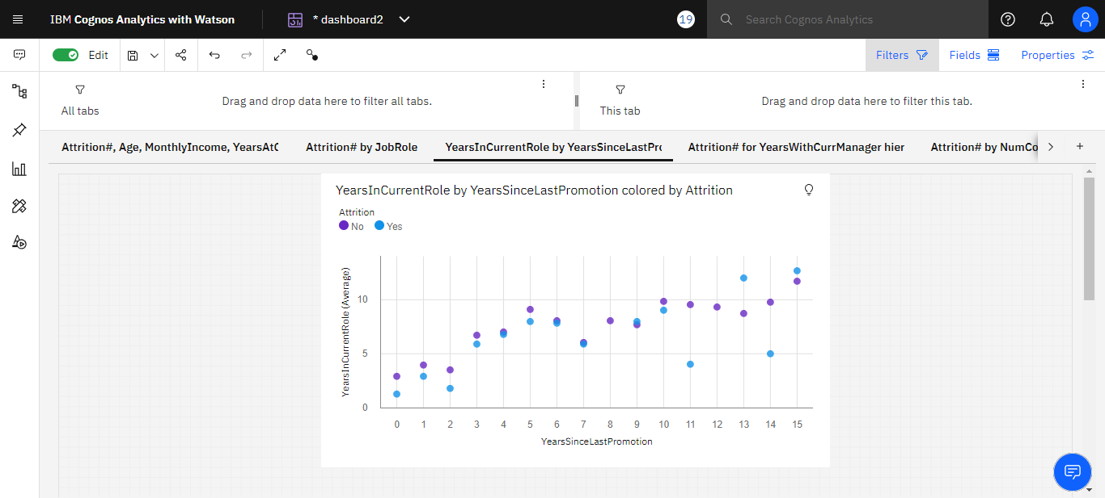

**Fig 6.3: This page contains Years in Current role by Years since last promotion.**

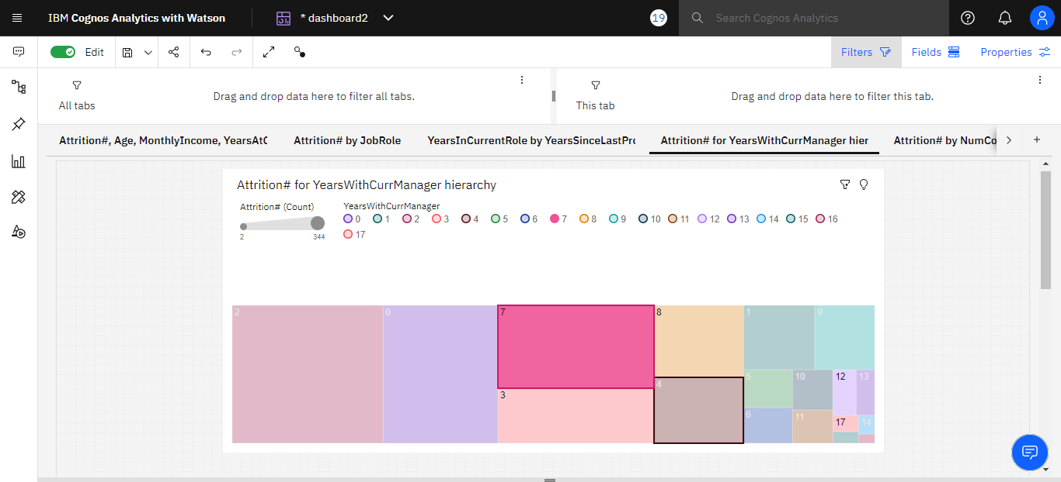

**Fig 6.4: This page contains Attrition for Years with Current Manager Hierarchy.**

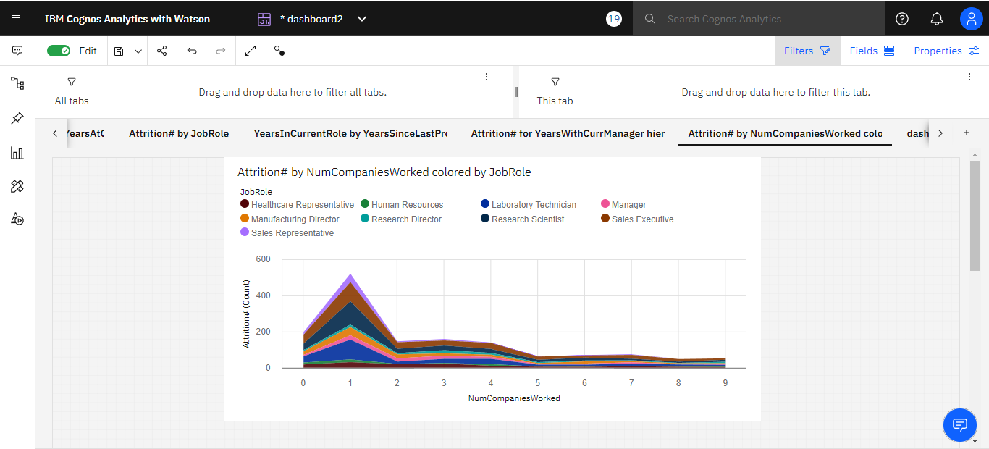

**Fig 6.5: This figure shows the Attrition by No of Companies Worked Colored by Job Role**

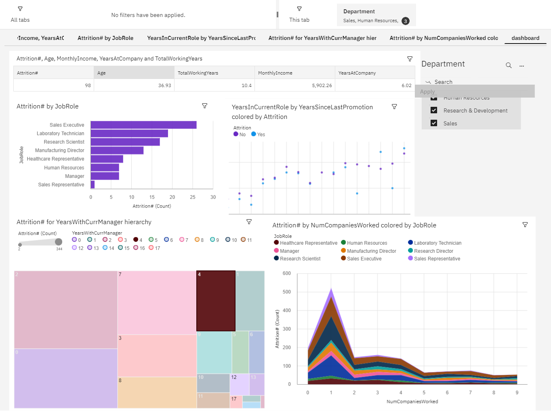

**Fig 6.6: HR and People Analytics Dashboard**

**CHAPTER 7**

**ADVANTAGES AND DISADVANTAGES**

# Advantages

1. IBM Cognos Dashboard Embedded provides developers the ability to embed a visualization platform directly into their application.
2. We can create powerful and professional visualizations that explain the story of our data.
3. Protects the data from misuse.
4. Self-service report authoring.

# Disadvantages

1. The software can take a lot of space.
2. Sometimes you can get stuck due to troubleshooting messages as a beginner.
3. Better data-driven subscription.

**CHAPTER 8**

**APPLICATIONS**

You as a developer have the flexibility to define the user workflow and control the options available to users. You can choose from a guided exploration of the analysis through authored fixed dashboards, to a free-form analytic exploration environment in which users choose their own visualizations and virtually anything in between.

Creating an IBM Cloud account and provisioning a Cognos Dashboard Embedded service instance.

1. Creating a service credential to access the service instance API.
2. Creating a Cognos Dashboard Embedded session from your web service application.
3. Adding Cognos Dashboard Embedded into your web client application through the Cognos Dashboard Embedded JavaScript API.

**CHAPTER 9**

**CONCLUSION AND FUTURESCOPE**

**Conclusion**

Gone are the days when data visualizations on the end user’s display were hindered by bandwidth and hardware resource limitations. Today’s edge machines and constrained devices routinely harness the cloud, while displaying results on inexpensive hardware: in most cases, with render capabilities and connection speeds comparable to that of a desktop on a high-speed wired connection. And, of course, the current global 5G rollout coupled with continuing advances in computing power/storage capacity (e.g., the general availability of graphical processing units) make the data visualization category an exciting space to watch in the near future.

# Future scope

Data analysis and management systems were some of the first applications to incorporate artificial intelligence (AI)/machine learning (ML) for automating information collection, analysis, and dissemination. Similar trends can now be observed in the data visualization space, with automated systems leveraging ML models trained on common user patterns and task execution to construct UI dashboards.