**PROJECT TITLE**

**Power Consumption Analysis For House Holds**

**Using IBM Watson Machine Learning**

**INTRODUCTION:**

**OVERVIEW:**

Electricity sector in India. India is the world's third largest producer and third largest consumer of electricity. The gross electricity consumption in 2018-19 was 1,181 kWh per capita. Energy use can be viewed as a function of total GDP, structure of the economy and technology. The increase in household energy consumption is more significant than that in the industrial sector. To achieve reduction in electricity consumption, it is vital to have current information about household electricity use. This Guided Project mainly focuses on applying a machine-learning algorithm to calculate the power consumed by all appliances. This will help you track the power consumed on regular intervals for all kinds of appliances which use heavy loads such as Air Conditioners, Oven or a washing machine etc.

**PURPOSE:**

Electricity is used in almost all homes, The typical U.S. household now uses more air conditioning, appliances, and consumer electronics than ever before. However, average annual site energy use per home has declined. The reasons for this decline include:

Improved efficiencies of heating and cooling equipment, water heaters, refrigerators, lighting, and appliances

Population migration to regions with lower heating—and thus lower total energy—demand.

**LITERATURE SURVEY**

**Existing problem:**

Given the rise of smart electricity meters and the wide adoption of electricity generation technology like solar panels, there is a wealth of electricity usage data available.

This data represents a multivariate time series of power-related variables, that in turn could be used to model and even forecast future electricity consumption.

In this , you will discover a household power consumption dataset for multi-step time series forecasting and how to better understand the raw data using exploratory analysis.

**PROPOSED SOLUTION:**

* The household power consumption dataset that describes electricity usage for a single house over four years.
* How to explore and understand the dataset using a suite of line plots for the series data and histogram for the data distributions.
* How to use the new understanding of the problem to consider different framings of the prediction problem, ways the data may be prepared, and modeling methods that may be used.

**FEATURES OF OUR PROJECT:**

* The household power consumption dataset that describes electricity usage for a single house over four years.
* To explore and understand the dataset using a suite of line plots for the series data and histogram for the data distribution
* To use the new understanding of the problem to consider different framings of the prediction problem, ways the data may be prepared, and modeling methods that may be used.

**THEORITICAL ANALYSIS**

**Block Diagram:**

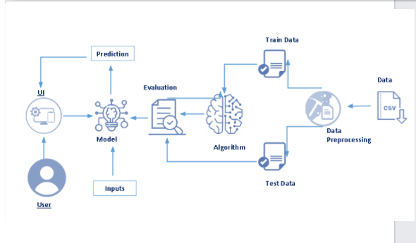

**Hardware/Software Designing:**

**Software Designing:**

* Numpy and Pandas : Open source data analysis and manipulation tool, built on top of the Python programming language.
* Matplotlib and Seaborn : Used for visualisation with python.
* The finalised model is now to be saved. We will be saving the model as a pickle or pkl file.
* HTML pages “pca.html” for our home page and “result1.html” which comes to use when we print out the final predictions made, both of these are stored in the templates folder .
* Let us build app.py flask file which is a web framework written in python for server-side scripting. Let’s see step by step procedure for building the backend application Import required libraries.
* Configure app.py to fetch the user inputs from the UI, process the values, and return the prediction.

**EXPERIMENTAL INVESTIGATION:**

The household power consumption dataset is a multivariate time series dataset that describes the electricity consumption for a single household over four years.

The data was collected between December 2006 and November 2010 and observations of power consumption within the household were collected every minute.

It is a multivariate series comprised of seven variables (besides the date and time); they are:

* **global_active_power**: The total active power consumed by the appliance other than the appliance mapped.(kilowatts).
* **global_reactive_power**: The total reactive power consumed by the household is the power which bounces back and froth without any usage or leakage
* .(kilowatts).
* **voltage**: Average voltage (volts).
* **global_intensity**: Average current intensity (amps).
* **sub_metering_1**: Active energy for kitchen (watt-hours of active energy).
* **sub_metering_2**: Active energy for laundry (watt-hours of active energy).
* **sub_metering_3**: Active energy for climate control systems (watt-hours of active energy).

Active and reactive energy refer to the technical details of [alternative current](https://en.wikipedia.org/wiki/AC_power).

In general terms, the active energy is the real power consumed by the household, whereas the reactive energy is the unused power in the lines.

We can see that the dataset provides the active power as well as some division of the active power by main circuit in the house, specifically the kitchen, laundry, and climate control. These are not all the circuits in the household.

The remaining watt-hours can be calculated from the active energy by first converting the active energy to watt-hours then subtracting the other sub-metered active energy in watt-hours.

**DATA VISUALIZATION:**

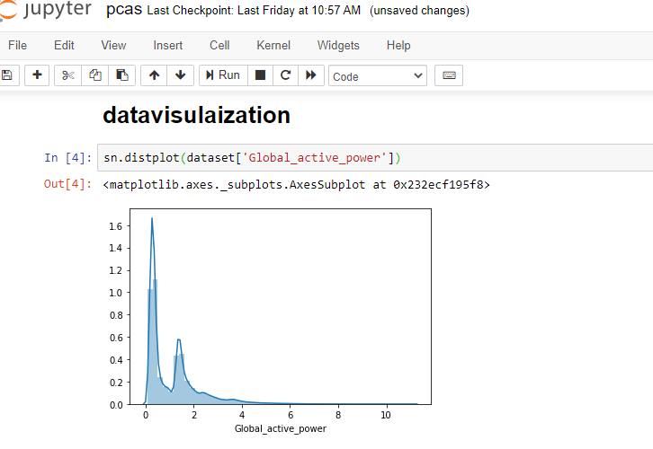

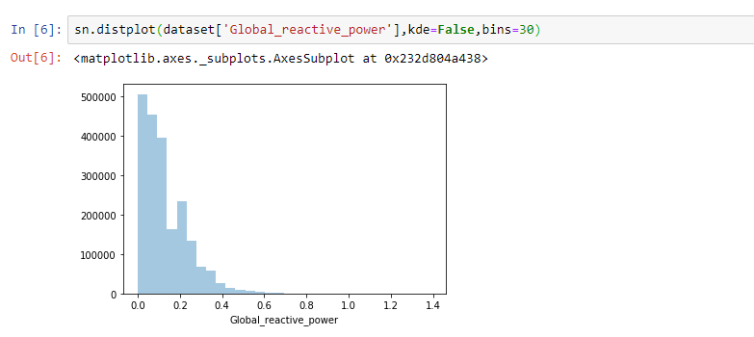

Saving the model using pickle file

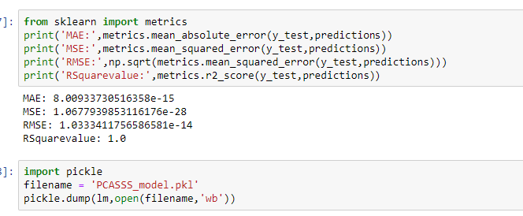

**Python (source code):**

from flask import Flask,request,render_template

import numpy as np

import pandas as pd

import pickle

import os

app = Flask(__name__)

model = pickle.load(open('PCA_model.pkl', 'rb'))

@app.route('/')

def home():

return render_template("pca.html")

@app.route('/predict',methods=["POST","GET"])

def predict():

input_features = [float(x) for x in request.form.values()]

features_value = [np.array(input_features)]

features_name = ['Global_reactive_power', 'Global_intensity', 'Sub_metering_1',

'Sub_metering_2', 'Sub_metering_3']

df = pd.DataFrame(features_value, columns=features_name)

output = model.predict(df)

return render_template('result1.html', prediction_text=output)

if __name__=="__main__":

#port = int(os.getenv('PORT', 8080))

#app.run(host='0.0.0.0', port=port, debug=False)

app.run(debug=False)

output:

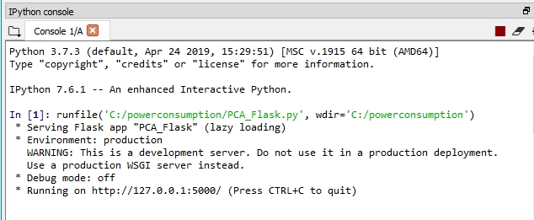

Let’s see how our output page looks like:

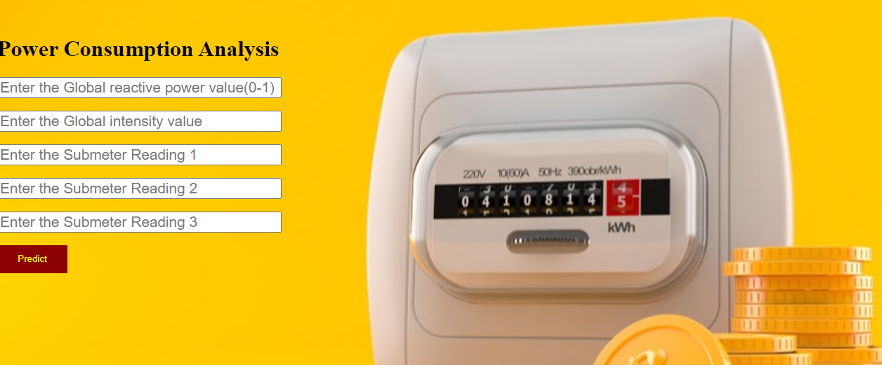

Enter the values

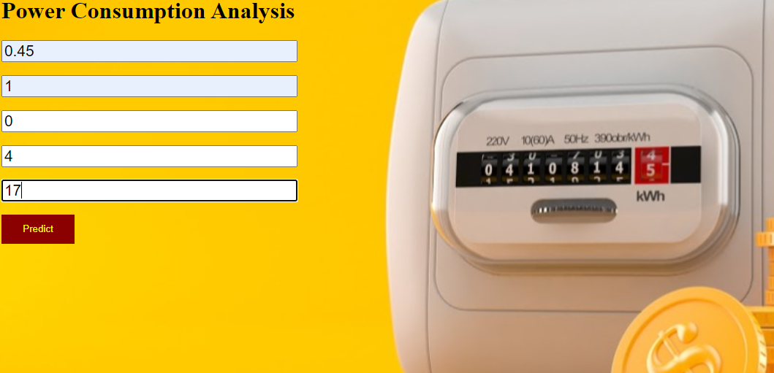

click on Predict button to view the result on result.html

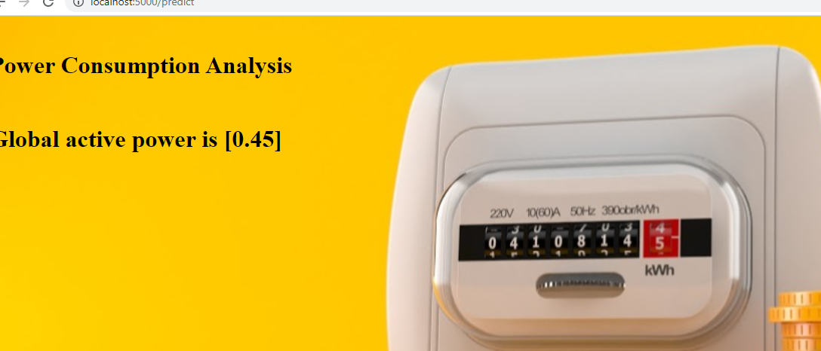

**FLOW CHART**



**Result:**

* Open the anaconda prompt from the start menu.
* Navigate to the folder where your app.py resides.
* Now type “python app.py” command.
* It will show the local host where your app is running on http://127.0.0.1.5000/
* Copy that local host URL and open that URL in the browser. It does navigate me to where you can view your web page.
* Enter the values, click on the predict button and see the result/prediction on the web page.

**Applications:**

1.To asses the energy efficiency and energy usage of their homes.

2 .To use the new understanding of the problem to consider different framings of the prediction problem, ways the data may be prepared, and modeling methods that may be used.

3.The household power consumption dataset is a multivariate time series dataset that describes the electricity consumption for a single household over four years.

**CONCLUSION:**

Finally, total power consumption by the appliances is Predicted and displayed.

Appendix:

**UI output screenshot:**



SOURCE CODE:

**Python (source code):**

from flask import Flask,request,render_template

import numpy as np

import pandas as pd

import pickle

import os

app = Flask(__name__)

model = pickle.load(open('PCA_model.pkl', 'rb'))

@app.route('/')

def home():

return render_template("pca.html")

@app.route('/predict',methods=["POST","GET"])

def predict():

input_features = [float(x) for x in request.form.values()]

features_value = [np.array(input_features)]

features_name = ['Global_reactive_power', 'Global_intensity', 'Sub_metering_1',

'Sub_metering_2', 'Sub_metering_3']

df = pd.DataFrame(features_value, columns=features_name)

output = model.predict(df)

return render_template('result1.html', prediction_text=output)

if __name__=="__main__":

#port = int(os.getenv('PORT', 8080))

#app.run(host='0.0.0.0', port=port, debug=False)

app.run(debug=False)

HTML SOURCE CODE:(demo.html)

html>

><style>

.idiv{

text-align:left;

}

body{

font-family:sergio;

}

input{

font-size:1.3em;

width:30%;

text-align:left;

}

input placeholder{

text-align:left;

}

button{

outline:0;

border:0;

background-color:darkred;

color:white;

width:100px;

height:40px;

}

</style>

<head>

<title>-- Power Consumption Analysis -- </title>

</head>

<body>

<style>

body

{

background-image:url('../static/PCA.jpg');

background-position: center;

font-family:serif;

background-size:cover;

}

</style>

<div class='idiv'>

</br>

</br>

<h1>Power Consumption Analysis</h1>

<form action="./predict" method="POST">

<input type="text" name="Global Reactive Power" placeholder="Enter the Global reactive power value(0-1)" required="required" /><br><br>

<input type="text" name="Global Intensity" placeholder="Enter the Global intensity value" required="required" /><br><br>

<input type="text" name="Submeter Reading 1" placeholder="Enter the Submeter Reading 1" required="required" /><br><br>

<input type="text" name="Submeter Reading 2" placeholder="Enter the Submeter Reading 2" required="required" /><br><br>

<input type="text" name="Submeter Reading 3" placeholder="Enter the Submeter Reading 3" required="required" /><br><br>

<button type="submit" class="my-cta-button">Predict</button>

</form>

<br/>

<br/>

<br/>

</div>

</body>

</html>

Html page2:(result:1)

<html>

<style>

.idiv{

text-align:left;

}

body{

font-family:sergio;

}

input{

font-size:1.3em;

width:60%;

text-align:left;

}

input placeholder{

text-align:left;

}

button{

outline:0;

border:0;

background-color:darkred;

color:white;

width:100px;

height:40px;

}

</style>

<head>

<title>Power Consumption Analysis</title>

</head>

<body>

<style>

body

{

background-image:url('../static/PCA.jpg');

background-position: center;

font-family:serif;

background-size:cover;

}

</style>

<div class='idiv'>

<br/>

<h1>Power Consumption Analysis</h1>

</br>

<h1>Global active power is {{prediction_text}}</h1>

<br/>

<br/>

<br/>

</div>

</body>

</html>