**Garbage Classification Using IBM Cloud**

**1. INTRODUCTION**

**1.1 Overview**

With the increase in the number of industries in the urban area, the disposal of solid waste is really becoming a big problem, and solid waste includes paper, wood, plastic, metal, glass, etc. The common way of managing waste is burning waste and this method can cause air pollution and some hazardous materials from the waste spread into the air which can cause cancer. Hence it is necessary to recycle the waste to protect the environment and human beings’ health, and we need to separate the waste into different components which can be recycled using different ways. The present way of separating waste/garbage is the hand-picking method, whereby someone is employed to separate out the different objects/materials. The person who separates waste is prone to diseases due to the harmful substances in the garbage. This problem can be overcome by automating the garbage classification process.

**1.2 Purpose**

In this project, we will be building a deep learning model that can detect and classify types of garbage. A web application is integrated with the model, from where the user can upload a garbage image like paper waste, plastic waste, etc., and see the analyzed results on UserInterface.

**2. LITERATURE SURVEY**

**2.1 Existing problem**

In recent time the use of Machine learning has surged with more computing power being available for research and training. Deep Learning is now helping us venture into problem areas pertaining to major environmental and ecological impacts. One such area of concern is garbage identification and classification. When garbage is identifiable it can be recycled efficiently thus helping the environment and climate change in the long run.

* 1. **Proposed solution**

In this project we will know fundamental concepts and techniques of the Artificial Neural Network and Convolution Neural Networks, Gain a broad understanding of image data, Work with Sequential type of modeling, Work with Keras capabilities, Work with image processing techniques, know how to build a web application using the Flask framework.

**3. THEORITICAL ANALYSIS**

**3.1 Block Diagram**

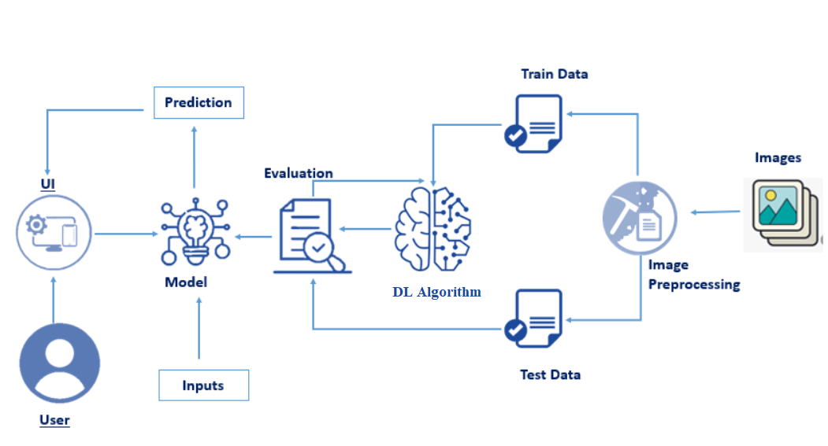

**3.2 Hardware / Software designing**

***Software Requirements:***

* Anaconda Navigator
* Tensor flow
* Keras
* Flask

***Hardware Requirements:***

* Processor              : Intel Core i3
* Hard Disk Space   : Min 100 GB
* Ram                        : 4 GB

**4. EXPERIMENTAL INVESTIGATIONS**

 This method is highly dependent on the surrounding environment, its classification still has limitations. The research of garbage classification system is mature, but the accuracy and speed of garbage classification still need to be improved. And there are few researches on garbage classification based on deep learning. At present, deep learning technology is widely used in image classification, and has some remarkable achievements and achieved an accuracy .It can be seen that the classification effect is good.It can meet the requirerments of the intelligent garbage bin well,and can complete the garbage classification accurately

**5. FLOW CHART**

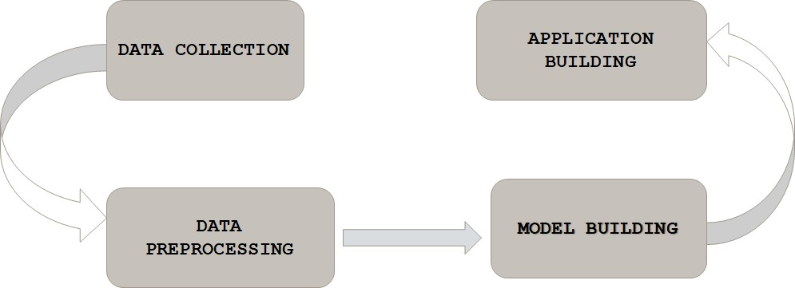

**6. RESULT**

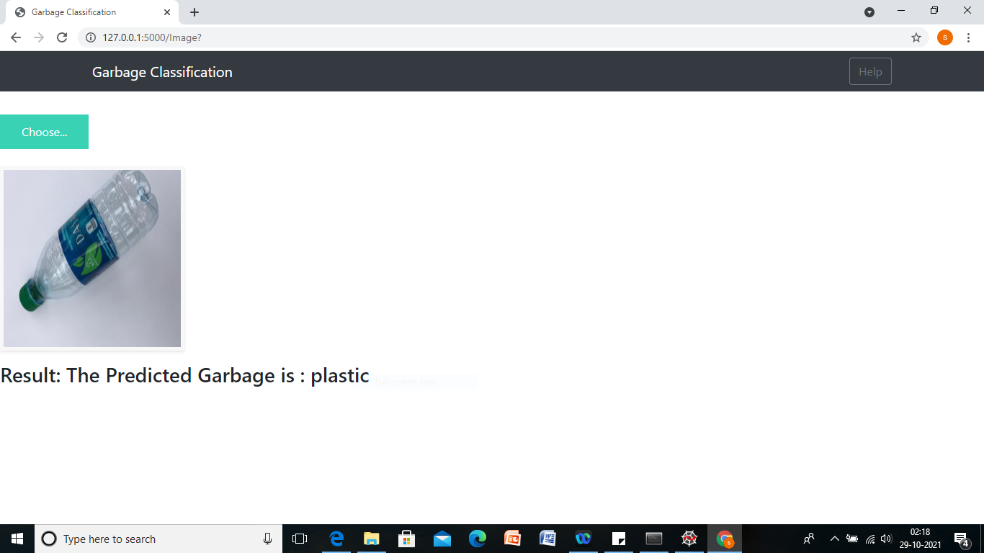

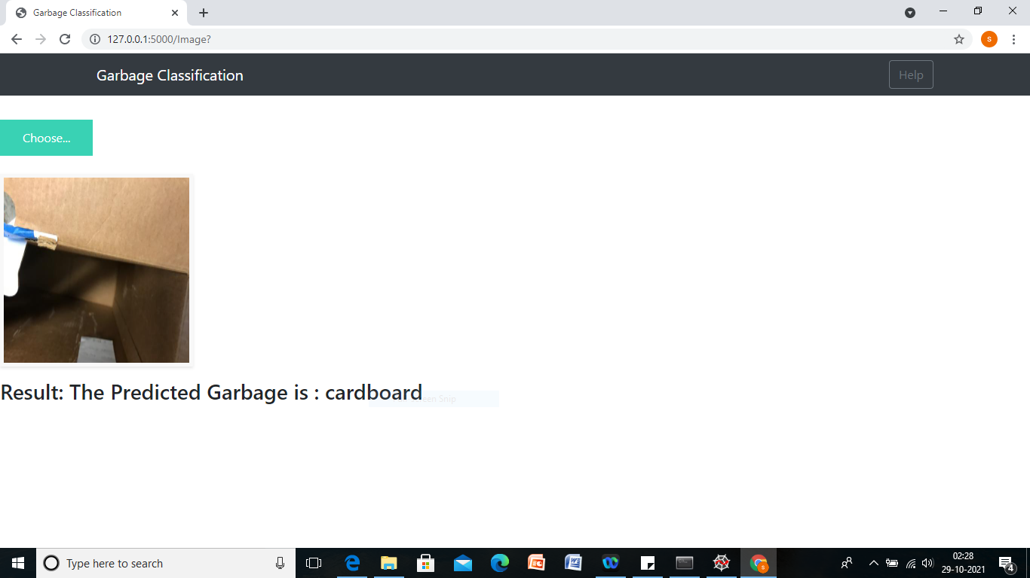

**7. ADVANTAGES & DISADVANTAGES**

***Advantages:***

* By garbage classification, we can remove substances that are recyclable and substances that are hard to be degraded. Thus reducing more than 50% of the waste.
* Reduce environmental pollution. The waste battery contains metal mercury, cadmium and other toxic substances that will do harm to human, the waste plastics in the soil will reduce the production of crop and the waste plastics can also lead to the death of animals. Thus recycling these wastes can reduce the damage.
* Garbage classification reduces the mutual pollution between different garbage, which is beneficial to the recycling of materials.

***Disadvantages:***

* A large scale of these garbage classification practices are done only as a small scale process.

**8. APPLICATIONS**

* Garbage classification reduces the mutual pollution between different garbage,which is beneficial to the recycling of materials.
* Garbage classification is conductive to the separation of ecological waste and non-ecological waste,reducing the difficulty of waste disposal.

**9. CONCLUSION**

Hence it is necessary to recycle the waste to protect the environment and human beings’ health, and we need to separate the waste into different components which can be recycled using different ways. The present way of separating waste/garbage is the hand-picking method, whereby someone is employed to separate out the different objects/materials. The person who separates waste is prone to diseases due to the harmful substances in the garbage. This problem can be overcome by automating the garbage classification process.

**10. FUTURE SCOPE**

Our attempt would be to further improve the predictions with models that are powerful. Imparting more features to our training set will enhance the predictions and will open up a new perspective on every front of garbage prediction.

**11. BIBILOGRAPHY**

G. Thung and M. Yang. "Dataset of images of trash; Torch-based CNN for garbage image classiﬁcation".GitHub Repository, 2016, [https://github.com/garythung/trashnet. Accessed 23 May 2020](https://github.com/garythung/trashnet.%20Accessed%2023%20May%202020).

G. Thung and M. Yang. "Classiﬁcation of Trash for Recyclability Status". CS229 Course Report, 2016,http://cs229.stanford.edu/proj2016/report/ThungYangClassiﬁcationOfTrashForRecyclabilityStatusreport.pdf. Accessed 08 Jun. 2020.

P. Kellow, R. Joel J P C, D. Ousmane, D. Ashok Kumar, d.- A.

Victor Hugo C, and K. Sergei A, “A Smart Waste Management

Solution Geared towards Citizens,” Sensors (Basel, Switzerland),

vol. 20, no. 8, pp.1-15, Apr.2020, doi:10.3390/s20082380.

[5] Y.-G. Cheng, N. Chen, and H. Zhang, “Coal Fly Ash as an Inducer

to Study Its Application in the Production of Methane Gas from

Domestic Waste,” Fresenius Environmental Bulletin, vol. 29, no. 2,

pp. 1082-1089, 2020

P. Kellow, R. Joel J P C, D. Ousmane, D. Ashok Kumar, d.- A.

Victor Hugo C, and K. Sergei A, “A Smart Waste Management

Solution Geared towards Citizens,” Sensors (Basel, Switzerland),

vol. 20, no. 8, pp.1-15, Apr.2020, doi:10.3390/s20082380.

[5] Y.-G. Cheng, N. Chen, and H. Zhang, “Coal Fly Ash as an Inducer

to Study Its Application in the Production of Methane Gas from

Domestic Waste,” Fresenius Environmental Bulletin, vol. 29, no. 2,

pp. 1082-1089, 2020

P. Kellow, R. Joel J P C, D. Ousmane, D. Ashok Kumar, d.- A.

Victor Hugo C, and K. Sergei A, “A Smart Waste Management

Solution Geared towards Citizens,” Sensors (Basel, Switzerland),

vol. 20, no. 8, pp.1-15, Apr.2020, doi:10.3390/s20082380.

[5] Y.-G. Cheng, N. Chen, and H. Zhang, “Coal Fly Ash as an Inducer

to Study Its Application in the Production of Methane Gas from

Domestic Waste,” Fresenius Environmental Bulletin, vol. 29, no. 2,

pp. 1082-1089, 2020

W.-B. Li, G. Ma, E.-Q. Yang, Y.-M. Cai, Z. Chen, R.-f. Gao, J.-H.

Yan, X.-F. Cao, and E.-J. Pan, “Study on characteristics of electric

dust removal fly ash and bag fly ash in circulating fluidized bed

waste incineration system,” Proceedings of the CSEE, vol.39, no.5,

pp.1397-1405, Mar.2019, doi: 10.13334/j.0258-8013.pcsee.181110.

[3] D. Porshnov, V. Ozols, and M. Klavins, “Thermogravimetric

analysis as express tool for quality assessment of refuse derived

fuels used for pyro-gasification,” Environmental Technology, vol.

41, no. 1, pp. 39-35, Mar 2020.

P. Kellow, R. Joel J P C, D. Ousmane, D. Ashok Kumar, d.- A.

Victor Hugo C, and K. Sergei A, “A Smart Waste Management

Solution Geared towards Citizens,” Sensors (Basel, Switzerland),

vol. 20, no. 8, pp.1-15, Apr.2020, doi:10.3390/s20082380.

[5] Y.-G. Cheng, N. Chen, and H. Zhang, “Coal Fly Ash as an Inducer

to Study Its Application in the Production of Methane Gas from

Domestic Waste,” Fresenius Environmental Bulletin, vol. 29, no. 2,

pp. 1082-1089, 2020

P. Kellow, R. Joel J P C, D. Ousmane, D. Ashok Kumar, d.- A.

Victor Hugo C, and K. Sergei A, “A Smart Waste Management

Solution Geared towards Citizens,” Sensors (Basel, Switzerland),

vol. 20, no. 8, pp.1-15, Apr.2020, doi:10.3390/s20082380.

[5] Y.-G. Cheng, N. Chen, and H. Zhang, “Coal Fly Ash as an Inducer

to Study Its Application in the Production of Methane Gas from

Domestic Waste,” Fresenius Environmental Bulletin, vol. 29, no. 2,

pp. 1082-1089, 2020

It can be seen

that the classification effect is good. It can meet the

requirements of the intelligent garbage bin well, and can

complete the garbage classification accurately

It can be seen

that the classification effect is good. It can meet the

requirements of the intelligent garbage bin well, and can

complete the garbage classification accurately

It can be seen

that the classification effect is good. It can meet the

requirements of the intelligent garbage bin well, and can

complete the garbage classification accurately

W.-B. Li, G. Ma, E.-Q. Yang, Y.-M. Cai, Z. Chen, R.-f. Gao, J.-H.

Yan, X.-F. Cao, and E.-J. Pan, “Study on characteristics of electric

dust removal fly ash and bag fly ash in circulating fluidized bed

waste incineration system,” Proceedings of the CSEE, vol.39, no.5,

pp.1397-1405, Mar.2019, doi: 10.13334/j.0258-8013.pcsee.181110.

[3] D. Porshnov, V. Ozols, and M. Klavins, “Thermogravimetric

analysis as express tool for quality assessment of refuse derived

fuels used for pyro-gasification,” Environmental Technology, vol.

41, no. 1, pp. 39-35, Mar 2020.

**APPENDIX**

**Source Code**



