**IBM POWERD AL ENABLED CANDIDATE RESUME SCREENING APPLICATION**

**1. INTRODUCTION**

**1.1 Overview**

This project aims at building a software which can screen the applicant's resume and send an email alert regarding their candidature. Resume screening is the most time-consuming part of the recruiting process for high volume agency and internal recruiters. Stats from LinkedIn shows that recruiters spend an average of 23 hours on screening resumes for a single hire, but AI resume screening can help reduce this time. Considering that the average job opening receives at least 250 resumes, of which 75% can be unqualified, it’s no surprise that talent acquisition leaders report the hardest part of recruitment is screening candidates from large applicant pools. Using recruiting automation or AI resume screening is a potential solution to this problem.

**1.2 Purpose**

Screening candidates for a job interview is something that every company should do during the recruitment process. The purpose of background checks is to give you complete confidence in the people you are hiring. Because your employees are the most important investment you can make. Screening is a process that allows employees to verify information such as education, and prior job history and performance. In addition the screening process reveals important information about a candidate's prior behavior which can help an employer assess potential risk posed by the candidate.

**2. LITERATURE SURVEY**

**2.1 Existing problem**

The challenges recruiters face while screening resumes: The high volume of resumes received – up to 88% of them are unqualified- greatly increases time to fill. Recruiters face increased pressure to show quality of hire but lack tools to link their resume screening to post-hire metrics.

**2.2 Proposed solution**

Our aim is to help recruitment and talent acquisition departments increase efficiency. It does that by organizing all the resumes received for each role so that the team is able to prioritize the candidates they want to invite to the interview process. A resume screening application is to find the perfect candidates that match the job requirements. It filters applications based on skills, education, experience or anything that is a requirement for an open role.

**3. THEORITICAL ANALYSIS**

**3.1 Block Diagram**

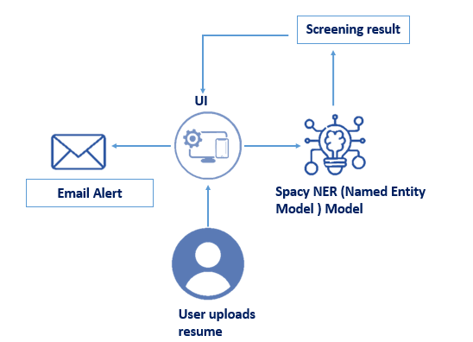

**3.2 Hardware / Software designing**

***Software Requirements:***

* Anaconda Navigator
* Keras
* Flask

***Hardware Requirements:***

* Processor              : Intel Core i3
* Hard Disk Space   : Min 100 GB
* Ram                        : 4 GB
* Display                  : 14.1 “Color Monitor(LCD, CRT or LED)
* Clock Speed         : 1.67 GHz

**4. EXPERIMENTAL INVESTIGATIONS**

In our study, we are using a screening application to extract details of a candidate as per the company needs. Many candidates can apply for a specific job roles. So extracting process have an important role. By the screening process we will extract skills, name, qualifications, mail etc from the resumes that are applied by the candidates. Because the organizations need a candidate with necessary skills or qualifications, In this resume parser is used for this purpose. After the skills got extracted, it will find whether the candidate is eligible or not eligible for the job. With the help of SMTP protocol, it will send a mail based on their candidature.

**5. FLOWCHART**

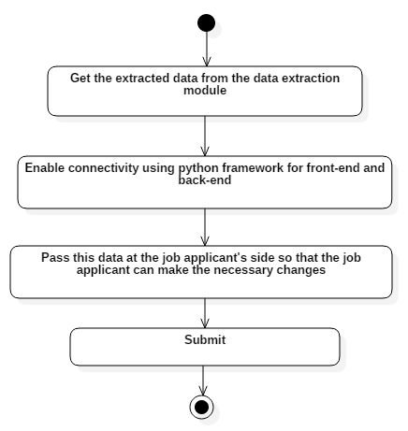

**6. RESULT**

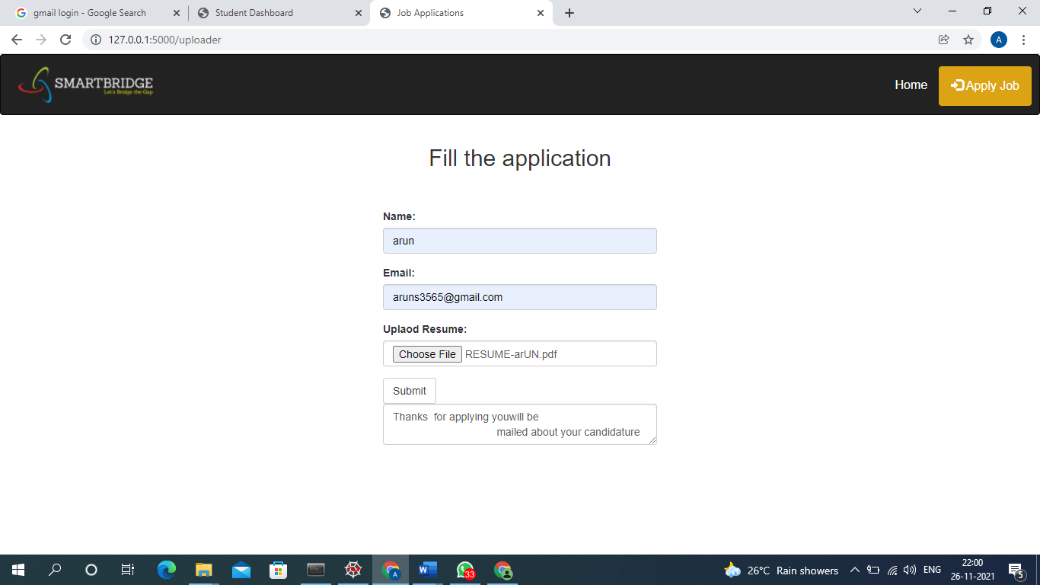

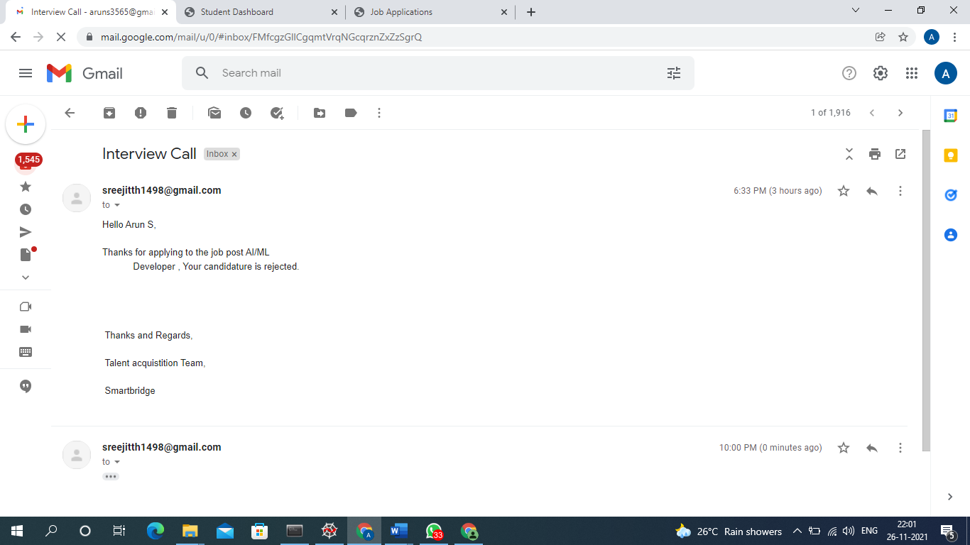

**7. ADVANTAGES & DISADVANTAGES**

***Advantages:***

* If you ask me what is the overall theme of the benefits of AI in recruitment, I would say it reduces the time to hire significantly. If you ask companies, one thing they want to improve in their hiring process, there is a high chance the answer would be “reducing the time to hire.”
* AI improves the quality of hire. However, it won’t automatically pick a candidate and tell you this is your next hire! No. There are many reasons why a candidate may get selected or rejected through the interview process. However, AI brings you to close in choosing the best candidate.

***Disadvantages:***

* **Accuracy and Reliability Is Still an Open Question.** Most AI-based tools are still on a learning phase, or more specifically on a data learning curve. For example, some candidate screening systems may neglect to filter candidates essentially because of the writing format used in their resumes.
* Skipping soft skills and culture fit. Some employees opt for a basic form of AI that is essentially a “matching” process or a verbatim-based algorithm. Judging candidates solely in this manner offers a single or one-dimensional view. Soft skills, cannot be measured by automation of this nature.

**8. APPLICATIONS**

* The goal of screening resumes is to decide whether to move a candidate forward usually onto an interviewor to reject them.
* If the candidate does not have the skills or abilities that the company has looking for then that candidate will get rejected. The employees who have the specified capabilities will be selected.
* Through this process, we will get the candidate who have the exact capabilities as per company needs.
* It will reduce the time taken for the recruitment process.

**9. CONCLUSION**

In this project, we have established the application to screen the candidates based on their skills and experience.  Resume screening allows recruiters to examine the background of individuals and determine their suitability for the job and company culture. Resume screening also allows the recruiter to consider whether the job ad's requirements are realistic for the job market.

**10. FUTURE SCOPE**

Our attempt would be to further improve the screening process because every organization need a candidate that is best suited for a job role. Imparting more features or skills to our applications will enhance the screening process more powerful. It will helps to get a more suitable candidate that is best fitted for the job.

**11. BIBILOGRAPHY**

* Ankit Basarkar, "Document Classification Using Machine Learning" Spring 5-25-2017.
* Vishnu M Menon, Rahulnath H A, "A Novel Approach to Evaluate and Rank Candidates in A Recruitment Process by Estimating Emotional Intelligence through Social Media Data" 2016 International Conference on Next Generation Intelligent Systems (ICNGIS), 2016.

**APPENDIX**

**Source Code**

