**TRAINING REPORT At**

**SATHYABAMA INSTITUTE OF SCIENCE AND TECHNOLOGY**

# (DEEMED TO BE UNIVERSITY)

Submitted in partial fulfillment of the requirements for the award of Bachelor of Engineering Degree in

Computer Science and Engineering

By

# SURYA DEEPTA MAZUMDAR (39110993)



**DEPARTMENT OF COMPUTER SCIENCE AND ENGINEERING SCHOOL OF COMPUTING SATHYABAMA INSTITUTE OF SCIENCE AND TECHNOLOGY JEPPIAAR NAGAR, RAJIV GANDHI SALAI, CHENNAI – 600119, TAMILNADU**

**AUGUST 2020**

# SATHYABAMA



**INSTITUTE OF SCIENCE AND TECHNOLOGY**

(DEEMED TO BE UNIVERSITY)

**Accredited with Grade “A” by NAAC**

**(Established under Section 3 of UGC Act, 1956)**

## JEPPIAAR NAGAR, RAJIV GANDHI SALAI, CHENNAI– 600119 [www.sathyabamauniversity.ac.in](http://www.sathyabamauniversity.ac.in/)

**DEPARTMENT OF COMPUTER SCIENCE AND ENGINEERING**

**BONAFIDE CERTIFICATE**

This is to certify that this Project Report is the bonafide work of

**SURYA DEEPTA MAZUMDAR (39110993)** who carried out the project entitled “**ROBOTIC PROCESS AUTOMATION USING BLUE PRISM**” under my supervision from April 2020 to July 2020.

**Internal Guide**

**Dr.R Aroul Canessane, M.E., Ph.D**

**Head of Department**

**Dr. S.VIGNESHWARI, M.E., Ph.D.,**

**Dr. Lakshmanan L, M.E, Ph.D.,**

**Submitted for Viva voce Examination held on**



**Internal Examiner External Examiner**

## DECLARATION

I,**SURYA DEEPTA MAZUMDAR (39110993)** hereby declare that the Project Report entitled “**ROBOTIC PROCESS AUTOMATION – BLUE PRISM”** done by me under the Guidance of

# Dr.R.Aroul Canessane , M.E., PhD at Sathyabama Institute of Science and Technology is submitted in partial fulfilment of the requirements for the award of Bachelor of Engineering degree in Computer Science and Engineering.

**DATE:**

**PLACE: CHENNAI SIGNATURE OF THE CANDIDATE**

## ACKNOWLEDGEMENT

I am pleased to acknowledge my sincere thanks to **Board of Management** of **SATHYABAMA** for their kind encouragement in doing this project and for completing it successfully. I am grateful to them.

I convey my thanks to **Dr. T.Sasikala M.E., Ph.D.**, **Dean**, School of Computing , **Dr.S.Vigneshwari M.E., Ph.D., and Dr.L.Lakshmanan M.E., Ph.D.,** Heads of the Department of Computer Science and Engineering for providing me necessary support and details at the right time during the progressive reviews.

I would like to express my sincere and deep sense of gratitude to my Project Guide **Dr. R.Aroul Canessane, M.E., PhD** for his valuable guidance, suggestions and constant encouragement paved way for the successful completion of my project work.

I wish to express my thanks to all Teaching and Non-teaching staff members of the **Department of Computer Science and Engineering** who were helpful in many ways for the completion of the project.

## TRAINING CERTIFICATE

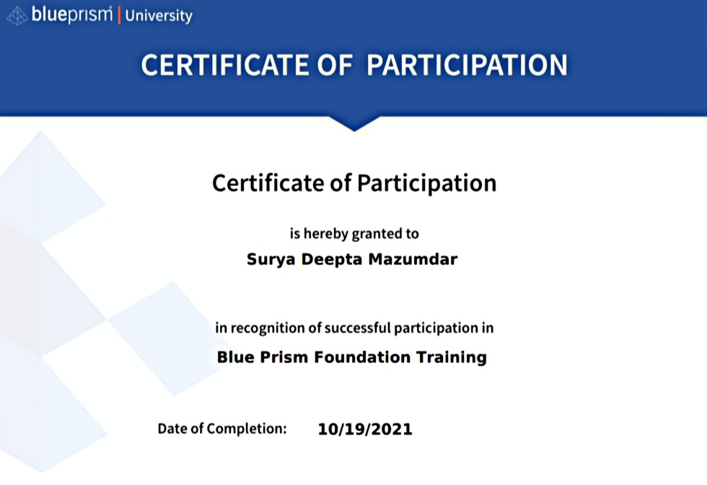

## ABSTRACT

The Blue Prism Tool or **Robotic Process Automation** is an RPA Tool which holds the capability of virtual workforce powered by software robots .This helps the enterprises to automate the business operations in an agile and cost-effective manner .The tool is based on Java Programming Language and offers a visual designer with drag and drop functionalities .Blue Prism Group, a UK multinational software corporation that pioneered and makes enterprise RPA software that provides a digital workflow designed to automate complex ,end-to-end operational activities.

## TABLE OF CONTENTS

**CHAPTER PAGE**

**NO.**  **TITLE NO.**

1. **INTRODUCTION 7**

1.1 OUTLINE 7

* 1. WHY USE BLUE PRISM TOOL 7

1.3 WHY RPA 7

1.4 LITERATURE REVIEW 8

1.5 PROBLEM STATEMENT 9

1.6 OBJECTIVES 10

1. **AIM & SCOPE OF BLUE PRISM 10** 
   1. REQUIREMENTS 10
      1. HARDWARE REQUIREMENTS 10
      2. SOFTWARE REQUIREMENTS 10
   2. ROLE OF BLUE PRISM 11

## 2.2.1 LANGUAGES USED FOR PROJECT 11

* 1. BLUE PRISM INSTALLATION 12
  2. ACTIVATE BLUE PRISM 15
  3. INSTALLING MS EXCEL 21

1. **METHODS AND MATERIAL USED 23**

3.1 MATERIAL USED 23

3.2 METHODS 23

3.2.1 DESIGNING THE PROJECT 23

1. **RESULT AND DISCUSSION 34**
2. **IMPORTANCE OF EMPLOYEE PAYROLL SYSTEM 35**
3. **CONCLUSION AND FUTURE WORK 37**
4. **SCREENSHOTS 38**
5. **REFERENCES 41**

**LIST OF FIGURES**

1. Blue Prism website to download Blue Prism
2. MS Excel Sheet
   * + 1. Robotic Process Automation
       2. How Blue Prism works
       3. Construct Work Flow
       4. Linking Excel Sheet to the Flow

## CHAPTER 1

**1.1 OUTLINE**

Robotic process automation (RPA) is a type of software automation technology involving software robots that perform simple, repetitive tasks, such as data entry. Unlike AI, RPA cannot make judgments about future scenarios or become more intelligent over time

.

**1.2 WHY USE BLUE PRISM TOOL**

The world is moving towards building new processes. This has fueled the absolute necessity for automation. Every organization, big or small, is aiming to automate its business processes in a way that it complements the manual strategizing and processes remain uninterrupted. Robotic Process Automation is a new-age technological marvel that is being utilized by enterprises to automate their tasks and process. In this RPA Blue Prism article, you will learn all the concepts of the popular RPA tool, Blue Prism and learn how it can be used for automation. Robotic Process Automation is a methodology in which robots perform a set of tasks by following a process, without any human intervention. All of these technologies reduce the manual workforce, by giving them time and harnessing their talents in better ways.

Well, robotic process automation does not include actual robots automating your tasks. But, it is the RPA Tools/Vendors providing you a set of libraries and runtime environments for automating business processes. There are a various number of tools in the RPA market. But, the top trending tools in today’s market are UiPath, Blue Prism & Automation Anywhere.

Blue Prism is an RPA Tool which holds the capability of virtual workforce powered by software robots. This helps the enterprises to automate the business operations in an agile and cost-effective manner. The tool is based on Java Programming Language and offers a visual designer with drag and drop functionalities.

Formed in 2001, this tool differs from the other tools in the market, by using a Top-Down approach. Also, Blue Prism offers a visual designer with no recorders, scripts or any intervention.

**1.3 WHY RPA**

The last few years have seen consistent growth in RPA, and Gartner forecasts this to continue well into the future, with 90% of large organizations adopting RPA by 2022. Gartner cites resilience and scalability as the main drivers for current and continued investment. But RPA provides a multitude of advantages for organizations.

Here’s why RPA is important for process automation:

Improve speed, quality, and productivity– RPA bots can be trained to undertake un-intelligent and repetitive tasks faster and more accurately than humans ever could.

Get more value from big data– many organizations are generating so much data that they can’t process all of it. There are many opportunities to gain insights from this data and drive greater efficiencies. RPA is ideally suited to help parse through large datasets, both structured and unstructured, helping organizations make sense of the data they are collecting.

Free up employees for more valuable tasks– RPA offers the opportunity to free employees up to work on more valuable tasks. Leaving tedious and repetitive work behind, employees can take up the jobs of the future, perhaps upskilling to implement automation and AI to achieve greater outcomes.

Become more adaptable to change– Recovering from the disruption caused by COVID-19 involves organizations becoming more agile and nimble in dealing with change. Resilience and adaptability are central to overcoming current and future challenges. RPA helps organizations speed up processes while reducing costs, ensuring organizations are ready to deal with disruption and change.

**1.4 LITERATURE REVIEW**

Changes in the global economy driven by the development of new technologies require businesses to become more agile and to quickly respond to the needs, wishes, and demands from their customers. Moreover, competitive and financial pressures force organizations to be more efficient, thus constantly seeking for new technologies and methodologies that would help them become more productive, save costs and add value to their business. One of the solutions which is emerging as a new technology is robotic process automation (RPA) which can replace employees on repetitive tasks and automate them, and therefore, enable employees to be involved in more complicated tasks which can bring organization more value. According to the reports of consulting companies RPA is recognized as an emerging and disruptive technology that is already delivering value . Although there is a number of authors reporting various benefits of implementing RPA within an organization , according to authors’ best knowledge, RPA is, at the moment, more often implemented in practice than it is investigated by the researches. Thus, it very important to discuss differences, similarities, and complementarities between RPA and similar technologies and approaches, one of which is business process management (BPM). For example, there is a recommendation for investigating the integration of BPMS and RPA . Moreover, investigating the state of the BPM market, Harmon indicated that 30% of the surveyed practitioners would like to add some kind of RPA capabilities to their process modeling suite. Therefore, aiming to properly understand RPA, to assess its relevance within the research community and to investigate its link to BPM, a systematic literature review (SLR) has been conducted. In that sense, this paper reports on three research questions related to the state and progress of the RPA research, its definition and practical usage, which are addressed in more detail later in this paper. Moreover, the paper aims to provide an understanding of the differences between RPA and BPMS. With the purpose of meeting the paper’s goal and to answer the research questions, the paper is structured as follows. After this introduction, a brief background on RPA is given in the second part of the paper, explaining RPA in theory and practice and its relation to BPM. The third part of the paper refers to the employed research methodology, in terms of identification of research questions as well as the SLR protocol. Next, research results regarding three research questions are presented in the fourth part of the paper, while in fifth, they are discussed. Last, the sixth part of the paper brings the conclusion.

As already indicated, it is important to investigate similarities and differences, as well as complementarities between RPA and like technologies. In that sense, since RPA and BPM are neighboring disciplines having complementary goals, Mendling et al. call for the BPM research community to investigate business process management systems (BPMSs) and RPA integration. BPM is a multidimensional approach aiming to achieve better business performance through continuous process improvement, optimization and digital transformation. BPMS as a holistic software platform that encompasses a wide range of functionalities such as process design, analytics, and monitoring is very often one of the BPM initiative inevitable perspectives. On the other side, RPA deals with discreet, repetitive tasks and execute processes as a human would. According to Cewe at al. "BPMS is used to orchestrate end-to-end process, and to manage human, robots and system interactions, RPA is responsible for repetitive sequences of tasks that can be fully delegated to software robots.

**1.5 PROBLEM STATEMENT**

The problem statement is to build a flow-chart in blue prism RPA for HR Payroll in object studio and run the following flow to update the following excel sheet with certain values obtained through the calculation stage of the given flow-chart and to successfully save the excel sheet using Robotic Process .

**1.6 OBJECTIVES**

The objective is to create systematic flow-chart based on the HR Payroll automation using blue prism software and make excel sheet and, following process flow.

## CHAPTER 2

**AIM & SCOPE OF BLUE PRISM**

**2.1 REQUIREMENTS**

***2.1.1 HARDWARE REQUIREMENTS***

The following is the Hardware required to complete this project:

● Internet connection to download and activate

● Administration access to install and run Blue Prism

● Minimum 10GB free disk space

● Windows 8.1 or 10 (64-bit version only) OR Cloud: Get started free, *Cloud account required.

Minimum System Requirements To run Office Excel 2013, your computer needs to meet the following

minimum hardware requirements:

● 500 megahertz (MHz)

● 256 megabytes (MB) RAM

● 1.5 gigabytes (GB) available space

● 1024x768 or higher resolution monitor

***2.1.2 SOFTWARE REQUIREMENTS:***

* Microsoft Excel installed in your pc
* Blue Prism Software

Blue Prism is the trading name of the Blue Prism Group plc, a British multinational software corporation that pioneered and makes enterprise robotic process automation (RPA) software that provides a digital workforce designed to automate complex, end-to-end operational activities.

**2.2 ROLE OF BLUE PRISM**

Blue Prism is a UK-based software development company in the field of Robotic Process Automation. The group supplies software robots that help to automate clerical back-office processes that work exactly like a human. The Robotic Process Automation (RPA) was invented by Blue Prism. This fact itself shows that the company is a pioneer in RPA software development.

Blue Prism software enables business operations to be agile and cost effective by automating, manual, rule-based, repetitive back-office processes and improving accuracy by developing a “Digital Workforce.”. The RPA Blue Prism tool offers flow chart like designer with drag and drop feature to automate each step of the business processes.

Blue Prism is the trading name of the Blue Prism Group plc, a British multinational software corporation that pioneered and makes enterprise robotic process automation (RPA) software that provides a digital workforce designed to automate complex, end-to-end operational activities.

Blue Prism's headquarters are at 2 Cinnamon Park Crab Lane Warrington WA2 0XP, UK with regional offices in the U.S. and Australia. The company is listed on the London Stock Exchange AIM market.

**2.2.1 LANGUAGES USED FOR PROJECT**

Robotic Process Automation using Blue Prism , java and artificial robotics-bot based project are obviously what the future holds . The tool is based on Java Programming Language and offers a visual designer with drag and drop functionalities. Formed in 2001, this tool differs from the other tools in the market, by using a Top-Down approach. Also, Blue Prism offers a visual designer with no recorders, scripts or any intervention.

**FEATURES OF BLUE PRISM:**

Following are some of the important features of Blue Prism :

Secure & Accurate – There is no limit to the number of processes which need to be executed in this tool. Blue Prism delivers secure and accurate results to any number of processes that you wish to automate.

Robust – It provides robust features like load balancing, data encryption, and end-to-end auditing. So, every change is audited and related back to the user related to it.

Scalable & Resilient – It allows scalability with central management. So, all the processes can be automated as per the need and can be monitored centrally.

24*7 Workforce – The tool is designed to work intelligently without a person physically monitoring every action occurring on the screen.

Analytics – Provides extended features to configure Dashboards so that the session information can be redirected to the Monitoring Systems.

Data Security and Data Abstraction – As the tool is designed to work autonomously, all the processing is performed and is stored in a data center. This provides a well-defined data abstraction of data and process security.

Provide Cloud support – Provides working capacity support as per the business requirement. So, users have to just create workers on demand and manage them centrally.

Execution Intelligence – Robots connect to systems and react dynamically to the responses in the data on multiple environments.

* 1. **BLUE PRISM INSTALLATION**

**Step 1:** Once you login to the portal, you will see the following page which shows various options such as [24]7.ai AIVA Platform, IN-D ID Document Processing VBO, Blue Prism Free On-Prem Trial and many others. Click on the **Blue Prism Free On-Prem Trial** option. Refer below.

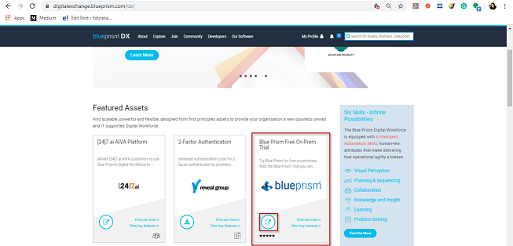

**Step 2:** Then, you will be redirected to the following page, where you have to choose the option of **Get Free Trial**.

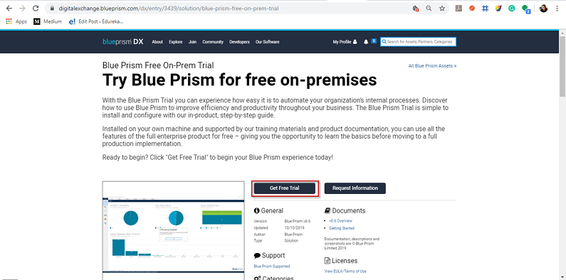

**Step 3:** Once you click on Get Free Trial, you will be redirected to the following page, wherein you have to mention details such as your name, phone number, company phone number, address, state, city and then click on **Submit**.

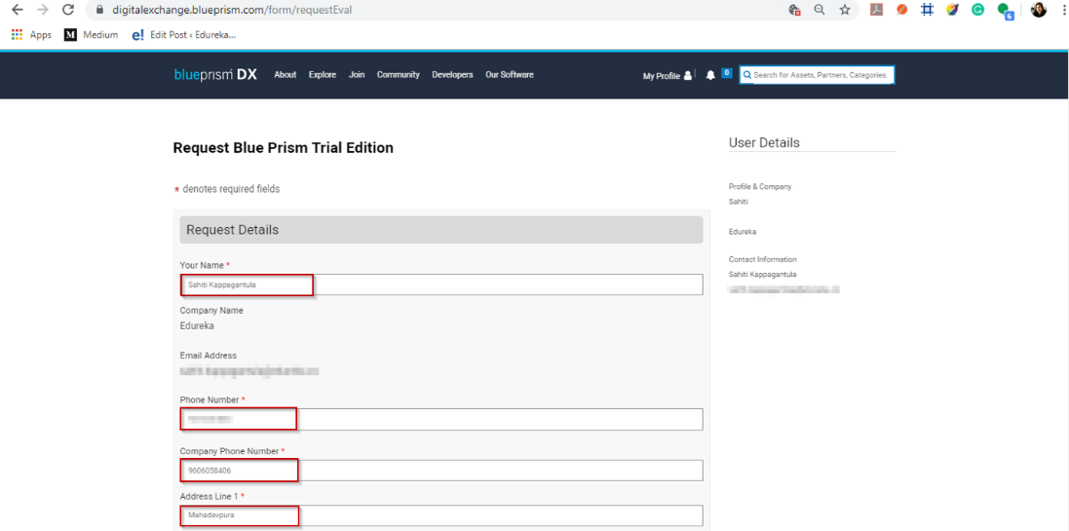

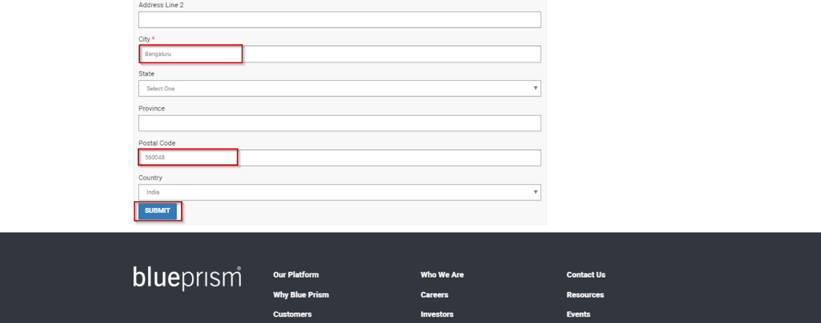

Once, you click on submit, you will be redirected to the following page.

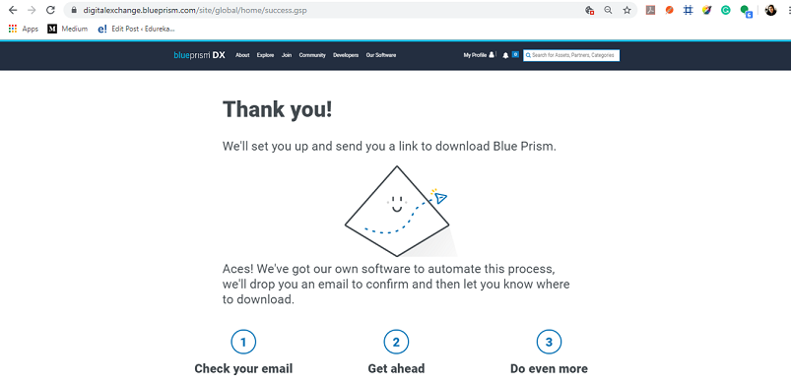

Apart from the above, an email will be sent to you by **Digital Worker**. This email will consist of the **License Key**, which will be required later in the installation. You will also see that the link:[**https://portal.blueprism.com/products/trial**](https://portal.blueprism.com/products/trial) will be sent in the email.

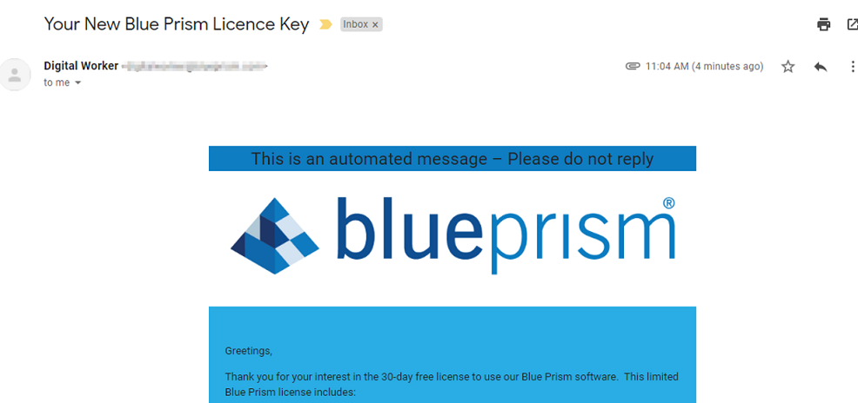

**Step 4:** Go to the above link, click on the **Download 64 Bit** option. Refer below.

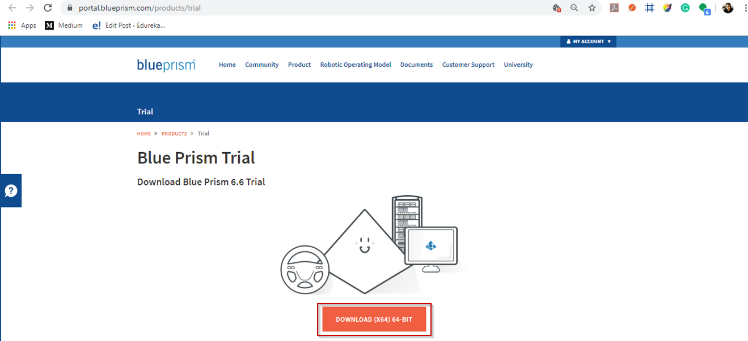

Once you click this option, you will see that Blue Prism is getting downloaded.

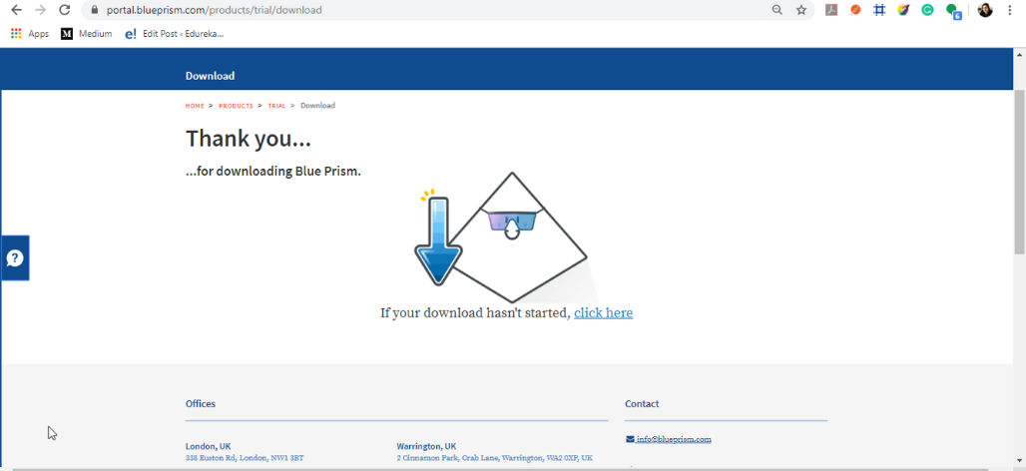

Next in this Blue Prism installation let us see how to configure Blue Prism.

* 1. **Activate Blue Prism**

**Step 1:** Now, open **Blue Prism App** from the Windows search bar and you will see the following screen. Here, click on **Next**.

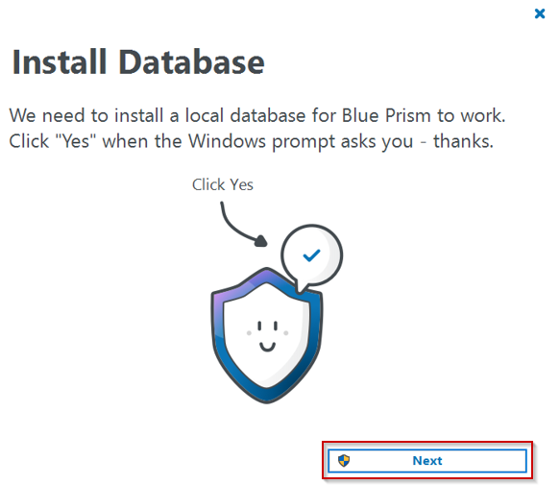

You will see that the database is being installed and built for Blue Prism to work. Refer below.

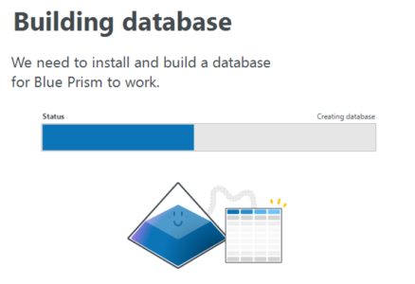

**Step 2:** Once the database is installed, you will see the following screen. Here, click on **Next**.

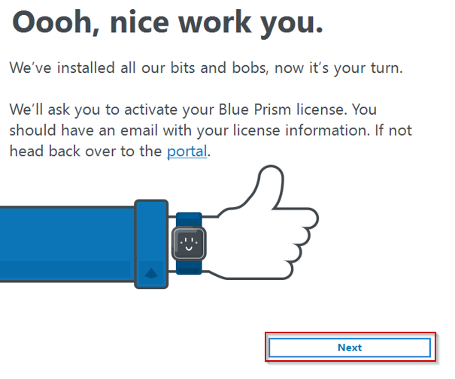

**Step 3:** After that, you have to login using the **username and password**, and then click on **Next**.

**Step 4:** Next, you have to activate Blue Prism, by**uploading the License File**, which you must have got in your email [Refer to step 3 of Blue Prism Installation]. Then, click on**Next**.

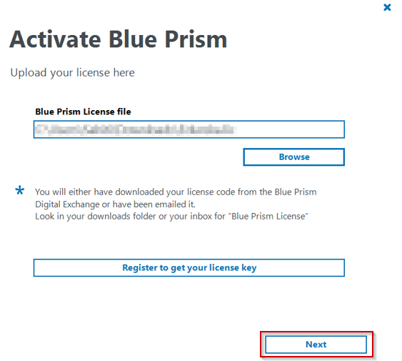

**Step 5:** In the next wizard that opens, click on **Generate new activation code,**and mention the**license key.**

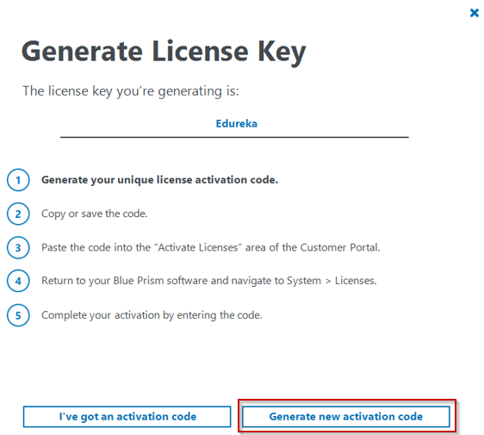

**Step 6:**Copy the license code and paste it in the action to activate the license.

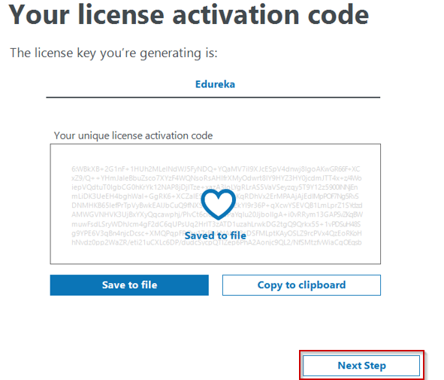

**Step 7:** Then, you will be redirected to the following page, where you have to click on the **Customer Portal** option.

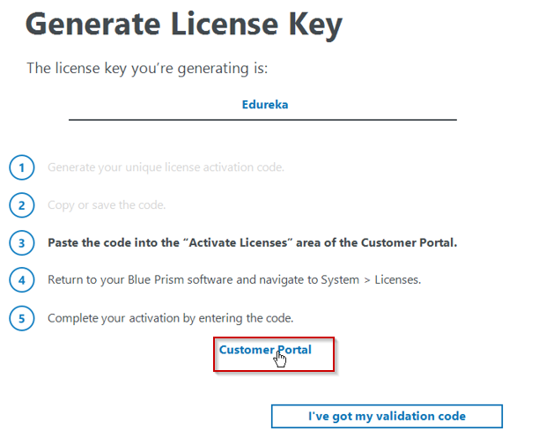

**Step 8:** Here, mention the **License key**and then click on **Submit License Activation.** Refer below.

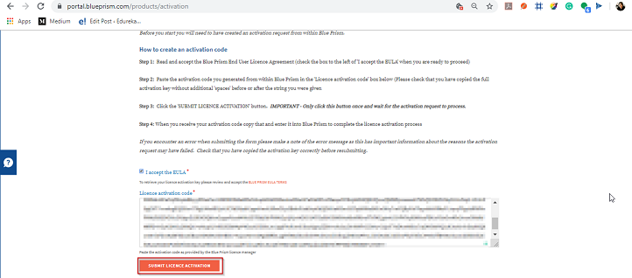

**Step 9:** Once, you click on **Submit License Activation**, you will **get a validation code** as below. Copy this code.

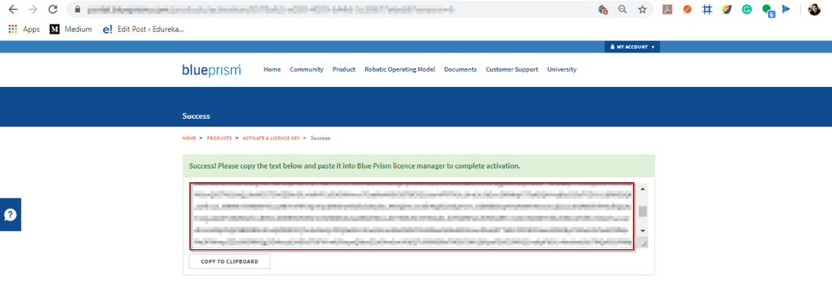

**Step 10:** Then mention this **validation code in** the Blue Prism wizard.

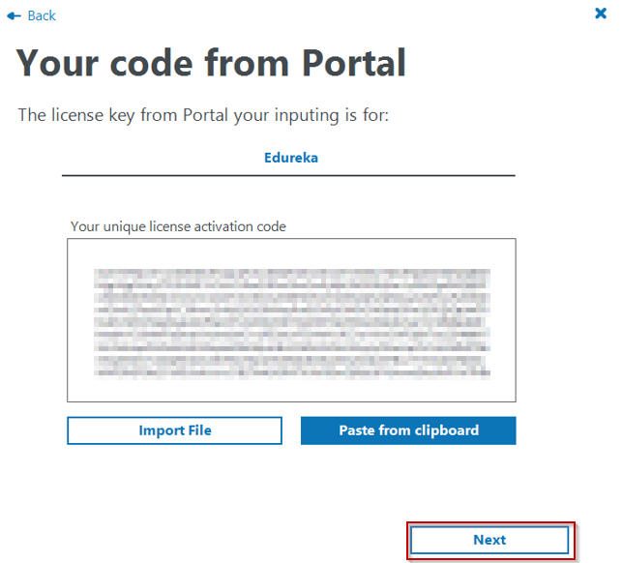

**Step 11:** After you mention the license, you will see the following screen. Click on **Next**. Refer below.

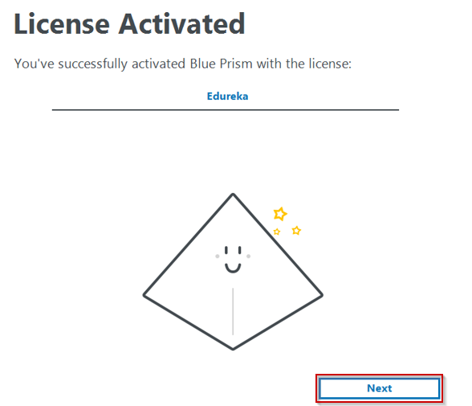

**Step 12:** In the next wizard which opens, click on **Finish**.

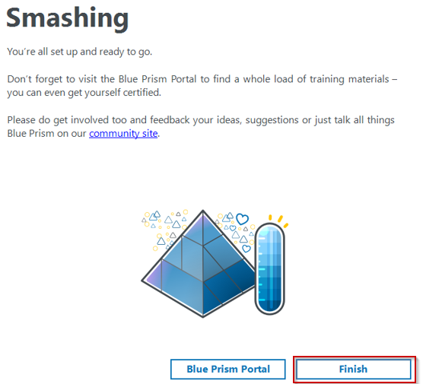

With this, you will finish installing and setting up Blue Prism. Now, you can open Blue Prism and start using it.

* 1. **INSTALLING MS EXCEL:**

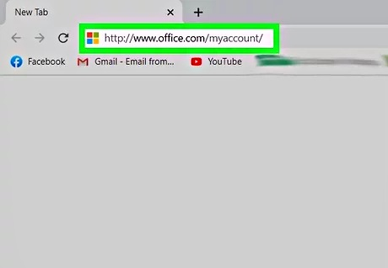

* **Open your account's Office page.** Go to <http://www.office.com/myaccount/> in your computer's web browser.**Click Install >.** It's an orange button on the left side of the page.

.

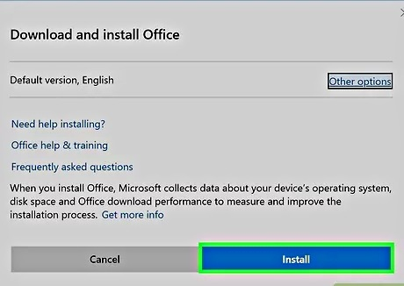

* **Click Install.** This button is on the right side of the page.

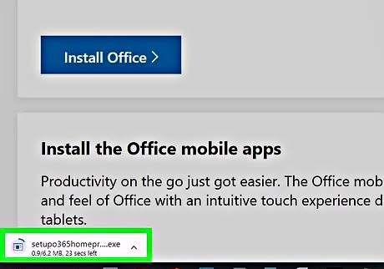

* **Install Office 365**

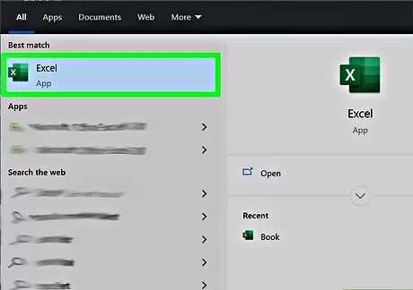

**CHAPTER 3**

## METHODS AND MATERIALS USED

**3.1 MATERIALS USED**

• Blue Prism & MS Excel

**3.2 METHODS**

**3.2.1 DESIGNING THE PROJECT**

The dataset is separated by using the Pandas module into 3 categories where each dataset belongs to one flower specie.

The Blue Prism Flow-Chart is created using the following steps:

1. Configuring the Process Studio.

1. Creating the Process Object from Object Studio.

1. Import the MS Excel VBO file.

1. Create the flow diagram and attach the following Excel VBO in the Action Stage (Open Excel file).

1. Use the Calculation Stage to calculate the needed blanks in the excel file and update the following calculations in excel using Blue Prism bots.
2. Save the Output Excel File and ending the Process.

There are 5 tasks involved in this project:

1. Make an Excel Sheet having specified details in row & column wise.
2. Create the work flow in Blue Prism.
3. Add the Excel file to the Blue Prism to get the output changes in the empty blanks by the calculation stage of the Process.
4. Run the following Process to Save and exit the got Excel sheet and to check whether the Process flow runs smoothly without any errors.
5. To save and export the Blue Prism Process flow.

## Activities:

Milestone 1: Configure the Process Studio

**Let us create the Process Object bind with MS Excel VBO.**

Object studio is mainly used to develop the objects. Inside the object, we have different types of actions as follows:

* 1. Application Modular to Spy the Elements

2. Initialize page and clean up page

## Activity 1: MS Excel VBO (Import VBO file)

**File -> Import -> Browse -> (C:\Program Files\Blue Prism Limited\Blue Prism Automate\VBO\BPA Object - MS Excel). Click Finish**.

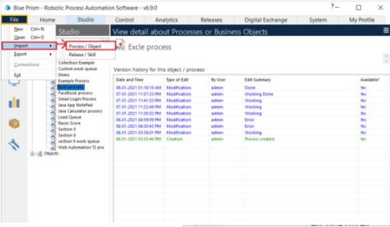

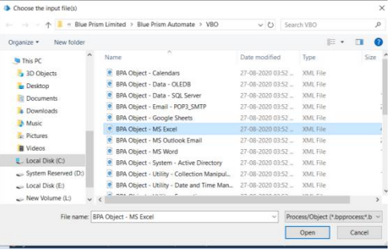

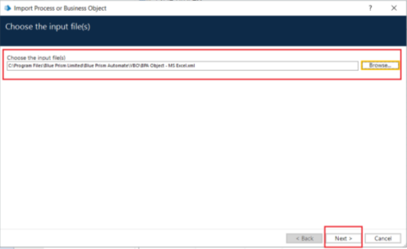

## Activity 2: Creating the Process Object from Object Studio

**Process studio has only the Main page. We can call from the process studio. We use the Process studio for developing and testing.**

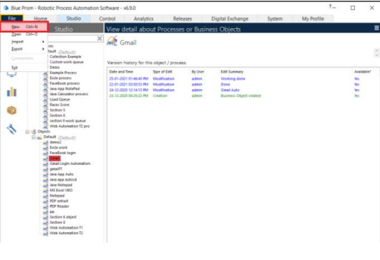

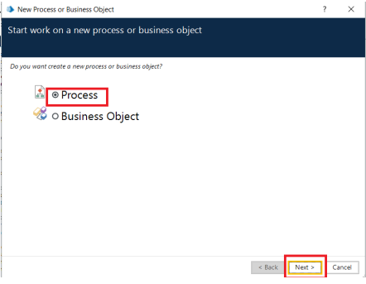

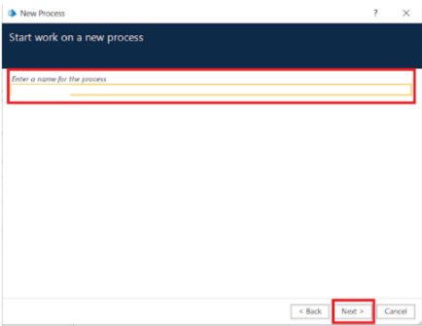

**Open Created Process Model (HR Payroll Process)**

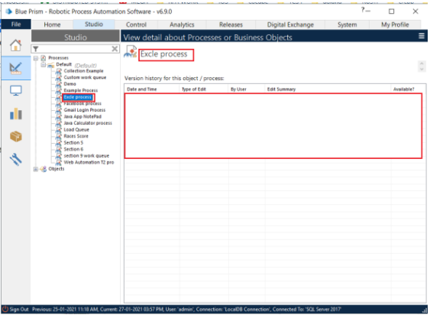

1. Create Action Stage as “Create Instance” (Business Object = MS Excel VBO; Action = Create Instance).

a. Click on the Outputs tab

i. Create Data Item, type = number, name = “handle”. Drag it into the Store In column.

ii. Click on ok.

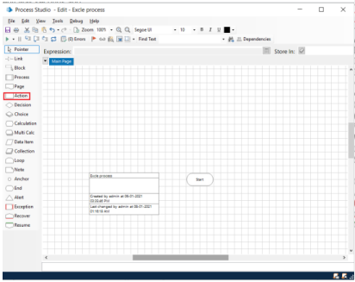

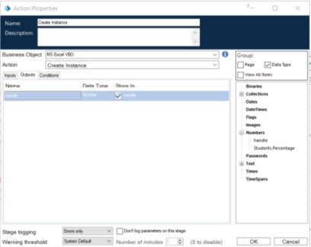

**2. Create Action Stage as “Open Excel file” (Business Object = MS Excel VBO; Action = Open WorkBook).**

a. Click on the Inputs tab

i. Drag “handle” data item into handle Valuecolumn.

ii. Set file path of excel file in File Name Value column

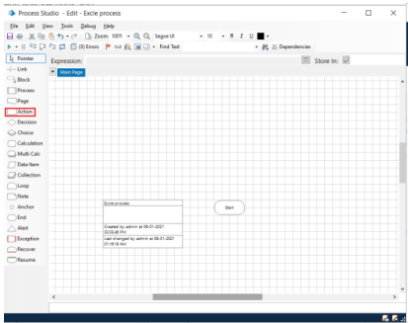

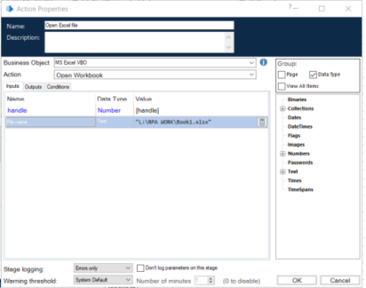

b. Click on the Outputs tab

i. Create Data Item, type = Text, name = “WorkBook Name”. Drag it into the Store In column. Click on OK.

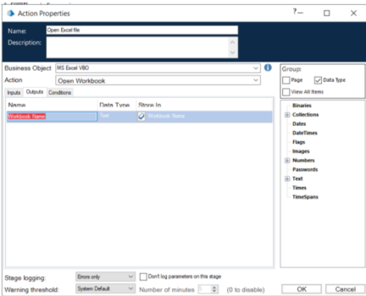

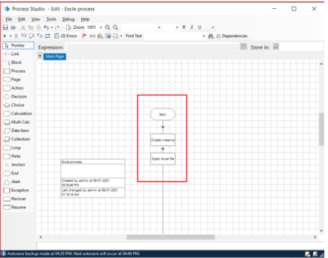

**3. Create Action as “Get to collection” (Business Object = MS Excel VBO; Action = Get WorkBook As Collection).**

a. Click on the Inputs tab

i. Drag “handle” data item into handle Value column.

ii. Drag “Workbook Name” data item into the Workbook Name Value column.

iii. Write Worksheet name as “Sheet1”.

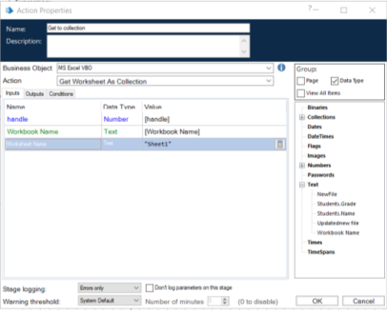

b. Click on the Outputs tab

i. Create Collection as “Employee”, with the following fields.

ii. Use Add Button to add fields in collection.

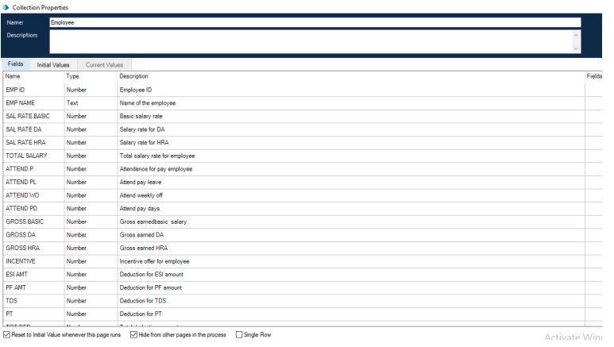

**4. Drag Loop module, Drag Multi Calculation module. Connect loop start with Multi Calc stage. Open Multi Calculation Properties and create the following fields.**

a. [Employee.SAL RATE BASIC]*0.1

b. ([Employee.SAL RATE BASIC+Employee.SAL RATE DA])*0.3

c. [Employee.SAL RATE BASIC+Employee.SAL RATE DA+Employee.SAL RATE HRA]

d. [Employee.ATTEND P]+[Employee.ATTEND PL]+[Employee.ATTEND WO]

e. ([Employee.SAL RATE BASIC]*[Employee.ATTEND PD])/31

f. ([Employee.SAL RATE DA]*[Employee.ATTEND PD])/31

g. ([Employee.SAL RATE HRA]*[Employee.ATTEND PD])/31

h. [Employee.GROSS BASIC]+ [Employee.GROSS DA]+ [Employee.GROSS HRA]+ [Employee.INCENTIVE]

i. [Employee.TOTAL GROSS]*0.0075

j. ([Employee.GROSS BASIC]+ [Employee.GROSS DA])*0.12

k. [Employee.ESI AMT]+[Employee.PF AMT]+[Employee.TDS]+[Employee.PT]

l. [Employee.TOTAL GROSS]-[Employee.TOT DED]

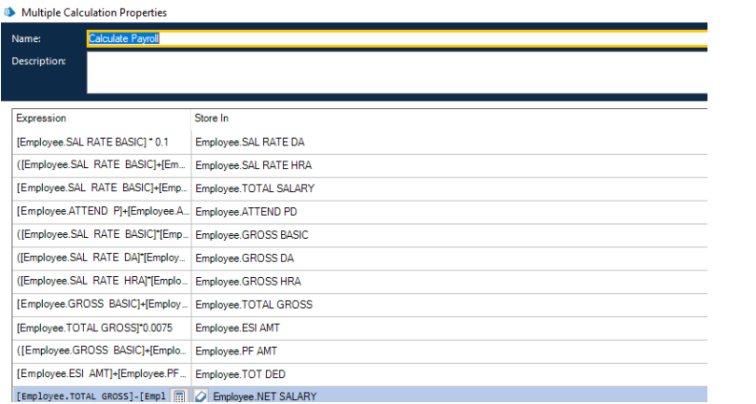

**5. Create Action Stage as “Write collection” (Business Object = MS Excel VBO; Action = Write Collection).**

a. Click on the Inputs tab

i. Drag “handle” data item into handle Value column.

ii. Drag “WorkBook Name” data item into the Workbook Name Value column.

iii. Drag “Employee” Collection into the Collection Value column.

iv. Write Worksheet name as “Sheet1”.

v. Write Cell Reference as “A1”.

vi. Set Include Column Names as True.

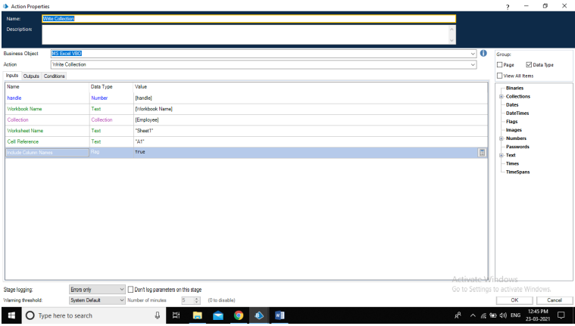

**6. Create Action Stage as “Save Excel file” (Business Object = MS Excel VBO; Action = Save Workbook).**

a. Click on the Inputs tab.

i. Drag “handle” data item into handle Value column.

ii. Drag “WorkBook Name” data item into the Workbook Name Value column.

**7. Create Action Stage as “Close workbook” (Business Object = MS Excel VBO; Action = Close Current WorkBook).**

a. Click on the Inputs tab

b. Drag “handle” data item into handle Value column

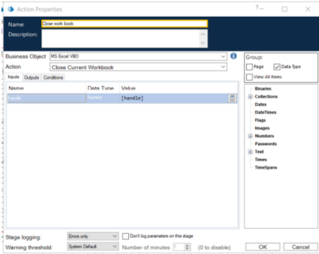

c. Do connections as follows.

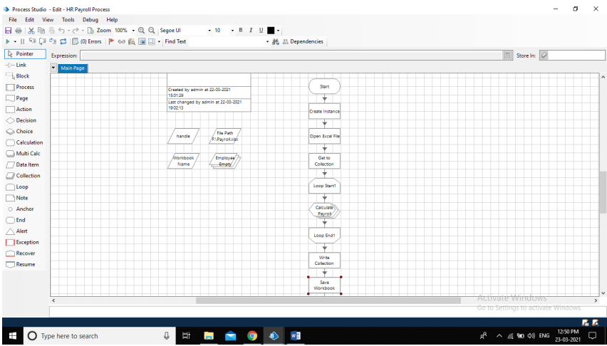

d. Input Excel file data.

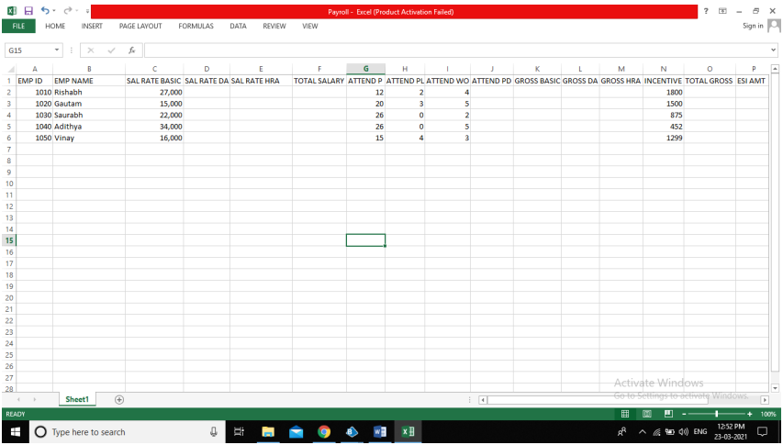

**Activity 3: Testing the Process Object from Object Studio**

**Click on the Main Page, click on the Green play button to run the ‘Excel Process’ Process object. It shows COMPLETED when there is no error or no failure in the object.**

**Click on the Main Page, click on the Reset button to reset the cache for rerun the process object as fresh.**

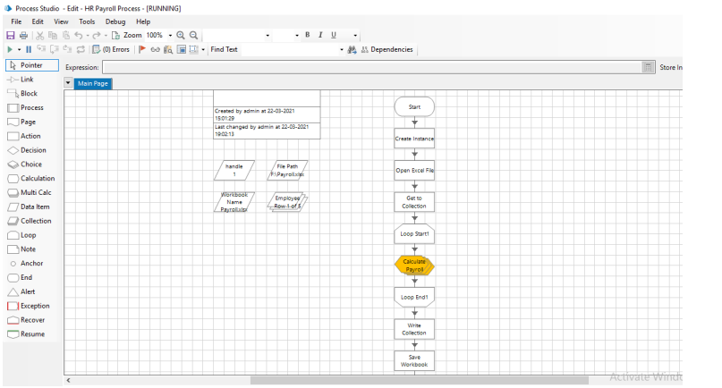

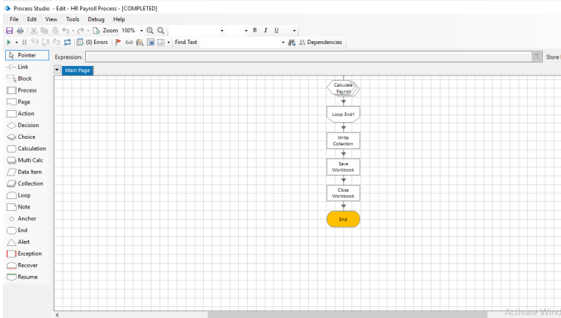

**Output Excel file.**

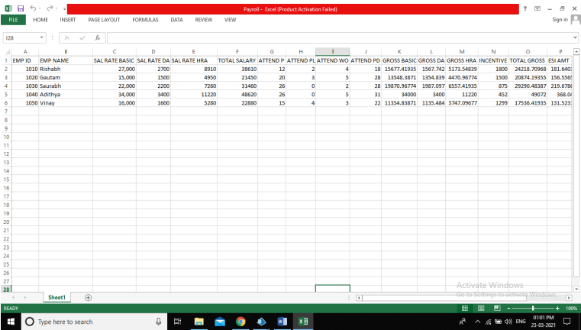

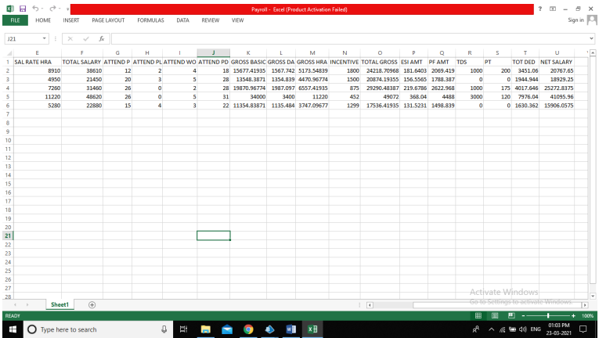

**CHAPTER 4**

**RESULT AND DISCUSSION**

Employee Payroll System using Robotic Process Automation in Blue Prism, I have completed the full work-flow of the given activity and calculating the needed payroll of the employees and storing in the attached excel sheet.

After the calculation part of the flow and checking the stored data in the Excel Sheet the next step was to check that the flow runs without any interruption or error till the end stage by saving the excel sheet and to the end of the process.

I have used Blue Prism software for this Employee Payroll System using RPA as it is easy to understand and very efficient and capable of doing work flow using bots and MS Excel to store the final result of the Process.

## CHAPTER 5

**IMPORTANCE OF EMPLOYEE PAYROLL SYSTEM**

Employees are considered the most important resource of the organization. Thus companies spend copious amounts of time recruiting, training, and maintaining sufficient employment for their business operations. One of the most important tasks thus is the process of their payroll. Employees need to be able to rely on being paid on a consistent basis without delays. Irrespective of the size of the organization, payroll plays a huge role in maintaining the morale of employees to the financial stability of the company.

Typically processing payroll is a time-consuming and complex task. More so for smaller companies who do not have a dedicated person to manage their payroll. Bigger companies may have an entire department dedicated to processing payroll. Medium companies, on the other hand, may find it more efficient and cost-effective to outsource their payroll needs.

## ****Determine compensation****

Payroll shows an employee what his net worth is within the company. Every individual’s total compensation is built into payroll. This covers everything from their salary, benefits to bonuses, increments. Usually, everyone has to go annual performance evaluations by their managers, after which they are either given an increase in their salary or a bonus or both.

## ****Increase morale****

Out of all the aspects of payroll, one of the most important is its impact on employee morale. If at any point in time payroll is late, employees may begin to question the company’s financial integrity. It may eventually lead to employees to start underperforming and be less engaged in their job if they feel it is not secure. They may also look for better opportunities and leave the company without prior warnings. Thus, it is necessary that payroll be paid in a timely manner to keep employee morale high.

## ****Maintain company reputation****

Apart from all the financial obligations that the companies have towards their employees, they also have to ensure that all payroll activities adhere to the country’s tax obligations and comply with employment legislation. Efficiently being able to meet these tax obligations on time as well as upholding legislative laws is a sure way to establish the organization’s reputation as a stable employer. It is well proven to be a value-added branding proposition that helps to ultimately attract and retain the right pool of talent to the organization.

## ****Re-allocation of Resources****

There are hundreds of manual tasks associated with payroll, which can be an extremely time-consuming and manual job. In addition, it is mandatory that payroll be performed regularly every month. Thus, many times additional resources need to be employed to make sure that the accuracy and precision of payroll calculations is maintained.

**ADVANTAGES OF EMPLOYEE PAYROLL SYSTEM:**

Easy Calculations

Accuracy is required to pay employees the right money they have earned. To avoid the difficulty of manually computing the payroll, you can use a software to automate the process. The withholding tax is calculated for each employee based on data entry in the conditions of detention. This reduces the likelihood of errors in the payroll tax, which can lead to charges from the Corporate tax and the income tax. The process is productive and efficient to save time and money. Your accounting department can create reports and financial documents easily.

Easy Forecasting

Payroll System allows you to view and control instantly all payroll expenses. This helps you graph the financial data to help you create a forecast. If you have an idea of your business performance, it will be much easier to choose when you need to employ new workforce for the company. You can make adjustments and calculate salary increases to help you make an assessment of how this will affect your money. It’s easier to know if your decision is good for business.

Save Time

It takes extra time and resources for a company to manage payroll manually. But the payroll software helps to accelerate all aspects of the payroll process with a number of automated functions.

Safe Backup

As a company, keeping large amounts of data on the payroll can be difficult. You can not store plenty of documents and data manually. However, when using payroll software, it is convenient to save the records to various databases available online. If your computer or system is destroyed, you should always have a backup to recover all your recordings.

Cost Effective

By taking control of the payroll through the software rather than hiring another person to keep records, there is great potential to save money … especially once you can use the software quickly and efficiently.

**TOOLS REQUIRED TO PERFROM EMPLOYEE PAYROLL SYSTEM:**

* **Microsoft Excel :** This tool is one of the most widely used tools for data storage collection. Mostly used for employee’s payment data, this tool analyzes the tasks that summarize the data with a preview of pivot tables.
* **Blue Prism** : This tool is used for creating the flow diagram for calculating and storing the required value in the excel sheet which is attached to it by Robotic Process Automation.

**Value of Employee Payroll System :**

Employee payments and salaries play a major role in the working of a successful organization. The biggest reason for this is that the compensation that employees are paid for the work they do, works as a major motivation for them to do better in the job.

When the payments and salaries are managed efficiently, it may be ensured that the working of the company is kept smooth and efficient. This implies that an effective, fact and error free method of salary computation and disbursement should be integrated in the working system. The [payroll management system](http://www.zinghr.com/solution/payroll-management-system/) can be implemented best with the help of software systems so that the work is done in a progressive manner. There is a great amount of significance in the use of such systems for companies, which compels more and more companies to join the league of those who rely on software systems for carrying out such tasks.

One of the biggest significances of the system is that the following of government rules and guidelines in the computation of taxes to be deducted from salaries becomes an easy task and the company do not land into legal issues because of lack of efficiency in tax calculation. It is also possible to keep a tab on the information of the employees who work for the company with the help of the software system; this goes a long way in helping companies in knowing their employees in a better manner.

## CHAPTER 6

**CONCLUSION & FUTURE WORK**

**SUMMARY:**

The intension of this project is to make the flow diagram for the Employee Payroll System on Robotic Process Automation in Blue Prism software and to assign the following tables through the calculation stage in the MS Excel and to save the following sheet.

**FUTURE WORK:**

In future projects I will implement Robotic Process Automation to count the number of leaves taken by an employee per month and to calculate the daily wages regarding the number of leaves in Employee Payroll System using Blue Prism.

**CONCLUSION:**

Open the required MS Excel sheet to check whether the blank tables in that sheet have been filled by the bots according to the calculation stage in the blue prism software.

## CHAPTER 7

**SCREENSHOTS:**







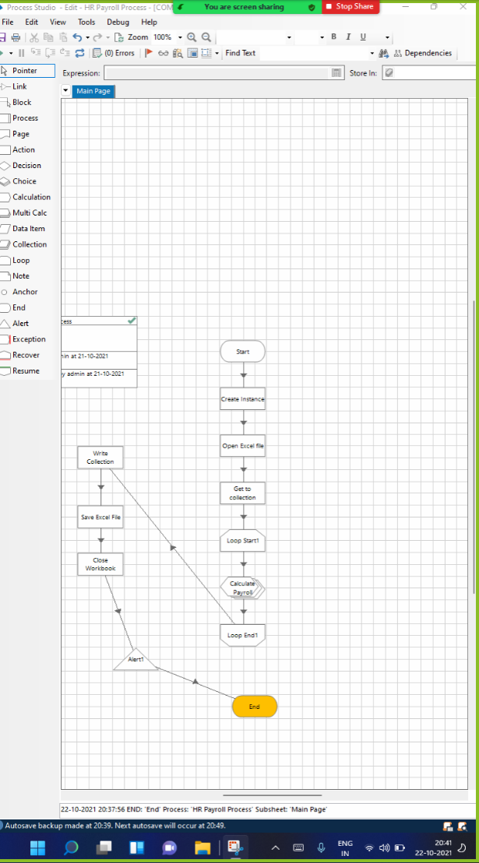

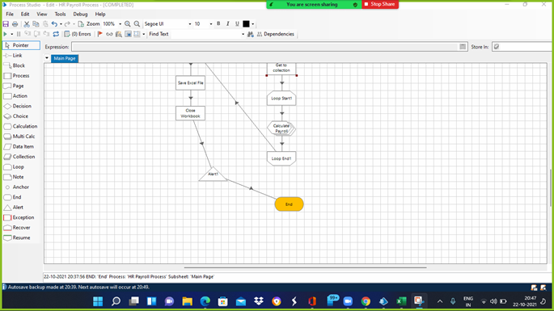

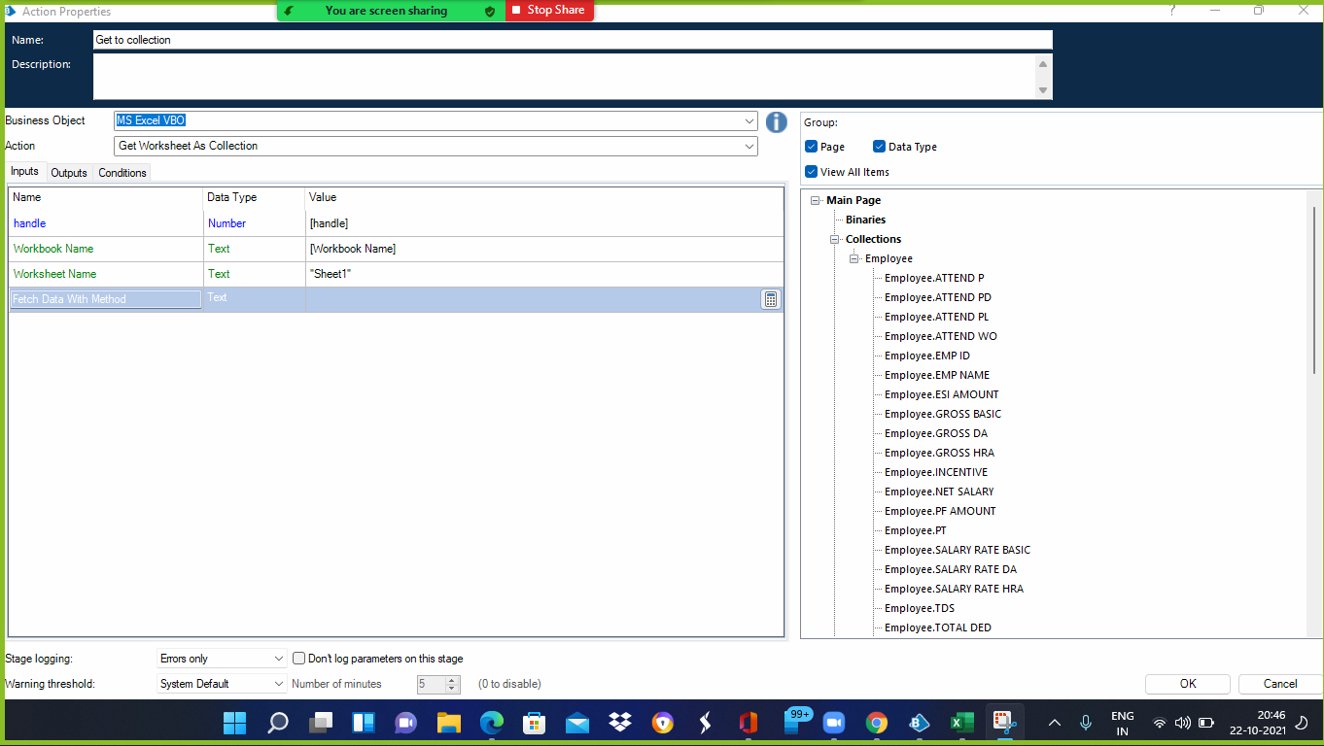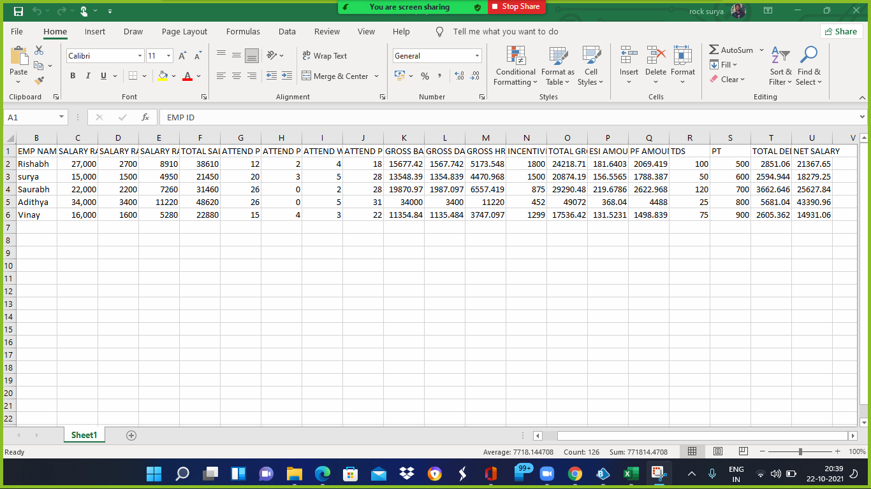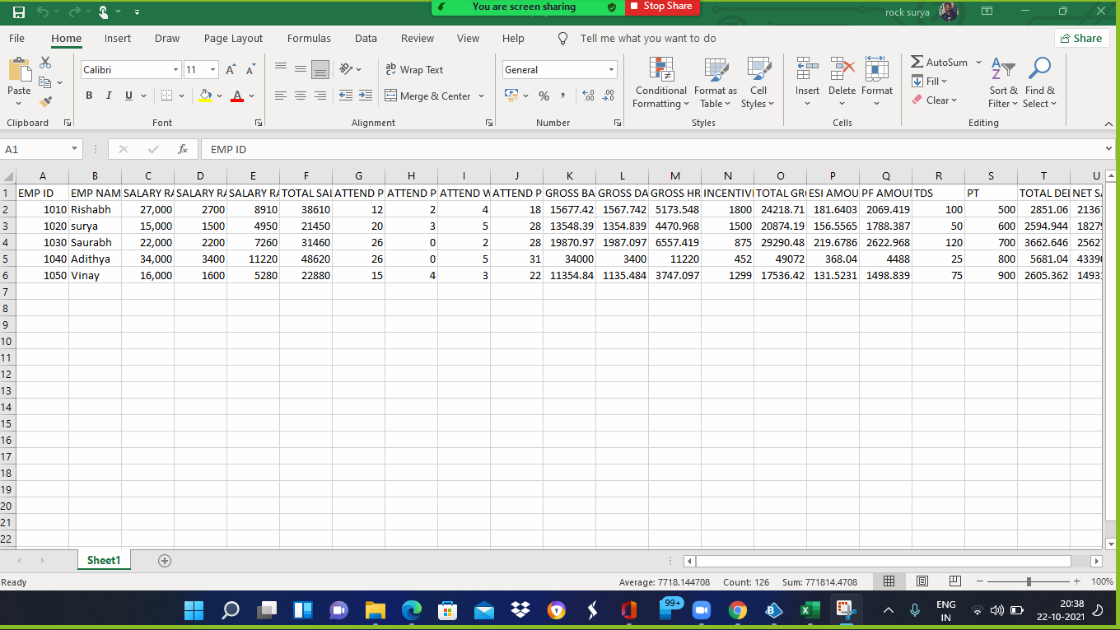

## CHAPTER 8

**REFERENCES:**

1. Automation of a Business Process Using Robotic Process Automation (RPA)
2. Robotic Automation Process-The next major revolution in terms of back office operations improvement
3. Robotic Automation Process – The operating system for the digital enterprise. In: Proceedings of the International Conference on Business Excellence, vol. 12
4. Understanding the success factors in adopting Business Process Management Software: case studies
5. Chappell, D.: Introducing Blue Prism: Automating business processes with presentation integration.
6. Everest Group: Robotic Process Automation Annual Report 2018-Creating Business Value in a Digital-First Word.
7. Institute for Robotic Process Automation: Introduction to Robotic Process Automation. Accessed 5 March 2019.
8. Ovum: Robotic Process Automation: Adding to the Process Transformation Toolkit - The role that RPA can play within service providers and enterprises.

1. Zhang, N., Liu, B.: The Key Factors Affecting RPA-business Alignment.
2. Geeks for Geeks
3. Quora
4. RPA Foundation Course – Blue Prism University