Walmart Store Sales Forecasting

Project Description
Sales forecasting is the process of estimating future sales. Accurate sales forecasts enable companies to make informed business decisions and predict short-term and long-term performance. Companies can base their forecasts on past sales data, industry-wide comparisons, and economic trends. Here, the company is Walmart. Walmart is a renowned retail corporation that operates a chain of hypermarkets. Walmart has provided a data by combining the data of 45 stores including store information and monthly sales. Walmart runs several promotional markdown events throughout the year. These markdowns precede prominent holidays, the four largest of which are the Super Bowl, Labor Day, Thanksgiving, and Christmas. The weeks including these holidays are weighted five times higher in the evaluation than non-holiday weeks. The data is provided on weekly basis. We have to find the impact of holidays on the sales of the store. The holidays included are Christmas, Thanksgiving, Super Bowl and Labour Day. We will be using algorithms such as ARIMA, Random Forest, and XgBoost. We will train and test the data with these algorithms. Flask integration and IBM deployment will also be done.

Architecture:
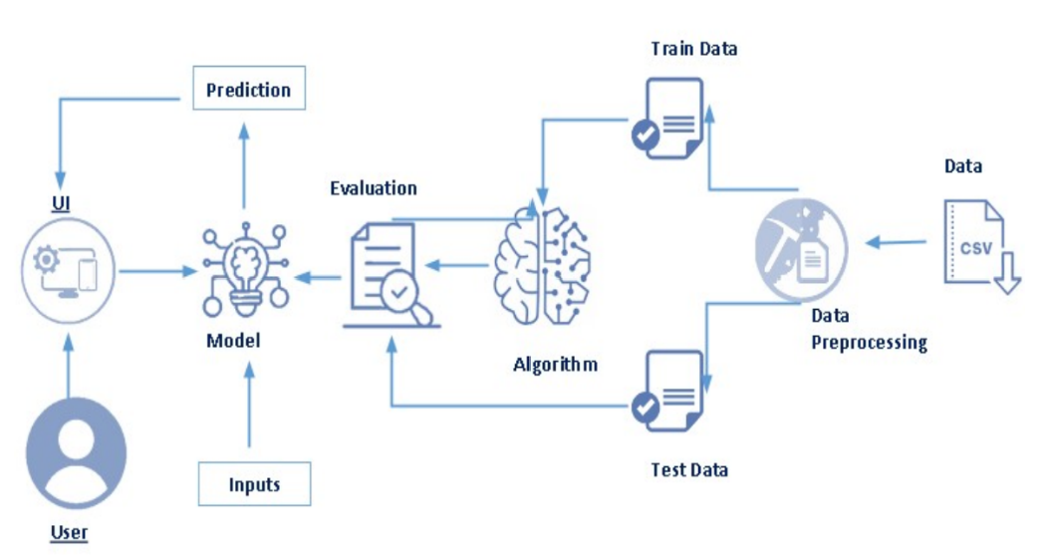

Pre-requisites
To complete this project, knowledge of the following software, concepts and packages is required.
● Anaconda navigator
● Python packages
o Open anaconda prompt as administrator
o Type “pip install numpy” and click enter.
o Type “pip install pandas” and click enter.
o Type “pip install matplotlib” and click enter.
o Type “pip install seaborn” and click enter.
o Type “pip install pmdarima” and click enter.

Prior Knowledge
You must have prior knowledge of following topics to complete this project.
● ML Concepts
o Supervised learning: https://www.javatpoint.com/supervised-machine-learning
o Unsupervised learning: https://www.javatpoint.com/unsupervised-machine-learning
o Regression and classification
o Random forest: https://www.javatpoint.com/machine-learning-random-forest-algorithm
o Xgboost: https://www.analyticsvidhya.com/blog/2018/09/an-end-to-end-guide-to- understand-the-math-behind-xgboost/
o Evaluation metrics: https://www.analyticsvidhya.com/blog/2019/08/11-important-model-evaluation-error-metrics/
https://towardsdatascience.com/what-are-rmse-and-mae-e405ce230383

Project Objectives
1. Accurate Sales Forecasting: Develop a robust model to predict Walmart store sales accurately, considering various factors such as historical sales data, seasonality, promotions, and external factors.
2.Optimize Inventory Management: Utilize sales forecasts to optimize inventory levels, ensuring that each store has the right amount of stock to meet demand without excess, minimizing both stockouts and overstock situations.
3.Improve Demand Planning: Enhance the ability to plan and allocate resources efficiently based on anticipated demand patterns, allowing for better workforce management and resource allocation.
4.Enhance Decision-Making: Provide actionable insights to decision-makers within Walmart by analyzing sales forecasts and identifying key drivers, enabling informed decision-making for promotions, pricing, and inventory management.
5. Real-Time Monitoring: Implement a system for real-time monitoring of sales performance against forecasts, allowing for quick adjustments and proactive management in response to unexpected changes in the market or internal factors.

Project Flow:
1.Data Collection:
- Gather historical sales data from Walmart stores, including information on promotions, pricing, and other relevant factors.
-Collect external data such as economic indicators, weather patterns, and local events that may impact sales.
2. Data Cleaning and Preprocessing:
- Clean and preprocess the collected data to handle missing values, outliers, and ensure data consistency.
- Explore relationships between different variables to identify potential features for the forecasting model.
3.Exploratory Data Analysis (EDA):
- Conduct EDA to gain insights into the data distribution, trends, and correlations.
- Identify seasonality patterns, peak sales periods, and any other significant patterns that may influence sales.
4.Feature Engineering:
- Create new features or transform existing ones to improve the model's predictive power.
- Incorporate external factors such as holidays, economic indicators, and local events.

Data Collection
ML depends heavily on data. It is most crucial aspect that makes algorithm training possible.
So this section allows you to download the required dataset.
Download the dataset
There are many popular open sources for collecting the data. Eg: kaggle.com, UCI repository,
etc.

In this project, Walmart-dataset.zip is used data which has features.csv, stores.csv, train.csv,
and test.csv. This data is downloaded from kaggle.com. Please refer the link given below to
download the dataset.
Visualizing and analysing the data
As the dataset is downloaded. Let us read and understand the data properly with the help of some visualization techniques and some analysing techniques.
There are numerous techniques for understanding the data. But here some of them are used. In addition, other and multiple techniques can also be used.
Importing the libraries
Import the necessary libraries as shown in the image.
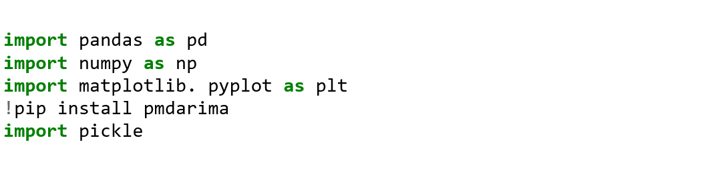
Read the Dataset
The dataset format might be in .csv, excel files, .txt, .json, etc. So, the dataset can be read with the help of pandas. In pandas we have a function called read_csv() to read the dataset. As a parameter we have to give the directory of csv file.
All the datasets are read in the same way.
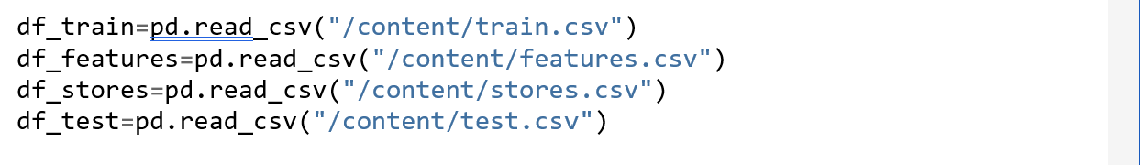
After reading the datasets, we will be viewing them by using the .head() function which will by default display first 5 rows of the dataset.
df_train. head()
Store Dept Date Weekly_Sales IsHoliday
0 1 1 2010-02-05 24924.50 False
1 1 1 2010-02-12 46039.49 True
2 1 1 2010-02-19 41595.55 False
3 1 1 2010-02-26 19403.54 False
4 1 1 2010-03-05 21827.90 False

df_features.head()
Store Date Temperature Fuel_Price MarkDown1 MarkDown2 \
0 1 2010-02-05 42.31 2.572 NaN NaN
1 1 2010-02-12 38.51 2.548 NaN NaN
2 1 2010-02-19 39.93 2.514 NaN NaN
3 1 2010-02-26 46.63 2.561 NaN NaN
4 1 2010-03-05 46.50 2.625 NaN NaN
MarkDown3 MarkDown4 MarkDown5 CPI Unemployment IsHoliday
0 NaN NaN NaN 211.096358 8.106 False
1 NaN NaN NaN 211.242170 8.106 True
2 NaN NaN NaN 211.289143 8.106 False
3 NaN NaN NaN 211.319643 8.106 False
4 NaN NaN NaN 211.350143 8.106 False

df_stores.head()
Store Type Size
0 1 A 151315
1 2 A 202307
2 3 B 37392
3 4 A 205863
4 5 B 34875
df=df_train.merge(df_features,how='left',indicator=True).merge(df_stores,how='left')
df.head()
Store Dept Date Weekly_Sales IsHoliday Temperature Fuel_Price \
0 1 1 2010-02-05 24924.50 False 42.31 2.572
1 1 1 2010-02-12 46039.49 True 38.51 2.548
2 1 1 2010-02-19 41595.55 False 39.93 2.514
3 1 1 2010-02-26 19403.54 False 46.63 2.561
4 1 1 2010-03-05 21827.90 False 46.50 2.625
MarkDown1 MarkDown2 MarkDown3 MarkDown4 MarkDown5 CPI \
0 NaN NaN NaN NaN NaN 211.096358
1 NaN NaN NaN NaN NaN 211.242170
2 NaN NaN NaN NaN NaN 211.289143
3 NaN NaN NaN NaN NaN 211.319643
4 NaN NaN NaN NaN NaN 211.350143
Unemployment _merge Type Size
0 8.106 both A 151315
1 8.106 both A 151315
2 8.106 both A 151315
3 8.106 both A 151315
4 8.106 both A 151315
Data Pre-processing
As we seen and understood the description of the data, lets pre-process the collected data.
The download data set is not suitable for training the machine learning model as it might have so much of randomness so, the dataset has to be cleaned properly in order to fetch good results. This activity includes the following steps.
● Handling missing values
● Handling categorical data
● Handling outliers
● Scaling Techniques
● Splitting dataset into training and test set
Note: These are the general steps of pre-processing the data before using it for machine learning. Depending on the condition of your dataset, you may or may not have to go through all these steps.

Checking for null values
● To find the data type, .info() function is used.

df.isnull().sum()
Store 0
Dept 0
Date 0
Weekly_Sales 0
IsHoliday 0
Temperature 0
Fuel_Price 0
MarkDown1 270889
MarkDown2 310322
MarkDown3 284479
MarkDown4 286603
MarkDown5 270138
CPI 0
Unemployment 0
_merge 0
Type 0
Size 0
dtype: int64
df2=df.drop(['MarkDown1','MarkDown2','MarkDown3','MarkDown4','MarkDown5'],axis=1)

df2.isnull().sum()
Store 0
Dept 0
Date 0
Weekly_Sales 0
IsHoliday 0
Temperature 0
Fuel_Price 0
CPI 0
Unemployment 0
_merge 0
Type 0
Size 0
dtype: int64
df2[df2.Weekly_Sales<0]
Store Dept Date Weekly_Sales IsHoliday Temperature \
846 1 6 2012-08-10 -139.65 False 85.05
2384 1 18 2012-05-04 -1.27 False 75.55
6048 1 47 2010-02-19 -863.00 False 39.93
6049 1 47 2010-03-12 -698.00 False 57.79
6051 1 47 2010-10-08 -58.00 False 63.93
... ... ... ... ... ... ...
419597 45 80 2010-02-12 -0.43 True 27.73
419598 45 80 2010-02-19 -0.27 False 31.27
419603 45 80 2010-04-16 -1.61 False 54.28
419614 45 80 2010-07-02 -0.27 False 76.61
419640 45 80 2011-02-11 -0.24 True 30.30
Fuel_Price CPI Unemployment _merge Type Size
846 3.494 221.958433 6.908 both A 151315
2384 3.749 221.671800 7.143 both A 151315
6048 2.514 211.289143 8.106 both A 151315
6049 2.667 211.380643 8.106 both A 151315
6051 2.633 211.746754 7.838 both A 151315
... ... ... ... ... ... ...
419597 2.773 181.982317 8.992 both B 118221
419598 2.745 182.034782 8.992 both B 118221
419603 2.899 181.692477 8.899 both B 118221
419614 2.815 182.318780 8.743 both B 118221
419640 3.239 183.701613 8.549 both B 118221
[1285 rows x 12 columns]
df3=pd.DataFrame(df2[df2.Weekly_Sales>0])
df3.head()
Store Dept Date Weekly_Sales IsHoliday Temperature Fuel_Price \
0 1 1 2010-02-05 24924.50 False 42.31 2.572
1 1 1 2010-02-12 46039.49 True 38.51 2.548
2 1 1 2010-02-19 41595.55 False 39.93 2.514
3 1 1 2010-02-26 19403.54 False 46.63 2.561
4 1 1 2010-03-05 21827.90 False 46.50 2.625
CPI Unemployment _merge Type Size
0 211.096358 8.106 both A 151315
1 211.242170 8.106 both A 151315
2 211.289143 8.106 both A 151315
3 211.319643 8.106 both A 151315
4 211.350143 8.106 both A 151315
df3[df3.Weekly_Sales<0].sum()
<ipython-input-49-391912987fe8>:1: FutureWarning: The default value of numeric_only in DataFrame.sum is deprecated. In a future version, it will default to False. In addition, specifying 'numeric_only=None' is deprecated. Select only valid columns or specify the value of numeric_only to silence this warning.
df3[df3.Weekly_Sales<0].sum()
Store 0.0
Dept 0.0
Date 0.0
Weekly_Sales 0.0
IsHoliday 0.0
Temperature 0.0
Fuel_Price 0.0
CPI 0.0
Unemployment 0.0
Type 0.0
Size 0.0
dtype: float64
Exploratory Data Analysis
From the description of the stores dataset. We can observe that there are 3 types of stores:
Type A, Type B, and Type C. Since there are 45 stores in total, we will plot a pie-chart to see
the percentage of each store type.

df3['Type'].unique()
array(['A', 'B', 'C'], dtype=object)
df3['Type'].value_counts()
A 214961
B 162787
C 42464
Name: Type, dtype: int64
stores = ['Type A','Type B','Type C']
data = df3['Type'].value_counts()
# Creating plot
fig, ax = plt.subplots()
plt.pie(data,labels=stores,autopct='%.0f%%')
ax.set_title('Which Type of stores has more sales')
# show plot
plt.show()
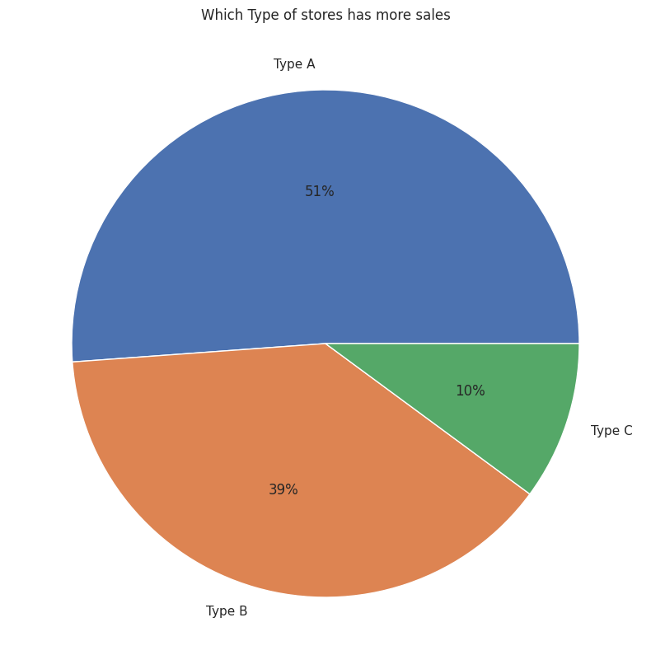
df3['year'] = pd.DatetimeIndex(df3['Date']).year
df3['month'] = pd.DatetimeIndex(df3['Date']).month
df3['week'] = pd.DatetimeIndex(df3['Date']).week
df3.head()
<ipython-input-53-bac6e3b1d5c9>:3: FutureWarning: weekofyear and week have been deprecated, please use DatetimeIndex.isocalendar().week instead, which returns a Series. To exactly reproduce the behavior of week and weekofyear and return an Index, you may call pd.Int64Index(idx.isocalendar().week)
df3['week'] = pd.DatetimeIndex(df3['Date']).week
Store Dept Date Weekly_Sales IsHoliday Temperature Fuel_Price \
0 1 1 2010-02-05 24924.50 False 42.31 2.572
1 1 1 2010-02-12 46039.49 True 38.51 2.548
2 1 1 2010-02-19 41595.55 False 39.93 2.514
3 1 1 2010-02-26 19403.54 False 46.63 2.561
4 1 1 2010-03-05 21827.90 False 46.50 2.625
CPI Unemployment _merge Type Size year month week
0 211.096358 8.106 both A 151315 2010 2 5
1 211.242170 8.106 both A 151315 2010 2 6
2 211.289143 8.106 both A 151315 2010 2 7
3 211.319643 8.106 both A 151315 2010 2 8
4 211.350143 8.106 both A 151315 2010 3 9
import matplotlib.pyplot as mp
import pandas as pd
import seaborn as sns
# import file with data
data = df3
# prints data that will be plotted
# columns shown here are selected by corr() since
# they are ideal for the plot
print(data.corr())
sns.set_theme(style="whitegrid")
# plotting correlation heatmap
dataplot = sns.heatmap(data.corr(), cmap="YlGnBu", annot=True)
sns.set(rc = {'figure.figsize':(40,12)})
# displaying heatmap
mp.show()
<ipython-input-54-e273f2bf13a4>:11: FutureWarning: The default value of numeric_only in DataFrame.corr is deprecated. In a future version, it will default to False. Select only valid columns or specify the value of numeric_only to silence this warning.
print(data.corr())
Store Dept Weekly_Sales IsHoliday Temperature \
Store 1.000000 0.024258 -0.085117 -0.000522 -0.050230
Dept 0.024258 1.000000 0.148749 0.000663 0.004727
Weekly_Sales -0.085117 0.148749 1.000000 0.012843 -0.002339
IsHoliday -0.000522 0.000663 0.012843 1.000000 -0.155775
Temperature -0.050230 0.004727 -0.002339 -0.155775 1.000000
Fuel_Price 0.065321 0.003544 0.000089 -0.078155 0.143700
CPI -0.211261 -0.007178 -0.021162 -0.001933 0.182223
Unemployment 0.208759 0.007787 -0.025806 0.010555 0.096768
Size -0.182763 -0.002491 0.244117 0.000797 -0.058413
year 0.002831 0.003716 -0.010015 -0.056572 0.065712
month 0.000907 0.000800 0.028401 0.123058 0.235957
week 0.000926 0.000767 0.027659 0.127846 0.236256
Fuel_Price CPI Unemployment Size year \
Store 0.065321 -0.211261 0.208759 -0.182763 0.002831
Dept 0.003544 -0.007178 0.007787 -0.002491 0.003716
Weekly_Sales 0.000089 -0.021162 -0.025806 0.244117 -0.010015
IsHoliday -0.078155 -0.001933 0.010555 0.000797 -0.056572
Temperature 0.143700 0.182223 0.096768 -0.058413 0.065712
Fuel_Price 1.000000 -0.164199 -0.033915 0.003632 0.779681
CPI -0.164199 1.000000 -0.299887 -0.003903 0.074547
Unemployment -0.033915 -0.299887 1.000000 -0.068335 -0.237210
Size 0.003632 -0.003903 -0.068335 1.000000 -0.004716
year 0.779681 0.074547 -0.237210 -0.004716 1.000000
month -0.040931 0.005366 -0.012562 -0.001051 -0.194295
week -0.031191 0.006428 -0.015614 -0.001130 -0.181804
month week
Store 0.000907 0.000926
Dept 0.000800 0.000767
Weekly_Sales 0.028401 0.027659
IsHoliday 0.123058 0.127846
Temperature 0.235957 0.236256
Fuel_Price -0.040931 -0.031191
CPI 0.005366 0.006428
Unemployment -0.012562 -0.015614
Size -0.001051 -0.001130
year -0.194295 -0.181804
month 1.000000 0.996000
week 0.996000 1.000000
<ipython-input-54-e273f2bf13a4>:14: FutureWarning: The default value of numeric_only in DataFrame.corr is deprecated. In a future version, it will default to False. Select only valid columns or specify the value of numeric_only to silence this warning.
dataplot = sns.heatmap(data.corr(), cmap="YlGnBu", annot=True)
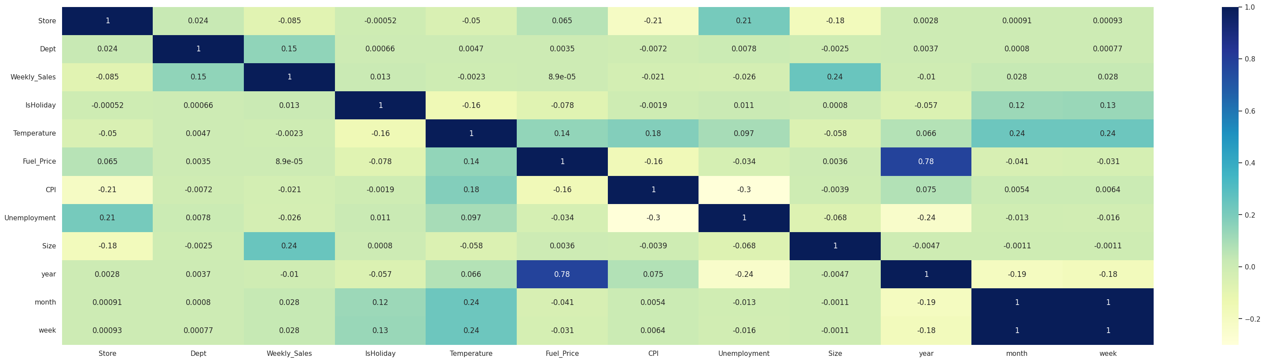
sns.barplot(x='year', y="Fuel_Price", data=df3)
sns.set(rc = {'figure.figsize':(4,1)})
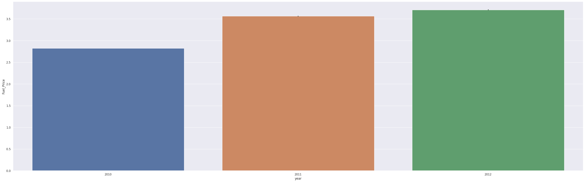
sns.barplot(x='Store', y="Weekly_Sales", data=df3)
sns.set(rc = {'figure.figsize':(12,8)})
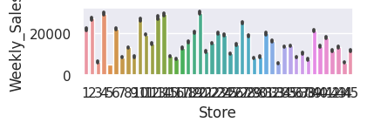
sns.lineplot(x="Store",y="Unemployment",data=data)
<Axes: xlabel='Store', ylabel='Unemployment'>
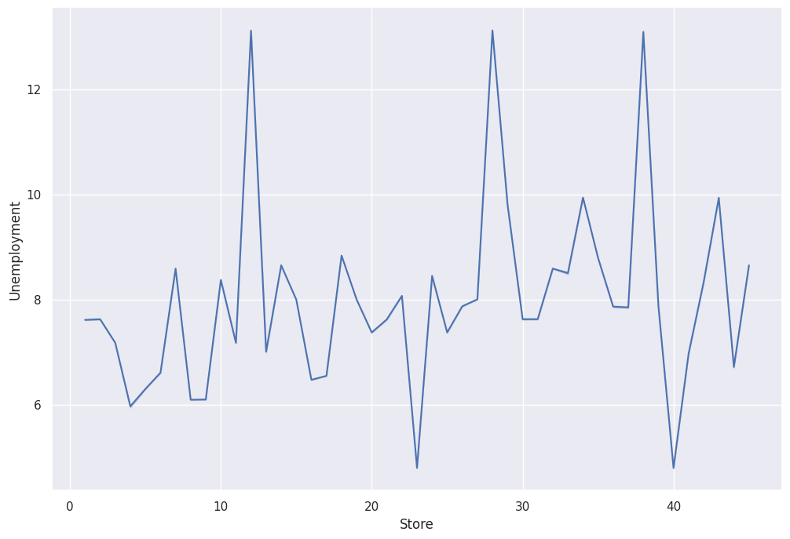
df3['Dept'].unique()
array([ 1, 2, 3, 4, 5, 6, 7, 8, 9, 10, 11, 12, 13, 14, 16, 17, 18,
19, 20, 21, 22, 23, 24, 25, 26, 27, 28, 29, 30, 31, 32, 33, 34, 35,
36, 37, 38, 40, 41, 42, 44, 45, 46, 47, 48, 49, 51, 52, 54, 55, 56,
58, 59, 60, 67, 71, 72, 74, 77, 78, 79, 80, 81, 82, 83, 85, 87, 90,
91, 92, 93, 94, 95, 96, 97, 98, 99, 39, 50, 43, 65])
sns.pointplot(x="Dept",y="Weekly_Sales",data=df3)
sns.set(rc = {'figure.figsize':(40,10)})
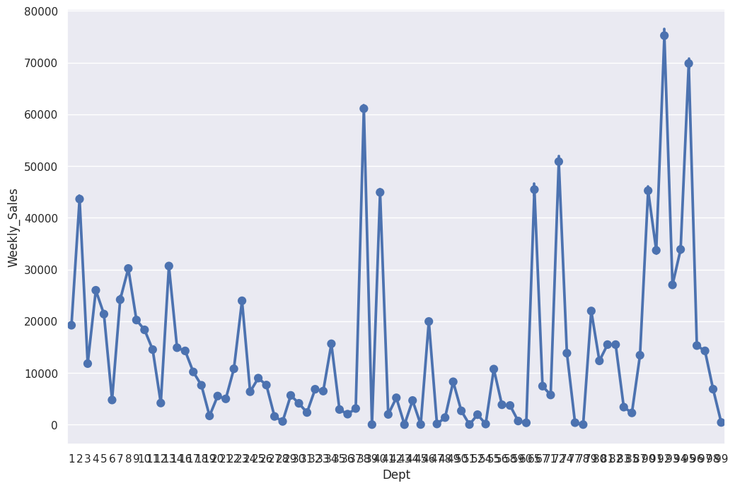
df4=df3.drop(columns=["Date"],axis=1)
df4.head()
Store Dept Weekly_Sales IsHoliday Temperature Fuel_Price CPI \
0 1 1 24924.50 False 42.31 2.572 211.096358
1 1 1 46039.49 True 38.51 2.548 211.242170
2 1 1 41595.55 False 39.93 2.514 211.289143
3 1 1 19403.54 False 46.63 2.561 211.319643
4 1 1 21827.90 False 46.50 2.625 211.350143
Unemployment _merge Type Size year month week
0 8.106 both A 151315 2010 2 5
1 8.106 both A 151315 2010 2 6
2 8.106 both A 151315 2010 2 7
3 8.106 both A 151315 2010 2 8
4 8.106 both A 151315 2010 3 9
month_wise_sales = pd.pivot_table(df4, values = "Weekly_Sales", columns = "year", index = "month")
month_wise_sales.plot()
<Axes: xlabel='month'>
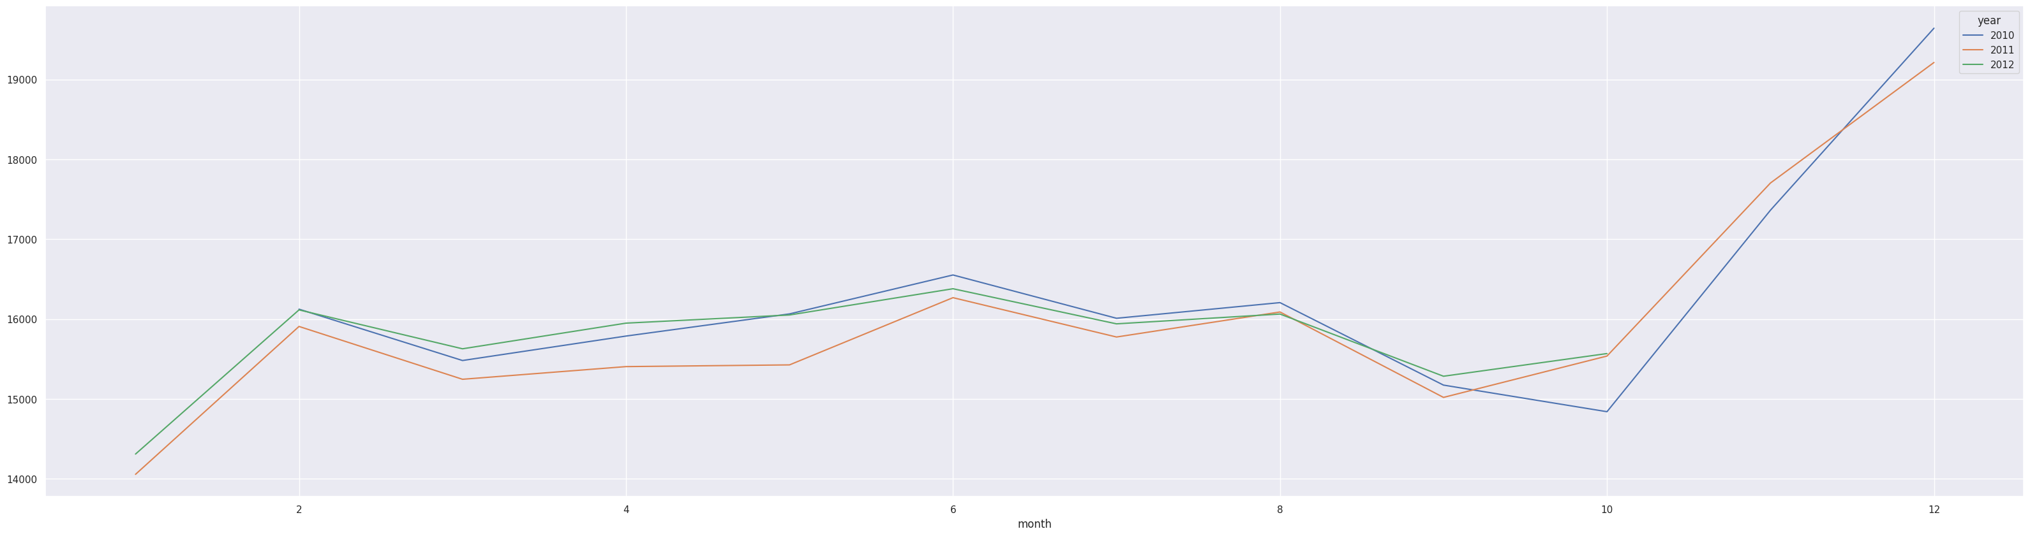
# Import label encoder
from sklearn import preprocessing
# label_encoder object knows how to understand word labels.
le= preprocessing.LabelEncoder()
# Encode labels in column 'species'.
df4['IsHoliday']= le.fit_transform(df4['IsHoliday'])
df4['Type']= le.fit_transform(df4['Type'])
df4.isnull().sum()
Store 0
Dept 0
Weekly_Sales 0
IsHoliday 0
Temperature 0
Fuel_Price 0
CPI 0
Unemployment 0
_merge 0
Type 0
Size 0
year 0
month 0
week 0
dtype: int64
df4=df4.drop(columns=['_merge'],axis=1)
df4=df4.drop([309678])
df4
Store Dept Weekly_Sales IsHoliday Temperature Fuel_Price \
0 1 1 24924.50 0 42.31 2.572
1 1 1 46039.49 1 38.51 2.548
2 1 1 41595.55 0 39.93 2.514
3 1 1 19403.54 0 46.63 2.561
4 1 1 21827.90 0 46.50 2.625
... ... ... ... ... ... ...
421565 45 98 508.37 0 64.88 3.997
421566 45 98 628.10 0 64.89 3.985
421567 45 98 1061.02 0 54.47 4.000
421568 45 98 760.01 0 56.47 3.969
421569 45 98 1076.80 0 58.85 3.882
CPI Unemployment Type Size year month week
0 211.096358 8.106 0 151315 2010 2 5
1 211.242170 8.106 0 151315 2010 2 6
2 211.289143 8.106 0 151315 2010 2 7
3 211.319643 8.106 0 151315 2010 2 8
4 211.350143 8.106 0 151315 2010 3 9
... ... ... ... ... ... ... ...
421565 192.013558 8.684 1 118221 2012 9 39
421566 192.170412 8.667 1 118221 2012 10 40
421567 192.327265 8.667 1 118221 2012 10 41
421568 192.330854 8.667 1 118221 2012 10 42
421569 192.308899 8.667 1 118221 2012 10 43
[420211 rows x 13 columns]
x=df4.drop(columns=['Weekly_Sales'],axis=1)
y=df4['Weekly_Sales']
x.head()
Store Dept IsHoliday Temperature Fuel_Price CPI Unemployment \
0 1 1 0 42.31 2.572 211.096358 8.106
1 1 1 1 38.51 2.548 211.242170 8.106
2 1 1 0 39.93 2.514 211.289143 8.106
3 1 1 0 46.63 2.561 211.319643 8.106
4 1 1 0 46.50 2.625 211.350143 8.106
Type Size year month week
0 0 151315 2010 2 5
1 0 151315 2010 2 6
2 0 151315 2010 2 7
3 0 151315 2010 2 8
4 0 151315 2010 3 9
from sklearn.model_selection import train_test_split
x_train, x_test, y_train, y_test= train_test_split(x,y, test_size= 0.2, random_state=47)

ARIMA
ARIMA is a forecasting technique that projects the future values of a series based entirely on its own inertia. The time series models assume that the given time-series data set in stationary meaning it has got the constant mean and constant variance. In order to apply ARIMA, we are required to calculate the triplet value (p,d,q). The value of p is number of Auto regressors, value of d is number of differences required to make series stationary and q is number of moving averages. In Auto-ARIMA, the triplet (p,q,d) values are automatically selected on the basis of least AIC and BIC scores which best fits the model.

import pmdarima
from pmdarima.arima import auto_arima
from sklearn.ensemble import RandomForestRegressor
from sklearn.tree import DecisionTreeRegressor
from sklearn.metrics import r2_score,mean_squared_error
from math import sqrt
DTRmodel = DecisionTreeRegressor(max_depth=3,random_state=0)
DTRmodel.fit(x_train,y_train)
y_pred = DTRmodel.predict(x_test)
print("R2 score :",r2_score(y_test, y_pred))
print("MSE score :",mean_squared_error(y_test, y_pred))
print("RMSE: ",sqrt(mean_squared_error(y_test, y_pred)))
R2 score : 0.3775568770578843
MSE score : 318683407.9587218
RMSE: 17851.706023759238
rf1 = RandomForestRegressor(n_estimators=50, random_state=42, n_jobs=-1, max_depth=20,
max_features = 'sqrt',min_samples_split = 3)
rf1.fit(x_train,y_train)
y_pred1 = rf1.predict(x_test)
print("R2 score :",r2_score(y_test, y_pred))
print("MSE score :",mean_squared_error(y_test, y_pred1))
print("RMSE: ",sqrt(mean_squared_error(y_test, y_pred1)))
R2 score : 0.3775568770578843
MSE score : 106584538.10076953
RMSE: 10323.978792150318

XgBoost
XGBRegressor algorithm is initialized and training data is passed to the model with .fit() function. Test data is predicted with .predict() function and saved in new variable.

from xgboost import XGBRegressor
model = XGBRegressor(objective='reg:squarederror', nthread= 4, n_estimators= 500, max_depth= 4, learning_rate= 0.5)
model.fit(x_train,y_train)
XGBRegressor(base_score=None, booster=None, callbacks=None,
colsample_bylevel=None, colsample_bynode=None,
colsample_bytree=None, device=None, early_stopping_rounds=None,
enable_categorical=False, eval_metric=None, feature_types=None,
gamma=None, grow_policy=None, importance_type=None,
interaction_constraints=None, learning_rate=0.5, max_bin=None,
max_cat_threshold=None, max_cat_to_onehot=None,
max_delta_step=None, max_depth=4, max_leaves=None,
min_child_weight=None, missing=nan, monotone_constraints=None,
multi_strategy=None, n_estimators=500, n_jobs=None, nthread=4,
num_parallel_tree=None, ...)
y_pred2 = model.predict(x_test)
print("R2 score :",r2_score(y_test, y_pred2))
print("MSE score :",mean_squared_error(y_test, y_pred2))
print("RMSE: ",sqrt(mean_squared_error(y_test, y_pred2)))
R2 score : 0.9482143725653065
MSE score : 26513619.680080418
RMSE: 5149.137760837286
y_pred2
array([14768.21 , 362.50912, 18262.584 , ..., 1361.111 ,
-383.30942, 2940.908 ], dtype=float32)
from sklearn.linear_model import Ridge
rr_model = Ridge(alpha=0.5)
rr_model.fit(x_train,y_train)
Ridge(alpha=0.5)
y_pred3 = model.predict(x_test)
42print("R2 score :",r2_score(y_test, y_pred3))
print("MSE score :",mean_squared_error(y_test, y_pred3))
print("RMSE: ",sqrt(mean_squared_error(y_test, y_pred3)))
R2 score : 0.9482143725653065
MSE score : 26513619.680080418
RMSE: 5149.137760837286
y_test
416618 13480.30
289535 44.19
267082 16511.71
277358 28412.57
102078 9113.78
...
132922 618.00
392742 15343.43
384522 856.38
341550 294.02
374273 2625.17
Name: Weekly_Sales, Length: 84043, dtype: float64

Comparing the models
For comparing the models PrettyTable function is defined.

from sklearn.model_selection import cross_val_score
rf = RandomForestRegressor(n_estimators=58, max_depth=27, min_samples_split=3,min_samples_leaf=1)
rf.fit(x_train, y_train.ravel())
y_pred =rf.predict(x_test)
from sklearn.model_selection import cross_val_score
xg_reg =XGBRegressor(objective="reg:squarederror", nthread= 4, n_estimators= 500, max_depth= 4, learning_rate= 0.5)
xg_reg.fit(x_train, y_train)
pred=xg_reg.predict(x_train)
y_pred=xg_reg.predict(x_test)
cv=cross_val_score(xg_reg,x,y,cv=10)
cv
array([0.70955904, 0.57916837, 0.54206571, 0.75134278, 0.84435843,
0.7636532 , 0.82873503, 0.80243917, 0.71913666, 0.8266943 ])
np.mean(cv)
0.7367152697407299
pickle.dump(rf,open('final_model.pkl','wb'))
import sklearn
print(sklearn.__version__)
1.2.2
pred1=xg_reg.predict(x_train)
pred2=xg_reg.predict(x_test)

Application Building
In this section, we will be building a web application that is integrated to the model we built.
A UI is provided for the uses where they have to enter the values for predictions. The entered values are given to the saved model and prediction is showcased on the UI.
This section has the following tasks
Building serverside script
Building HTML Pages:

Building HTML Pages:
For this project, an HTML file called ‘index.html’ is created and saved in templates folder.
The index.html page looks like:

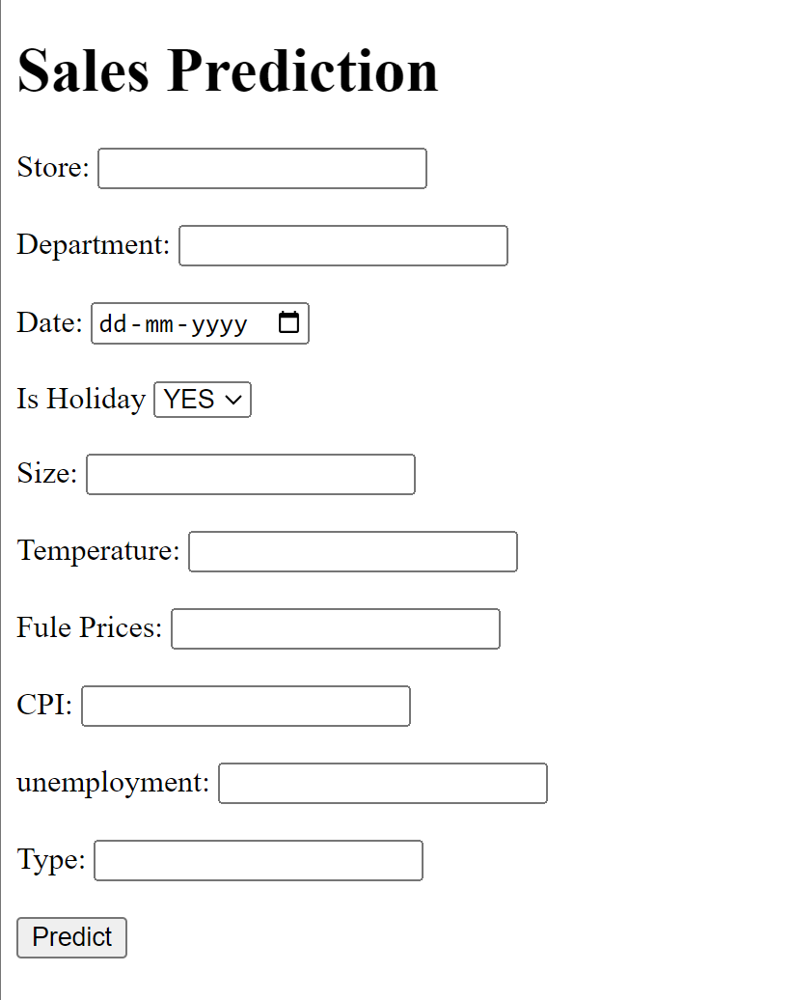

Building the python code in flask:
Import the libraries:
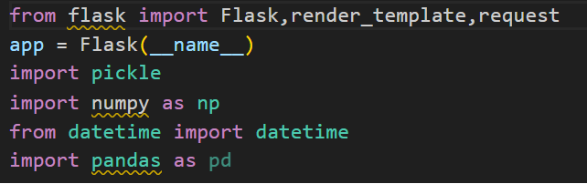

Then load the saved model. Importing flask module in the project is mandatory. An object of Flask class is our WSGI application. Flask constructor takes the name of the current module (__name__) as argument.

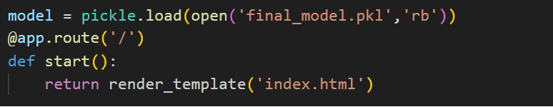

Render the HTML page:


Here we will be using declared constructor to route to the HTML page which we have created earlier and stores in the templates folder.
In the above example, ‘/’ URL is bound with index.html function. Hence, when the home page of the web server is opened in browser, the html page will be rendered. Whenever you enter the values from the html page the values can be retrieved using POST Method.
Retrieves the value from UI:
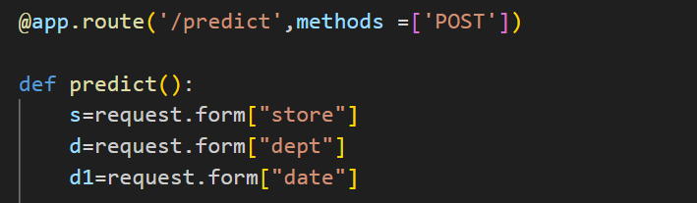
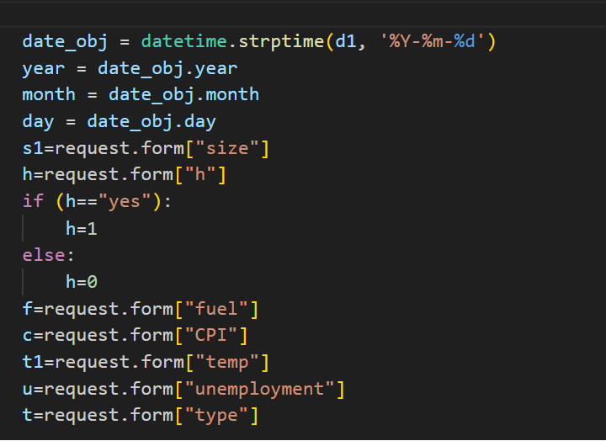

Here we are routing our app to predict() function. This function retrieves all the values from
the HTML page using Post request. That is stored in an array. This array is passed to the
y_pred() function. This function returns the prediction. And this prediction value will
rendered to the text that we have mentioned in the submit.html page earlier.
Main Function:
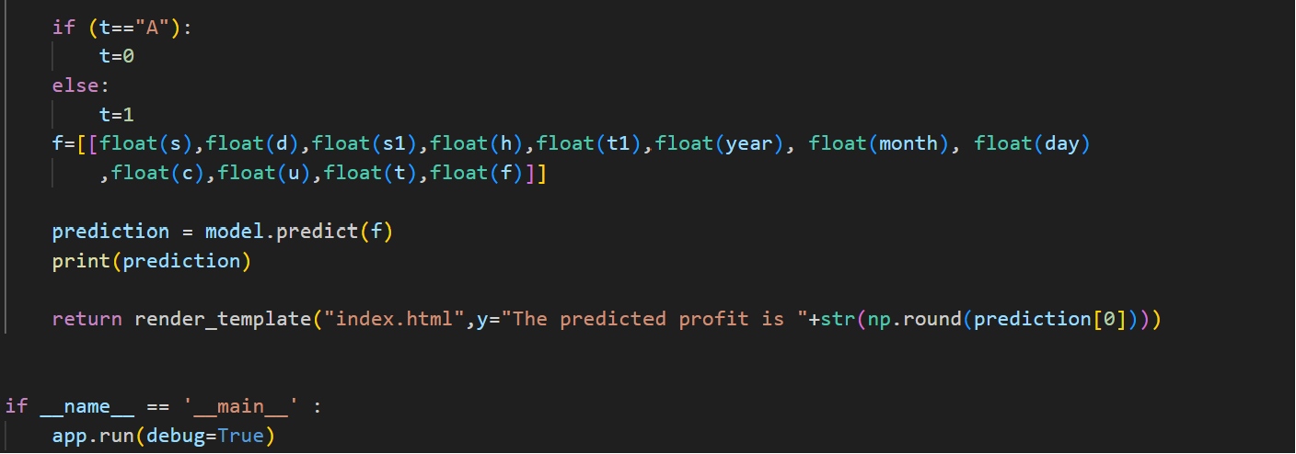

Activity 3: Run the application
● Open anaconda prompt from the start menu
● Navigate to the folder where your python script is.
● Now type “python app.py” command
● Navigate to the localhost where you can view your web page.
● Click on the predict button from the top right corner, enter the inputs, click on
the submit button, and see the result/prediction on the web.

