**Team 592802**

**Disease Prediction Using Machine Learning**

In today’s face paced world, there is little to no time spared for healthcare. Even after developing severe symptoms to various diseases patients do not see a doctor. Using Google to type in our symptoms does not lead to good results, it always boils down to one stereotypical disease. So people have stopped using Google to look for their symptoms or the probable disease.

Catering to all the problems stated above, we have developed a model which can predict up to 42 diseases when given symptoms as input. This model can be used by doctors for consulting patients online based on the output of the model or this model can be used by patients for preventive diagnosis and self care as the charges to visit a doctor are high. This model does not ask for personalised data such as name, age, gender, religion, address, etc. You can use this web application anytime you feel you might be suffering from a disease and the model will give the probable disease based on the symptoms. Now you can take a call whether to visit a doctor or no.

The model is right 97 out of 100 times on an average. This model should be used for preventive diagnosis and early intervention by doctors and should not be taken as completely accurate and the final call.

**Technical Architecture:**

**Project Flow:**

* User is shown the Home page. The user will browse through Home page and click on the Predict button.
* After clicking the Predict button the user will be directed to the Details page where the user will input the symptoms they are having and click on the Predict button.
* User will be redirected to the Results page. The model will analyse the inputs given by the user and showcase the prediction of the most probable disease on the Results page.

To accomplish this we have to complete all the activities listed below:

* Define problem / Problem understanding o Specify the business problem o Business Requirements o Literature Survey o Social or Business Impact
* Data Collection and Preparation o Collect the dataset o Data Preparation
* Exploratory Data Analysis o Descriptive statistical o Visual Analysis
* Model Building o Creating a function for evaluation o Training and testing the Models using multiple algorithms
* Performance Testing & Hyperparameter Tuning o Testing model with multiple evaluation metrics o Comparing model accuracy before & after applying hyperparameter tuning o Comparing model accuracy for different number of features.
  + Building model with appropriate features.
* Model Deployment o Save the best model o Integrate with Web Framework

**Prior Knowledge:**

You must have the prior knowledge of the following topics to complete this project.

* ML Concepts:
  + Supervised learning: <https://www.javatpoint.com/supervised-machine-learning>o K Nearest Neighbours:

[https://www.javatpoint.com/k-nearest-neighbor-algorithm-for-machine-learnin g](https://www.javatpoint.com/k-nearest-neighbor-algorithm-for-machine-learning) o SVM:

[https://www.javatpoint.com/machine-learning-support-vector-machine-algorit hm](https://www.javatpoint.com/machine-learning-support-vector-machine-algorithm) o Decision tree:

[https://www.javatpoint.com/machine-learning-decision-tree-classificationalgor ithm](https://www.javatpoint.com/machine-learning-decision-tree-classificationalgorithm)

* + Random forest:

<https://www.javatpoint.com/machine-learning-random-forest-algorithm>

* + Evaluation metrics:

[https://www.analyticsvidhya.com/blog/2019/08/11-important-modelevaluation -error-metrics/](https://www.analyticsvidhya.com/blog/2019/08/11-important-modelevaluation-error-metrics/)

* Flask Basics: <https://www.youtube.com/watch?v=lj4I_CvBnt0>

**Project Structure:**

Create project folder which contains files as shown below:

* The data obtained is in two csv files, one for training and another for testing.
* We are building a Flask application which will require the html files to be stored in the templates folder.
* The css files should be stored in the static folder.
* App.py file is used for routing purposes using scripting.
* Model.pkl is the saved model. This will further be used in the Flask integration.
* Training folder contains a model training file.

# Milestone 1: Define Problem/ Problem Understanding

## Activity 1: Specify the Business Problem

Disease prediction involves identifying individuals who are at risk of developing a particular disease, based on various risk factors such as medical history and demographic factors. Predictive analytics and machine learning techniques can be used to analyse large amounts of data to identify patterns and risk factors associated with different diseases. Disease prediction using machine learning involves the use of various algorithms to analyse large datasets and identify patterns and risk factors associated with diseases. By analysing this data, machine learning algorithms can help identify individuals who are at risk of developing a particular disease, enabling healthcare professionals to provide personalized preventive care and early intervention.

## Activity 2: Business Requirements

A disease classification project can have a variety of business requirements, depending on the specific goals and objectives of the project. Some potential requirements may include:

* Accurate and reliable information:

The case of disease prediction is critical and no false information can be tolerated since the consequences can be severe. Also the right symptoms should be linked to the right diseases so that the output is inline with all the patients health situations and variations.

* Trust:

Trust needs to be developed for the users to use the model. It is difficult to create trust among patients while dealing with a healthcare problem.

* Compliance:

The model should be fit with all the relevant laws and regulations, such as Central Drug Standard Control Organization, Ministry of Health, etc.

* User friendly interface:

The interface should be easy to use and understand by the user. The model should not ask inputs for which the user does not have answers.

## Activity 3: Literature Survey

A literature survey for a disease prediction project would involve researching and reviewing existing studies, articles, and other publications on the topic of disease prediction. The survey would aim to gather information on current classification systems, their strengths and weaknesses, and any gaps in knowledge that the project could address. The literature survey would also look at the methods and techniques used in previous disease prediction projects, and any relevant data or findings that could inform the design and implementation of the current project.

**Activity 4: Social or Business Impact.**

**Social Impact:**

Improved preventive diagnosis by predicting the likely disease. Users can easily see which is the probable disease for their symptoms and then decide whether to visit a doctor.

This will also allow for better online diagnosis by doctors.

**Business Impact:**

Doctors can treat wider range of patients using online consulting. The rush in the hospitals can be decreased and better care can be taken for critical patients. The doctors can suggest the patients to undergo certain tests before coming to visit them.

**Milestone 2: Data Collection and Preparation:**

Machine Learning depends heavily on data. It is the most crucial part aspect that makes algorithm training possible. So, this section guides on how to download dataset.

## Activity 1: Collect the dataset

There are many popular open sources for collecting the data. Eg: kaggle.com, UCI repository, etc.

In this project we have used .csv data. This data is downloaded from kaggle.com. Please refer to the link given below to download the dataset.

Link: <https://www.kaggle.com/datasets/kaushil268/disease-prediction-using-machine-learning>

As the dataset is downloaded. Let us read and understand the data properly with the help of some visualisation techniques and some analysing techniques.

**Note:** There are a number of techniques for understanding the data. But here we have used some of it. In an additional way, you can use multiple techniques.

## Activity 1.1: Importing the Libraries

Import the necessary libraries as shown in the image. Some of them are optional and can be skipped according to your usage.

## Activity 1.2: Read the Dataset

Our dataset format might be in .csv, excel files, .txt, .json, etc. We can read the dataset with the help of pandas.

In pandas we have a function called read_csv() to read the dataset. As a parameter we have to give the directory of the csv file.

As we have two datasets, one for training and other for testing we will import both the csv files.

## Activity 2: Data Preparation

As we have understood how the data is, let us preprocess the collected data.

The Machine Learning model cannot be trained on the imported data directly. The dataset might have randomness, we might have to clean the dataset and bring it in the right form. This activity involves the following steps:

* Removing Redundant Columns
* Handling Missing Values

Note: These are the general steps of pre-processing the data before using it for machine learning. Depending on the condition of your dataset, you may or may not have to go through all these steps.

## Activity 2.1: Removing Redundant Columns

Unnamed: 133 is the redundant column which does not have any values.

## Activity 2.2: Handling Missing Values

There are no missing values in the dataset. That is why we can skip this step.

# Milestone 3: Exploratory Data Analysis

## Activity 1: Descriptive Statistical

Descriptive analysis is to study the basic features of data with the statistical process. Here pandas has a worthy function called describe. With this describe function we can understand the unique, top and frequent values of categorical features. And we can find mean, std, min, max and percentile values of continuous features.

## Activity 2: Visual Analysis

Visual analysis is the process of using visual representations, such as charts, plots, and graphs, to explore and understand data. It is a way to quickly identify patterns, trends, and outliers in the data, which can help to gain insights and make informed decisions.

**Activity 2.1: Univariate Analysis:**

In simple words, univariate analysis is understanding the data with a single feature. We have displayed three different types of graphs and plots.

For simple visualizations we can use the matplotlib.pyplot library.

Here the plt.figure() command is used to determine the size of the plot. Then we divide the space for 2 pie plots.

The pie plot on the left shows the different values distribution in the Itching column. It shows that there are 86% observations where the itching symptom has value 0 and there are 14% observations where the itching symptom has value 1.

The pie plot on the right shows the different values distribution in the continuous_sneezing column. It shows that there are 95% observations where the continuous_sneezing symptom has value 0 and there are 5% observations where the continuous_sneezing symptom has value

1.

Here we have plotted 2 bar graphs. These bar graphs can be plotted without using any external library. We divide the plot into two subplots using subplot function from the matplotlib.pyplot library. We have plotted the bar graph using the inbuilt plot function in python.

The bar graph on the left shows the distribution of stomach pain symptom values. We can see that the 0 value has count of around 4700 and the 1 value has count of around 400.

The graph on the right shows the distribution of vomiting symptom values. We can see that the 0 value has count of around 3000 and the 1 value has count of around 2000.

Here we have plotted 2 horizontal bar graphs. These bar graphs can be plotted without using any external library. We divide the plot into two subplots using subplot function from the matplotlib.pyplot library. We have plotted the bar graph using the inbuilt plot function in python.

The bar graph on the left shows the distribution of restlessness symptom values. We can see that the 0 value has count of around 4800 and the 1 value has count of around 300.

The graph on the right shows the distribution of vomiting symptom values. We can see that the 0 value has count of around 4500 and the 1 value has count of around 400.

**Activity 2.2: Bivariate Analysis:**

To find the relation between two features we use bivariate analysis. Here we are visualising the relationship between prognosis where the values are Fungal Infection and Itching symptom.

Here we use Boolean Indexing to filter out values from the prognosis column where the values are ‘Fungal Infection’. These observations are stored in variable ‘a’. Alse we filter out values from the prognosis where values are ‘Fungal Infection’ and also the values of Itching variable are 1. From the plot we can see that when there is Fungal Infection there is a high chance that the Itching column has value 1. There are 120 values where the value are fungal infection and there are 104 values where the value of itching column is 1. This shows that when there is a fungal infection there is a high chance that there is itching as a symptom.

Next we have also seen the relationship between prognosis when the disease is Tuberculosis and the symptom yellowing_of_eyes. . From the plot we can see that when there is

Tuberculosis there is a high chance that the yellowing of eyes column has value 1. There are 120 values where the value is Tuberculosis and there are 119 values where the value of yellowing_of_eyes column is 1. This shows that when there is tuberculosis there is a high chance that there is yellowing_of_eyes as a symptom.

**Activity 2.3: Multivariate Analysis**

In multivariate analysis we try to find the relation between multiple features. This can be done primarily with the help of Correlation matrix.

As we have 131 columns which have numerical values the correlation matrix is of dimensions 131 X 131. These many features can only be parsed by scrolling. From the correlation matrix we try to remove the values which are highly correlated with each other. When 2 values are highly correlated with each other, we can only remove one of them. We remove columns where the correlation between the columns is above 0.9

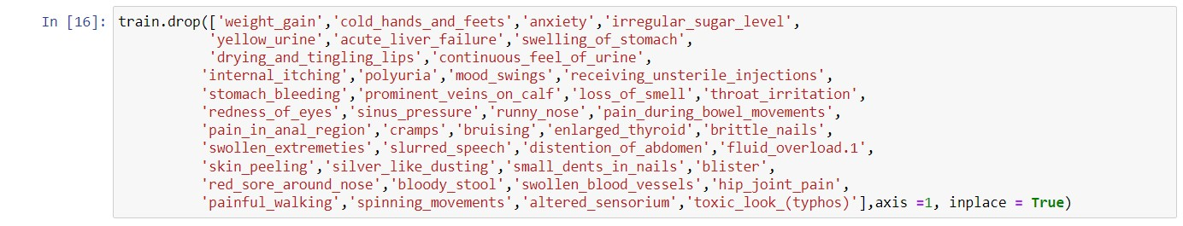

We can see the columns that are removed due to high correlation.

For multivariate analysis we will also plot a swarmplot of weightloss and fatigue column where the prognosis column is Tuberculosis.

From this swarm plot we can see that for Tuberculosis disease, there is no observation when the fatigue and weight loss is 0. There are some cases when there is only either of the two, but for Tuberculosis there is a high chance that the patient will have fatigue and weight loss as symptoms.

## Preprocessing of Test data

The preprocessing needs to be done for the test data. We can create a function for test data preprocessing which will only leave us with the required features. This function will contain all the steps which we have done for the training data.

This function drops all the columns which needs to be dropped.

Here we call the function for the test data.

## Activity 2.5: Split data into training, validation and testing data

We have training and testing data given separately. We further split the training data into training and validation data. This validation data can be used for hyper parameter tuning.

We first need to separate the features and the target variable. The features are used to predict the target variable.

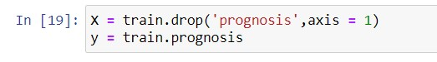

We split the training data into features(X) and target variable(y).

Here we split the test data into features(X_test) and the corresponding target variables(y_test)

Now we need to split the training data into training and validation data. It can be done using the following command.



We have kept 80 % data for training and 20% is used for validation.

# Milestone 4: Model Building

## Activity 1: Creating a function for model evaluation

We will be creating multiple models and then testing them. It will reduce our monotonous task if we directly write a function for model evaluation.

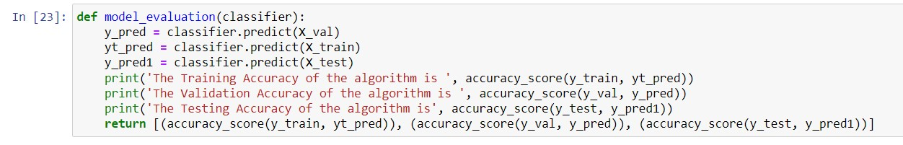

This function will show the accuracies of prediction of model for training, validation and testing data. It will also the return those accuracies.

## Activity 2: Training and testing the models using multiple algorithms

Now that we have clean data, a function for evaluation it is time to build models to train the data. For this project we will be using 4 different classification algorithms to build our models. The best model will be used for prediction.

## Activity 2.1: K Nearest Neighbors Model

A variable is created with name knn which has KNeighborsClassifier() algorithm initialised in it. The knn model is trained using the .fit() function. The model is trained on the X_train and y_train data that is the training features and training target variables. This model is then given to the model_evaluation function to check its performance.

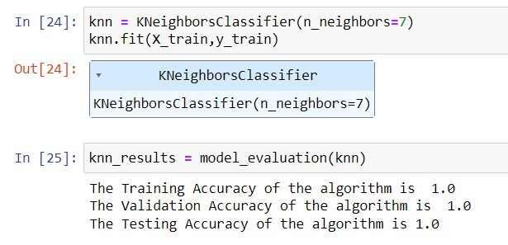

Here we can see that the model has achieved 100% accuracies on training, validation as well as testing data. As the accuracies are high, there is no need for hyperparameter tuning. The results are stored in a variable named knn_results.

## Activity 2.2: SVM Model

A variable is created with name svm which has SVC() algorithm initialised in it. The svm model is trained using the .fit() function. The model is trained on the X_train and y_train data that is the training features and training target variables. This model is then given to the model_evaluation function to check its performance.

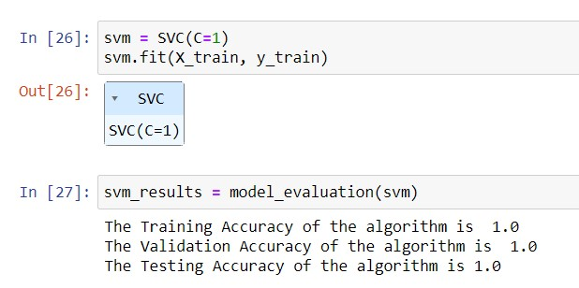

Here we can see that the model has achieved 100% accuracies on training, validation as well as testing data. As the accuracies are high, there is no need for hyperparameter tuning. The results are stored in a variable named svm_results.

## Activity 2.3: Decision Tree Model

A variable is created with name dtc which has DecisionTreeClassifier() algorithm initialised in it with a parameter max_features set to 10. The dtc model is trained using the .fit() function. The model is trained on the X_train and y_train data that is the training features and training target variables. This model is then given to the model_evaluation function to check its performance.

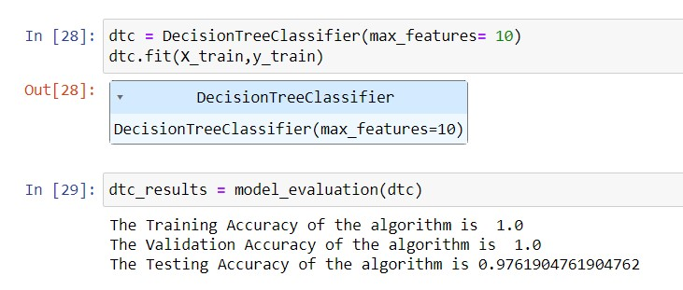

Here we can see that the model has achieved 100% accuracies on training and validation data . It has achieved 97.6% accuracy for testing data. As the accuracies are high, there is no need for hyperparameter tuning. The results are stored in a variable named dtc_results.

## Activity 2.4: Random Forest Model

Random Forest Classifier is a Bagging model which utilises multiple decision trees and takes their aggregate to give a prediction. A variable is created with name rfc which has RandomForestClassifier() algorithm initialised in it with a parameter max_depth set to 13. The rfc model is trained using the .fit() function. The model is trained on the X_train and y_train data that is the training features and training target variables. This model is then given to the model_evaluation function to check its performance.

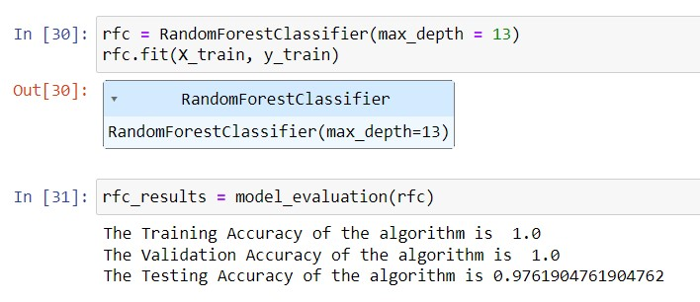

Here we can see that the model has achieved 100% accuracies on training and validation data . It has achieved 97.6% accuracy for testing data. As the accuracies are high, there is no need for hyperparameter tuning. The results are stored in a variable named rfc_results.

# Milestone 5 : Performance Testing & Hyperparameter Tuning

## Activity 1: Testing model with Multiple Evaluatiton metrics

The data has 41 features, hence it is difficult to make confusion matrix as the dimensions of confusion matrix will be 41 X 41. We can check accuracy to test the model. We have already values of the training, validation, and test accuracies of various models. We can put them in a table and then check for the best model.

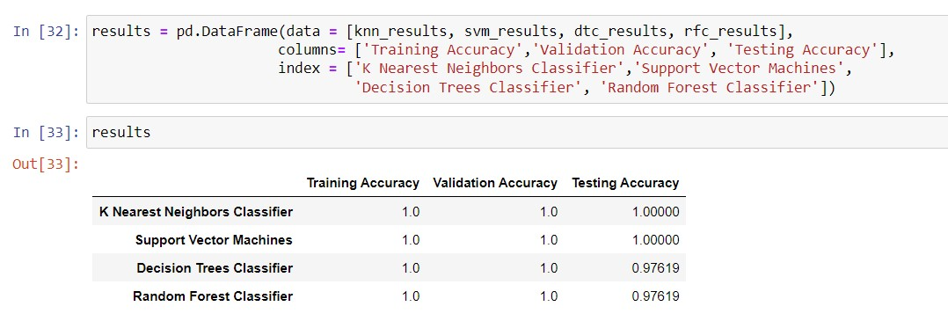

From the table we can see that KNN and SVM models perform the best.

**Activity 2: Comparing model accuracy before and after applying**

## hyperparameter tuning

As the accuracies are already so high, we need not do hyperparameter tuning for the models.

**Activity 3: Comparing Model accuracy for different number of features.**

Currently the training data has 90 features, which are a high number. If we need to reduce the number of features, we need to check the accuracies for various number of features.

We can check the feature importance using the Random Forest Classifier model.

In the figure below we have created a dictionary with the column names as indexes and the values as their feature importance. Much importance is not assigned to any feature. It is distributed among all the features.

We will keep some number of features for training and check for the accuracy. This process will be repeated a number of times.

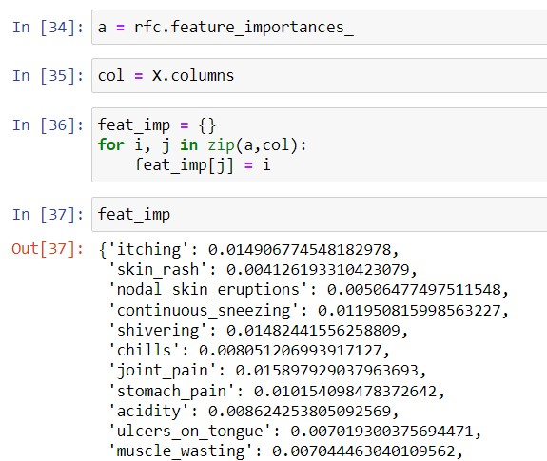

We get a dictionary named feat_imp with 90 column names and their feature importance.

We will drop columns which have very less feature importance.

Let us create a for loop which will train the model and give out the accuracy.

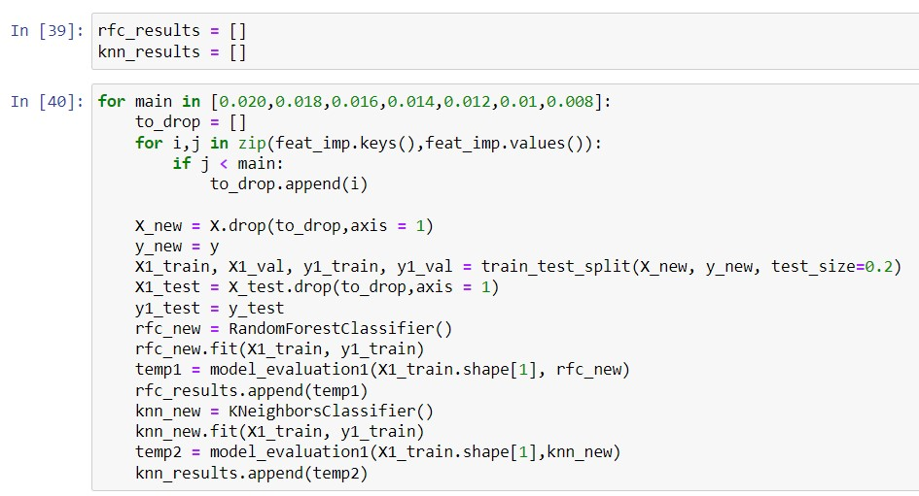

Here we create 2 lists for 2 models, knn and random forest classifier.

The for loop will iterate over values given in the list one be one. The first value will be 0.020 and the last will be 0.008

There is a to_drop list created.

If the feature_importance is below threshold then the column name will be added to the to_drop list.

The columns whose name is in the to_drop list will be dropped.

The new data will be split into features and target variable. Further they will be split into training, validation and testing data.

Random Forest Classifier model will be trained and its accuracy will be stored in the list.

Knn model will be trained and its accuracy will be stored in the list.

This process will go on till all the values for i are iterated.

We then plot a table using the number of features and accuracies.

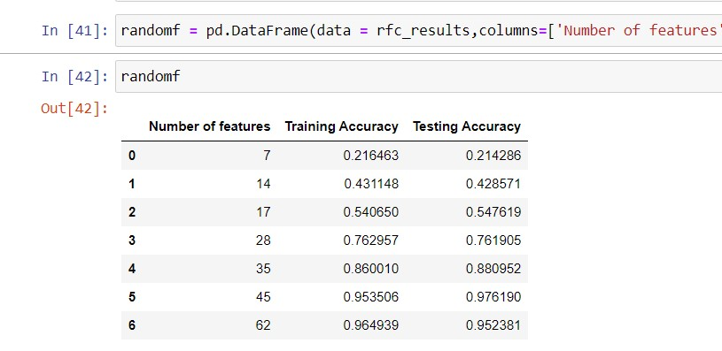

This is the table for random forest Classifier for various features. We can see that as the number of features go on increasing, the accuracies increase.

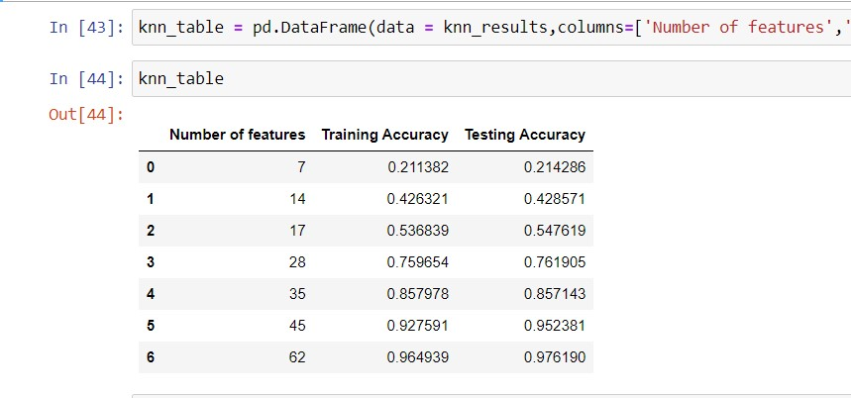

This is the table for knn model for various number of features. We can see that as the number of features go on increasing, the accuracies increase.

## Activity 4: Building Model with appropriate features

From the above result tables, we can see that the accuracy does not change much from 45 features to 62 features. Hence we will choose 45 features for our training.

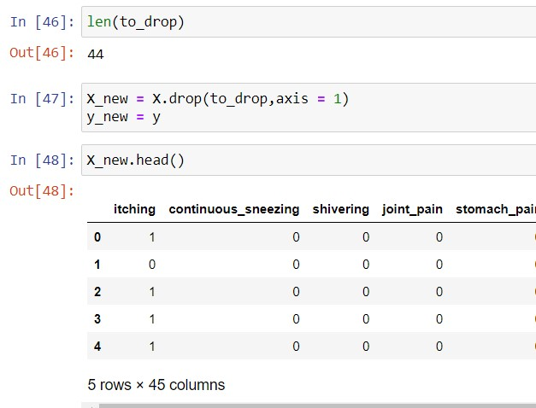

We drop 44 features. Create new datasets for features and their labels. As we can see in the figure above we are left with 45 features now. We will build a Random Fores Classifier on the new data and check for the accuracies. As we can see in the figure below our model has achieved test accuracy of 97.6 % which is quite good for the number of features. Previously for 90 features we had similar accuracy for Random Forest Classifier. This states that there were many features which were not contributing much to our model.

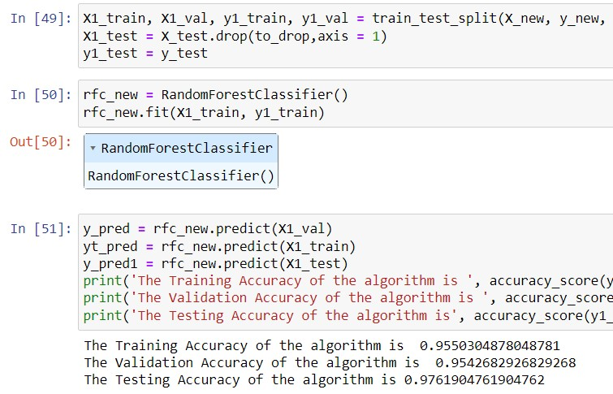

We will also train the model for KNN algorithm as KNN algorithm tends to perform better in such cases.

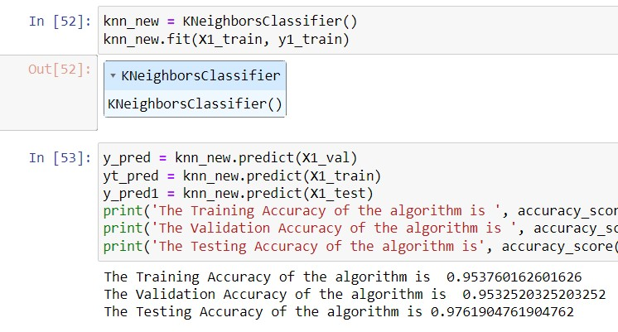

After training the knn model we check the accuracies. Our model has achieved 97.6 % accuracy for the test data.

To confirm let us check the compare our predicted results with the actual values.

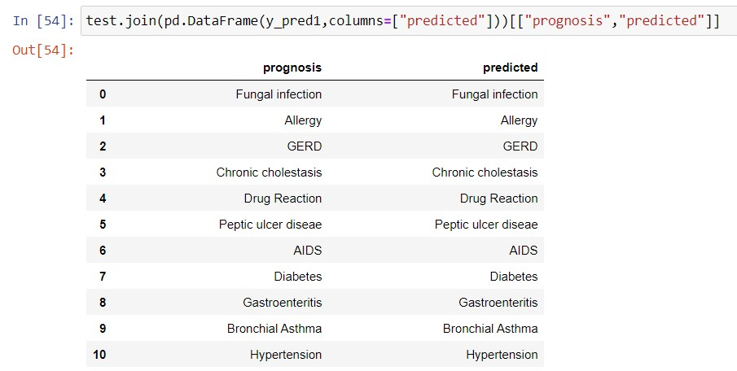

As we can see above that the values our model has predicted are same as the actual values. This shows that our model is performing good.

**Milestone 6: Model Deployment**

## Activity 1: Save the best model

Saving the best model after comparing its performance using different evaluation metrics means selecting the model with the highest performance and saving its weights and configuration. This can be useful in avoiding the need to retrain the model every time it is needed and also to be able to use it in the future**.**

After checking the performance, we decide to save the knn model built with 45 features.

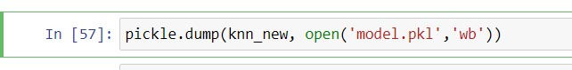

We save the model using the pickle library into a file named model.pkl

## Activity 2: Integrate with Web Framework

In this section, we will be building a web application that is integrated to the model we built. A UI is provided for the uses where he has to enter the values for predictions. The enter values are given to the saved model and prediction is showcased on the UI. This section has the following tasks

* Building HTML Pages
* Building server-side script
* Run the web application

**Activity 2.1: Building HTML pages:**

For this project we create three HTML files namely

* Index.html
* Details.html
* Results.html

And we will save them in the templates folder.

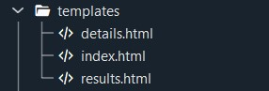

## Activity 2.2: Build Python code

Create a new app.py file which will be store in the Flask folder.

Import the necessary Libraries.

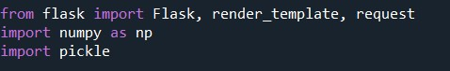

This code first loads the saved Linear Regression model from the "bodyfat.pkl" file using the "pickle.load()" method. The "rb" parameter indicates that the file should be opened in binary mode to read data from it.

After loading the model, the code creates a new Flask web application object named "app" using the Flask constructor. The "name" argument tells Flask to use the current module as the name for the application.



This code sets up a new route for the Flask web application using the "@app.route()" decorator. The route in this case is the root route "/", which is the default route when the website is accessed.

The function "home()" is then associated with this route. When a user accesses the root route of the website, this function is called.

The "render_template()" method is used to render an HTML template named "index.html". The “index.html” is the home page.

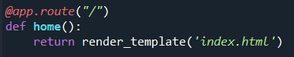

The route in this case is "/details". When a user accesses the "/predict" route of the website, this function is “index()” called. The "render_template()" method is used to render an HTML template named "details.html".

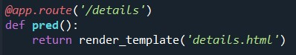

This code sets up another route for the Flask web application using the

"@app.route()" decorator. The route in this case is "/predict", and the method is set to GET and POST.

The function "predict()" is then associated with this route. In this function we create a list named col which has all the 45 column names that we have used in our model. In the details.html page we are going to take inputs from the user, which will be in the form of text.

The values are stored in request.form.values()

These values are stored in a list named inputt in the form of strings.

A list is created with 45 0s and stored in variable b.

In the for loop x will take values from 0 to 45.

Another for loop is written where y will iterate over the values given by the user as inputs.

If the name of the column which is at the x index in col list matches with the y from the inputt list then a 1 is stored at that index in the list b.

This list b is converted into an array and the shape of the array is changed to (1,45).

Then this array b is given to the model for prediction.

This prediction is returned to the results.html page using render_template()

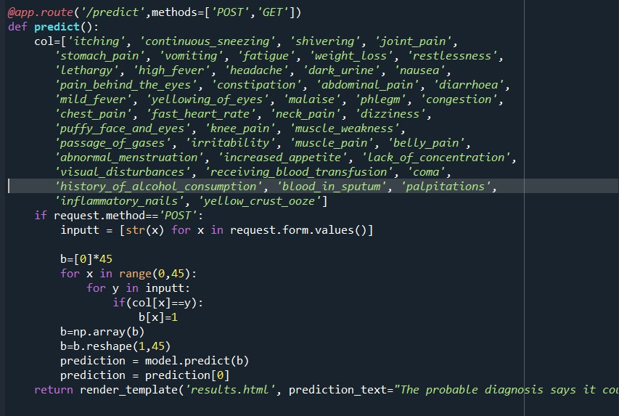

**Main Function:**

This code sets the entry point of the Flask application. The function “app.run()” is called, which starts the Flask deployment server.



## Activity 2.3: Run the Web Application

When you run the “app.py” file this window will open in the console or output terminal. Copy the URL given in the form [http://127.0.0.1:5000](http://127.0.0.1:5000/) and paste it in the browser.

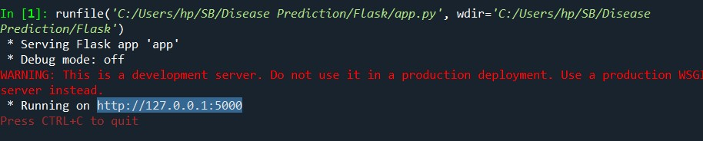

When we paste the URL in a web browser, our index.html page will open. It contains various sections in the header bar such as Home, Predict, About Model, Testimonials, FAQ, Contact. There is some information given on the web page about our model.

If you click on the Predict button on home page or in the header bar you will be redirected to the details.html page.



Our Detials.html looks as shown below.

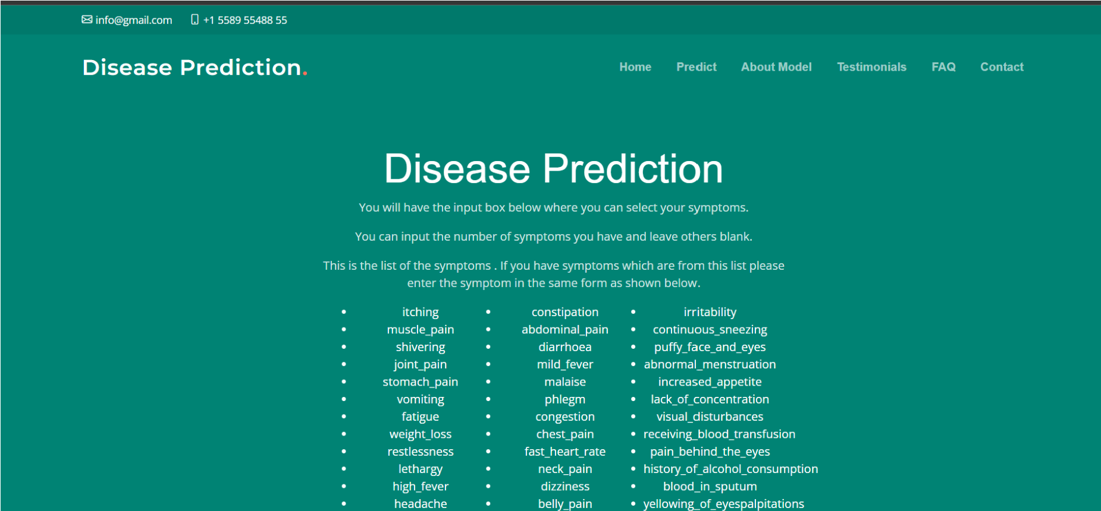

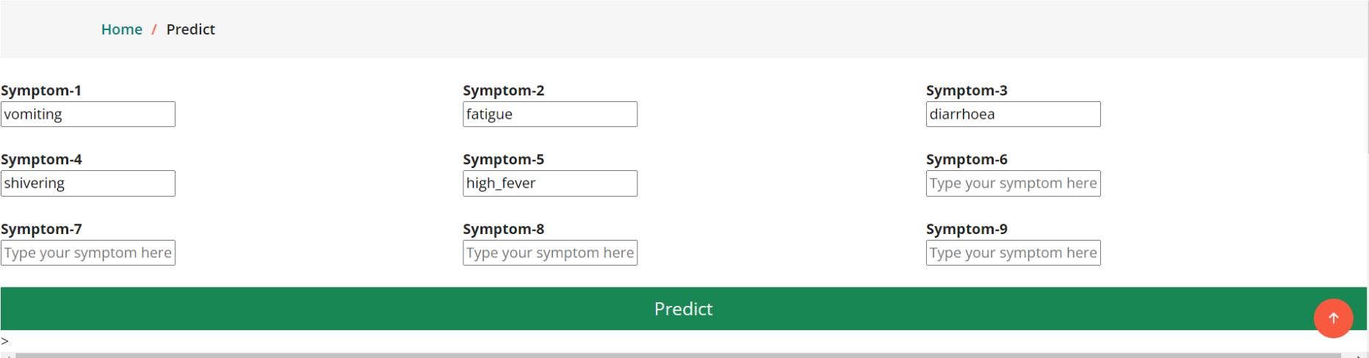

We are provided with 9 input fields where we can input our symptoms. We can fill all 9 boxes or can just fill 1. We are provided with a list of symptoms in the form of bullet points above.

We can input symptoms from above but they have to be in the same form as given in the list since they are the column names.

We will input some symptoms such as vomiting, fatigue, diarrhoea, shivering, high_fever and click on Predict button to get the output.

We will be redirected to the Results.html page once we click the Predict button.

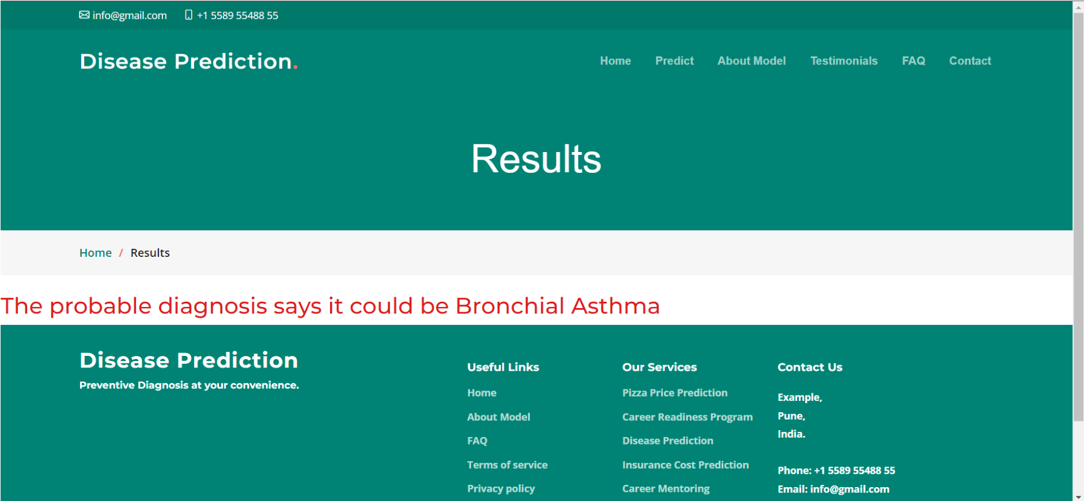

The results say that there are high chances that patient has Bronchial Asthma based on the various symptoms we have given as input.

**Link to GitHub Repository:**

https://github.com/smartinternz02/SI-GuidedProject-612297-1699706390/tree/main