Project Planning Phase

Project Planning Template (Product Backlog, Sprint Planning, Stories, Story points)

Date

Team ID

Project Name

Maximum Marks

27 October 2022

PNT2022TMID591855

Project - Green Classify: Deep Learning-based

Approach for Vegetable Image Classification:

8 Marks

Product Backlog, Sprint Schedule, and Estimation (4 Marks)

Use the below template to create product backlog and sprint schedule

Sprint | Functional | User Story | User Story / Task | Story Points | Priority | Team
 | Requirement (Epic) | Number |  |  |  | Members
Sprint-1 | Image Data Source | USN-1 | As a user, I can upload vegetable images to the | 7 | High | 1
 |  |  | application from local storage.
Sprint-1 | Image Data Source | USN-2 | As a user, I can provide URLs of vegetable | 7 | High | 1
 |  |  | images to the application for classification.
Sprint-1 | Preprocessing | USN-3 | As a user, I can see that the uploaded images | 6 | Medium | 1
 |  |  | are resized to a consistent dimension for
 |  |  | classification.
Sprint-2 | Deep Learning Model | USN-4 | As a user, I can see that the model is initialized | 8 | High | 1
 |  |  | with pre-trained weights for accurate
 |  |  | classification.
Sprint-2 | Training | USN-5 | As a user, I can monitor the training process | 6 | Medium | 1
 | Infrastructure |  | and check the status of model checkpoints.
Sprint-2 | Training Data | USN-6 | As a user, I can view the par33oned training, | 6 | Medium | 1
 |  |  | valida3on, and test sets for model evalua3on.


Sprint-3 | Inference Engine | USN-7 | As a user, I can submit new, unlabeled | 10 | High | 1
 |  |  | vegetable images for classifica3on via a RESTful
 |  |  | API.
Sprint-3 | Inference Engine | USN-8 | As a user, I can receive the predicted class | 10 | High | 1
 |  |  | label and confidence score for a submitted
 |  |  | image.
Sprint-4 | User Interface | USN-9 | As a user, I can interact with the application's UI | 7 | High | 1
 |  |  | to upload and classify vegetable images.
Sprint-4 | User Interface | USN-10 | As a user, I can see the classification results | 7 | High | 1
 |  |  | displayed, including the predicted vegetable
 |  |  | type and confidence score.
Sprint-4 | Training Data | USN-11 | As a user, I can view and manage the | 6 | Medium | 1
 | Storage |  | structured training data in the RDBMS.
Sprint-5 | Cloud Object Storage | USN-12 | As a user, I can store and retrieve images in the | 10 | Medium | 1
 |  |  | cloud storage (e.g., Amazon S3).
Sprint-5 | Machine Learning | USN-13 | As a user, I can choose different machine | 10 | Medium | 1
 | Model |  | learning models for classification.


Project Tracker, Velocity & Burndown Chart: (4 Marks)

Sprint | Total Story | Duration | Sprint Start Date |  | Sprint End Date |  | Story Points | Sprint Release Date
 | Points |  |  |  | (Planned) |  | Completed (as on | (Actual)
 |  |  |  |  |  |  | Planned End Date)
Sprint-1 | 20 | 3 Days | 24 | Oct 2023 | 26 | Oct 2023 | 20 | 26 | Oct 2023
Sprint-2 | 20 | 6 Days | 27 | Oct 2023 | 01 | Nov 2023 | 20 | 01 | Nov 2023
Sprint-3 | 20 | 3 Days | 02 | Nov 2023 | 04 | Nov 2023 | 20 | 04 | Nov 2023

Sprint-4 | 20 | 3 Days | 05 Nov 2023 | 07 | Nov 2023 | 20 | 05 | Nov 2023
Sprint-5 | 20 | 2 Days | 08 Nov 2023 | 09 | Oct 2023 | 20 | 09 | Oct 2023

Velocity:

Imagine we have a 10-day sprint duration, and the velocity of the team is 20 (points per sprint). Let’s calculate the team’s average velocity (AV) per iteration unit (story points per day)
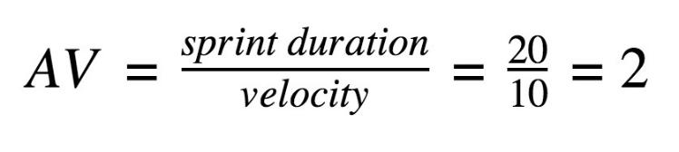

Velocity = 100 / 5 = 20 story points per sprint
Burndown Chart:

A burn down chart is a graphical representation of work left to do versus time. It is often used in agile software development methodologies such as Scrum. However, burn down charts can be applied to any project containing measurable progress over time.
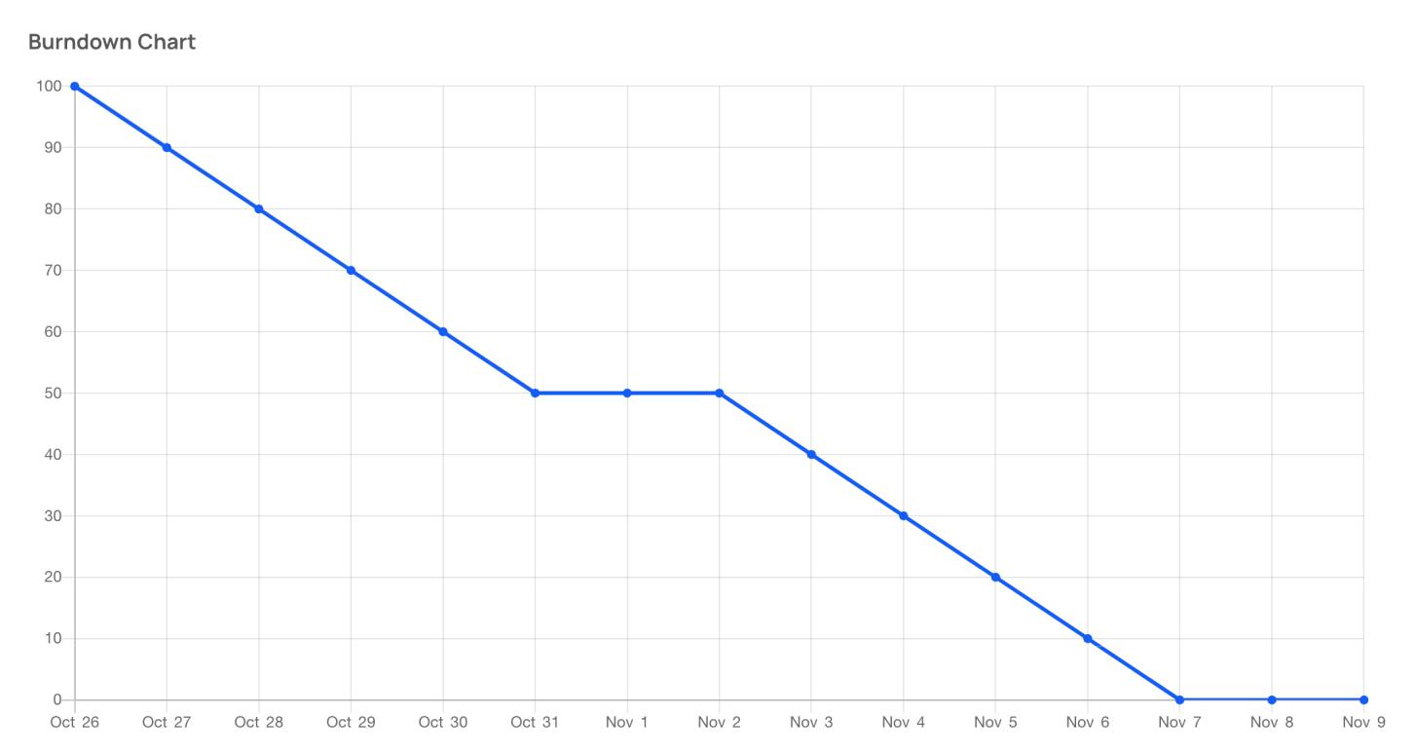

https://www.visua l-paradigm.com/scrum/scrum- burndown- chart/


https://www.atlassian.com/agile/tutorials/burnd o wn- charts

Reference:


https://www.atlassian.com/agile/projec t -management https://www.atlassian.com/agile/tutorials/ho w-t o-do- scrum-with-jir a-software https://www.atlassian.c om/agile/tutorials/epics https://www.atlassian.com/agile/tutorials/sprint s https://www.atlassian.com/agile/proje c t-management/estimation https://www.atlassian.com/agile/tutorials/burndow n - charts


