Project Design Phase-I

Solu5on Architecture

Date 29 April 2023
Team ID PNT2022TMID591855

Project Name GreenClassify: Deep Learning-based Approach

for Vegetable Image ClassificaIon

Maximum Marks 5 Marks
Solution Architecture:

Solution architecture is a complex process – with many sub-processes – that bridges the gap between business problems and technology solutions. Its goals are to:

- Find the best tech solution to solve existing business problems.

- Describe the structure, characteristics, behavior, and other aspects of the software to project stakeholders.

- Define features, development phases, and solution requirements.

- Provide specifications according to which the solution is defined, managed, and delivered.

Example - Solution Architecture Diagram:
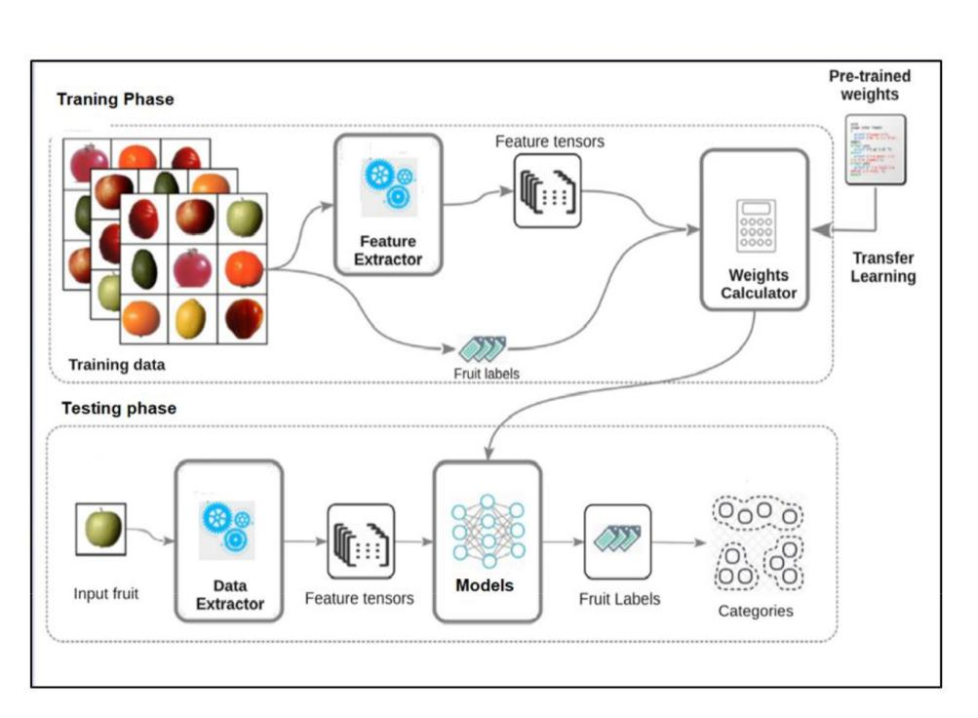

Figure: Architecture and data flow of the Vegetable Identifier sample application

