# Stage 2:

**Plugin Catalog Exploration**

* **Plugin Database Review: Dive into the Nessus plugin database/catalog. Explore the range of plugins available, categorized based on vulnerability assessments, compliance checks, malware detection, etc.**

Solution:

Nessus is a popular vulnerability scanner that can help you identify and assess the security risks of your network or system. Nessus uses plugins to perform various security tests and checks, such as vulnerability assessments, compliance checks, malware detection, and more. Plugins are programs that are written in the Nessus Attack Scripting Language (NASL), and that contain information, remediation actions, and algorithms to test for the presence of security issues.

There are over 199,000 plugins available for Nessus, covering over 80,000 CVE IDs and over 30,000 Bugtraq IDs. The plugins are divided into different families, based on their type, function, or category. Some of the plugin families are:

* **Databases**: This family contains plugins that test the security of various database systems, such as Oracle, MySQL, PostgreSQL, MongoDB, and more. The plugins can detect vulnerabilities, misconfigurations, weak passwords, and other issues that may affect the database security.
* **Web Applications**: This family contains plugins that test the security of various web applications, such as WordPress, Joomla, Drupal, Magento, and more. The plugins can detect vulnerabilities, such as SQL injection, cross-site scripting, file inclusion, and other issues that may affect the web application security.
* **Malware**: This family contains plugins that test the presence of malware, such as viruses, worms, trojans, ransomware, and more, on the scanned hosts. The plugins can detect malware signatures, behaviours, or indicators of compromise, and provide remediation actions to remove or quarantine the malware.
* **Compliance**: This family contains plugins that test the compliance of the scanned hosts with various standards, regulations, or policies, such as PCI-DSS, HIPAA, NIST, CIS, and more. The plugins can check the configuration, settings, or policies of the hosts, and provide recommendations or actions to improve the compliance level.
* **Windows**: This family contains plugins that test the security of Windows operating systems, such as Windows 10, Windows Server, Windows Defender, and more. The plugins can detect vulnerabilities, patches, updates, or other issues that may affect the Windows security.

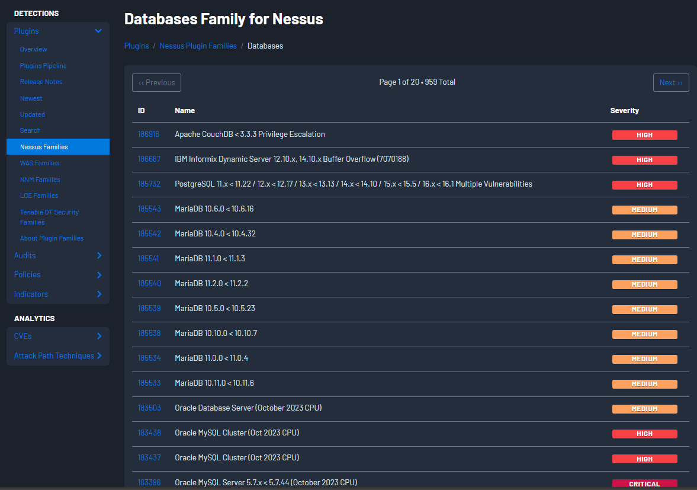

* **Plugin Classification: Understand how plugins are categorized and organized within Nessus, focusing on their functionalities and intended uses for threat detection.**

Solution:

Nessus is a popular vulnerability scanner that can help you identify and assess the security risks of your network or system. Nessus uses plugins to perform various security tests and checks, such as vulnerability assessments, compliance checks, malware detection, and more.

Plugins are programs that are written in the Nessus Attack Scripting Language (NASL), and that contain information, remediation actions, and algorithms to test for the presence of security issues. Plugins are divided into different families, based on their type, function, or category. For example, some of the plugin families are:

* **Databases**: This family contains plugins that test the security of various database systems, such as Oracle, MySQL, PostgreSQL, MongoDB, and more. The plugins can detect vulnerabilities, misconfigurations, weak passwords, and other issues that may affect the database security.
* **Web Applications**: This family contains plugins that test the security of various web applications, such as WordPress, Joomla, Drupal, Magento, and more. The plugins can detect vulnerabilities, such as SQL injection, cross-site scripting, file inclusion, and other issues that may affect the web application security.
* **Malware**: This family contains plugins that test the presence of malware, such as viruses, worms, trojans, ransomware, and more, on the scanned hosts. The plugins can detect malware signatures, behaviours, or indicators of compromise, and provide remediation actions to remove or quarantine the malware.
* **Compliance**: This family contains plugins that test the compliance of the scanned hosts with various standards, regulations, or policies, such as PCI-DSS, HIPAA, NIST, CIS, and more. The plugins can check the configuration, settings, or policies of the hosts, and provide recommendations or actions to improve the compliance level.

**Plugin Functionality Analysis**

* Plugin Workflow: Study the workflow of various plugins, examining how they scan, detect, and report vulnerabilities or threats within different system components or network devices.

Solution:

Nessus is a popular vulnerability scanner that can help you identify and assess the security risks of your network or system. Nessus uses plugins to perform various security tests and checks, such as vulnerability assessments, compliance checks, malware detection, and more.

Plugins are programs that are written in the Nessus Attack Scripting Language (NASL), and that contain information, remediation actions, and algorithms to test for the presence of security issues. Plugins are divided into different families, based on their type, function, or category. For example, some of the plugin families are:

* **Databases**: This family contains plugins that test the security of various database systems, such as Oracle, MySQL, PostgreSQL, MongoDB, and more. The plugins can detect vulnerabilities, misconfigurations, weak passwords, and other issues that may affect the database security.
* **Web Applications**: This family contains plugins that test the security of various web applications, such as WordPress, Joomla, Drupal, Magento, and more. The plugins can detect vulnerabilities, such as SQL injection, cross-site scripting, file inclusion, and other issues that may affect the web application security.
* **Malware**: This family contains plugins that test the presence of malware, such as viruses, worms, trojans, ransomware, and more, on the scanned hosts. The plugins can detect malware signatures, behaviours, or indicators of compromise, and provide remediation actions to remove or quarantine the malware.
* **Compliance**: This family contains plugins that test the compliance of the scanned hosts with various standards, regulations, or policies, such as PCI-DSS, HIPAA, NIST, CIS, and more. The plugins can check the configuration, settings, or policies of the hosts, and provide recommendations or actions to improve the compliance level.

The basic workflow of Nessus tool is to login, create or configure the policy, run the scan, and analyses the results. The policy defines the scan settings, such as the target hosts, the plugin families, the scan options, and the credentials. The scan executes the plugins against the target hosts, and collects the plugin output, such as the vulnerability name, severity, description, solution, and evidence. The results show the scan summary, details, and reports, such as the number of vulnerabilities, the vulnerability list, the vulnerability details, and the vulnerability graphs.

* Feature Examination: Analyse specific features within plugins such as scripting capabilities, exploitability checks, or protocol-specific detections to understand their contributions to threat identification.

Solution:

Analyzing specific features within plugins for threat identification involves understanding how these features enhance the security posture of a system. Here are some key features commonly found in security plugins, and their contributions to threat identification:

- Scripting Capabilities:

Purpose: Plugins with scripting capabilities allow users to write custom scripts or automate certain tasks within the security tool.

Contribution to Threat Identification: Scripting enables the creation of custom detection rules and responses. Security professionals can write scripts to analyse logs, monitor specific activities, or even implement complex correlation logic. This flexibility enhances the tool's capability to detect and respond to unique threats tailored to the organization's specific environment.

- Exploitability Checks

Purpose: Some plugins include checks for known vulnerabilities and exploits in the system.

Contribution to Threat Identification: By actively scanning for known vulnerabilities and exploits, these plugins contribute to the identification of potential threats before they can be exploited. They often leverage databases of known vulnerabilities and provide alerts or remediation suggestions when a vulnerable system or application is detected.

- Protocol-Specific Detections:

Purpose: Many security plugins are designed to understand and analyse specific network protocols or communication channels.

Contribution to Threat Identification: By focusing on specific protocols, these plugins can identify threats that may be unique to certain types of communication. For example, they may detect anomalies in network traffic, unauthorized access attempts, or protocol-specific attacks. This specialization enhances the accuracy of threat identification and reduces false positives.

- Behavioral Analytics:

Purpose: Some plugins use behavioral analytics to establish a baseline of normal system behavior and identify deviations.

Contribution to Threat Identification: Behavioral analytics help in identifying threats based on abnormal patterns of activity. This includes detecting unusual user behavior, deviations from established network patterns, or unexpected changes in system configurations. By continuously learning and adapting, these plugins can improve their accuracy in identifying emerging threats.

- Integration with Threat Intelligence Feeds:

Purpose: Integration with threat intelligence feeds allows plugins to stay updated on the latest threats and indicators of compromise.

Contribution to Threat Identification: By incorporating threat intelligence, plugins can proactively identify known malicious entities and activities. This ensures that the security tool is equipped with the latest information about emerging threats, helping to identify and respond to them quickly.

- Logging and Auditing:

Purpose: Comprehensive logging and auditing capabilities within plugins capture detailed information about system activities.

Contribution to Threat Identification: In the event of a security incident, detailed logs facilitate post-incident analysis. Security professionals can review logs to trace the steps of an attack, identify the entry point, and understand the extent of the compromise. Logging also supports compliance requirements by providing a record of security events.

When evaluating security plugins, organizations should consider the specific needs of their environment, the types of threats they are likely to face, and the level of customization and automation required for effective threat identification and response. Regular updates and maintenance of plugins are essential to ensure they remain effective against evolving threats.

**Hands-On Plugin Testing**

* Testing Scenarios: Select a range of plugins and conduct hands-on testing within a controlled environment. Simulate different threat scenarios to observe how the plugins perform in detecting vulnerabilities or potential threats.

Solution:

* Reporting and Analysis: Analyse the reports generated by the plugins post-testing, understanding their comprehensiveness, accuracy, and prioritization of identified threats.

Solution:

**Best Practices And Customization**

* Best Practices Research: Explore industry best practices and guidelines for leveraging Nessus plugins effectively in threat detection strategies.

Solution:

Nessus is a widely used vulnerability assessment tool that offers a variety of plugins to help organizations identify and mitigate security risks. Leveraging Nessus plugins effectively in threat detection strategies involves following industry best practices and guidelines. Here are some recommendations:

* Regular Plugin Updates:

Keep Nessus plugins up to date to ensure that the tool has the latest signatures for detecting vulnerabilities and threats. Regular updates help in identifying new vulnerabilities and adapting to changes in the threat landscape.

* Thorough Scanning:

Conduct thorough scans across the entire infrastructure, including networks, servers, and applications. Perform both authenticated and unauthenticated scans to get a comprehensive view of potential vulnerabilities.

* Customization for Environment:

Tailor Nessus scans to match the specific environment and technologies used within your organization. Adjust settings and configurations to avoid false positives and ensure accurate detection of vulnerabilities relevant to your infrastructure.

* Risk-Based Prioritization:

Prioritize identified vulnerabilities based on risk severity. Focus on addressing high-risk vulnerabilities first to mitigate the most critical threats. Nessus provides risk ratings for vulnerabilities, helping you prioritize remediation efforts.

* Integration with Workflow:

Integrate Nessus with your organization's workflow and security processes. This may include integration with ticketing systems, security information and event management (SIEM) solutions, and other tools for streamlined incident response and remediation.

* Credentials and Authentication:

Use authenticated scans whenever possible. Authenticated scans provide more accurate results by allowing Nessus to log in and assess the system from an insider's perspective. This is especially important for identifying configuration issues and missing patches.

* Compliance Scanning:

Leverage Nessus for compliance scanning to ensure that systems adhere to industry standards and regulatory requirements. This helps in identifying security gaps that may lead to compliance violations.

* Asset Discovery:

Utilize Nessus for asset discovery to maintain an up-to-date inventory of devices on your network. This is crucial for understanding the attack surface and ensuring that all systems are included in vulnerability assessments.

* Create Custom Policies:

Tailor scan policies based on the nature of the assets being scanned. Create custom policies for different types of systems, such as web servers, databases, and workstations, to optimize scanning efficiency and accuracy.

* Advanced Scanning Options:

Explore advanced scanning options provided by Nessus, such as credentialed scans, compliance checks, and malware detection. These features enhance the tool's capability to identify a wide range of security issues.

* Audit Trail and Logging:

Maintain detailed audit trails and logs of Nessus scan activities. This information is valuable for post-assessment analysis, auditing, and forensic purposes.

* Regular Reporting:

Generate and review regular reports to track the progress of vulnerability remediation efforts. Nessus provides various report templates that can be customized to meet specific reporting requirements.

* Training and Skill Development:

Ensure that personnel responsible for using Nessus are adequately trained and have the necessary skills to interpret scan results, prioritize vulnerabilities, and take appropriate remediation actions.

* Stay Informed:

Stay informed about the latest features, updates, and best practices related to Nessus. Tenable, the company behind Nessus, provides documentation, webinars, and community forums that can be valuable resources.

* Customization and Optimization: Experiment with plugin customization options, configurations, or tuning settings to optimize their performance in aligning with specific security requirements or compliance standards.

Solution:

**Title of the Project: Enhancing Security Operations: SIEM Qradar & SOC Dashboard Management**

# Overview:

Cybersecurity is of utmost importance in today's interconnected digital world because it safeguards all types of data against theft and loss. Sensitive data, protected health information (PHI), personally identifiable information (PII), intellectual property, personal information, data, and government and business information systems are all included.

Following are some Important points that has to be considered as cyber security is concern,

* **Protection of sensitive information**: Cybersecurity ensures the confidentiality, integrity, and availability of sensitive data, such as personal information, financial records, intellectual property, and trade secrets. Breaches of this information can lead to identity theft, financial loss, and reputational damage for individuals and organizations.
* **Safeguarding critical infrastructure**: Many essential services like power grids, transportation systems, healthcare facilities, and communication networks are now operated through interconnected computer systems. Protecting these critical infrastructures from cyber threats is essential to ensure the continuity of services and prevent potential catastrophic consequences.
* **Preserving privacy**: With the increasing amount of personal data being collected and shared online, ensuring privacy is crucial. Cybersecurity measures help prevent unauthorized access to private information and protect individuals' rights to privacy.
* **Preventing financial losses:** Cyberattacks can lead to significant financial losses for individuals and businesses. This includes direct financial theft, loss of revenue due to downtime, and costs associated with mitigating the damage caused by an attack.
* **Cybercrime and fraud prevention**: Cybersecurity plays a crucial role in identifying and preventing various types of cybercrimes and fraudulent activities, such as phishing attacks, ransomware, and online scams.
* **Mitigating social and economic disruptions**: Large-scale cyberattacks can cause significant social and economic disruptions, affecting not only businesses but also individuals and entire communities. Robust cybersecurity measures can help mitigate the impact of such disruptions.
* **Risk Assessment and Management:** By implementing effective risk mitigation measures and a robust risk management plan, we can address identified vulnerabilities proactively.
* **Employee Training and Awareness:** Recognizing that our employees play a crucial role in safeguarding our information, we provide comprehensive cybersecurity training. By educating them on best practices, including recognizing and mitigating common attack vectors like phishing and social engineering, we promote a security-conscious culture throughout the organization.
* **Access Control Measures:** Ensuring the confidentiality and integrity of our sensitive data and critical systems is paramount. To achieve this, we have implemented strong access control measures that restrict data access to authorized personnel only. As an extra layer of security, we employ multi-factor authentication (MFA) to prevent unauthorized access.
* **Network Security:** network should be protected by cutting-edge firewalls, intrusion detection/prevention systems (IDS/IPS), and secure gateways.
* **Regular Security Audits and Updates:** To maintain the effectiveness of our cybersecurity measures, we conduct regular security audits. These evaluations assess the efficiency of our security infrastructure and identify areas for improvement.

By implementing these cybersecurity measures, we aim to fortify our organization against potential cyber threats, protect sensitive information, and maintain the trust of our stakeholders in our commitment to safeguarding their data and ensuring the continuity of our operations.

# Personal Details:

|  |  |  |
| --- | --- | --- |
| **Name** | **College** | **Contact No.** |
| Ms. Neha Deshmukh | A.P. Shah Institute of Technology,  Thane (West)  Mumbai, Maharashtra. | 8454845117 |

|  |  |  |
| --- | --- | --- |
| **Sr.no** | **Vulnerability Name** | **CWE References** |
| 1 | Broken Access Control | CWE-284: Improper Access Control |
| 2 | Cryptographic Failures | CWE-310: Cryptographic Issues |
| 3 | Injection | CWE-89: Improper Neutralization of Special Elements used in an SQL Command ('SQL  Injection') |
| 4 | Insecure Design | CWE –1348  A04:2021-Insecure Design  CWE-657: Violation of Secure Design Principles |
| 5 | Security Misconfiguration | CWE – 1349  A05:2021-Security Misconfiguration |
| 6 | Vulnerable and Outdated Components | CWE – 1352  A06:2021-Vulnerable and Outdated Components. |
| 7 | Identification and Authentication Failures | CWE – 1353  A07:2021-Identification and Authentication Failures. |
| 8 | Software and Data Integrity Failures | CWE-1354  A08:2021 Software and Data Integrity Failures |
| 9 | Security Logging and Monitoring | CWE-778: Insufficient Logging |
| 10 | Server-Side Request Forgery | CWE-918: Server-Side Request Forgery (SSRF) |

**List of Vulnerability Table:**

1. **Vulnerability Name**: Improper access control

**CWE**: CWE-284

**OWASP Category**: A01:2021 – Broken Access Control

**Description:** Improper access control refers to a security flaw in which unauthorized individuals or entities gain access to sensitive data, systems, or resources that they should not be allowed to access.

This vulnerability can occur due to misconfigurations, weak authentication mechanisms, inadequate permission settings, or other weaknesses in an organization's security infrastructure.

# Business Impact:

* 1. **Data Breaches:** Unauthorized access can lead to data breaches, exposing sensitive customer information, proprietary data, financial records, and trade secrets. Such breaches can tarnish the company's reputation and result in legal liabilities and regulatory fines.
  2. **Financial Losses:** Infiltration by malicious actors may lead to financial fraud, theft, or ransom demands, causing substantial financial losses to the organization.
  3. **Intellectual Property Theft:** Improper access control puts valuable intellectual property at risk, making it vulnerable to theft or unauthorized use by competitors or cybercriminals.

1. **Vulnerability Name**: Cryptographic failures

**CWE**: CWE-310: Cryptographic Issues

**OWASP Category**: A3:2017-Sensitive Data Exposure

**Description:** Cryptographic failures refer to weaknesses or vulnerabilities in the implementation or use of cryptographic algorithms and protocols.

# Business Impact:

* 1. **Data Breaches:** If sensitive data is not adequately encrypted or if encryption is weak, it becomes easier for attackers to steal and exploit the data, leading to data breaches and potential legal and financial consequences.
  2. **Loss of Trust:** Cryptographic failures can erode customer trust in the organization's ability to protect their sensitive information. This loss of trust can have long-term negative effects on customer loyalty and brand reputation.
  3. **Intellectual Property Theft:** Inadequate encryption can expose valuable intellectual property, trade secrets, and proprietary information to theft by competitors or cybercriminals.
  4. **Financial Losses:** The fallout from cryptographic failures can lead to significant financial losses, including legal costs, compensation for affected parties, and expenses related to data recovery and incident response.
  5. **Disruption of Operations:** Cryptographic failures may result in disruptions to critical business operations, leading to downtime and loss of productivity.

1. **Vulnerability Name**: Injection:

**CWE**: CWE-89:

**OWASP Category**: A03 2021 Injection

**Description:** Injection is a type of cybersecurity vulnerability where untrusted data is sent to an application's interpreter or query language, leading to unintended execution of malicious commands. Attackers exploit this weakness to insert harmful code, often in the form of SQL, NoSQL, OS, or LDAP queries, into the application's input fields or parameters.

# Business Impact:

* 1. Successful injection attacks can expose sensitive data, such as customer information, financial records, or intellectual property, leading to data breaches.
  2. Attackers can bypass authentication mechanisms and gain unauthorized access to restricted areas of the application or system.
  3. **Application Takeover:** Injection attacks can lead to full control over the application or system, enabling attackers to manipulate data, compromise accounts, or disrupt services.
  4. **Unauthorized Access:** Attackers can bypass authentication mechanisms and gain unauthorized access to restricted areas of the application or system.

1. **Vulnerability Name**: Insecure Design

**CWE**: CWE – 1348

**OWASP Category**: A04:2021 - Insecure Design

**Description:** Insecure design, also known as security design flaws or architectural vulnerabilities, refers to the presence of fundamental weaknesses in the design and architecture of software, systems, or networks.

# Business Impact:

* 1. **Increased Vulnerability Surface:** Such flaws create a larger attack surface, making it easier for attackers to find and exploit weaknesses.
  2. **Data Breach:** Security design flaws can lead to data breaches, exposing sensitive information and resulting in financial and reputational damage.
  3. **Regulatory Non-Compliance:** Failure to implement secure design practices may lead to non-compliance with industry regulations and data protection laws, resulting in legal consequences and fines.
  4. **Downtime and Disruptions:** Exploitation of design flaws can lead to system crashes, downtime, and disruptions in critical business operations.
  5. **Loss of Customer Trust:** Insecure design undermines customer trust, potentially leading to loss of customers and a negative impact on the organization's reputation

1. **Vulnerability Name**: Security Misconfiguration

**CWE**: CWE: 1349

**OWASP Category:** A05:2021 - Security Misconfiguration

**Description:** Security misconfiguration is a cybersecurity vulnerability that occurs when a system, application, or network is not properly configured to implement appropriate security settings

# Business impact:

* 1. **Data Breaches:** Misconfigurations can lead to unauthorized access to sensitive data, resulting in data breaches and potential legal and financial liabilities.
  2. **System Compromise:** Attackers can exploit misconfigurations to gain control of systems or applications, potentially leading to data manipulation, service disruptions, or system takeovers.
  3. **Reputation Damage:** Security misconfiguration incidents can significantly damage an organization's reputation, eroding customer trust and loyalty.
  4. **Regulatory Non-Compliance:** Misconfigurations may lead to non-compliance with industry standards, data protection regulations, and privacy laws, resulting in fines and penalties.
  5. **Disruptions and Downtime:** Security misconfigurations can cause application crashes, service disruptions, or downtime, impacting business operations and productivity.

1. **Vulnerability Name**: Vulnerable and Outdated Components

**CWE**: CWE: 1352

**OWASP Category:** A06:2021 - Vulnerable and Outdated Components

**Description:** Vulnerable components are software modules, libraries, frameworks, or dependencies that have publicly known security flaws or weaknesses. These vulnerabilities may arise from coding errors, design flaws, or issues discovered after the component's release.

# Business impact:

Ransomware and Malware Attacks: Attackers often exploit vulnerabilities in components to deliver ransomware or malware, potentially leading to data loss, extortion, or further compromise.

1. **Vulnerability Name**: Identification and Authentication Failures

**CWE**: 1353

**OWASP Category:** A07:2021 - Identification and Authentication Failures

**Description:** Identification and authentication failures refer to security vulnerabilities that occur when systems, applications, or networks have weaknesses in their identification and authentication processes.

# Business impact:

* 1. Unauthorized Access: Attackers can exploit authentication weaknesses to gain unauthorized access to sensitive data, applications, or systems.
  2. Data Breaches: Weak identification and authentication processes can lead to data breaches, exposing sensitive information and potentially leading to legal and financial liabilities.
  3. Fraud and Account Takeover: Inadequate authentication can result in fraudulent activities and account takeovers, impacting users and damaging the organization's reputation.
  4. Loss of Trust: Security incidents resulting from identification and authentication failures can erode customer trust and confidence in the organization.
  5. Regulatory Non-Compliance: Failing to implement strong authentication measures can lead to non-compliance with industry regulations and data protection laws, resulting in fines and penalties.
  6. Disruptions and Downtime: Successful attacks due to authentication failures may lead to system crashes, downtime, and disruptions in critical business operations.

# Vulnerability Name: Software and Data Integrity Failures CWE: 1354

**OWASP Category:** A08:2021 - Software and Data Integrity Failures

# Description:

* Software and data integrity failures refer to cybersecurity vulnerabilities that involve the compromise, alteration, or corruption of software code or data.
* These failures can occur due to various reasons, including malicious attacks, accidental errors, or hardware malfunctions.

# Business impact:

* 1. **Data Loss:** Unintended alterations or deletions of data can result in data loss, leading to operational disruptions and potential financial losses.
  2. **Compromised Systems:** Software integrity failures can lead to the installation of malware or unauthorized software on systems, compromising their security and functionality.
  3. **Loss of Customer Trust:** Failure to maintain software and data integrity can erode customer trust, damaging the organization's reputation and affecting customer retention.
  4. **Compliance Issues:** Integrity failures may result in non-compliance with industry regulations and data protection laws, leading to legal liabilities and fines.
  5. **Business Continuity Disruptions:** Cyberattacks or accidental data corruption can disrupt business operations, leading to downtime and loss of productivity.
  6. **Intellectual Property Theft:** Tampering with software code or data can result in intellectual property theft or unauthorized access to proprietary information.

# Vulnerability Name: Security Logging and Monitoring CWE: CWE-778

**OWASP Category:**

**Description:** Security logging and monitoring are essential cybersecurity practices that involve the systematic recording, analysis, and tracking of security-related events and activities within an organization's IT infrastructure.

# Business impact:

* 1. **Early Threat Detection**: Timely detection of security incidents allows organizations to respond proactively before the situation worsens.
  2. **Reduced Dwell Time:** Monitoring helps reduce dwell time, the duration between an intrusion and its detection, minimizing potential damage.
  3. **Compliance and Auditing**: Security logging is crucial for compliance with industry standards and regulations that mandate data protection and monitoring practices.
  4. **Incident Response Efficiency**: Real-time monitoring enables rapid incident response, limiting the impact of security breaches and reducing recovery time.
  5. **Improved Security Posture**: Continuous monitoring helps identify weaknesses in the security infrastructure, allowing organizations to strengthen their overall security posture.
  6. **Protection against Insider Threats**: Monitoring user activity can help identify insider threats and potential misuse of privileges.

# Vulnerability Name: Server-Side Request Forgery CWE: CWE-918

**OWASP Category:**

**Description:** Server-Side Request Forgery (SSRF) is a cybersecurity vulnerability that

occurs when an attacker exploits a web application to make unauthorized requests to other internal or external systems.

SSRF attacks typically target web applications that fetch data from external resources or perform HTTP requests to other systems. The attacker manipulates the application to send crafted requests that trick the server into making unintended and potentially harmful requests on its behalf.

# Business impact:

1. **Data Exposure:** SSRF attacks can access sensitive data stored on internal systems, leading to data breaches and disclosure of confidential information.
2. **Service Disruption:** Attackers can exploit SSRF to overload internal services, causing denial-of-service (DoS) conditions, disrupting normal operations, and affecting users' experiences.
3. **Unauthorized Access:** Attackers may use SSRF to bypass access controls and interact with internal systems that they should not be allowed to access directly.
4. **Lateral Movement:** Once inside the network, attackers can use SSRF to pivot and further explore the internal infrastructure, potentially leading to broader compromises.
5. **Compliance and Legal Consequences:** Exploiting SSRF vulnerabilities may result in non-compliance with data protection regulations and industry standards, leading to legal and financial liabilities.

**Stage: 2 Report NESSUS Vulnerability Report**

**Introduction:** Nessus is a powerful vulnerability assessment tool that provides in-depth analysis of a company's network, systems, and applications for potential security weaknesses. This report outlines the findings of a comprehensive vulnerability scan conducted on Company’s infrastructure to identify potential security risks and recommend mitigation measures. The assessment was carried out to ensure the company's digital assets are protected against potential cyber threats and to maintain a robust cybersecurity posture.

# Scope:

* The Nessus vulnerability scan covered a wide range of targets, including servers, workstations, networking devices, web applications, and databases.
* The assessment aimed to identify common vulnerabilities and exposures (CVEs), misconfigurations, and potential security gaps that could be exploited by malicious actors.

# Key Findings:

1. **High Severity Vulnerabilities**: The scan revealed a few high-severity vulnerabilities, which pose significant risks to the company's assets and could be exploited to gain unauthorized access or cause disruptions.
2. **Unpatched Software**: Some systems and applications were found to be running outdated software versions with known vulnerabilities. Timely patching is crucial to address these security holes.
3. **Weak Passwords**: The scan identified instances of weak and easily guessable passwords, increasing the risk of unauthorized access and potential data breaches.
4. **SSL/TLS Vulnerabilities**: Several SSL/TLS-related issues were detected, indicating possible weak encryption configurations or outdated protocols.
5. **Exposed Services**: Certain services and ports were found to be exposed to the internet, increasing the attack surface and potential for unauthorized access.
6. **Default Configurations**: Some systems and devices still had default configurations, which are often well-known to attackers and can be exploited easily.
7. **Lack of Security Patches**: Some critical security patches were missing, leaving the company vulnerable to exploits that have already been addressed by software vendors.
8. **Insecure Web Applications**: Vulnerabilities in web applications were identified,

including Cross-Site Scripting (XSS), SQL injection, and other common web application flaws.

# Recommendations:

1. **Patch Management**: Prioritize and apply security patches promptly to address known vulnerabilities and reduce the risk of exploitation.
2. **Strong Authentication**: Enforce the use of strong passwords and consider implementing multi-factor authentication (MFA) to enhance the security of user accounts.
3. **SSL/TLS Configuration**: Review and update SSL/TLS configurations to utilize the latest secure protocols and ciphers and disable weak ones.
4. **Network Segmentation**: Implement proper network segmentation to limit the impact of potential breaches and restrict unauthorized lateral movement.
5. **Security Awareness Training**: Conduct regular security awareness training for employees to educate them about cybersecurity best practices and potential threats.
6. **Web Application Security**: Perform thorough security testing and code reviews for web applications to identify and remediate vulnerabilities.
7. **Reduce Attack Surface**: Disable unnecessary services, close unused ports, and restrict access to critical systems to reduce the attack surface.
8. **Regular Vulnerability Scanning**: Schedule periodic Nessus vulnerability scans to ensure continuous monitoring of the company's security posture and to detect new vulnerabilities as they emerge.

# Target Website :

A.P. SHAH College of Engineering: <http://moodle.apsit.org.in/moodle/>

**Target IP:** 103.123.226.102

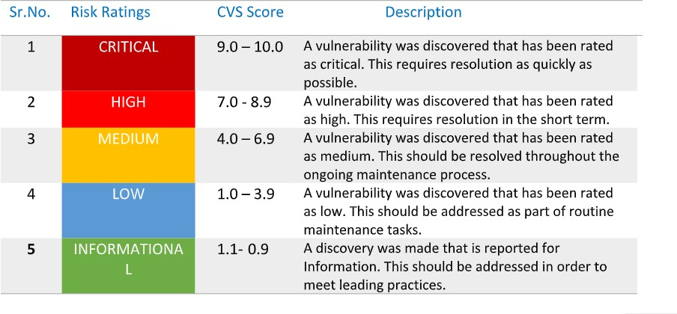

# Findings Overview

|  |  |  |
| --- | --- | --- |
| **Sr.no** | **Description** | **Severity** |
| 1 | **HTTP TRACE / TRACK Methods**  **Allowed** | **Medium** |
| 2 | **Apache Banner Linux Distribution**  **Disclosure** | **Low** |
| 3 | **Apache HTTP Server Version** | **Low** |
| 4 | **Backported Security Patch Detection**  **(PHP)** | **Low** |
| 5 | **Backported Security Patch Detection**  **(WWW)** | **Low** |
| 6 | **Common Platform Enumeration (CPE)** | **Low** |
| 7 | **HTTP Server Type and Version** | **Low** |
| 8 | **Hyper-Text Transfer Protocol (HTTP)**  **Information** | **Low** |
| 9 | **OS Identification** | **Low** |
| 10 | **PHP Version Detection** | **Low** |
| 11 | **Service Detection** | **Low** |
| 12 | **TCP/IP Timestamps Supported** | **Low** |
| 13 | **Traceroute Information** | **Low** |

**Vulnerability Name and Details:**

|  |  |  |  |  |  |  |  |
| --- | --- | --- | --- | --- | --- | --- | --- |
| **Sr.No** | **Vulnerability** | **Severity** | **Description** | **Solution** | **Business Impact** | | **Port No** |
| 1 | HTTP TRACE  / TRACK  Methods Allowed | Medium | The remote web server supports the TRACE and/or TRACK methods. TRACE and  TRACK are HTTP  methods  that are used to debug web server connections. | Disable these HTTP methods.  Refer to the  plugin output for more  information. | Allowing HTTP TRACE and TRACK methods can lead to Cross- Site Tracing (XST) attacks, which may result in the exposure of sensitive data, such as  authentication credentials,  session cookies, and other  sensitive | | tcp/80/www |
| information |  |
| 2 | Apache Banner Linux  Distribution Disclosure | Low | Nessus was able to extract the banner of the Apache web server and  determine which Linux distribution the remote host is running. | If you do not wish to display  this information, edit 'httpd.conf' and set the  directive 'ServerTokens Prod' and  restart Apache. | Exposing the Apache server version and  underlying Linux distribution can provide valuable information to potential  attackers. Hackers can use this  information to target specific vulnerabilities associated with that version,  making it easier for them to plan and execute  targeted attacks | | tcp/0 |
| 3 | Apache HTTP Server Version | Low | The remote host is running the Apache HTTP Server, an open source web  server. It was  possible to read the version number from the banner | n/a | n/a | | tcp/80/www |
| 4 | Backported Security Patch Detection (PHP) | Low | Security patches may have been 'backported' to the  remote PHP install  without changing its version | n/a | n/a | | tcp/80/www |

.

|  |  |  |  |  |  |  |
| --- | --- | --- | --- | --- | --- | --- |
|  |  |  | number.  Banner-based  checks have been disabled to avoid false positives.  Note that this test is informational only and does not denote any security  problem. |  |  |  |
| 5 | Backported Security Patch Detection (WWW) | Low | Security patches may have been 'backported' to the remote HTTP  server without  changing its version number.  Banner-based | n/a | n/a | tcp/80/www |
|  |  |  | checks have been |  |  |  |
|  |  |  | disabled to avoid |  |  |  |
|  |  |  | false positives. |  |  |  |
| 6 | Common Platform Enumeration (CPE) | Low | By using  information  obtained from a Nessus scan, this plugin reports CPE (Common Platform Enumeration)  matches for various hardware and  software products found on a host. Note that if an official CPE is not available for the  product, this plugin computes the best possible CPE  based on the | n/a | n/a | tcp/0 |
|  |  |  | information |  |  |  |
|  |  |  | available from the |  |  |  |
|  |  |  | scan. |  |  |  |
| 7 | HTTP Server | Low | This plugin | n/a | n/a | tcp/80/www |
|  | Type and |  | attempts to |  |  |  |
|  | Version |  | determine the type |  |  |  |
|  |  |  | and the version of |  |  |  |
|  |  |  | the remote web |  |  |  |
|  |  |  | server. |  |  |  |
| 8 | HyperText Transfer Protocol (HTTP)  Information | Low | This test gives some information about  the remote HTTP protocol - the  version used, whether HTTP Keep-  Alive and HTTP | n/a | n/a | tcp/80/www |
|  |  |  | pipelining are |  |  |  |
|  |  |  | enabled |  |  |  |

|  |  |  |  |  |  |  |
| --- | --- | --- | --- | --- | --- | --- |
| 9 | OS  Identification | Low | Using a  combination of  remote probes (e.g., TCP/IP, SMB, HTTP, NTP,  SNMP, etc.), it is possible to guess the name of the remote operating  system in use. It is also possible  sometimes to guess the version of the operating system | n/a | n/a | tcp/0 |
| 10 | PHP Version Detection | Low | Nessus was able to determine the  version of PHP available on the  remote web server | n/a | n/a | tcp/80/www |
| 11 | Service Detection | Low | Nessus was able to identify the remote service by its  banner or by  looking at the error message it sends when it receives an HTTP request | n/a | n/a | tcp/80/www |
| 12 | Traceroute  Information | Low | Makes a traceroute  to the remote host. | n/a | n/a | udp/0 |
| 13 | TCP/IP  Timestamps Supported | Low | The remote host implements TCP timestamps, as defined by RFC1323. | n/a | n/a | tcp/0 |

# Stage 3 Report

**Achieving Proactive Cybersecurity with SOC and SIEM Integration**

# SECURITY OPERATIONS CENTER (SOC)

A Security Operations Center (SOC) is a centralized unit within an organization that is responsible for monitoring and defending the organization's IT infrastructure, networks, and data against cybersecurity threats. The SOC plays a crucial role in ensuring the security and integrity of an organization's digital assets and preventing, detecting, and responding to security incidents.

**Key Functions of a SOC:**

Monitoring and Threat Detection: The SOC continuously monitors the organization's systems and networks for signs of suspicious or malicious activity. It uses various security technologies, such as Intrusion Detection Systems (IDS), Intrusion Prevention Systems (IPS), Security Information and Event Management (SIEM) tools, and advanced threat detection solutions to identify potential security threats.

Incident Response: When a security incident is detected, the SOC initiates an incident response process. This involves investigating the incident, determining its severity and impact, containing the threat, and implementing measures to remediate and recover from the incident.

Threat Intelligence: SOC analysts utilize threat intelligence feeds and sources to stay informed about the latest cybersecurity threats, vulnerabilities, and attack techniques. This knowledge helps the SOC in better understanding potential risks and adjusting security measures accordingly.

Vulnerability Management: The SOC collaborates with other IT teams to manage vulnerabilities in the organization's systems and applications. It identifies and prioritizes vulnerabilities and works with relevant stakeholders to apply patches and remediate security gaps.

Log Analysis and Forensics: The SOC reviews and analyzes logs and security events to identify patterns, potential security incidents, and indicators of compromise. In cases of a security breach, the SOC conducts forensics investigations to determine the root cause and extent of the incident.

Threat Hunting: The SOC actively seeks out hidden threats or indicators of compromise that may not be readily apparent in standard security logs. This proactive approach helps identify potential threats before they cause significant damage.

Security Awareness and Training: The SOC provides security awareness training to employees,

educating them about common cybersecurity threats and best practices to reduce the risk of human error leading to security incidents.

Continuous Improvement: A well-functioning SOC continuously assesses its processes, tools, and procedures to improve its capabilities and response effectiveness. It learns from past incidents and adjusts its strategies to stay ahead of emerging threats.

**SOC Team Roles:**

A SOC typically consists of the following key roles:

**SOC Analysts:** Responsible for monitoring and analyzing security alerts, investigating potential incidents, and assisting in incident response activities.

**SOC Engineers:** Handle the deployment, configuration, and maintenance of security technologies used in the SOC.

**Incident Response Specialists**: Skilled in handling and coordinating incident response activities in the event of a security breach.

**Threat Intelligence Analysts:** Focused on collecting, analyzing, and disseminating threat intelligence to help the SOC stay informed about the latest threats and attack trends.

**Benefits of a SOC:**

* Enhanced Security Posture: The SOC's proactive monitoring and incident response

capabilities improve an organization's ability to detect and respond to security threats in a timely manner.

* Reduced Downtime and Damage: Rapid incident response helps minimize the impact of security incidents, reducing downtime and potential data loss.
* Compliance and Reporting: A SOC can assist with meeting regulatory compliance

requirements by maintaining security logs, incident records, and providing necessary reports.

* Increased Customer Trust: A robust SOC demonstrates an organization's commitment to

cybersecurity, increasing customer trust and confidence in the organization's ability to protect sensitive data.

**SOC LIFE CYCLE:**

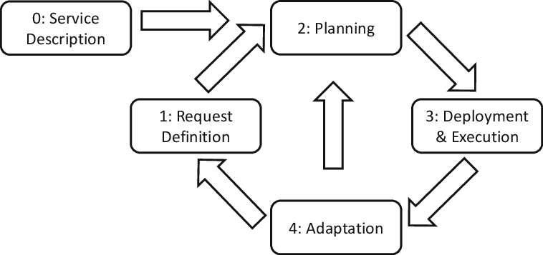

# SIEM

* SIEM stands for Security Information and Event Management. It is a comprehensive approach to security management that combines two critical functions: Security Information Management (SIM) and Security Event Management (SEM).
* SIEM solutions collect, aggregate, and analyze data from various sources within an organization's IT environment, including logs from systems, applications, network devices, and security controls.
* The primary goal of SIEM is to provide real-time visibility into an organization's security posture and enable effective threat detection, incident response, and compliance management.

**Key Components of SIEM:**

1. **Data Collection:** SIEM solutions collect data from various sources, such as logs from firewalls, intrusion detection systems (IDS), antivirus software, servers, and applications. Data can be collected in real-time or near real-time.
2. **Data Aggregation and Correlation:** The collected data is aggregated and correlated to identify patterns, anomalies, and potential security incidents. Correlation rules help SIEM systems determine if specific events or activities indicate a potential security threat.
3. **Alerting and Incident Detection:** When a security event matches predefined correlation rules or thresholds, the SIEM generates alerts to notify security analysts of potential incidents.
4. **Incident Response and Workflow:** SIEM solutions provide incident response workflows, enabling security teams to investigate and respond to security incidents efficiently.
5. **Reporting and Compliance:** SIEM generates reports and dashboards that provide insights into the organization's security posture, compliance status, and trends in security incidents.
6. **Threat Intelligence Integration**: SIEM systems often integrate with external threat intelligence feeds to enhance the detection of advanced threats and zero-day exploits.

**SIEM Life Cycle:**

The SIEM life cycle consists of several stages:

1. **Planning:** The organization identifies its security requirements, goals, and budget constraints. This stage involves evaluating the scope of the SIEM deployment, defining use cases, and identifying data sources to be integrated.
2. **Design and Architecture**: During this stage, the SIEM architecture is designed to meet the organization's specific needs. Decisions are made on hardware, software, data storage, and scalability requirements.
3. **Deployment**: The SIEM solution is implemented and integrated into the organization's IT environment. Data sources are connected, and the necessary configurations are applied.
4. **Data Collection and Onboarding:** Data sources are onboarded to the SIEM platform, and log data collection begins. This process may involve configuring agents, syslog servers, or APIs to forward logs to the SIEM.
5. **Tuning and Customization:** SIEM correlation rules and alerts are tuned and customized to match the organization's threat landscape and security policies. This step ensures that the SIEM produces actionable and relevant alerts.
6. **Training and Skill Development**: Security analysts and SOC teams are trained on using the SIEM effectively for threat detection, incident response, and compliance reporting.
7. **Operationalization:** The SIEM becomes an integral part of the organization's security operations. Security analysts continuously monitor the SIEM for alerts and respond to potential security incidents.
8. **Maintenance and Updates:** Regular maintenance, software updates, and tuning of the SIEM are performed to ensure its optimal performance and effectiveness.
9. **Continuous Improvement**: Organizations continuously evaluate the SIEM's performance, identify areas of improvement, and enhance its capabilities to address emerging threats and new requirements.
10. **Retirement or Replacement**: As technology evolves and security needs change, organizations may retire or replace their SIEM solution to keep up with the latest security challenges.

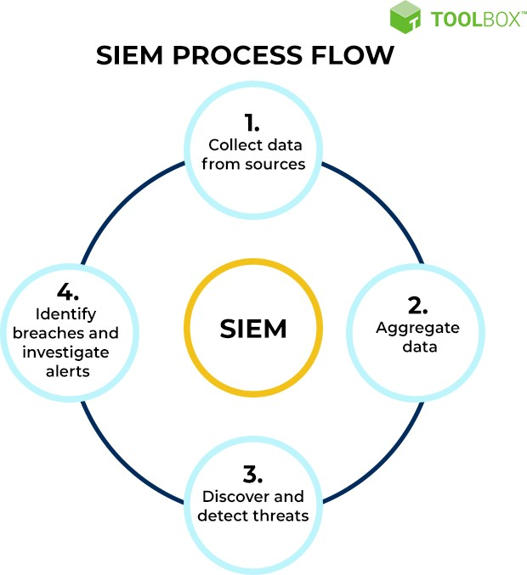

**Five Predictions For The Future Of SIEM (Security Information and Event Management):**

1. **AI-Powered Threat Detection and Response:** SIEM solutions will increasingly leverage artificial intelligence (AI) and machine learning (ML) to enhance threat detection and response capabilities. AI algorithms can process vast amounts of security data, identify patterns, and detect anomalies in real-time, enabling more accurate and proactive threat hunting.
2. **Cloud-Native SIEM Solutions:** As organizations continue to migrate their infrastructure and applications to the cloud, SIEM solutions will follow suit. Cloud-native SIEM platforms will emerge, offering more flexibility, scalability, and ease of deployment for cloud-based environments.
3. **Integration with IoT and OT Security:** With the proliferation of Internet of Things (IoT) and Operational Technology (OT) devices, SIEM solutions will need to extend their capabilities to monitor and analyze the security of these devices and networks. Integration with IoT and OT security tools will become crucial for comprehensive threat monitoring.
4. **User and Entity Behavior Analytics (UEBA) Integration:** SIEM solutions will increasingly integrate User and Entity Behavior Analytics (UEBA) to better understand and detect abnormal user behavior. UEBA can provide insights into insider threats, compromised accounts, and other user-related risks.
5. **Automated Incident Response and Orchestration:** SIEM platforms will evolve to include automated incident response and security orchestration capabilities. This means that in addition to detecting threats, SIEM will be able to trigger automated responses or collaborate with other security tools to take immediate action against threats without human intervention.

# How you think you deploy soc in your college

Deploying a Security Operations Center (SOC) in an organization involves careful planning, resource allocation, and a structured approach.

**Assessment and Requirements Gathering:**

1. Conduct a thorough assessment of the organization's current cybersecurity posture, including existing security measures, tools, and processes.
2. Identify the specific security challenges, risks, and compliance requirements that a SOC will address.
3. Define the goals and objectives of the SOC deployment to align with the organization's overall security strategy.
4. Budget and Resource Allocation: Determine the budget and resource requirements for establishing and maintaining the SOC.

Allocate personnel, hardware, software, and other necessary resources to support the SOC operations.

**Build a Skilled Team:**

* Recruit or assign skilled security professionals to form the SOC team.
* The team should include security analysts, incident responders, threat hunters, and SOC management personnel.

**Infrastructure and Technology Setup:**

* Establish the physical or virtual infrastructure for the SOC, including servers, network equipment, and storage.
* Deploy the required security technologies, such as SIEM,intrusion detection and prevention systems (IDS/IPS), firewalls, endpoint protection, and threat intelligence feeds.

**Integration and Data Collection:**

* Integrate security tools and systems with the SIEM to centralize log and event data collection.
* Ensure that critical data sources, such as firewalls, servers, network devices, and applications, are sending logs to the SIEM.

**Establish Processes and Procedures:**

* Define standard operating procedures (SOPs) for various SOC activities, including incident handling, response protocols, escalation procedures, and communication guidelines.
* Implement incident categorization and prioritization mechanisms.

**Implement Monitoring and Alerting:**

* Configure the SIEM to generate real-time alerts based on predefined correlation rules and security use cases.
* Fine-tune alerting thresholds to minimize false positives and focus on critical alerts.

**Incident Response and Escalation:**

* Develop a formal incident response plan that outlines the steps to be taken in the event of a security incident.
* Define roles and responsibilities for incident handling, and establish a clear escalation path for severe incidents.

**Training and Skill Development:**

* Provide comprehensive training to the SOC team on the use of security tools, incident analysis, threat hunting, and incident response best practices.
* Keep the team updated on the latest cybersecurity trends, attack techniques, and relevant certifications.

**Testing and Continuous Improvement:**

* Conduct regular tabletop exercises and simulated cyber attack scenarios to test the SOC team's response capabilities.
* Use the insights gained from testing to improve and refine the SOC's processes and procedures.

**Monitoring and Reporting:**

* Continuously monitor the SOC's performance and effectiveness in detecting and responding to security incidents.
* Generate regular reports and metrics to measure the SOC'sperformance and communicate its value to stakeholders.

**Integration with IT and Business Functions:**

* Foster collaboration between the SOC and other IT and business units to ensure a coordinated approach to security.
* Engage with executive management and board members to gain support and buy-in for SOC initiatives
* Deploying a SOC is an ongoing process that requires adaptability and continuous improvement. Regular assessments, training, and update are essential to ensure that the SOC remains effective in addressing the organization's evolving security challenge.

# Qradar and Its Details:

* IBM QRadar is a leading Security Information and Event Management (SIEM) solution designed to help organizations detect, investigate, and respond to cybersecurity threats effectively.
* It provides comprehensive visibility into an organization's security environment by collecting and analyzing data from various sources, including logs, network traffic, and security devices. Here are some key details about IBM QRadar

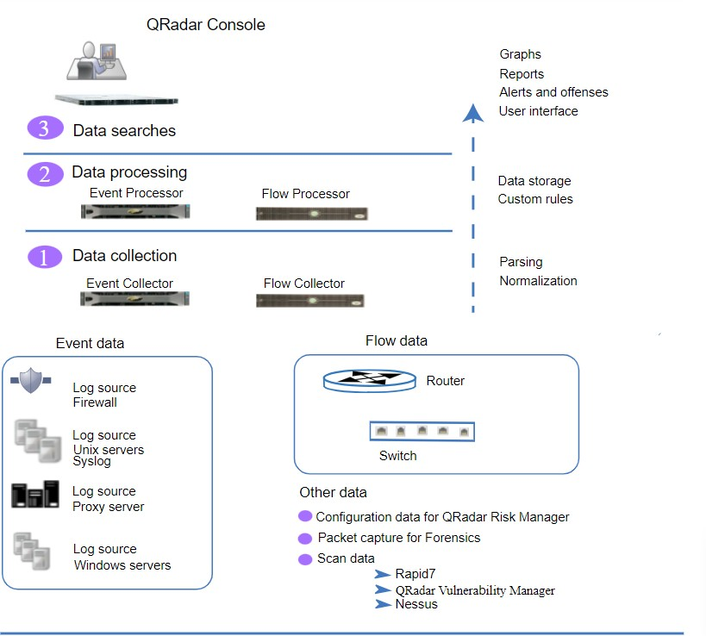

**Key Features and Capabilities:**

1. **Log Management:** QRadar collects and stores logs from various devices, systems, and applications, enabling centralized log management and analysis.
2. **Real-Time Event Correlation:** The platform uses advanced correlation algorithms to detect security incidents by analyzing events from multiple sources and identifying patterns of malicious activity.
3. **Network Traffic Analysis:** QRadar monitors network traffic to detect suspicious behavior, such as unusual communication patterns or data exfiltration.
4. **User and Entity Behavior Analytics (UEBA):** QRadar includes UEBA capabilities to identify abnormal user behavior and potential insider threats.
5. **Threat Intelligence Integration:** The platform integrates with external threat intelligence feeds to enhance threat detection and provide context on emerging threats.
6. **Incident Investigation and Forensics:** QRadar provides tools for incident investigation and forensic analysis, helping security analysts understand the scope and impact of security incidents.
7. **Security Incident Response:** The platform offers automated incident response workflows and integrations with security tools to enable faster response times and remediation.
8. **Compliance Reporting:** QRadar includes pre-built compliance reporting templates to assist with meeting regulatory requirements and security audits.
9. **Anomaly Detection:** The platform uses behavioral analysis and anomaly detection techniques to identify deviations from normal patterns of activity.

**Deployment Options:**

1. **On-Premises Deployment:** Organizations can deploy QRadar on their own infrastructure, allowing them to have complete control over the system and data.
2. **Cloud Deployment:** IBM also offers QRadar on the cloud, providing organizations with the flexibility and scalability of cloud-based SIEM.

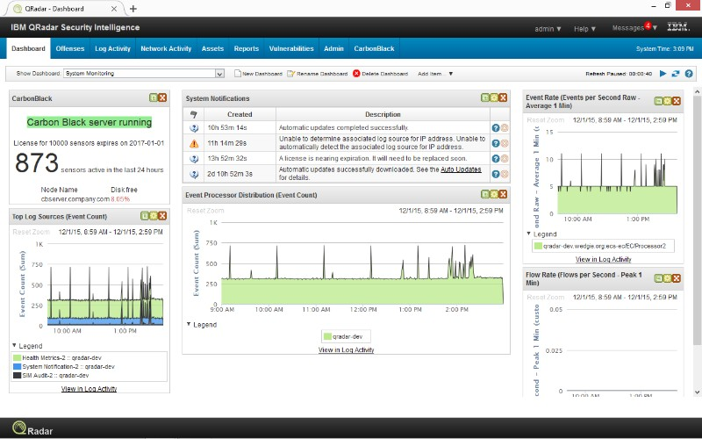

**Figure Name : QRadar dashboard**

**Benefits:**

1. **Centralized Visibility:** QRadar provides a single pane of glass view of an organization's security posture, allowing security teams to monitor and manage security events from a centralized location.
2. **Threat Detection and Response:** By leveraging advanced analytics and correlation, QRadar helps identify security incidents in real-time, enabling faster incident response.
3. **Compliance Management:** QRadar's reporting capabilities assist organizations in meeting compliance requirements and demonstrating adherence to security policies.
4. **Reduced Incident Dwell Time:** The platform's capabilities to detect and respond to threats efficiently help reduce the time between detection and remediation.
5. **Scalability:** QRadar can scale to handle large amounts of security data and event logs, making it suitable for organizations of all sizes.
6. **Integration Ecosystem:** QRadar offers an extensive integration ecosystem with other security tools, allowing organizations to create a comprehensive security architecture.

**Conclusion:**

IBM QRadar is a robust and well-established SIEM solution that has earned a reputation for its capabilities in threat detection, incident response, and compliance management. Its advanced analytics and ability to integrate with various security tools make it a popular choice for organizations seeking to strengthen their cybersecurity defenses.