## Facebook Test Cases for New User Sign Up

A registration page is a page where users can sign up for an account and a log in page is one where users can log in to an existing account. This Page is usually the first page that users see when they visit a website.

Sign Up Page Looks Like:

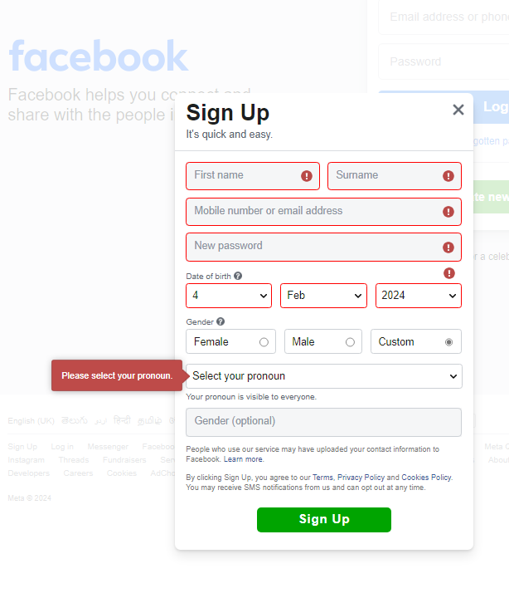

| **Features to be Tested** | **Test Cases** |
| --- | --- |
| **Email field** | 1. Test that the email field is in the correct format 2. Test that the email address is in the correct format 3. Enter an invalid email address in the email field. 4. Enter an email address with special characters in the email field. 5. Enter an email address with spaces in the email field. 6. Leave the email field blank. |
| **Terms and conditions** | 1. Test that the terms and conditions are accepted 2. The user should be able to read the terms and conditions before ticking the checkbox. 3. The user should be able to tick the checkbox only if they have read and agreed to the terms and conditions. 4. The user should be able to see a confirmation message after ticking the checkbox and submitting the form. 5. Verify that the terms and conditions are visible on the registration page. 6. Verify that the terms and conditions can be scrolled through. 7. Verify that the terms and conditions can be printed. 8. Verify that the terms and conditions can be downloaded as a PDF. 9. Verify that the terms and conditions can be emailed to a user. |
| **Password** | 1. Password should be a minimum of 8 characters long. 2. Password should have at least 1 uppercase letter. 3. Password should have at least 1 lowercase letter. 4. Password should have at least 1 number. 5. Password should have at least 1 special character. 6. Password should not be same as username. 7. Test the password and confirm password fields match. |
| **Confirmation message** | Test that the user can see a confirmation message after a successful registration |
| **Registration form** | 1. Enter all valid details in the registration form and check if the user is able to register successfully 2. Enter all invalid details in the registration form and check if the user is able to register successfully 3. Try to register with an already existing username and check if the user is able to register successfully |
| **Login page** | Test that the user is redirected to the login page after a successful registration |
| **Date of Birth Field** | 1. Enter & Verify Enter Valid Date of Birth, DD/MMM/YYYY, [ 1 – 31 (Date), Jan – Dec (Month), 1905 – Current Year (Year) ]. |
| **Gender & Gender(optional)** | Select & Verify the Gender:  If Selected Custom:  Then need to select pronoun either He/ Him or She/ Her or They/ Them  Else If selected Female;  Else Male |