# Image result for stlc

# Requirements Analysis

# Define Problem/ Problem Understanding:

Specify Business Problem:

Providing flexible and prominent services to end users to connect with friends and families throughout the globe

Business Requirements:

A FACEBOOK project can have a variety of business requirements, depending on the specific goals and objectives of the project. Some potential requirements may include:

* Accurate and up-to-date information: The project should use the most recent and reliable information to connect and search friends and family, in order to ensure that the information is accurate and relevant to end user requirements
* Flexibility: The FACEBOOK system should be flexible and able to adapt to end user requirements in searching their near ones in an accurate way.
* Compliance: The project should comply with all relevant laws and regulations.
* User-friendly interface: The FACEBOOK system should be easy to use and understand for end user actions in an efficient manner.

Literature Survey:

A literature survey for a FACEBOOK project would involve researching and reviewing existing studies, articles, and other publications on the topic of drug classification. The survey would aim to gather information on current scheduling/appointment systems, their strengths and weaknesses, and any gaps in knowledge that the project could address. The literature survey would also look at the methods and techniques used in previous drug classification projects, and any relevant data or findings that could inform the design and implementation of the current project.

Social Impact and Business Impact:

**Social Impact :-** Improved end user Interface By providing accurate and up-to-date information about friends suggestion to connect with them, a FACEBOOK project can help end user to  make more informed decisions, like suggesting friends  belong to them or not, leading to improved  UI.  
**Business Impact:** By providing information about friends and family around the globe in different ways, A FACEBOOK project can assist  end users in the accepting and rejecting of new notifications if in case the friends/family does not belong to them.

1. Test Planning:

Test Case Scenario: -

User Interface Login Page:

|  |  |
| --- | --- |
| features to be tested | test cases |
| Login Page | 1. Open the browser and enter the URL for the Facebook login page. |
| 2. Verify that the password textbox is present on the UI login page. |
| 3. Verify that the username textbox is present on the UI login page. |
| 4. Verify that the login button is present on the UI login page. |
| Credentials Page | 1. Enter the valid username and password in the respective text boxes and click on the login button. |
| 2. Verify that the error message is displayed when the user tries to login with invalid credentials. |
| Profile Page | Verify that the user is able to login successfully by checking the presence of the profile name. |
| Error Message | 1. Verify that the user is able to see the error message when the username is wrong. |
| 2. Verify that the user is able to see the error message when the password is wrong. |
| Home Page | 1. Verify that the user is able to see the home page after successful login. |
| 2. Verify that the user is able to see the logout button on the home page. |

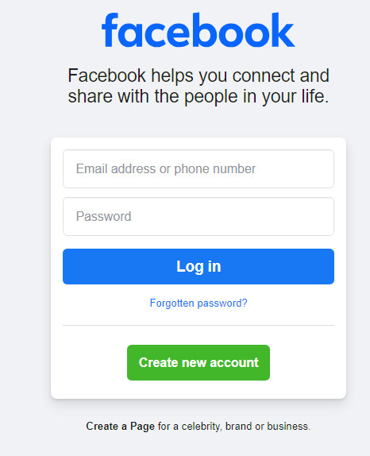

New User sign up:

|  |  |
| --- | --- |
| Features to be tested | test cases |
| Email Field | 1. Test that the email field is in the correct format 2. Test that the email address is in the correct format. 3. Enter an invalid email address in the email field. 4. Enter an email address with special characters in the email field. 5. Enter an email address with spaces in the email field. 6. Leave the email field blank. |
| Terms and Conditions | 1. Test that the terms and conditions are accepted 2. The user should be able to read the terms and conditions before ticking the checkbox. 3. The user should be able to tick the checkbox only if they have read and agreed to the terms and conditions. 4. The user should be able to see a confirmation message after ticking the checkbox and submitting the form. 5. Verify that the terms and conditions are visible on the registration page. 6. Verify that the terms and conditions can be scrolled through. 7. Verify that the terms and conditions can be printed. 8. Verify that the terms and conditions can be downloaded as a PDF. 9. Verify that the terms and conditions can be emailed to a user. |
| Password | 1. Password should be a minimum of 8 characters long. 2. Password should have at least 1 uppercase letter. 3. Password should have at least 1 lowercase letter. 4. Password should have at least 1 number. 5. Password should have at least 1 special character. 6. Password should not be same as username. 7. Test the password and confirm password fields match |
| Confirmation message | Test that the user can see a confirmation message after a successful registration. |
| REGISTRATION FORM | 1. Enter all valid details in the registration form and check if the user is able to register successfully. 2. Enter all invalid details in the registration form and check if the user is able to register successfully. 3. Try to register with an already existing username and check if the user is able to register successfully |
| LOGIN PAGE | Test that the user is redirected to the login page after a successful registration |
| DATE OF BIRTH | Select and Verify the Label, Value, Index  For Day/ Month/ Year Fields. |
| GENDER | Try to Select and Verify that the user can able to select on the desired field. |

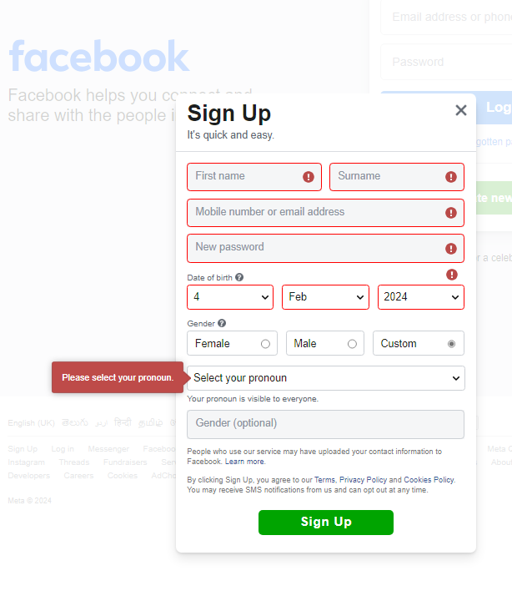

3. Test Case Development:

C:\Users\91868\git\SI-GuidedProject-705681-1704985596\Facebook_Test_Case_Developmen.xlsx

4. Test ENVIRONMENT Setup:

software tools:

~ katalon studio (software automation test tool)

~ Git & GITHUB (project REPOSITORY INTEGRATING with katalon studio)

~ Jenkins

hardware:

~ necessary hardware and network configuration for test execution

5. test execution:

in katalon studio tools.

(Test execution, defect logging, test data preparation, test environment setup, test result analysis, defect retesting, test reporting)

6. test Closure:

test summary report in katalon studio, and project is in

GitHub repository

<https://github.com/smartinternz02/SI-GuidedProject-705681-1704985596>

Best regards,

Althaf Shaik.