**Garbage Classification Using IBM Cloud**

**1 INTRODUCTION**

1.1 **Overview**

With the increase in the number of industries in the urban area, the disposal of solid waste is really becoming a big problem, and solid waste includes paper, wood, plastic, metal, glass, etc. The common way of managing waste is burning waste and this method can cause air pollution and some hazardous materials from the waste spread into the air which can cause cancer. Hence it is necessary to recycle the waste to protect the environment and human beings’ health, and we need to separate the waste into different components which can be recycled using different ways. The present way of separating waste/garbage is the hand-picking method, whereby someone is employed to separate out the different objects/materials. The person who separates waste is prone to diseases due to the harmful substances in the garbage. This problem can be overcome by automating the garbage classification process.

In this project, we have build a deep learning model that can detect and classify types of garbage. A web application is integrated with the model, from where the user can upload a garbage image like paper waste, plastic waste, etc., and see the analyzed results on User Interface.

1.2 **Purpose The use of this project.**

The problem is pretty much straight forward, we all are familiar with Garbage and waste material which is very harmful for our society. If we talk about amount of waste then the world almost generates at least 5 million tons of waste per day and this number is still increasing day by day that's why we need to aware about waste. This model which helps us to classify waste with 7 different waste materials and it will show you the details of that particular waste materials. This will help to raise awareness for people to reduce and recycle waste.

**2 LITERATURE SURVEY**

2.1 **Existing problem Existing approaches**

Solid Waste Management is of critical concern and needs attention. Whereas many developed countries are searching for ready-made sustainable waste management solutions.

Waste that goes uncollected can lead to blocked drains, flooding and the spread of waterborne diseases. Organic matter dumped in landfills — where it lacks the air to decompose quickly — generates methane gas, accelerating climate change.

The plant, which burns waste instead of fossil fuels, is capable of converting 450,000tons of trash into energy annually, delivering electricity to 30,000 households and heating to 72,000.Though it still produces CO2 emissions from burning, the city plans to install a system to capture the carbon released by the incineration process, and then store the carbon or find a commercial use for it.By tapping an otherwise unused resource, it will also help the city move away from its dependence on fossil fuels.

Typically, cities send out different trucks to collect different types of waste - one truck collecting plastic for recycling, another collecting food waste, for example. But that requires a lot of trucks, which means added costs and more traffic.

2.2 **Proposed solution**

In this project, we have build a deep learning model that can detect and classify types of garbage. A web application is integrated with the model, from where the user can upload a garbage image like paper waste, plastic waste, etc., and see the analyzed results on User Interface.

Garbage classification is a very important environmental protection issue in contemporary. The investigation found that due to the wide variety of garbage, people often cannot correctly determine which type of garbage they throw out. If it can be recognized intelligently, it can help people to classify and reduce the rate of misclassification. This project takes pictures of Garbage like CardBoard ,Paper,Plastic, Glass, Trash & Metal as identification objects, and trains through the establishment of a convolutional neural network model to realize automatic identification of garbage pictures and assist people in distinguishing various types of garbage.

3 **THEORITICAL ANALYSIS**

3.1 **Block diagram**

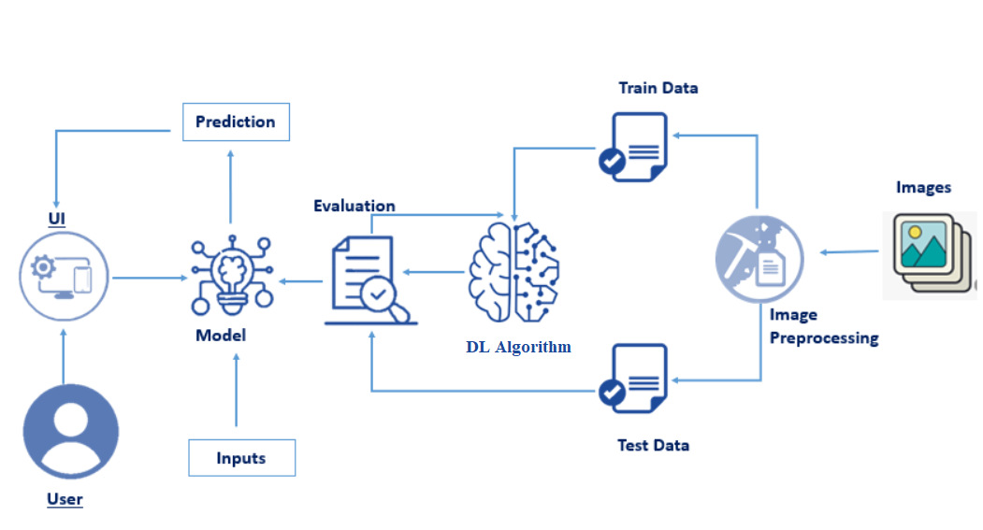

3.2 **Hardware and software requirements of the project**

To complete this project you should have the following software  and packages

**Anaconda Navigator :**

Anaconda Navigator is a free and open-source distribution of the Python and R programming languages for data science and machine learning related applications. It can be installed on Windows, Linux, and macOS.Conda is an open-source, cross-platform,  package management system. Anaconda comes with so very nice tools like JupyterLab, Jupyter Notebook,

QtConsole, Spyder, Glueviz, Orange, Rstudio, Visual Studio Code. For this project, we will be using Jupiter notebook and spyder

**Tensor flow:** TensorFlow is an end-to-end open-source platform for machine learning. It has a comprehensive, flexible ecosystem of tools, libraries, and community resources that lets researchers push the state-of-the-art in ML and developers can easily build and deploy ML powered applications.

**Keras :** Keras leverages various optimization techniques to make high level neural network API easier and more performant. It supports the following features:

* Consistent, simple and extensible API.
* Minimal structure - easy to achieve the result without any frills.
* It supports multiple platforms and backends.
* It is user friendly framework which runs on both CPU and GPU.
* Highly scalability of computation.

Flask: Web frame work used for building  Web applications

* **Python packages:**
  + open anaconda prompt as administrator
  + Type “pip install numpy” and click enter.
  + Type “pip install pandas” and click enter.
  + Type “pip install scikit-learn” and click enter.
  + Type “pip install tensorflow==2.3.2” and click enter.
  + Type “pip install keras==2.3.1” and click enter.
  + Type “pip install Flask” and click enter.

4 **EXPERIMENTAL INVESTIGATIONS**

- Image Pre-processing includes the following main tasks

* Import ImageDataGenerator Library.
* Configure ImageDataGenerator Class.
* Applying ImageDataGenerator functionality to the trainset and test set.

Note: The ImageDataGenerator accepts the original data, randomly transforms it, and returns only the new, transformed data.

* - As the input image contains three channels, we are specifying the input shape as (128,128,3).
* We have added a convolution layer with activation function as “relu” and

with a small filter size (3,3) and the number of filters (32) followed by a max-pooling layer.

* Max pool layer is used to downsample the input.( Max pooling is a pooling operation that selects the maximum element from the region of the feature map covered by the filter)
* Flatten layer flattens the input. Does not affect the batch size.

- A dense layer is a deeply connected neural network layer. It is the most common and frequently used layer.

* - The compilation is the final step in creating a model. Once the compilation is done, we can move on to the training phase. The loss function is used to find errors or deviations in the learning process. Keras requires loss function during the model compilation process.
* Optimization is an important process that optimizes the input weights by comparing the prediction and the loss function. Here we are using adam optimizer
* Metrics are used to evaluate the performance of your model. It is similar to the loss function, but not used in the training process

5 **FLOWCHART**

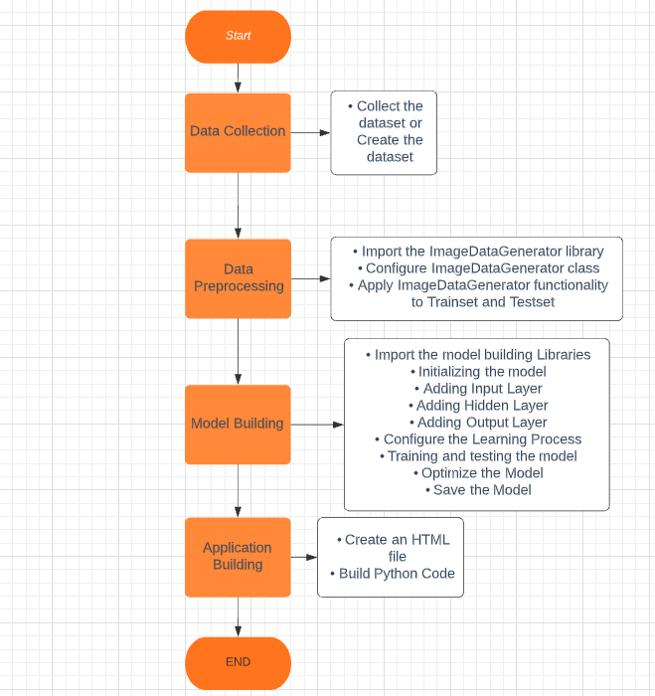

6 **RESULT**

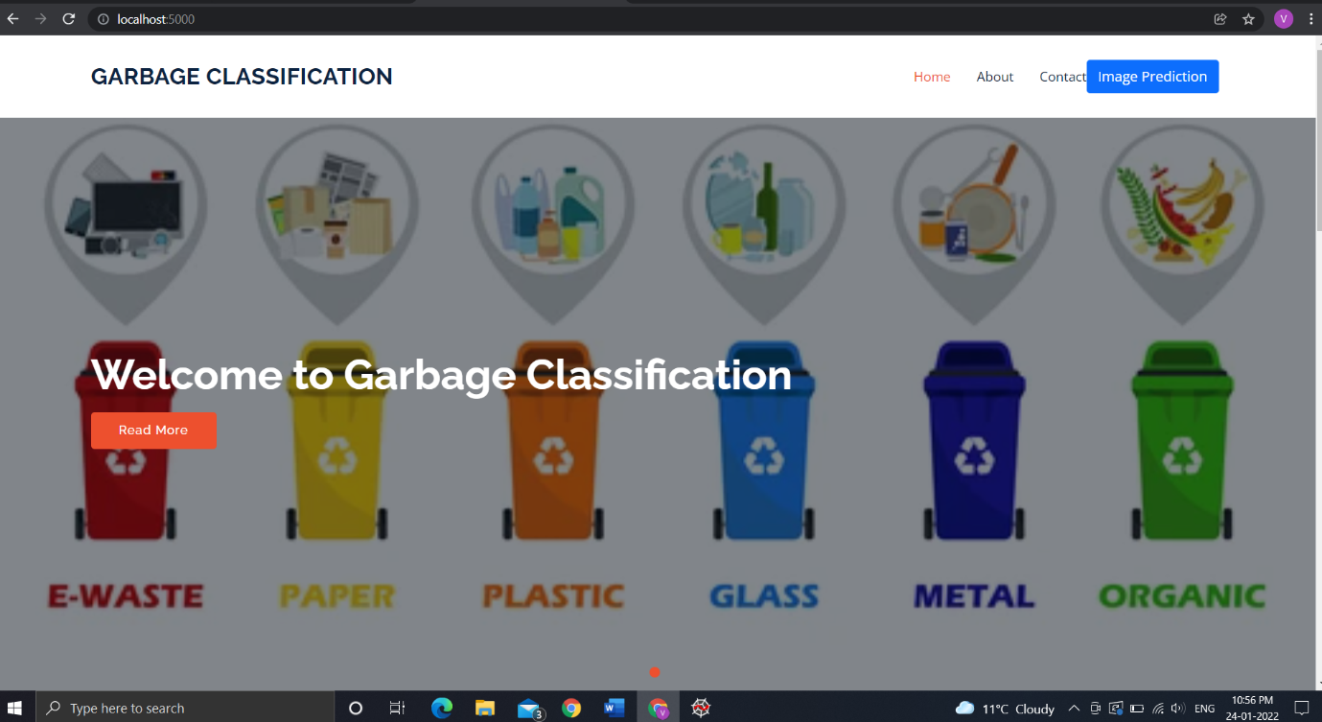

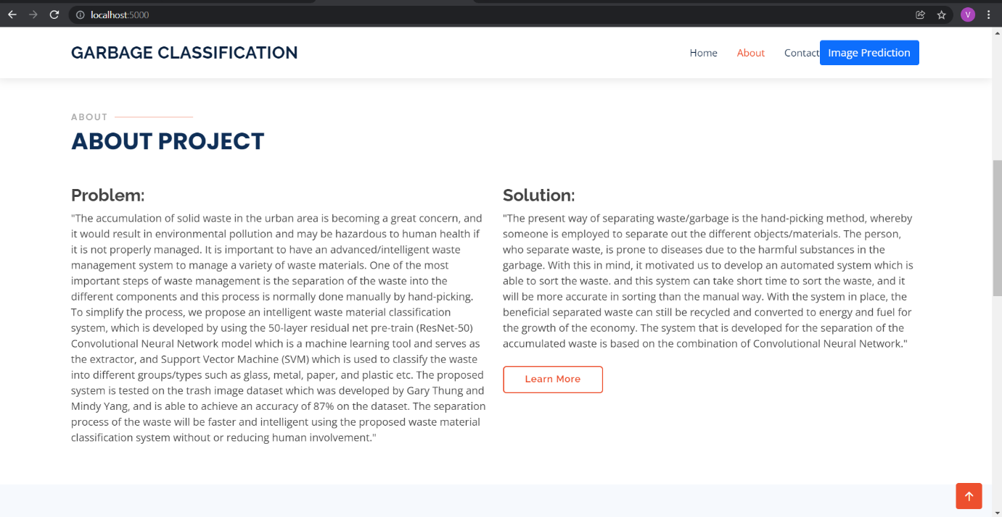

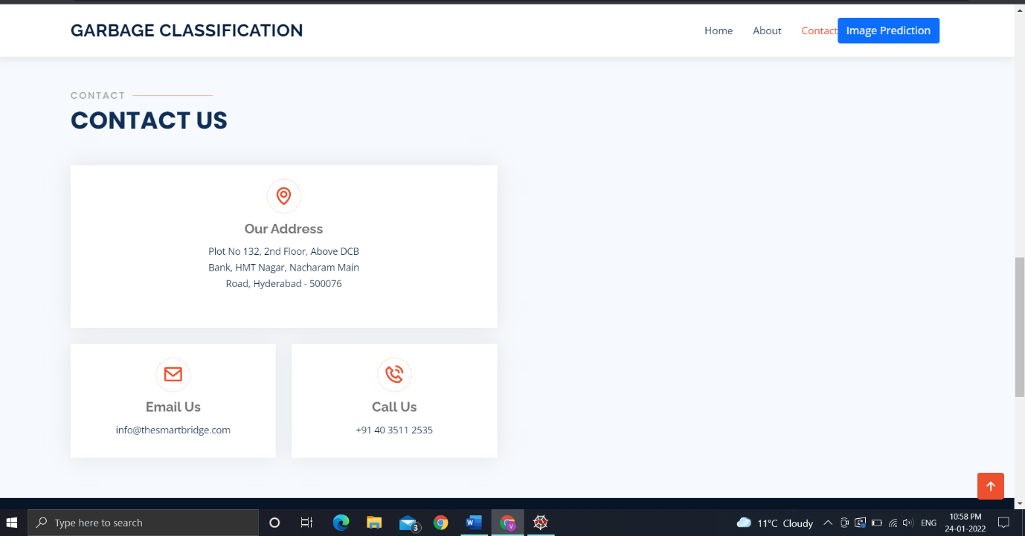



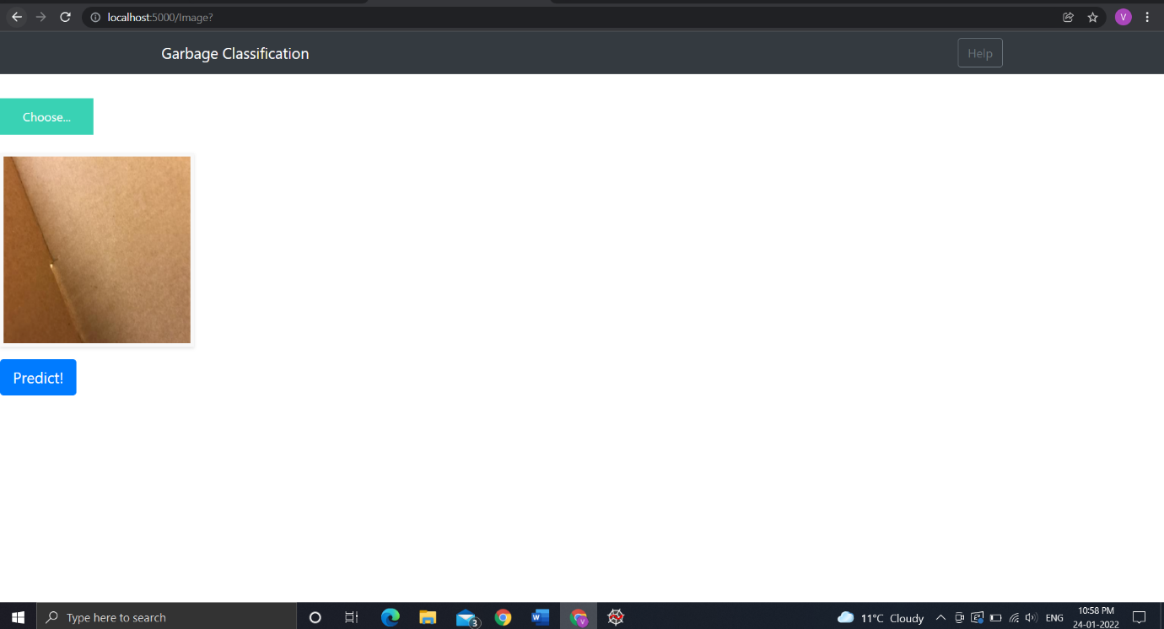

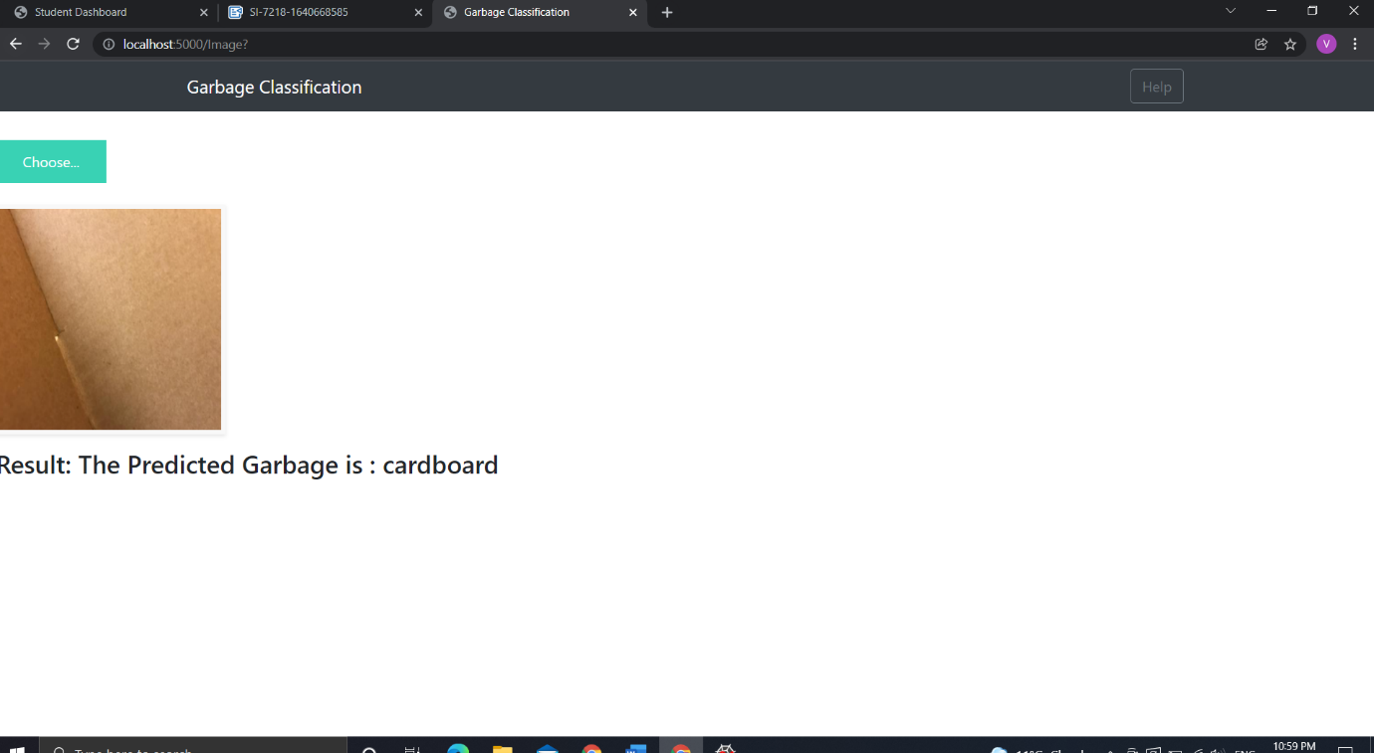

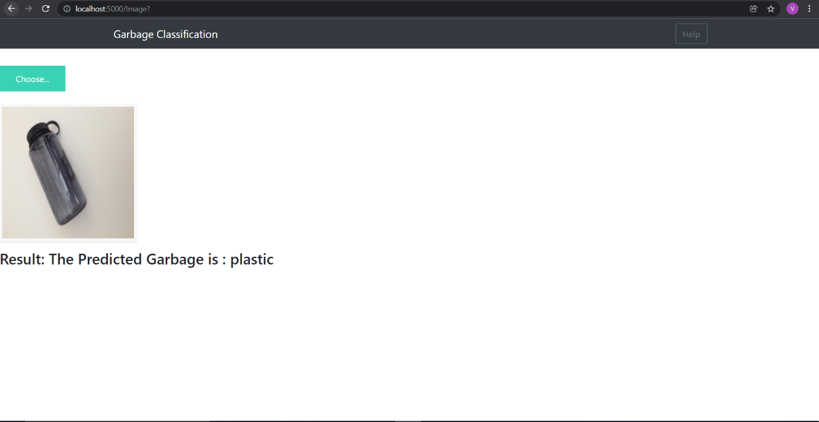

7 **ADVANTAGES & DISADVANTAGES**

Advantages:

* **reduce the amount of garbage disposal and treatment equipment**
* reduce the treatment cost
* reduce the consumption of land resources
* and have social, economic, and ecological benefits.

Disadvantages:

* Classification of Images with different Positions
* Adversarial examples
* Coordinate Frame
* Other minor disadvantages like performance

8 **APPLICATIONS**

The traditional waste classification techniques are manual, very slow, inefficient and costly. Therefore, automatic waste classification and management are essential for cities that are being urbanized for the better recycling of waste. In conclusion, a smart waste classification model is presented with all of its structures and the running environment that are essential to deploy the model in a real-world environment. The model is necessary with respect to advanced technologies, especially the concept of smart cities. The manual separation of waste and clustering of all waste items are unsuitable for smart cities.

The smart waste classification model is the basis for the multilayer convolutional deep learning model with some physical requirements, including a system with a conveyer belt, a pushing hammer and garbage baskets which will collect the garbage items pushed by the hammer according to the class of the waste item. The dataset used in this model is generated in a real-time environment with a high-resolution camera. Each waste item moving on the conveyer belt is firstly captured through a camera placed at a fixed position and then the picture of the waste item is given as an input to the trained model. The model predicts the class of the waste item and when the item reaches the relevant basket, it is thrown into it by activating the correct hammer. The deployment of this model will surely not only be helpful in fast real-time clustering of waste items but also allow recycling companies to use these waste items for the production of new items. The effect of this model on climate change will be very positive as less waste will be sent to landfills which will cause less burning of waste and garbage.

9 **CONCLUSION**

 CNN (convolutional neural network) model is used to classify garbage images, and the final accuracy is 83.32%. This model is used to assist people with garbage classification, reducing the time and energy needed for the classification and identification, so as to achieve the purpose of promoting garbage classification. With the promotion and advance of garbage classification, it is believed that public support for garbage classification will increase. Later, the research on garbage classification problem should be more on the optimization of each link, such as the planning of garbage transportation routes, various types of garbage recycling frequency, screening of garbage with correct classification and so on.

10 **FUTURE SCOPE**

The word sustainability has taken its place in the media ever since the 19th century, but business module approaches to sustainability have recently gained importance. Companies have started branding their companies as environment friendly in order to increase their sustainability and have a customer-friendly policy. Measuring demographic awareness for household and individual actions for waste management and taking measures against them is seen as a profit that the authorities can bring to socity. To sum up, Waste management's future includes turning waste into energy, IoT-enabled practices, improvement in monitoring systems, data collection, and much more technology-based advancements.