Day 1: 03/01/2022, Monday

Topic: Create your salesforce developer org to get started

Milestone / Activities: Creating Developer Account

Account Activation

Login to your Salesforce account

Detailed Description:

First sign up the developers.salesforce.com with all the required information, after clicking the sign up button I will get an email for activating the developer account, then I verify the account, then finally I login to the salesforce account

Upload the Screenshot of Milestone / Activity:

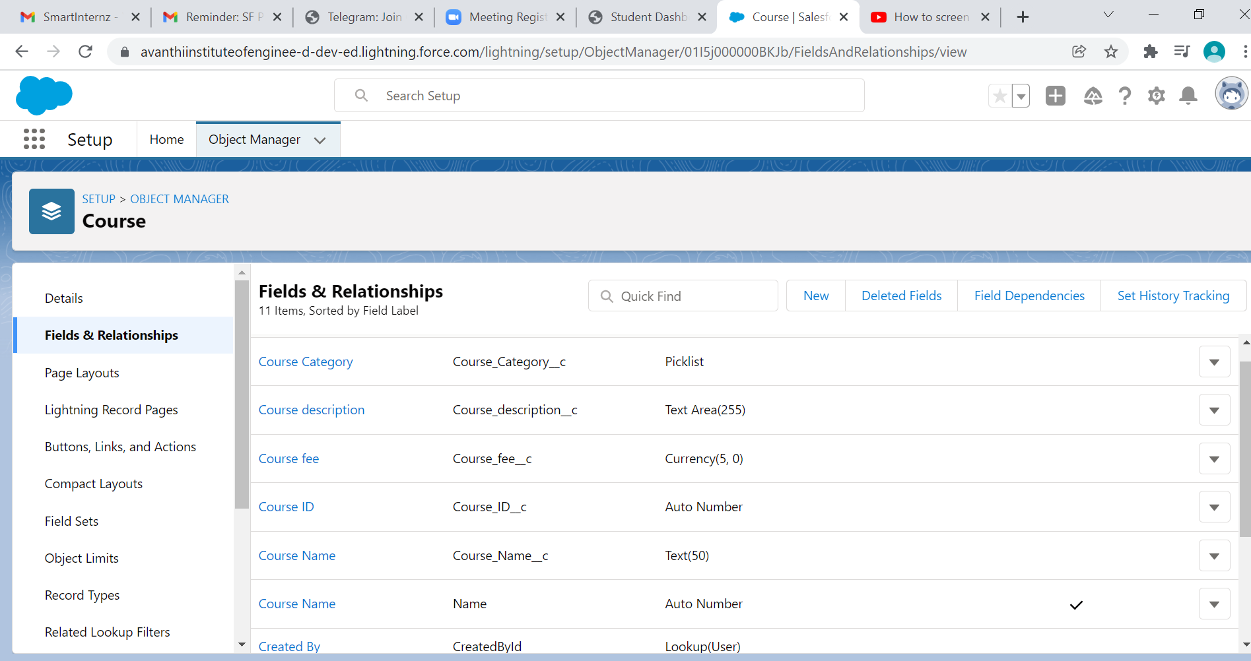

After Creating a Trainer Object the following are the fields we are created. Trainer ID, Full Name, Email, Phone Number, Whatsapp Number, Date of Birth, Age, Experience, LinkedIN Profile and Expertise.

Upload the Screenshot of Milestone / Activity: (Create Custom Fields On Trainer Object)

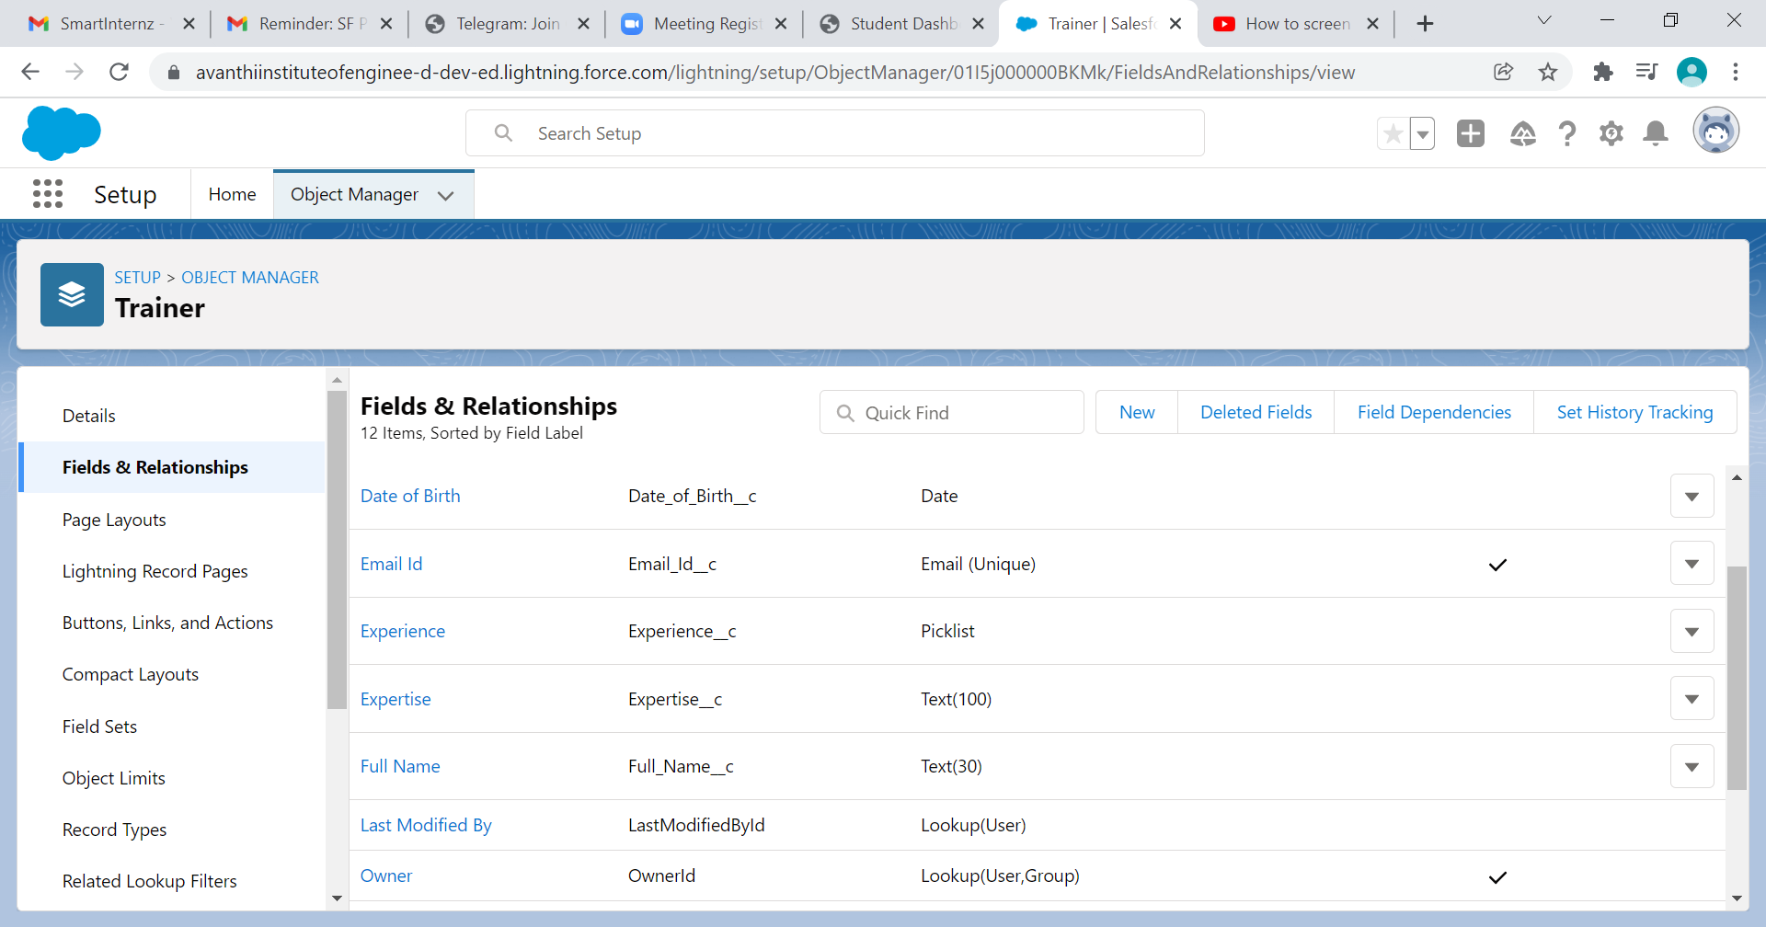

The following are the fields that are created on Student Object that are Student ID, First Name, Last Name, Email, Phone Number, Date of Birth, Whatsapp Number, Enrollment Date, Student and Enrollment.

Upload the Screenshot of Milestone / Activity: (Create Custom Fields On Student Object)

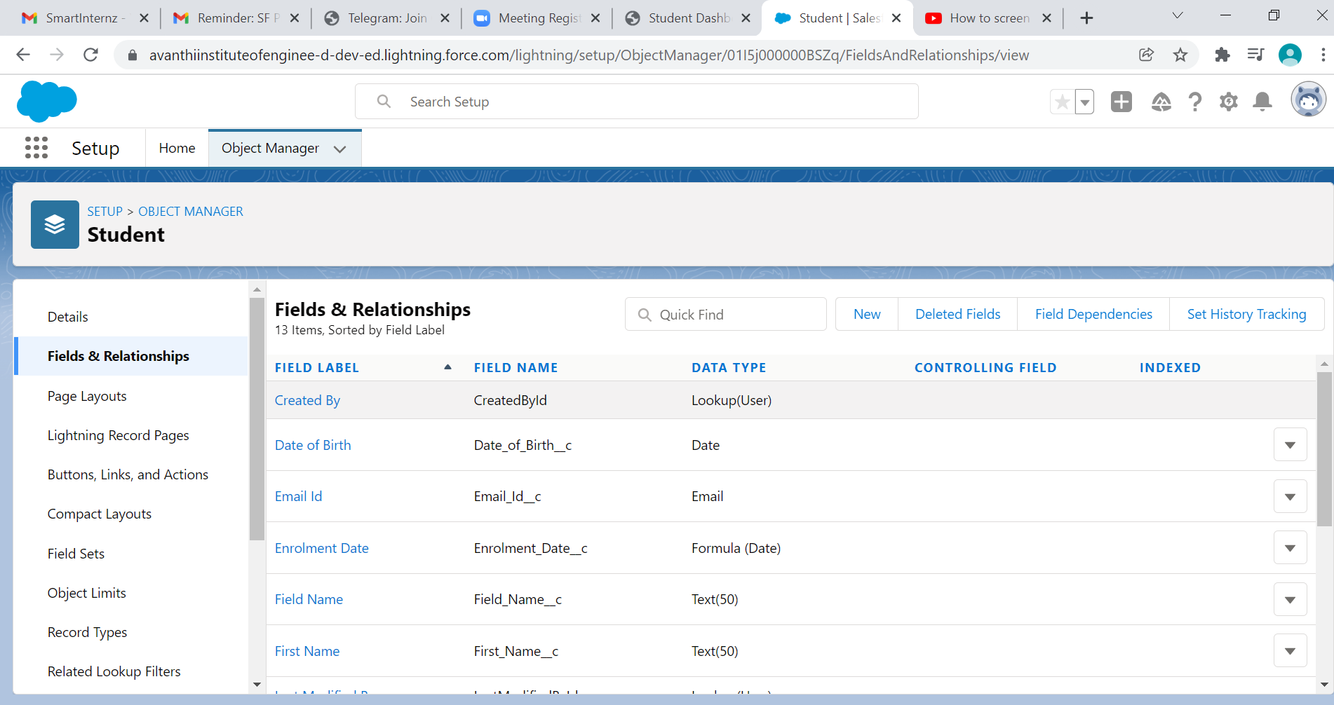

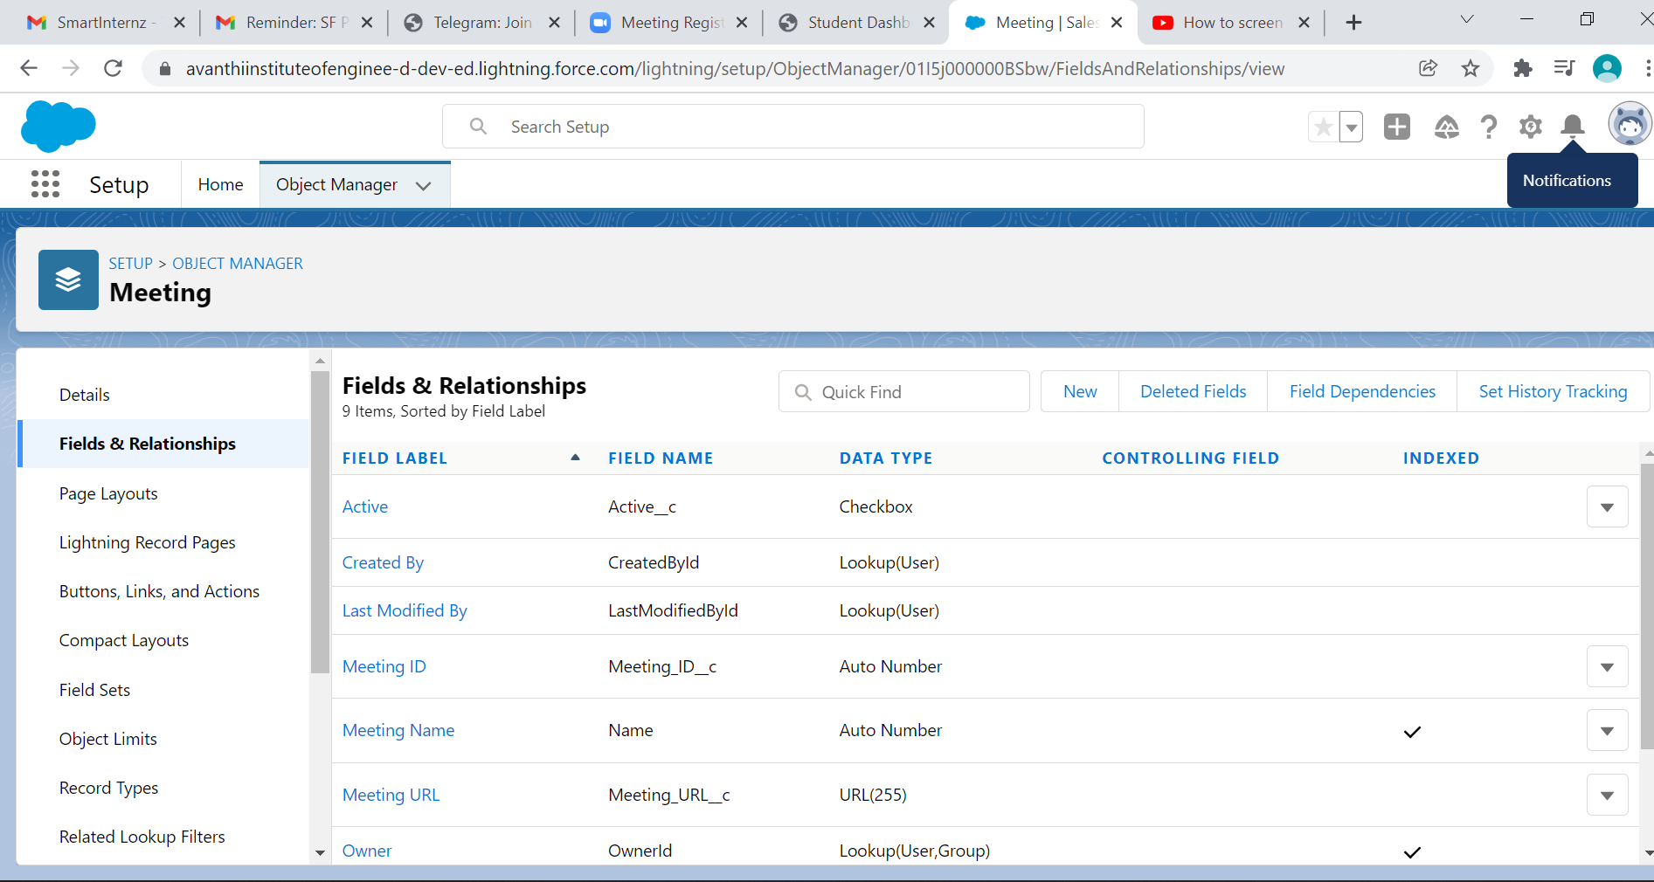

The following are the fields we are created on Batch Object that are Batch ID, Batch Type, Start Date, End Date, Course ID, Meeting ID, Trainer ID, Status, Number Of Students Enrolled and Details.

Upload the Screenshot of Milestone / Activity: (Create Custom Fields On Batch Object)

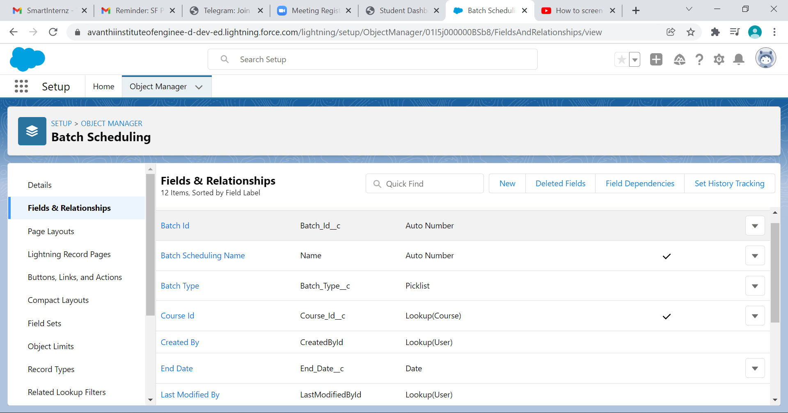

Day 3: 05/01/2022, Wednesday

Topic: Create Validation Rules

Milestone / Activities: Create Validation Rules on Course Object

Create Validation Rules on Trainer Object

Create Validation Rules on Student Object

Create Validation Rules on Meeting Object

Detailed Description:

From Object Manager find out the Course Object and create a validation rules on Course Object. The first validation rule are Course Fees cannot be negative by using the formula Course_Fees__c < 0. The second validation rule are Course Fees should be less than or equal to 3000 by using the formula Course_Fees__c <=3000.

Upload the Screenshot of Milestone / Activity: (Create Validation Rules on Course Object)

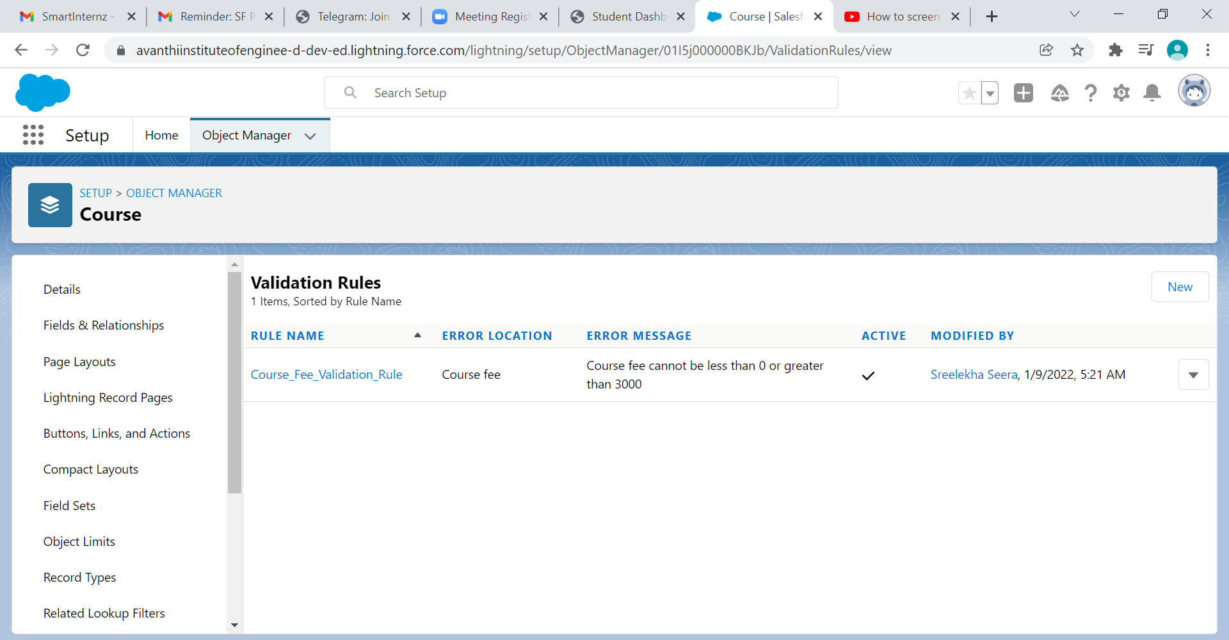

Create a validation rules on Trainer Object. The validation rules are FullName, Phone Number, Date of Birth and Experience fields should not be blank, age should not be less than 25 years and Phone Number and Whatsapp Number should have min 10 digits and max 15 digits.

Upload the Screenshot of Milestone / Activity: (Create Validation Rules on Trainer Object)

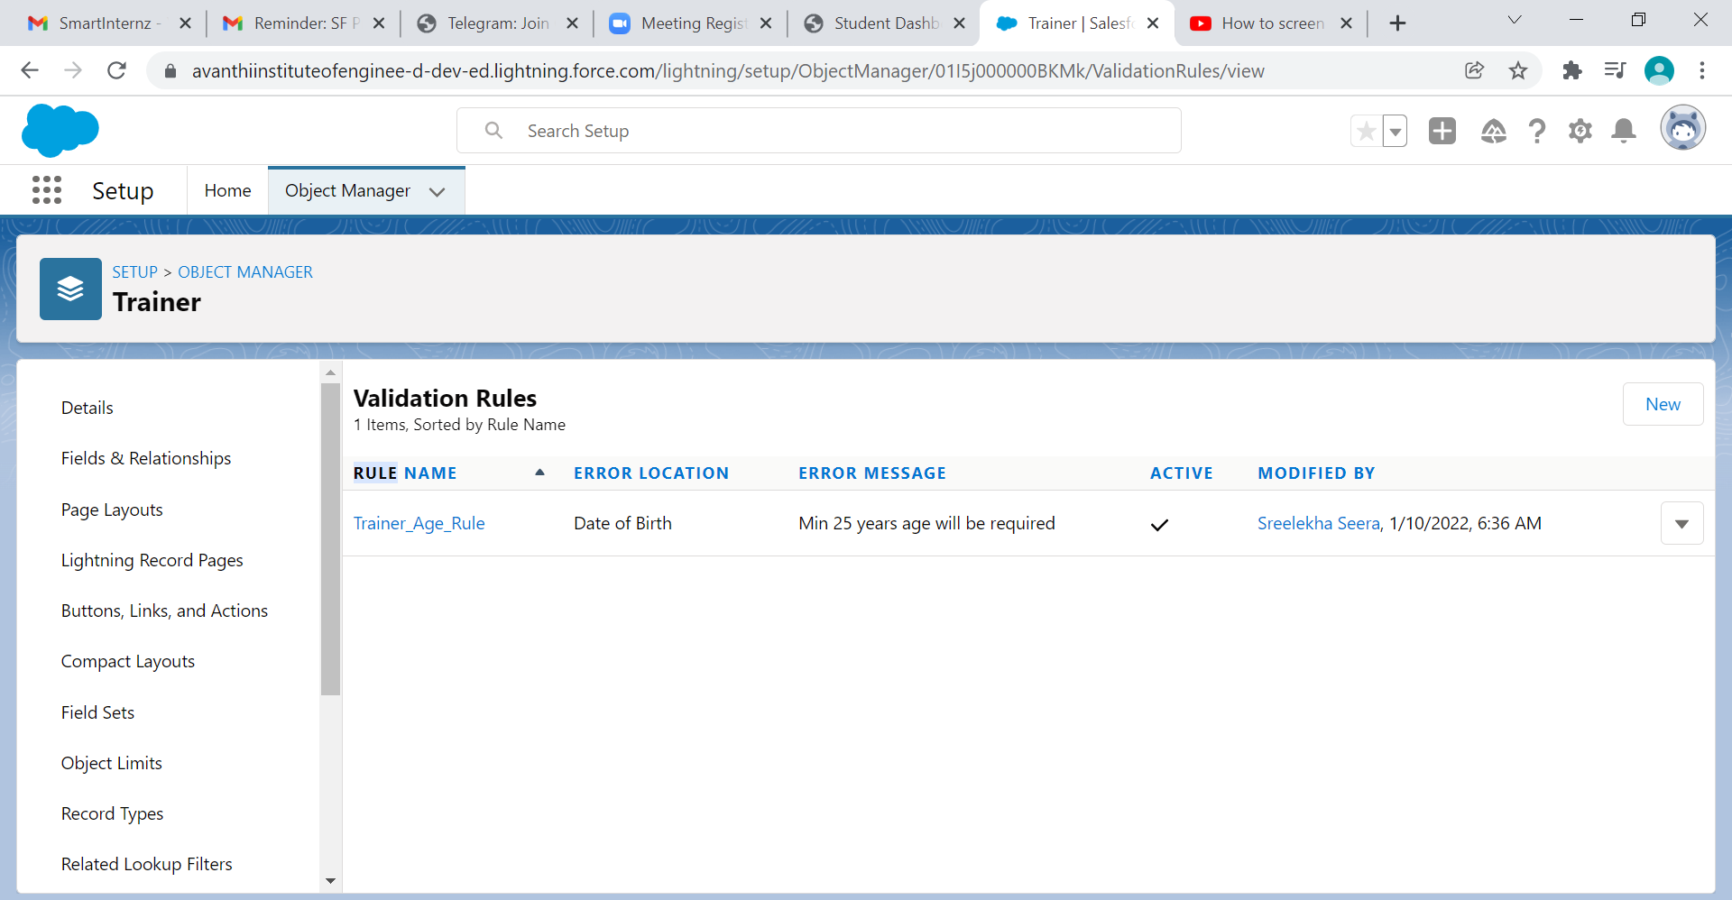

Create a validation rules on Student Object. The validation rules are Last Name should not be blank, Minimum 16 years of age and PhoneNumber and Whatsapp Number should have minimum 10 digit.

Upload the Screenshot of Milestone / Activity: (Create Validation Rules on Student Object)

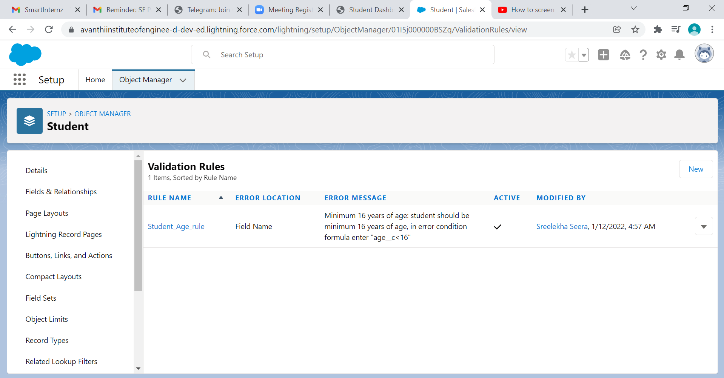

Create a Validation rules on Meeting Object. The validation rules are Valid from should not be less than current date, Valid to cannot be less than valid from and minimum 14 days difference in between valid from and valid to.

Upload the Screenshot of Milestone / Activity: (Create Validation Rules on Meeting Object)

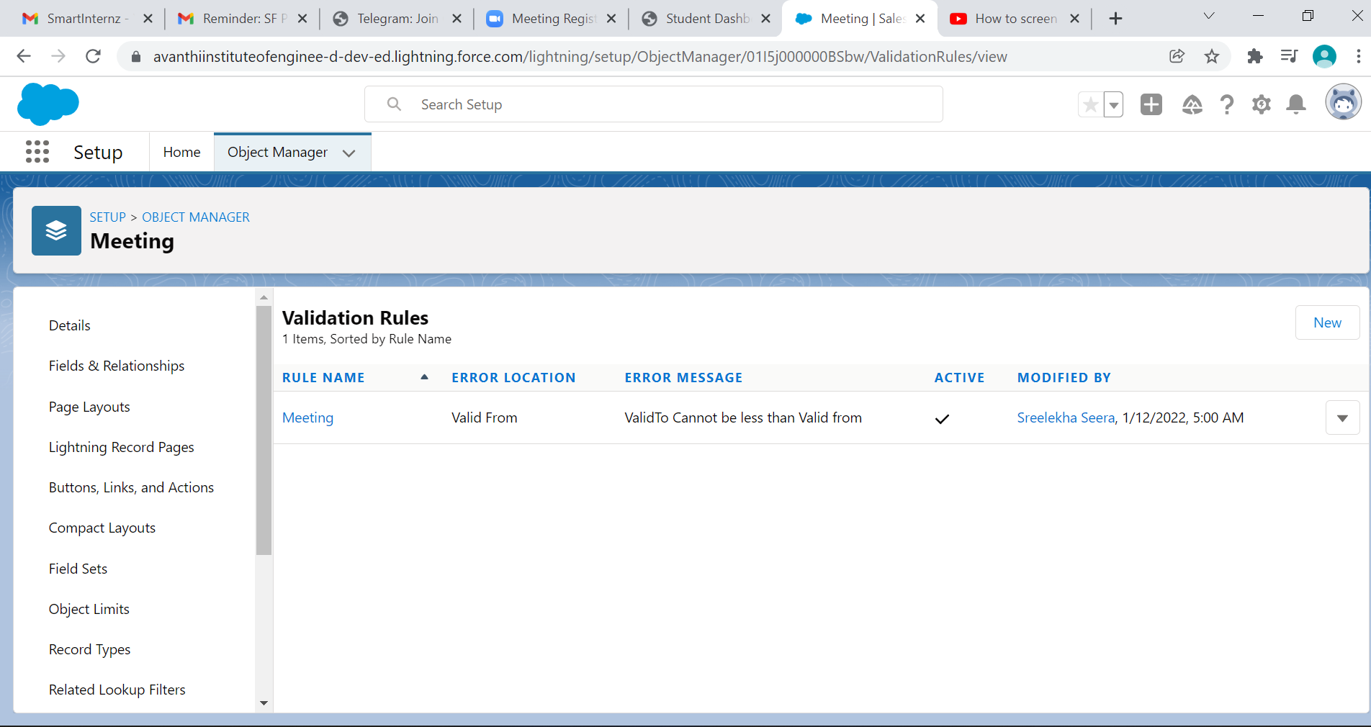

Day 5: 07/01/2022, Friday

Topic: Process Automation

Milestone / Activities: Creating Work Flow Rules On Meeting Object

Creating Work Flow Rules On Class/Batch Object

Detailed Description:

Search For Work Flow Rules on Object Manager. Create a Work Flow Rules on Meeting Object and enter a Rule name and in the formula section TODAY() - Valid_to__c = 1 and select active field in workflow action.

Create another Work Flow on Meeting Object and enter a rule name and in formula evaluates enter TODAY() - Valid_to__c = 1 and enter the details in Email Template in workflow action. Finally active the workflow actions.

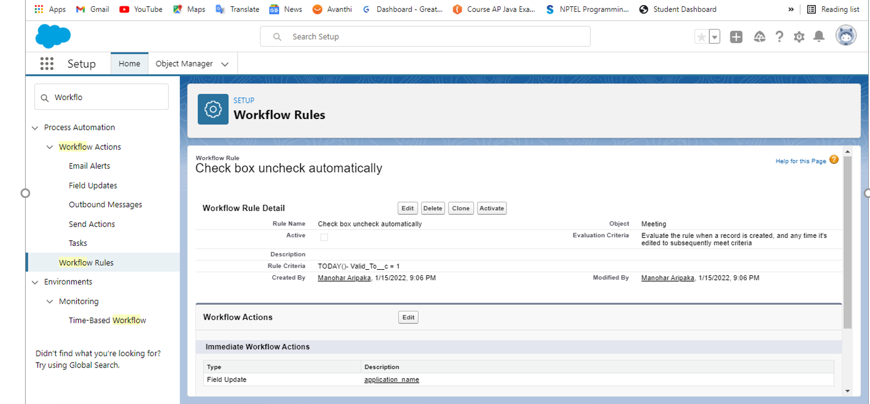

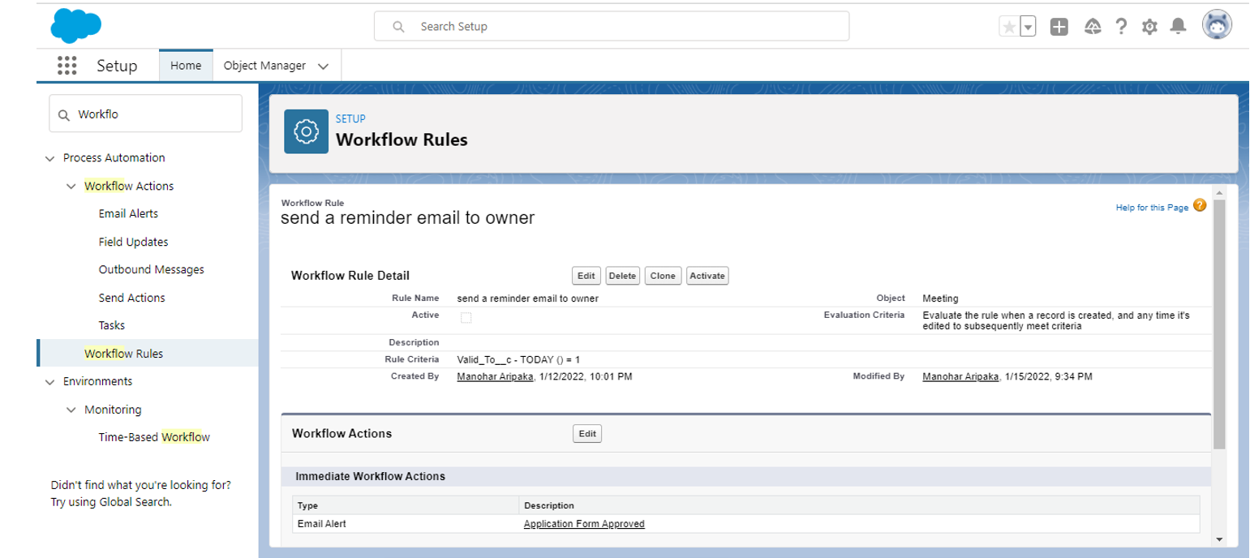

Upload the Screenshot of Milestone / Activity: (Creating Work Flow Rules On Class/Batch Object)

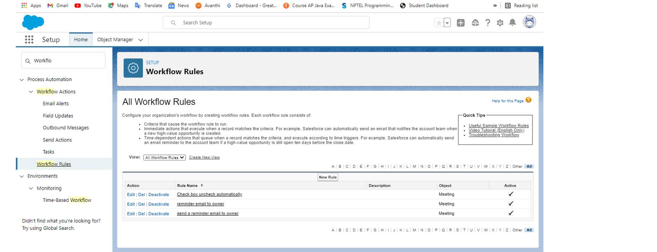

Day 6: 08/01/2022, Saturday

Topic: Creating Custom Pages Using VisualForce

Milestone / Activities: Creating New Course Using Custom Controller

Create New Trainer Using Custom Controller

Create New Student Using Standard Controller

Create New Meeting Using Standard Controller

Create New Batch Using Standard Controller

Detailed Description:

Open Developer Console and select File and then select new Visualforce page and paste the Course Visualforce code given in the task of "Creating New Course Using Custom Controller", and then select new apex class and paste the Course Controller code.

Upload the Screenshot of Milestone / Activity: (Create New Course Using Custom Controller)

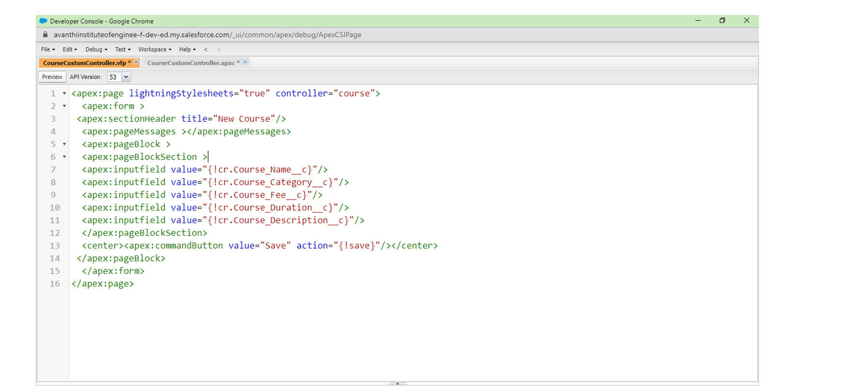

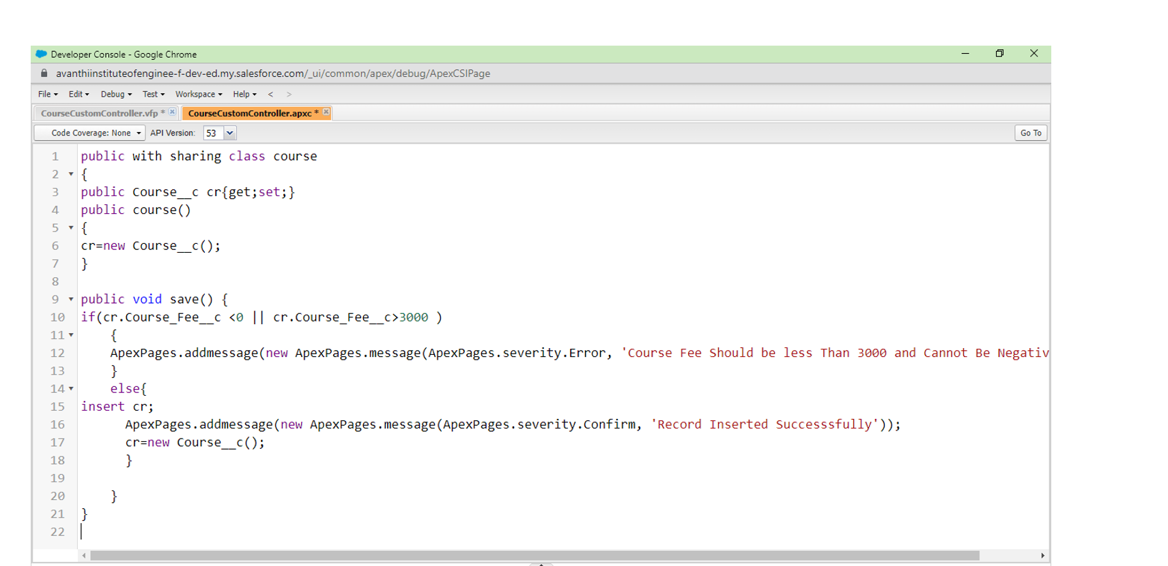

From File and then select new Visualforce page and paste the Trainer Visualforce code given in the task of "Creating New Trainer Using Custom Controller", and then select new apex class and paste the Trainer Controller code.

Upload the Screenshot of Milestone / Activity: (Create New Trainer Using Custom

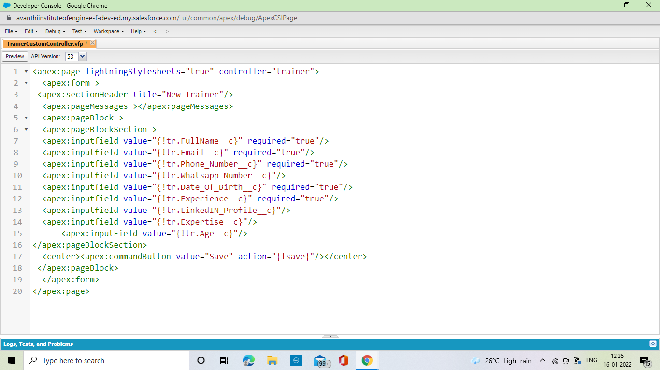

From developer console create a new VisualForce page and paste the Student Visualforce code in the visualforce page.

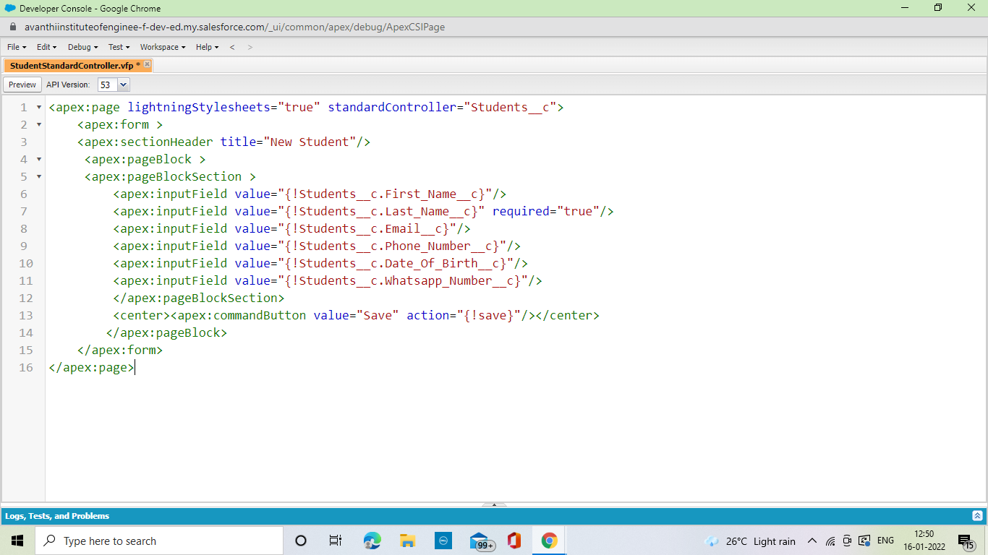

Day 9: 12/01/2022, Wednesday

Topic: Triggers

Milestone / Activities: Trigger On Trainer Object

Trigger On Student Object

Trigger On Meeting Object

Detailed Description:

Create New Apex Triggers in Developer Console of Trainer, Student and Meeting. Paste the Trigger of Trainer, Student and Meeting code in the files of Trigger.

Day 9: 12/01/2022, Wednesday

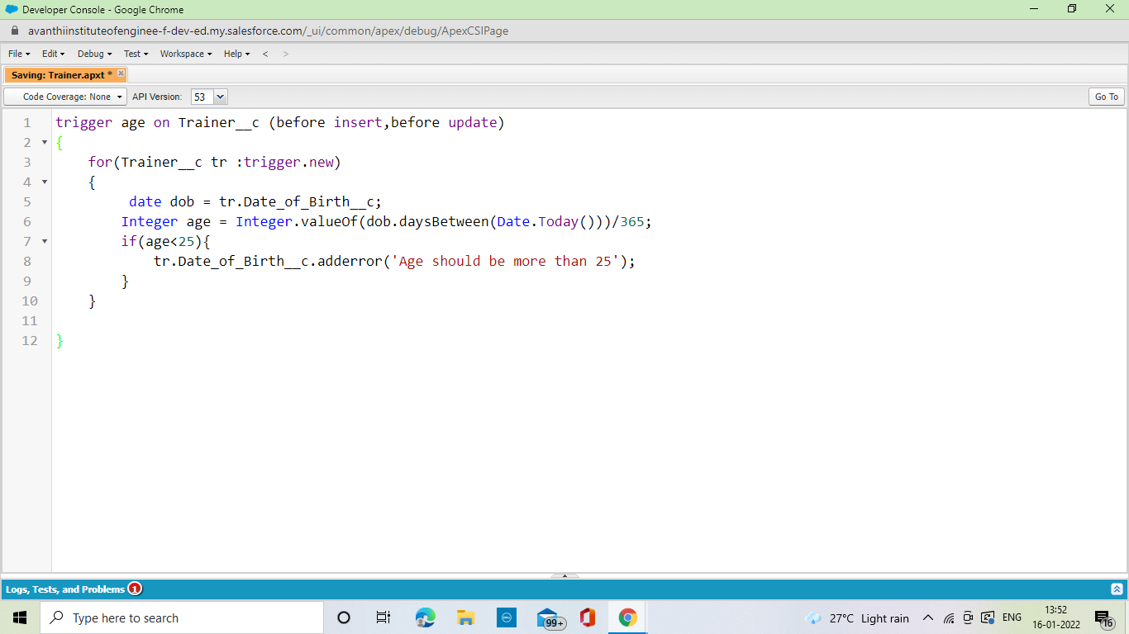

Upload the Screenshot of Milestone / Activity: (Trigger On Student Object)

