Online Training Management - developer ....

### 

By Heta Patel.

INDEX:

SALESFORCE PROJECT READY - ONLINE TRAINING MANAGEMENT DEVELOPER.

### > Create Your Salesforce Developer Org To Get Started.

### >Custom Object Creation.

### >Create Validation Rules.

### >Process Automation.

### >Creating Custom Pages Using Visualforce.

>Triggers.

### Online Training Management - Developer

**PROJECT INTRODUCTION:-**

In this project we will be creating an online training management application that will store all the details of the training from courses offered, trainers, students enrolled, Meeting/training information, and many more. In the project, we will be creating objects to store these records and will also create various fields to store the values of these records. We will establish relationships between various objects and create custom pages using visualforce and also about the triggers.

### > Create Your Salesforce Developer Org To Get Started:-

Creating a developer org in salesforce.

### Login To Your Salesforce Account

1. Go to salesforce.com and click on login.

2.Enter the username and password that you just created.

3.After login this is the home page which you will see.

> Custom Object Creation:-

### Creating The Custom Objects For The Application.

The required custom objects are:

a)Courses.

b)Trainer.

c)Student.

d)Meeting.

e)Batch/Class Scheduling.

Course Object:-

We need to add these fields in the object.

|  |  |  |
| --- | --- | --- |
| Field Name | DataType | Values |
| Course ID | Auto Number(Change the data type to AutoNumber  While creating course object and changing record  Type to course id) | Format(C-000001)  Starting number=1 |
| Course Name | Text |  |
| Course Duration | Picklist | 1month,2 months,3 months |
| Course Fees | Currency |  |
| Course Description | Text(Long) |  |
| Course Category | Picklist | Data science, cloud computing, AI, ML |
|  |  |  |
| Course Trainer | Master-Detail(Trainer) |  |
|  |  |  |

Trainer Object:-

We need to add these fields in the object.

|  |  |  |
| --- | --- | --- |
| Field Name | Data Type | Values |
| Trainer ID | Autonumber | Format=T-00001,Starting number=1 |
| Full Name | Text |  |
| Email | Email |  |
| PhoneNumber | Phone |  |
| Whatsapp Number | Phone |  |
| DateofBirth | Date |  |
| Age | Formula | TODAY()-Date_of_Birth__c |
| Experience | Picklist | 1year,2years,3years,……… |
| LinkedIN Profile | URL |  |
| Expertise | Text |  |

Student Object:-

We need to add these fields in the object.

|  |  |  |
| --- | --- | --- |
|  |  | |
| Field Name | Data Type | Values |
| Student ID | Autonumber | Format=S-00001,Starting Number=1 |
| First Name | Text |  |
| Last Name | Text |  |
| Email | Email |  |
| PhoneNumber | Phone |  |
| Date Of Birth | Date |  |
| Whatsapp Number | Phone |  |
| Enrollment Date | Formula | TODAY() |
| Student Enrollment | Master Detail(Batch) |  |

**Meeting Object:-**

We need to add these fields in the object.

|  |  |  |
| --- | --- | --- |
| Field Name | Data Type | Values |
| Meeting ID | Autonumber | Format=M-00001, Starting Number=1 |
| Valid From | Date |  |
| Valid To | Date |  |
| Active | Checkbox |  |
| Meeting Link | URL |  |

Batch Scheduling Object:-

|  |  |  |
| --- | --- | --- |
| Field Name | Data Type | Values |
| Meeting ID | Autonumber | Format=M-00001, Starting Number=1 |
| Valid From | Date |  |
| Valid To | Date |  |
| Active | Checkbox |  |
| Meeting Link | URL |  |

The data model of the above Custom objects is,

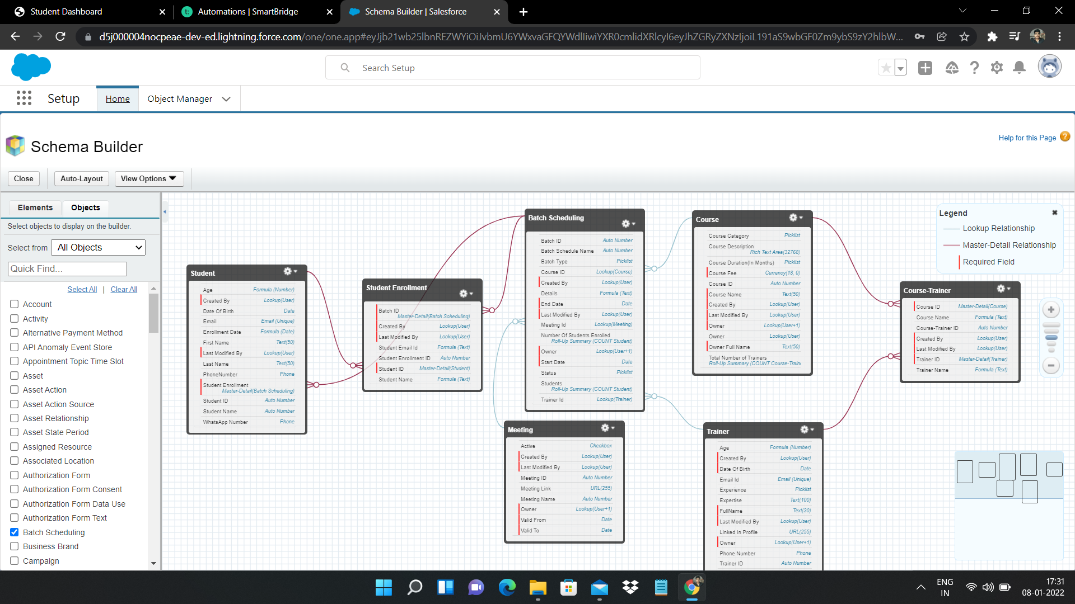

> Create Validation Rules:-

> For the Course object the validation rules we need to had is,

1.Course Fees Cannot be Negative: From Object Manager select the course object and click on validation rules, give your rule a name and in error condition formula enter "Course_Fee__c<0", give error message according to the condition.

1. Course Fees Should Be Less than 3000$: From Object Manager select the course object and click on validation rules, give your rule a name and in error condition formula enter "Course_Fee__c>=3000",give error message according to the condition.

> For the Trainer object the validation rules we need to had is,

1.Full Name, Phone Number, Dateof Birth , Experience fields on the trainer object should not be blank: Search for Trainer Object from the object manager ,click on validation rules, click new and give your rule a name, in error condition formula enter "ISBLANK(Field Name)" and enter the error message according to the validation rule.

2. Age Should Not Be Less than 25 years: Enter "age__c<25" in error condition formula and enter the error message according to the rule.

1. Phone Number and Whatsapp Number should accept minimum 10 digits and maximum 15 digits: In error condition formula enter"NOT(REGEX(FIELDNAME, "[0-9]{10,15}"))" and error message according to the validation rule.

> For the Student object the validation rules we need to had is,

1. Lastname should not be Blank: enter the following error condition formula "ISBLANK(Field name)" and give the error message according to the rule.

2. Minimum 16 years of age: student should be minimum 16 years of age, in error condition formula enter "age__c<16" and give the error message according to the rule.

3.Phone and whatsappNumber should be minimum 10 digits : in error condition formula enter "NOT(REGEX(Fieldname, "[0-9]{10}"))" and give the error message accoding to the validation rule.

> For the Meeting object the validation rules we need to had is,

1. Valid From should not be less than current date: Click on validation rules from meeting object, give your rule a name and in error condition formula enter "Valid_from__c < TODAY()" and enter the error message according to the rule.

2.ValidTo Cannot be less than Valid from : Click on validation rules from meeting object, give your rule a name and in error condition formula enter "Valid_to__c < Valid_from__c " and enter the error message according to the rule.

3. Minimum 14 days difference should be in between valid from and valid to : Click on validation rules from meeting object, give your rule a name and in error condition formula enter "Valid_to__c - Valid_from__c < 14 " and enter the error message according to the rule

> Process Automation:**-**

There are four automation tools in salesforce:

1. Approval Process

2. Process builder

3. Flows

4. Workflows

For Creating an automation first we need to add the email alerts. We added email alerts for,

1)Email Alert to Course Record owner

2)Meeting Expiry Date Reminder Alert

3)Training Confirmation Email Alert

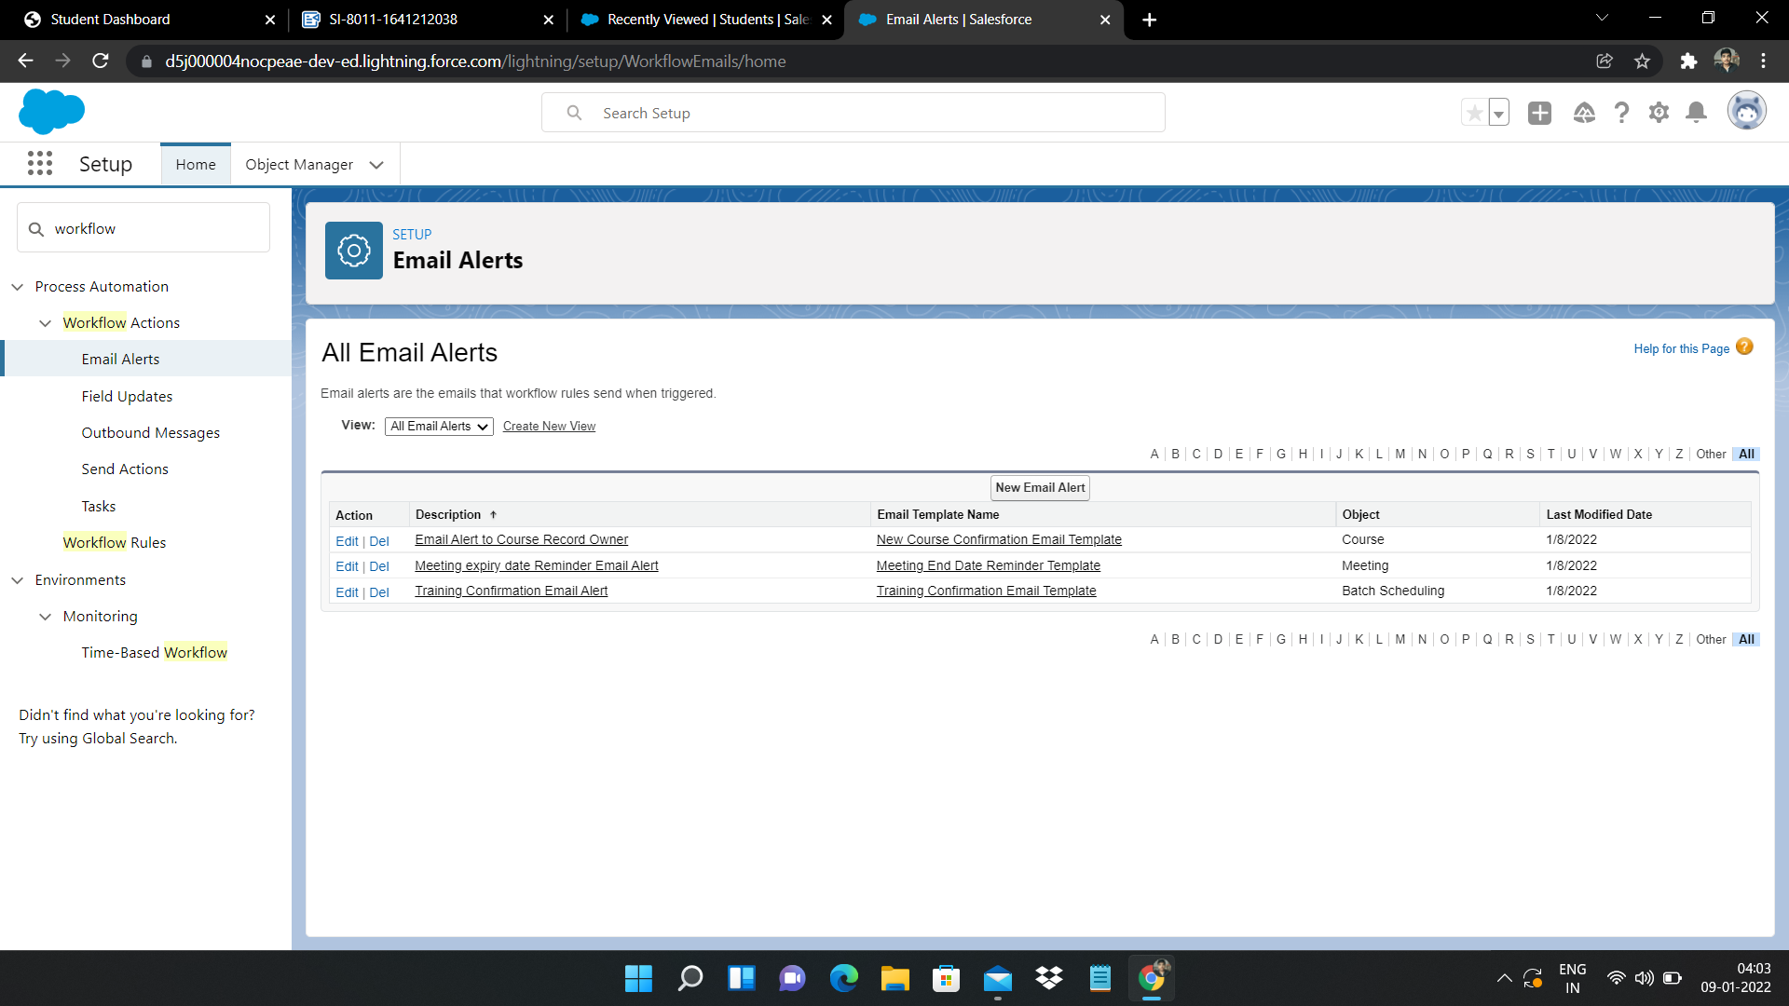

### Creating Work Flow Rules On Meeting Object:-

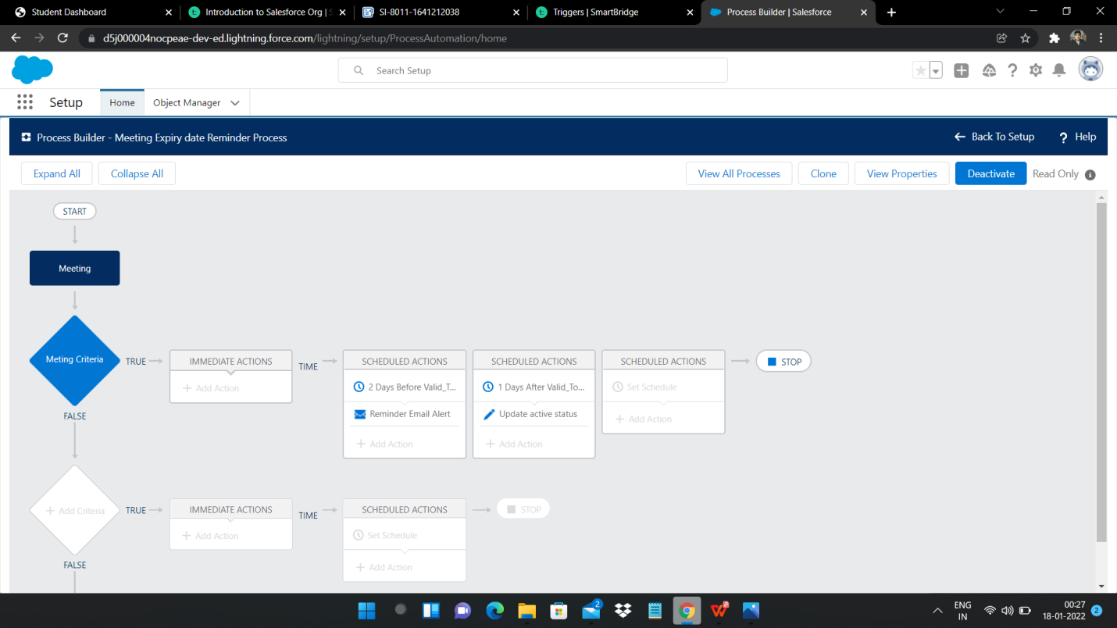

### >Creating Custom Pages Using Visualforce:-

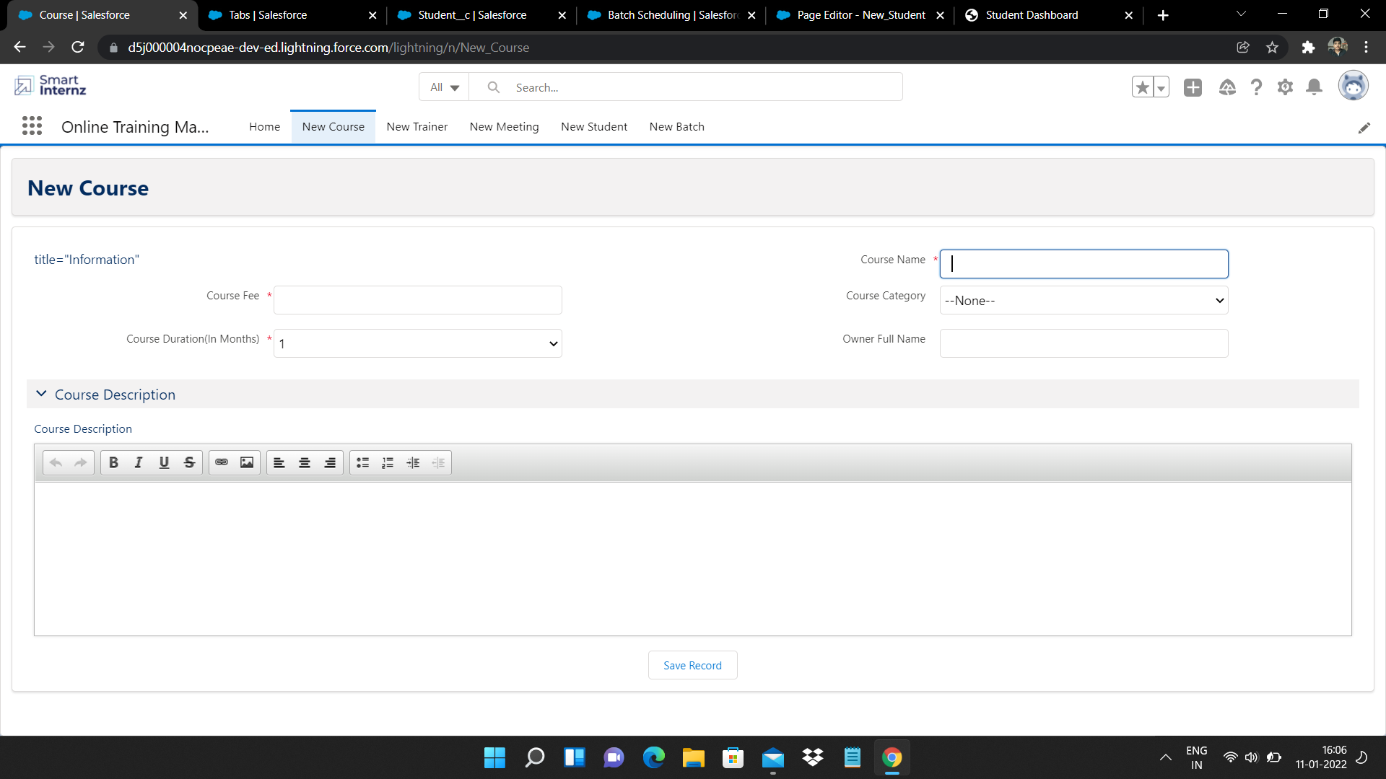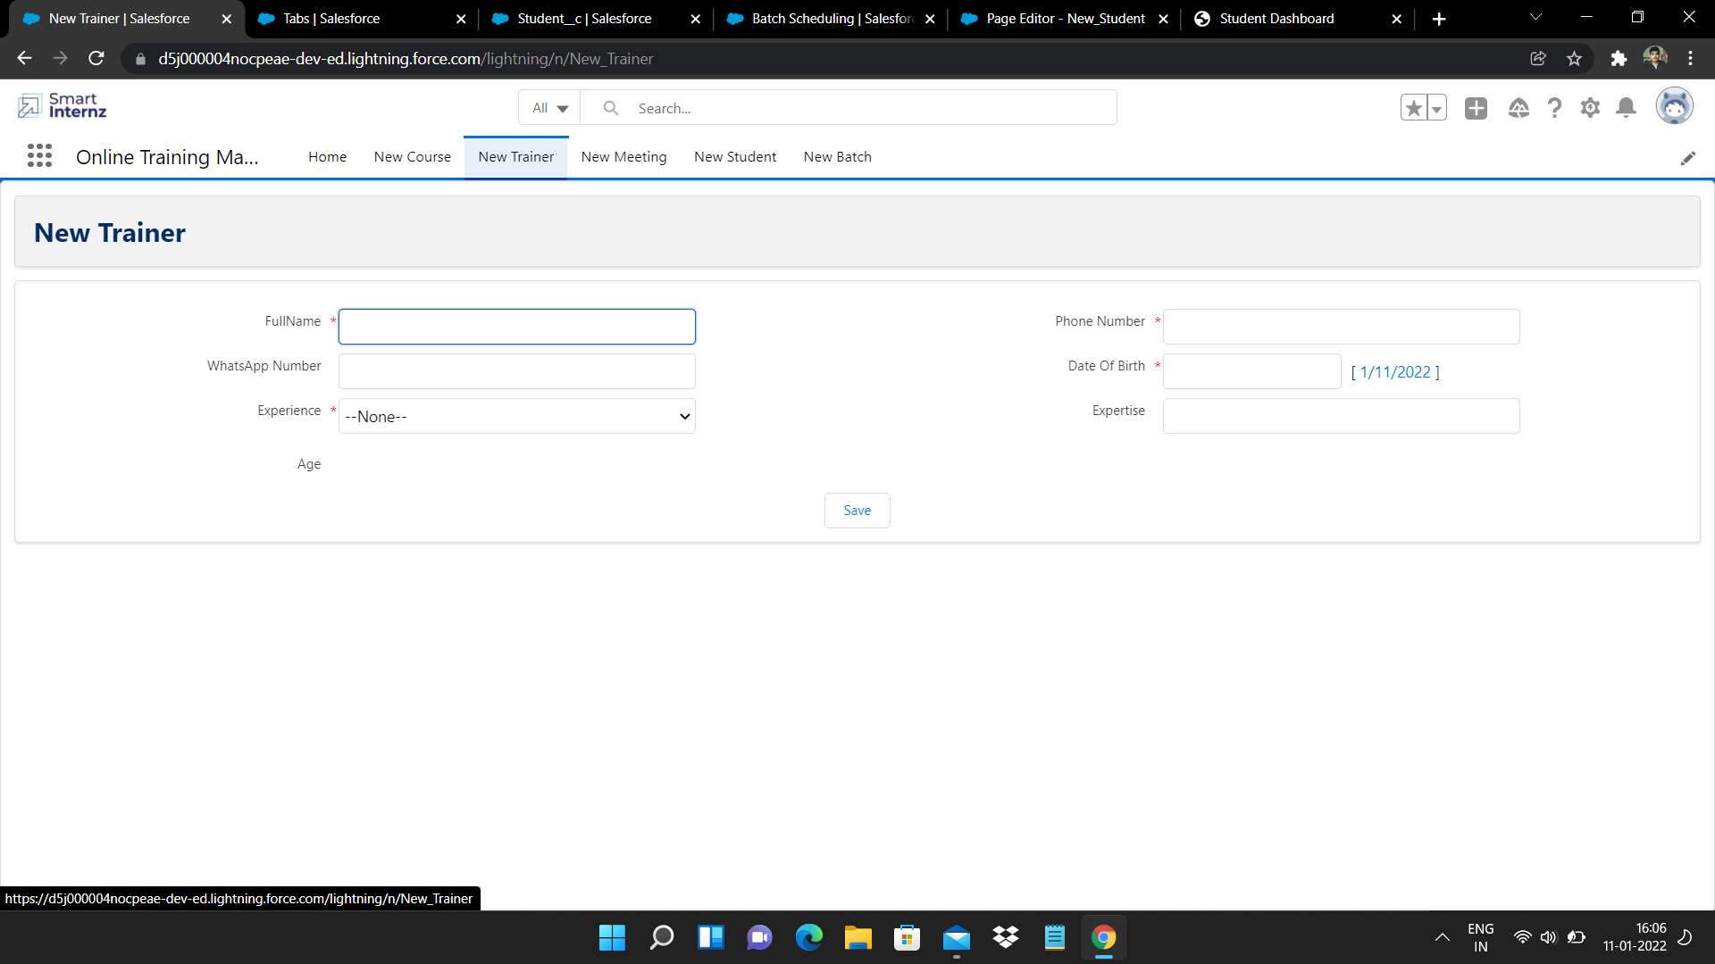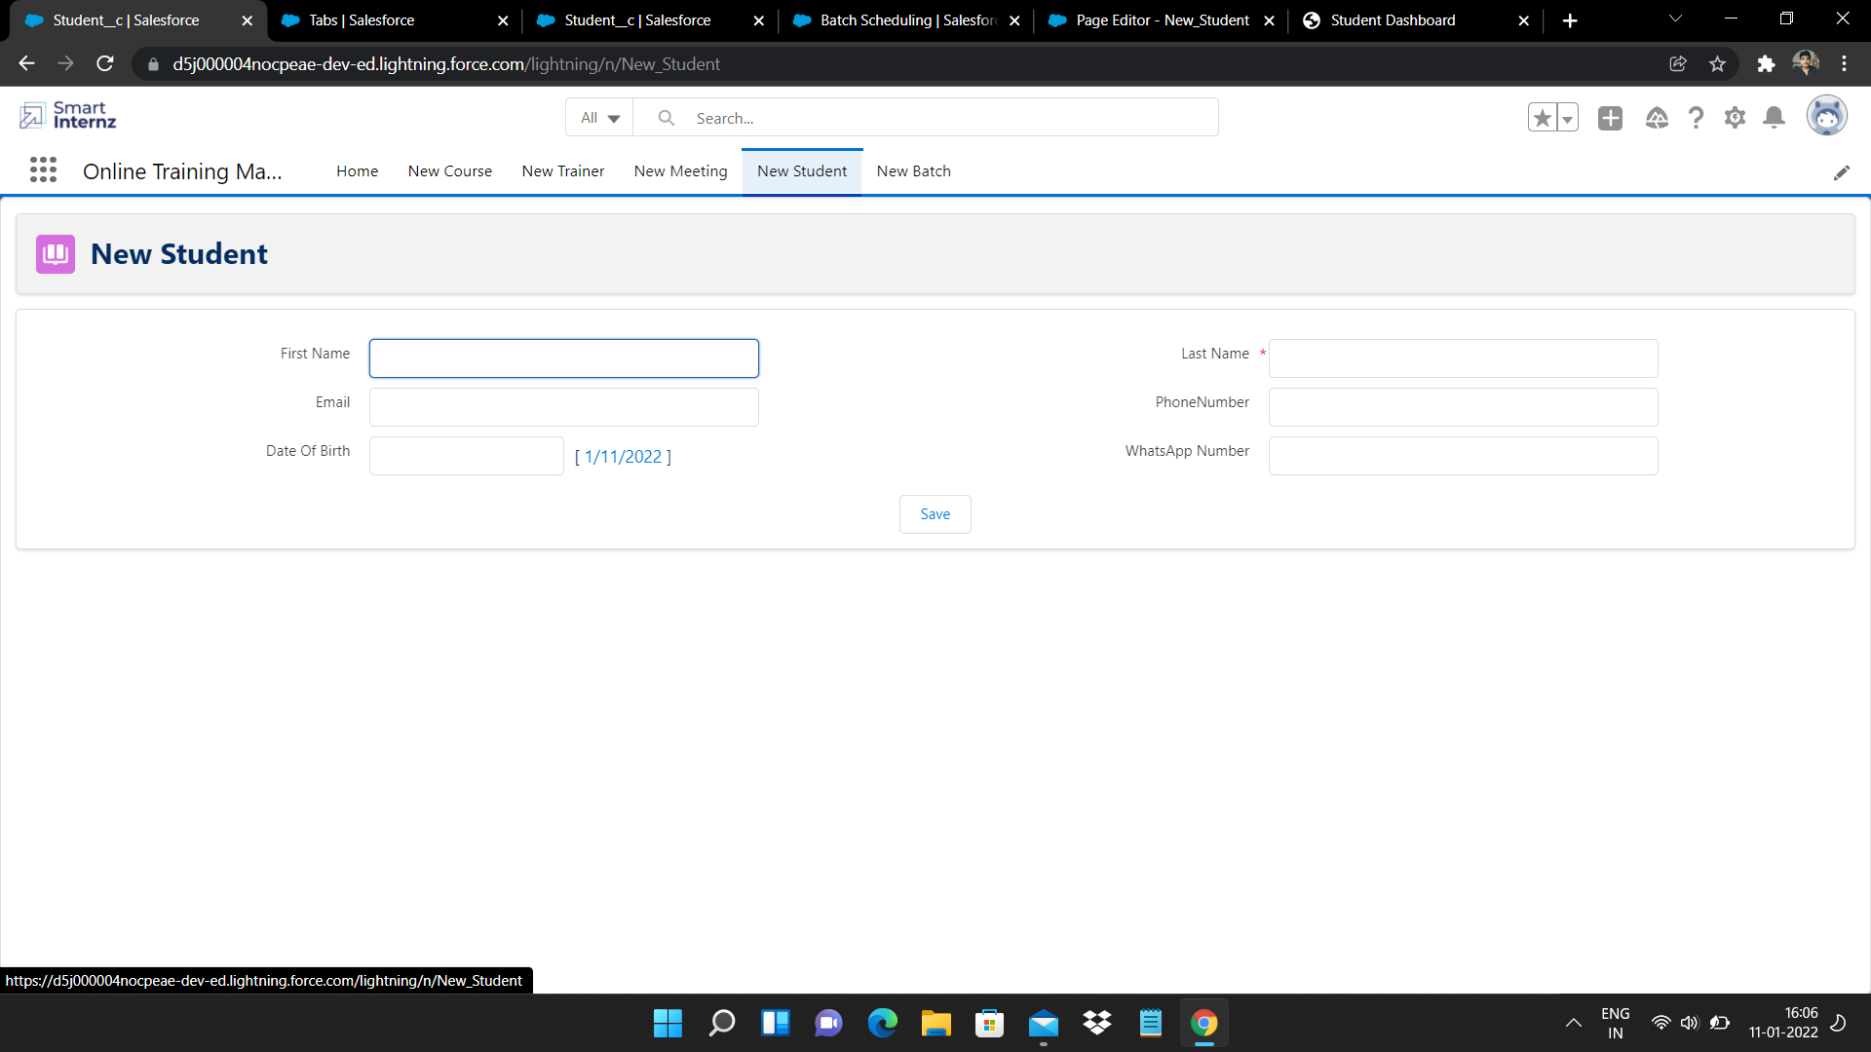

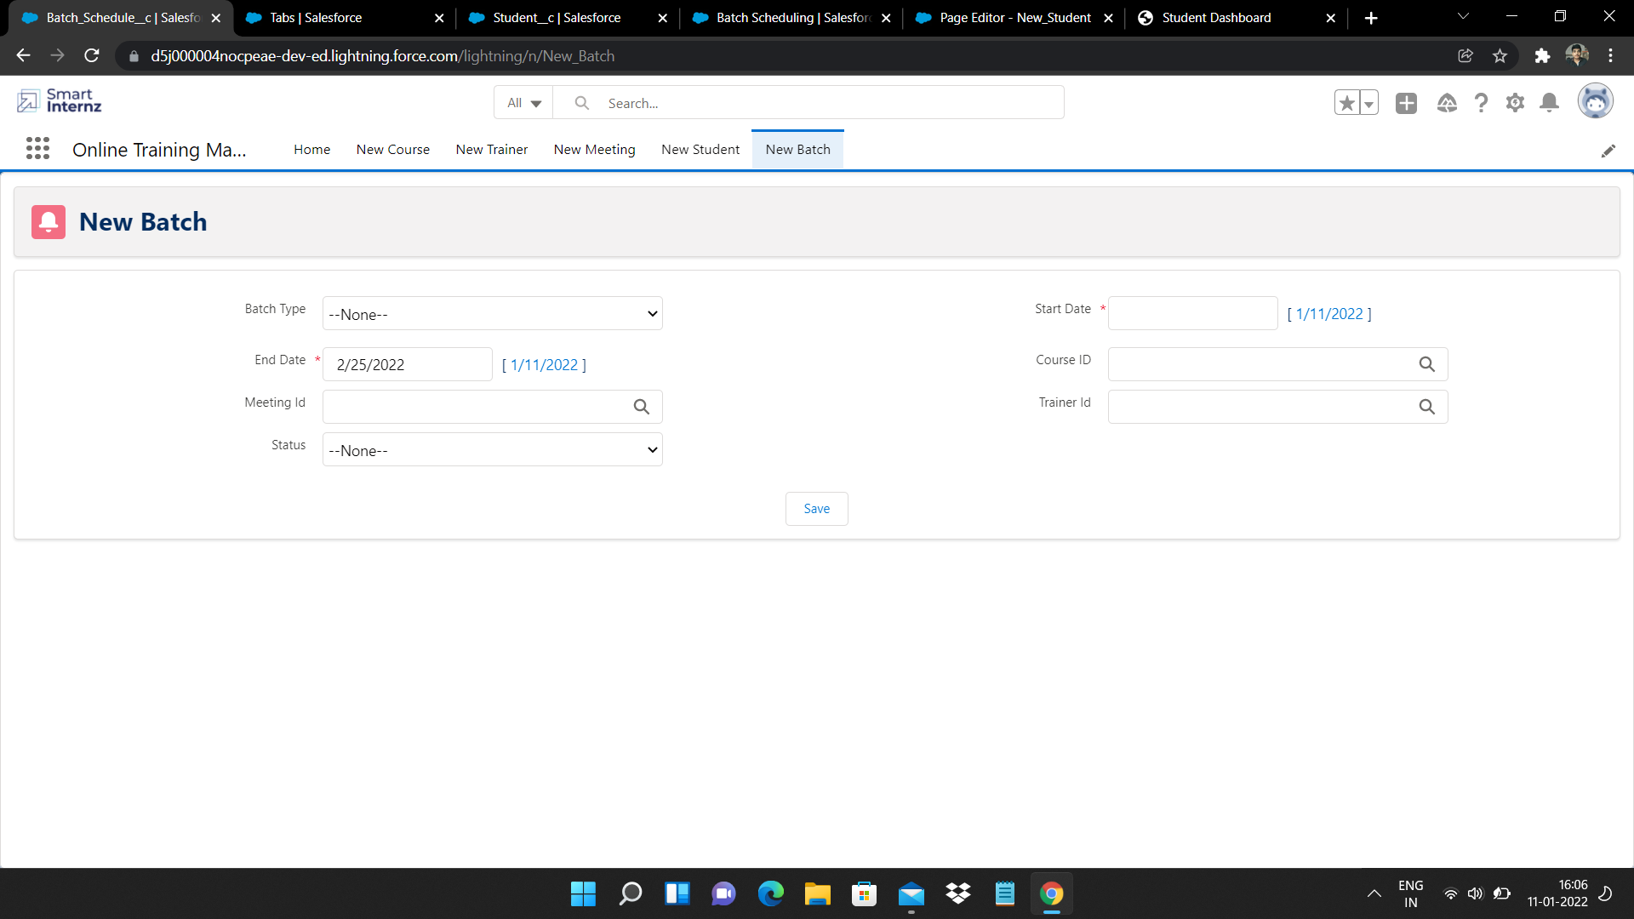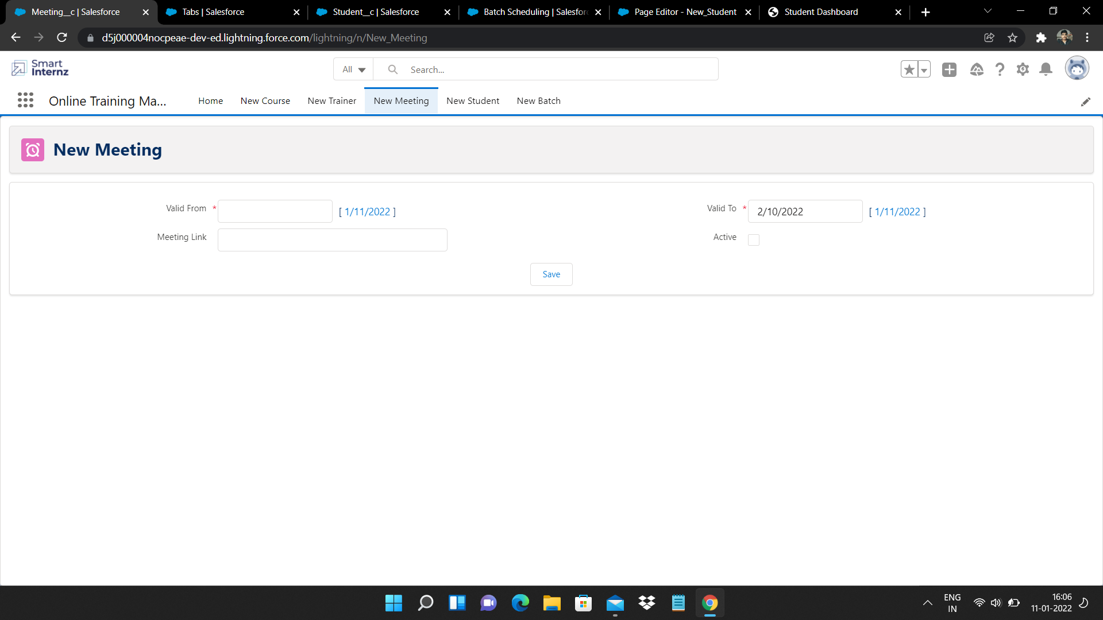

> Triggers:-

A trigger is an Apex script that executes before or after data manipulation language (DML) events occur. Apex triggers enable you to perform custom actions before or after events to record in Salesforce, such as insertions, updates, or deletions. Just like database systems support triggers, Apex provides trigger support for managing records.

Trigger On Trainer Object:- :-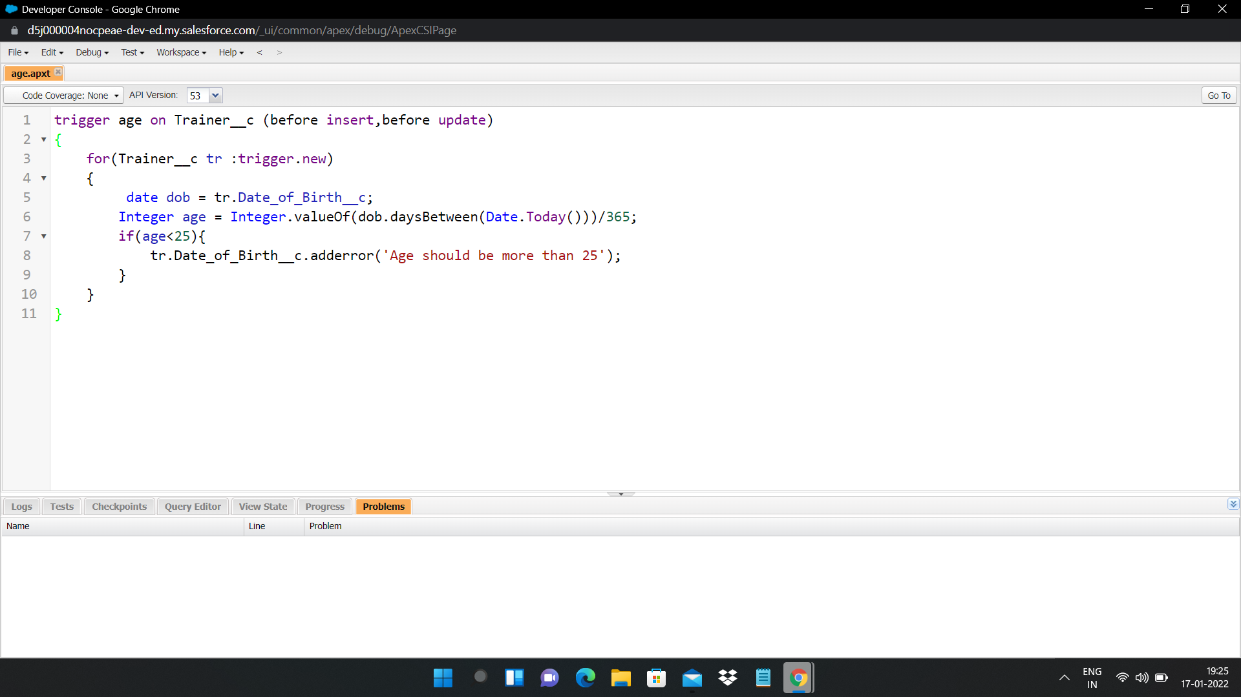

### 

### Trigger On Student Object:-

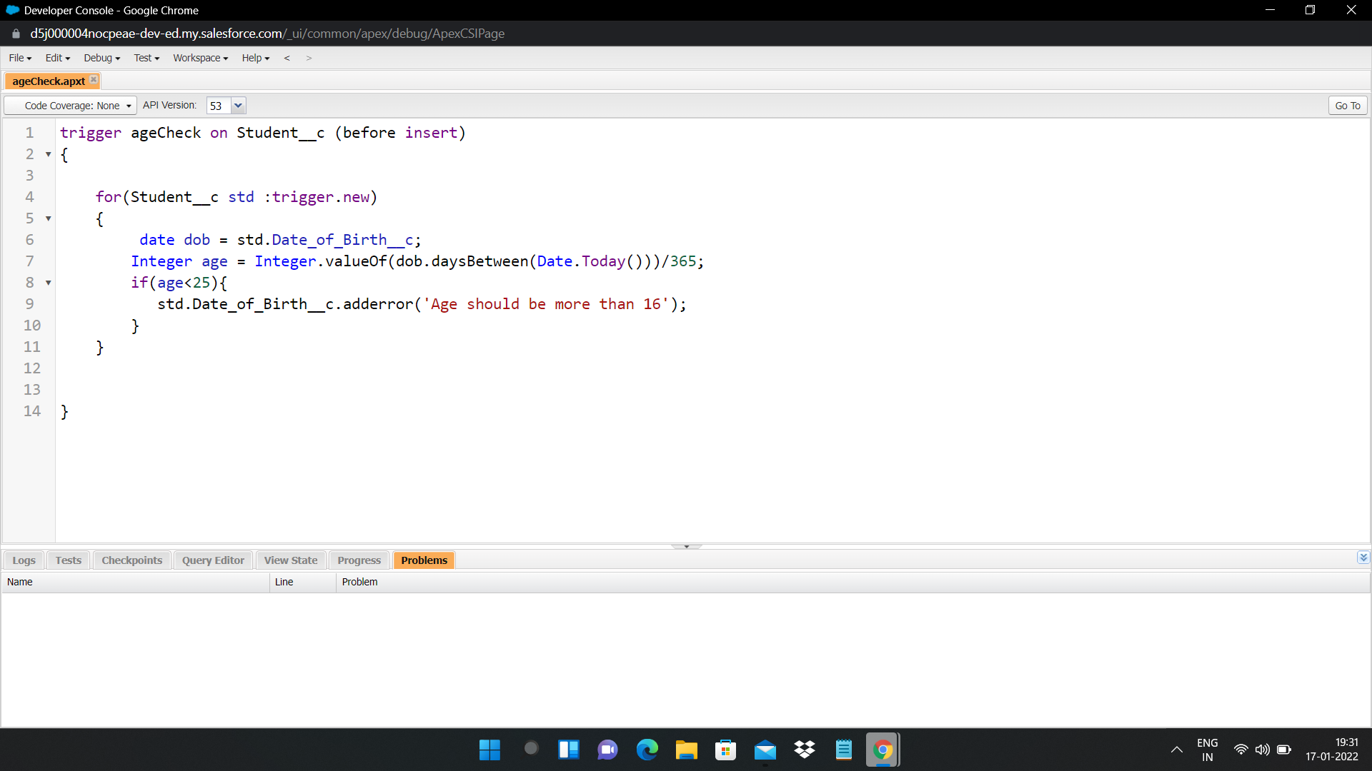

### Trigger On Meeting Object:-

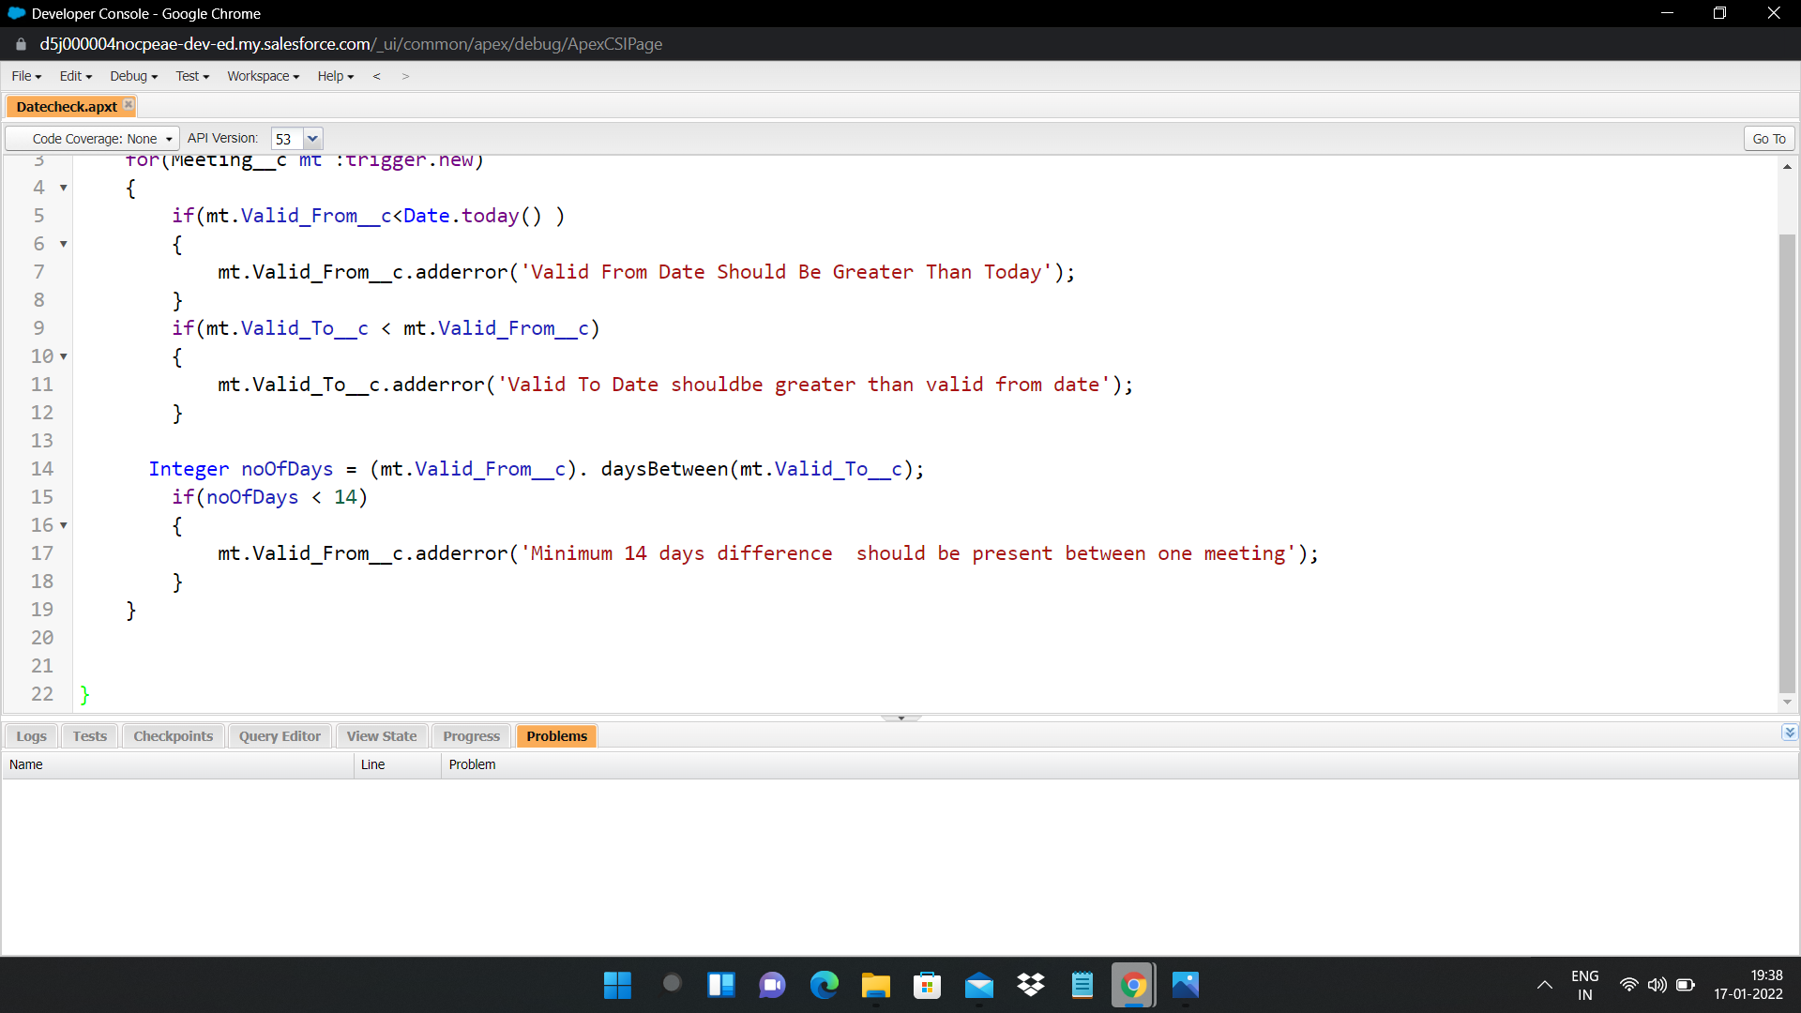

Conclusion of the Project:-

In this Project I have learnt many things like how to create an application,how to create the custom objects and also the various types to create an custom objects like by using schema builder,creating validation rules for the custom objects,process automations in the salesforce,Creating custom pages in the visual force by using standard and custom controllers and also the triggers.Now I have got experience to perform in the various projects without any errors.