**Day1: Activities**

* Creation of Salesforce Developer Org.
* Activating Account in Salesforce.
* Logging into the account and initializing the tasks.

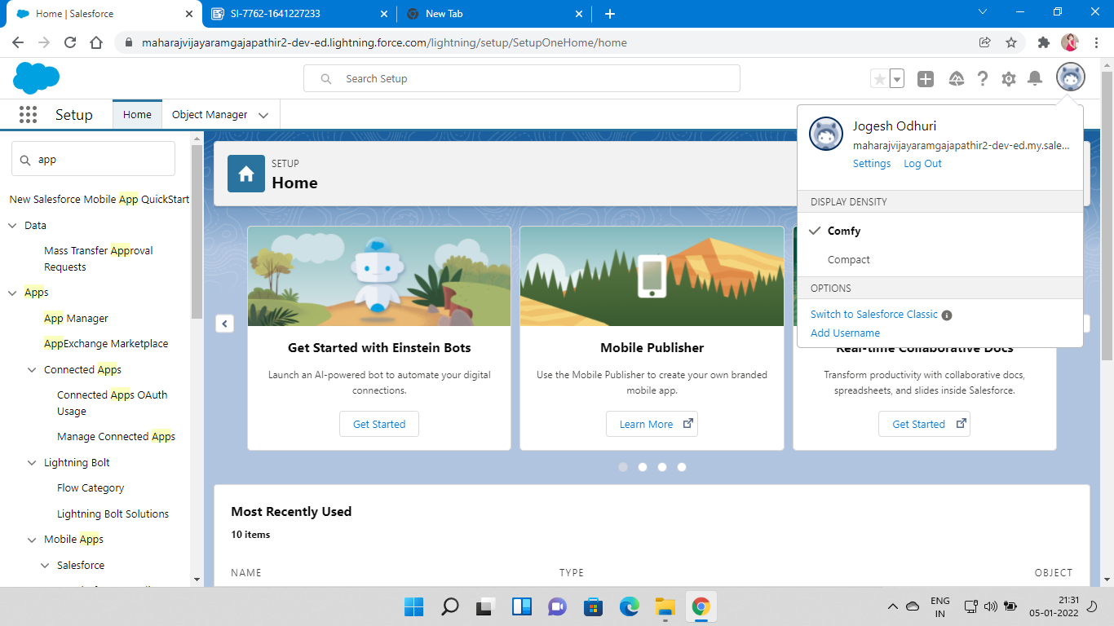

**Day2:**

Creating the New Lightening app named College Management and add up all these objects to this app after creation of below custom Objects.

Created Few Custom Objects in Environment named as

* College
* Application Form
* Student
* Subject

After creating these custom object Fields respective to the objects are created as Stated below respectively .

1.College(Custom Object)

1. Record Info (Text DateType)
2. Colleges Fees(Currency DataType)
3. Hostel Fees(Currency DataType)
4. College Name(Picklist DataType)
5. Email(Picklist DataType)
6. Capacity Of Students(Picklist DataType)

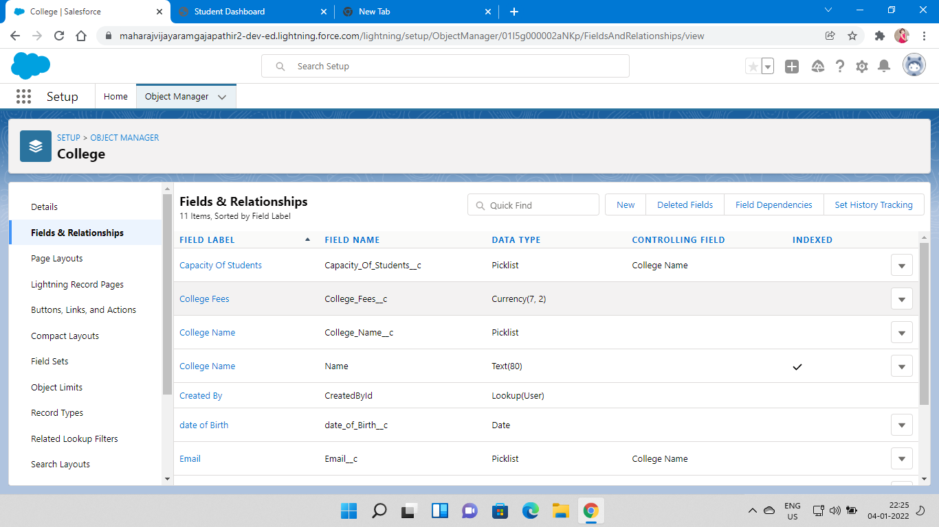

2.Application Form

1. Application Form ID(Auto number DataType)
2. Address(Text DataType)
3. College (Master-detail Relationship with College)
4. College Fees(Currency DataType)
5. Hostel Fees(Currency DataType)
6. date of Birth(Date DataType)
7. Email(Email DataType)
8. Guardian Name(Text DataType)
9. Looking For Hostel Stay(CheckBox DataType)
10. Ready to Join(CheckBox DataType)
11. Student Name(Text DataType)
12. Phone(Phone DataType)

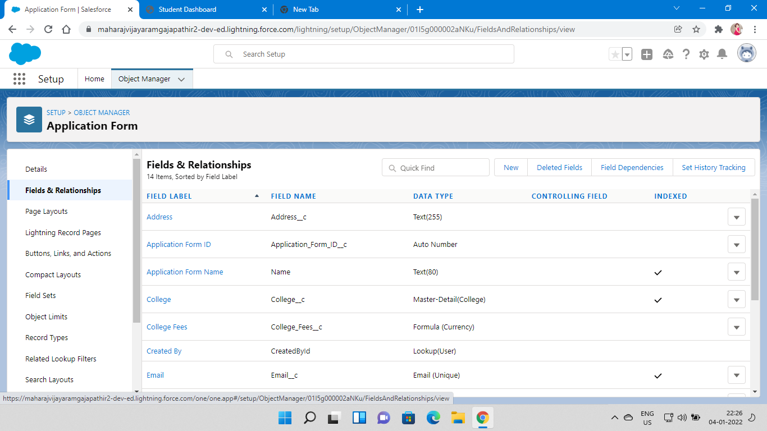

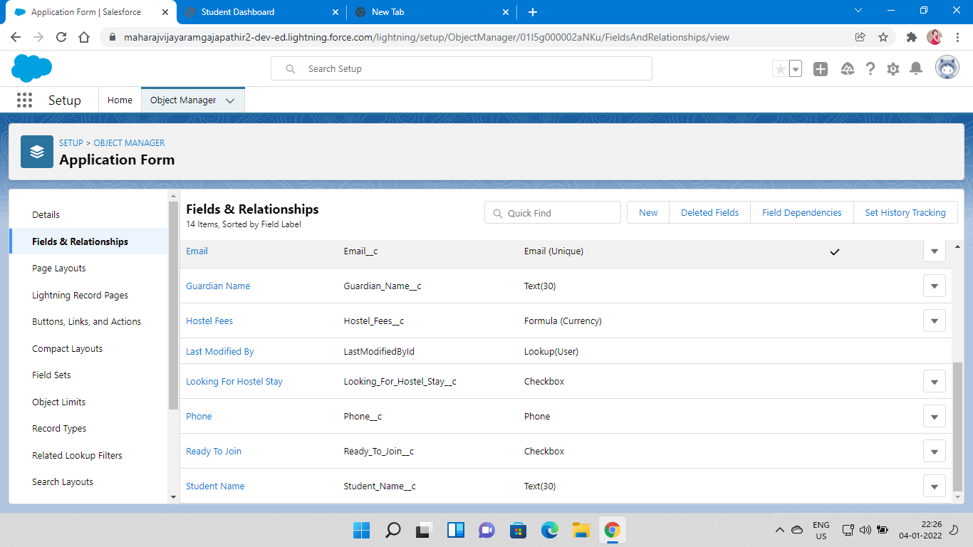

3.Student

1. Student Name(Text DataType)
2. Address(Text DataType)
3. Application Form(Lookup Relationship with Application Form)
4. College Name(Formula with text return type)
5. Date Of Birth(Date DataType)
6. Guardian Name(Text DataType)
7. Phone(Phone DataType)

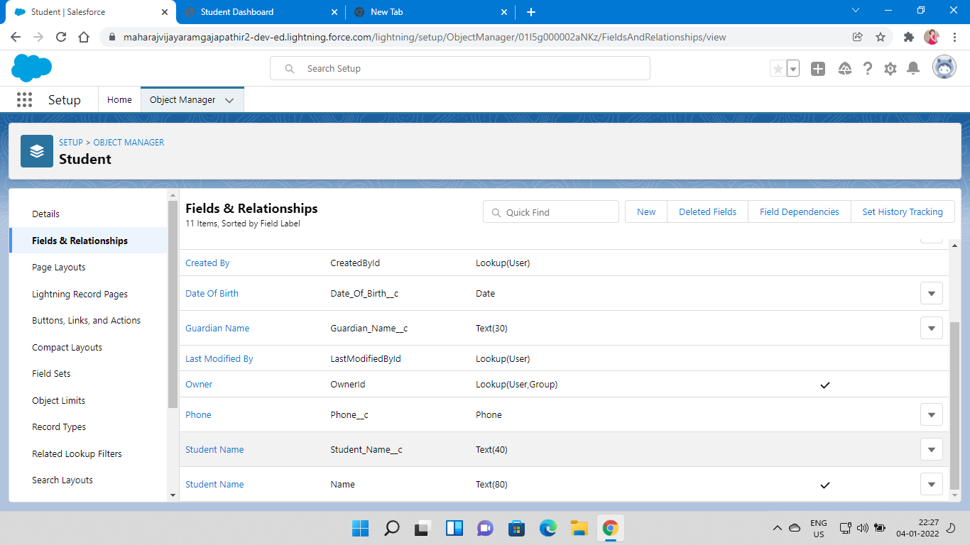

4.Subject

1. Subject ID(AutoNumber DataType)
2. Paper1(Picklist which values are drawn from Global picklist)
3. Paper2(Picklist which values are drawn from Global picklist)
4. Student(Lookup Relationship with Student)

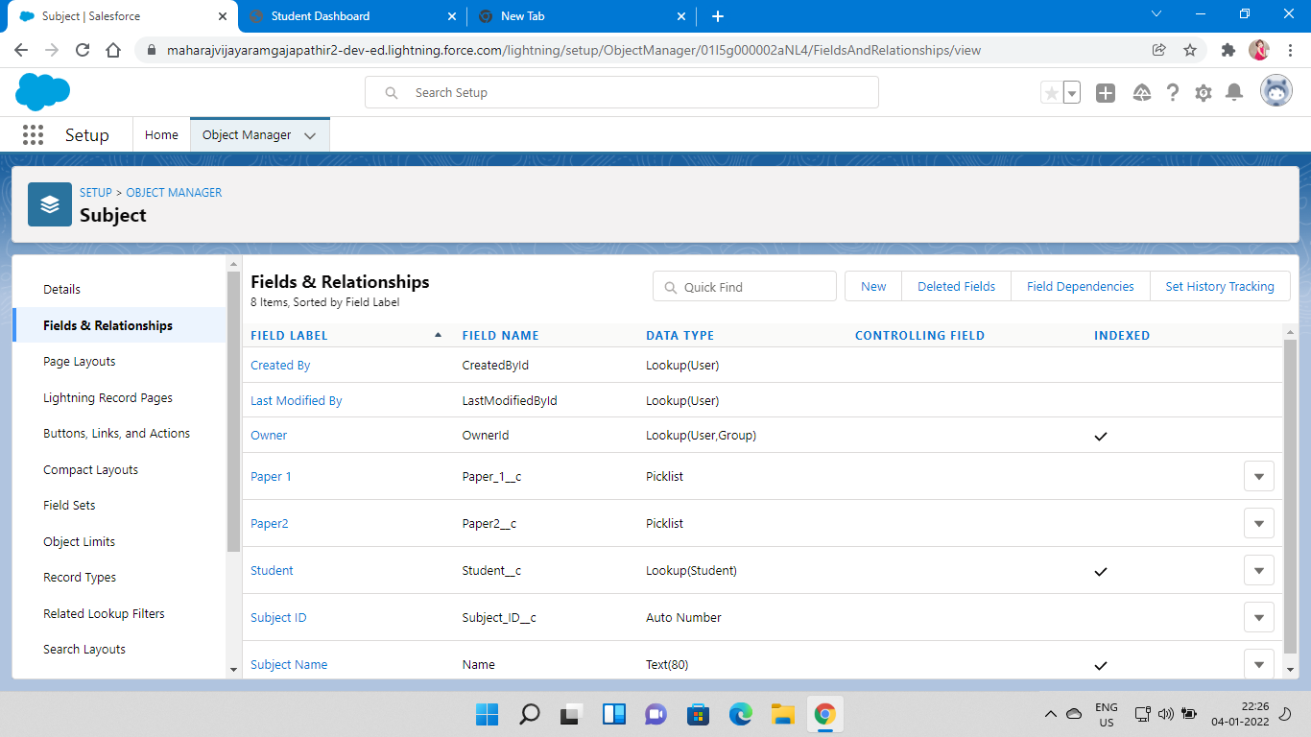

* After all,Creation of few Global Picklist Values which are used in above picklist Fields like College Name,Paper1,Paper2
* Global Picklist Value Sets are

1. College
2. Paper1
3. Paper2

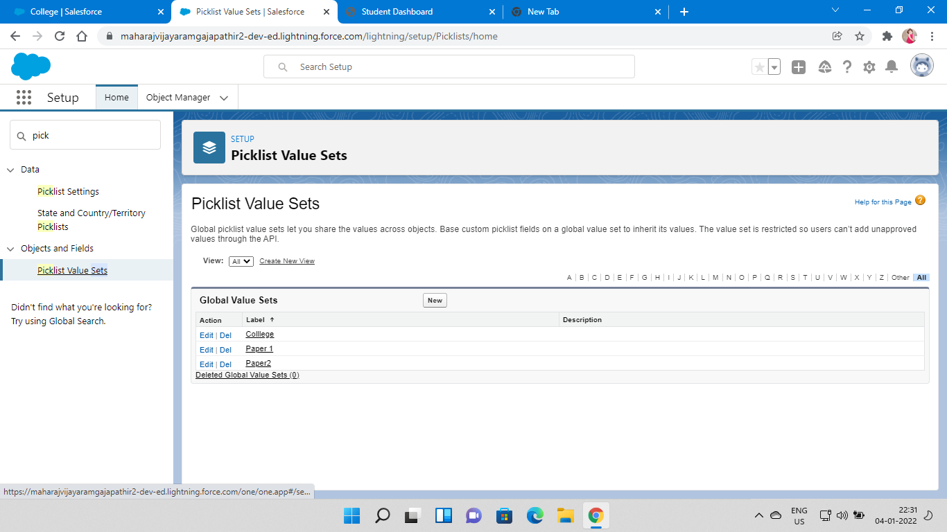

* Creation of Feild Dependency in College Object between College Name and Email where could be the College Name Controlling and Email is dependent based on college name, Email restricted.
* Creation of Another Field Dependency in College Object between College Name and Capacity Of Students where could be the College Name be Controlling Field and Capacity of Students is dependent.

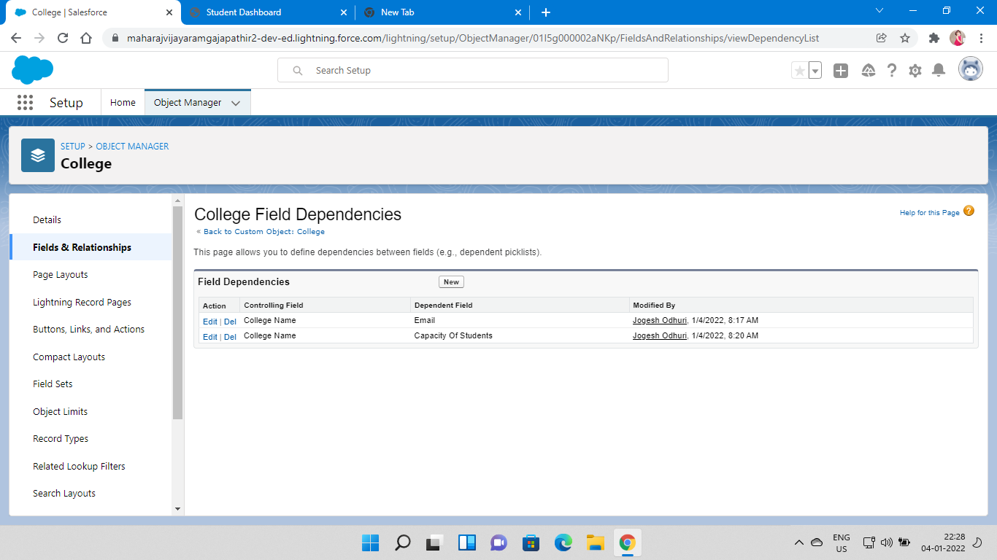

* Now Creation of Validation Rule with a logic that checks for College Name and Record Info are same or not.

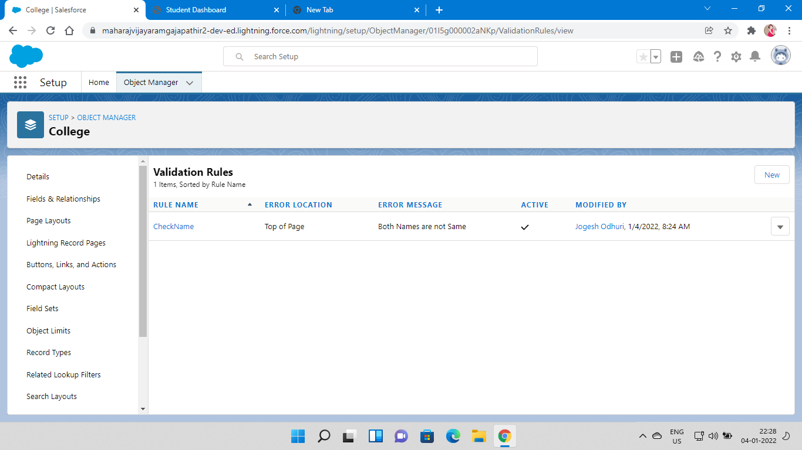

* create another validation rule of our own name in Application Form object to stop the modifications on Application form once the record is created in Student.

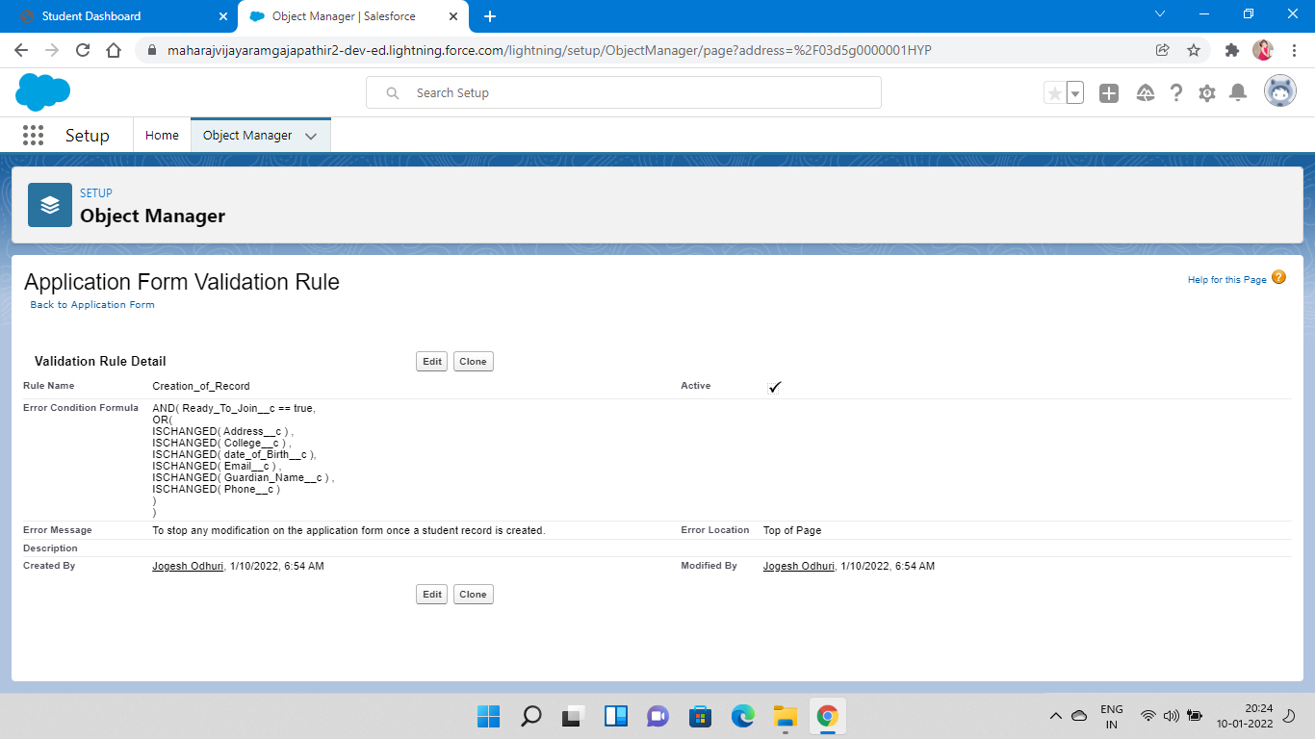

**Day3 : Activities**

* Creation of New Automation Process in such a way that Student records should be created when we check the Ready to Join field in Application Form.
* Triggering criteria is when Ready to Join Field is Checked.
* After ,the Immediate Action is to Creation of Record of Student type with all the Fields created in Student Object

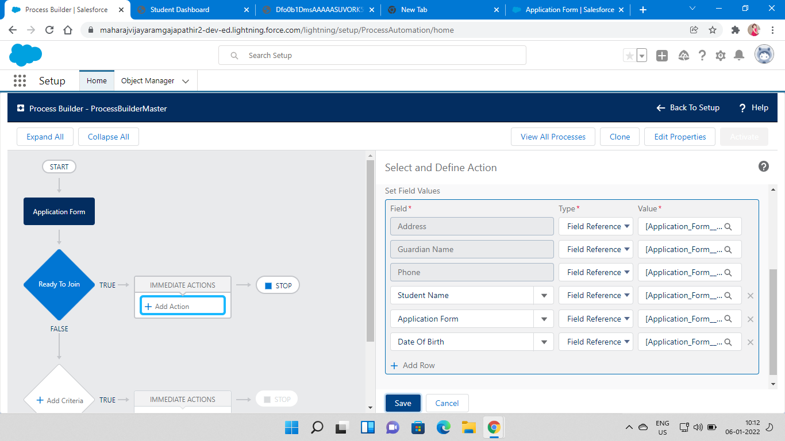

**Day4:Activities**

* Creation of Student Record using Flows by deactivating the previously created Process Automation process
* And now create New Flow in Flows such that it is related to record triggered flow and select object Application Form
* Condition is Ready to Join Equals to True.
* Now create the variable named Student in Resource Section.
* Make below conditions to be filled in new assignmnet in flow.
* Now Add Create the record.

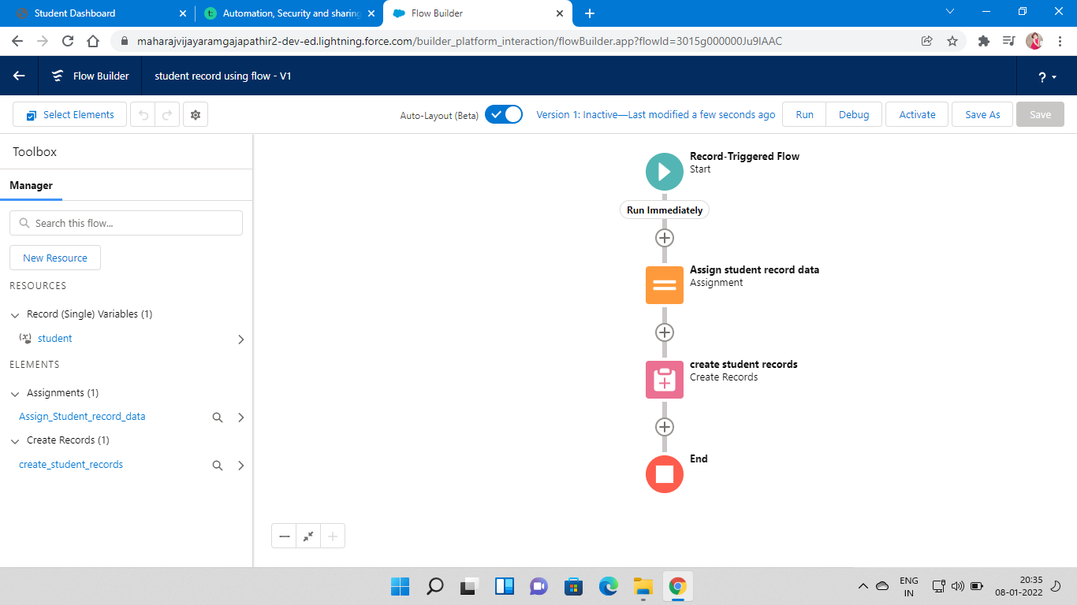

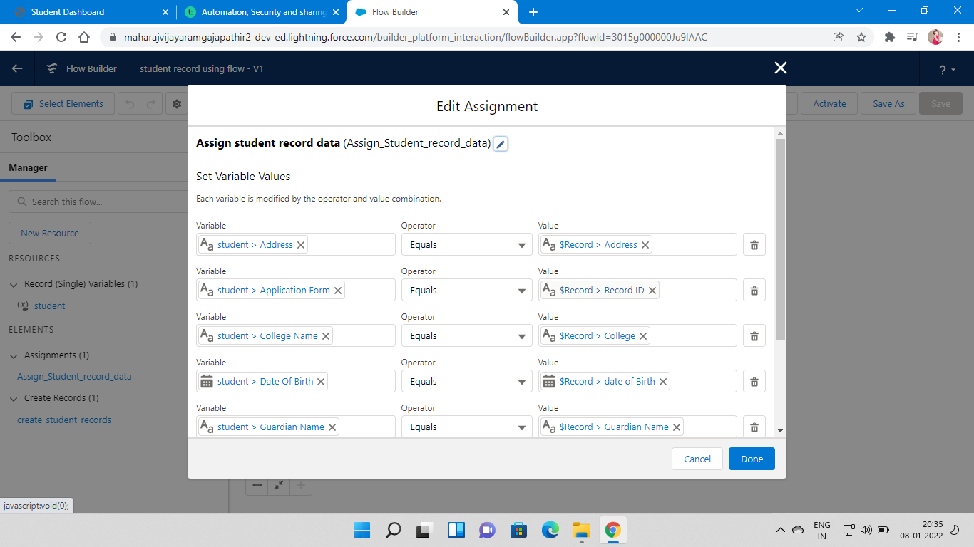

**Day5:Activities**

* Create an Apex Class with an name of ApplicationBatchTest with implementation of Batch able and use the needed conditions in Apex as Follows.
* Another apex class for Scheduling the Apex with required conditions as stated below and Schedule the Apex in Apex Class with requirements

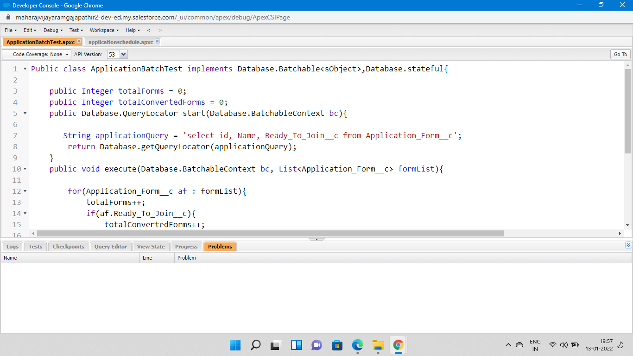

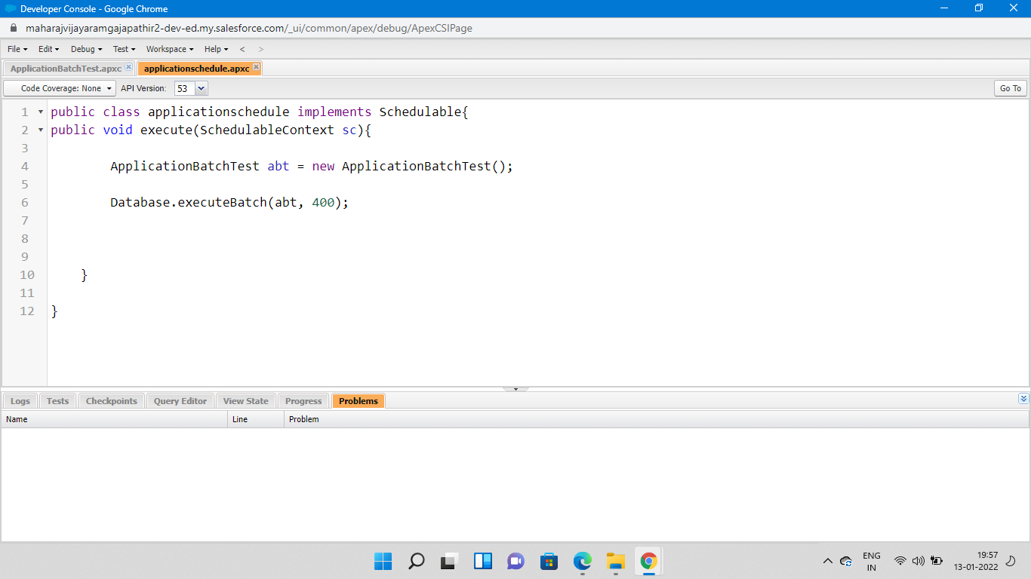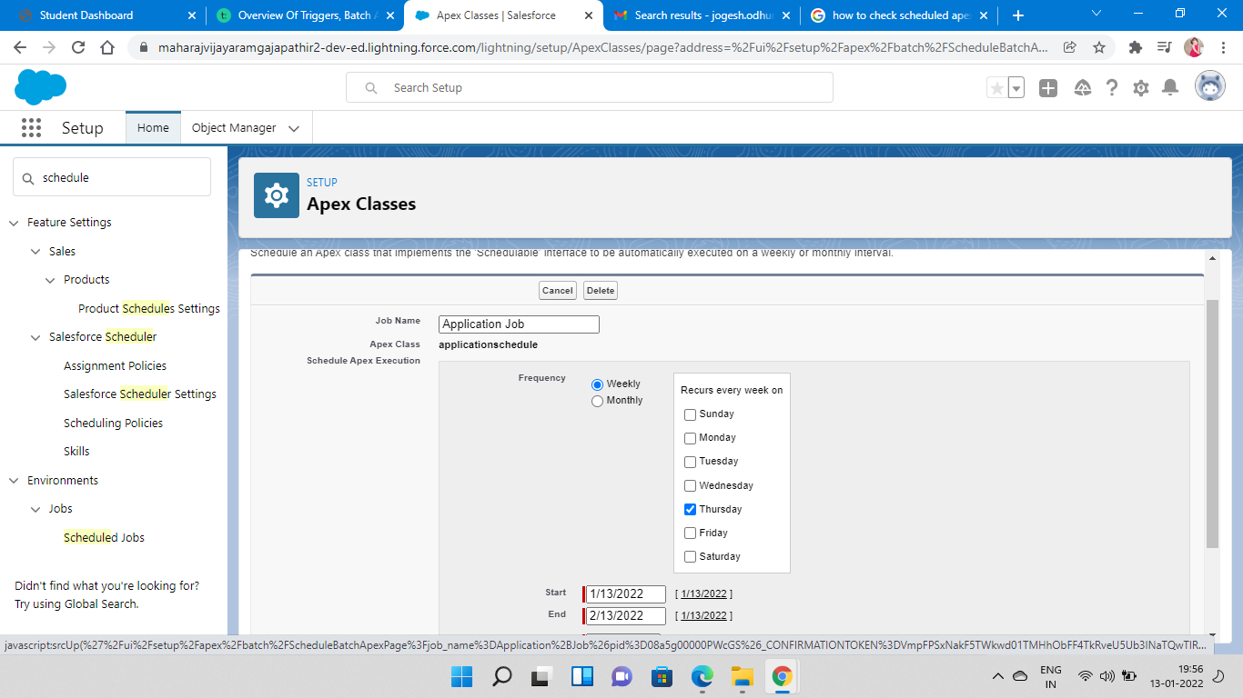

**Day6:Activities**

* Create an CollegeDataTable Componenet with Record Page ,Home Page and App Page .
* Create an Apex Class in LWC with name as GetapplicationDetails with required Conditions.
* After creating the CollegeDataTable ,code and complete the html,js and meta files with specified or needed Conditions as done below
* Before Completing Above Add the LWC Salesforce Editor to the Chrome and the go on with Procedure

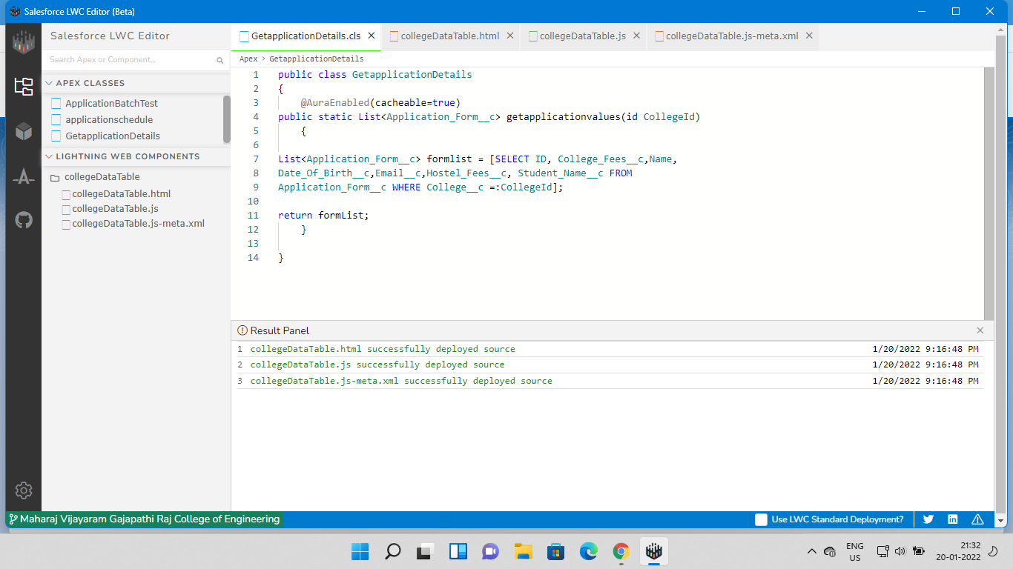

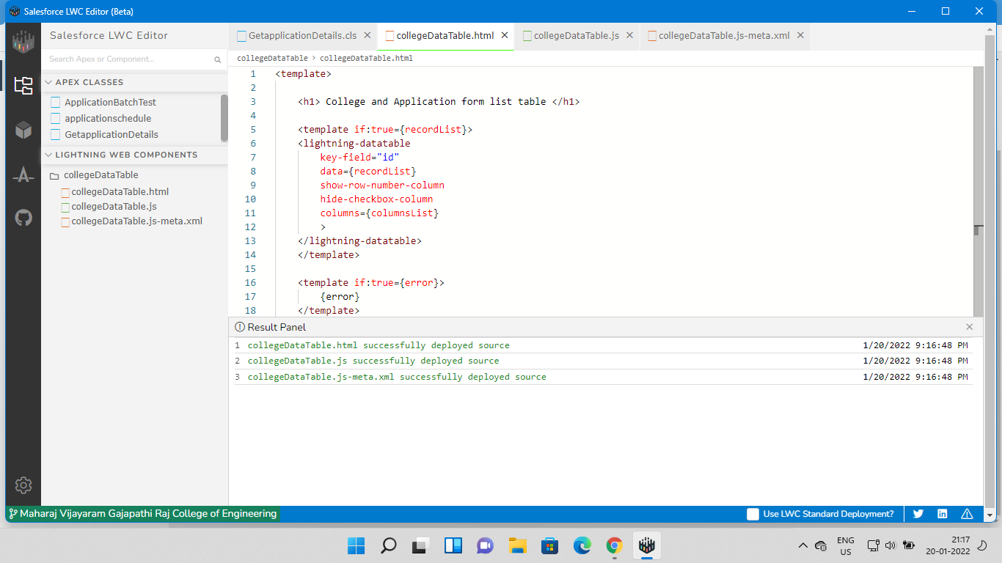

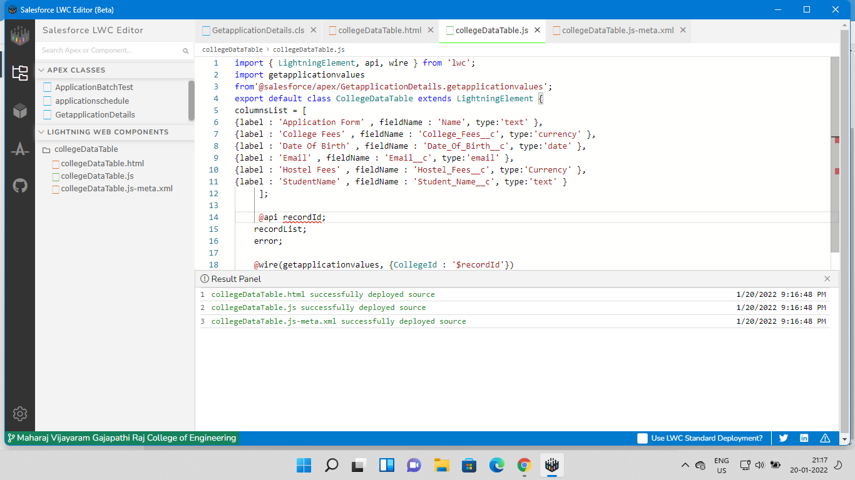

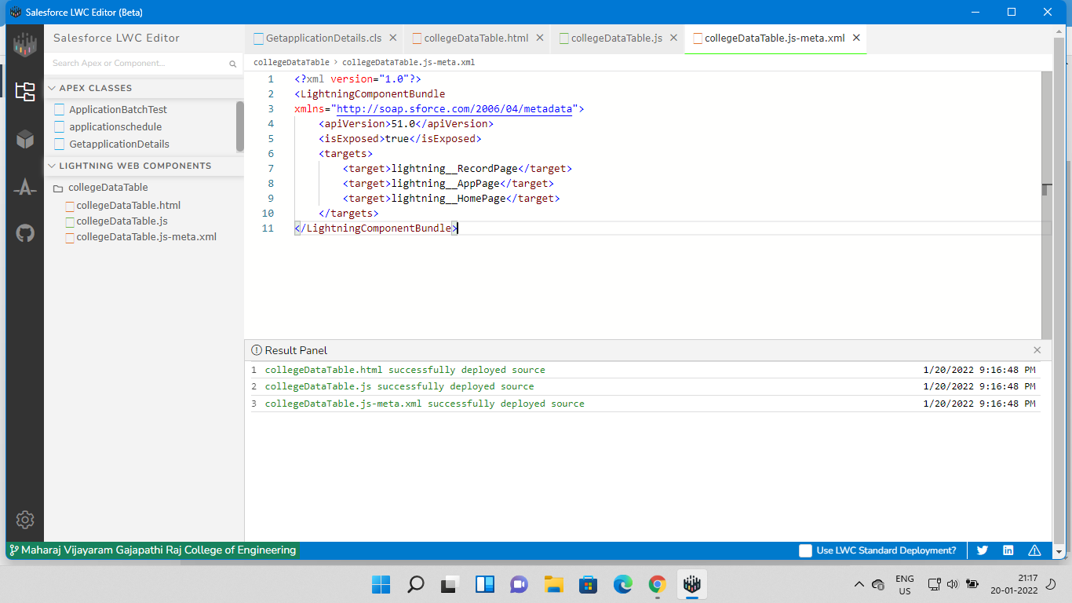

* After Doing all these check the result as Data table which will be Show with Fields given and Specified .And the Data Shown as Stated as Below.

