**Day1**:

* Creation of Salesforce Developer Org
* Activating account in Salesforce
* Logging into the account and intializing the tasks.

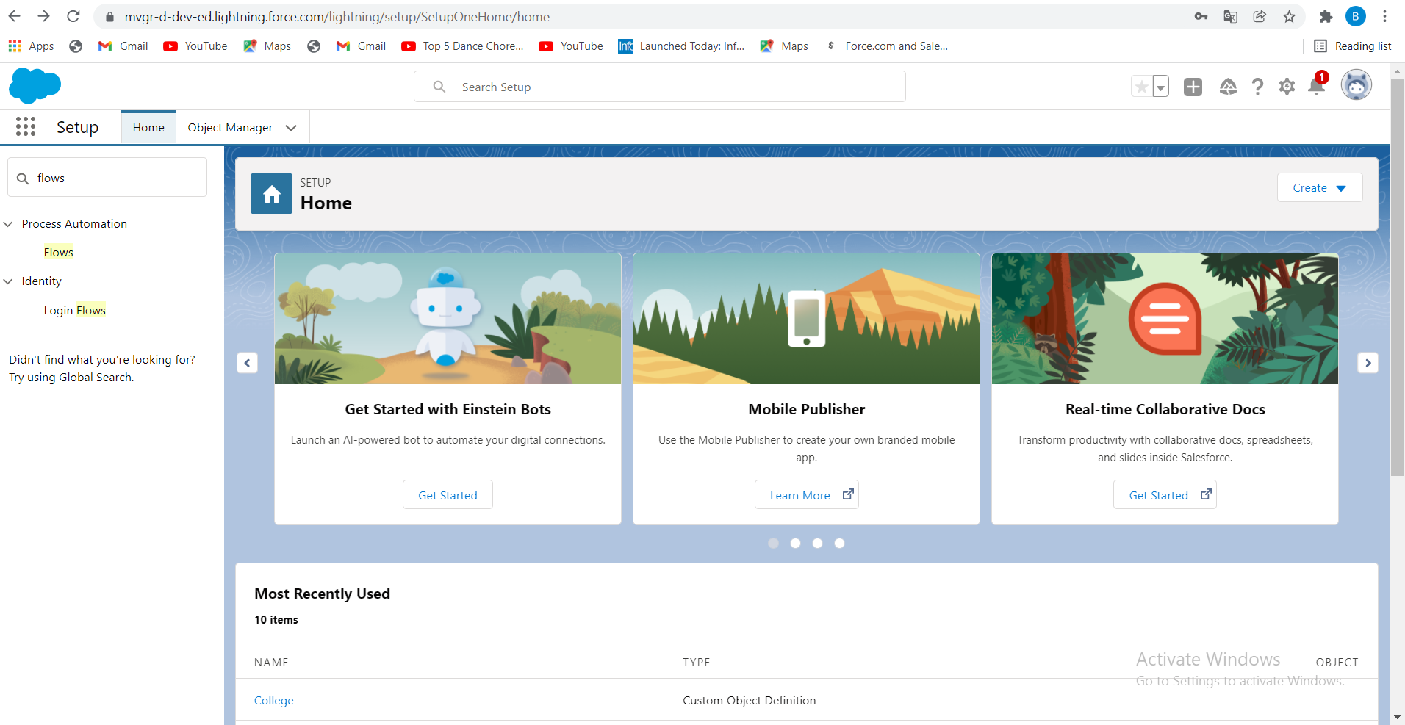

**Day2:**

* Creating a new lightening app named College Management System and add up all these objects after creation of custom objects which are mentioned below:

1. College

2. Application Form.

3. Students.

4. Subjects.

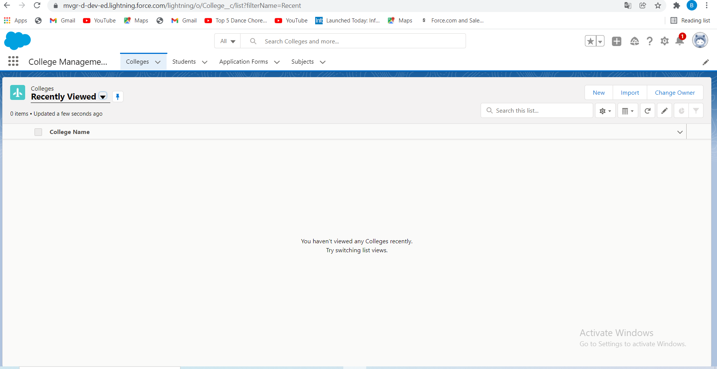**1.College**

a.Record Info(Text Datatype)

b.College fees(Currency Datatype)

c.Hostelfees(Currency Datatype)

d.CollegeName(Picklist Datatype)

e.Email(Picklist Datatype)

f.Capacity of Students(Picklist Datatype)

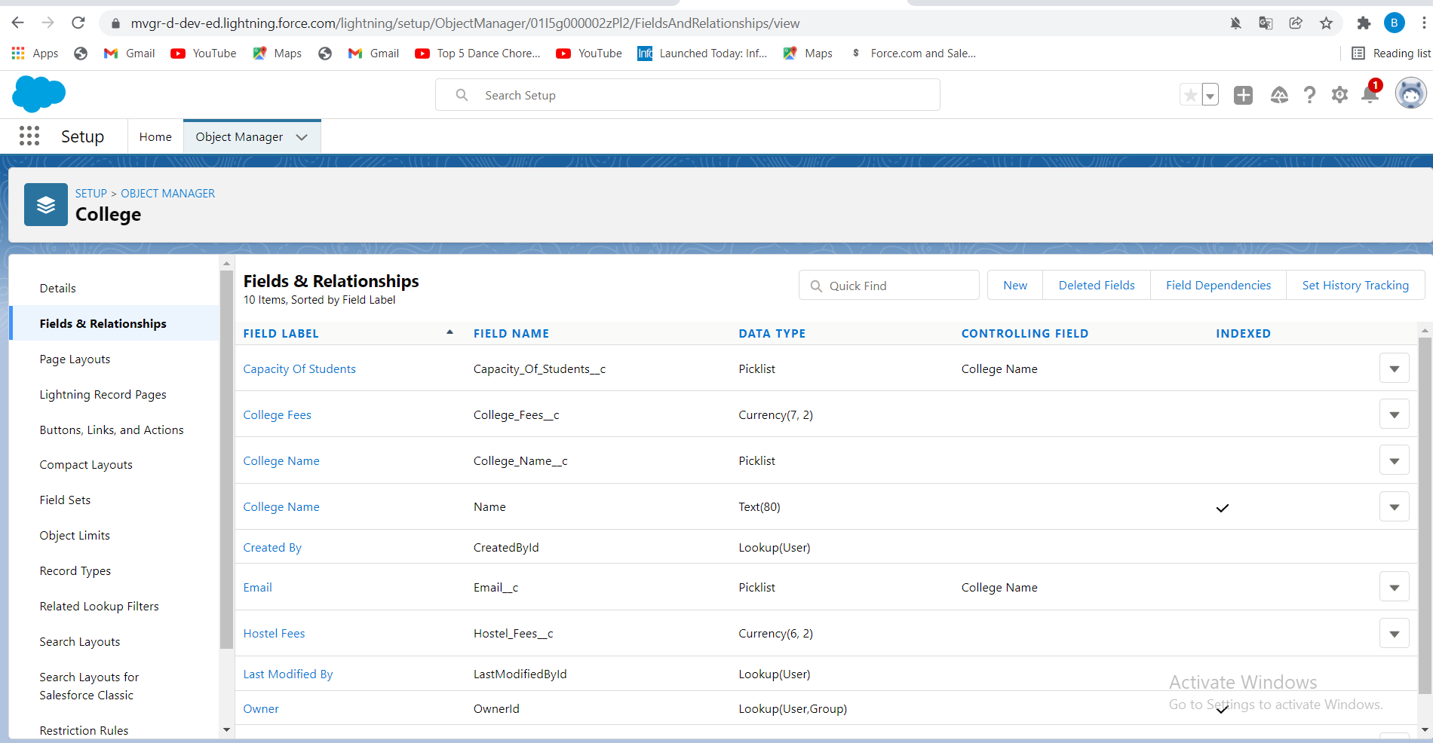

**2.Application form**

a.Application Form ID(Auto Number Datatype)

b.Address(Text Datatype)

c.College(Master-detail Relationship Datatype)

d.College Fees(Formula Datatype)

e.Hostel Fees(Formula Datatype)

f.Date of Birth(Date Datatype)

g.Email(Email Datatype)

h.Gaurdian Name(Text Datatype)

i.Looking for Hostel Stay(Checkbox Datatype)

j.Ready to join(Checkbox Datatype)

k.Student Name(Text Datatype)

l.Phone(phone Datatype)

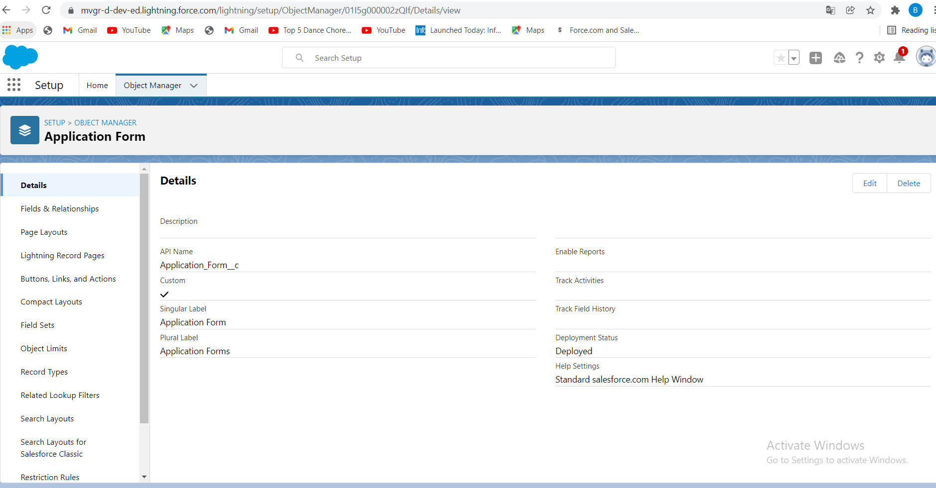

**3.Students**

a.Student Name(Text Datatype)

b.Address(Text Datatype)

c.Application Form(Lookup Relationship Datatype)

d.College Name(Formula with text return type)

e.Date of Birth(Date Datatype)

f.Gaurdian Name(Text Datatype)

g.Phone(phone Datatype)

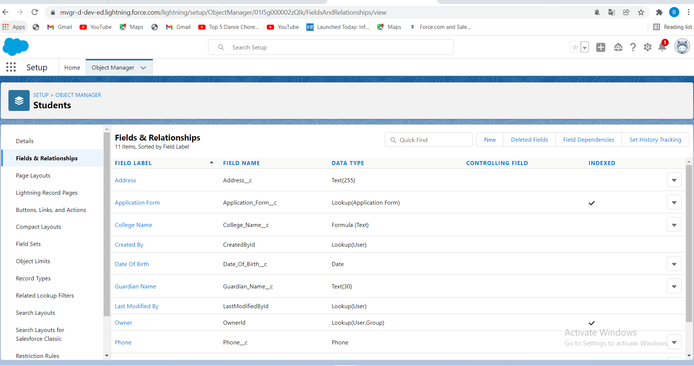

**4.Subjects**

a.Subject ID(Auto Number Datatype)

b.Paper1(Picklist Datatype)

c.Paper2(Picklist Datatype)

d.Student(Lookup Datatype )

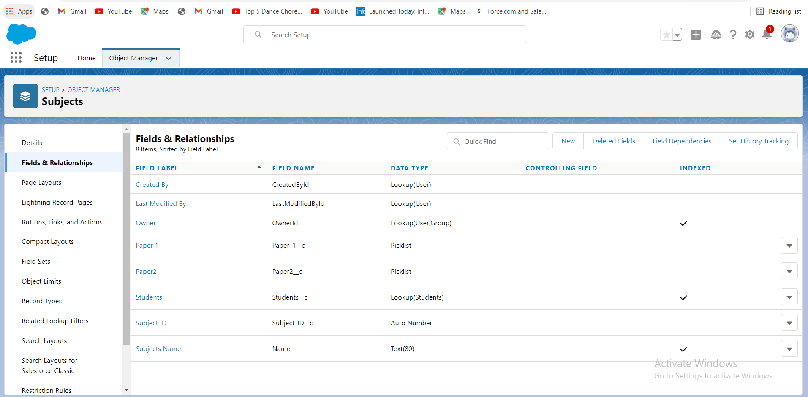

* Global Picklistvalues are:

a.College

b.Paper1

c.Paper2

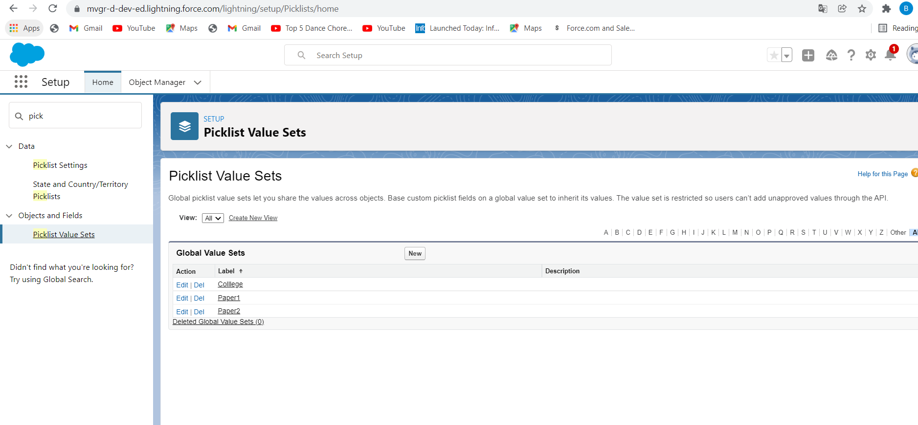

* Creation of Field Dependency in College Object between College Name and

Email where the controlling field is college Name and dependent field is Email. Select the email ids according to the college names.

* Creation of Another Field Dependency in College Object between College Name and Capacity of Students where controlling field is college Name and dependent field is Capacity of Students. Select the values according to your wish.

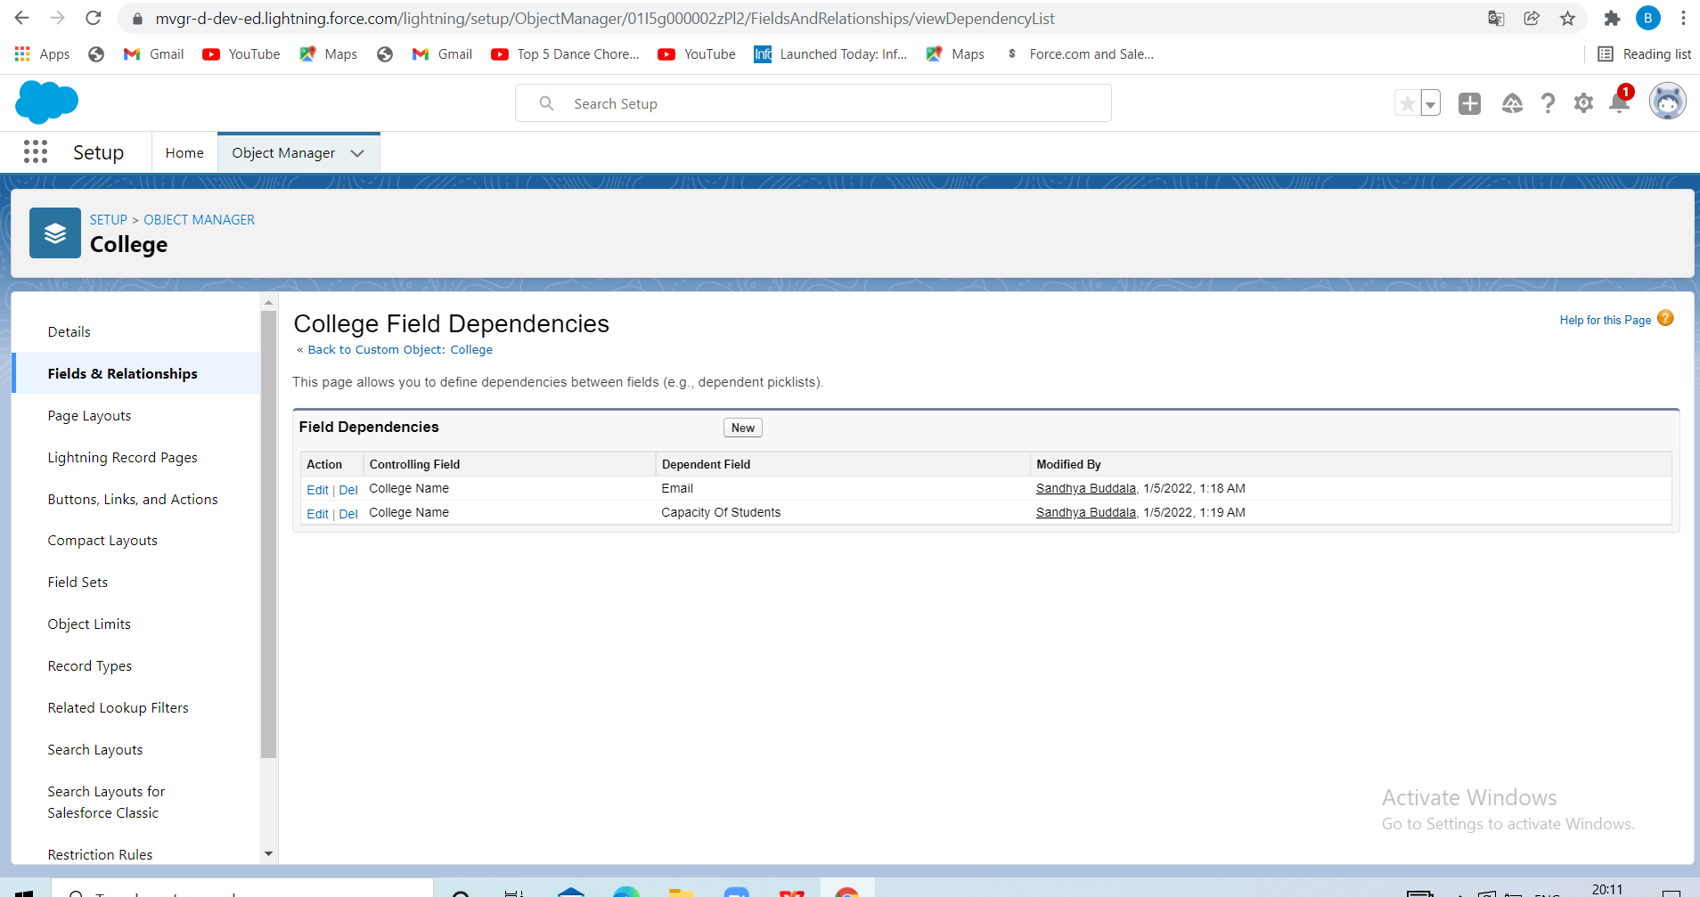

Now Creation of Validation Rule with a logic that checks for College Name and Record info are same or not.

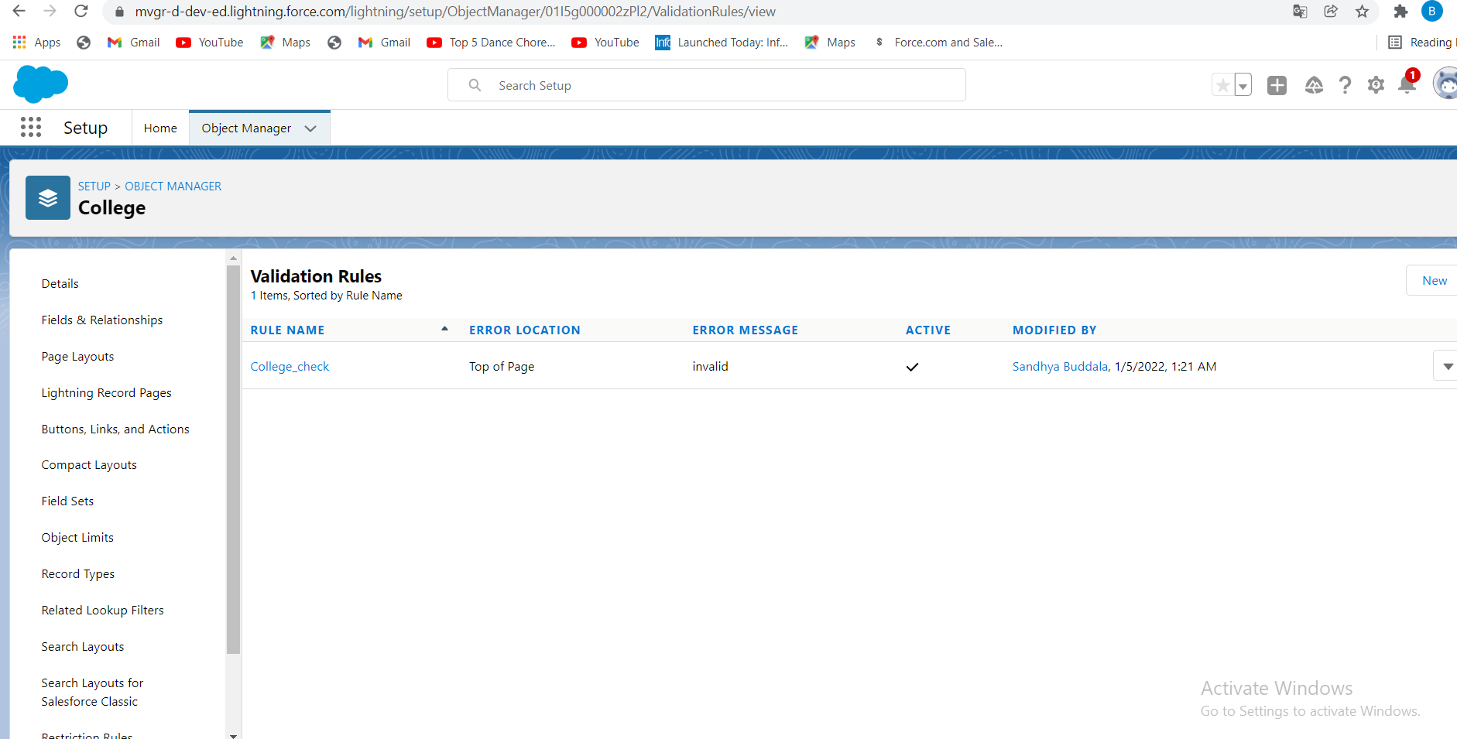

**Day 3:**

* Creation ofautomation process such that when the "ready to join" field is checked on the application form object we need to create the student record automatically with the information specified in the application form record.

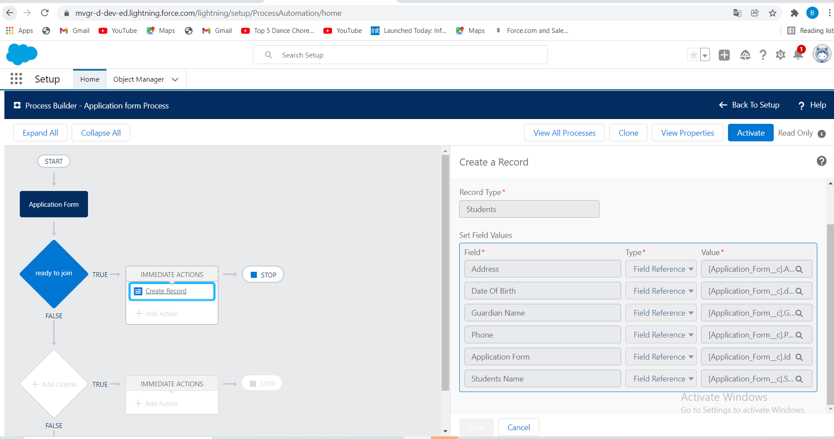

**Day 4:**

* Create the student record using flow

Before to do this,we have to deactivate the process that we created before.

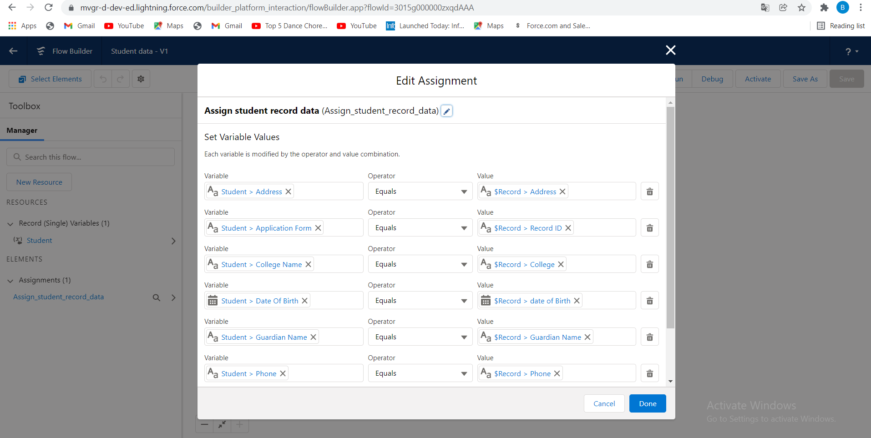

**Day5:**

* To Create a batchapex for application form,we need to a write a apex class in developer console.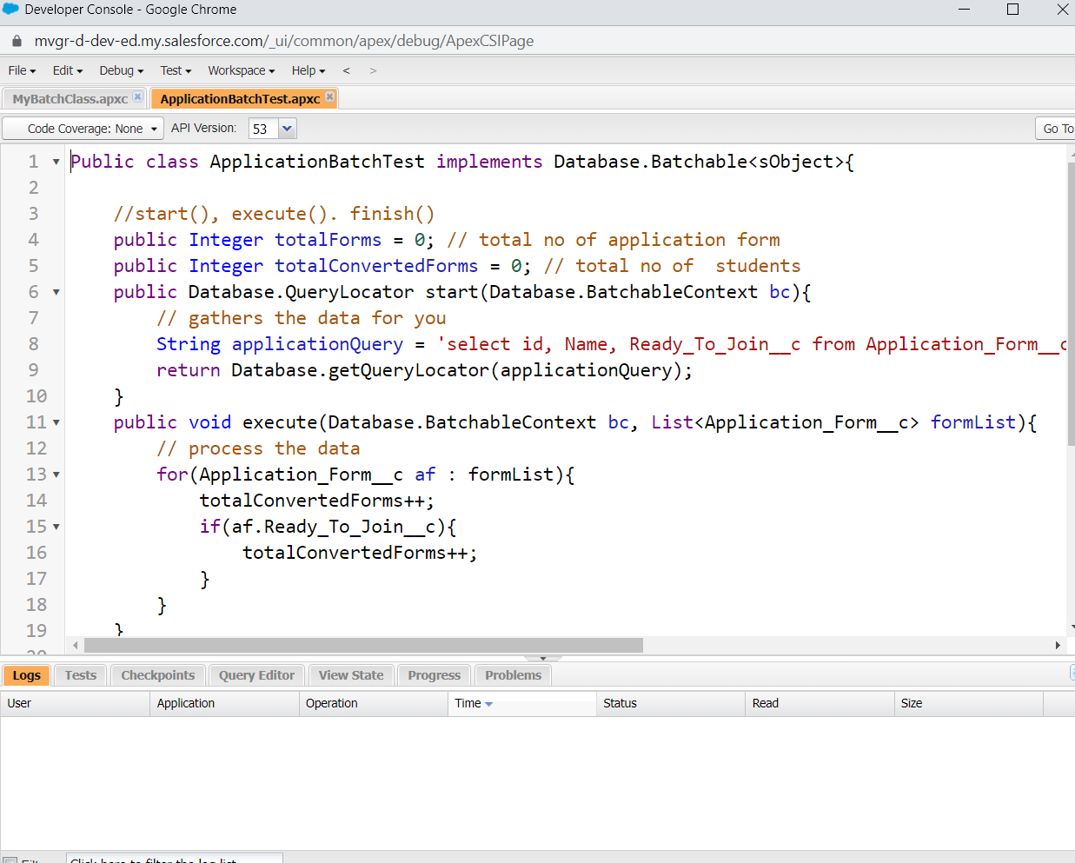

**Day6:**

To create a scheduler class,we need to write a apex class in developer console.

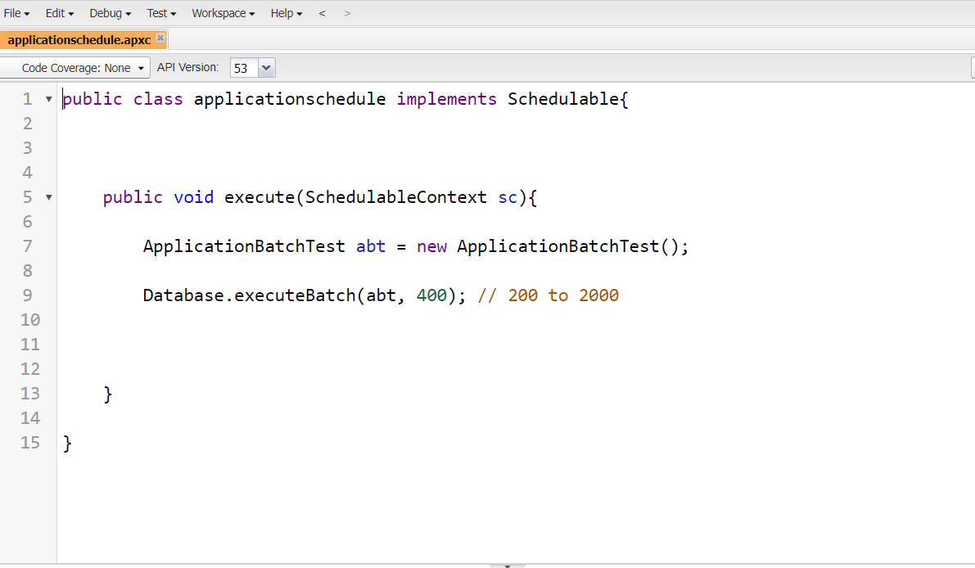

* After writing the apex class without any error,we need to go to setup.
* From setup search apex class and click on schedule jobs and give as per our requirements.

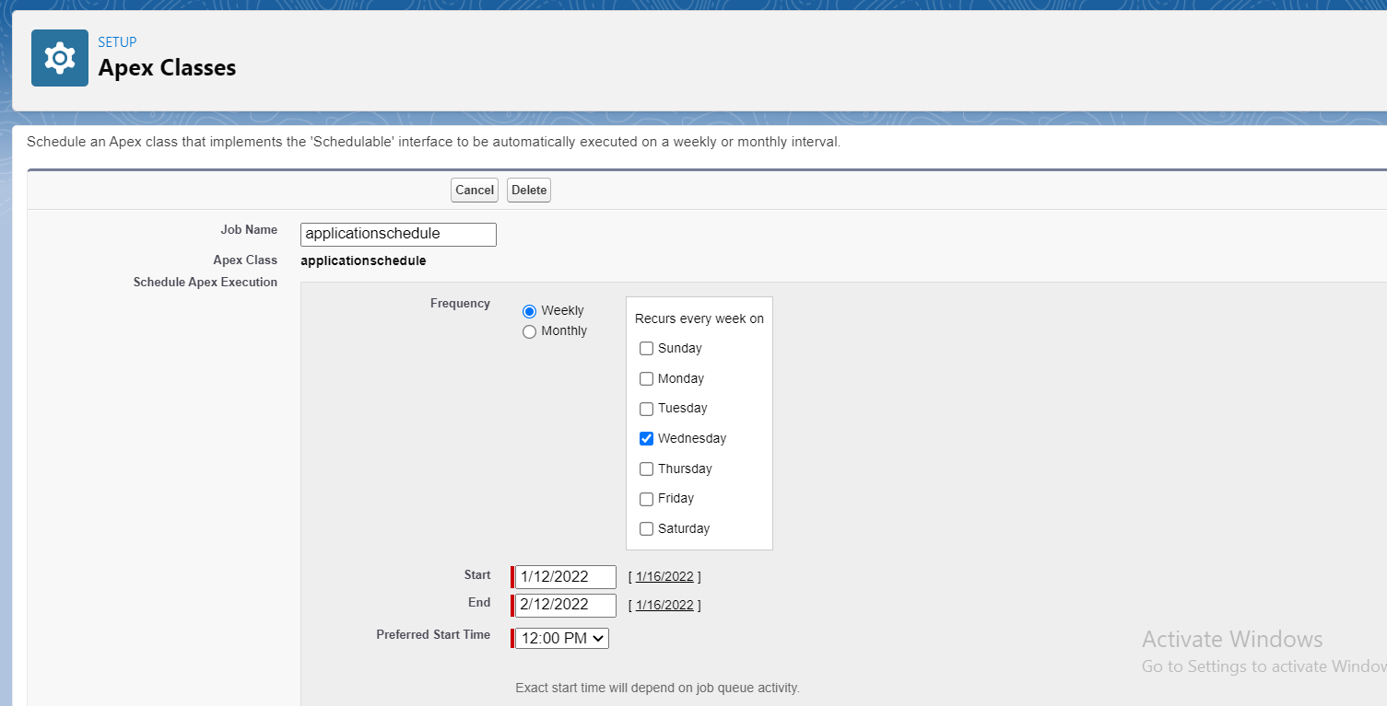

**Day7:**

* we are going to create the college data table, for this we need to create an apex class, from which we are going to retrieve the data and Html, javascript files for UI .

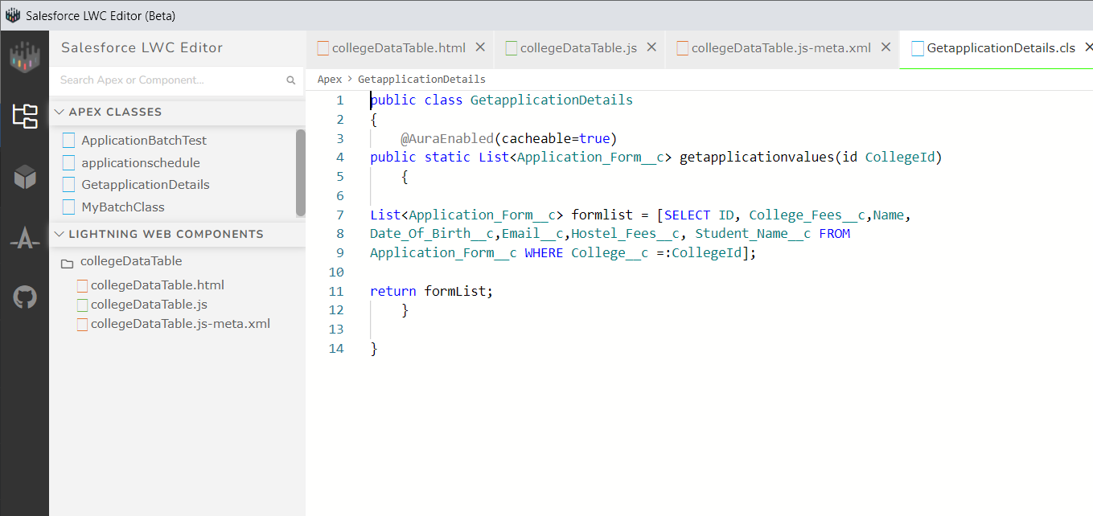

* Create the component with the following files.

HTML:

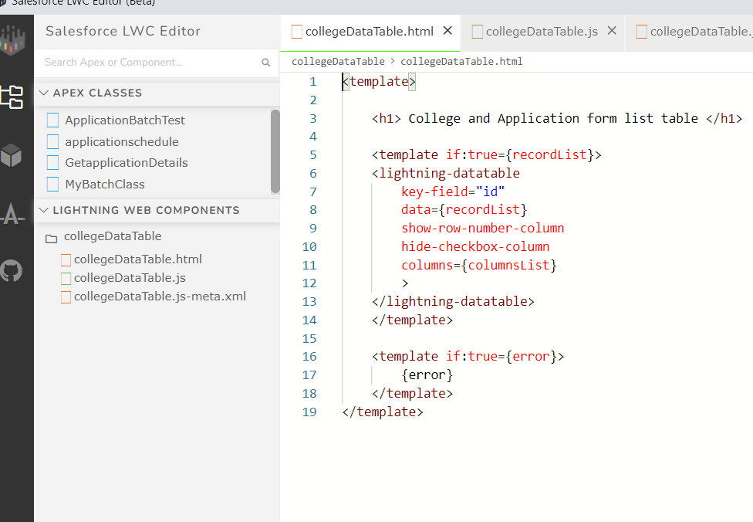

### Create College DataTable Component(JAVA SCRIPT FILE)

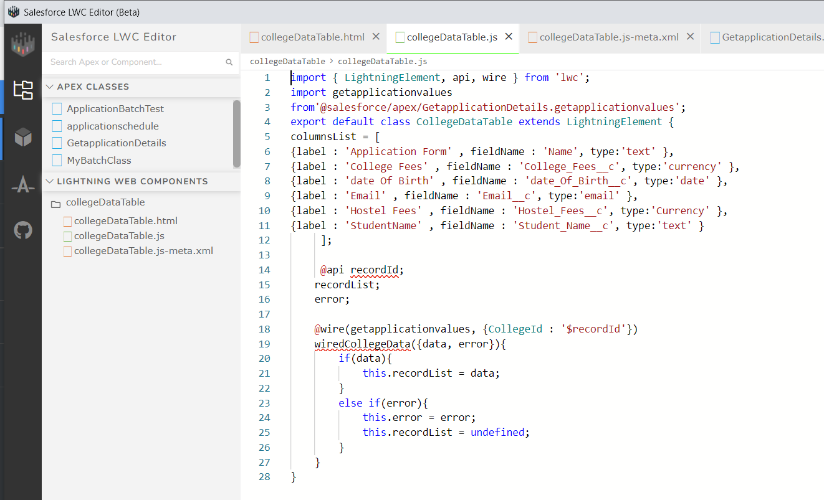

### Create College DataTable Component(META FILE)

