**DAY1:**

To create College Management Application Project

Created Salesforce Developer Org to get started

> Created developer Account

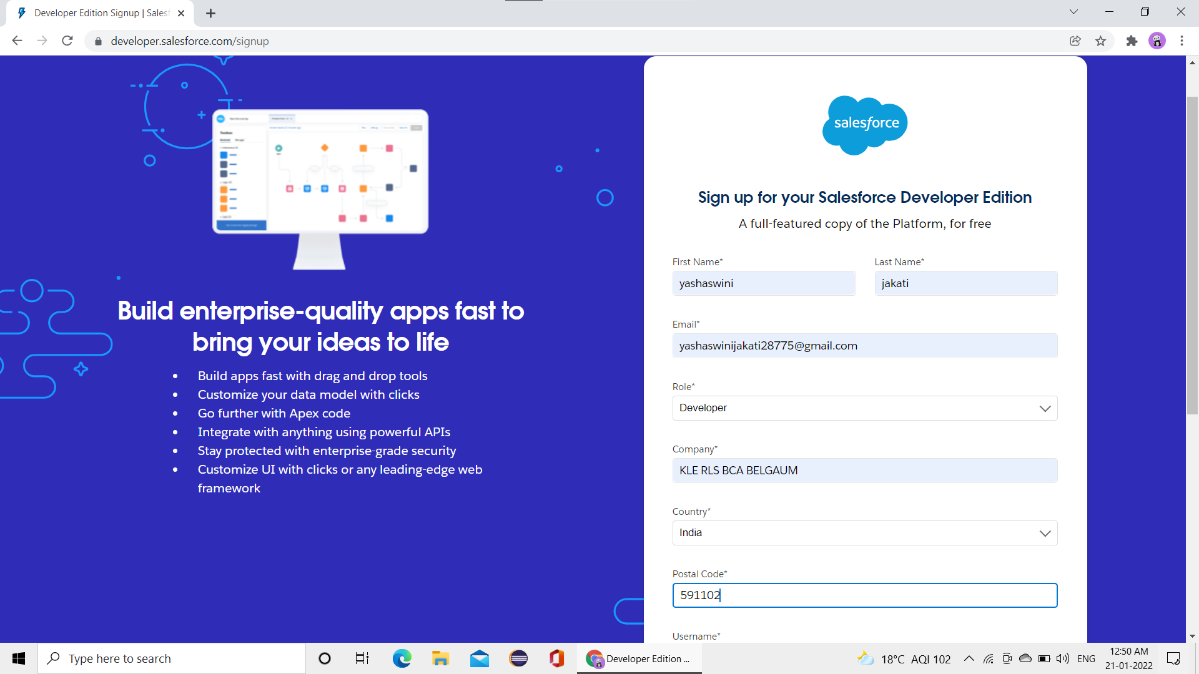

**>Account activation**

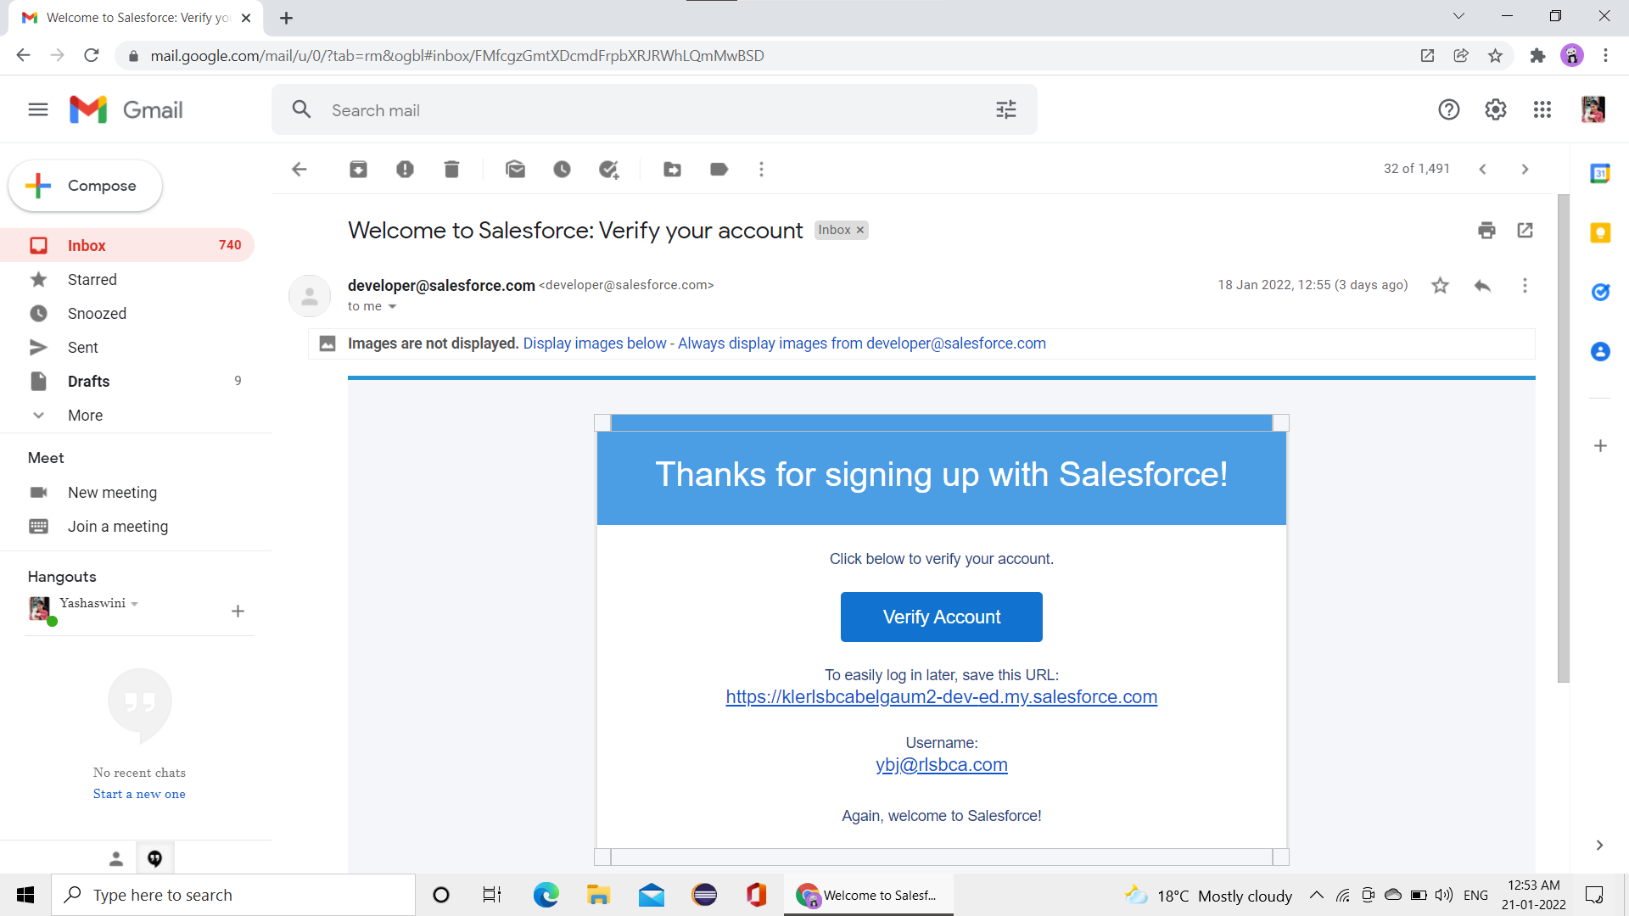

> Login to sales force account

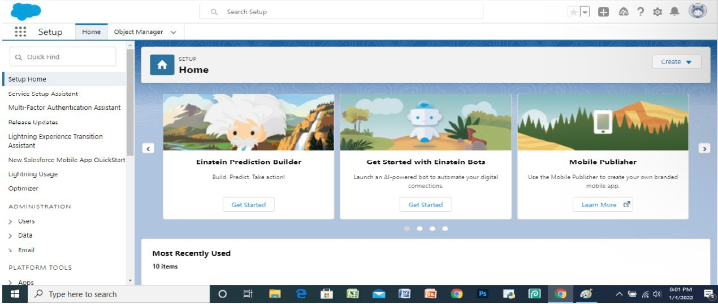

Additional things learned in 1st session

> Sandbox

> 4 Types of sandbox

developer sandbox

developer pro sandbox

partial copy sand box

full copy sandbox

> objects

> environment

> relationship

> fields

DAY 2:

Custom object creation

Create application called **COLLEGE MANAGEMENT APPLICATION**

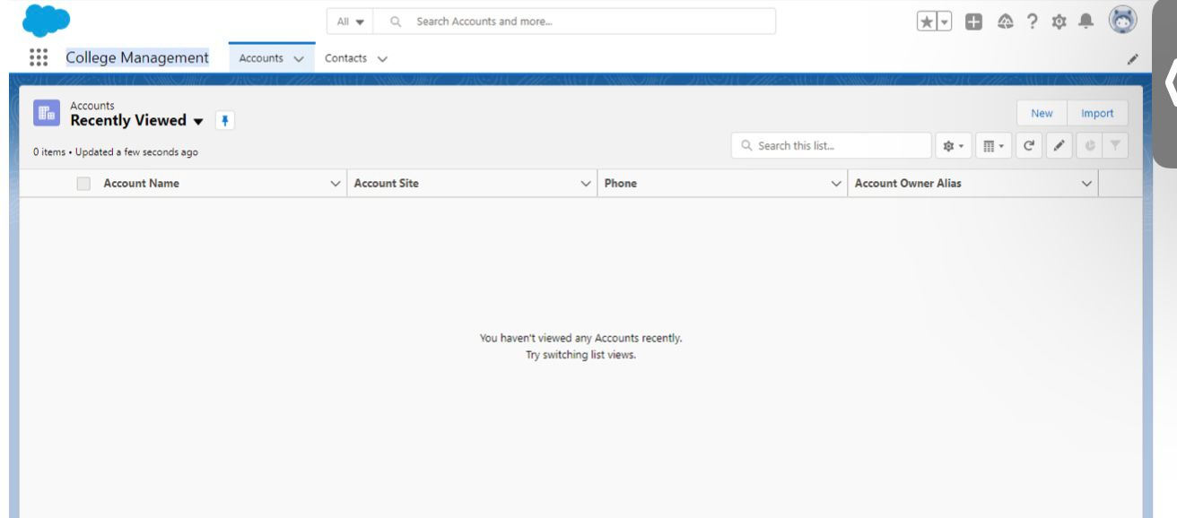

> Create fields for **COLLEGE** custom object

Record info

College Fees

Hostel Fees

College Name

Email

Capacity of students

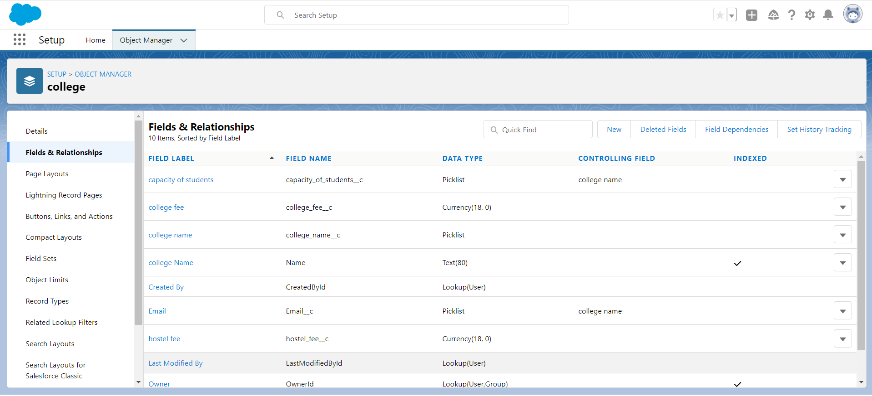

> Create Fields on **Application Form** object

Address

College

College Fees

Hostel Fees

Date of birth

Email

Guardian Name

Looking for hostel stay

Ready to join

Student name

Phone

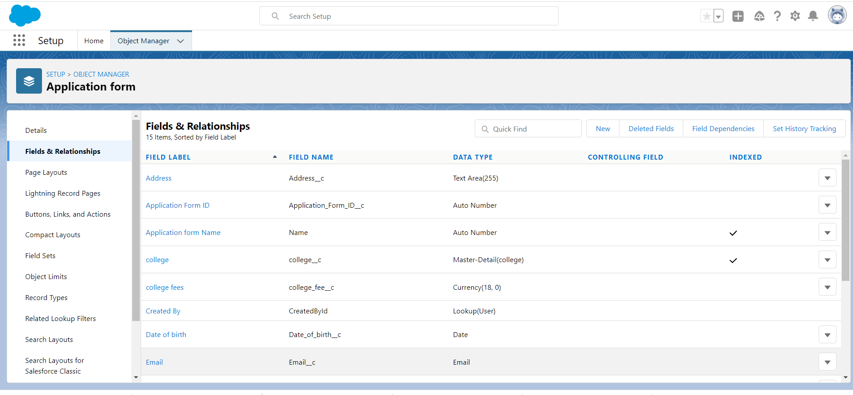

1 Application record created

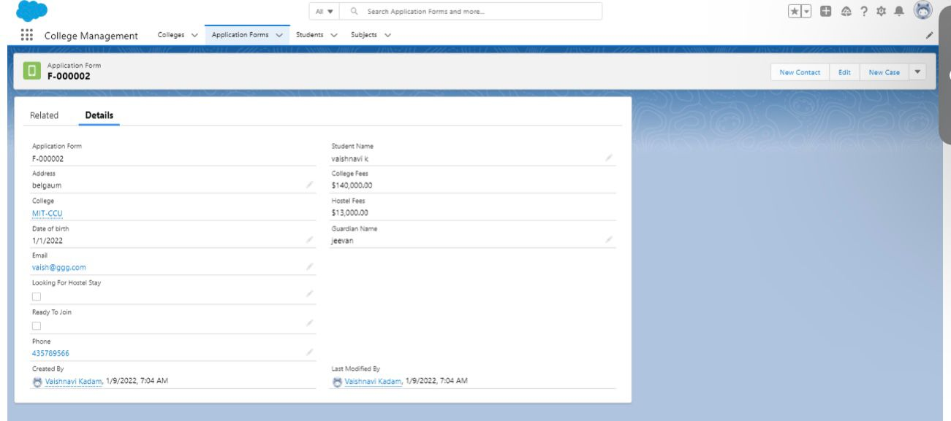

**DAY3:**

> Create fields of **Student**

Address

Application Form

College name

Date of birth

Guardian name

Phone

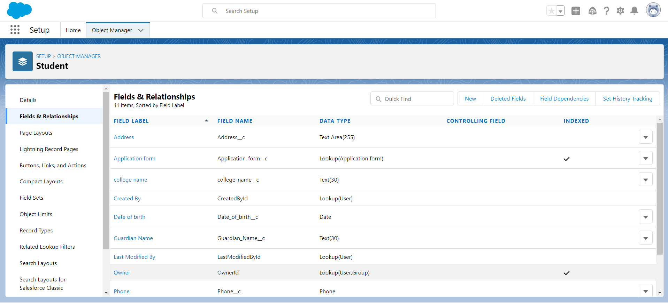

> Create fields on **Subject** object

Paper1

Paper2

Student

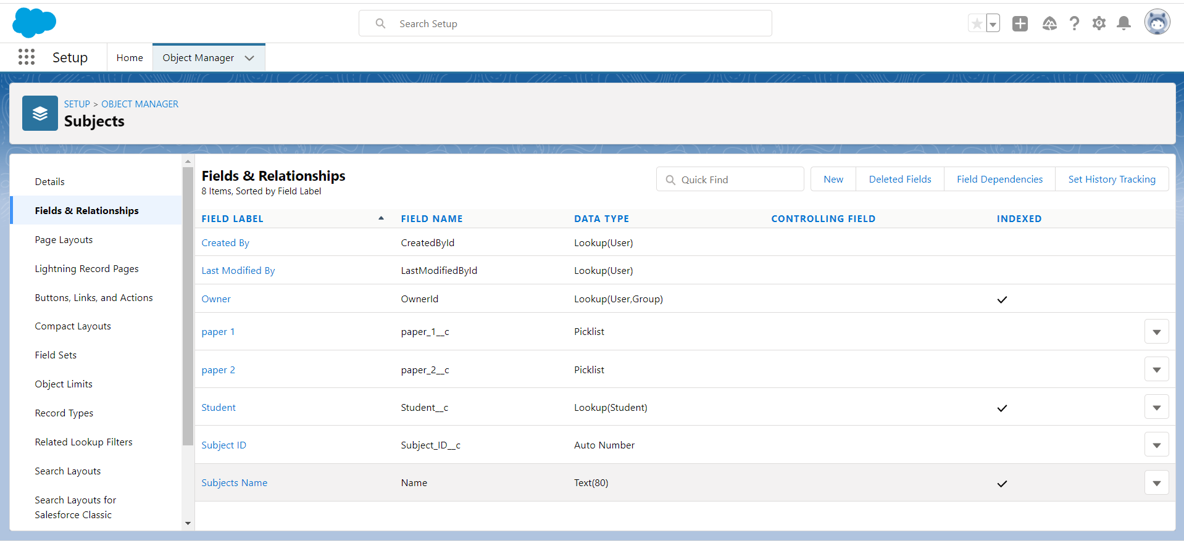

> college management application display

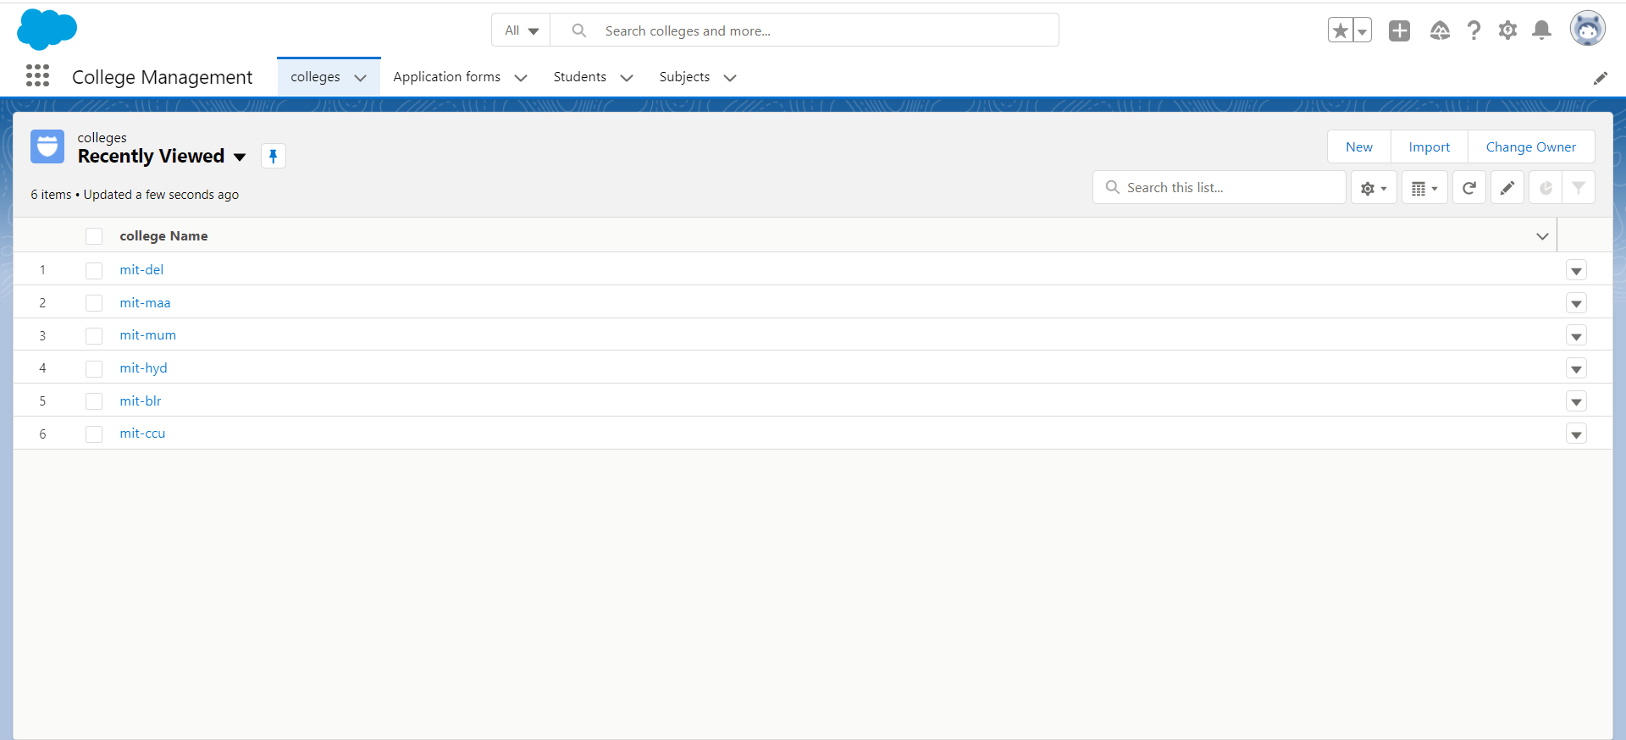

**here the tabs are lookup relationship**

**COLLEGE >> APPLICATION FORM >> STUDENT >> SUBJECT**

> **Legend** it shows symbolic representation ,which symbol represents what.

SCEME BUILDER

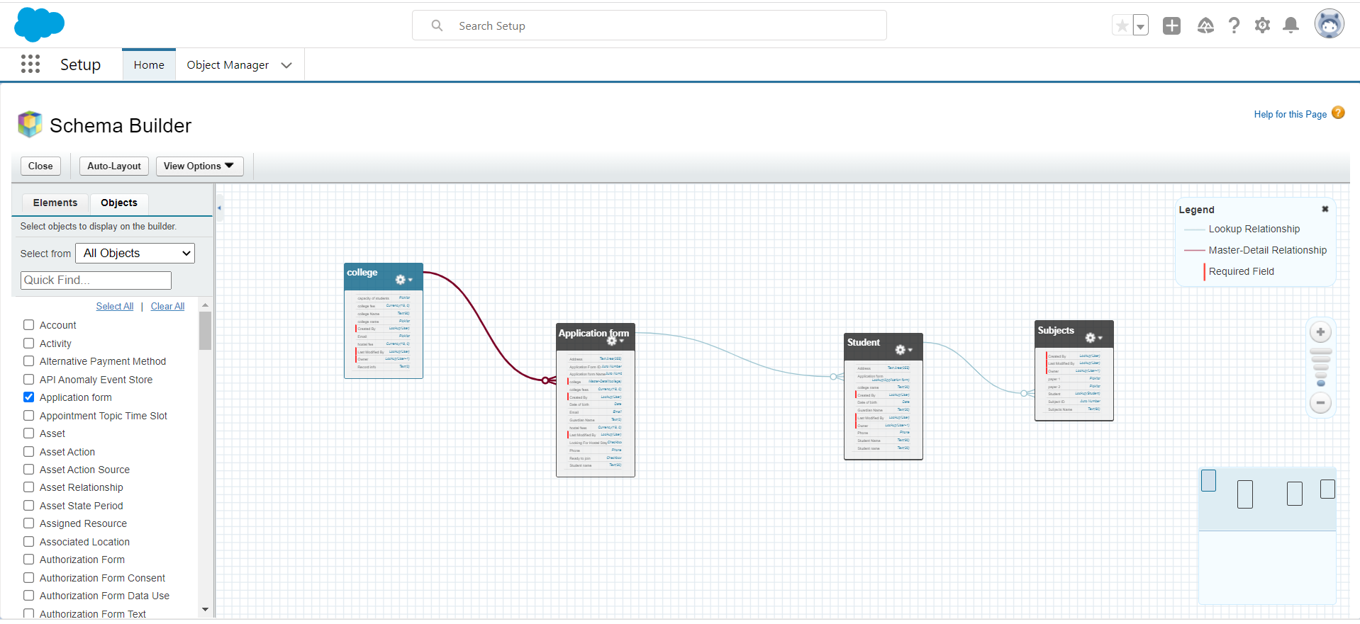

**>Legend**

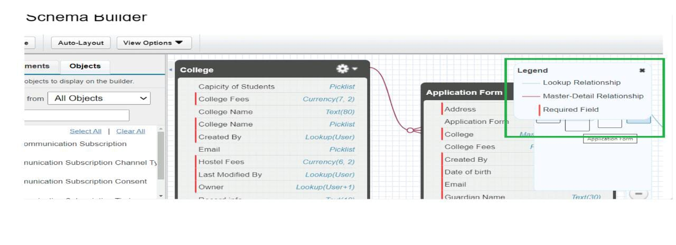

> How to display list view fields

1. Go to list view ,select all

2. Click list view control

3. Select fields to display

4.Select the fields that you want to display.

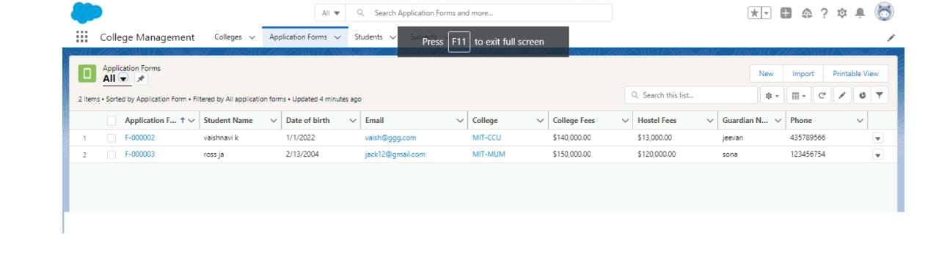

> Process Automation

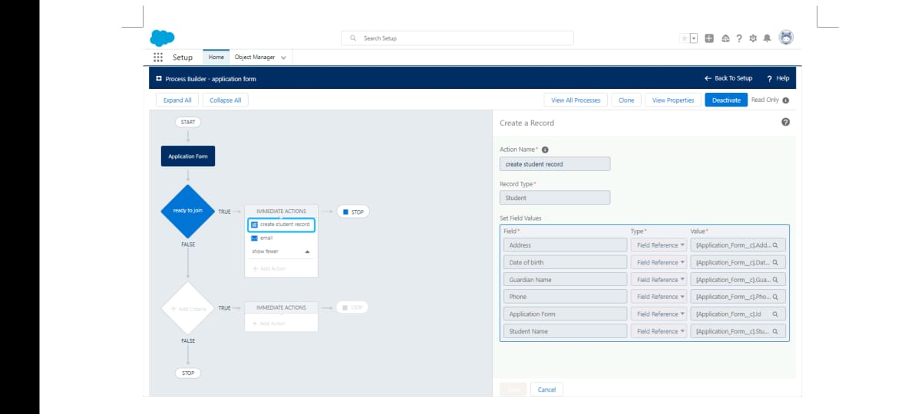

New record created

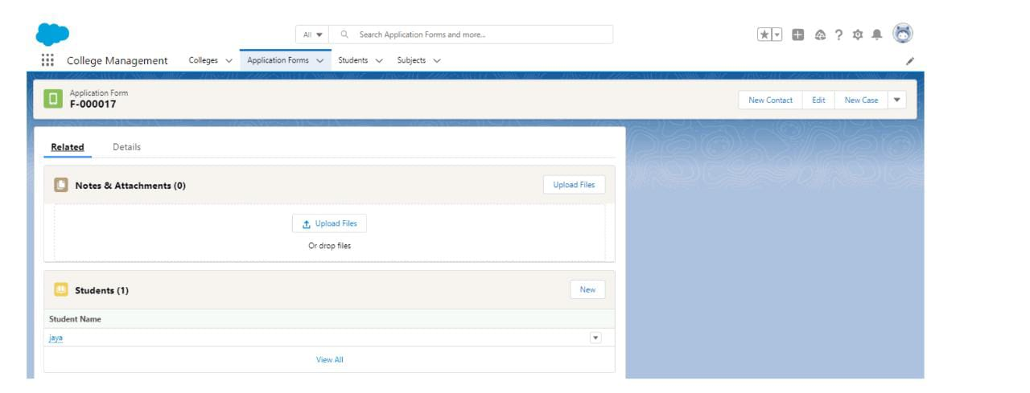

email for record creation

1. Go to list view ,select all

2. Click list view control

3. Select fields to display

**DAY 4:**

> Create student record using flow

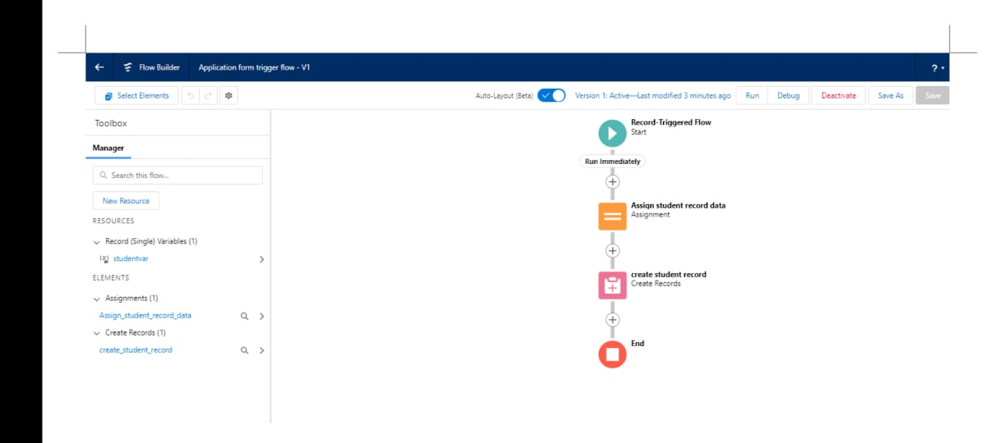

**assign student record data**

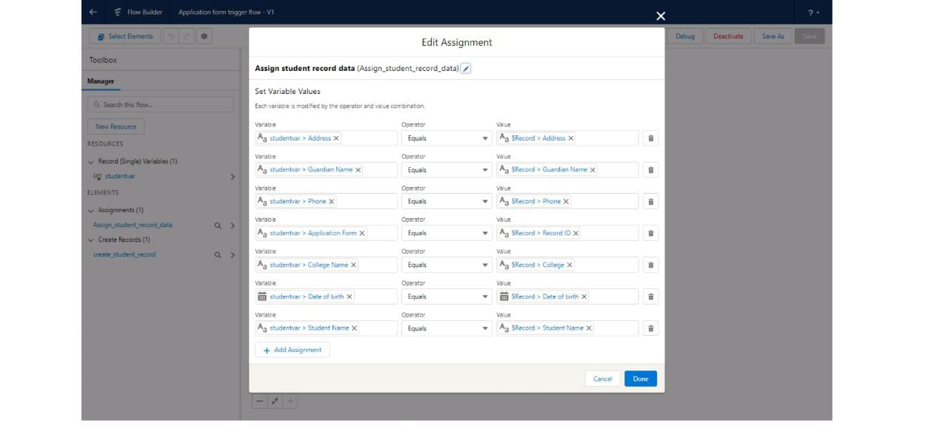

> record created using flow

**> Related data**

> learned about developer console

> salesforce primitive data-types : boolean ,string,date,time,id, integer ,double

> collection: list,map,set

**DAY 5:**

> Query

SOQL :Sales force object query object

Query example for Application form

> SOSL: sales force object search language

> collection

> apex

two types of apex classes

1. sync : Synchronous Apex means **entire Apex code is executed in one single go**.

2. a sync : Asynchronous apex is executed when resources are available

types of a sync apex:

1. future method

2. batch class

3. queue able class

4. scheduler class

**DAY 6:**

> Create a batch apex for application form

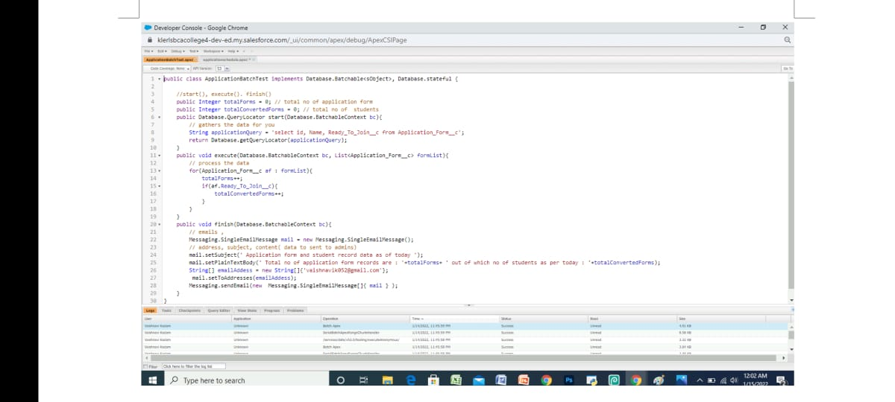

> Create a scheduler class

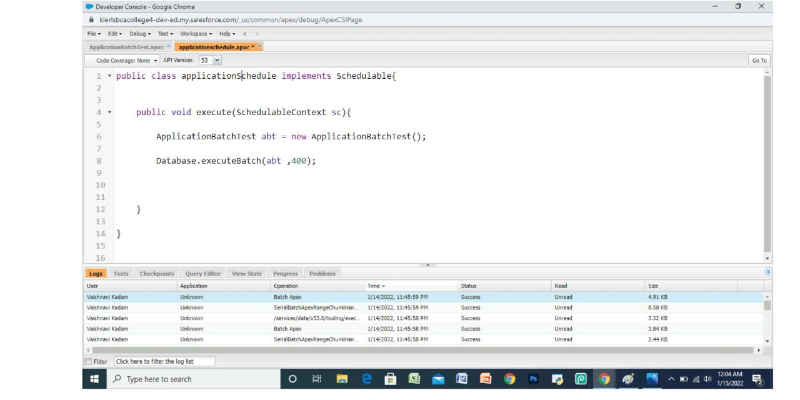

**DAY 7:**

1. **Apex Trigger**

> Two types of triggers

Before trigger and After trigger

> Operations performed :- insert ,update ,delete ,un delete

2. Trigger context variables

>Bulkification :whatever code we write should be capable of handling everything.

> Should have collection variable whenever we write class,trigger.

> Never write DML statements inside for loop

> If you want to add DML statements than use list, map it will not hit any governor limits.

> Can use Multiple for() loop but cannot use nested for loop

4. Test class: it is automate script for a developer to test his/her logic

**-** trigger minimal coverage =0%/1%

**-** apex minimal coverage should be more than 75%

5. - @istest

- @testup

- @test.start test();

- @test.stop test();

6. System assertEquals(actual,expected);

**DAY 8:**

Introduction to LWC (lightning web component)

> What is LWC:It is programming model to develop sales force lightning components.

> Why LWC

> Benefits of LWC

> Web stack transformation

> LWC file contains main 3 files

- html ,javascript(js),meta-xml and one out of the box css file.

> Introduction to javascript

-js functions

> Installation of **vs.code**

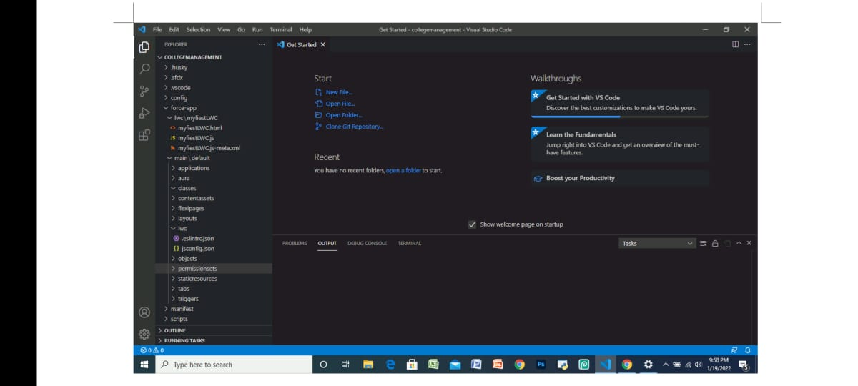

> In vs.code download **Sales force extension pack**

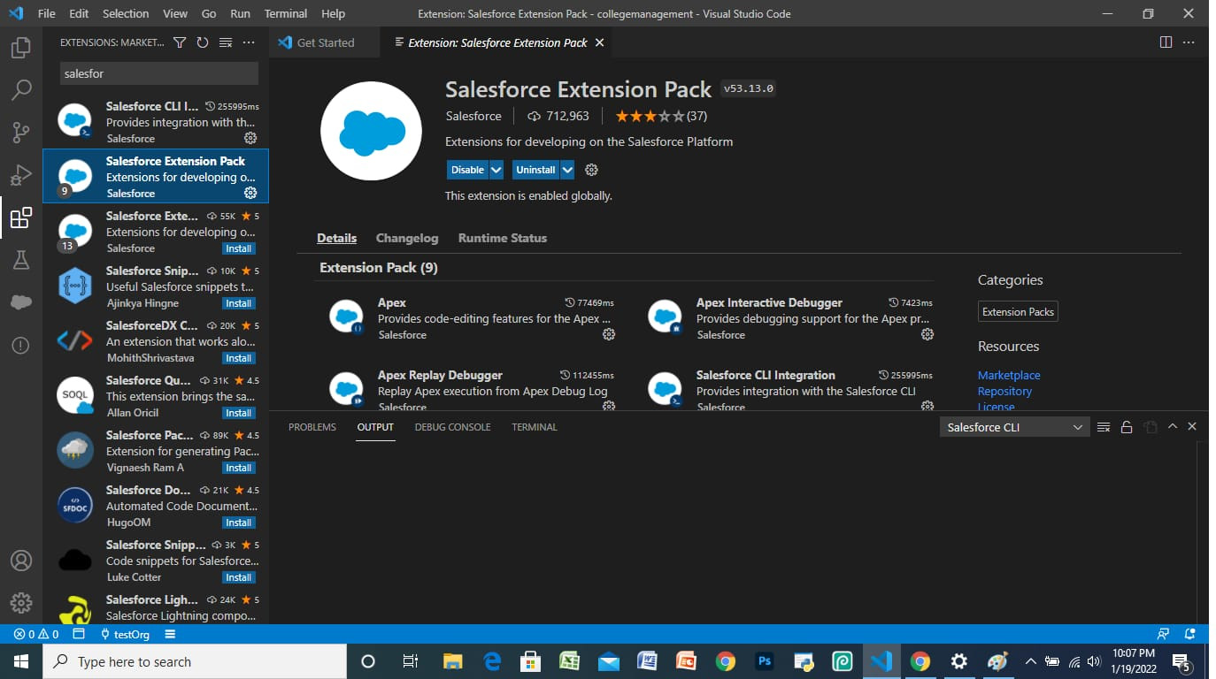

> Installation of **Sales force LWC editor**

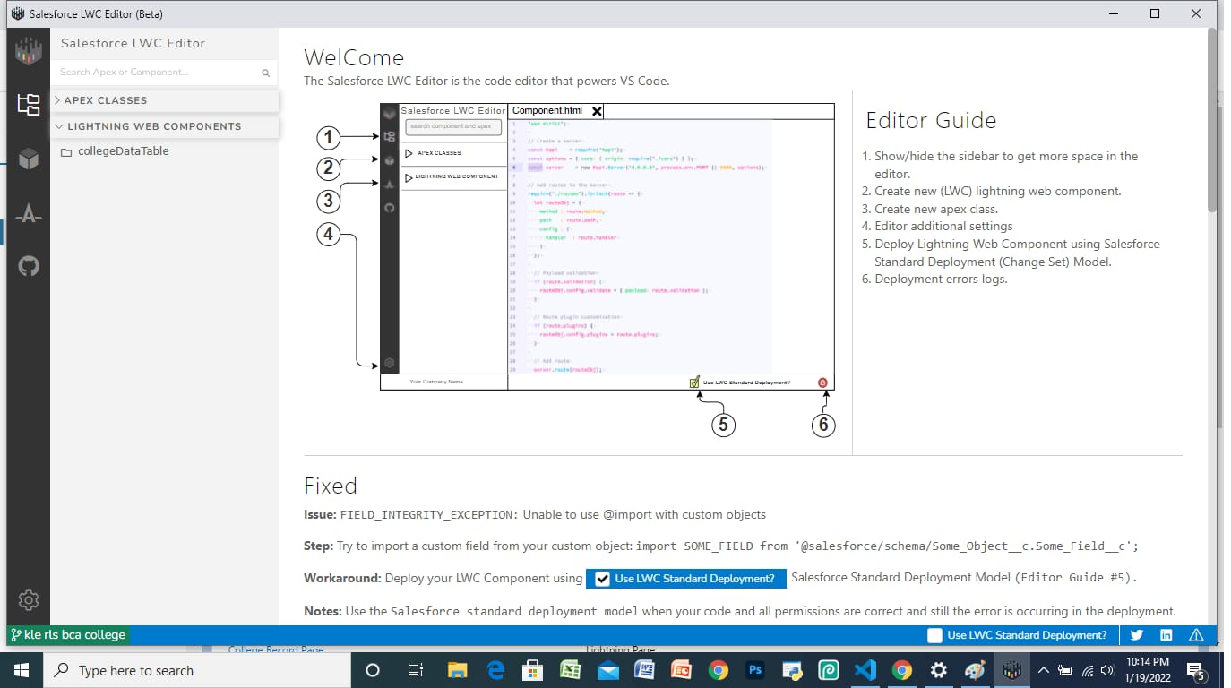

> Worked with date time and javascript.

**DAY 9:**

> Installed **Sales force CLI**

> Create Lightning web component

> learned how to deploy and retrieve sources in sales force org

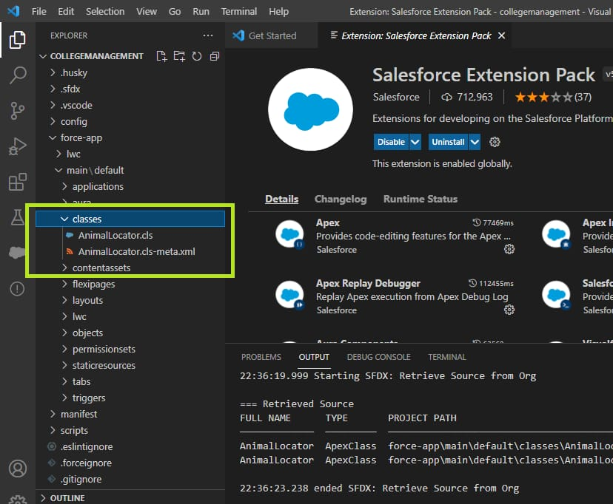

> Map and set in javascript

> Map :it stores data in terms of key and value.

> set : set of values without key and it only contains unique values.

> map and set functions.

> Operators in js

> Difference between ==and ===

> Strings in javascript

> Objects in javascript

> Functions in javascript

> Arrow function ,console statements.

> Example on LWC component.

**DAY 10:**

Lightning web component

> Create College data table component (Apex class)

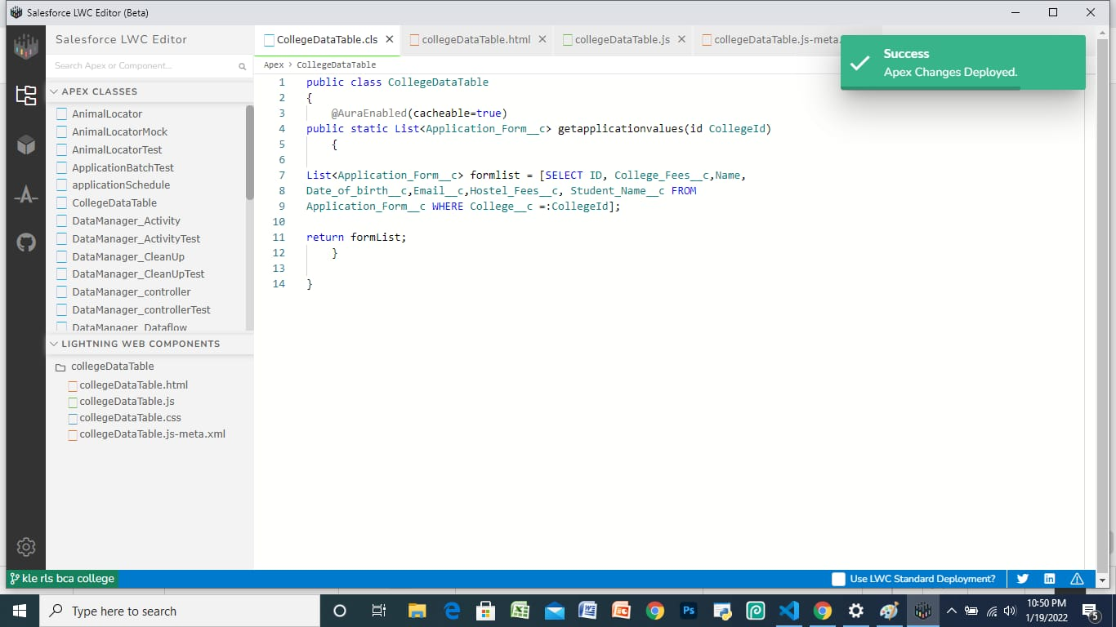

> Create College data table (html file)

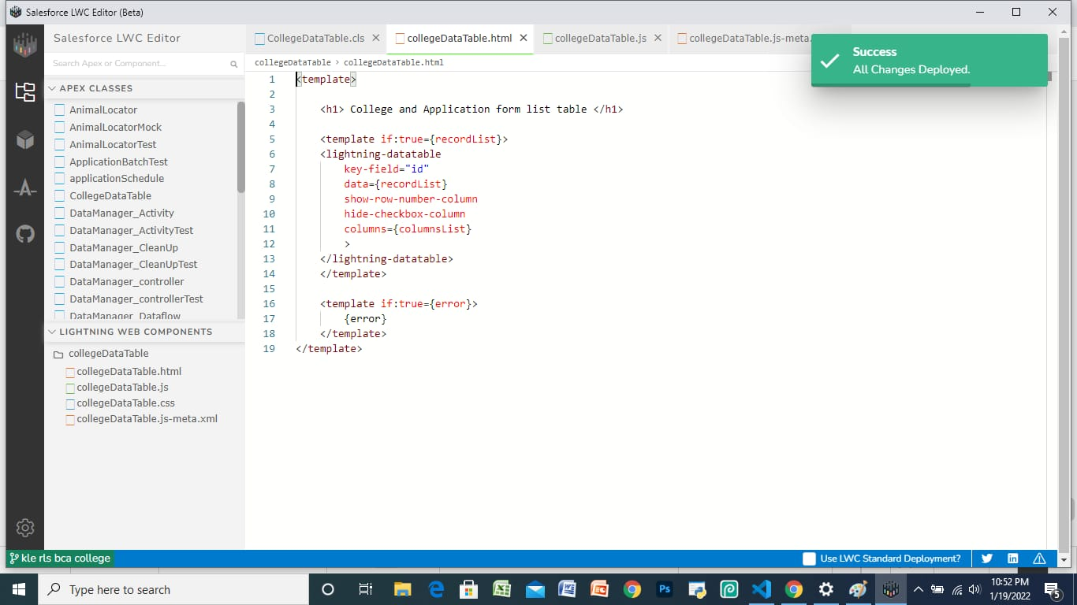

> Create College data table (js file)

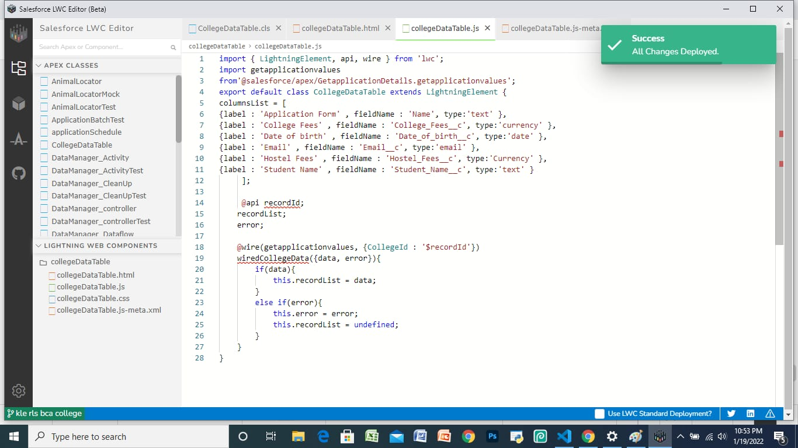

>Create College data table (meta-xml file)

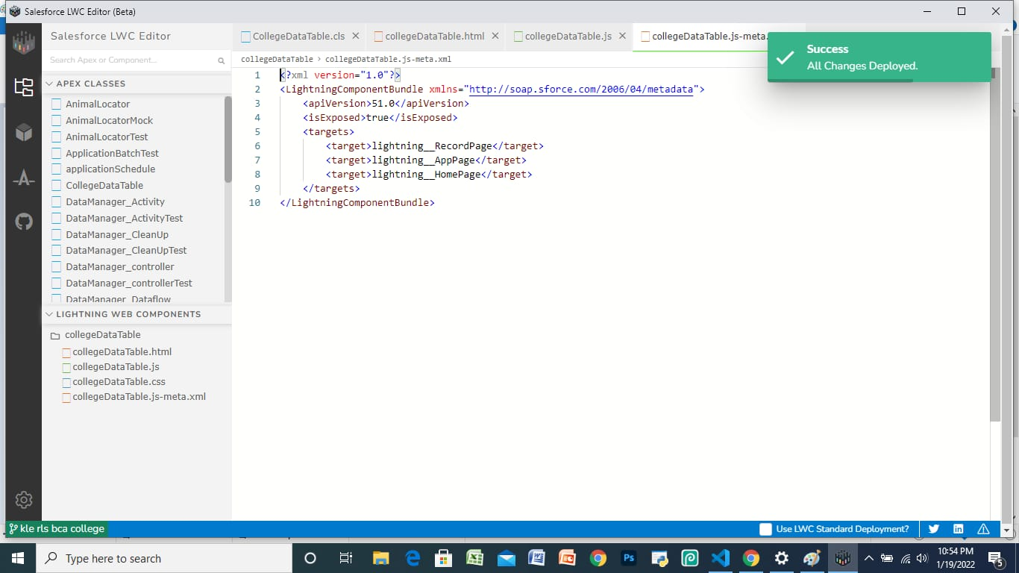

> Output for College data table

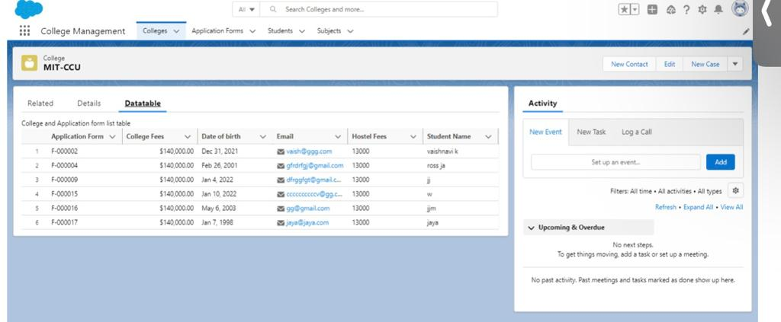

> Communication between parent to child and child to parent

**DAY 11:**

Life Cycle Hooks in LWC

> Constructor(), Connectedcallback(),

- constructor: fires when component instance is created.

- flows from parents to child component.

- structure of constructor().

> render(), render callback()

>disconnected callback(), error callback()

> Toast messages

Indicates/inform user that they are writing something wrong

> Four types of Toast messages

- Success (in green colour)

- Warning (in orange/yellow colour)

- info (in grey colour)

- error (in red colour)

> sample examples on toast messages

> Doubt clearing session