# Agriculture Data Analytics In Crop Yield Estimation Using IBM Cognos

# 1 INTRODUCTION

# 1.1 Overview

Crop production in India is one of the important sources of income and India is one of the top countries to produce crops. As per this project we will be analyzing some important visualization, creating a dashboard and by going through these we will get most of the insights of Crop production in India.

# 1.2 Purpose

Following are the objectvies of working on this project:

* Gaining insights of Crop production in India.
* Crop related analytics using IBM Cognos Analytics.
* Plotting different graphs based on the requirements.
* Creating meaningful dashboards.

# 2 LITERATURE SURVEY

**2.1 Existing problem**

Following are the problems with existing approaches:

* Requires greater time
* Plotting different graphs needs to be done manually or by using only limited types of graph templates
* Creation of dashboard is not very simple
* Reports and dashboards present data in not so easily-understandable formats.

**2.2 Proposed solution**

IBM Cognos Analytics.

# 3 THEORITICAL ANALYSIS

# 3.1 Block diagram

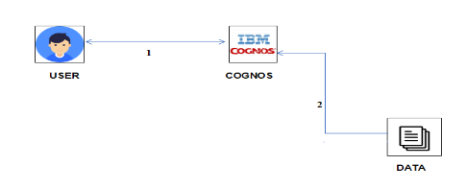

**3.2 Hardware / Software designing**

IBM Cognos Analytics.

# 4 EXPERIMENTAL INVESTIGATIONS

**Analysis:**

* Seasons with average productions
* With years usage of Area and Production
* Top 10 States with most area
* State with crop production
* States with the crop production along with season (Text Table)

# 5 FLOWCHART

**Control flow of the solution:**

* Login to IBM Cloud Account
* Open Cognos Analytics
* Working with the Dataset
  + Understand the Dataset
  + Loading the Dataset
* Creating Data visualization charts
* Dashboard Creation
* Export the Analytics

# 6 RESULT

**Final findings (Output) of the project along with screenshots:**

Seasons With Average Productions

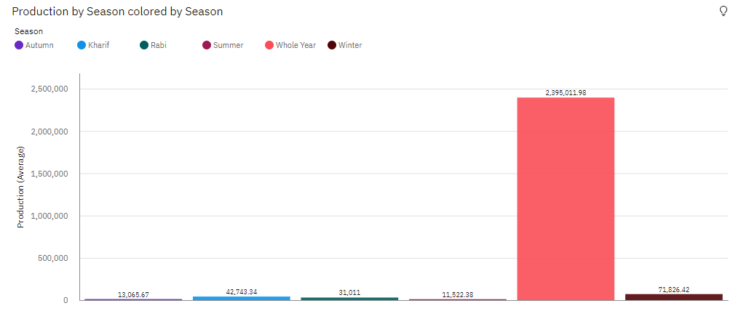

With Years Usage Of Area And Production

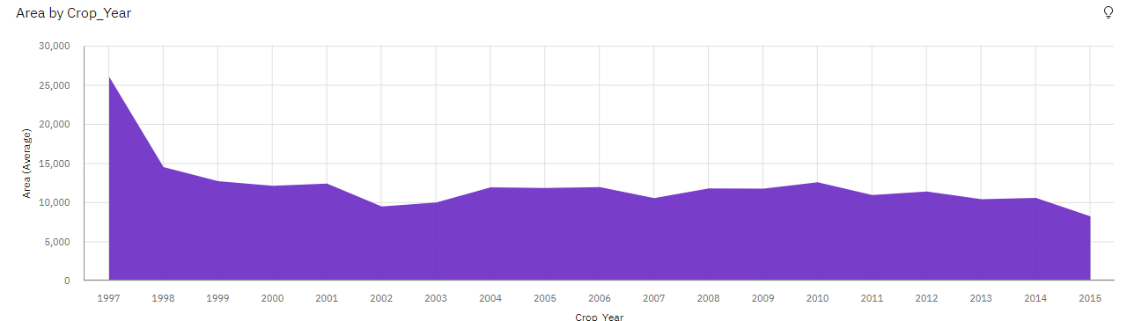

Top 10 States With Most Area

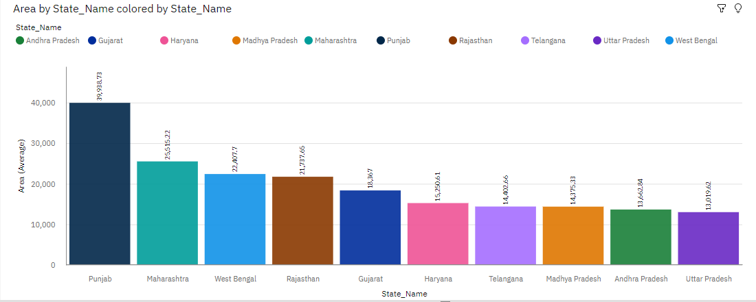

State With Crop Production

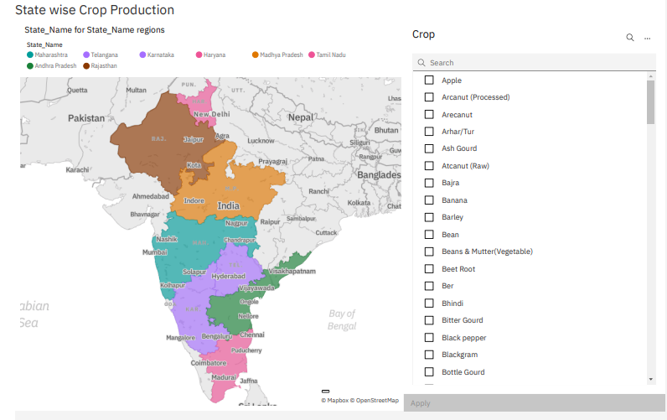

States With The Crop Production Along With Season (Text Table)

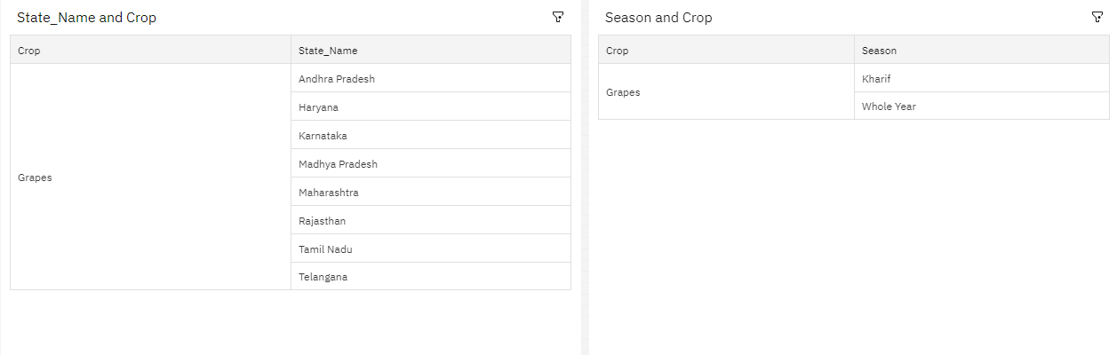

Dashboard

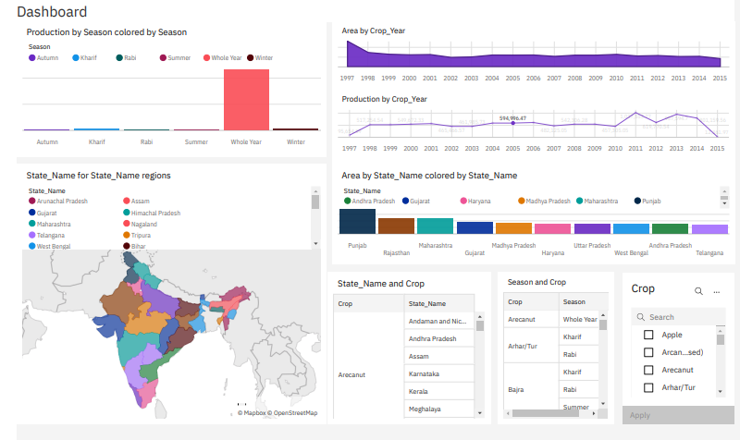

# 

# 7 ADVANTAGES & DISADVANTAGES

List of advantages of the proposed solution

* Faster results—shortens reporting time due to seamless integration and adaptive authoring.
* Improved decision making—reports and dashboards present data in easily-understood formats.
* Ability to use a variety of charts—crosstabs, bar or 3D bar, pie or doughnut, line, gauge, funnel, scatter, dot density, waterfall, and so forth.
* Ability to create complex, multi-page layouts using different data sources.

List of disadvantages of the proposed solution

* Won't work smoothly with large data sets having many parameters.
* Cross-browser compatibility is often problematic.

# 8 APPLICATIONS

The areas where this solution can be applied are insurance, education, retail, consumer packaged goods, manufacturing, banking and financial services, etc.

# 9 CONCLUSION

IBM Cognos Analytics is a web-based integrated business intelligence suite by IBM. It provides a toolset for reporting, analytics, scorecarding, and monitoring of events and metrics. The software consists of several components designed to meet the different information requirements in a company.

# 10 FUTURE SCOPE

IBM Cognos is a leading Business software and performance management tool. It permits organisations to become top-performing and analytics-driven entities. It’s designed to assist everybody in your organisation create the selections that win higher business outcomes, versatile preparation choices, and to enable you to simply scale your analytics to fulfil dynamic business desires.

**11 BIBILOGRAPHY**

https://www.appsruntheworld.com/customers-database/products/view/ibm-cognos-business-intelligence