**Prediction Of Full Load Electrical Power Output Of A Base Load Operated Combined Cycle Power Plant Using IBM Watson**

1 INTRODUCTION

* 1. Overview

This Project examines and compares some machine learning regression methods to develop a predictive model, which can predict hourly full load electrical power output of a combined cycle power plant. Predicting full load electrical power output of a base load power plant is important in order to maximize the profit from the available megawatt hour.The base load operation of a power plant is influenced by four main parameters, which are used as input variables in the dataset, such as ambient temperature, atmospheric pressure, relative humidity, and exhaust steam pressure. These parameters affect electrical power output, which is considered as the target variable. A web application is built to enter the inputs and view the result.

* 1. Purpose

Using IBM Watson Studio we train the data set using Random Forest

Regression algorithm that help to train the model with the help of

machine learning services provided by the IBM. Using the dataset which

have the existing sample data of four main parameters, which are used as input variables in the dataset, such as ambient temperature, atmospheric pressure, relative humidity, and exhaust steam pressure.

So according to these factors electric power output can be predicted. machine will learn about it using the algorithm, The predicted power can be used to understand the hourly full load electrical power output of a combined cycle power plant.

2.LITERATURE SURVEY

2.1 Existing problem

The existing power output prediction model based on several ANN based architecture have been proposed to predict electric power output. ANN based power output prediction has been reported where six years data has been used to predict electric power output. The prediction model was based on parameters such as ambient temperature, atmospheric pressure, relative humidity, and exhaust steam pressure.the training phase can be thought of as an optimizing problem where an error function is usually minimized. It has been revealed that the standard algorithms may be unable to approximate the exact pattern of the data if is reasonably complex.

2.2 Proposed solution

Predicting full load electrical power output of a base load power plant is important in order to maximize the profit from the available megawatt hour.

This Project examines and compares some machine learning regression methods to develop a predictive model, which can predict hourly full load electrical power output of a combined cycle power plant. The base load operation of a power plant is influenced by four main parameters, which are used as input variables in the dataset, such as ambient temperature, atmospheric pressure, relative humidity, and exhaust steam pressure Consequently, these parameters directly and indirectly influence the output power of a CCPP. Therefore, power production can be improved and fuel consumption can be reduced by optimally controlling these parameters . The primary focus of this research is to analyze the influence of ambient parameters on output power prediction rather than controlling the parameters. For this purpose, these environmental parameters are used to predict the electric power through various machine learning algorithms

3.THEORITICAL ANALYSIS

3.1 Block diagram

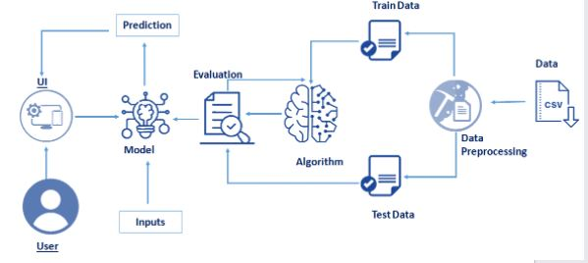

3.2 Hardware / Software designing

Processor : intel i5 7th Gen or above

Ram : 4GB

Hard disk : 100GB

Input device : Standard Keyboard and Mouse

Output device : Monitor

Operating System : Windows

Programming : python 3.6

4 EXPERIMENTAL INVESTIGATIONS

Here we are going to build a machine learning model that predicts

the full load electric power output based on the following parameters

● ambient temperature

● atmospheric pressure

● relative humidity

● exhaust steam pressure.

Here there are 4 parameters which is used to detect the hourly full load electrical power output of a combined cycle power plan

4.1 EXPERIMENTAL ANALYSIS

Visualization

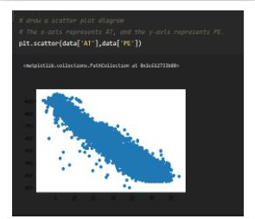

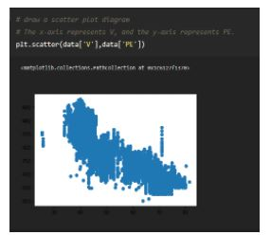

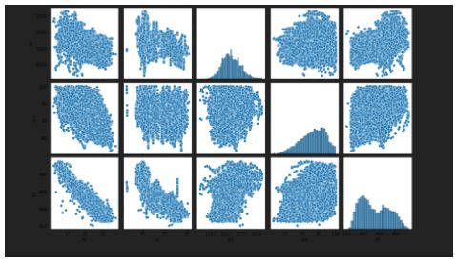

5 FLOWCHART

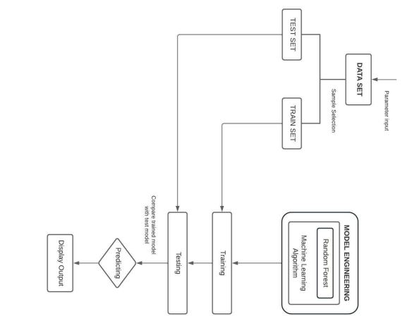

6 RESULT

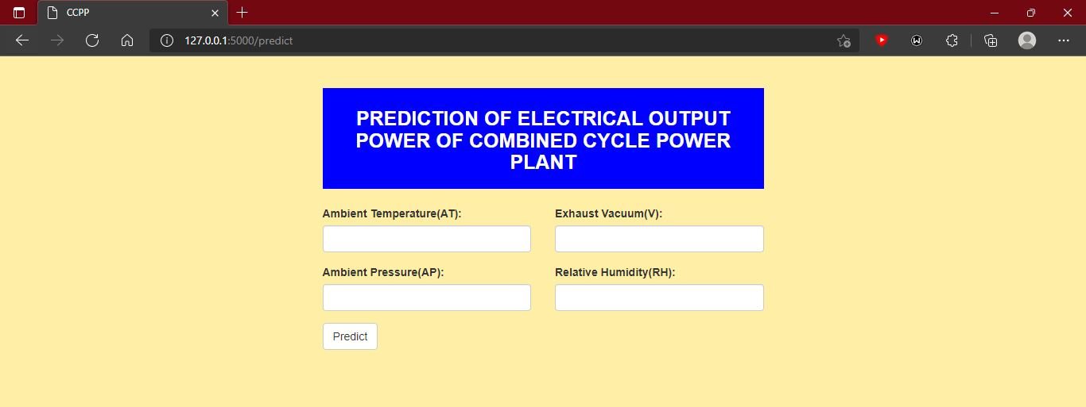

When we input the values in each input fields of ambient temperature ,exhaust vaccum, ambient pressure, relative humidity we will get the electric output

Input as :

ambient temperature = 8.38

exhaust vaccum= 40.77

ambient pressure= 1010.84

relative humidity= 90.01

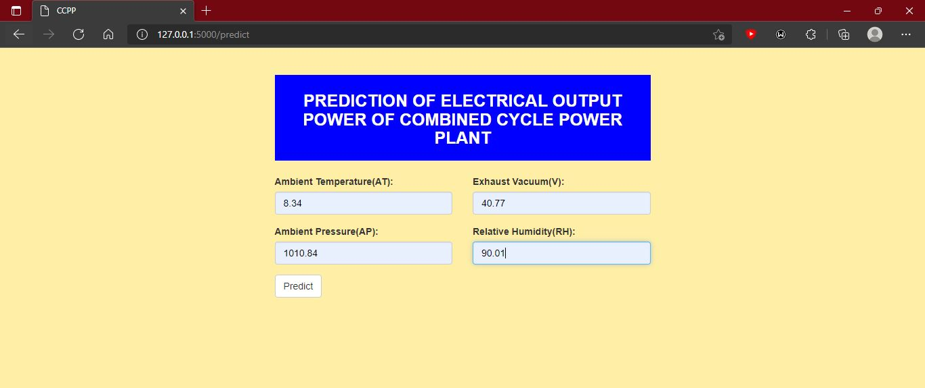



Here we got the prediction of full load electric power output as 480.48

7 ADVANTAGES & DISADVANTAGES

7.1 Advantages

Faster Claim Settlements & Save time:

We can predict the output very fast compared to other system and it

save time due to machine learning so we can predict the full load electric power output using the machine learning techniques

Cost Efficiency:

Due to automation of everything therefore the cost is reduced compared to the manual process

1. Automation of Everything

Machine Learning is responsible for cutting the workload and time. By automating things we let the algorithm do the hard work for us. Automation is now being done almost everywhere. The reason is that it is very reliable. Also, it helps us to think more creatively.Due to ML, we are now designing more advanced computers. These computers can handle various MachineLearning models and algorithms efficiently. Even though automation is spreading fast,we still don’t completely rely on it. ML is slowly transforming the industry with its automation.

2. Wide Range of Applications

ML has a wide variety of applications. This means that we can apply ML on any of the major fields. ML has its role everywhere from medical, business, banking to science and tech. This helps to create more opportunities.

3. Scope of Improvement

Machine Learning is the type of technology that keeps on evolving. There is a lot of scope in ML to become the top technology in the future. The reason is, it has a lot of research areas in it. This helps us to improve both hardware and software.

In hardware, we have various laptops and GPUs. These have variousML and Deep Learning networks in them. These help in the faster processing power of the system. When it comes to software we have various UIs and libraries in use. These help in designing more efficient algorithms.

4. Efficient Handling of Data

Machine Learning has many factors that make it reliable. One of them is data handling. ML plays the biggest role when it comes to data at this time. It can handle any type of data.

Machine Learning can be multidimensional or different types of data. It can process and analyze these data that normal systems can’t. Data is the most important part of any Machine Learning model. Also, studying and handling of data is a field in itself.

7.2 Disadvantages

1. Possibility of High Error

In ML, we can choose the algorithms based on accurate results. For that, we have to run the results on every algorithm. The main problem occurs in the training and testing of data. The data is huge, so sometimes removing errors becomes nearly impossible. These errors can cause a headache to users. Since the data is huge, the errors take a lot of time to resolve.

2. Algorithm Selection

The selection of an algorithm in Machine Learning is still a manual job. We have to run and test our data in all the algorithms. After that only we can decide what algorithm we want. We choose them on the basis of result accuracy. The process is very much time-consuming.

3. Data Acquisition

In ML, we constantly work on data. We take a huge amount of data for training and testing. This process can sometimes cause data inconsistency. The reason is some data constantly keep on updating. So, we have to wait for the new data to arrive. If not, the old and new data might give different results. That is not a good sign for an algorithm.

4. Time and Space

Many ML algorithms might take more time than you think. Even if it’s the best algorithm it might sometimes surprise you. If your data is large and advanced,the system will take time. This may sometimes cause the consumption of more CPU power. Even with GPUs alongside, it sometimes becomes hectic. Also, the data might use more than the allotted space

8 APPLICATIONS

We use different types of applications to predict and detect the full load electric power out put.

A combined cycle power plant is an assembly of heat engines that work in tandem from the same source of heat, converting it into mechanical energy. On land, when used to make electricity the most common type is called a combined cycle gas turbine (CCGT) plant. The same principle is also used for marine propulsion, where it is called a combined gas and steam (COGAS) plant. Combining two or more thermodynamic cycles improves overall efficiency, which reduces fuel costs.

Shell’s**Appomattox** production platform in the Gulf of Mexico, Clean, high-e˜ciency**power Gas** turbine**combined cycle** (GTCC), Wärtsilä are some of the top companies that test the quality of the water using this machine learning

applications and Auto AI methods and also uses deep learning methods to test the electric output

9 CONCLUSION

Using this machine learning techniques and IBM Watson studio we are able to detect the quality of the full load electric poer output Its only a prediction not an exact value due to automation there will be slight change in prediction but using the algorithm we get the accurate values by cross checking data values using Random Forest Regressionand finally we get the electric output using the factors such as ambient temperature ,exhaust vaccum, ambient pressure, relative humidity etc..Because of concerns brought about by climate change and global warming as of late, renewable energy is blasting. Hence, precise prediction of renewable energy power is significant, and many related approaches have been directed. Energy analysis also regularly includes the assurance of proportions of execution: energy destruction proportions, energy misfortune proportions, and energy efficiencies. In this, such proportions of execution are thought of. The CCPP, where the dataset is provided for this has begun to utilize this created predictive model for the following day's hourly energy output. First, the applications of machine-learning techniques to renewable energy have been expanding, and the employments of artificial intelligence techniques and mixed-race models in solar-energy and wind-energy predictions are the larger part. The Combined Cycle Power Prediction, where the dataset is provided for this approach, has utilized this created predictive model for the following day's hourly energy output. By tweaking the hyper-parameters using cross-validation, The model is able to achieve an accuracy of 93% on Test Data. Thus, we can use this model for predicting with high accuracy what would be the Power output of a Combined Cyle Power Plant. This can substantially bring down the cost of production by controlling the input parameters of the plant and lead to increased efficiency.

10 FUTURE SCOPE

While machine learning artificial intelligence may be seen as a data-hungry machine, the crucial aspect of a successful AI system is itsability to develop efficient reasoning and intuitively read and understand trends.So in the future we can add more parameters to predict and analyze the

Ful load electric power fast and accurate.

In future, the output power can be controlled by changing the value of the parameters. Moreover, by incorporating these parameters as well as increasing the number of input parameters, the power prediction of different types of power plants can be done by using more advance machine learning algorithms

11 BIBILOGRAPHY

<https://www.semanticscholar.org/paper/Prediction-of-full-load-electrical-power-output-of-T%C3%BCfek%C3%A7i/f164ee353ada936ef97d0d379f8581336ddc9733>

<https://www.sciencedirect.com/science/article/abs/pii/S0142061514000908>

P. Tüfekci, “Prediction of full load electrical power output of a base load operated combined cycle power plant using machine learning methods,” *International Journal of Electrical Power & Energy Systems*, vol. 60, pp. 126–140, 2014.