Forecasting sales of store using IBM watson studio

1 INTRODUCTION

  - OVERVIEW
Forecasting of sales is an essential task for the management of a store. It is very important to be able to predict the sales of the store so as to be prepared with the inventory that they will need. So we are building a system that analyses the previous trends of sales which includes sales on various days and predicts future sales. This will be beneficial for both the store owners and customers as their will be sufficient supplies at all times.

  - PROPOSED SYSTEM
In this project, we are building a system that analyses the previous trends of sales which includes sales on various days and predicts future sales. The goal of this project is to forecast the sales of stores by using time series analysis. Here time series analysis algorithms such as RNN (Recurrent Neural Network) & LSTM (Long Term Short Memory) are used to analyze the past trends of sales of stores. Create and deploy flask-based web Application and integrate AI model to it.
The objective of the project is to build a web application where the user gives the last ten days' sales values and gets the prediction for the 11 th day which is showcased on UI.

2 LITERATURE SURVEY

2.1 EXISTING PROBLEM
With the existing system it is difficult to manually calculate the sales of the store and also to predict the number of commodities that will be sold in the coming 10 days. By predicting the same, the shop owners are able to understand the stock of the product and how much will be sold.

2.2 PROPOSED SYSTEM
In this project, we are building a system that analyses the previous trends of sales which includes sales on various days and predicts future sales. The goal of this project is to forecast the sales of stores by using time series analysis. Here time series analysis algorithms such as RNN (Recurrent Neural Network) & LSTM (Long Term Short Memory) are used to analyze the past trends of sales of stores. Create and deploy flask-based web Application and integrate AI model to it.
The objective of the project is to build a web application where the user gives the last ten days' sales values and gets the prediction for the 11 th day which is showcased on UI.

3 THEORITICAL ANALYSIS

3.1 BLOCK DIAGRAM
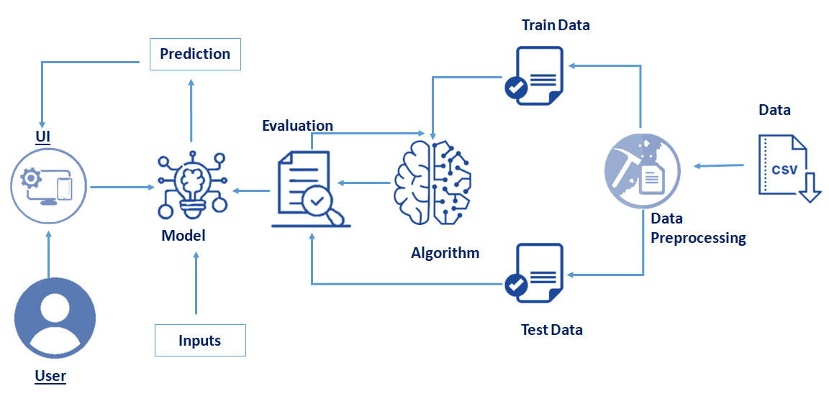

3.2 HARDWARE/SOFTWARE DESIGNING
Software requirements:
- Ananconda navigator
- Python packages
- IBM watson studio

4 EXPERIMENTAL INVESTIGATION

- Shape of inputs plays a major role in the correctness of the model.
- IBM Cloud helps to deploy machine learning models and test the correctness of our model.
- Integrating Flask with the machine learning model involves a lot of data preprocessing to make the predictions correctly.

5 FLOWCHART

- User interacts with the UI (User Interface) to enter the data of the previous 10 days to get the future prediction
- Entered data is analyzed by the model which is integrated
- Once the model analyses the input the prediction of the next day is showcased on the UI

To accomplish this, we have to complete all the activities and tasks listed below
Data Collection.
- Collect the dataset or Create the dataset
Data Preprocessing.
- Import the Libraries.
- Importing the dataset.
- Analyze the data
- Taking care of Missing Data
- Feature Scaling
- Data Visualization
- Splitting Data into Train and Test.
- Creating a dataset with a sliding window.
Model Building
- Import the model building Libraries
- Initializing the model
- Adding LSTM Layers
- Adding Output Layer
- Configure the Learning Process
- Training the model
- Model Evaluation
- Save the Model
- Test the Model
Application Building
- Create an HTML file
- Build Python Code

6 RESULT
SOURCE CODE:
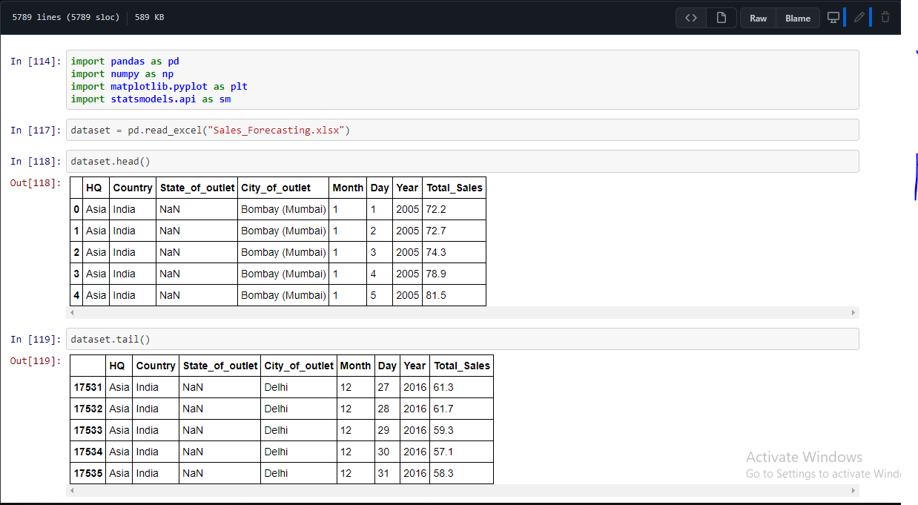

UI OUTPUT:

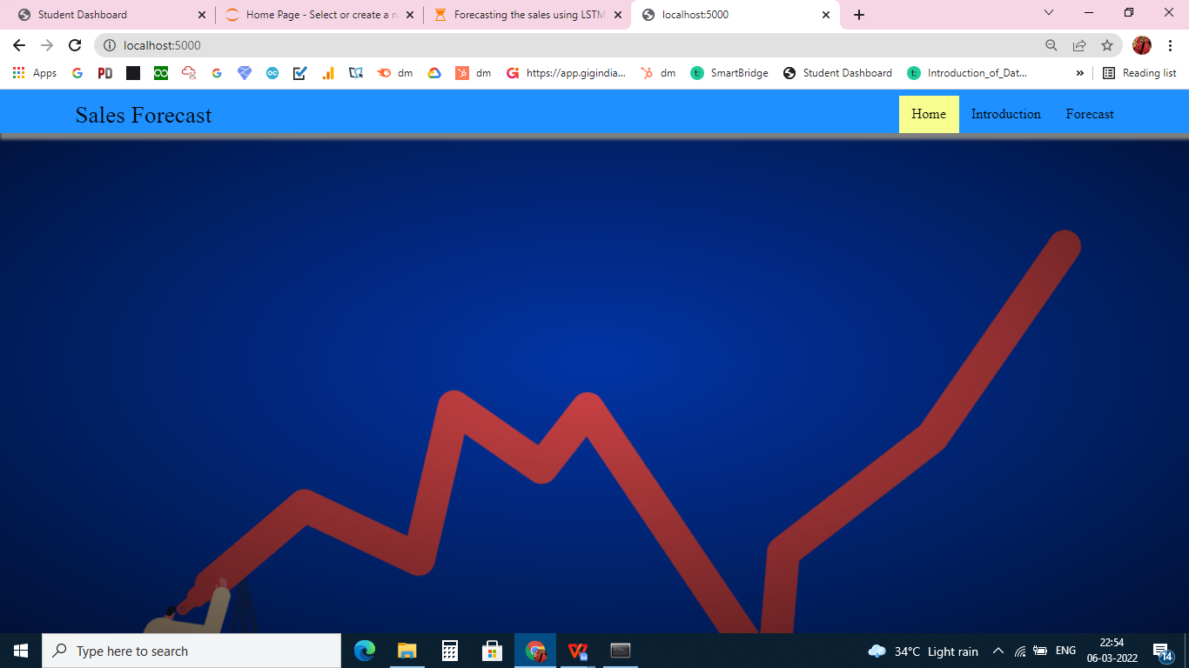

ENTERING 10 VALUES:
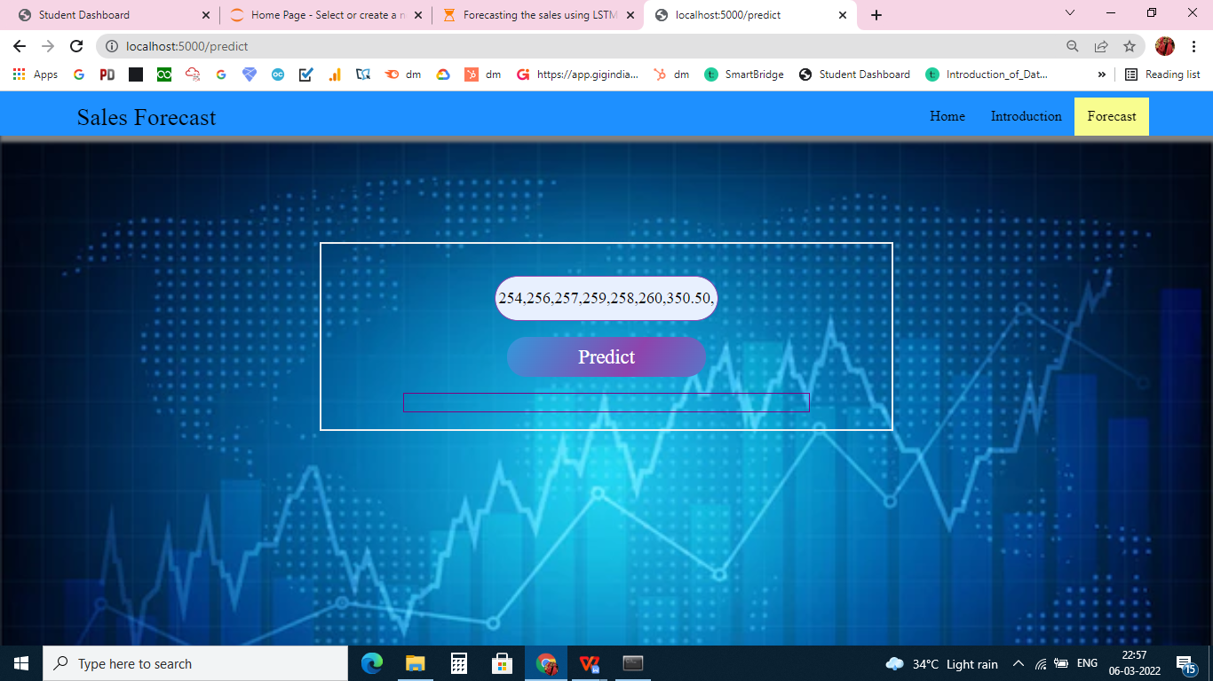

PREDICTED THE VALUE:
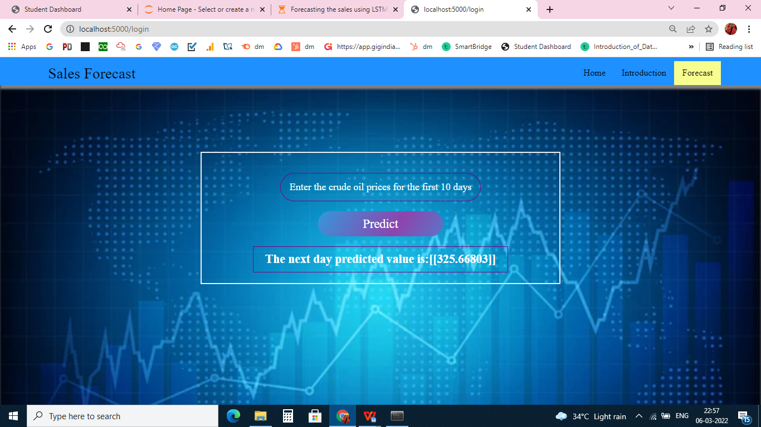

7 ADVANTAGES AND DISADVANTAGES
ADVANTAGES:
- Useful in forecasting sales for industrial products, consumer, durables and new products
- Relatively inexpensive and fast
- Alignment of Strategy and Results
- Opportunities Adjustments

DISADVANTAGES:
- Difficulty getting a panel experts
- Longer time for getting consensus
- Uncertain environment

8 APPLICATION

- Shopping malls
- Book store
- Medical store

9 CONCLUSION
- Know fundamental concepts and techniques of time series forecasting and LSTM
- Gain a broad understanding of time series data.
- Know how to split the data for time series forecasting.
- Know how to build a web application using the Flask framework.

10 FUTURE SCOPE
Sales forecasting allows companies to efficiently allocate resources for future growth and manage its cash flow. Sales forecasting also helps businesses to estimate their costs and revenue accurately based on which they are able to predict their short-term and long-term performance

11 BIBLIOGRAPHY
- https://youtu.be/pCuV_7H2vyQ
- https://www.neuraldesigner.com/solutions/sales-forecasting
- https://youtu.be/AtkWpgJJHgQ
- https://towardsdatascience.com/7-ways-to-handle-missing-values-in-machine-learning-1a6326adf79e

12 APPENDIX
import pandas as pd #Reading the dataset
import numpy as np #numerical calculations
import matplotlib.pyplot as plt #for data visualization
import statsmodels.api as sm #statistical data exploration
#tensorflow :open source used for both ML and DL for computation
from tensorflow.keras.models import Sequential#it is a plain stack of layers
from tensorflow.keras.layers import Dense#Dense layer is the regular deeply connected neural network layer
from tensorflow.keras.layers import LSTM #Long Short Trem Memory
data=pd.read_excel("Sales_Forecasting.xlsx")
data.head()
data.info()
data.describe()
from datetime import datetime
data['Date'] = data.apply(lambda row: datetime.strptime(f"{int(row.Year)}-{int(row.Month)}-{int(row.Day)}", '%Y-%m-%d'), axis=1)
data['Date'].min(), data['Date'].max()
data.shape
cols = ['Month','Day','Year','City_of_outlet','State_of_outlet','Country','HQ']
data.drop(cols, axis=1, inplace=True)
data = data.sort_values('Date')
data.head()
data.isnull().sum()
data = data.groupby('Date')['Total_Sales'].sum().reset_index()
data.head()
sale = np.array(data['Total_Sales'])
plt.figure(figsize=(12,6))
plt.plot(sale)
plt.title('SALES FROM 2005 TO 2016')
plt.xlabel('Days')
plt.ylabel('Sales')
plt.show()
training_size=int(len(sale)*0.80)
test_size=len(sale)-training_size
train_data,test_data=sale[0:training_size],sale[training_size:]
def prepare_data(timeseries_data, n_features):
X, y =[],[]
for i in range(len(timeseries_data)):
# find the end of this pattern
end_ix = i + n_features
# check if we are beyond the sequence
if end_ix > len(timeseries_data)-1:
break
# gather input and output parts of the pattern
seq_x, seq_y = timeseries_data[i:end_ix], timeseries_data[end_ix]
X.append(seq_x)
y.append(seq_y)
return np.array(X), np.array(y)
xtrain, ytrain = prepare_data(train_data, 10)
xtest, ytest = prepare_data(test_data, 10)
xtrain.shape, xtest.shape
xtrain = xtrain.reshape((xtrain.shape[0], xtrain.shape[1], 1))
xtest = xtest.reshape((xtest.shape[0], xtest.shape[1], 1))
xtrain.shape, xtest.shape
model=Sequential()
model.add(LSTM(50,activation='relu',return_sequences=True,input_shape=(10,1)))
model.add(LSTM(50,activation='relu'))
model.add(Dense(1))
model.compile(loss='mse',optimizer='adam')
model.summary()
model.fit(xtrain,ytrain,validation_data=(xtest,ytest),epochs=150,batch_size=64,verbose=1)
a=[[275,281,279,287,271,281,288,255,278,298]]
A
model.predict(a)
model.save('forcast_sales.h5')
x_input=sale[4372:4382].reshape(1,-1)
x_input.shape
temp_input=list(x_input)
temp_input
temp_input=list(x_input)
temp_input
from numpy import array
lst_output=[]
n_steps=10
i=0
while(i<10):

if(len(temp_input)>=10):
#print("temp_input",temp_input)
x_input=np.array(temp_input[0:])
print("{} day input {}".format(i,x_input))
x_input=np.expand_dims(x_input, axis=0)
#x_input=scaler.transform(x_input)
x_input = x_input.reshape((1, n_steps, 1))
yhat = model.predict(x_input, verbose=0)
#yhat=scaler.inverse_transform(yhat)
print("{} day output {}".format(i,yhat))
temp_input.extend(yhat[0].tolist())
temp_input=temp_input[1:]
#print(temp_input)
lst_output.extend(yhat.tolist())
i=i+1
else:
print("Please give 10 number of inputs")

