1. **INTRODUCTION**

**1.1 Overview**

Amazon Kindle Store is an e-book e-commerce store for all the book reading hobbyists. Online reviews are a category of product information created by users based on personal handling experience. Online shopping websites endow with platforms for consumers to review products and carve up opinions. The problem is most of the comments from customer reviews about the products are contradicted to their ratings. Many customers will post their comments and forgot to rate the product or not engrossed to rate it.

Sentiment mining plays a very important role in business to understand the opinion of customers to improve the products. Customer also depends on the opinion of others who have bought the products already. Reviews or feedback becomes the deciding factor to buy or sell a product. A rating of the products gives a speedy clarification to pact with the product. We will be using Natural language processing to analyse the sentiment (positive or a negative) of the given review.

**1.2 Purpose**

A book review helps other users get a clear idea of the book before reading it. They can read the reviews and make their mind clear, and decide whether the book is worth read or not.

Sentiment mining plays a very important role in business to understand the opinion of customers to improve the products. Customer also depends on the opinion of others who have bought the products already. Reviews or feedback becomes the deciding factor to buy or sell a product.

**2.LITERATURE SURVEY**

**2.1 Existing system**

In the existing system it is not easy to identify the review is correct or not. And also we want to ensure that the review is a valid statement.

It is very time consuming task that to validate the review is true.

**2.2 Proposed system**

Amazon Kindle is a series of e-readers designed and marketed by Amazon. Amazon Kindle devices enable users to browse, buy, download, and read e-books, newspapers, magazines and other digital media via wireless networking to the Kindle Store.

Using deep learning algorithms we have to check whether the review is positive or negative. And also it is easy to identify the review about the kindle store books.

**3.THEORETICAL ANALYSIS**

**3.1 Block diagram**

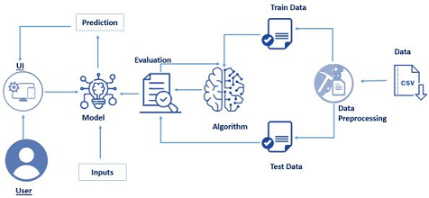

**3.2 Software/ Hardware designing**

1. IBM Watson studio:

Watson Studio accelerates the machine and deep learning workflows required to infuse AI into your business to drive innovation. it provides the environment and tools for collaborate work on data to solve business problems. It provides the tools to analyze and visualize data, to cleanse and shape data, to ingest streaming data, or to create and train machine learning models.

2. IBM Watson Machine learning:

3. IBM Cloud Object storage:

**4. EXPERIMENTAL INVESTIGATION**

In this section, we will be creating and testing our model for predicting if a review is negative or positive. since there are multiple algorithms, we can use to build our model, we will compare the accuracy scores after testing and pick the most accuarate algorithm.

From the list, we are using Natural language processing which gives the highest accuracy and select it as our algorithm of choice for future use.

On the basis of results we have done the conclusion the NLP is the most accurate model which we have tested.

**5.FLOWCHART**

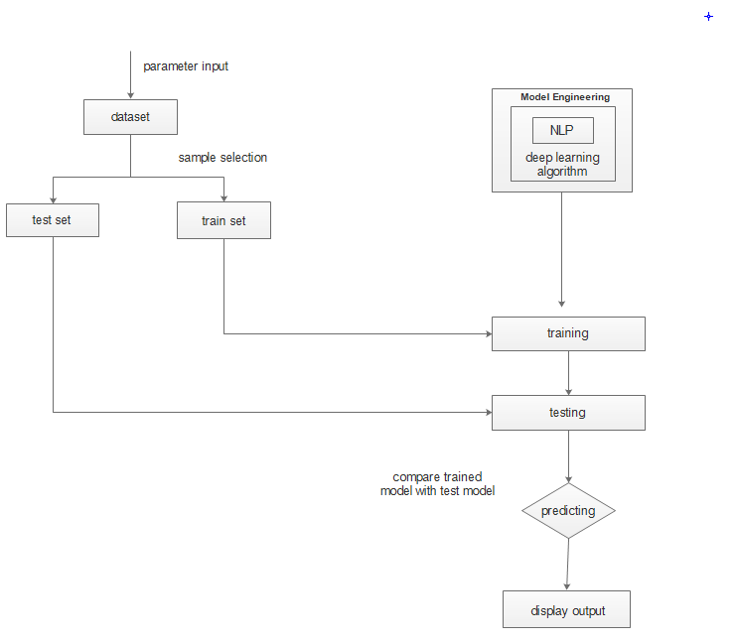

**6.RESULT**

The final result of the Amazon Kindle review store is using NLP predict the review is positive or negative.

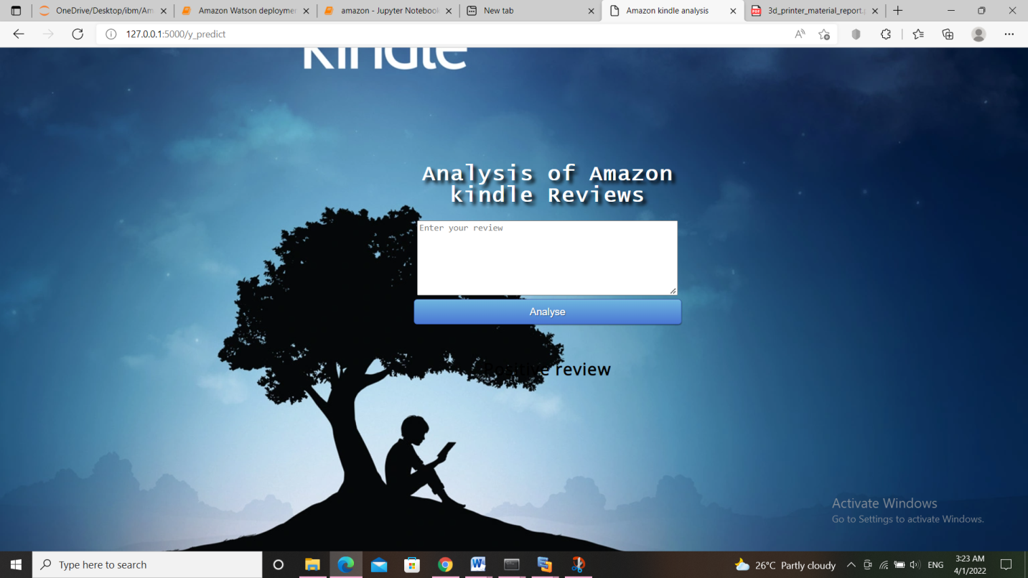

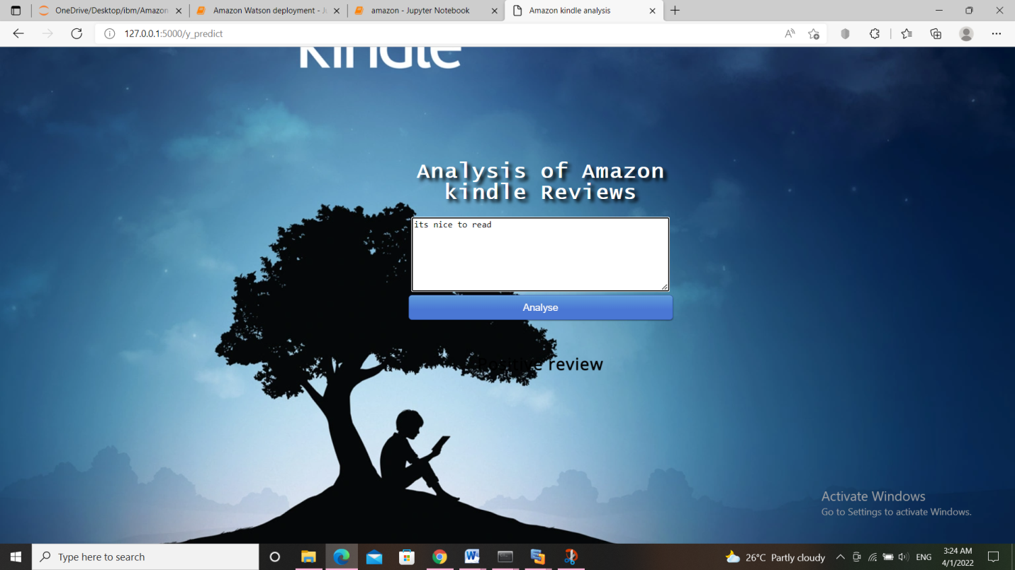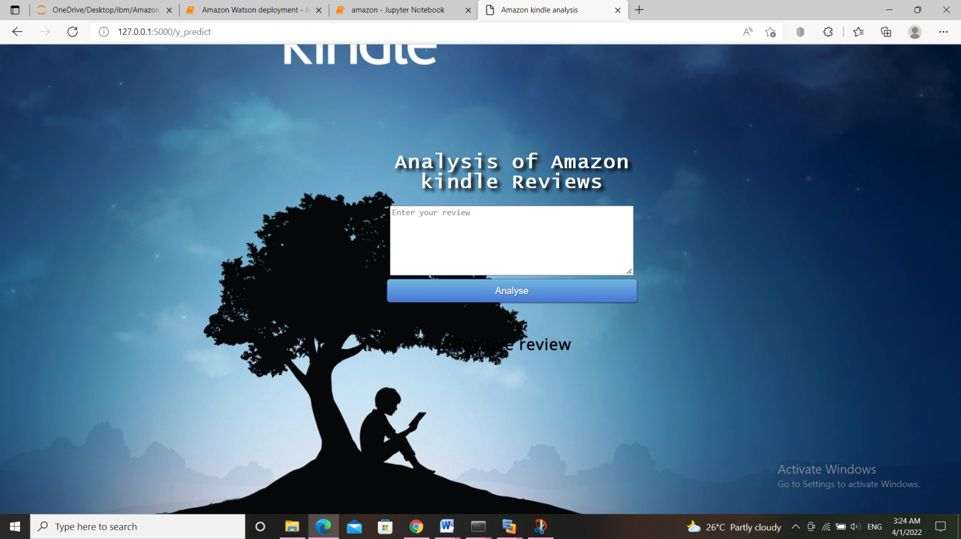

**7. ADVANTAGES AND DISADVANTAGES**

**7.1 Advantages**

The model is fast and accurate and it gives the exact reviews about kindle store books. Its very time consuming because we use NLP in this project. We get the output easily when we analyze so user can’t wait much time for the output. It is very useful for a new customer who hasn’t any idea about the book or product.

**7.2 Disadvantages**

A lack of negative review will affect the downloading of a book. So it’s a big disadvantage. We use deep learning to implement this system so its need a large amount of data to predict the book reviews. The review is depend only on the interest of a customer so it may vary depend on the persons.

**8.APPLICATIONS**

1. From Authors side, they can know the interest of the customers.

2. From Customers side, they can know the review as negative or positive.

3. Kindle store became more user friendly.

**9.CONCLUSION**

Amazon Kindle Store is an e-book e-commerce store for all the book reading hobbyists. Online reviews are a category of product information created by users based on personal handling experience. Online shopping websites endow with platforms for consumers to review products and carve up opinions. The problem is most of the comments from customer reviews about the products are contradicted to their ratings. Many customers will post their comments and forgot to rate the product or not engrossed to rate it.

**10. FUTURE SCOPE**

Deep learning and machine learning are the growing technologies so we can easily update the system in future. It is very useful for the new users so there is always a future scope for the system.

**11. BIBILIOGRAPHY**

1)https://machinelearningmastery.com/

2)<http://www.kaggle.com/>

3)<https://www.geeksforgeeks.org/decision-tree/>

4)https://arxiv.org/ 5)<https://cloud.ibm.com/docs/create-deploy-retrain-machine-learning-mode>

SOURCE CODE

