Table of Contents
1 INTRODUCTION 2
1.1 Overview 2
1.2 Purpose 2
2 LITERATURE SURVEY 2
2.1 Existing problem 2
2.2 Proposed solution 3
3 THEORITICAL ANALYSIS 3
3.1 Block diagram 3
3.2 Hardware / Software designing 3
Hardware requirements 3
Software requirements: 3
4 EXPERIMENTAL INVESTIGATIONS 4
5 FLOWCHART 4
6 RESULT 5
7 ADVANTAGES & DISADVANTAGES 11
8 APPLICATIONS 11
9 CONCLUSION 11
10 FUTURE SCOPE 11

1 INTRODUCTION

1.1 Overview

Agriculture is the most important sector in today’s life. Most plants are affected by a wide variety of bacterial and fungal diseases. Diseases on plants placed a major constraint on the production and a major threat to food security. Hence, early and accurate identification of plant diseases is essential to ensure high quantity and best quality. In recent years, the number of diseases on plants and the degree of harm caused has increased due to the variation in pathogen varieties, changes in cultivation methods, and inadequate plant protection techniques.
Its very difficult for the farmers to identify the disease. If they get guidance to prevent or cure the diseases in the early stage of farming they can yield the best quality crop.

1.2 Purpose

An automated system needs to be introduced to identify different diseases on plants by checking the symptoms shown on the leaves of the plant. We need to use deep learning techniques to identify the diseases and suggest the precautions that can be taken for those diseases

2 LITERATURE SURVEY

2.1 Existing problem

Diseases on plants placed a major constraint on the production and a major threat to food security. Hence, early and accurate identification of plant diseases is essential to ensure high quantity and best quality. In recent years, the number of diseases on plants and the degree of harm caused has increased due to the variation in pathogen varieties, changes in cultivation methods, and inadequate plant protection techniques. Without proper understanding and guidance for the farmers the crops may get destroyed or yield may decrease.

2.2 Proposed solution

Deep learning techniques can be used to identify the diseases and suggest the precautions that can be taken for those diseases

3 THEORITICAL ANALYSIS

3.1 Block diagram

Input the image
:
:
Process the image and evaluate against the known disease
:
:
Predict the disease and suggest the procedure to be followed

3.2 Hardware / Software designing

Hardware requirements

Processor - Intel® Xeon® CPU E5-2640 @ 2.50GHz
RAM - 32 /64 GB

Software requirements:

Operating system - 64-bit Windows 10 / MAC OS / Linux
Python,Python Web Frame Works,IBM Cloud,IBM Watson Studio,IBM Machine Learning,Python-Flask

4 EXPERIMENTAL INVESTIGATIONS
Analysis or the investigation made while working on the solution.

- Preprocess the images.
- Apply the CNN algorithm to the dataset.
- Need to use deep neural networks to detect the disease.
- Need to find the best accuracy of the model.
- Need to build web applications using the Flask framework to integrate with the model

5 FLOWCHART
Diagram showing the control flow of the solution
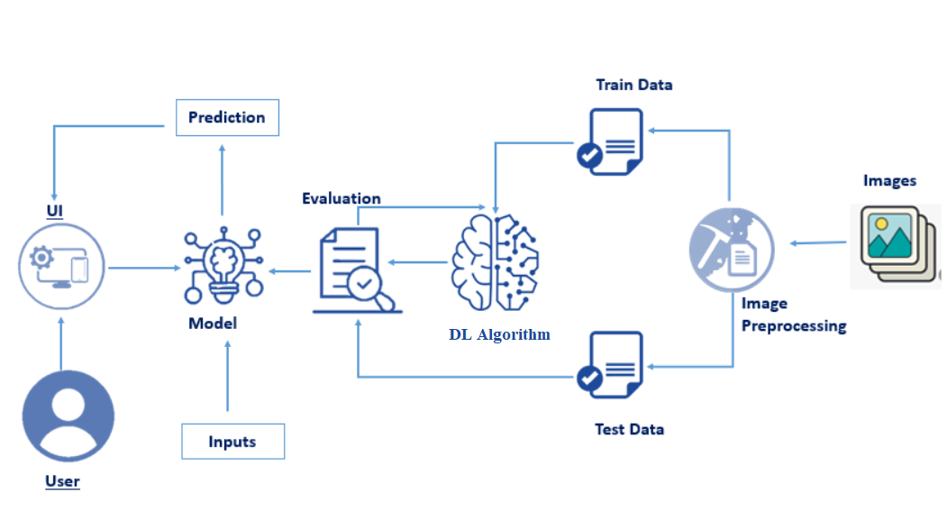

6 RESULT

home.html
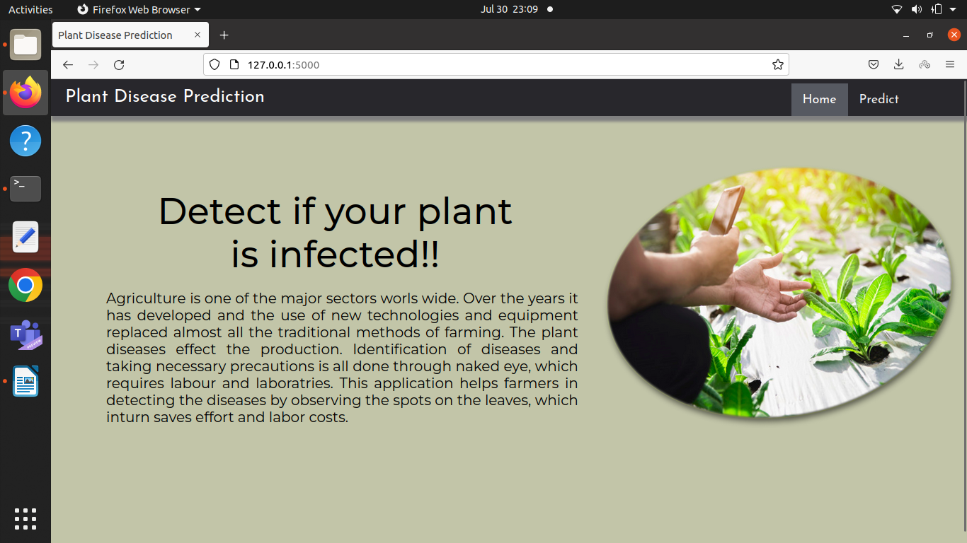
predict.html

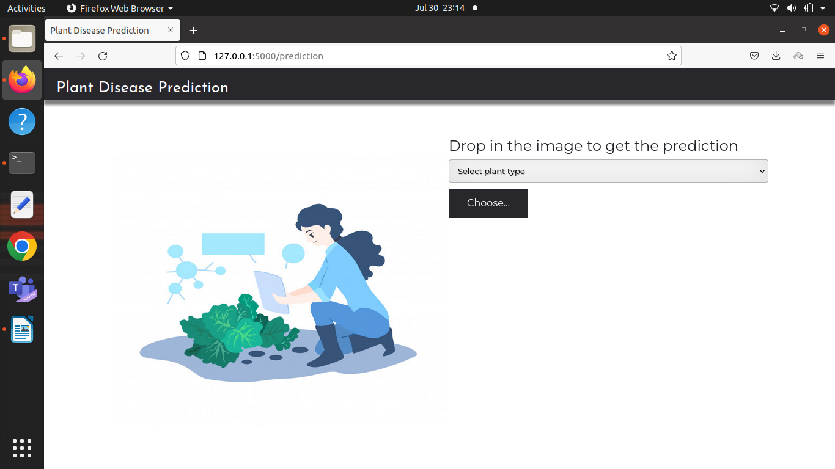

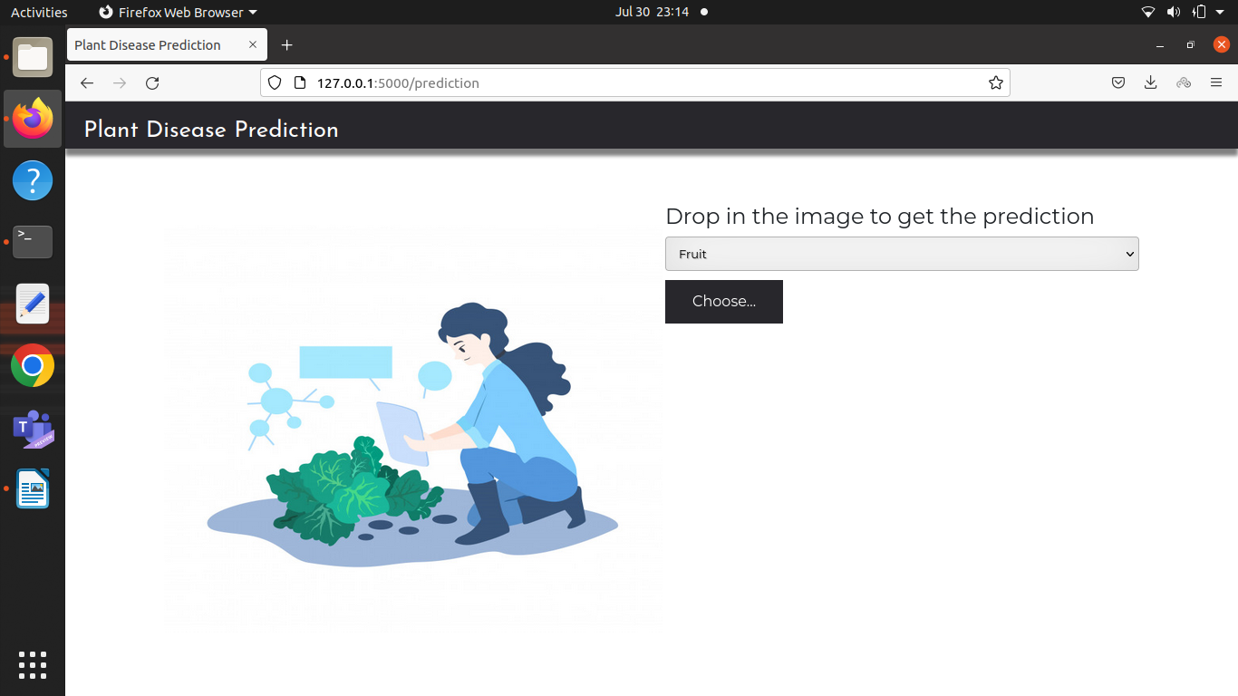
Selected the ‘Fruit’ option from the list

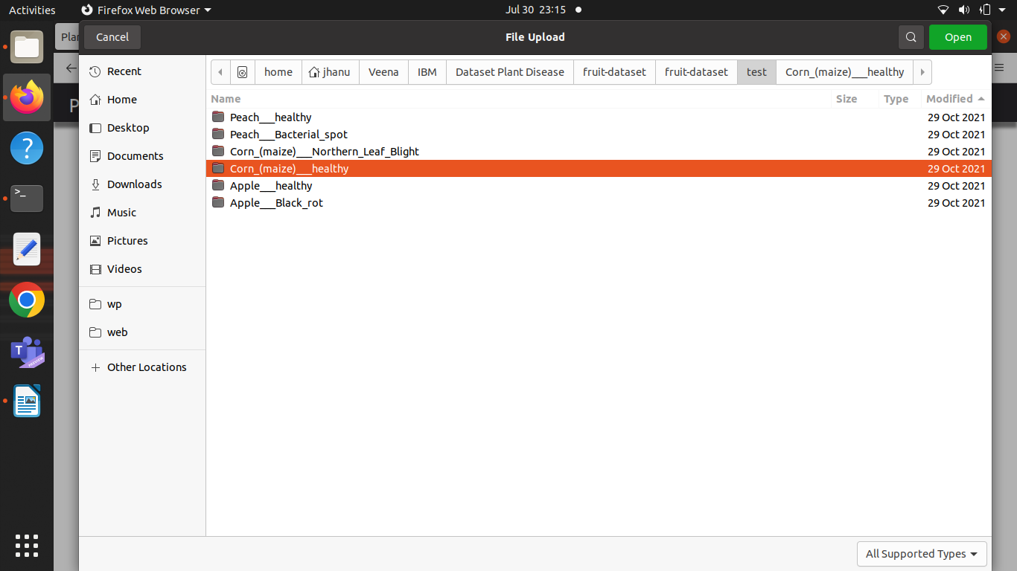
Selected the folder from fruit-dataset/test/Corn_(maize)__healthy

Select one image from the folder
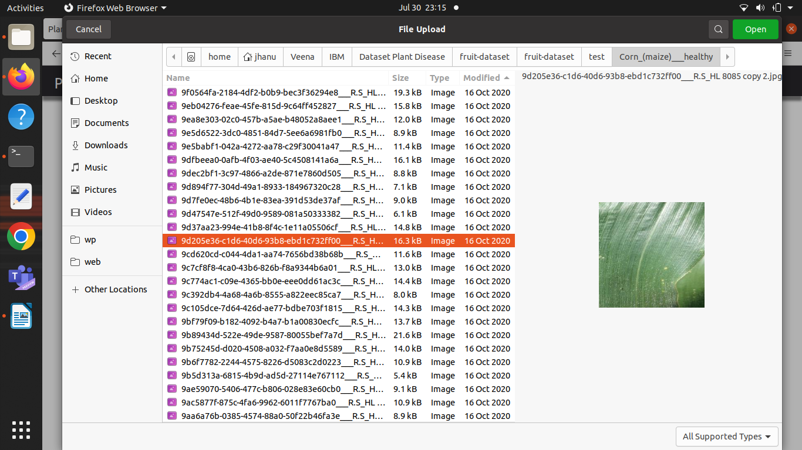

Image got uploaded to the browser and then ‘Predict’ button is clicked

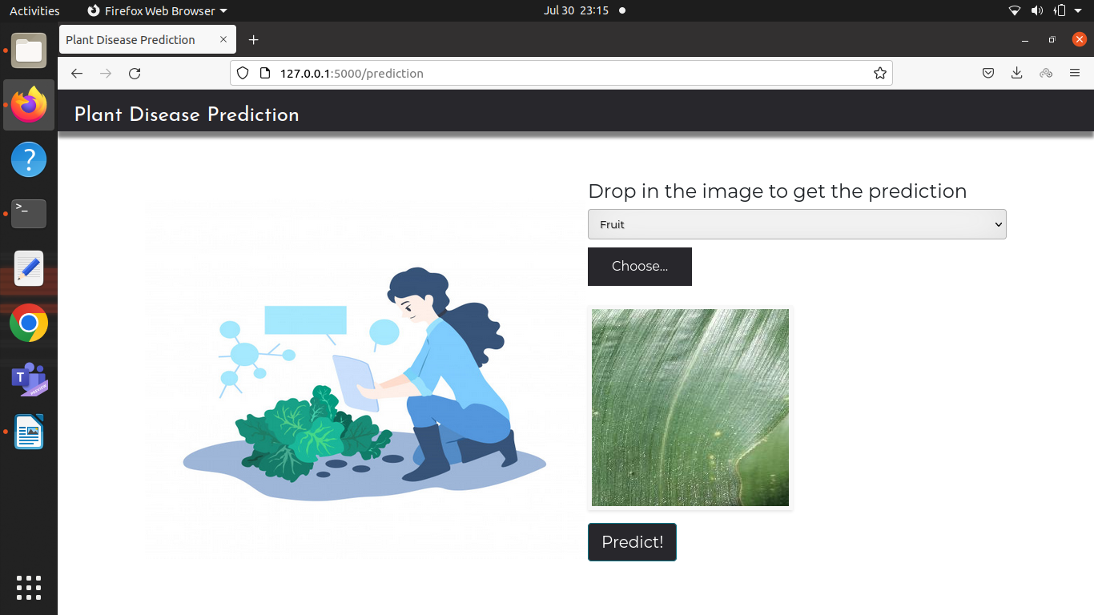

After loading the image, the disease is predicted using the model and results is displayed on the browser

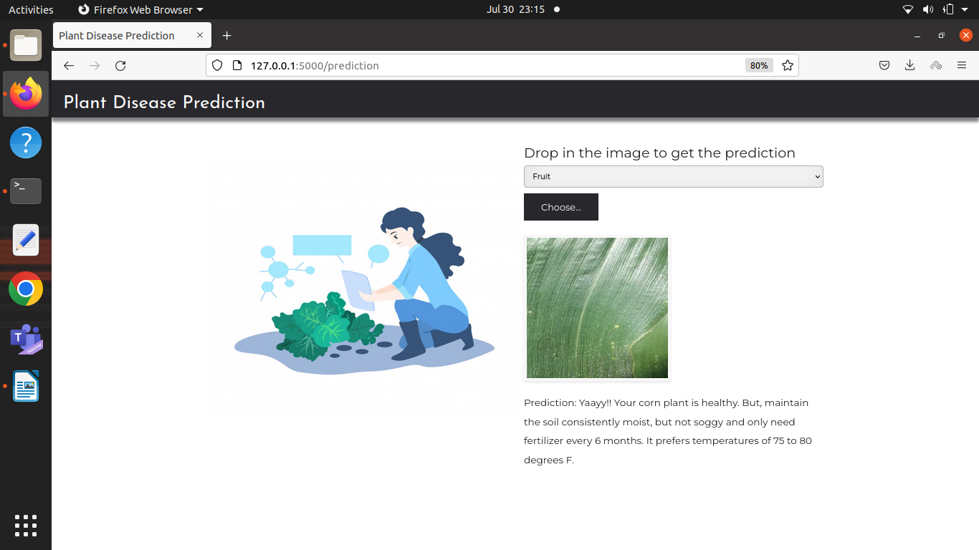

Selected the ‘Vegetable’ option from the list

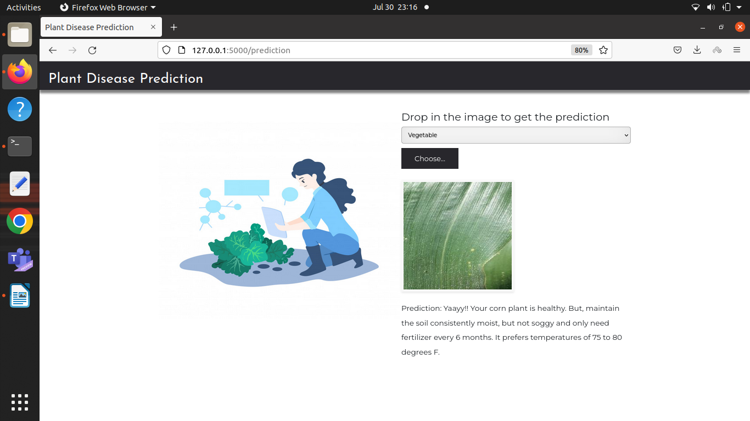

Selected the folder from Veg-dataset/test_set/Tomato_Bacterial_spot

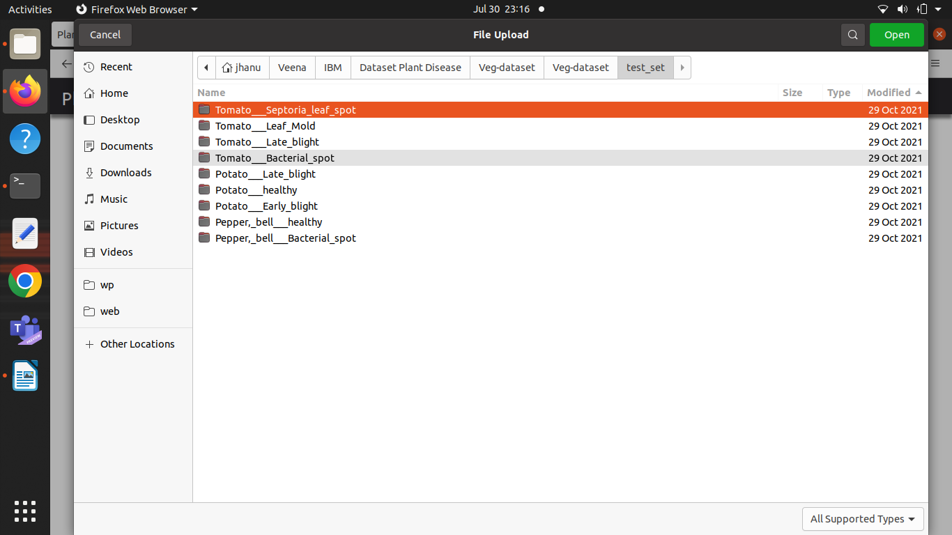

Image got uploaded to the browser and then ‘Predict’ button is clicked

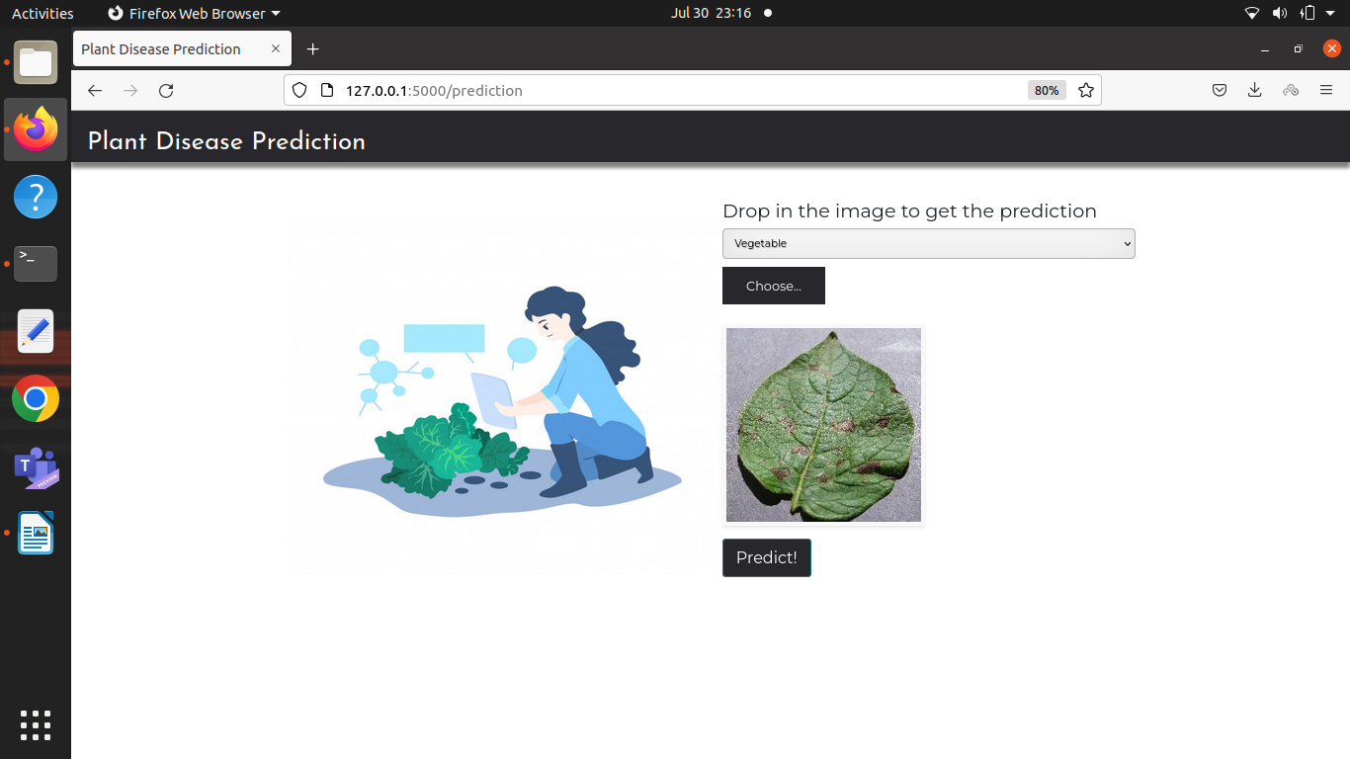
After loading the image, the disease is predicted using the trained model and results is displayed on the browser

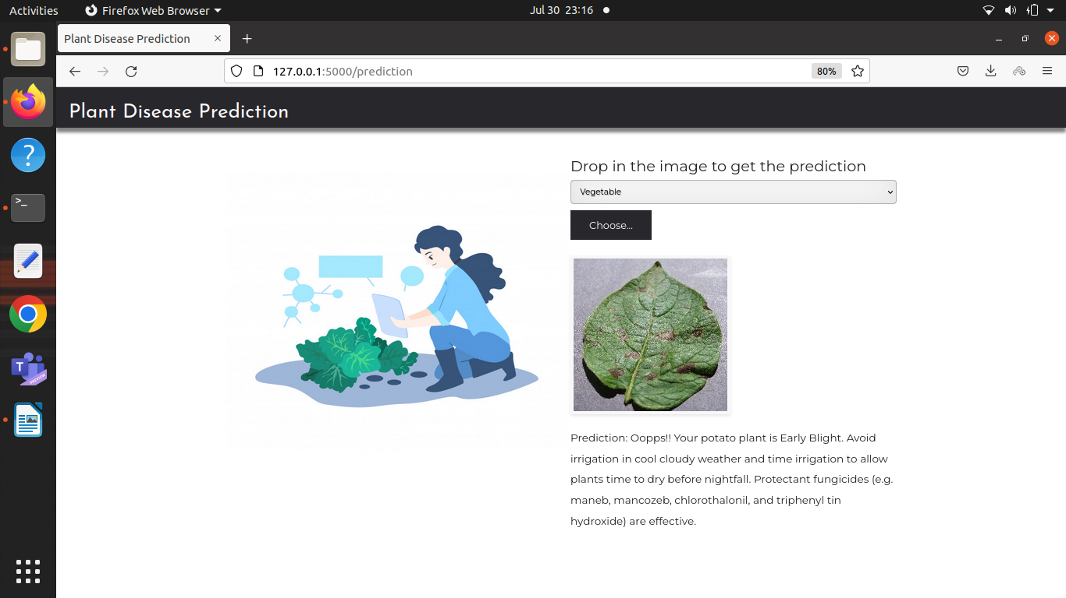

7 ADVANTAGES & DISADVANTAGES
List of advantages and disadvantages of the proposed solution

Advantages

- Evaluates the input image againt thousands of preprocessed images
- Faster prediction

Disadvantages

- Cannot predict new diseases
- Sometimes it is very difficult to differentiate between very near images.

8 APPLICATIONS
- Agriculture
- Skin diseases
- Health sector

9 CONCLUSION
The trained model will help the farmers to get predictions very fast and help them to analyse the problem and give proper suggestions on time.

10 FUTURE SCOPE
* More modules can be added to guide the farmer from the seeds to yield

* This software can be integrated with IOT systems so that the model can predict the disease immediately instead of farmer uploading it manually

