J.Tejaswi 39110395 EmployeePromotionPrediction

Table of Contents

INTRODUCTION.................................................................................................................... 6 OVERVIEW ...........................................................................................................................................6 PURPOSE ......................................................................................................................................... 6 LITERATURE ANALYSIS.........................................................................................................................6

EXISTING PROBLEM ..........................................................................................................................6 PROPOSED SOLUTION ..................................................................................................................... 8 THEORITICAL ANALYSIS..............................................................................................................9 BLOCK DIAGRAM ............................................................................................................................... 9 HARDWARE/SOFTWARE DESIGNING ..........................................................................................10 EXPERIMENTAL INVESTIGATION.................................................................................................... 10 FLOWCHART ..................................................................................................................................... 15 RESULT ............................................................................................................................................. 15 ADVANTAGES & DISADVANTAGES ............................................................................................. APPLICATIONS ................................................................................................................................ 18 CONCLUSION ............................................................................................................................. 18

FUTURE SCOPE .................................................................................................................................19 BIBILOGRAPHY .................................................................................................................................19

**INTRODUCTION**

**OVERVIEW** : The problem of employee turnover has shot to prominence in organizations because of its negative impacts on issues ranging from work place morale and productivity, to disruptions in project continuity and to long term growth strategies. One way organizations deal with this problem is by predicting the risk of attrition of employees using machine learning techniques thus giving organizations leaders and Human Resources (HR) the foresight to take pro-active action for retention or plan for succession. However, the machine learning techniques historically used to solve this problem fail to account for the noise in the data in most HR Information Systems (HRIS). Most organizations have not prioritized investments in efficient HRIS solutions that would capture an employee’s data during his/her tenure. One of the major factors is the limited understanding of benefits and cost. It is still difficult to measure the return of investment in HRIS . This leads to noise in the data, which in turn attenuates the generalization capability of these algorithms PURPOSE: Employee Promotion plays a big role in Employee Satisfaction. It aids in employee engagement, boosts morale, reduces absenteeism, and ultimately in productivity. Employee Promotion is also a helpful tool for reducing attrition retention •

**2. LITERATURE SURVEY**

**EXISTING PROBLEM**: To overcome this problem, organizations are now taking support via machine learning techniques to predict the employee turnover. With high precision in prediction, organizations can take necessary actions at due course of time for retention or succession of employees. Most of the data comes from basic HR based database systems, which are not highly efficient in prediction and modeling and these models are not very accurate in data models and cannot assist the organizations to take successful decisions. The primary objective of this research paper is to predict employee attrition i.e. whether the employee is planning to leave or continue to work within the organization Data collection Collecting data allows you to capture a record of past events so that we can use data analysis to find recurring patterns. From those patterns, you build predictive models using machine learning algorithms that look for trends and predict future changes.

**Data collection**

Collecting data allows you to capture a record of past events so that we can use data analysis to find recurring patterns. From those patterns, you build predictive models using machine learning algorithms that look for trends and predict future changes.

**Block Diagram:**

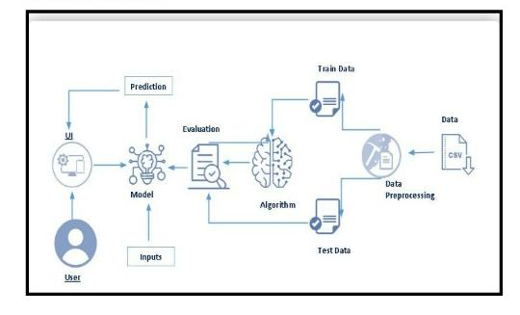

**Hardware Requirement: System :**

Pentium i3 Processor.

Hard Disk : 500 GB

Monitor : 15’’ LED

Input Devices : Keyboard, Mouse Ram : 2 GB

**Software Requirement :**

Operating system : Windows 10.

Coding Language : Python

**Univariate Analysis**

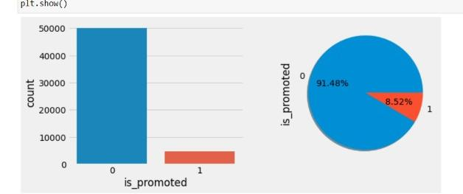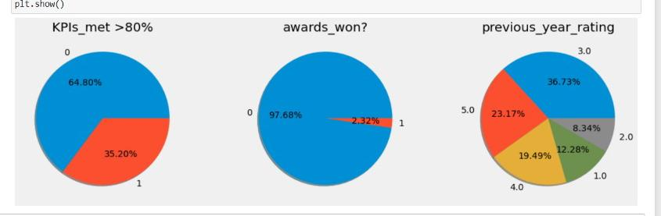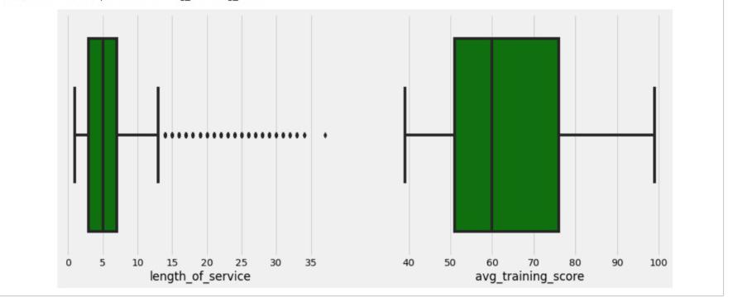

**Multivariate Analaysis**

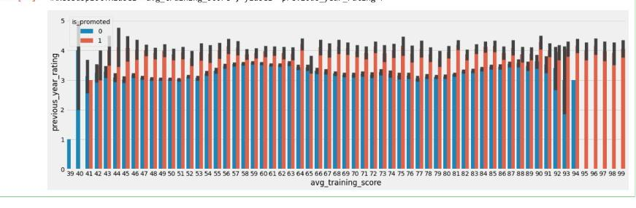

**Advantages**

The more you promote your brand, the more will the customers know about you and your company and the more will they be interested in your products. Promotion can be done even by giving out free samples which work wonders for customers

**Disadavantages**

No new or fresh ideas are brought into the organisation. The job advertised may require skills not currently available within the organisation. Promotion of an internal employee could cause resentment amongst other employees, who may feel they deserve the post more than the promoted employee.

Testing Model

In this module we test the trained machine learning model using the test dataset Quality assurance is required to make sure that the software system works according to the requirements. Were all the features implemented as agreed? Does the program behave as expected? All the parameters that you test the program against should be stated in the technical specification document. Moreover, software testing has the power to point out all the defects and flaws during development. You don’t want your clients to encounter bugs after the software is released and come to you waving their fists. Different kinds of testing allow us to catch bugs that are visible only during runtime.

increasing customer traffic.

The more you promote your brand, the more will

the customers know about you and your company and the

more will they be interested in your products.

Promotion can be done even by giving out free samples

which work wonders for customers.

**Datacollection**

Collecting data allows you to capture a record of past events so that we can use data analysis to find recurring patterns. From those patterns, you build predictive models using machine learning algorithms that look for trends and predict future changes. Predictive models are only as good as the data from which they are built, so good data collection practices are crucial to developing high-performing models.

The data need to be error-free (garbage in, garbage out) and contain relevant information for the task at hand. For example, a loan default model would not benefit from tiger population sizes but could benefit from gas prices over time.

In this module, we collect the employee promotion prediction data from kaggle dataset archives. This dataset contains the information of divorce in previous years.

**5. FLOWCHART**

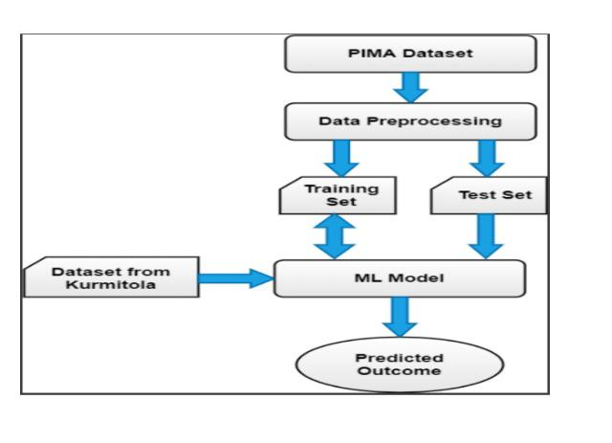

**6. RESULT&Conclusion**

The importance of predicting employee turnover in organizations and the application of machine learning in building turnover models was presented in this paper. The key challenge of noise in the data from HRIS that compromises the accuracy of these predictive models was also highlighted. Data from the HRIS of a global retailer was used to compare the XGBoost classifier against six other supervised class that had been historically used to build turnover models. The results of this research demonstrate that the XGBoost classifier is a superior algorithm in terms of significantly higher accuracy, relatively low runtimes and efficient memory utilization for predicting turnover.

its regularization makes it a robust technique capable of handling the noise in the data from HRIS, as compared to the other classifiers, thus overcoming the key challenge in this domain.

Because of these reasons it is recommended to use XGBoost for accurately predicting employee turnover, thus enabling to take actions for retention or succession of employees.