1 INTRODUCTION

* 1. Overview:

Determining the house rent is very important nowadays as the price of the land and price of the house increases frequently So, it becomes challenging to estimate the house rent. The price of a rental house helps the people to know the rent of the house based on their preferred location and also, they’ll able to choose the right place based on their budget. There are several factors that affect the price of the rental house such as the physical condition, location, landmarks, etc.

* 1. Purpose:

In this project, we present a house rent prediction technique that utilizes historical data to train simple machine learning models which are more accurate and can help us predict the rent of the house. The evaluation results show that the accuracy of the models is good enough to be used alongside the current state-of-the-art techniques.

2 LITERATURE SURVEY

2.1. Proposed solution:

This project uses various regression techniques to predict the house rent such as Decision tree, Random Forest techniques, etc. We will train and test the data with these algorithms. From this best model is selected and saved in pkl format. We will be doing flask integration and IBM deployment.

3 THEORITICAL ANALYSIS

3.1 Block diagram

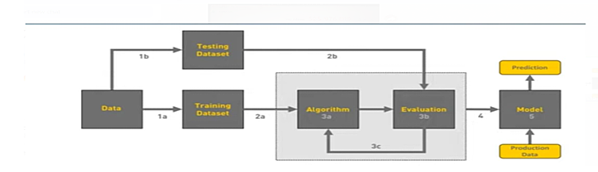

1

3.2 Hardware / Software requirements:

· Anaconda Navigator

· Jupyter notebook and Spyder

· Python packages

· Flask - Web framework

· RAM-8GB · OS:WINDOWS 10

4 EXPERIMENTAL INVESTIGATIONS

· Data Collection:

· Collect the dataset or Create the dataset

· Visualizing and analyzing data:

· Univariate analysis

· Multivariate analysis

· Descriptive analysis

· Data pre-processing:

· Checking for null values

· Drop unwanted features

· Data Cleaning.

· Handling outlier

· Handling categorical data

· Splitting Data into Train and Test.

· Feature scaling

· Model Building:

· Import the model building Libraries

· Initializing the model

· Training and testing the model

· Save the Model

2

·Application Building:

· Create an HTML file

· Build a Python Code

5 FLOWCHART :

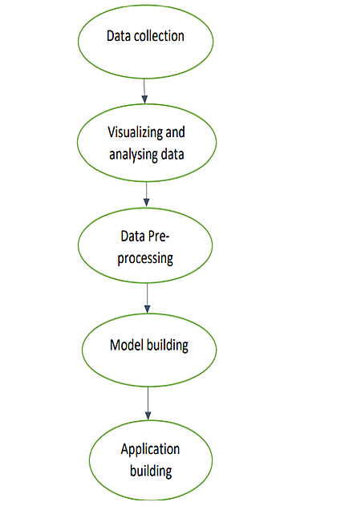

3

6 RESULT

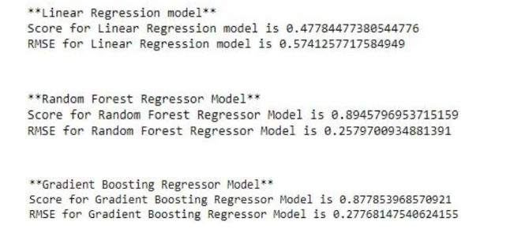

7 ADVANTAGES:

· You’ll be able to understand the problem to classify if it is a regression or a classification kind of problem.

· You will be able to know how to preprocess/clean the data using different data pre-processing techniques.

· You will be able to analyse or get insights of data through visualization.

· Applying different algorithms according to dataset and based on visualization.

· You will be able to know how to find the accuracy of the model.

· You will be able to know how to build a web application using the Flask framework.

4

DISADVANTAGES:

· Need Massive data sets to train on, and these should be inclusive/unbiased, and of good quality.

· Another major challenge is the ability to accurately interpret results generated by the algorithms. You must also carefully choose the algorithms for your purpose.

· highly susceptible to errors.

8.APPLICATIONS

· The application area is in the automation of property management.

9.CONCLUSION

Buying your own house is what every human wish for. Using this proposed model, we want people to buy houses and real estate at their rightful prices and want to ensure that they don't get tricked by sketchy agents who just are after their money. Additionally, this model will also help Big companies by giving accurate predictions for them to set the pricing and save them from a lot of hassle and save a lot of precious time and money. Correct real estate prices are the essence of the market and we want to ensure that by using this model.

5

FUTURE SCOPE:

The supplementary feature that can be added to our proposed system is to avail users of a full-fledged user interface so there can be multiple functionalities for users to use with the ML model for numerous locations. Also, an Amazon EC2 connection will take the system even further and increase the ease of use. Lastly, developing a well-integrated web application that can predict prices whenever users want it to will complete the project.

11 BIBILOGRAPHY

[1] Thuraiya Mohd, Suraya Masrom, Noraini Johari, "Machine Learning Housing Price Prediction in Petaling Jaya, Selangor, Malaysia ", International Journal of Recent Technology and Engineering (IJRTE), Volume-8, Issue-2S11, 2019. [2] G. Naga Satish, Ch. V. Raghavendran, M.D.Sugnana Rao, Ch.Srinivasulu , "House Price Prediction Using Machine Learning" , International Journal of Innovative Technology and Exploring Engineering (IJITEE), Volume-8 Issue-9, 2019. [3] Kuvalekar, Alisha and Manchewar, Shivani and Mahadik, Sidhika and Jawale, Shila, House Price Forecasting Using Machine Learning (April 8, 2020). Proceedings of the 3rd International Conference on Advances in Science & Technology (ICAST) 2020 [4] Neelam Shinde, Kiran Gawande , "Valuation Of House Prices Using Predictive Techniques", International Journal of Advances in Electronics and Computer Science, Volume-5, Issue-6, 2018. [5] Jingyi Mu, Fang Wu,and Aihua Zhang , " Housing Value Forecasting Based on Machine Learning Methods", Hindawi Publishing Corporation Abstract and Applied Analysis, Volume 2014. [6] Sayan Putatunda, "PropTech for Proactive Pricing of Houses in Classified Advertisements in the Indian Real Estate Market".

6

[7] Atharva Chouthai, Mohammed Athar Rangila , Sanved Amate, Prayag Adhikari, Vijay Kukre , "House Price Prediction Using Machine Learning" , International Research Journal of Engineering and Technology(IRJET), Vol:06 Issue: 03, 2019. [8] B.Balakumar, P.Raviraj, S.Essakkiammal , "Predicting Housing Prices using Machine Learning Techniques". [9] Akshay Babu, Dr. Anjana S Chandran , "Literature Review on Real Estate Value Prediction Using Machine Learning" , International Journal of Computer Science and Mobile Applications, Vol: 7 Issue: 3, 2019. [10] Mr. Rushikesh Naikare, Mr. Girish Gahandule, Mr. Akash Dumbre, Mr. Kaushal Agrawal, Prof. Chaitanya Manka , "House Planning and Price Prediction System using Machine Learning" , International Engineering Research Journal, Vol:3 Issue: 3, 2019.

[11] Aswin Sivam Ravikumar, Thibaut Lust, "Real Estate Price Prediction Using Machine Learning", 2016. [12] Bindu Sivasankar, Arun P. Ashok, Gouri Madhu, Fousiya S , "House Price Prediction" , International Journal of Computer Science and Engineering(IJCSE), Vol: 8 Issue: 7, 2020. [13] M Thamarai, S P Malarvizhi, " House Price Prediction Modeling Using Machine Learning", International Journal of Information Engineering and Electronic Business(DJIEEB), VoL12, No.2, pp. 15- 20, 2020. DOI: 10.5815/ijieeb.2020.02.03

7

APPENDIX

SOURCE CODE:

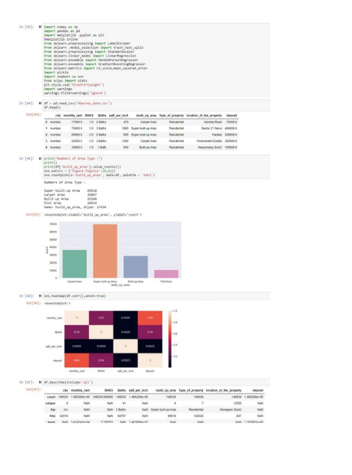

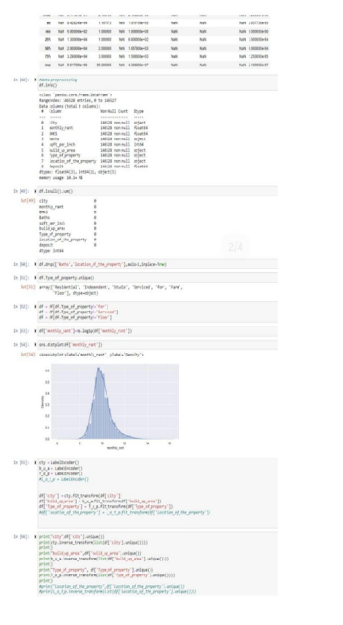

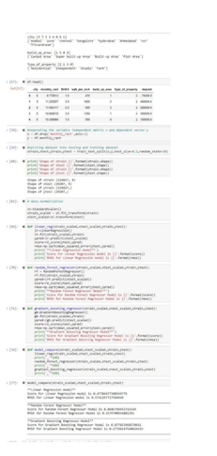

8

9

10