**OUTPUTS:**

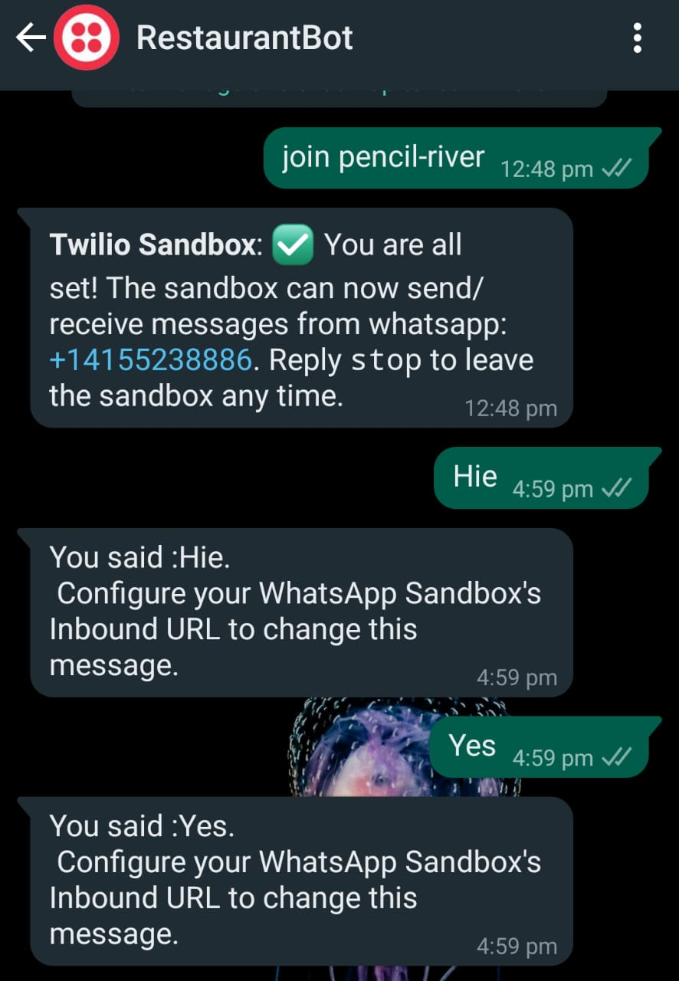 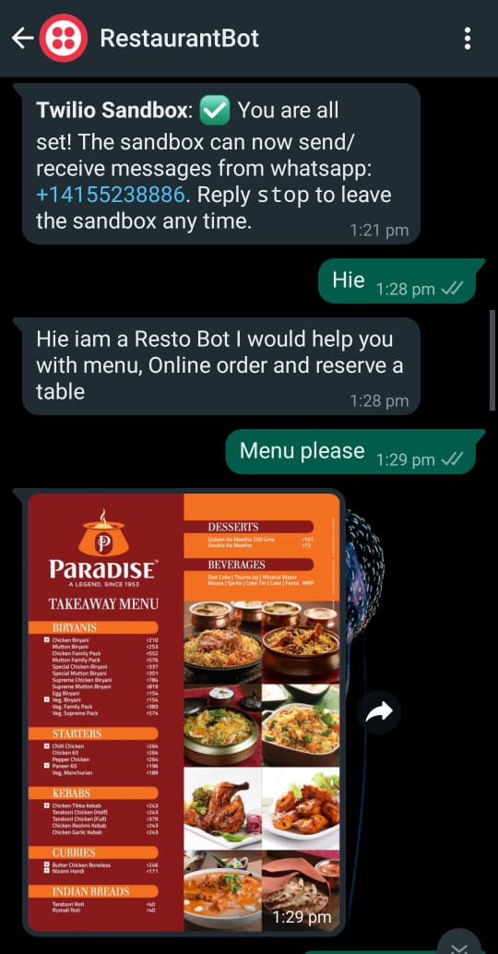

**Figure 48(a): Output for RestaurantBot startup, GeneralGreetings and Menu**

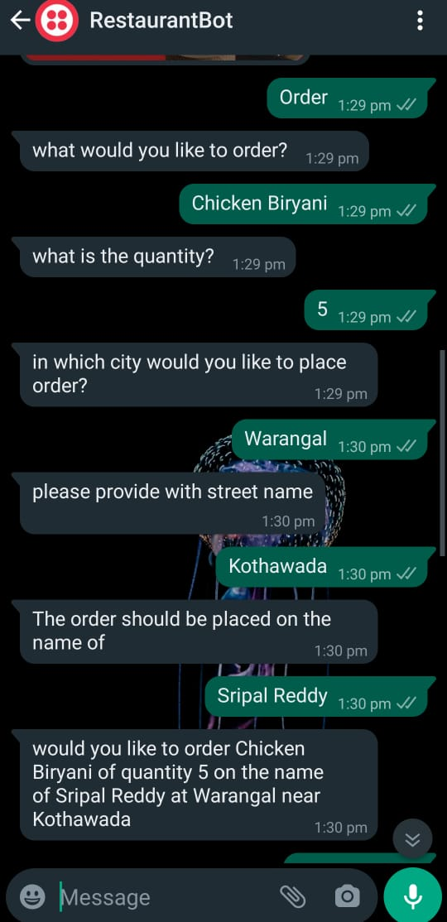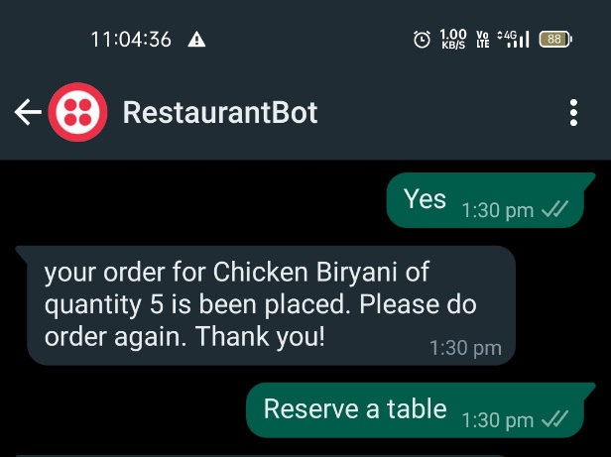

**Figure 48(b): Output for Ordering the food**

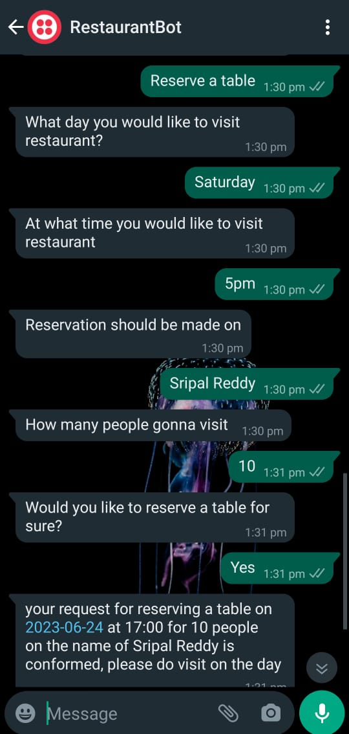 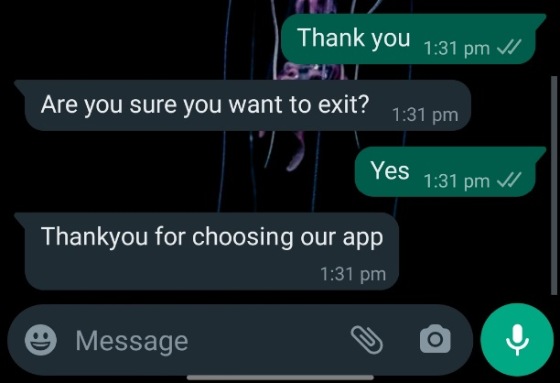

**Figure 48(c): Output for Reservation of table and End of the conversation**