**BUCKSY**

Personal Expense Tracker

# A PROJECT REPORT

Submitted by

**NAVAMI B G**

Bapuji Institute of Engineering and Technology

**TABLE OF CONTENTS**

1. **INTRODUCTION** 
   1. Overview
   2. Purpose
2. **LITERATURE SURVEY** 
   1. Existing problem
   2. Proposed solution
3. **THEORETICAL ANALYSIS** 
   1. Block diagram
   2. Hardware / Software designing
4. **EXPERIMENTAL INVESTIGATIONS**
5. **FLOWCHART**
6. **RESULT**
7. **ADVANTAGES& DISADVANTAGES**
8. **APPLICATIONS**
9. **CONCLUSION**
10. **FUTURE SCOPE**
11. **BIBLIOGRAPHY**

# INTRODUCTION

## Overview

**Personal Expense Tracker** System is designed to keep a track of IncomeExpense of any individual on a day-to-day basis. This System divides the Income based on daily expenses. If you exceed month’s expense, system will give you an alert message to your registered Email id and users will have an option to update their monthly limit amount. If that month’s expense is less, it will directly add into database with no alert. Personal expense tracking System will generate report at the end of month to show Income-Expense Curve. Personal Expense Tracker System is a system which will keep a track of Income-Expense of any individual on a day to day basis, This System takes Income and if it is less than selected monthly limit, expenses are allowed, If u exceed that monthly expenses It will add into your database by giving an alert that you limit of that particular month has been exceeded.

## Purpose

**Personal Expense Tracker** (PET) aims to help everyone who are planning to know their expenses and limit it from spending more. PET is a Web application which users can execute in their Desktops/PC and update their daily expenses so that they are well known to their expenses. Here user can define their own Description for expense type like food, clothing, rent and bills where they have to enter the money that has been spent and also can add some information in additional information to specify the expense. All the expenses and incomes of that day will be display after you add one expense/income on that day. User will be able to see Graphical analytics of expenses and incomes of whole month will be displayed in the dashboard.

# LITERATURE SURVEY

## Existing System

In existing, we need to maintain the Excel sheets, CSV etc. files for the user’s daily and monthly expenses. In existing, there is no as such complete solution to keep a track of its daily expenditure easily. To do so a person as to keep a log in a diary or in a computer, also all the calculations need to be done by the user which may sometimes results in errors leading to financial losses.

## Proposed Solution

To reduce manual calculations, we propose an application which is developed by using HTML, CSS and python framework called Flask. This application allows users to maintain a digital automated diary. Each user will be required to register on the system at registration time, the user will be provided id, which will be used to maintain the record of each unique user. Expense Tracker application which will keep a track of Income-Expense of a user on a day to day basis. This application takes Incomes and expenses from user and user need to specify expense limit for month. If u exceed that monthly expense an alert mail will be sent to your registered email id, User also have an option to update their monthly limit. if that month expense is less it will directly added into database. Expense tracking application will generate report when you click on dashboard by displaying the incomes and expenses you’ve entered for that particular month. Graphical analytics option is also provided so that user can have a pictorial form of their Income-Expense. It will let you limit your expense and start savings.

# THEORETICAL ANALYSIS

## Block Diagram

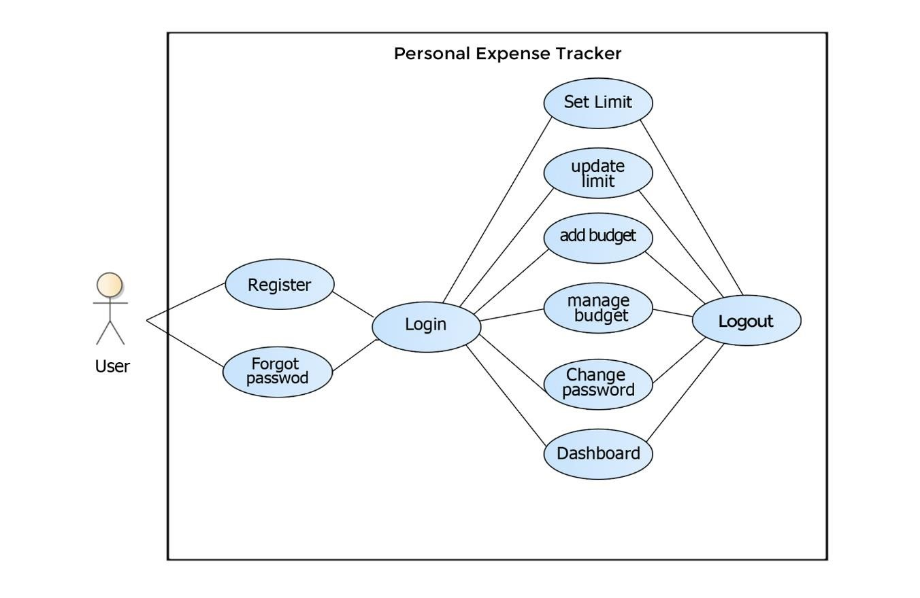

Block diagram of personal expense tracker

# HARDWARE / SOFTWARE REQUIREMENTS

**Number Description**

|  |  |
| --- | --- |
| **1** | PC with 250 GB or more Hard disk. |

**2** PC with 2 GB RAM.

|  |  |
| --- | --- |
| **3** | PC with Pentium 1 and Above. |

|  |  |  |
| --- | --- | --- |
| **Number** | **Description** | **Type** |
| **1** | Operating System | Windows/Linux |
| **2** | Language | Python, Markup Language (HTML) Styling (CSS) |
| **3** | Framework | Flask |
| **4** | Database | MySQL |
| **5** | IDE | Visual Code, Anaconda (spyder) |

**6** Browser Google Chrome, Firefox

# EXPERIMENTAL INVESTIGATION

We should lot of research on web applications which are related to our project and discover what features they were missed. And make a quick survey and ask some people who already have an experience this kind of web applications, that what are the problems they are facing while using this application and the changes that they are expecting. By taking all the feedback from them we as a developer need to bring a minimal solution to all those problems by adding new functionality to our web application

I personally visited some of the websites related to expense tracking and noted the drawbacks of it like not having an option to remove expense and incomes of particular date and in most of the websites they have not included graphical representation of monthly data. By keeping all this in mind I came to a conclusion to make a web application resolving all this drawbacks with user-friendly User interface (UI) to make user to access with ease. Everything we are using is realtime so we decided to use remotemysql as our database.

# FLOW CHART

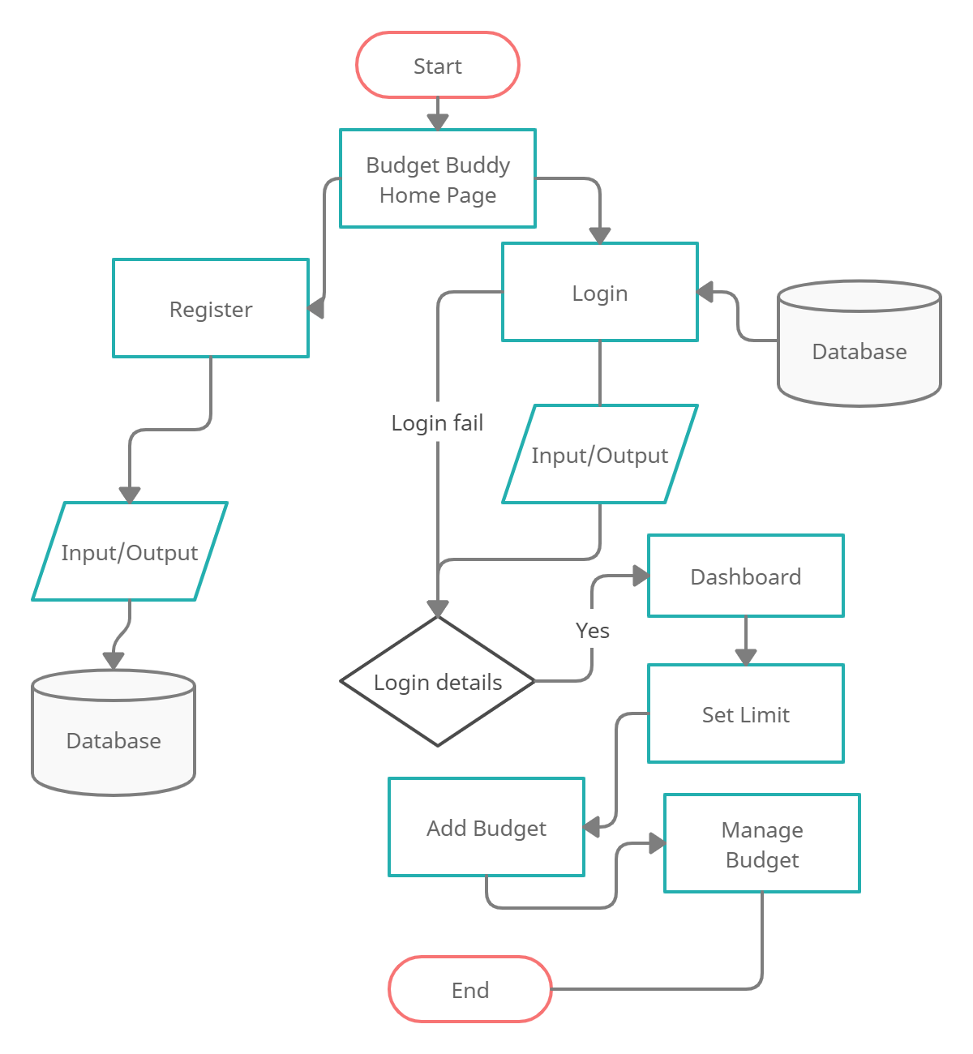

# DATABASE DESIGN

“Expensify” expense tracker consists of four tables namely expenses, income, mlimit, users. The structure of all the mentioned tables are shown below,

**1.EXPENSE**

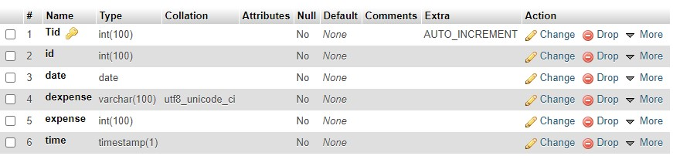

**2.INCOME**

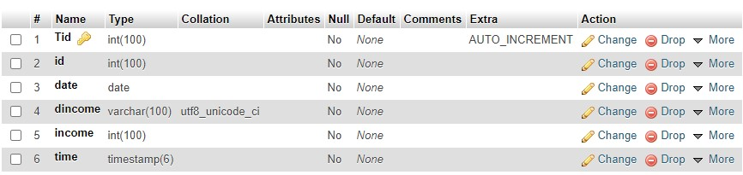

**3.USERS**

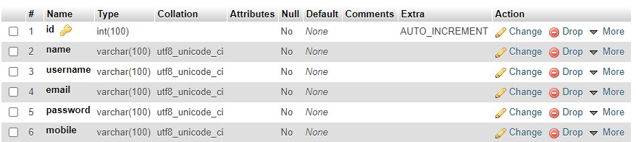

## Advantages

* This system helps users to reduce their expenses.
* Easy to use. • You’ll have better insight into your spending habits.
* provides a better overview and comprehensive analysis.
* Limit your spending.

## Disadvantages

* Need to spend specified time to enter data.
* On some occasions it is not mandatory to restrict expenses

# CONCLUSION

“BUCKSY” Personal Expense Tracker is a web application. We created this application so that a user can accurately calculate his/her daily cost. After making this application we assure that this application will help its users to manage the cost of their daily expenditure. It will guide them and aware them about their daily expenses. It will prove to be helpful for the people who are frustrated with their daily budget management, irritated because of amount of expenses and wishes to manage money and to preserve the record of their daily cost which may be useful to change their way of spending money. In short, this application will help its users to overcome the wastage of money.

# FUTURE SCOPE

Now in our web application we covered almost all features but in future we will add some more futures. The features are below:

* Multiple account support.
* Giving an alert message to user’s mobile number.
* Include currency converter.
* Reports are created in category.
* Giving user to export the data in all available formats like pdf, excel etc…

# BIBILOGRAPHY

* <https://www.w3schools.com/>
* <https://flask.palletsprojects.com/en/1.1.x/>
* <https://jinja.palletsprojects.com/en/2.11.x/>
* <https://www.youtube.com/Traversymedia>
* <https://www.tutorialspoint.com/python/python_sending_email.htm>
* <https://www.chartjs.org/docs/latest/>