DOCUMENTATION OF E-COMMERCE SHOPPING APPLICATION

COMPILED BY:

MOHAMMED FAHAD

ROLL NO:19UK1A0515

VAAGDEVI ENGINEERING COLLEGE

**project URL:**

<https://iacademy.oracle.com/ords/f?p=1367:LOGIN_DESKTOP:12925545871497>:::::

**login details:**

Username: usertest

Password: 123456789

ABSTRACT

Now a days the life style of the people is different. People feel uncomfortable and time consuming for going crowded markets. So, E-Shopping is a boon as it saves lot of time. Online shopping is a process whereby consumers directly buy goods, services etc. from a seller without an intermediary service over the Internet. Shoppers can visit web stores from the comfort of their house and shop as by sitting in front of the computer. Online stores are usually available 24 hours a day and many consumers have internet access both at work and at home. So, it is very convenient for them to shop Online. One of the most enticing factors about online shopping, particularly during holiday season is, it alleviates the need to wait in long lines or search from a store for a particular item. Variety of goods are available in online. So, the researcher wants to know the preference of the consumers. So, fifty respondents were met and data were collected regarding their preference towards shopping online.

**CONTENTS**

**S.no TOPIC**

**1-> INTRODUCTION**

**2-> THEORITICAL ANALYSIS**

**3-> FLOW CHART**

**4-> RESULT**

**5-> ADVANTAGES & DISADVANTAGES**

**6-> APPLICATIONS**

**7-> CONCLUSION**

**8-> FUTURE SCOPE**

**9-> APPENDIX**

**1.INTRODUCTION**

Online shopping is becoming increasingly popular for variety of reasons. There are certainly outside factors such as increasing gas prices, difficulty in getting to traditional stores and hassles often associated with shopping malls and other traditional stores to contribute to the increased interest in online shopping.

Consumers can get full information about the product with its reviews being passed by the existing users. If one wants to buy a product he/she is no longer limited to asking the friends and families because there are many products reviews on the web which gives opinions of the existing users of the product.

Online shopping sites contain wide variety of goods both high quality and mild quality keeping in mind the level of people.

**2. THEORITICAL ANALYSIS**

**Architecture:**

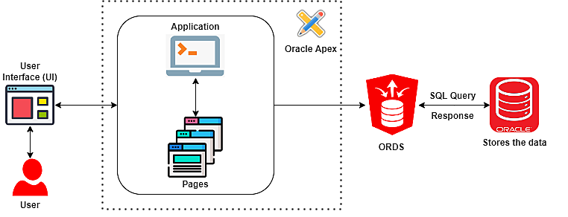

Shopping Cart application that allows managing products, customers, and stores. The application will have two application roles:

Administrators:

* To manage the products, customers and stores
* To access a dashboard to identify the top products

Customers:

* To review, add, delete, or edit the number of products in the shopping cart
* To submit orders

**3. FLOWCHART**

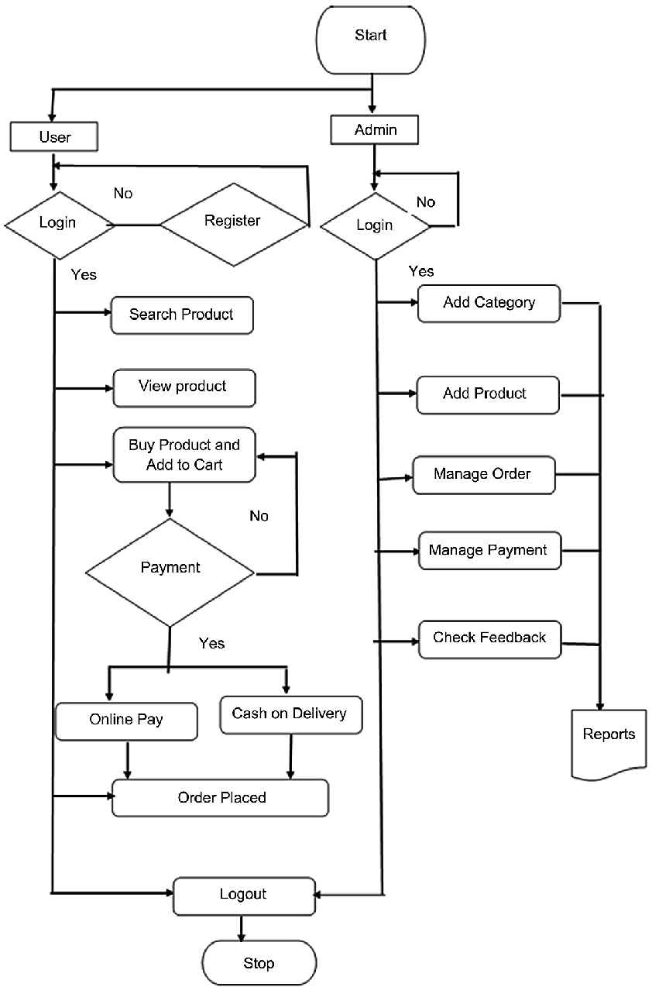

**4.RESULT**

**Steps to follow for results:**

**STEP-1:** Click on the given link to open V-cart Website (<https://iacademy.oracle.com/ords/f?p=1367:LOGIN_DESKTOP:12925545871497>:::::

)

This gets redirected to the page shown below,

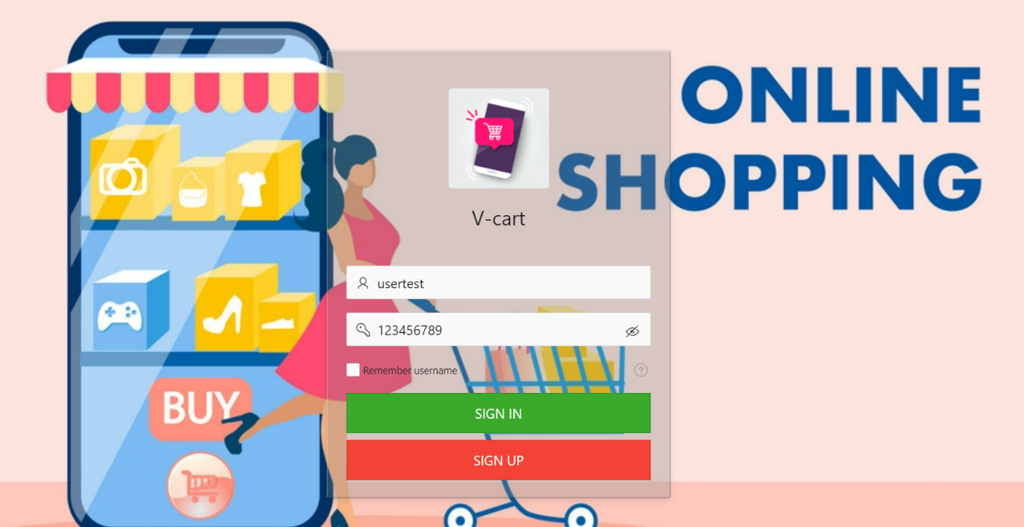

**STEP-2:** Already registered users can enter their credentials to ‘Sign In’. If you’re a new user then click on ‘Sign Up’ button to register.

**STEP-3:**When you click on the ‘Sign Up’ button you will be redirected to registration page.

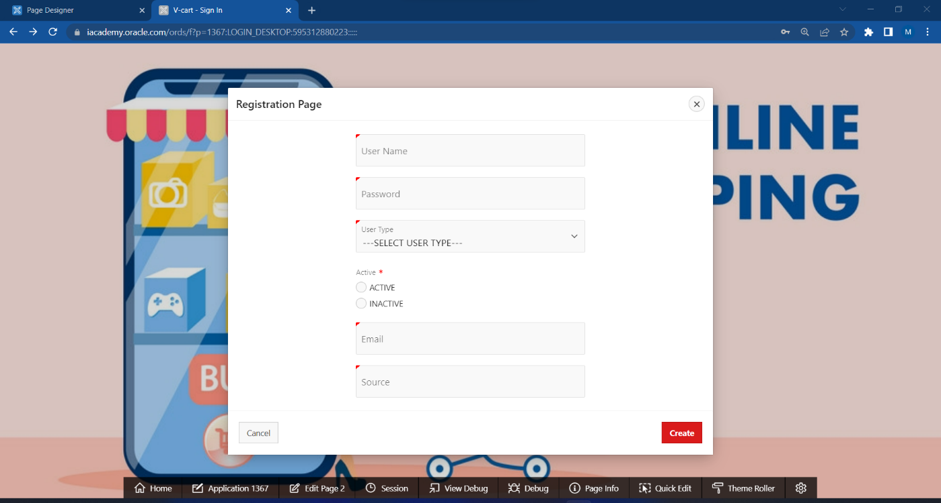

**STEP-4:** Enter your credentials in the registration page such as

->Username

->Password

->User Type

->Active status

->Email

->Source

**STEP-5:**Click on ‘Register’ button to confirm your registration.

Note: use the same credentials to login into the V-cart App

**STEP-6:** After you logged in into the app the below interface will be appeared with home page as below

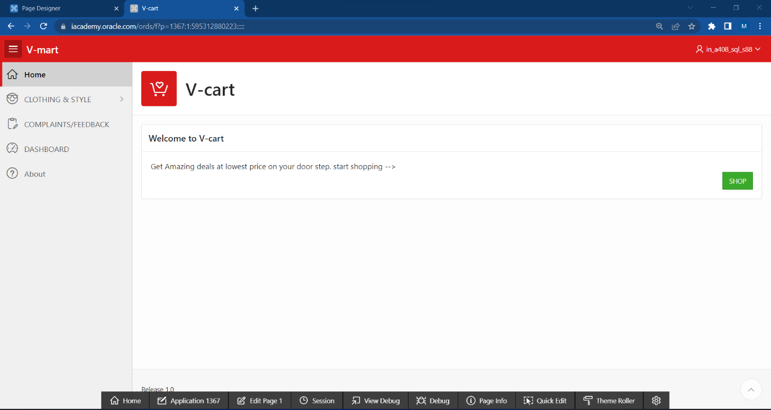

**STEP-7**: Now click on ‘Shop’ button then you will be redirect to the shopping page

**STEP-8**: Checkout all the available products in CLOTHING page.

**STEP-9**: Click on ‘Select Products’

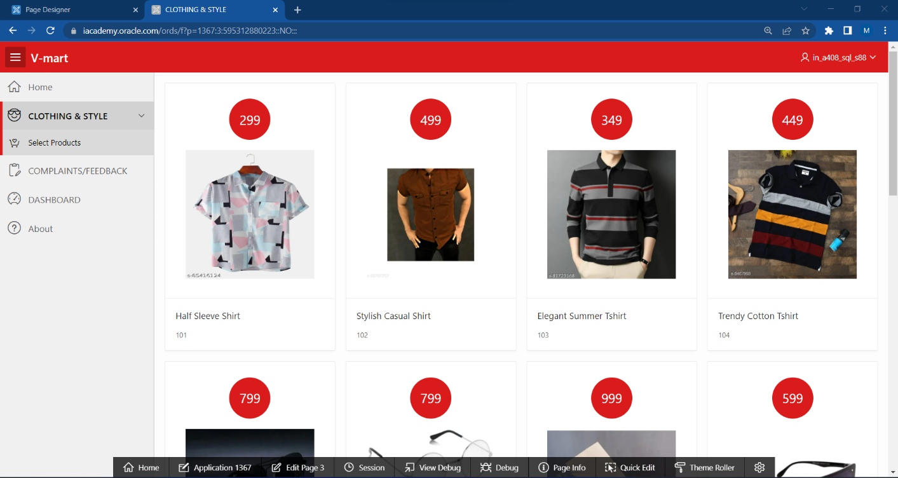

**STEP-10:** When you click on ‘Select Products’ this redirects to the Page as shown below.

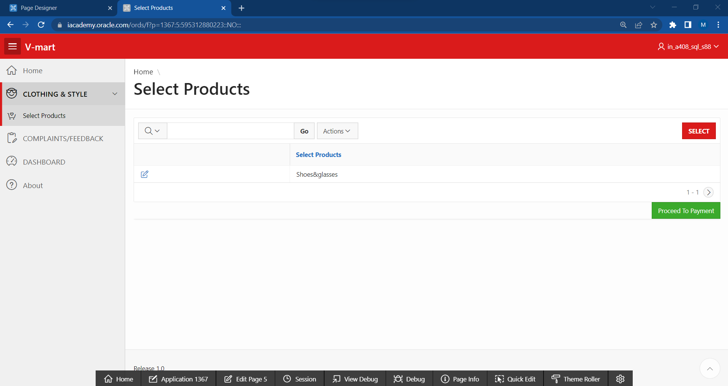

**STEP-11:** Click on ‘SELECT’ button to add the products.

**STEP-12:** Select your products which you want to order and click ‘SELECT’ button.

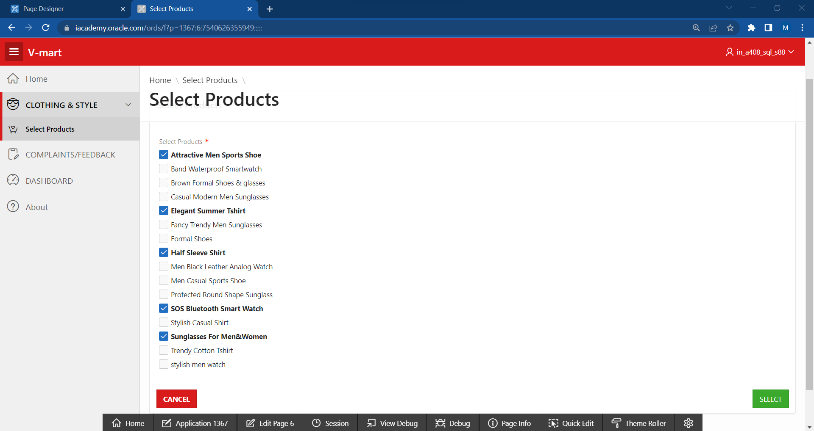

Finally, Selected Products gets added to your cart as shown in below figure.you will see ‘Products Added Successfully !!’

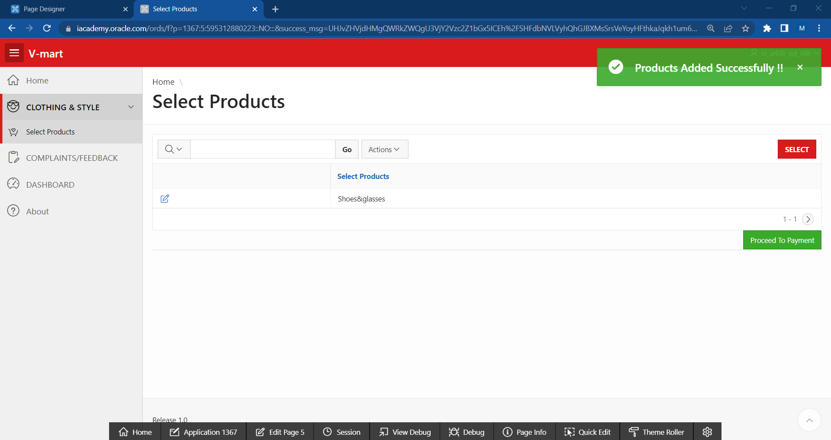

**STEP-13:** Now click on ‘Proceed to Payment’ button to add your Address for product delivery and select type of payment.

Note: Before placing the order Confirm the data provided and click ‘SUBMIT’

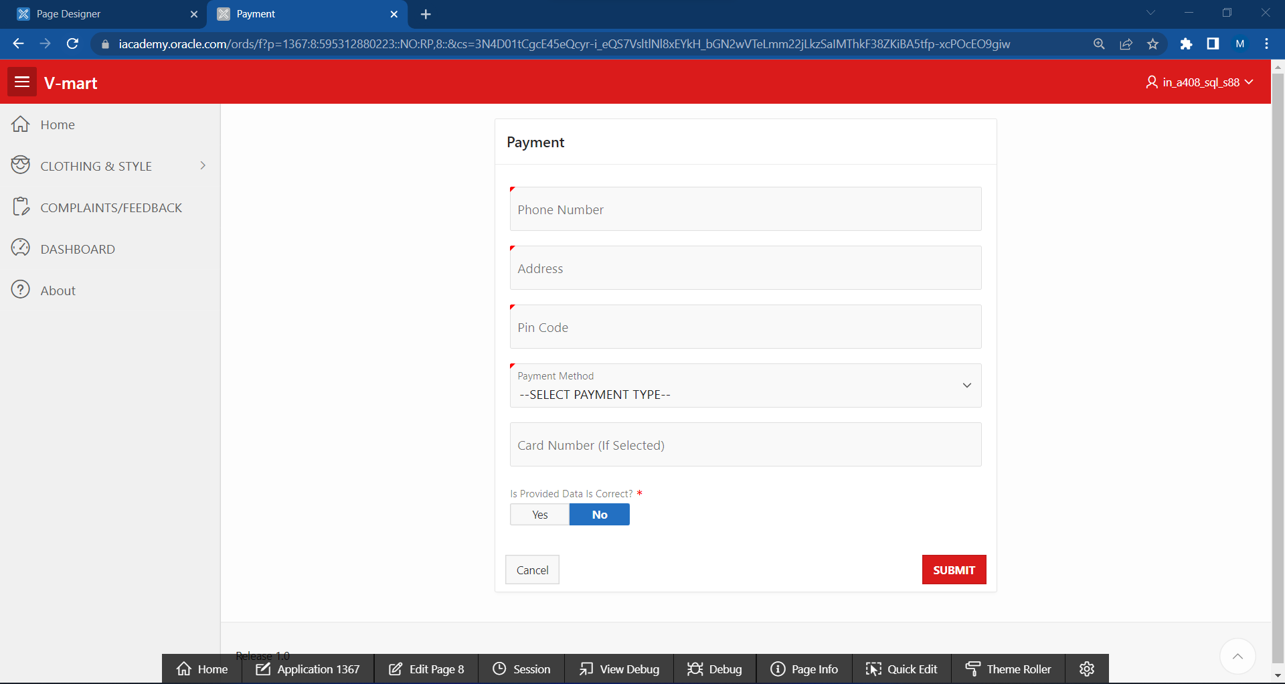

when you click on the ‘SUBMIT’ your order will be confirmed and gets placed.

**STEP-14:** Click on ‘COMPLAINTS/FEEDBACK’ to give feedback or suggestions.

You’ll be redirected to the following page, now provide Name, Email, the Issue raised and then click on ‘Submit’ button to submit the Complaint/Feedback**.**

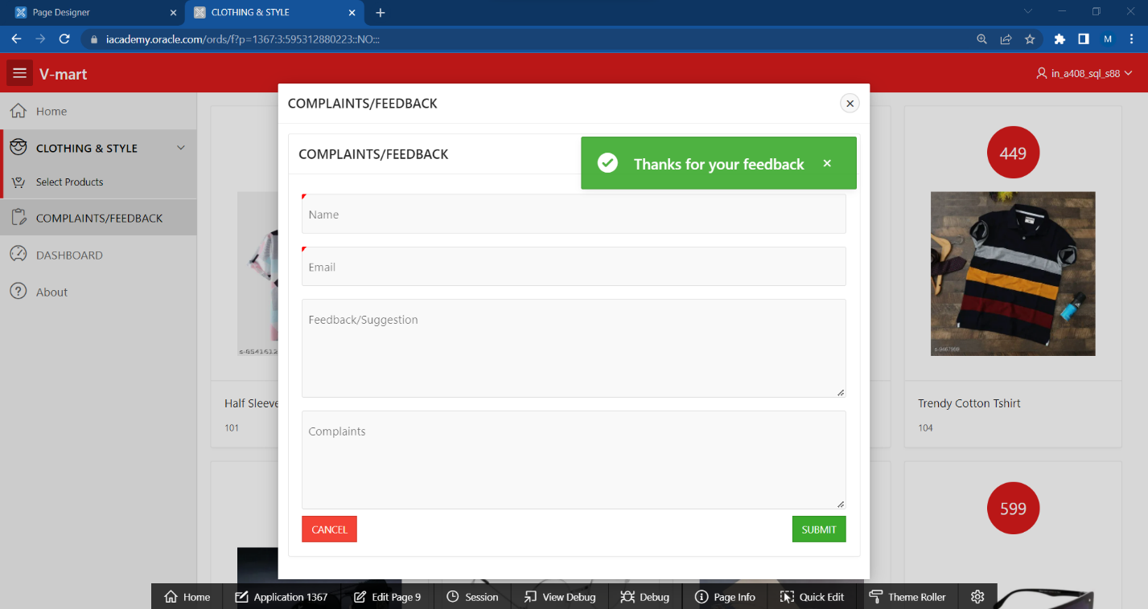

**STEP-15:** To view the customer statistics click on ‘DASHBOARD’

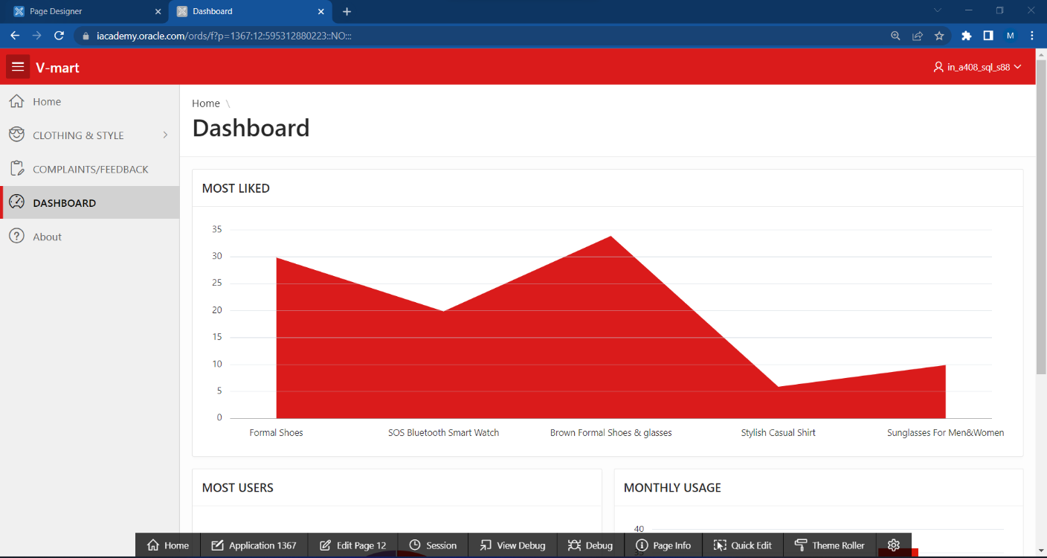

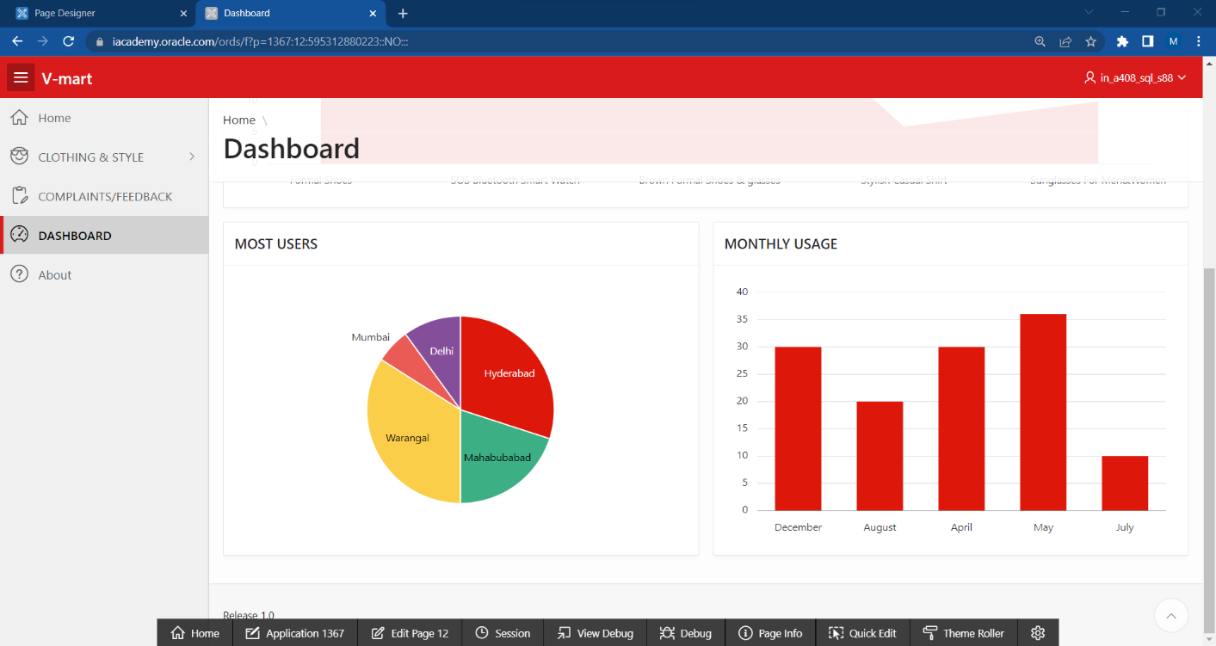

**STEP-16:**Click on ‘About’ to know more about our Company.

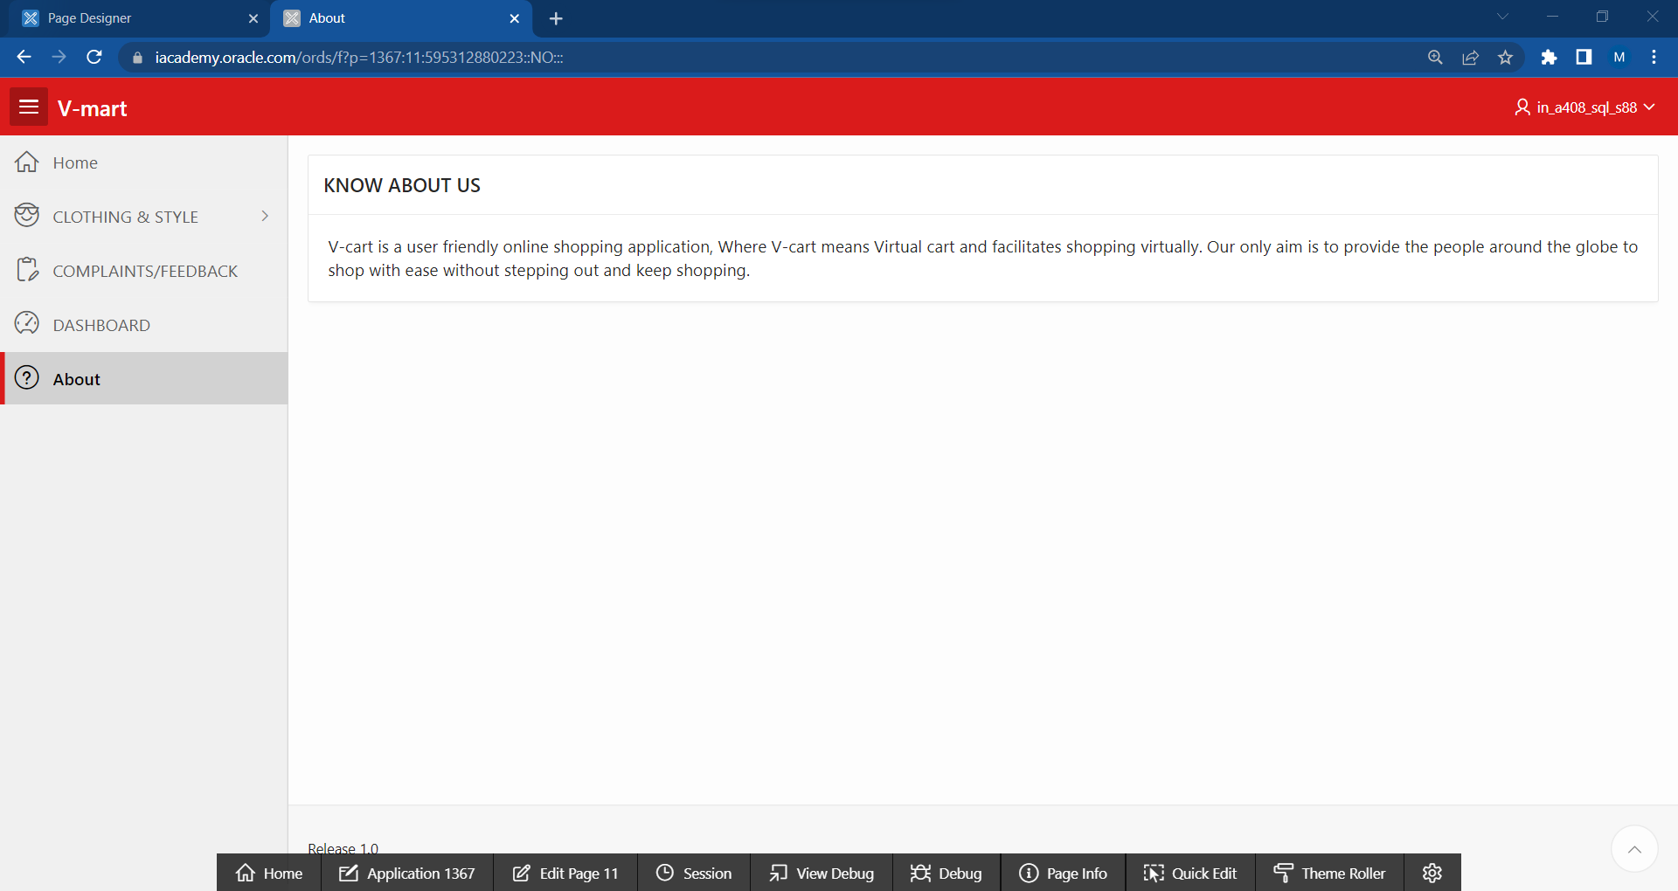

**5. ADVANTAGES AND DISADVANTAGES**

|  |  |
| --- | --- |
| Advantages of Shopping application | Disadvantages of Shopping application |
| Better Prices | Shipping Problems and Delays |
| More Variety | Risk of Fraud |
| Easy to Send Gifts | Less Contact With Your Community |
| More Control  easy interface  fast access  user defined timings | Spending Too Much Time Online  data loss  no privacy |

**6. APPLICATIONS:**

The purpose of shopping cart software is to support the work of online merchants with larger customer databases, and enable at least a simplified self-service method. On an eCommerce website with a reliable shopping cart service, prospective buyers have the possibility to preselect, reserve, and store items they’d like to own. The cart itself is often the leading element that inspires trust in the shopping process, and lets them know they’re dealing with a professional provider. On the owner’s side of the axis, meanwhile, this leads to accelerated checkout and out-of-the-box possibilities to cross-sell related products, and please customers with ‘just-what-I-wanted’ offers.

**7.CONCLUSION:**

The researcher made a thorough analysis over the Study of customer preference towards online shopping with reference to Nagercoil town. It is of the opinion that , though there are a number of products available in the market , large number of respondents mostly prefer to purchase Books through online shopping. Because variety of Books are available while searching online web stores.

**8. FUTURE SCOPE:**

Greater personalization of ads, retargeting, and automated marketing to ensure maximum conversion of visitors, abandoned cart shoppers etc.

The future of online shopping depends on savvy professionals who can create a personalized, engaging virtual shopping experience for consumers. Those entering a career in business administration must adopt the latest digital technologies and tools — such as data analytics, machine learning, and mobile trends — to meet the demands of today’s online shopper.

**9. APPENDIX**

1. **Source code of USER_ACCOUNT Table:**

CREATE TABLE "USER_ACCOUNT"

( "USER_NAME" VARCHAR2(100),

"PASSWORD" VARCHAR2(30) NOT NULL ENABLE,

"USER_TYPE" VARCHAR2(10),

"ACTIVE" VARCHAR2(1) NOT NULL ENABLE,

"EMAIL" VARCHAR2(64) NOT NULL ENABLE,

"SOURCE" VARCHAR2(64),

CONSTRAINT "USER_ACCOUNT_CON" UNIQUE ("EMAIL")

USING INDEX ENABLE,

CONSTRAINT "USER_ACCOUNT_PK" PRIMARY KEY ("USER_NAME")

USING INDEX ENABLE,

CONSTRAINT "USER_ACCOUNT_UQ" CHECK ( "ACTIVE" IS NOT NULL) ENABLE,

CONSTRAINT "USER_ACCOUNT_UQ1" CHECK ( "EMAIL" IS NOT NULL) ENABLE

)

/

1. **Source code of PRODUCT_DTL:**

CREATE TABLE "PRODUCT_DTL"

( "ID" NUMBER,

"PRODUCT_CODE" VARCHAR2(20),

"PRODUCT_NAME" VARCHAR2(200),

"IMAGE" BLOB,

"PRICE" NUMBER(12,2)

)

/

**c .Source code of ORDER_PRODUCT1:**

CREATE TABLE "ORDER_PRODUCT1"

( "ID" NUMBER,

"PRODUCT_CODE" VARCHAR2(200),

"PRODUCT" VARCHAR2(200),

"RATE" NUMBER,

"QTY" NUMBER,

"USER_NAME" VARCHAR2(20)

)

/

**d. Source code of INLINE CSS:**

select "ROWID",

"ID",

"PRODUCT_CODE" CARD_SUBTEXT,

"PRODUCT_NAME" CARD_TEXT,

sys.dbms_lob.getlength("IMAGE") "CARD_TITLE",

"PRICE" CARD_INITIALS

from "PRODUCT_DTL"