**REPORT**

It’s one thing to keep track of your expenses just so you can monitor where your money goes, it’s another to do something about expenses that tiptoe the lines and harm the general budget. An expense tracking sheet is not just a compilation of your expenses, it’s also a documentation of your spending habits and when you’re made aware of your spending habits, it should be easy to identify which ones need to stay and which ones need to go. When you get an overall idea of your spending, you anticipate and handle periodic expenses better that it no longer impacts your budget and you also avoid getting yourself into financial problems.

**Expense Tracker** – the sheet with the tracker itself: it allows you to filter out expenses by categories according to the selected period. This sheet also contains the breakdown of income and expenses by categories/months.

**Import your income/expenses** – the sheet where you can manually or automatically import data about your revenues and expenses.

                 Date – specify the date of your income/expense. Click on the cell and select the date

                Period – a technical field which extracts the name of the month from the data you specify in the Date column.

               Income – select the type of income from the drop-downlist. (The list  consists of the income categories from the Expense Tracker sheet)

              Expense – select the type of expense from the drop-downlist. (The list  consists of the expense categories from the Expense Tracker sheet)

             Amount – specify the amount of income/expense in the currency you need.

**How do I track my household expenses?**

According to Courtney Jespersen in an article they wrote for Nerdwallet, they list 5 steps for tracking your monthly expenses.

* Check your account statements.
* Categorize your expenses.
* Use a budgeting or expense-tracking application.
* Explore other expense trackers.
* Identify room for change.

**Advantages**

It reduces impulsive and mindless buying:

It tracks your financial progress:

It reduces financial stress:

**Screenshots**

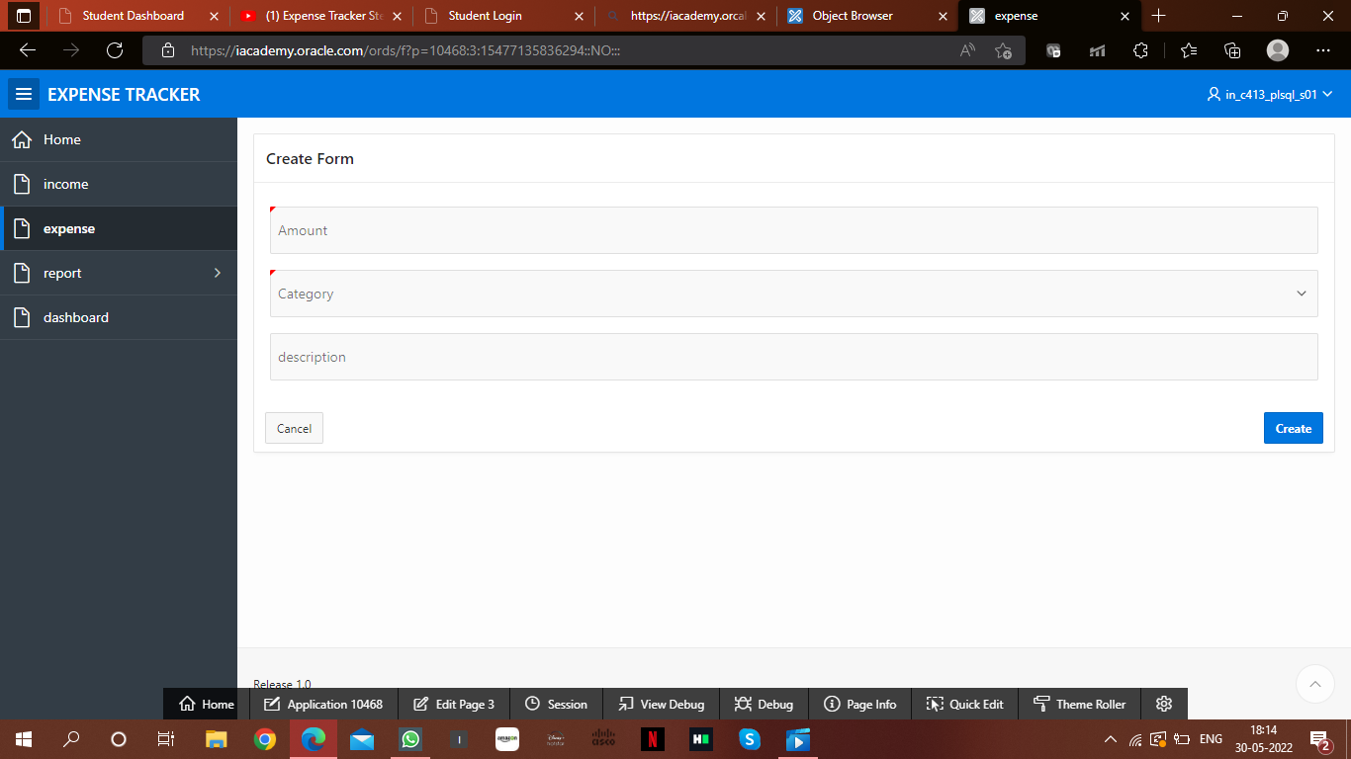

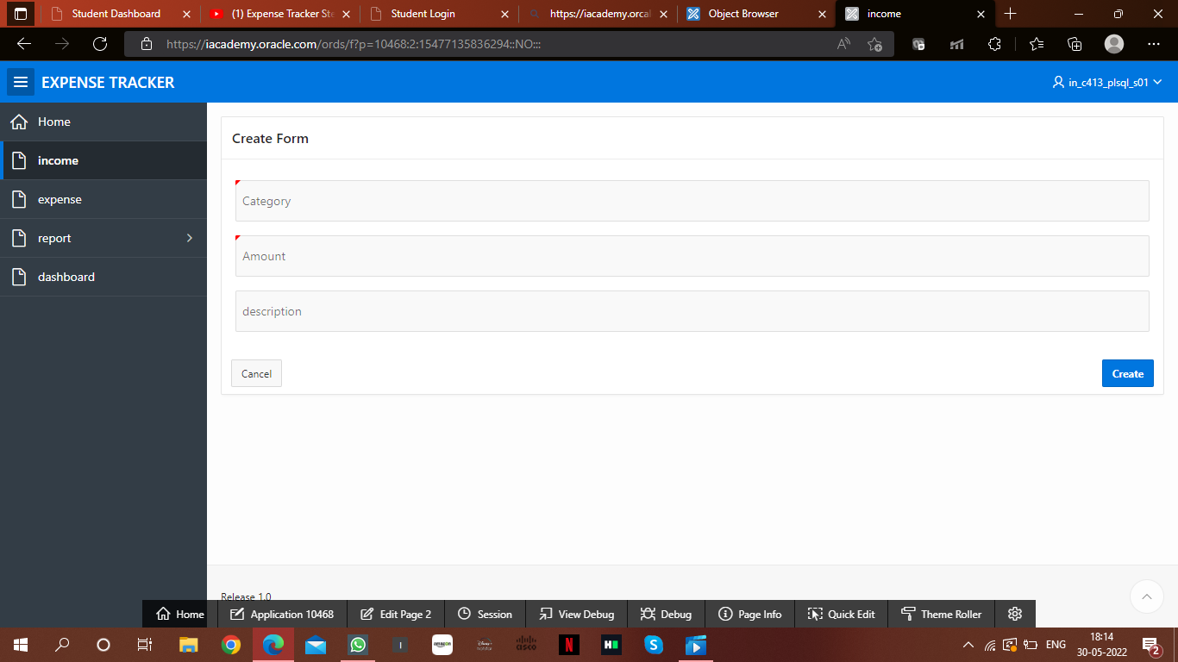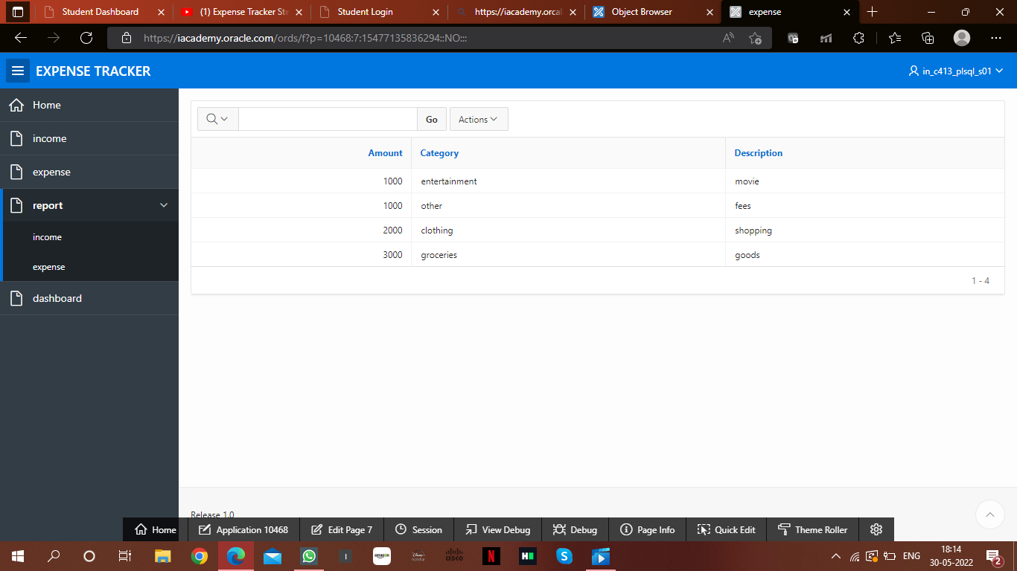

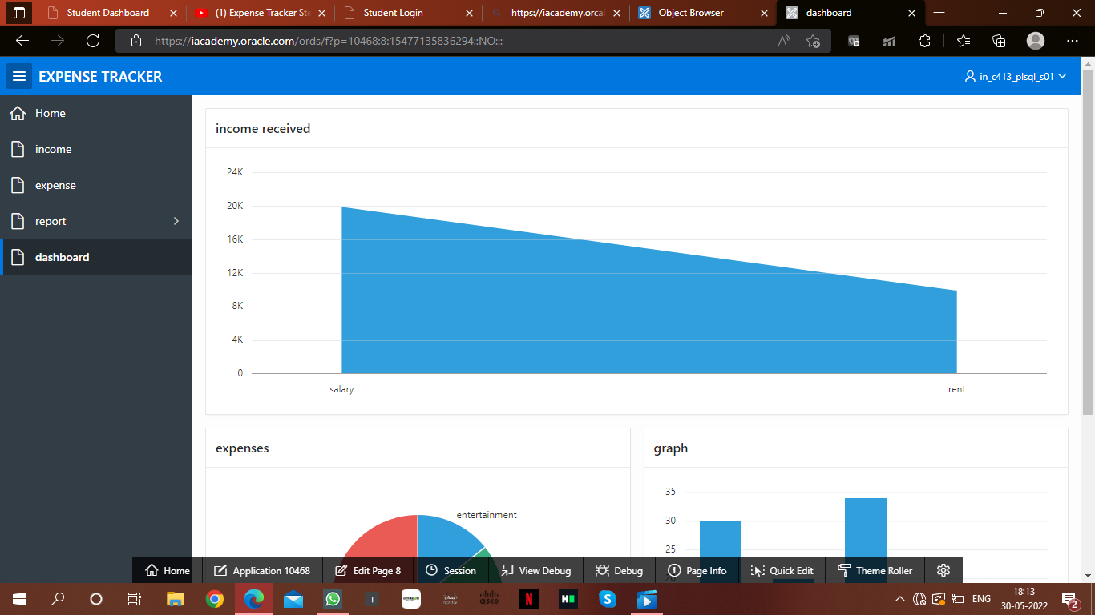

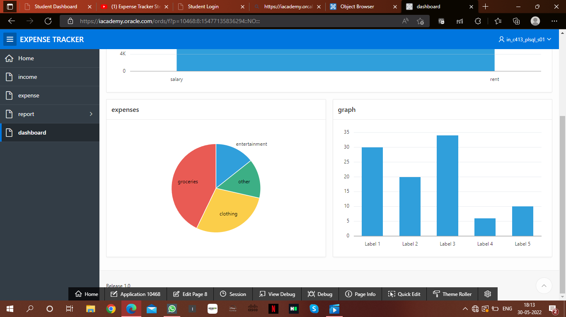

**REFERENCES**

https://www.sample.net/

[Daily Expense Tracker Android App Project SRS Documentation | T4Tutorials.com](https://t4tutorials.com/daily-expense-tracker-android-app-project-srs-documentation/)

[Expense tracker (slideshare.net)](https://www.slideshare.net/layleangsros1/expense-tracker-54071992)