**REPORT**

Tracking expenses is the only way to make sure that your money does not go down the drain. The idea is pretty simple: you need to categorize expenses by category and analyse how much you spend on each.  Examples of categories include food, insurance, utilities, etc. Based on the analysis, you’ll be able to decrease expenses and increase savings.

* **Expense Tracker** – the sheet with the tracker itself: it allows you to filter out expenses by categories according to the selected period. This sheet also contains the breakdown of income and expenses by categories/months.
* **Import your income/expenses** – the sheet where you can manually or automatically import data about your revenues and expenses.

*Date* – specify the date of your income/expense. Click on the cell and select the date.

*Period* – a technical field which extracts the name of the month from the data you specify in the Date column.

*Income* – select the type of income from the drop-down list. (The list  consists of the income categories from the *Expense Tracker* sheet)

*Expense* – select the type of expense from the drop-down list. (The list  consists of the expense categories from the *Expense Tracker* sheet)

*Amount* – specify the amount of income/expense in the currency you need.

Expense Tracker gives detail view of expenses in the form of graph, pie diagrams, it shows the accurate values so that we can manage the expenses

**WORKING**

A home page, income page, expenses page, report dashboard is created. monthly investments are added. report page we can see the income and expenses separately. In dashboard we see the graph, pie diagram and profit and loss. monthly or weekly expenses can be updated so that graph also will be updated.

**SCREENSHOTS**

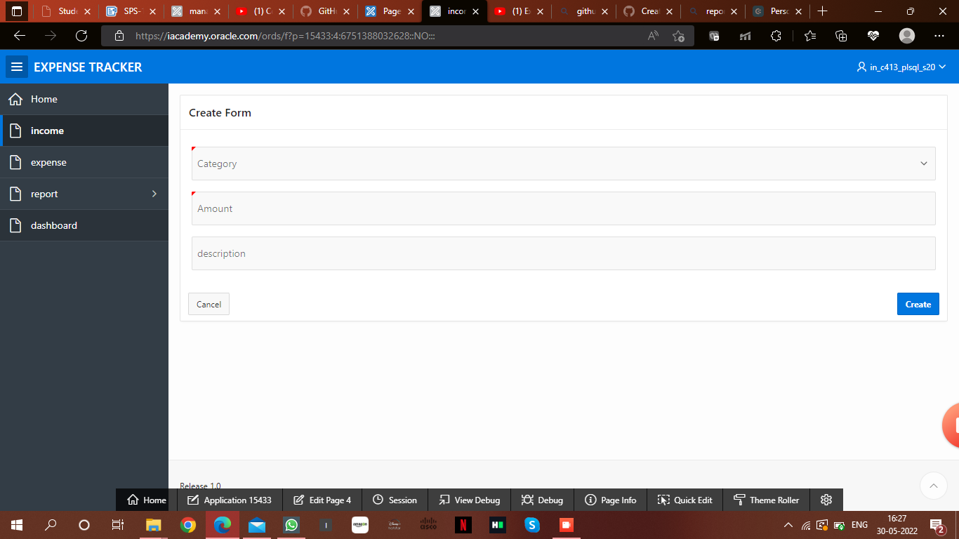

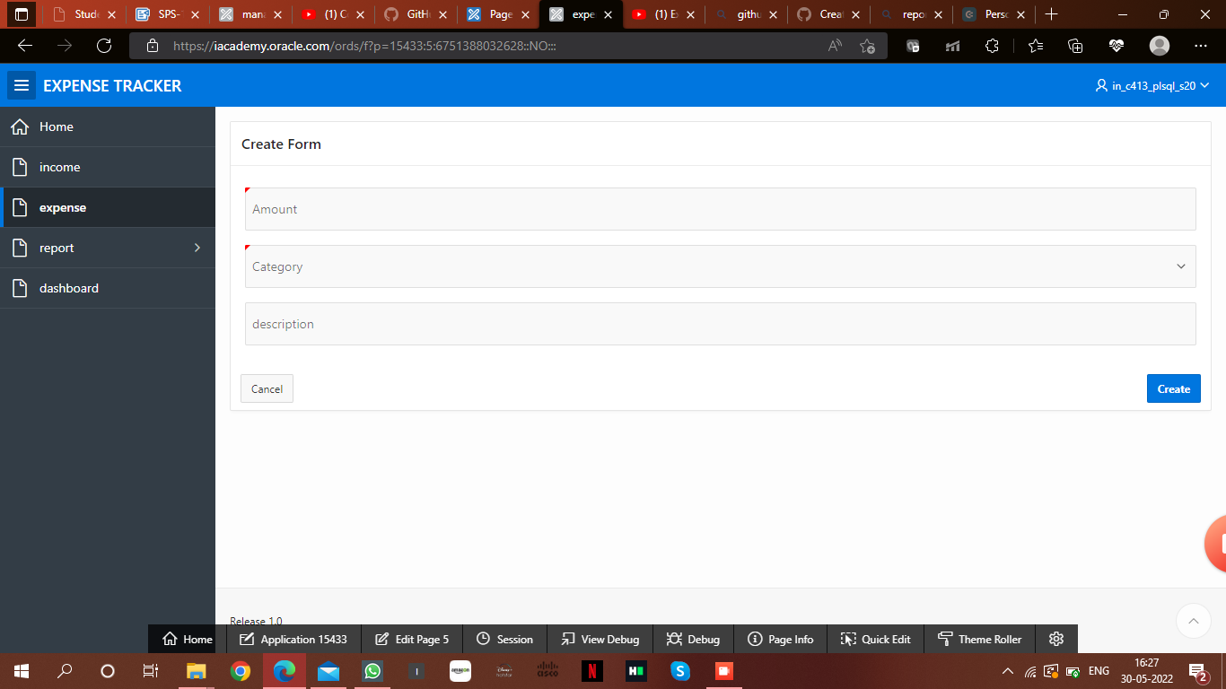

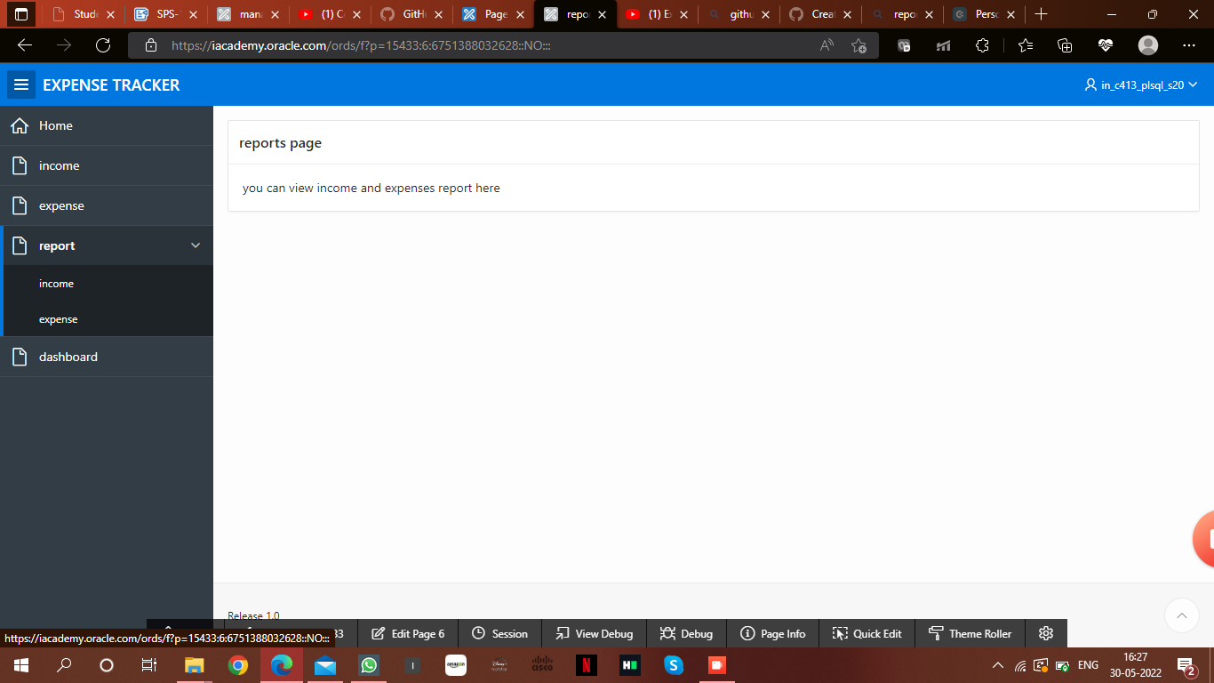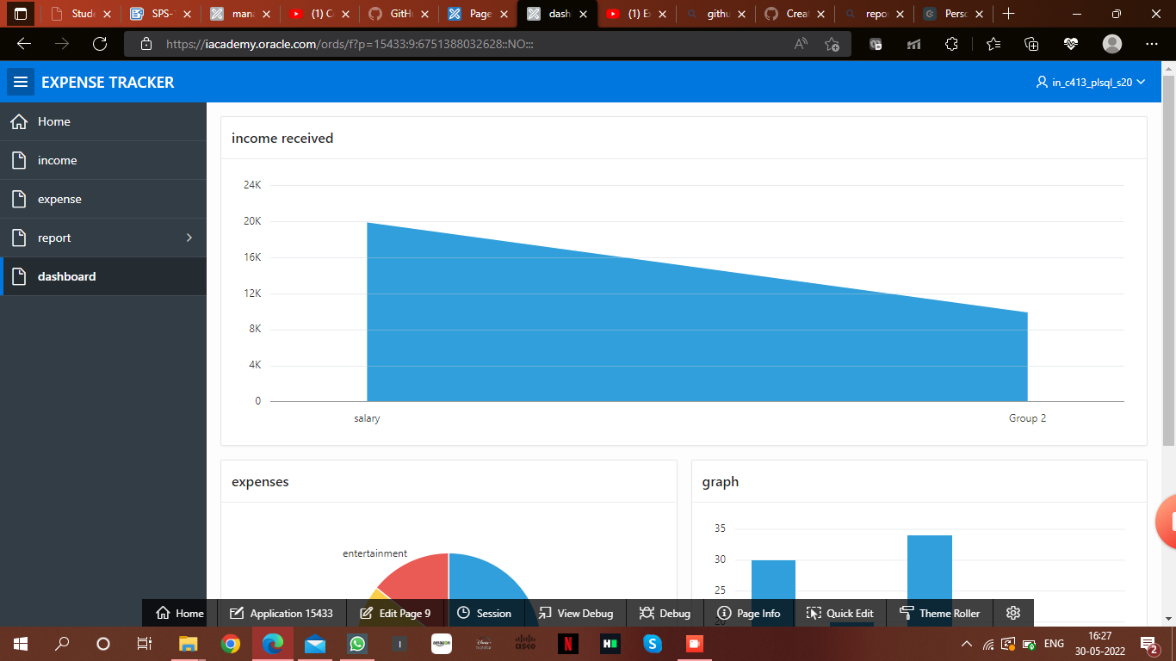

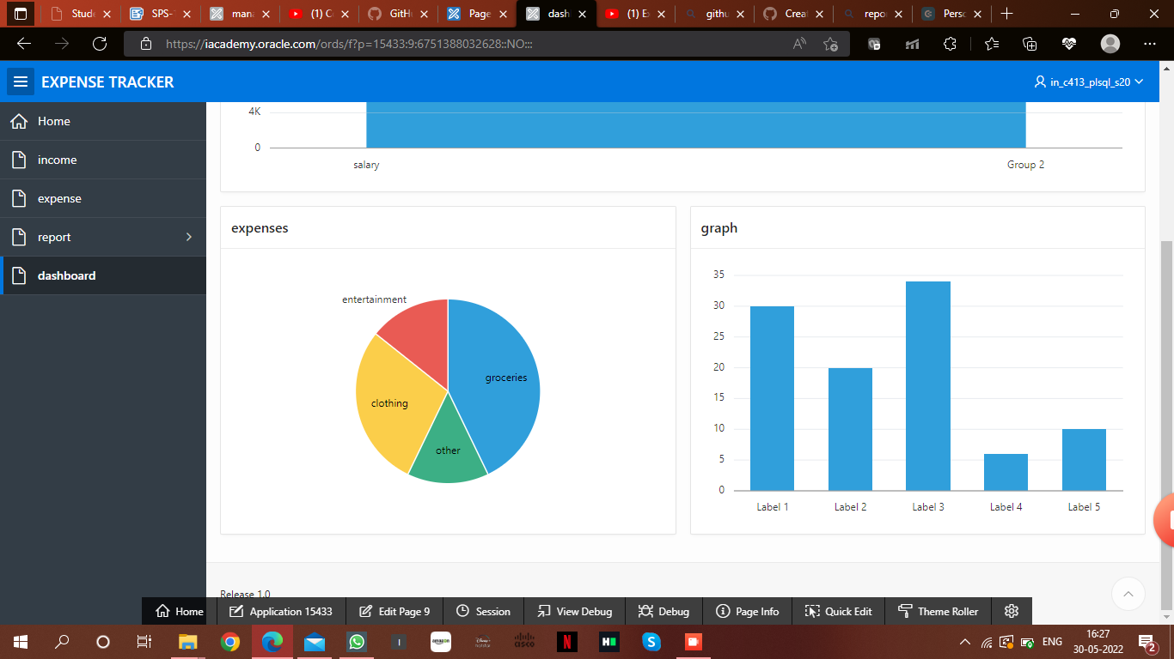

**ADVANTAGES**

finding and eliminating bad spending habits, preventing overspending, making sure you pay yourself first, and ensuring your spending reflects your priorities. You can also lower financial stress and spot fraudulent activity when you track your expenses.

Identifies budget categories to re-evaluate

Keeps you from overspending

Helps you avoid debt

Helps you cut out impulse spending

Reduces stress

Ensures you catch fraudulent transactions in time

Gives you a sense of accomplishment

**REFERENCES**

**https://www.bing.com/**

[Personal Expense Tracker Google Sheets in 2022 | Coupler.io Blog](https://blog.coupler.io/personal-expenses-tracker-google-sheets/)

[Excel Expense Tracker | Manage & Create Expense Tracker in Excel (educba.com)](https://www.educba.com/excel-expense-tracker/)