**DC MOTOR SPEED CONTROL USING 555 TIMER**

**by**

**SWATHI k**

**1. Introduction**

**1.1 Overview:**

The objective of this project is to illustrate how the DC motor's speed can be controlled using a 555 timer. This timer works in PWM mode (Pulse Width Modulator).DC motors have very wide applications because of their high starting torque and high response. DC motor operates using direct current. It converts electrical signal to mechanical energy and this power is applied to the connected devices. DC Motors can be used in daily life like CPU fans, controlling the movement of robotics, fume extinguishers, movement of motors, toy cars etc. They use DC power supply (battery) to operate. Most of the times we have to adjust the speed of the motors as per our requirement. Consider the example of CPU Fan, it has to operate at very high speed when the CPU is preforming heavy tasks like games or video editing. But for normal usage like editing documents, the speed of the fan can be reduced. Some systems have an automatic adjustment to control the speed of the fan and manual adjustment is required in some applications.

In this project I have designed DC motor speed controller using 555 timer. I have used Eagle software to draw the schematic, to create PCB layout and finally created Gerber files. These files when given to industry people, prepares Printed Circuit Board. Components can be soldered and can be used as a device. PCB designing is important because assembling components on simple bread board with wires may not be useful for real time applications.

**1.2 Purpose:**

Controlling the motor speed has great impact on rotation of the motor and in turn it influences the machine’s functionality. The following are the few examples where motor speed control is important.

* During installation of pumps, the conveyor belt and functional speed of the motor are to be in sync which in turn depending on the speed of the motor.
* During drilling process, different materials have different rotational speed and it changes based on drill size also. It in turn requires the motor speed control.
* Few more examples

So, motor speed control is to be taken into consideration. There are two ways to control the speed of a motor manual and automatic. In this project I have used manual controlling using potentiometer.

**2. Literature Survey**

**2.1 Existing problem:**

In earlier days, the speed of the DC motor can be controlled mainly using the two techniques

* Field controlled technique
* Armature controlled technique

Field control uses magnetic flux due to field winding, to control the speed. Magnetic flux and current through the winding are depending on each other so by varying the current we can vary the speed. Most important thing is that speed of DC motor is inversely proportional to armature voltage drop, inversely proportional to flux due to field winding and directly proportional to supply voltage .Current can be varied using a variable resistor in series with the field winding resistor. Here is the scenario to illustrate the above statement. When the variable resistor is at minimum position, rated current flows through the winding because of supply voltage and results in the normal motor speed. The current through the field windings decreases when the resistance is increased. The decreasing current in turn decreases the flux so the speed of the motor increases.

In armature control, armature resistance is used to control the speed of the DC motor. A variable resistor in series with the armature is used in this method. When the variable resistor reaches its minimum value, the armature resistance is at a normal one, and therefore, the armature voltage drops. When the resistance value is gradually increased, the voltage across the armature decreases. This in turn leads to a decrease in the speed of the motor.

These methods have some disadvantages which leads to the invention of PWM mode speed control technique. Here are some of the issues with armature controlled motors. The initial cost is very high and they rare efficient to use for shorter durations. It causes wastage of power if used for longer periods. The issues with field controlled DC motors are as follows. These types of motors can only be operative above the normal speed. With a weaker speed, one can able to achieve only certain speeds. The following section explains the proposed technique to solve the above issues.

**2.2 Proposed solution:**

The proposed solution uses 555 timer in astable multivibrator mode which produces PWM signals. These waves are used to control the speed of a motor. This is the most widely technique and it proves to be very efficient because of its low power and less complexity. Working principle and advantages are explained in further chapters.

**3. THEORITICAL ANALYSIS**

**3.1 Block Diagram:**

The following Fig 1, shows the internal block diagram of 555 timer. PWM is a method through which we can generate variable voltage by turning on and off the power that’s going to the electronic device at a fast rate. The average voltage depends on the duty cycle of the signal, or the amount of time the signal is ON versus the amount of time the signal is OFF in a single period of time. The 555 Timer is capable of generating PWM signal when set up in an astable mode. Fig 2 and 3, shows the internal block diagram of 555 timer. It consists of 2 [comparators](https://en.wikipedia.org/wiki/Comparator), a [flip-flop](https://en.wikipedia.org/wiki/Flip-flop_(electronics)), a voltage divider, a discharge transistor and an output stage. The voltage divider consists of three identical 5k resistors which create two reference voltages at 1/3 and 2/3 of the supplied voltage, which can range from 5 to 15V. Next are the two comparators. A comparator is a circuit element that compares two analog input voltages at its positive (non-inverting) and negative (inverting) input terminal. If the input voltage at the positive terminal is higher than the input voltage at the negative terminal the comparator will output 1. Vice versa, if the voltage at the negative input terminal is higher than the voltage at the positive terminal, the comparator will output 0.

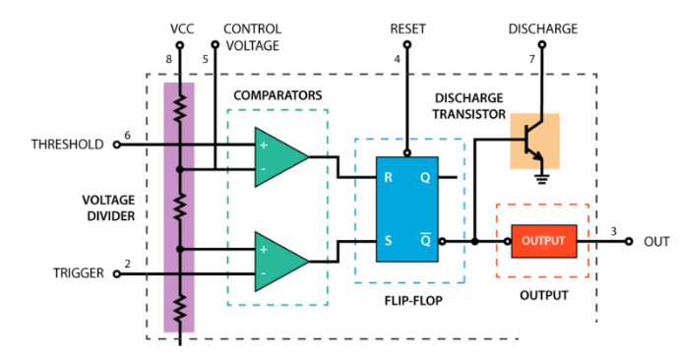

Fig1: Internal block diagram of 555 timer

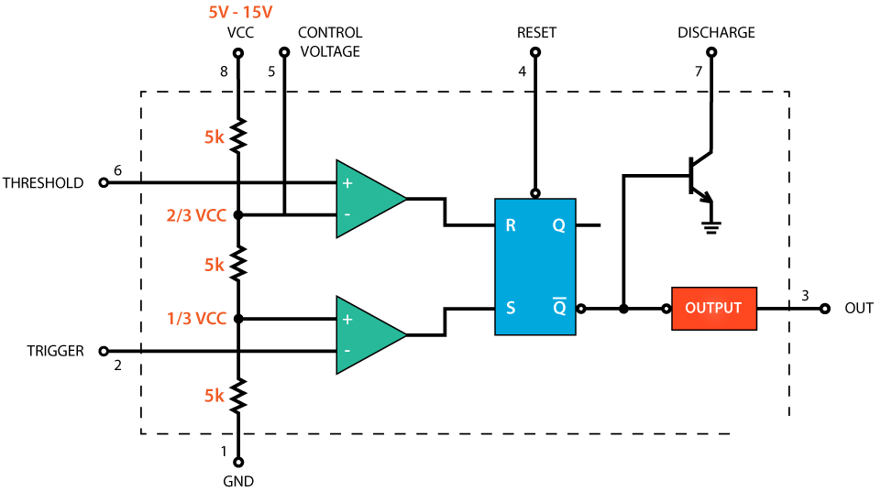

Fig 2. Voltage divider

The first comparator negative input terminal is connected to the 2/3 reference voltage at the voltage divider and the external “control” pin, while the positive input terminal to the external “Threshold” pin. On the other hand, the second comparator negative input terminal is connected to the “Trigger” pin, while the positive input terminal to the 1/3 reference voltage at the voltage divider. So using the three pins, Trigger, Threshold and Control, we can control the output of the two comparators which are then fed to the R and S inputs of the flip-flop. The flip-flop will output 1 when R is 0 and S is 1, and vice versa, it will output 0 when R is 1 and S is 0. Additionally the flip-flop can be reset via the external pin called “Reset” which can override the two inputs, thus reset the entire timer at any time. The Q-bar output of the flip-flip goes to the output stage or the output drivers which can either source or sink a current of 200mA to the load. The output of the flip-flip is also connected to a transistor that connects the “Discharge” pin to ground.

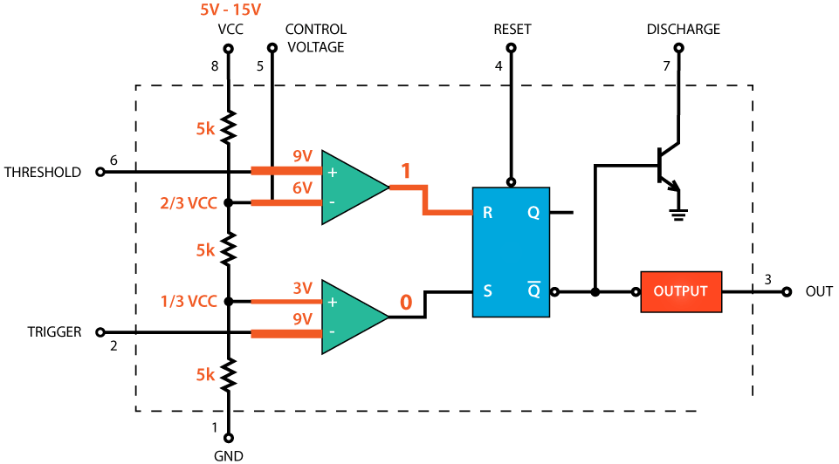

Fig 3. Comparator

Next, let’s see how the 555 Timer works in an astable mode. Fig4, shows this. In this mode the IC becomes an oscillator or also called Free Running Multivibrator. It doesn’t have a stable state and continuously switches between High and Low without application of any external trigger. Here’s an example circuit of the 555 Timer operating in astable mode. We only need two resistors and a capacitor. The Trigger and Threshold pins are connected to each other so there is no need of external trigger pulse. Initially, the voltage source will start charging the capacitor through the Resistors R1 and R2. While charging the Trigger comparator will output 1 because the input voltage at the Trigger pin is still lower than 1/3 of the supplied voltage. That means that the Q-bar output is 0 and the discharge transistor is closed. At this time the output of the 555 Timer is High. Once the voltage across the capacitor reaches 1/3 of the supplied voltage, the Trigger comparator will output 0 but at this point that won’t do any change as both R and S inputs of the flip-flop are 0. So the voltage across the capacitor will keep rising, and once it reaches 2/3 of the supplied voltage, the Threshold comparator will output 1 to the R input of the flip-flop. This will active the discharging transistor and now the capacitor will start discharging through the resistor R2 and the discharging transistor. At this moment the output of the 555 Timer is Low. While discharging, the voltage across the capacitor starts to decline, and the Threshold comparator right away starts to output 0, which actually doesn’t do any change as now both R and S inputs of the flip-flop are 0. But once the voltage across the capacitor drops to 1/3 of the supplied voltage, the Trigger comparator will output 1. This will turn off the discharge transistor and the capacitor will start to charge again. So this processes of charging and discharging between 2/3 and 1/3 of the supplied voltage will keep running on its own, thus producing a square wave on the 555 Timer output. While discharging, the voltage across the capacitor starts to decline, and the Threshold comparator right away starts to output 0, which actually doesn’t do any change as now both R and S inputs of the flip-flop are 0. But once the voltage across the capacitor drops to 1/3 of the supplied voltage, the Trigger comparator will output 1. This will turn off the discharge transistor and the capacitor will start to charge again. So this processes of charging and discharging between 2/3 and 1/3 of the supplied voltage will keep running on its own, thus producing a square wave on the 555 Timer output.

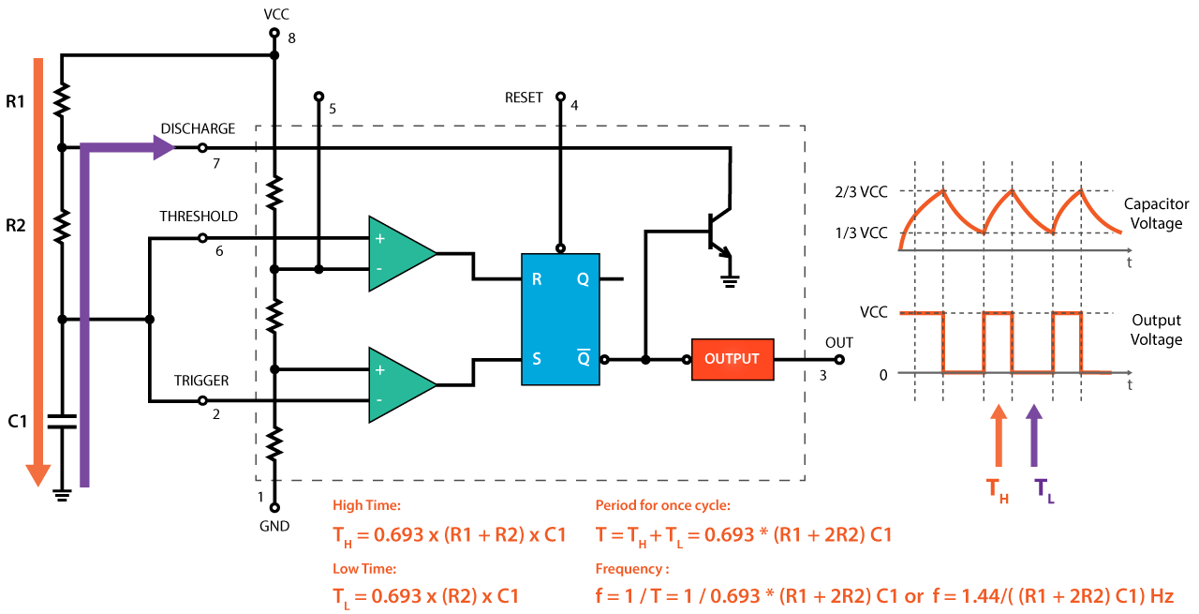

Fig 4. Astable multivibrator

We can calculate the time the output is High and Low using the shown formulas.  The High time depends the on the resistance of both R1 and R2, as well as the capacitance of the capacitor. On the other hand, the Low time depends only on the resistance of R2 and the capacitance of the capacitor. If we sum the High and Low times we will get the Period of one cycle. On the other hand, the frequency is how many times this happens in one second, so one over the Period will give use the frequency of the square wave output. So we can notice that if we change the values of any of these three components we will get different ON and OFF times, or different duty cycle of the square wave output signal. An easy and instant way to do this is to replace the R2 resistor with a potentiometer, and additionally add two diodes in the circuit. Fig 5 shows this configuration. In this configuration the On time will depend on the resistor R1, the left side of the potentiometer and the capacitor C1, while the Off time will depend on the capacitor C1 and the right side of the potentiometer. We can also notice that in this configuration the period of one cycle, thus the frequency, will always be the same, because the total resistance, while charging and discharging, will remain the same. Usually the R1 resistance is much smaller than the resistance of the potentiometer, for example, 1K compared to 100K of the potentiometer. In that way we have 99% control over the charging and discharging resistance in the circuit. The control pin of the 555 Timer is not used but it’s connected to a 100nF capacitor in order to eliminate any external noise from that terminal. The reset, pin number 4, is active low so therefore it is connected to VCC in order to prevent any unwanted reset of the output.The output of the 555 timer can sink or source a current of 200mA to the load. So if the motor that we want to control exceeds this rating we need to use a transistor or a MOSFET for driving the motor. In this example, I used a (TIP122) Darlington transistor which can handle a current up to 5A. The output of the IC needs to be connected to the base of the transistor through a resistor, and in my case I used 1k resistor. For preventing any voltage spikes produced by the motor we need to use a flyback diode which is connected in parallel with the motor.

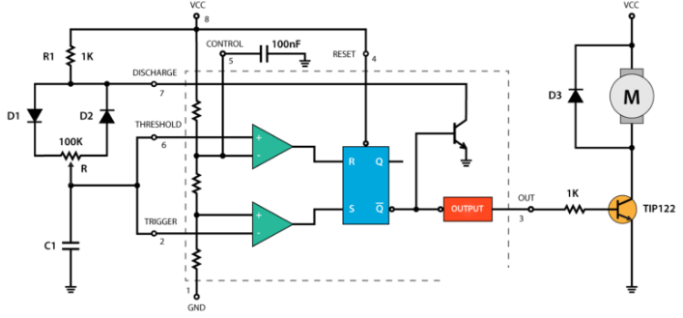

Fig 5: Block diagram of proposed technique

**3.2 Hardware or Software required:**

This section explains the hardware components and also the software required to prepare schematic, PCB layout and Gerber files creation.

### Hardware Components Required

* 555 Timer IC
* 12V DC Motor
* 1N4007 x 3
* 100nF x 2
* 1KΩ Resistor  x 2
* 100KΩ Potentiometer
* TIP122 Darlington transistor
* Mini Breadboard
* 12V Power Supply or battery
* Connecting Wires

Software required:

One can use any electronic design automation (EDA) **software** that can create PCB layout and Gerber files. Few examples are

* EAGLE
* Ki Cad
* Pulsonix
* OrCad

I have used EAGLE software for the entire project. The following chapters explains the procedure to use the software from schematic diagram to Gerber generation.

**4. EXPERIMENTAL INVESTIGATIONS & 5. FLOW CHART**

## This section explains the flow of project. It starts with schematic diagram creation and as follows

## Schematic diagram creation

## ERC check

## PCB design including routing

## Gerber files generation

## Now we can move on and design a custom PCB for this circuit. For that purpose I have used EAGLE software. Here we can start by searching and placing the components on the blank canvas. The library has hundreds of thousands of components so I didn’t have any problem finding all of the required components for this PWM DC Motor Speed Controller circuit. One advantage of this software is, when you choose the component, the corresponding footprint is also visible in a side window. No need to create footprints again. The schematic window is shown in Fig 6.

## Once the schematic is ready, perform electric rule check (ERC) to ensure the circuit is connected properly. Minimize the warnings and completely resolve the errors. Once the schematic is error free, then we can choose switch to board option to create the PCB. It opens another window where we can create PCB along with routing. It is shown in Fig 7.Auto routing option is also available. Using the tracking tool we need to connect all the components. The tracking tool is quite intuitive and easy to work with. We can use both the top and the bottom layer for avoiding crossings and making the tracks shorter. Once it is done, it is the time to create Gerbers. Follow the steps required and create Gerbers, Once it is done, we can able to see multiple files with different extensions I our project directory. These files we can forward to the manufactures to get the PCBs.

## 

## Fig 6.Schematic

## 

## Fig 9. PCB window

## 6. RESULT

## This session shows you the complete schematic and final PCB screen shots.

## C:\Users\Murthy\Desktop\dcmotorspeedcontrolusing555timerfiles (1)\Schematic screenshot.jpeg

## Fig 8. Schematic diagram

## The next diagram is the PCB.I have used double layer for routing to avoid crossings.

## C:\Users\Murthy\Desktop\dcmotorspeedcontrolusing555timerfiles (1)\PCB screenshot.jpeg

## Fig 9. PCB

## 7. ADVANTAGES and DISADVANTAGES

* One of the best things about this circuit is that you can make it work as an astable multivibrator with little hardware and little cost, which can save both the cost involved in making it as well as the space on the printed circuit board (PCB).
* If you want a sophisticated pulse width modulator which works more accurately and which can have more adjusting capabilities, then it is better to use a microcontroller based pulse width modulator than the one which we are using now.
* However, the circuit or the application for which we are using a pulse width modulator is not so sensitive and hence does not demand so much of accuracy. In such a case, the circuit which we are using with a bare IC 555 is better as it saves our monetary as well as space resources in building the circuit.
* The duty cycle of the circuit can be changed by changing the value of the potentiometer. If we increase the duty cycle, the speed of the motor increases and if we decrease the duty cycle, the speed of the motor decreases.

**8. APPLICATIONS**

There are many applications in daily life such as

* Medical applications
* Conveyor belts
* Drilling machines
* Washing machines
* CPU fans
* Robotics
* Mills
* And many more

**9. CONCLUSION**

The dc motor speed is controlled by using power electronic device and the PWM is used which to control the speed of dc motor. The speed pulse train will be based on required input speed. This circuit is useful to operate the dc motors at required speed with very low losses and low cost. The circuit response time is fast. Hence high reliability can be achieved. The designed circuit was tested for various speed inputs satisfactorily. The method already employed in traction system and has a good scope ahead.

**10. FUTURE SCOPE**

* DC motor plays a significant role in modern industries. They are widely used in industry because of its low cost, less complex control structure and wide range of speed and torque so better future of this project.
* In this project we are used pulse width modulation technique, it is a modern technology in solid state field and it provide smooth speed control of motor.
* Now a day PWM technique are using in fuzzy logic control system, so PWM method is very efficient and reliable method to control the speed of motor so it future is also bright in the modern era with fuzzy logic.

## 

## 11. BIBLIOGRAPHY

## <https://www.electronicshub.org/>

## <https://www.circuitstoday.com/>

## <https://howtomechatronics.com/>

## <https://rcciit.org.in/>

## https://www.electronics-lab.com/