***PROJECT TITLE:***

***Baby Monitoring Smart Cradle***

**Introduction:**   
As we are very well familiar with the hurdles faced by Parents to nurture their infant and especially in case if both the Parents are working. To give 24 hours of time in such cases is next to impossible. Thus, we need to develop something unique that can help Parents to have a continuous surveillance/watch on the Baby/Infant and can notify about the same.   
Thus, we have come up with an idea to design a Smart Cradle System using IOT which will help the Parents to monitor their child even if they are away from home & detect every activity of the Baby from any distant corner of the world.

**BABY MONITORING SMART CRADLE – How it is a boon for Parents?**   
It is an innovative, smart & protective Cradle System to nurtue an infant in an efficient way. This system considers all the minute details required for the care & protection of the Baby in the cradle. The design of smartness & innovation comes with the use of technologies/methodologies which include Internet Of Things (IOT) (Modules like Raspberry Pi, Arduino, Humidity & Temperature sensing), Swing Automation, Cry Detecting Mechanism, Live Video Surveillance, Cloud Computing (Data Storage) & User Friendly Android Mobile Application (for User Controls).   
In order to detect each & every activity of Baby, different Sensors/Modules are attached to the Cradle: Temperature Sensing Module for detection of the temperature of the body, A Camera on top of the Cradle for live video footage & Cry Detection Circuit to analyse Cry Patterns which eventually triggers the swinging mechanism (if required based on the range of frequency).   
All the data which is been taken from the sensors/modules will be stored in IBM Cloud & analyzed at regular intervals.

An instant mobile notification will be generated if any abnormal activity is detected (something unusual OR crying of baby OR Baby temperature) in the Android Mobile Application which has been developed. It has UI controls which include the feature of controlling the swinging mechanism of the cradle (can be turned on, turned off & can maintain the speed of swing), control for switching on the camera live footage & controls for playing the toy/projector whenever the baby cries.

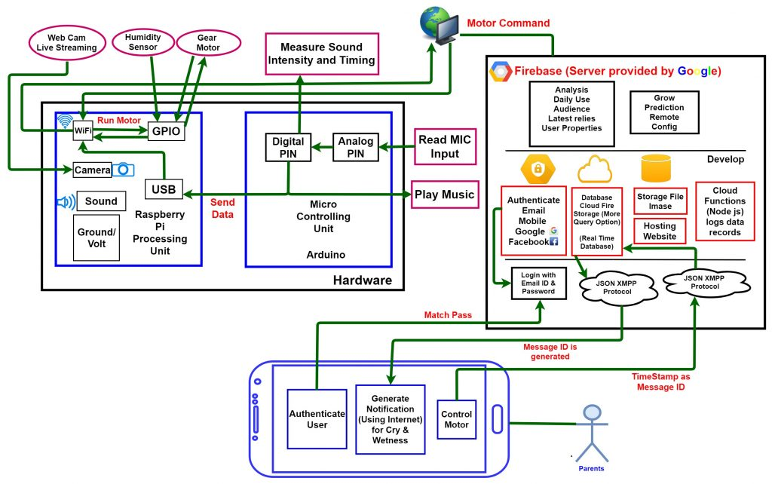

***Since the project is done online , the model is not prepared.***

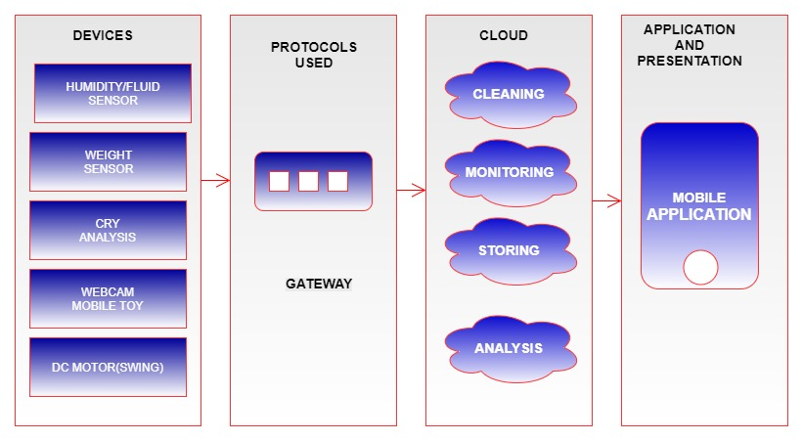

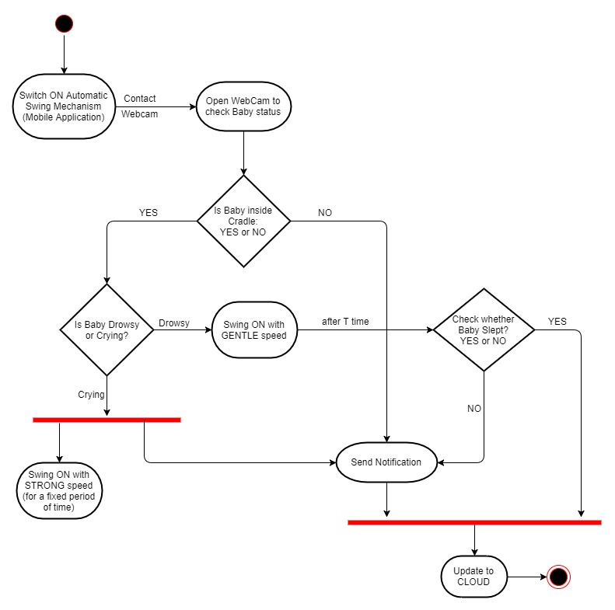

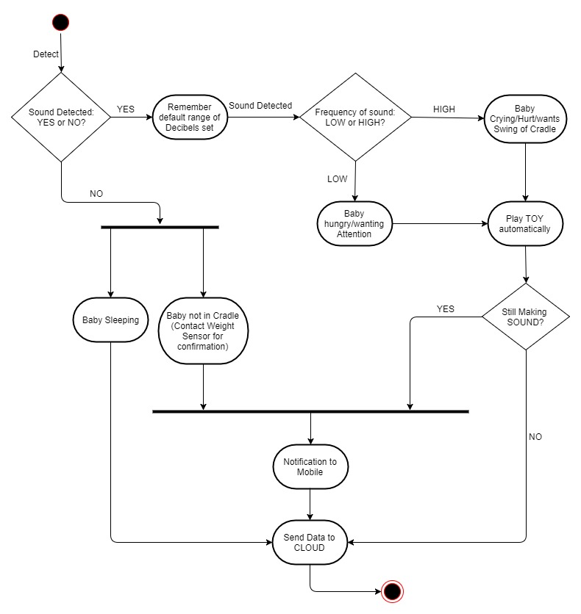

**Tools Used:**

* Software Used:
  1. Advanced IP Scanner
  2. PuTTY
  3. WinSCP
  4. Raspbian OS
  5. Arduino IDE – v 1.8.5
  6. Notepad++ – v 7.5.6
  7. Python IDLE – v 3.4
  8. Android Studio – v 3.0.1
* Hardware Used:
  1. Raspberry Pi 3
  2. Arduino Mega
  3. DHT11 Digital Temperature and Humidity Sensor
  4. Sound Microphone (Input)
  5. USB Camera
  6. NPN Transistors
  7. PN Junction Diodes
  8. IC chip (L293D)
  9. 10k ohm Resistors
  10. LEDs
  11. DC Motor (30 rpm)
  12. Plastic Gear
  13. 9v batteries

***The above tools are used to prepare a model.***

***Now a days some people are being in kitchen and they need to monitor the baby in the bedroom.***

***We have done the project in this mechanism.***

***The temperature of the baby is monitored for every 2 seconds as the babies temperature increases the user will get a notification to his / her mobile phone.***

***If the baby is crying we need to touch the button of crying then automatically it will say us the song is playing and turn on the swing and set the speed of the swing .***

***If the baby stops crying , then we need to press the command as stopped crying.then automatically song stops and it warns us to slowdown the speed of the swing.***

***The following fig is the node-red flow of the project.***

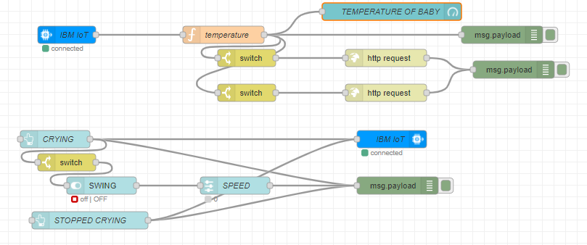

***The Following image of dashboard of web application.***

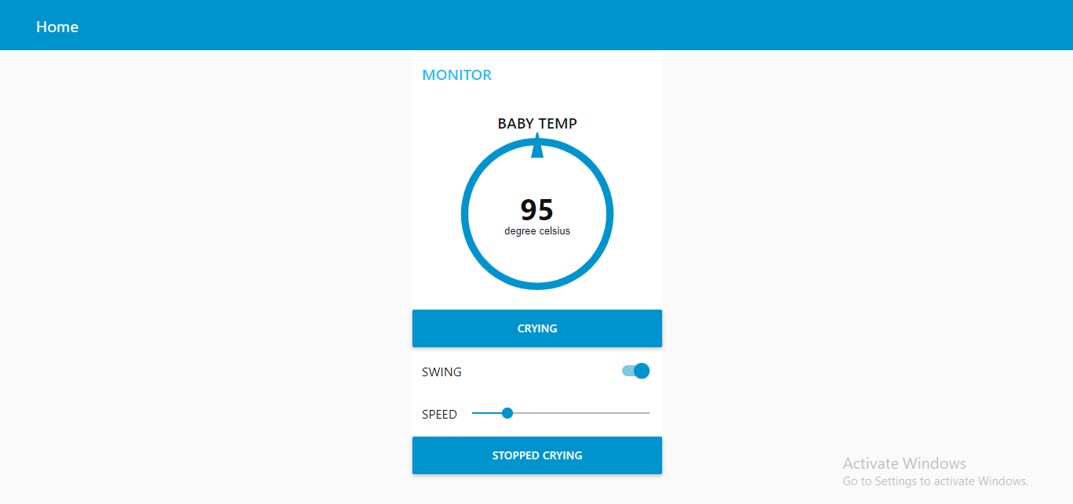

***Here, we set the temperature using python code.***

***Since we don’t have anysensors right now, we are doing it using the python code.***

***As the temperature crosses the limit of body temperature the enduser will get a text notification as the baby is suffering from fever as shown below.***

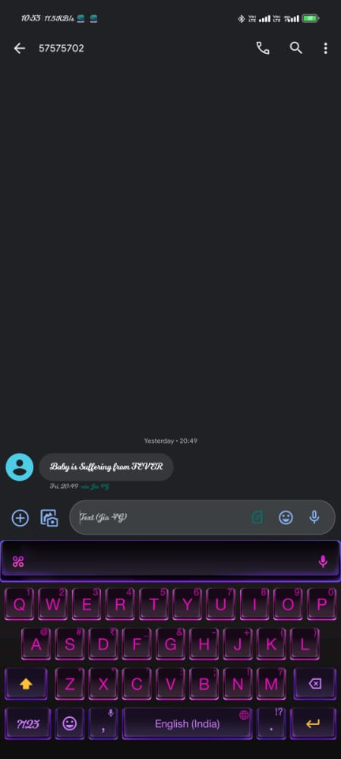

***\*\*\* THANK YOU \*\*\****