**Horticulture**

**Introduction**

**About Project:**

The project is about to build story telling visualization on the concept **HORTICULTURE**. Horticulture is the art of cultivating plants in gardens to produce food and medicinal ingredients, or for comfort and ornamental purposes. Horticulturists grow flowers, fruits and nuts, vegetables and herbs, as well as ornamental trees and lawns.

**Purpose:**

According to the statistics, India is the second-largest country in the production of fruits and vegetables after China. In India, the majority of the population depends upon agriculture for their livelihood and it’s around 55-60 percent of people who depend completely on agriculture to sustain their life. Horticultural crops constitute a significant portion of the total agricultural produce in India. They cover a wide cultivation area and contribute around 28 percent of gross domestic product.

Visualization is one of the best tools in order to represent this information in a more meaningful and understandable manner.

**Literature Survey**

**Existing Problem:**

Farmers are facing trouble for cultivating the crops due to unaware of the demand of crops in society. They didn't know which crop has higher demand and which is not. For example onions have higher demand in the market when compared to turmeric, but farmers will spend their money more on turmeric then it leads to loss.

**Proposed Solution:**

In order to help the farmers to take decisions over which crop is necessary to cultivate more in the current situation and which is not, we have to represent the information about demand on crops visually.

**Experimental Analysis**

The higher rate of returns from horticulture is also backed by favourable demand and supply factors. For example -

* **Changes in taste and preferences** **-** Due to changes in taste, preferences and food habits, the consumption pattern in India has been shifting towards fruits and vegetables.
* **Increasing incomes -** 1 per cent increase in per capita expenditure results in 1.9% and 1.02% increase in demand for fruits and vegetables respectively. Thus, per capita intake of fruits and vegetables in the country will keep rising in coming years.
* **Increasing imports -** There is large deficiency of these items in Indian diet. India’s import of fruits is rising by 20 per cent per year. All these indicators suggest that demand side prospects for fruits and vegetables are very bright.
* **Technological developments -** Horticultural crops have facilitated some diversification. Varieties of horticultural crops have been developed for cultivation in off season, under diverse climatic conditions and with various attributes to attract consumers.

**Flowchart**

Start

Analyzing Datasets

Collect the Information from the datasets

Visualize the data using tableau software

Build the Dashboards and Stories

End

**Result**

* Fruits and vegetables give 4-10 times the return from other crop groups namely Medicinal and Aromatic crops, Ornamental crops, Plantation and Spices.
* 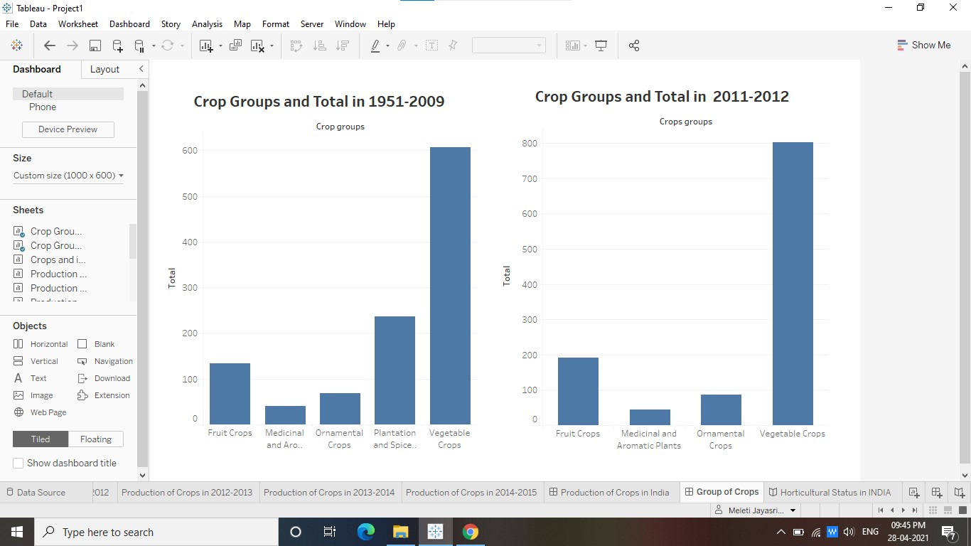A one per cent shift in area from non-horticultural crops to horticultural crops adds 0.46 percentage points to growth rate of agriculture sector.

**Advantages**

* This visual information help us to know about the production of crops in all over INDIA.
* This helps the farmers to make decisions.

**Disadvantages**

* Building the understandable information visually it takes lots of time and mental efforts.
* Without using correct format it may leads to loss of information.

**Applications**

**Horticulture** crops perform a vital role in the **Indian** economy by

* generating employment,
* providing raw material to various food processing industries,
* higher farm profitability due to higher production
* export earnings from foreign exchange.

**Conclusion**

As we conclude that Horticultural crops, particularly vegetables, are more popular with smaller size land holdings as they have advantage in terms of family labour required for labour intensive production. However, such farmers are severally constrained by scale factor in marketing of produce.