# Apex Specialist Superbadge

## Challenge 1:

This the ﬁrst challenge where we attend a quiz answering some general questions regarding the superbadge challenge that we are doing.

## Challenge 2:

It is all about preparing my organization with the necessary pakage installations and customizations as per given in the Prepare Your Oraganization section to complete the Apex Specialist Superbadge.

## Challenge 3:

### In this challenge we automate record creation using apex class and apex trigger by creating a apex class called MaintainanceRequestHelper and a apex trigger called MaintenanceRequest.

Apex Class code:

public with sharing class MaintenanceRequestHelper { public static void updateWorkOrders(List<Case> caseList) { List<case> newCases = new List<Case>(); Map<String,Integer> result=getDueDate(caseList);

for(Case c : caseList){ if(c.status=='closed')

if(c.type=='Repair' || c.type=='Routine Maintenance'){ Case newCase = new Case(); newCase.Status='New';

newCase.Origin='web'; newCase.Type='Routine Maintenance';

newCase.Subject='Routine Maintenance of Vehicle'; newCase.Vehicle c=c.Vehicle c; newCase.Equipment c=c.Equipment c; newCase.Date_Reported c=Date.today(); if(result.get(c.Id)!=null)

newCase.Date_Due c=Date.today()+result.get(c.Id); else

newCase.Date_Due c=Date.today(); newCases.add(newCase);

}

}

insert newCases;

}

/

public static Map<String,Integer> getDueDate(List<case> CaseIDs){ Map<String,Integer> result = new Map<String,Integer>();

Map<Id, case> caseKeys = new Map<Id, case> (CaseIDs); List<AggregateResult> wpc=[select Maintenance_Request r.ID cID,min(Equipment r.Maintenance_Cycle c)cycle

from Work_Part c where Maintenance_Request r.ID in :caseKeys.keySet() group by Maintenance_Request r.ID ];

for(AggregateResult res :wpc){ Integer addDays=0; if(res.get('cycle')!=null)

addDays+=Integer.valueOf(res.get('cycle')); result.put((String)res.get('cID'),addDays);

}

return result;

}

}

### Apex Trigger code:

trigger MaintenanceRequest on Case (before update, after update) {

/ ToDo: Call MaintenanceRequestHelper.updateWorkOrders if(Trigger.isAfter) MaintenanceRequestHelper.updateWorkOrders(Trigger.New);

}

## Challenge 4:

In challenge 3 we synchronize salesforce data with an external system using apex class of name WarehouseCalloutService which is already given and after writing code in it and executing it anonymously in a separate window, the process will be successful.

### Apex class code:

public with sharing class WarehouseCalloutService {

private static ﬁnal String WAREHOUSE_URL = 'https:/ th-superbadge- apex.herokuapp.com/equipment';

@future(callout=true)

public static void runWarehouseEquipmentSync() {

/ ToDo: complete this method to make the callout (using @future) to the

/ REST endpoint and update equipment on hand. HttpResponse response = getResponse(); if(response.getStatusCode() == 200)

{

List<Product2> results = getProductList(response); / get list of products from Http callout response

if(results.size() >0)

upsert results Warehouse_SKU c; / Upsert the products in your org based on the external ID SKU

}

}

/ Get the product list from the external link

public static List<Product2> getProductList(HttpResponse response)

{

List<Object> externalProducts = (List<Object>) JSON.deserializeUntyped(response.getBody());

/ desrialize the json response

List<Product2> newProducts = new List<Product2>(); for(Object p : externalProducts)

{

Map<String, Object> productMap = (Map<String, Object>) p; Product2 pr = new Product2();

/ Map the ﬁelds in the response to the appropriate ﬁelds in the Equipment object pr.Replacement_Part c = (Boolean)productMap.get('replacement');

pr.Cost c = (Integer)productMap.get('cost'); pr.Current_Inventory c = (Integer)productMap.get('quantity'); pr.Lifespan_Months c = (Integer)productMap.get('lifespan') ;

pr.Maintenance_Cycle c = (Integer)productMap.get('maintenanceperiod'); pr.Warehouse_SKU c = (String)productMap.get('sku');

pr.ProductCode = (String)productMap.get('_id'); pr.Name = (String)productMap.get('name'); newProducts.add(pr);

}

return newProducts;

}

/ Send Http GET request and receive Http response public static HttpResponse getResponse() {

Http http = new Http();

HttpRequest request = new HttpRequest(); request.setEndpoint(WAREHOUSE_URL); request.setMethod('GET');

HttpResponse response = http.send(request);

return response;

}

}

### Execute anonymous window:

WarehouseCalloutService.runWarehouseEquipmentSync();

## Challenge 5:

In challenge 4 we will be scheduling our synchronization using WarehouseSyncSchedule in th apex class and execute a code in an anonymous window.

### Apex Class code:

global class WarehouseSyncSchedule implements Schedulable{

/ implement scheduled code here

global void execute (SchedulableContext sc){ WarehouseCalloutService.runWarehouseEquipmentSync();

/ optional this can be done by debug mode String sch = '00 00 01 * * ?';/ on 1 pm

System.schedule('WarehouseSyncScheduleTest', sch, new WarehouseSyncSchedule());

}

}

### Execute anonymous window:

WarehouseSyncSchedule scheduleInventoryCheck();

## Challenge 6:

In this challenge we are testing our automation logic using apex trigger class MaintenanceRequest and three apex classes where two are used for testing and one is used for sharing and those classes are given below.

### Apex trigger:

trigger MaintenanceRequest on Case (before update, after update) { if(Trigger.isUpdate && Trigger.isAfter) MaintenanceRequestHelper.updateWorkOrders(Trigger.New);

}

### Apex class:

@IsTest

private class InstallationTests {

private static ﬁnal String STRING_TEST = 'TEST';

private static ﬁnal String NEW_STATUS = 'New'; private static ﬁnal String WORKING = 'Working'; private static ﬁnal String CLOSED = 'Closed'; private static ﬁnal String REPAIR = 'Repair';

private static ﬁnal String REQUEST_ORIGIN = 'Web';

private static ﬁnal String REQUEST_TYPE = 'Routine Maintenance'; private static ﬁnal String REQUEST_SUBJECT = 'AMC Spirit'; public static String CRON_EXP = '0 0 1 * * ?';

static testmethod void testMaintenanceRequestNegative() { Vehicle c vehicle = createVehicle();

insert vehicle;

Id vehicleId = vehicle.Id;

Product2 equipment = createEquipment(); insert equipment;

Id equipmentId = equipment.Id;

Case r = createMaintenanceRequest(vehicleId, equipmentId); insert r;

Work_Part c w = createWorkPart(equipmentId, r.Id); insert w;

Test.startTest(); r.Status = WORKING; update r; Test.stopTest();

List<case> allRequest = [SELECT Id FROM Case];

Work_Part c workPart = [SELECT Id FROM Work_Part c

WHERE Maintenance_Request c =: r.Id]; System.assert(workPart != null); System.assert(allRequest.size() == 1);

}

static testmethod void testWarehouseSync() { Test.setMock(HttpCalloutMock.class, new WarehouseCalloutServiceMock()); Test.startTest();

String jobId = System.schedule('WarehouseSyncSchedule', CRON_EXP,

new WarehouseSyncSchedule());

CronTrigger ct = [SELECT Id, CronExpression, TimesTriggered, NextFireTime FROM CronTrigger

WHERE id = :jobId];

System.assertEquals(CRON_EXP, ct.CronExpression);

System.assertEquals(0, ct.TimesTriggered); Test.stopTest();

}

private static Vehicle c createVehicle() {

Vehicle c v = new Vehicle c(Name = STRING_TEST); return v;

}

private static Product2 createEquipment() { Product2 p = new Product2(Name = STRING_TEST, Lifespan_Months c = 10,

Maintenance_Cycle c = 10, Replacement_Part c = true); return p;

}

private static Case createMaintenanceRequest(Id vehicleId, Id equipmentId) { Case c = new Case(Type = REPAIR,

Status = NEW_STATUS, Origin = REQUEST_ORIGIN,

Subject = REQUEST_SUBJECT,

Equipment c = equipmentId, Vehicle c = vehicleId); return c;

}

private static Work_Part c createWorkPart(Id equipmentId, Id requestId) { Work_Part c wp = new Work_Part c(Equipment c = equipmentId, Maintenance_Request c = requestId);

return wp;

}

}

### Apex class:

public with sharing class MaintenanceRequestHelper { public static void updateWorkOrders(List<case> caseList) { List<case> newCases = new List<case>(); Map<String,Integer> result=getDueDate(caseList); for(Case c : caseList){

if(c.status=='closed')

if(c.type=='Repair' || c.type=='Routine Maintenance'){ Case newCase = new Case(); newCase.Status='New';

newCase.Origin='web';

newCase.Type='Routine Maintenance'; newCase.Subject='Routine Maintenance of Vehicle'; newCase.Vehicle c=c.Vehicle c; newCase.Equipment c=c.Equipment c; newCase.Date_Reported c=Date.today(); if(result.get(c.Id)!=null)

newCase.Date_Due c=Date.today()+result.get(c.Id); else

newCase.Date_Due c=Date.today(); newCases.add(newCase);

}

}

insert newCases;

}

/

public static Map<String,Integer> getDueDate(List<case> CaseIDs){ Map<String,Integer> result = new Map<String,Integer>();

Map<Id, case> caseKeys = new Map<Id, case> (CaseIDs); List<aggregateresult> wpc=[select Maintenance_Request r.ID cID,min(Equipment r.Maintenance_Cycle c)cycle

from Work_Part c where Maintenance_Request r.ID in :caseKeys.keySet() group by Maintenance_Request r.ID ];

for(AggregateResult res :wpc){ Integer addDays=0; if(res.get('cycle')!=null)

addDays+=Integer.valueOf(res.get('cycle')); result.put((String)res.get('cID'),addDays);

}

return result;

}

}

### Apex class:

@isTest

public class MaintenanceRequestTest {

static List<case> caseList1 = new List<case>();

static List<product2> prodList = new List<product2>();

static List<work_part c> wpList = new List<work_part c>(); @testSetup

static void getData(){

caseList1= CreateData( 300,3,3,'Repair');

}

public static List<case> CreateData( Integer numOfcase, Integer numofProd, Integer numofVehicle,

String type){

List<case> caseList = new List<case>();

/ Create Vehicle

Vehicle c vc = new Vehicle c(); vc.name='Test Vehicle';

upsert vc;

/ Create Equiment

for(Integer i=0;i<numofProd;i++){ Product2 prod = new Product2(); prod.Name='Test Product'+i; if(i!=0)

prod.Maintenance_Cycle c=i; prod.Replacement_Part c=true; prodList.add(prod);

}

upsert prodlist;

/ Create Case

for(Integer i=0;i< numOfcase;i++){ Case newCase = new Case(); newCase.Status='New'; newCase.Origin='web';

if( math.mod(i, 2) ==0) newCase.Type='Routine Maintenance'; else

newCase.Type='Repair';

newCase.Subject='Routine Maintenance of Vehicle' +i; newCase.Vehicle c=vc.Id;

if(i<numofProd)

newCase.Equipment c=prodList.get(i).ID; else

newCase.Equipment c=prodList.get(0).ID; caseList.add(newCase);

}

upsert caseList;

for(Integer i=0;i<numofProd;i++){ Work_Part c wp = new Work_Part c(); wp.Equipment c =prodlist.get(i).Id ;

wp.Maintenance_Request c=caseList.get(i).id;

wplist.add(wp) ;

}

upsert wplist; return caseList;

}

public static testmethod void testMaintenanceHelper(){ Test.startTest();

getData();

for(Case cas: caseList1) cas.Status ='Closed'; update caseList1; Test.stopTest();

}

}

## Challenge 7:

In challenge 6 we are testing our callout logic by using two apex classes which are used for testing where one of the classes implements HTTPCalloutMock.

### Apex class:

@IsTest

private class WarehouseCalloutServiceTest {

/ implement your mock callout test here @isTest

static void testWareHouseCallout(){

Test.setMock(HttpCalloutMock.class, new WarehouseCalloutServiceMock()); WarehouseCalloutService.runWarehouseEquipmentSync();

}

}

### Apex class:

@isTest

public class WarehouseCalloutServiceMock implements HTTPCalloutMock {

/ implement http mock callout

public HTTPResponse respond (HttpRequest request){ HttpResponse response = new HTTPResponse(); response.setHeader('Content-type','application/json');

response.setBody('[{"_id":"55d66226726b611100aaf741","replacement":false,"quantity":5,"name": "Generator 1000 kW","maintenanceperiod":365,"lifespan":120,"cost":5000,"sku":"100003"},{"_id":"55d66226726b611

100aaf742","replacement":true,"quantity":183,"name":"Cooling Fan","maintenanceperiod":0,"lifespan":0,"cost":300,"sku":"100004"},{"_id":"55d66226726b611100a af743","replacement":true,"quantity":143,"name":"Fuse 20A","maintenanceperiod":0,"lifespan":0,"cost":22,"sku":"100005"}]'); response.setStatusCode(200);

return response;

}

}

## Challenge 8:

In this challenge we are testing our Scheduling logic by using a apex test class to test our scheduling logic and the code is given below.

### Apex class:

@isTest

private class WarehouseSyncScheduleTest {

public static String CRON_EXP = '0 0 0 15 3 ? 2022'; static testmethod void testjob(){ MaintenanceRequestTest.CreateData( 5,2,2,'Repair'); Test.startTest();

Test.setMock(HttpCalloutMock.class, new WarehouseCalloutServiceMock());

String joBID= System.schedule('TestScheduleJob', CRON_EXP, new WarehouseSyncSchedule());

/ List<Case> caselist = [Select count(id) from case where case] Test.stopTest();

}

}

with this the Apex Specialist Superbadge is completed succesfully.

**Process Automation Specialist Superbadge**

## Challenge 1:

It is the same as the previous superbadge challenge 1 where we answer a quiz before moving into the actual Superbadge challenges.

## Challenge 2:

This challenge is all about automating leads where we create a Validation rule under leads and you can give any Rule Name and the Error condition fomula will be given below for validating leads.After this we have to create two Queues with the given name as per in the instruction of the challenge and then create a assignment rule.If all these things are done properly, the challenge will be completed without any problems.

### Error Condition Formula:

OR(AND(LEN(State) > 2, NOT(CONTAINS("AL:AK:AZ:AR:CA:CO:CT:DE:DC:FL:GA:HI:ID:IL:IN:IA:KS:KY:LA:ME:MD:MA:MI:M

N:MS:MO:MT:NE:NV:NH:NJ:NM:NY:NC:ND:OH:OK:OR:PA:RI:SC:SD:TN:TX:UT:VT:VA:WA:WV:WI:

WY", State )) ), NOT(OR(Country ="US",Country ="USA",Country ="United States", ISBLANK(Country))))

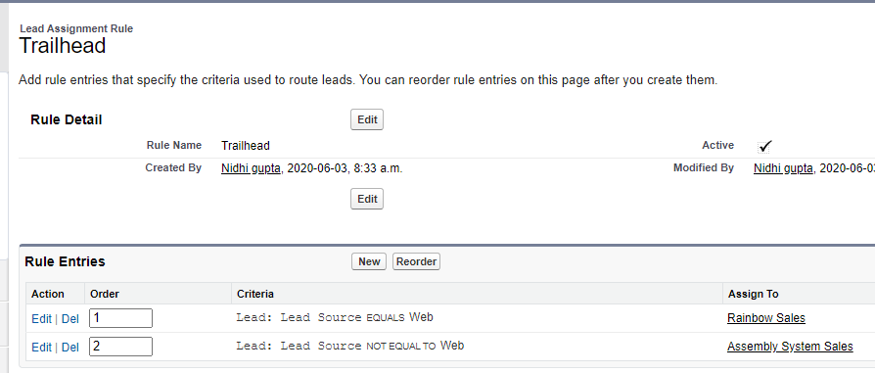

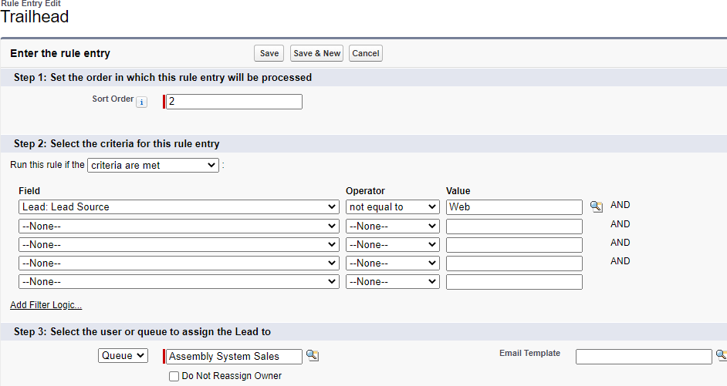

## Challenge 3:

In this challenge we are given the task of automating accounts by creating Roll Up Summmary ﬁleds as it is given in the instructions and after that by creating two Error Condition Formulas we automate our accounts and the code will be given below for these two formulas

### Error Condition Formula 1:

OR(AND(LEN(BillingState) > 2, NOT(CONTAINS("AL:AK:AZ:AR:CA:CO:CT:DE:DC:FL:GA:HI:ID:IL:IN:IA:KS:KY:LA:ME:MD:MA:MI:M

N:MS:MO:MT:NE:NV:NH:NJ:NM:NY:NC:ND:OH:OK:OR:PA:RI:SC:SD:TN:TX:UT:VT:VA:WA:WV:WI:

WY", BillingState ))

),AND(LEN(ShippingState) > 2, NOT(CONTAINS("AL:AK:AZ:AR:CA:CO:CT:DE:DC:FL:GA:HI:ID:IL:IN:IA:KS:KY:LA:ME:MD:MA:MI:M

N:MS:MO:MT:NE:NV:NH:NJ:NM:NY:NC:ND:OH:OK:OR:PA:RI:SC:SD:TN:TX:UT:VT:VA:WA:WV:WI:

WY", ShippingState))

),NOT(OR(BillingCountry ="US",BillingCountry ="USA",BillingCountry ="United States", ISBLANK(BillingCountry))),

NOT(OR(ShippingCountry ="US",ShippingCountry ="USA",ShippingCountry ="United States", ISBLANK(ShippingCountry))))

### Error Condition Formula 2:

ISCHANGED( Name ) && ( OR( ISPICKVAL( Type ,'Customer - Direct') ,ISPICKVAL( Type

,'Customer - Channel') ))

## Challenge 4:

It is the easiest challenge in this superbadge where we dont have to do a lot of things, we only have to create Robot Setup object with a master-detail relationship with the opportunity and the create a few ﬁelds as per given in the challenge instructions.

## Challenge 5:

In this challenge we are creating a Sales Process and Validating its opportuities, First we have to create a ﬁeld with checkbox type with the name Approval where it can only be viewed by System Administrators and Sales Managers.Then we have add a picklist value as Awating Approval to the ﬁled Stage.Lastly we have to add the desired ﬁelds and then add a Validation rule in the Opportunity object.

### Validation Rule:

IF(( Amount > 100000 && Approved c <> True && ISPICKVAL( StageName,'Closed Won')

),True,False)

## Challenge 6:

In this challenge we are Automating Opportunities, First we have to create three Email Templates upon reading instructions and create a approval process by selecting opportunity object in the approval process with the necessary ﬁeld updates in the process and set a criteria where this process will only run if the criteria is met.

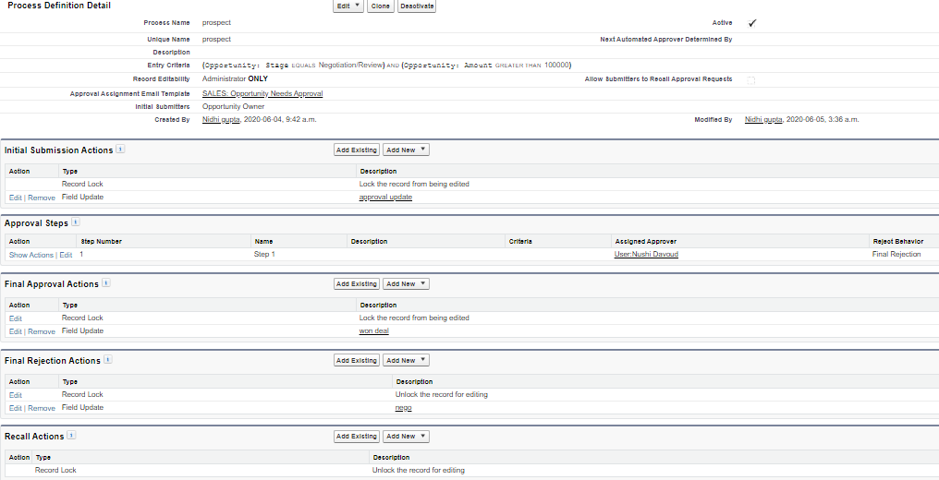Then go to the process builder and start building a process by selecting a object ﬁrst and by setting four criterias where each criteria will do a action upon meeting the criterias.

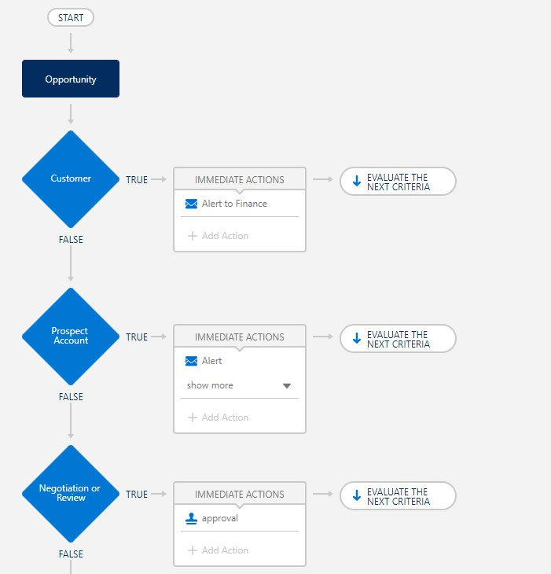

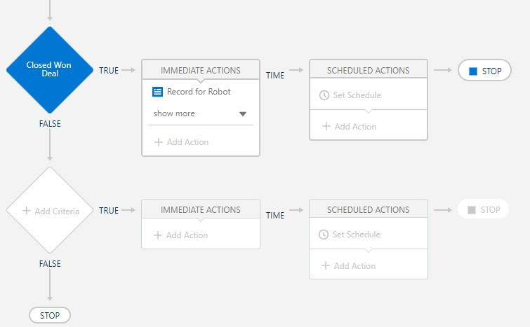

## Challenge 7:

In this challenge we are creating Flow for Opportunities, First with a Start element then Screen element where it then gets Records and there's a loop to get each record and after that the process ends with a screen element where it shows the products.The products are created as per given in the challenge instructions to successfully complete the challenge.

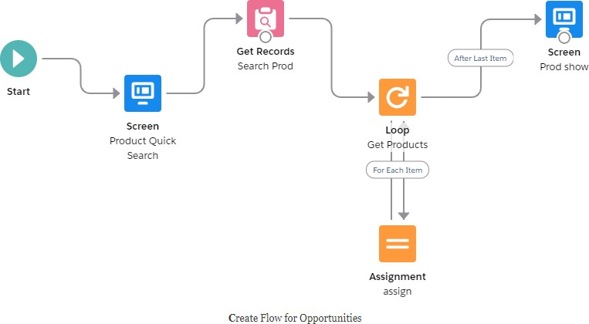

## Challenge 8:

It is the last challenge of the superbadge where we Automate Setups, First we have to change the formula in one of the ﬁelds of the Robot object where the Formula will be given below and then we have go to the ﬂows process that we created previously and clone it to make changes where we change the formula for the last criteria to Automate setups according to dates.

### Formula 1:

Case ( WEEKDAY( Date c ), 1,"Sunday",

2,"Monday",

3,"Tuesday", 4,"Wednesday", 5,"Thursday",

6,"Friday",

7,"Saturday", Text(WEEKDay(Date c)))

### Formula 2:

CASE(MOD([Opportunity].CloseDate + 180 - DATE(1900, 1, 7),7), 0, [Opportunity].CloseDate +

181, 6, [Opportunity].CloseDate + 182, [Opportunity].CloseDate + 180)

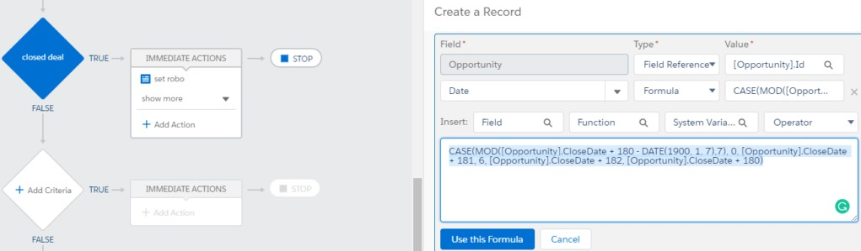

And with this you will have successfully completed this Superbadge.

# Apex Triggers

## Get Started with Apex Triggers:

### Apex trigger:

trigger AccountAddressTrigger on Account (before insert,before update) {

List<Account> acclst=new List<Account>(); for(account a:trigger.new){

if(a.Match_Billing_Address c==true && a.BillingPostalCode!=null){ a.ShippingPostalCode=a.BillingPostalCode;

}

}

}

## Bulk Apex Triggers:

### Apex Trigger:

trigger ClosedOpportunityTrigger on Opportunity (after insert, after update) {

List <Task> tasks = new List<Task>();

for(Opportunity opp : [SELECT Id, StageName FROM Opportunity WHERE StageName='Closed Won'

AND Id IN :Trigger.new]){

tasks.add(new Task(Subject = 'Follow Up Test Task' , WhatId = opp.Id));

}

if(tasks.size() > 0){ insert tasks;

}

}

# Apex Testing

## Get Started with Apex Unit Tests:

### Apex class:

@isTest

private class TestVerifyDate {

@isTest static void testWithin30Days() {

Date Datetest = VerifyDate.CheckDates(System.today(), System.today()+10); System.assertEquals(System.today()+10, Datetest);

}

@isTest static void testSetEndOfMonth() {

Date Datetest = VerifyDate.CheckDates(System.today(), System.today()+52); System.assertEquals(System.today()+27, Datetest); <!--27days until last day of Current

Month-->

}

}

## Test Apex Triggers:

### Apex Class:

@isTest

private class TestRestrictContactByName { static testMethod void metodoTest()

{

List<Contact> listContact= new List<Contact>();

Contact c1 = new Contact(FirstName='Francesco', LastName='Riggio' , email='Test@test.com');

Contact c2 = new Contact(FirstName='Francesco1', LastName = 'INVALIDNAME',email='Test@test.com');

listContact.add(c1); listContact.add(c2);

Test.startTest(); try

{

insert listContact;

}

catch(Exception ee)

{

}

Test.stopTest();

}

}

## Create Test Data for Apex Tests:

### Apex Class:

public with sharing class RandomContactFactory

{

public static List<Contact> generateRandomContacts( Integer noOfContacts, String lastName )

{

List<Contact> contacts = new List<Contact>();

for( Integer i = 0; i < noOfContacts; i++ )

{

Contact con = new Contact( FirstName = 'Test '+i, LastName = lastName

);

contacts.add( con );

}

return contacts;

}

}

# Asynchronous Apex

## Use Future Methods:

### Apex class:

public class AccountProcessor{ @future

public static void countContacts(List<Id> accountIds){ List<Account> vAccountList = new List<Account>(); List<Account> acc = [SELECT Id,Name,

(SELECT Id,Name FROM Contacts)

FROM Account WHERE Id IN :accountIds]; System.debug('total contact in Account: ' + acc);

if(acc.size() > 0){ for(Account a: acc){

List<Contact> con = [SELECT Id,Name FROM Contact WHERE accountId = :a.Id]; a.Number_of_Contacts c = con.size();

vAccountList.add(a);

}

if(vAccountList.size()>0)

{

update vAccountList;

}

}

}

}

Test Class:

==================

@isTest

public class AccountProcessorTest {

@isTest public static void testNoOfContacts(){ Account a = new Account(Name = 'Acme1'); Insert a;

Account b = new Account(Name = 'Acme2'); insert b;

Contact c = new Contact(FirstName = 'Gk', LastName = 'Gupta', accountId = a.Id); insert c;

Contact c1 = new Contact(FirstName = 'Gk1', LastName = 'Gupta1', accountId = b.Id); insert c1;

List<account> acnt = [SELECT Id FROM Account WHERE Name = :a.Name OR Name =

:b.Name];

System.debug('size of acnt: ' + acnt); List<ID> acntIDLST = new List<Id>(); for(Account ac: acnt){

acntIDLST.add(ac.Id);

}

Test.startTest(); AccountProcessor.countContacts(acntIDLST); Test.stopTest();

}

}

## Use Batch Apex:

### Apex Class:

global class LeadProcessor implements Database.Batchable<Sobject>

{

global Database.QueryLocator start(Database.BatchableContext bc)

{

return Database.getQueryLocator([Select LeadSource From Lead ]);

}

global void execute(Database.BatchableContext bc, List<Lead> scope)

{

for (Lead Leads : scope)

{

Leads.LeadSource = 'Dreamforce';

}

update scope;

}

global void ﬁnish(Database.BatchableContext bc){ }

}

@isTest

public class LeadProcessorTest

{

static testMethod void testMethod1()

{

List<Lead> lstLead = new List<Lead>(); for(Integer i=0 ;i <200;i++)

{

Lead led = new Lead(); led.FirstName ='FirstName'; led.LastName ='LastName'+i; led.Company ='demo'+i; lstLead.add(led);

}

insert lstLead; Test.startTest();

LeadProcessor obj = new LeadProcessor(); DataBase.executeBatch(obj);

Test.stopTest();

}

}

## Control Processes with Queueable Apex:

### Apex Class:

public class AddPrimaryContact implements Queueable

{

private Contact c; private String state;

public AddPrimaryContact(Contact c, String state)

{

this.c = c; this.state = state;

}

public void execute(QueueableContext context)

{

List<Account> ListAccount = [SELECT ID, Name ,(Select id,FirstName,LastName from contacts ) FROM ACCOUNT WHERE BillingState = :state LIMIT 200];

List<Contact> lstContact = new List<Contact>(); for (Account acc:ListAccount)

{

Contact cont = c.clone(false,false,false,false); cont.AccountId = acc.id;

lstContact.add( cont );

}

if(lstContact.size() >0 )

{

insert lstContact;

}

}

}

@isTest

public class AddPrimaryContactTest

{

@isTest static void TestList()

{

List<Account> Teste = new List <Account>(); for(Integer i=0;i<50;i++)

{

Teste.add(new Account(BillingState = 'CA', name = 'Test'+i));

}

for(Integer j=0;j<50;j++)

{

Teste.add(new Account(BillingState = 'NY', name = 'Test'+j));

}

insert Teste;

Contact co = new Contact(); co.FirstName='demo'; co.LastName ='demo'; insert co;

String state = 'CA';

AddPrimaryContact apc = new AddPrimaryContact(co, state); Test.startTest();

System.enqueueJob(apc); Test.stopTest();

}

}

## Schedule Jobs Using the Apex Scheduler:

### Apex Class:

global class DailyLeadProcessor implements Schedulable { global void execute(SchedulableContext ctx) {

List<Lead> lList = [Select Id, LeadSource from Lead where LeadSource = null];

if(!lList.isEmpty()) {

for(Lead l: lList) {

l.LeadSource = 'Dreamforce';

}

update lList;

}

}

}

@isTest

public class DailyLeadProcessorTest {

public static String CRON_EXP = '0 0 0 15 3 ? 2022'; static testMethod void testDailyLeadProcessorTest() {

List<Lead> listLead = new List<Lead>(); for (Integer i=0; i<200; i++) {

Lead ll = new Lead(); ll.LastName = 'Test' + i; ll.Company = 'Company' + i;

ll.Status = 'Open - Not Contacted'; listLead.add(ll);

}

insert listLead;

Test.startTest();

DailyLeadProcessor daily = new DailyLeadProcessor();

String jobId = System.schedule('Update LeadSource to Dreamforce', CRON_EXP, daily);

List<Lead> liss = new List<Lead>([SELECT Id, LeadSource FROM Lead WHERE LeadSource != 'Dreamforce']);

Test.stopTest();

}

}

# Apex Integration Services

## Apex Rest Callouts:

### Apex Class:

public class AnimalLocator {

public static String getAnimalNameById(Integer id) { Http http = new Http();

HttpRequest request = new HttpRequest();

request.setEndpoint('https:/ th-apex-http-callout.herokuapp.com/animals/'+id); request.setMethod('GET');

HttpResponse response = http.send(request);

/*Map<String,Object> results = (Map<String,Object>)JSON.deserializeUntyped(response.getBody());

system.debug(' >results'+results);

List<Object> animals = (List<Object>) results.get('animal'); system.debug(' >animal'+animals);*/

Map<Integer,String> mapAnimal = new Map<Integer,String>();

Integer varId; String varName;

JSONParser parser1= JSON.createParser(response.getBody()); while (parser1.nextToken() != null) {

if ((parser1.getCurrentToken() == JSONToken.FIELD_NAME) && (parser1.getText() ==

'id')) {

}

/ Get the value. parser1.nextToken();

/ Fetch the ids for all animals in JSON Response. varId=parser1.getIntegerValue();

System.debug(' >varId-->'+varID);

parser1.nextToken();

if ((parser1.getCurrentToken() == JSONToken.FIELD_NAME) && (parser1.getText() == 'name')) {

parser1.nextToken();

/ Fetch the names for all animals in JSON Response. varName=parser1.getText();

System.debug(' >varName-->'+varName);

}

mapAnimal.put(varId,varName);

}

system.debug(' >mapAnimal-->'+mapAnimal);

return mapAnimal.get(id);

}

}

Mock Test Class:

@isTest

global class AnimalLocatorMock implements HttpCalloutMock {

/ Implement this interface method

global HTTPResponse respond(HTTPRequest request) {

/ Create a fake response

HttpResponse response = new HttpResponse(); response.setHeader('Content-Type', 'application/json');

response.setBody('{"animal":[{"id":1,"name":"chicken","eats":"chicken food","says":"cluck

cluck"},{"id":2,"name":"duck","eats":"worms","says":"pek pek"}]}'); response.setStatusCode(200);

return response;

}

}

Test Class:

@isTest

private class AnimalLocatorTest { @isTest static void testGetCallout() {

/ Set mock callout class

Test.setMock(HttpCalloutMock.class, new AnimalLocatorMock());

/ This causes a fake response to be sent

/ from the class that implements HttpCalloutMock. String response = AnimalLocator.getAnimalNameById(1); system.debug('Test Response1--->'+response);

String expectedValue = 'chicken'; System.assertEquals(expectedValue,response);

String response2 = AnimalLocator.getAnimalNameById(2); system.debug('Test Response2--->'+response2);

String expectedValue2 = 'duck'; System.assertEquals(expectedValue2,response2);

}

}

## Apex SOAP Callouts:

### Apex Class:

Service:

/ Generated by wsdl2apex

public class ParkService {

public class byCountryResponse { public String[] return_x;

private String[] return_x_type_info = new String[]{'return','http:/ parks.services/',null,'0','- 1','false'};

private String[] apex_schema_type_info = new String[]{'http:/ parks.services/','false','false'}; private String[] ﬁeld_order_type_info = new String[]{'return_x'};

}

public class byCountry { public String arg0;

private String[] arg0_type_info = new String[]{'arg0','http:/ parks.services/',null,'0','1','false'}; private String[] apex_schema_type_info = new String[]{'http:/ parks.services/','false','false'};

private String[] ﬁeld_order_type_info = new String[]{'arg0'};

}

public class ParksImplPort {

public String endpoint_x = 'https:/ th-apex-soap-service.herokuapp.com/service/parks'; public Map<String,String> inputHttpHeaders_x;

public Map<String,String> outputHttpHeaders_x; public String clientCertName_x;

public String clientCert_x;

public String clientCertPasswd_x; public Integer timeout_x;

private String[] ns_map_type_info = new String[]{'http:/ parks.services/', 'ParkService'}; public String[] byCountry(String arg0) {

ParkService.byCountry request_x = new ParkService.byCountry(); request_x.arg0 = arg0;

ParkService.byCountryResponse response_x;

Map<String, ParkService.byCountryResponse> response_map_x = new Map<String, ParkService.byCountryResponse>();

response_map_x.put('response_x', response_x); WebServiceCallout.invoke(

this, request_x,

response_map_x,

new String[]{endpoint_x, '',

'http:/ parks.services/', 'byCountry',

'http:/ parks.services/', 'byCountryResponse', 'ParkService.byCountryResponse'}

);

response_x = response_map_x.get('response_x'); return response_x.return_x;

}

}

}

Class:

public class ParkLocator {

public static String[] country(String country){ ParkService.ParksImplPort parks = new ParkService.ParksImplPort(); String[] parksname = parks.byCountry(country);

return parksname;

}

}

Test:

@isTest

private class ParkLocatorTest{ @isTest

static void testParkLocator() { Test.setMock(WebServiceMock.class, new ParkServiceMock()); String[] arrayOfParks = ParkLocator.country('India');

System.assertEquals('Park1', arrayOfParks[0]);

}

}

Mock Test:

@isTest

global class ParkServiceMock implements WebServiceMock { global void doInvoke(

Object stub, Object request,

Map<String, Object> response, String endpoint,

String soapAction, String requestName, String responseNS, String responseName, String responseType) {

ParkService.byCountryResponse response_x = new ParkService.byCountryResponse(); List<String> lstOfDummyParks = new List<String> {'Park1','Park2','Park3'}; response_x.return_x = lstOfDummyParks;

response.put('response_x', response_x);

}

}

## Apex Web Services:

### Apex Class:

@RestResource(urlMapping='/Accounts/*/contacts') global with sharing class AccountManager{

@HttpGet

global static Account getAccount(){ RestRequest request = RestContext.request;

String accountId = request.requestURI.substringBetween('Accounts/','/contacts'); system.debug(accountId);

Account objAccount = [SELECT Id,Name,(SELECT Id,Name FROM Contacts) FROM Account WHERE Id = :accountId LIMIT 1];

return objAccount;

}

}

/ Test class @isTest

private class AccountManagerTest{ static testMethod void testMethod1(){

Account objAccount = new Account(Name = 'test Account'); insert objAccount;

Contact objContact = new Contact(LastName = 'test Contact',

AccountId = objAccount.Id);

insert objContact;

Id recordId = objAccount.Id;

RestRequest request = new RestRequest(); request.requestUri =

'https:/ sandeepidentity-dev-ed.my.salesforce.com/services/apexrest/Accounts/'

+ recordId +'/contacts'; request.httpMethod = 'GET'; RestContext.request = request;

/ Call the method to test

Account thisAccount = AccountManager.getAccount();

/ Verify results System.assert(thisAccount!= null);

System.assertEquals('test Account', thisAccount.Name);

}

}

# Lightning Web Components

## Deploy Lightning Web Component Files:

### bikeCard.html:

<template>

<div>

<div>Name: {name}</div>

<div>Description: {description}</div>

<lightning-badge label={material}></lightning-badge>

<lightning-badge label={category}></lightning-badge>

<div>Price: {price}</div>

<div><img src={pictureUrl}/></div>

</div>

</template>

### bikeCard.js:

import { LightningElement } from 'lwc';

export default class BikeCard extends LightningElement { name = 'Electra X4';

description = 'A sweet bike built for comfort.'; category = 'Mountain';

material = 'Steel'; price = '$2,700';

pictureUrl = 'https:/ s3-us-west-1.amazonaws.com/sfdc-demo/ebikes/electrax4.jpg';

}

### bikeCard.js-meta.xml:

<?xml version="1.0" encoding="UTF-8"?>

<LightningComponentBundle xmlns="http:/ soap.sforce.com/2006/04/metadata">

<!-- The apiVersion may need to be increased for the current release -->

<apiVersion>52.0</apiVersion>

<isExposed>true</isExposed>

<masterLabel>Product Card</masterLabel>

<targets>

<target>lightning AppPage</target>

<target>lightning RecordPage</target>

<target>lightning HomePage</target>

</targets>

</LightningComponentBundle>