DETECTION OF PARKINSON’S DISEASE USING ML

Introduction
A research paper in 2017 by Zham et al explained how to detect parkinson disease without doing any MRI scans on the brain just by detecting the speed and pen presuure of sketching a spiral or a wave. So by this we can automate the process and detect the disease by scanning the pattern of the patient and by using simple computer vision algorithms and machine learning we can train a model to classify between a patient and a healthy person.

Overview
Biomarkers derived from human voice can offer in-sight into neurological disorders, such as Parkinson's disease (PD), because of their underlying cognitive and neuromuscular function. PD is a progressive neurodegenerative disorder that affects about one million people in the United States, with approximately sixty thousand new clinical diagnoses made each year . Historically, PD has been difficult to quantity and doctors have tended to focus on some symptoms while ignoring others, relying primarily on subjective rating scales. Due to the decrease in motor control that is the hallmark of the disease, voice can be used as a means to detect and diagnose PD

Algorithm Used
I've used HOG (Histogram of oriented gradients) to extract features from the dataset and then passed these features to a random forest classifier to train the model on classifying patterns of patients and healthy drawings.

Software Designing
- Jupyter Notebook Environment
- Machine Learning Algorithms
- Python
- HTML
- Flask

We developed this Iceberg detection by using the Python language, which is a high level programming language along with Machine Learning Algorithm such as Random Forest. For coding we used the Jupyter Notebook of Anaconda distributions and an integrated scientific programming in python language. Flask is used as a user interface for the prediction. Hypertext Markup Language (HTML) is the standard markup language for documents designed to be displayed in a web browser.

Datasets
You can train the model by using spiral or wave drawings
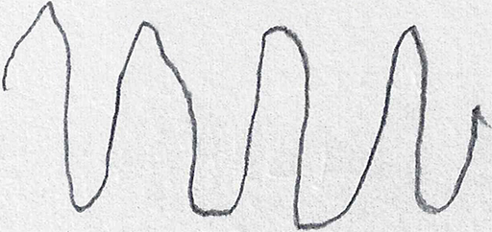


spira drawing wave drawing

Result
Thus the RandomForest model to detect parkinson disease from the images was developed successfully with an accuracy of 88%. This model is now used to classify the images, as healthy or parkinson, uploaded in a web page which is integrated with Flask.

Screenshots

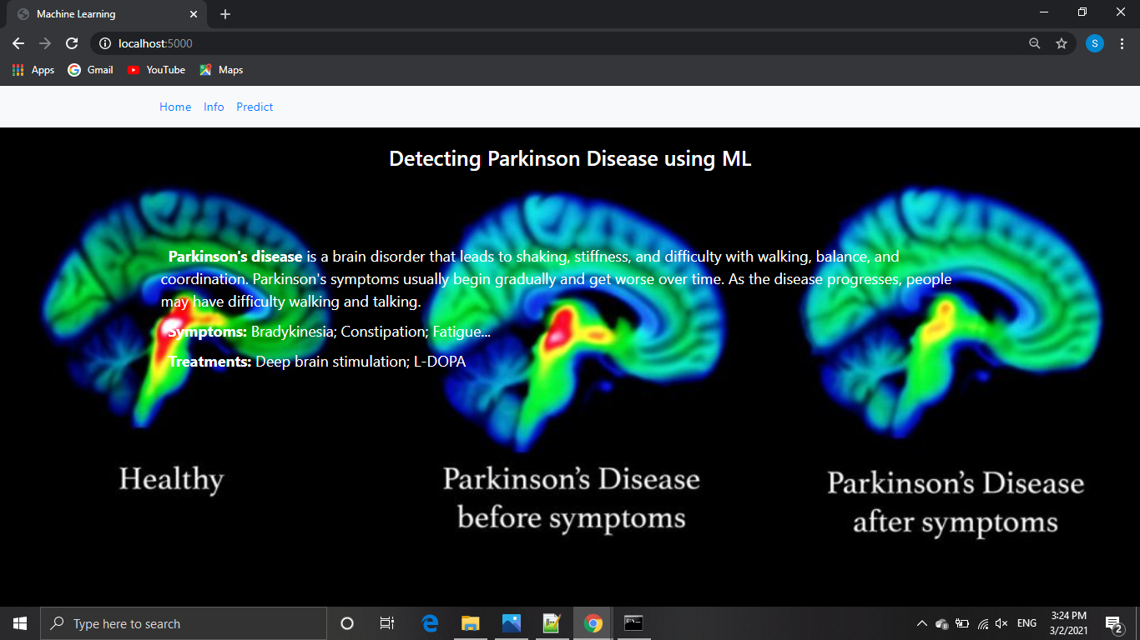

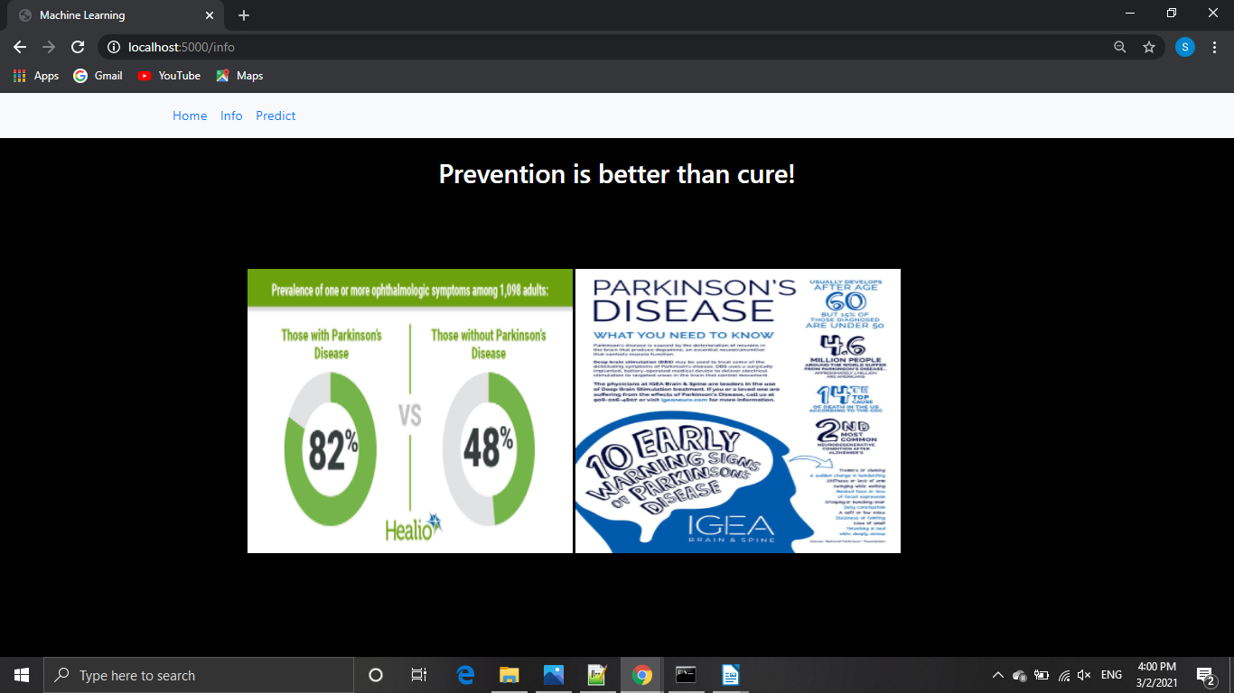

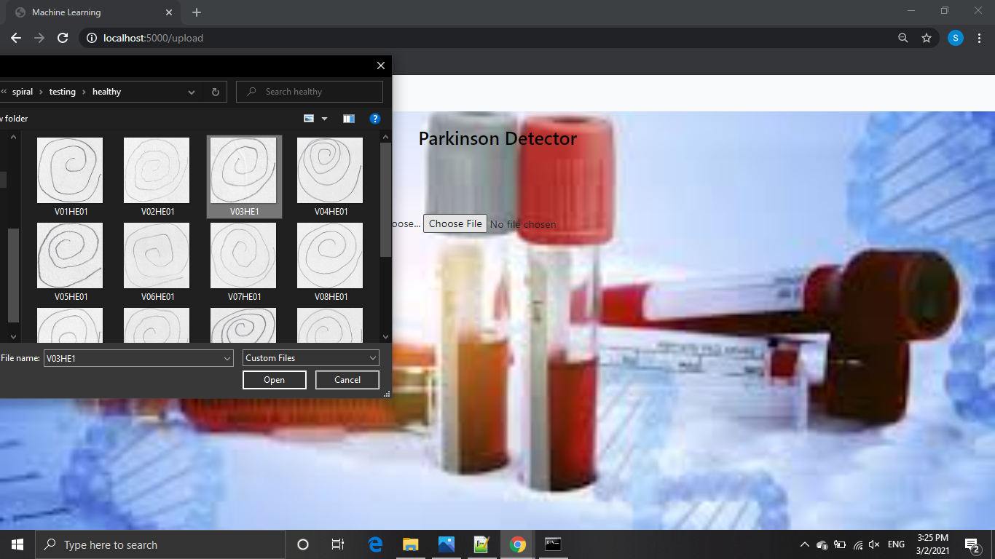

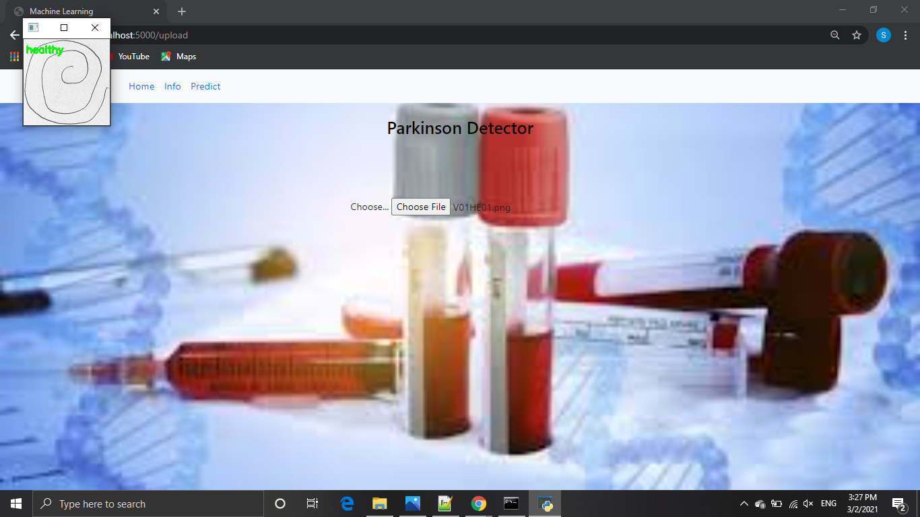

Appendix

HTML File :

<!DOCTYPE html>
<html>
<head>
<meta charset="UTF-8">
<meta name="viewport" content="width=device-width, initial-scale=1.0">
<meta http-equiv="X-UA-Compatible" content="ie=edge">
<title>Machine Learning</title>
<link href="https://cdn.bootcss.com/bootstrap/4.0.0/css/bootstrap.min.css" rel="stylesheet">
<script src="https://cdn.bootcss.com/popper.js/1.12.9/umd/popper.min.js"></script>
<script src="https://cdn.bootcss.com/jquery/3.3.1/jquery.min.js"></script>
<script src="https://cdn.bootcss.com/bootstrap/4.0.0/js/bootstrap.min.js"></script>
<style>
body{
margin:0;padding:0;
background:url({{url_for('static',filename='images/predictbg.jpg')}}) no-repeat center center fixed;
-webkit-background-size:cover;
-moz-background-size:cover;
-o-background-size:cover;
}
h3{
text-align:center;
color:black;
}
.main{
margin-top:100px;
}

</style>
</head>
<body>
<div class="bg">
<nav class="navbar navbar-expand-sm bg-light opacity-3 rounded-pill" id="navv">
<div class="container">
<ul class="navbar-nav">
<li class="nav-item ">
<a class="nav-link" href="{{url_for('about')}}">Home</a>
</li>
<li class="nav-item">
<a class="nav-link" href="{{url_for('information')}}">Info</a>
</li>
<li class="nav-item">
<a class="nav-link" href="#">Predict</a>
</li>
</ul>
</div>
</nav>
<br>
<h3>Parkinson Detector</h3>
<center><div class="main">
<form action="http:/localhost:5000/predict" id="upload-file" method="post" enctype="multipart/form-data">
<label for="imageUpload" class="upload-label">
Choose...
</label>
<input type="file" name="image" id="imageUpload" accept=".png, .jpg, .jpeg">
</form>
<br>
<div class="image-section" style="display: block;">
<div class="img-preview">
<div id="imagePreview">
</div>
</div>
<div>
<button type="button" class="btn btn-primary btn-lg "id="btn-predict">Predict!</button>
</div>
</div>
<div class="loader" style="display:block"></div>
<h3 id="result">
<span> </span>
</h3>
</div>
</div>
</center>
</body>
<footer>
<script src="{{ url_for('static', filename='js/main.js') }}" type="text/javascript"></script>
</footer>
</html>

Flask program – app.py :

import pickle
import cv2
from skimage import feature
from flask import Flask,request,render_template
import os.path

app=Flask(__name__)

#rendering html pages

@app.route("/")
def about():
return render_template('about.html')

@app.route("/about")
def home():
return render_template("home.html")

@app.route("/info")
def information():
return render_template("info.html")

@app.route("/upload")
def test():
return render_template("index6.html")

@app.route("/predict",methods=['GET','POST'])
def upload():
if request.method=='POST':
f=request.files['image'] #request the file
basepath=os.path.dirname(__file__) #store the file dir
filepath=os.path.join(basepath,"uploads",f.filename) #stores the the file in uploads folder
f.save(filepath) #saving the file
print("[Info] Loading model...")
model=pickle.loads(open('parkinson.pkl',"rb").read())

# pre-process the image in same manner

image=cv2.imread(filepath)
output=image.copy()

# load the input image,convert to grayscale and resize

output=cv2.resize(output,(128,128))
image=cv2.cvtColor(image,cv2.COLOR_BGR2GRAY)
image=cv2.resize(image,(200,200))
image=cv2.threshold(image,0,255,cv2.THRESH_BINARY_INV | cv2.THRESH_OTSU)[1]

#feature using last trained random forest

features=feature.hog(image,orientations=9,pixels_per_cell=(10,10),cells_per_block=(2,2),transform_sqrt=True,block_norm="L1")
preds=model.predict([features])
print(preds)
ls=["healthy","parkinson"]
result=ls[preds[0]]

#the set of output images
if result=="healthy":
color=(0,255,0)
else:
color=(0,0,255)

cv2.putText(output,result,(3,20),cv2.FONT_HERSHEY_SIMPLEX,0.5,color,2)
cv2.imshow("Output",output)
cv2.waitKey(0)
return result

return None

# MAin Function

if __name__ == "__main__":
app.run(debug=True)

-------------------- XXXXXXXXXX ----------------------

