Modern Application Development (Java Spring Boot)

ASSIGNMENT – 3

Creating the Database that we need to connect to Java JDBC:

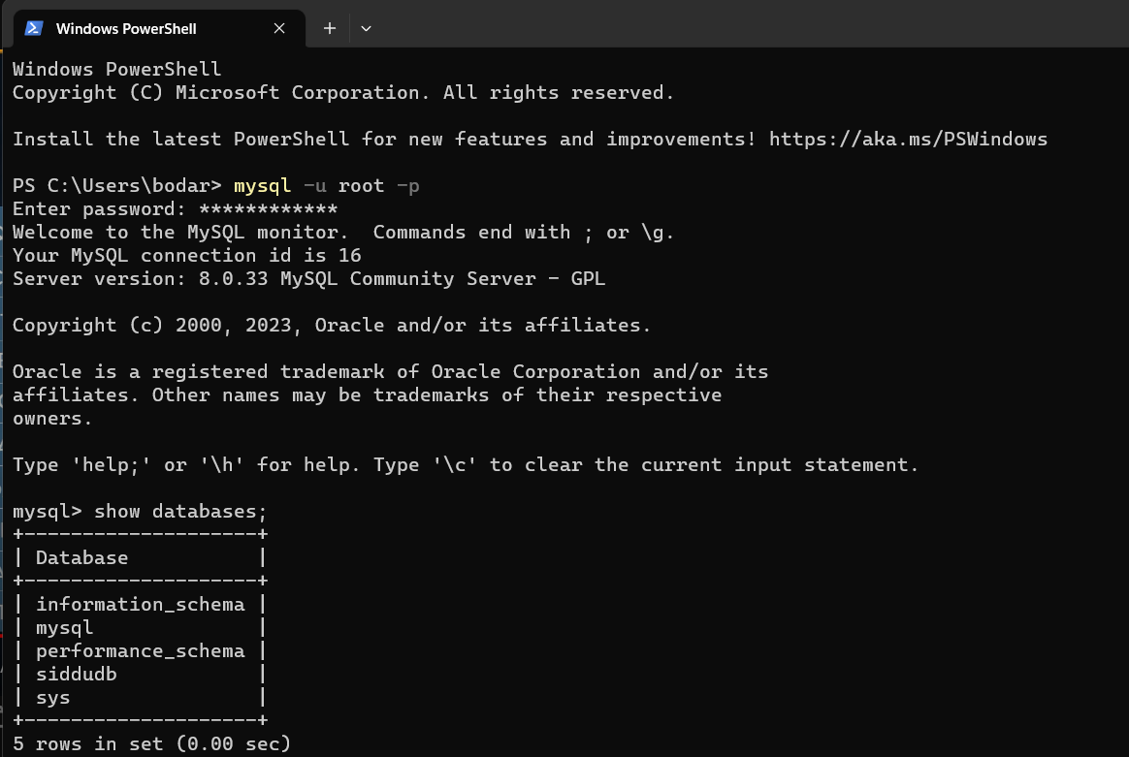

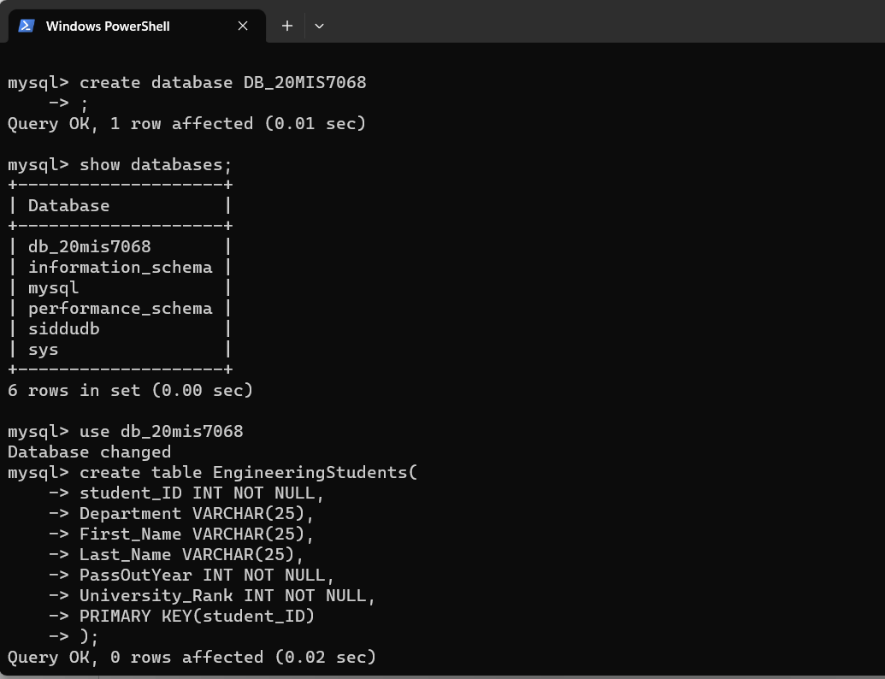

Inserting values into the Database db_20mis7068:

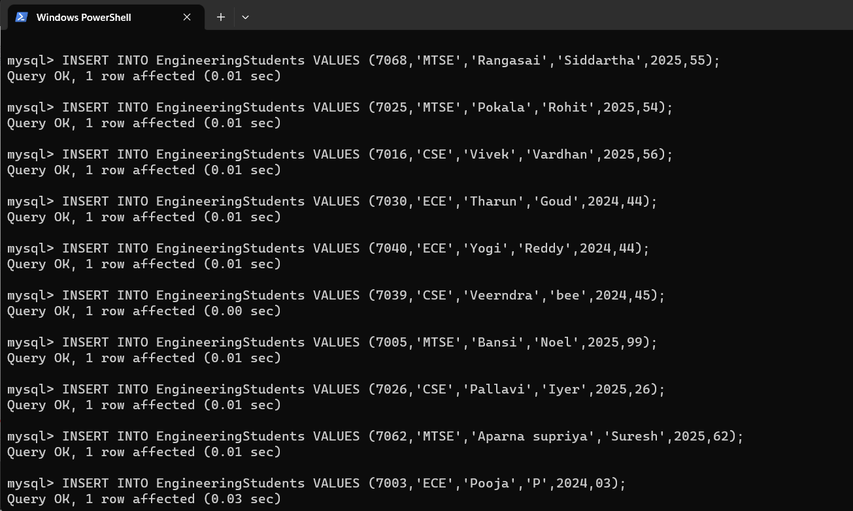

Visualizing the Database db_20mis7068:

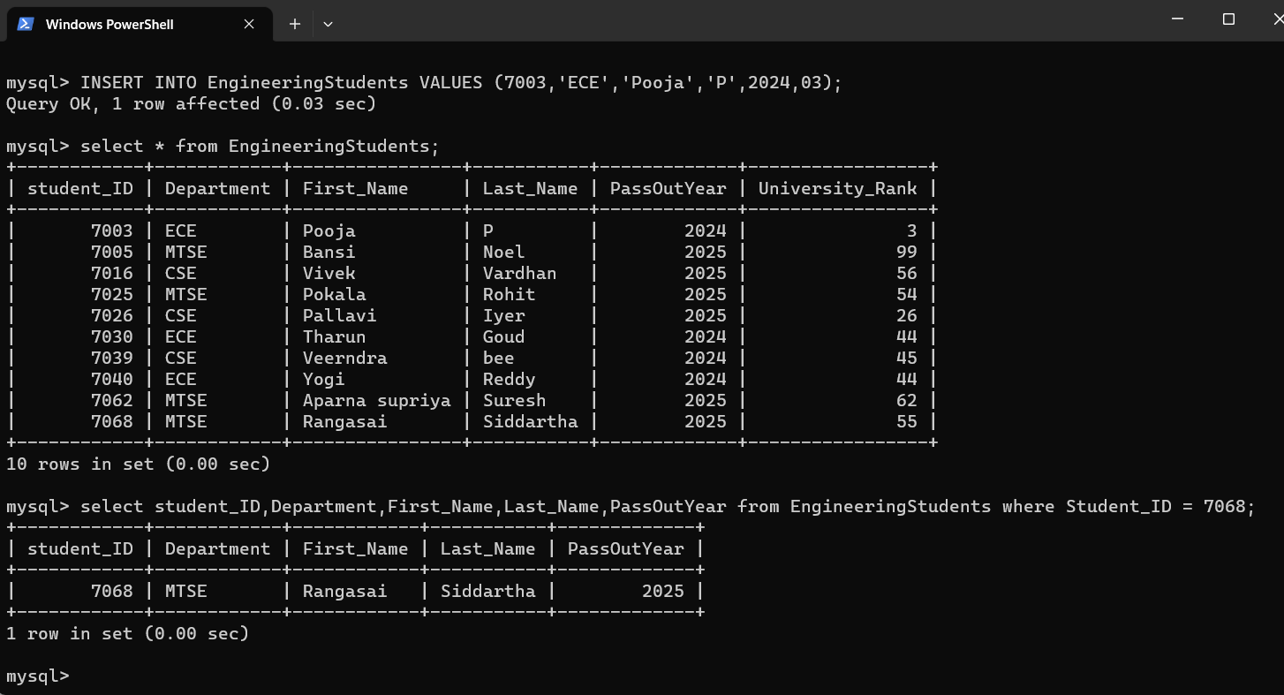

WorkBench Output:

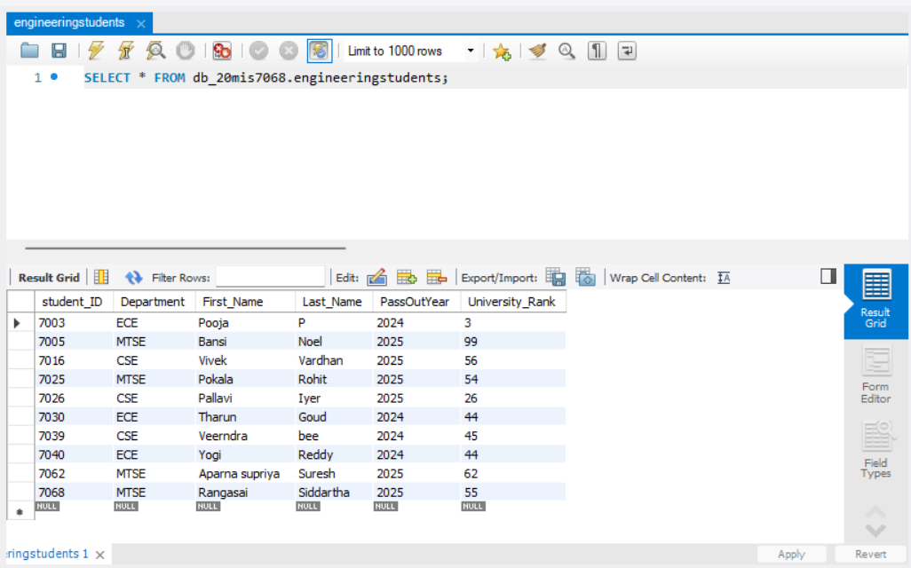

Connecting the Database with Java JDBC:

We need to perform try catch method and the modules need to import are:

* Connection
* DriverManager
* ResultSet
* Statement

package com.Siddartha;  
  
import java.sql.Connection;  
import java.sql.DriverManager;  
import java.sql.ResultSet;  
import java.sql.Statement;  
  
public class main {  
 public static void main(String[] args) {  
 try {  
 Connection conn = DriverManager.*getConnection*("jdbc:mysql://localhost:3306/db_20mis7068","root","Anuprasad_19");  
 Statement statement = conn.createStatement();  
 ResultSet resultSet = statement.executeQuery("select * from EngineeringStudents");  
 while (resultSet.next()) {  
 System.*out*.println(resultSet.getString("First_Name"));  
 }  
 }  
 catch (Exception e) {  
 e.printStackTrace();  
 }  
 }  
}

Output that displays the First_Name column of the Database db_20mis7068:

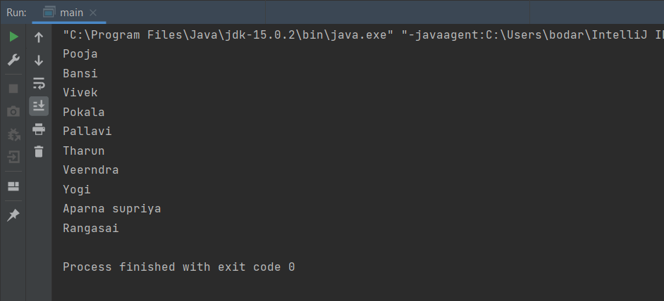

package com.Siddartha;  
  
import java.sql.Connection;  
import java.sql.DriverManager;  
import java.sql.ResultSet;  
import java.sql.Statement;  
  
public class main {  
 public static void main(String[] args) {  
 try {  
 Connection conn = DriverManager.*getConnection*("jdbc:mysql://localhost:3306/db_20mis7068","root","Anuprasad_19");  
 Statement statement = conn.createStatement();  
 ResultSet resultSet = statement.executeQuery("select * from EngineeringStudents");  
 while (resultSet.next()) {  
 System.*out*.println(resultSet.getString("First_Name")+ " " +resultSet.getString("Last_Name"));  
 }  
 }  
 catch (Exception e) {  
 e.printStackTrace();  
 }  
 }  
}

Output that displays the First_Name + Last_Name columns of the Database db_20mis7068:

