Name-Sneha Dutta

Registration Number -20BEE0349

CRUD operations:

Create

Insert

INSERT INTO carsales.car

VALUES (0825, 'Sneha', 'Dutta', 60000, 87590345, '2002-05-11'),

(1400, 'Aavesh', 'Khan', 150000, 63590340, '2003-03-24'),

(1402, 'Soumi', 'Dutta', 200000, 87595765, '2004-11-09'),

(1907, 'Prashanth', 'S', 200000, 63043456, '2002-05-11'),

(1225, 'Michelle', 'V', 6000000, 87589066, '2000-02-12'),

(1876, 'Monali', 'Nayak', 1500000, 87594567, '2005-06-12'),

(5678, 'Ranya', 'Deb', 60000, 86090345, '2007-07-11');

Read the table

select * from carsales.car;

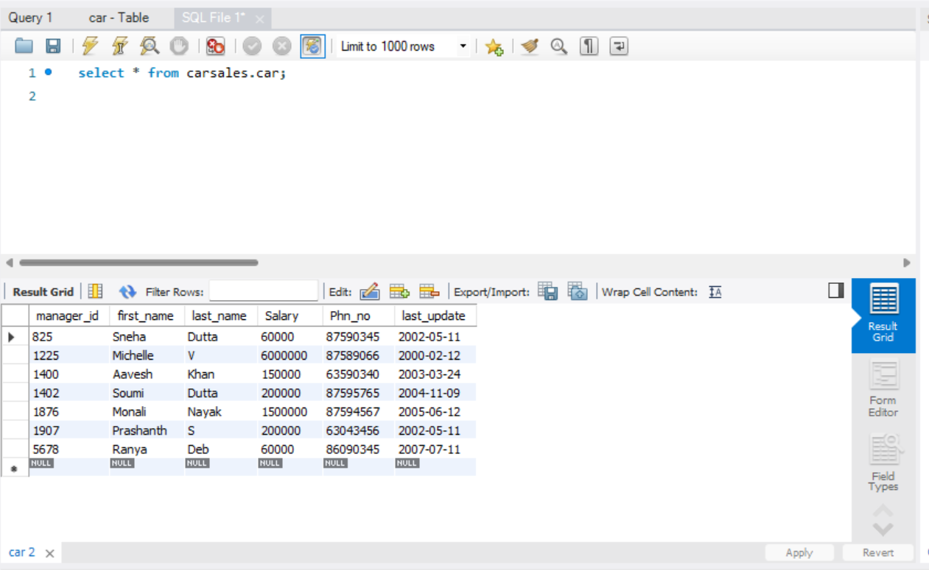

select first_name from carsales.car where manager_id=1225;

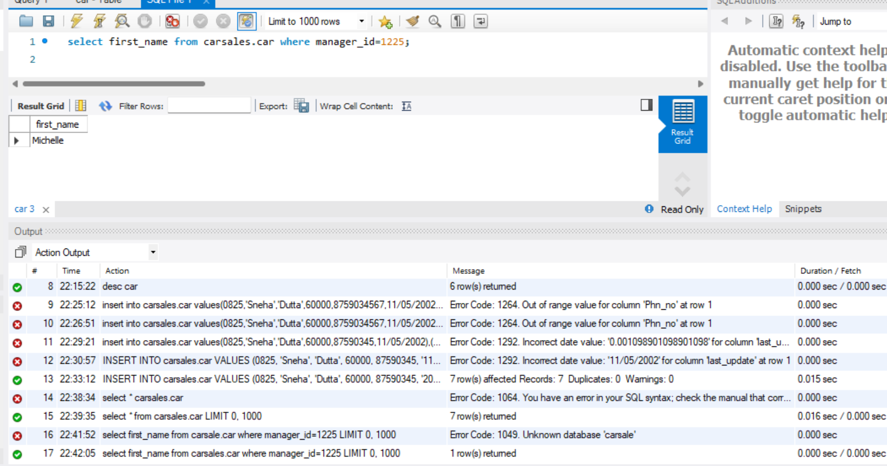

Update the table

update carsales.car set Salary=120000 where manager_id=1876;

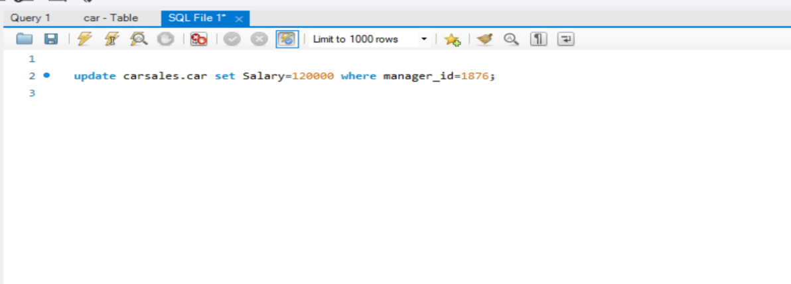

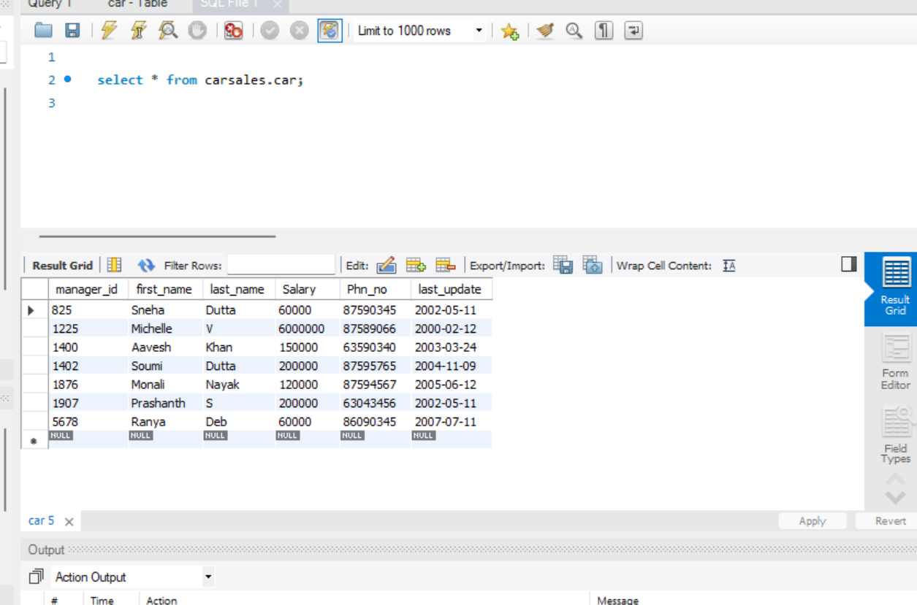

Delete the table

delete from carsales.car where manager_id=5678;

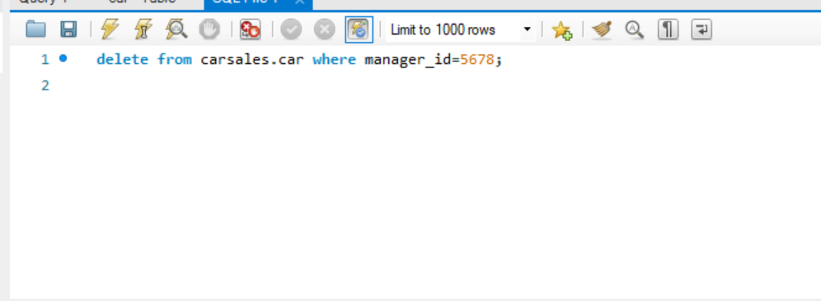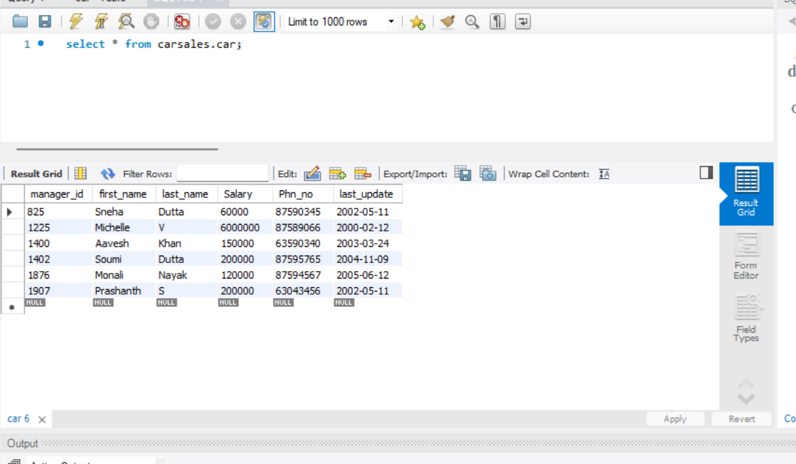

Joining two tables :

Create the order table

CREATE TABLE `carsales`.`orders` (

`OrderID` INT NOT NULL,

`CustomerID` INT NOT NULL,

`OrderDate` DATE NOT NULL,

PRIMARY KEY (`OrderID`));

CREATE TABLE `carsales`.`customers` (

`CustomerID` INT NOT NULL,

`CustomerName` VARCHAR(45) NOT NULL,

`ContactName` VARCHAR(45) NOT NULL,

`Country` VARCHAR(45) NOT NULL,

PRIMARY KEY (`CustomerID`));

Insert into table

Order table:

insert into carsales.orders values(1234,5678,'2002-05-22'),(2345,6789,'2002-05-22'),(3456,7890,'2022-05-22'),(4567,8900,'2002-05-22');\

Customer table:

insert into carsales.customers values(5678,'Sneha','989067890','India'),(6789,'Aavesh','630067890','India'),(7890,'Gunjan','9776080222','Australia'),(8900,'Arpita','6303645394','Switzerland');

Read customer table

select * from carsales.orders;

RIGHT JOIN:

SELECT carsales.orders.OrderDate,carsales.customers.customerName,carsales.customers.Country

FROM carsales.orders

RIGHT JOIN carsales.customers ON carsales.orders.CustomerID = carsales.customers.CustomerID;

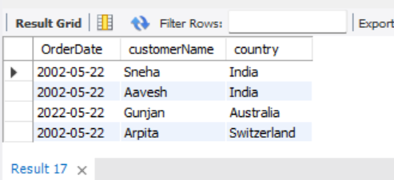

LEFT JOIN

SELECT *

FROM carsales.orders

LEFT JOIN carsales.customers ON carsales.orders.CustomerID = carsales.customers.CustomerID;

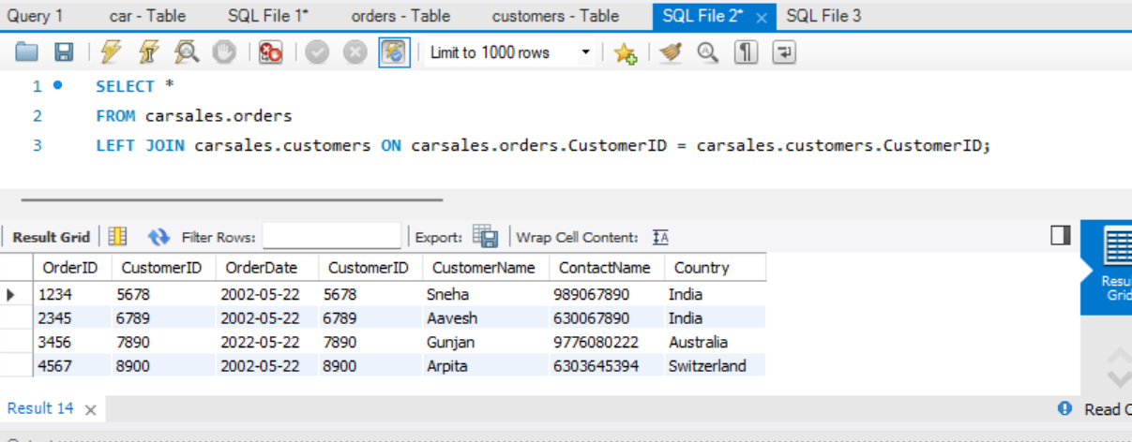

MONGO DB CRUD operations

show dbs;

admin 40.00 KiB

carsales 8.00 KiB

config 84.00 KiB

db 40.00 KiB

demo 8.00 KiB

local 72.00 KiB

test 48.00 KiB

use carsales

Insert values into table

db.posts.insertMany([{Name:"Sneha",Age:20,phnno:6303645394,date:'2002-05-11',Salary:50000},{Name:"Aavesh",Age:15,phnno:678906654,date:'2002-02-10',Salary:1000000},{Name:"Gunjan",Age:19,phnno:9776080222,date:'2002-07-11',Salary:20000}])

{

acknowledged: true,

insertedIds: {

'0': ObjectId("64739d52a301d5f344891e65"),

'1': ObjectId("64739d52a301d5f344891e66"),

'2': ObjectId("64739d52a301d5f344891e67")

}

}

----------------------------------------------------------

Reading the values

db.posts.find({});

{

_id: ObjectId("64739d52a301d5f344891e65"),

Name: 'Sneha',

Age: 20,

phnno: 6303645394,

date: '2002-05-11',

Salary: 50000

}

{

_id: ObjectId("64739d52a301d5f344891e66"),

Name: 'Aavesh',

Age: 15,

phnno: 678906654,

date: '2002-02-10',

Salary: 1000000

}

{

_id: ObjectId("64739d52a301d5f344891e67"),

Name: 'Gunjan',

Age: 19,

phnno: 9776080222,

date: '2002-07-11',

Salary: 20000

}

----------------------------------------

Update the table

db.posts.updateOne({Name:"Sneha"},{$set:{Age:21}})

After Updating the table :

{

_id: ObjectId("64739d52a301d5f344891e65"),

Name: 'Sneha',

Age: 21,

phnno: 6303645394,

date: '2002-05-11',

Salary: 50000

}

--------------------------------------------

Delete:

db.posts.deleteOne({Name:"Gunjan"})

After deleting one record:

{

_id: ObjectId("64739d52a301d5f344891e65"),

Name: 'Sneha',

Age: 21,

phnno: 6303645394,

date: '2002-05-11',

Salary: 50000

}

{

_id: ObjectId("64739d52a301d5f344891e66"),

Name: 'Aavesh',

Age: 15,

phnno: 678906654,

date: '2002-02-10',

Salary: 1000000

}