Name - Sneha Dutta

Registration Number - 20BEE0349

Assignment - 3

**Code :**

**package** testcase;

**import** java.sql.Connection;

**import** java.sql.DriverManager;

**import** java.sql.ResultSet;

**import** java.sql.Statement;

**public** **class** Test1 {

**public** **static** **void** main(String args[])

{

**try** {

Class.*forName*("com.mysql.cj.jdbc.Driver");

Connection conn = DriverManager.*getConnection*("jdbc:mysql://localhost:3306/carsales","root","Mitti227!!");

Statement stmt = conn.createStatement();

ResultSet rs =stmt.executeQuery("select * from carsales.car");

**while** (rs.next())

{

System.***out***.println(rs.getInt(1)+ " " + rs.getString(2)+ " " + rs.getString(3) + " " + rs.getInt(4) + " " + rs.getLong(5) + " " + rs.getDate(6));

}

conn.close();

}

**catch**(Exception e) {

System.***out***.println(e);

}

}

}

**Output :**

**Select statement query using Java and JDBC Driver**

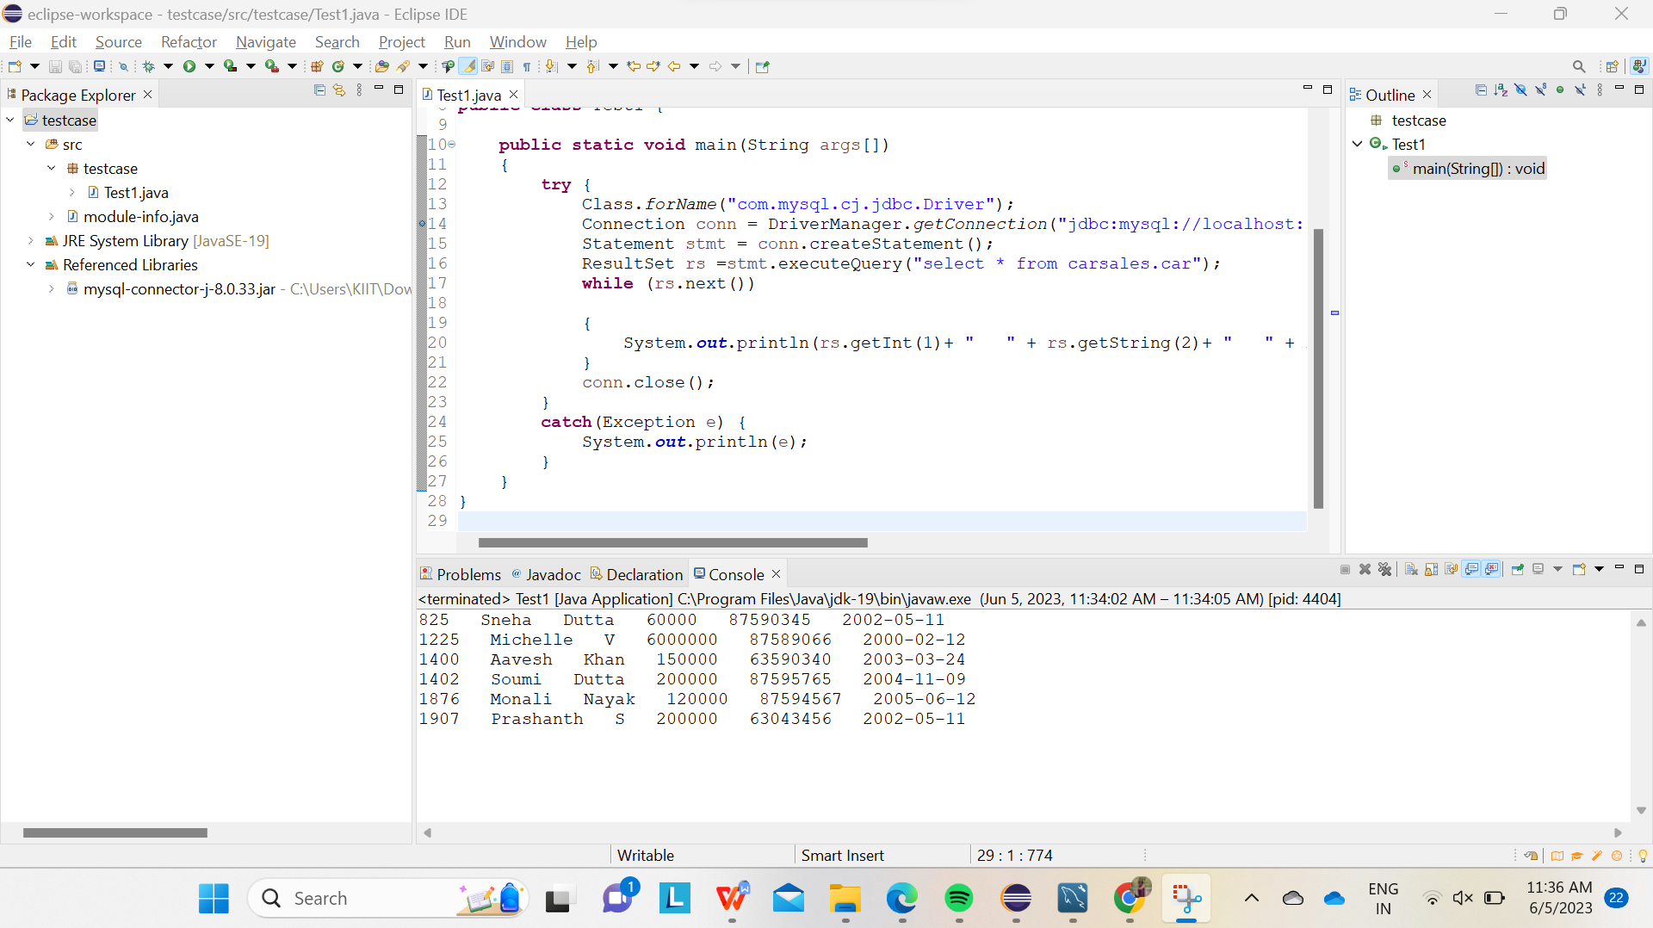

**(ii) For updating the records in the table using JDBC Driver :**

**CODE :**

**package** testcase;

**import** java.sql.Connection;

**import** java.sql.DriverManager;

**import** java.sql.ResultSet;

**import** java.sql.Statement;

**import** java.sql.PreparedStatement;

**public** **class** Test1 {

**public** **static** **void** main(String args[])

{

**try** {

Class.*forName*("com.mysql.cj.jdbc.Driver");

Connection conn = DriverManager.*getConnection*("jdbc:mysql://localhost:3306/carsales","root","Mitti227!!");

String updateQuery = "update carsales.car set Salary = 6000000 where manager_id=1402";

PreparedStatement pstmt = conn.prepareStatement(updateQuery);

**int** rowsAffected =pstmt.executeUpdate();

System.***out***.println("Rows updated: " +rowsAffected);

pstmt.close();

Statement stmt = conn.createStatement();

ResultSet rs =stmt.executeQuery("select * from carsales.car");

**while** (rs.next())

{

System.***out***.println(rs.getInt(1)+ " " + rs.getString(2)+ " " + rs.getString(3) + " " + rs.getInt(4) + " " + rs.getLong(5) + " " + rs.getDate(6));

}

conn.close();

}

**catch**(Exception e) {

System.***out***.println(e);

}

}

}

**OUTPUT after updating the record of our MySQL Table :**

