## **ASSIGNMENT – 1**

## **Akshat Sharma(20BCE2496) VIT VELLORE**

## SMARTBRIDGE EXTERNSHIP Modern Application Development (Java Spring Boot)

## Q) Make a form using html and CSS

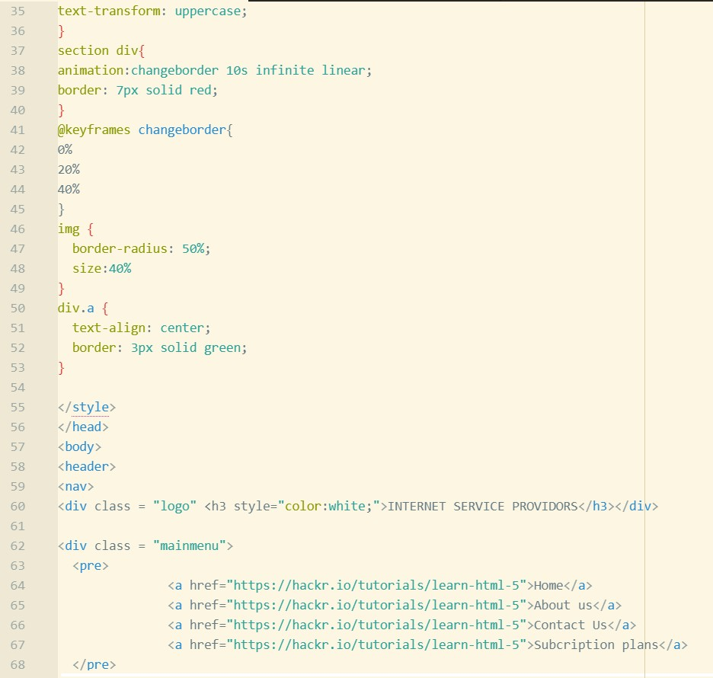

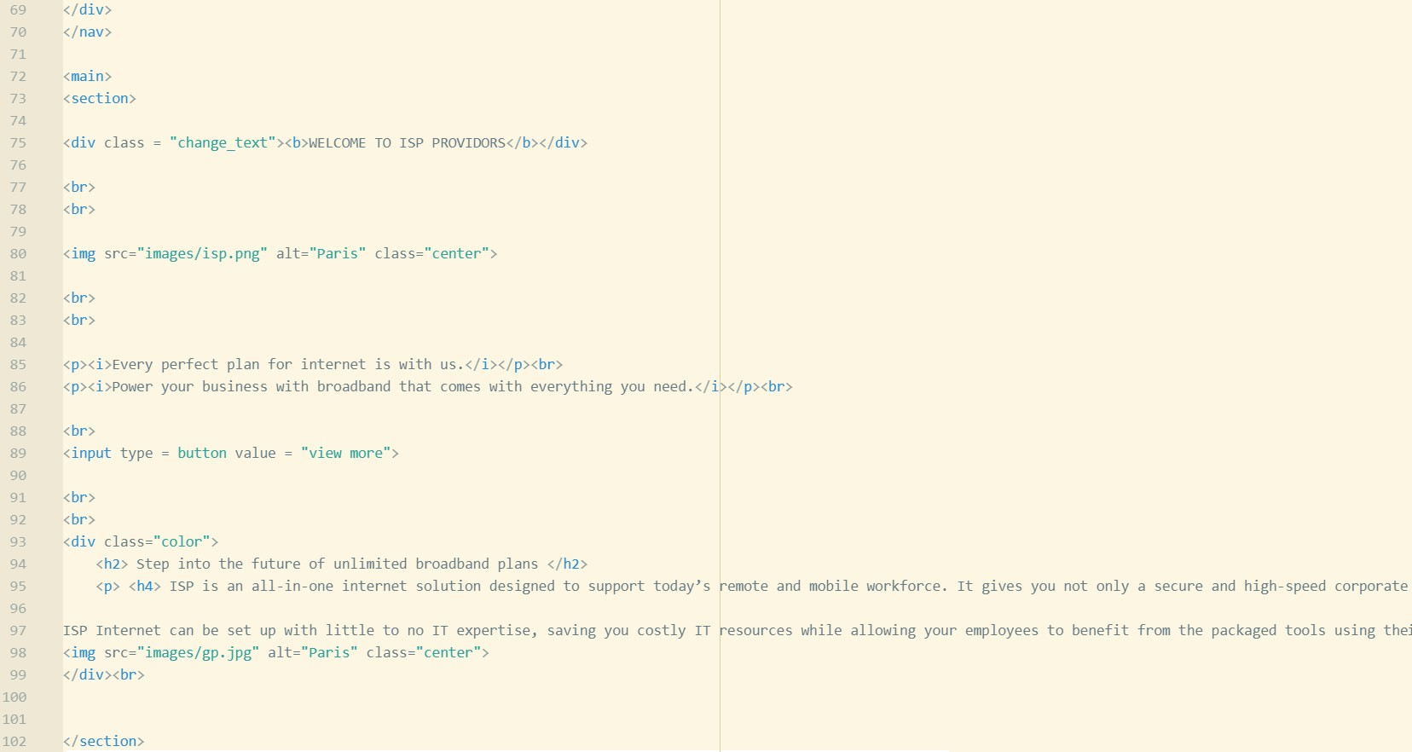

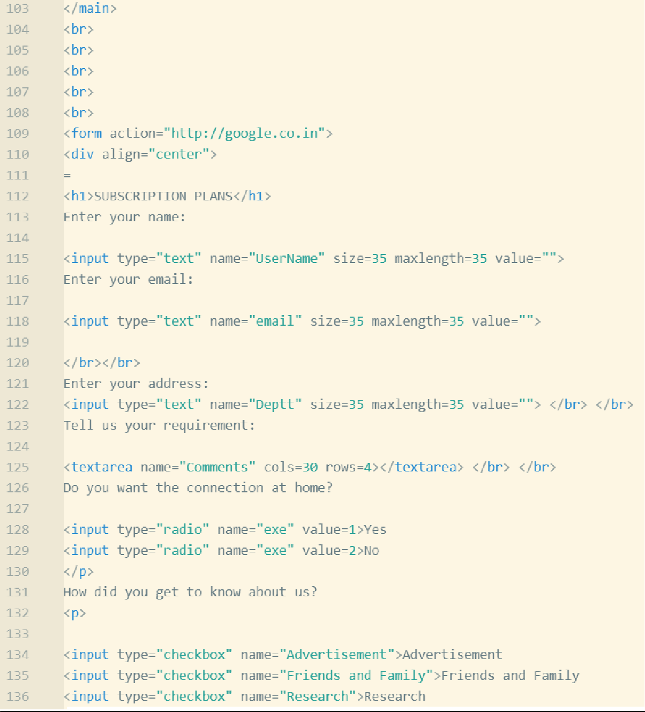

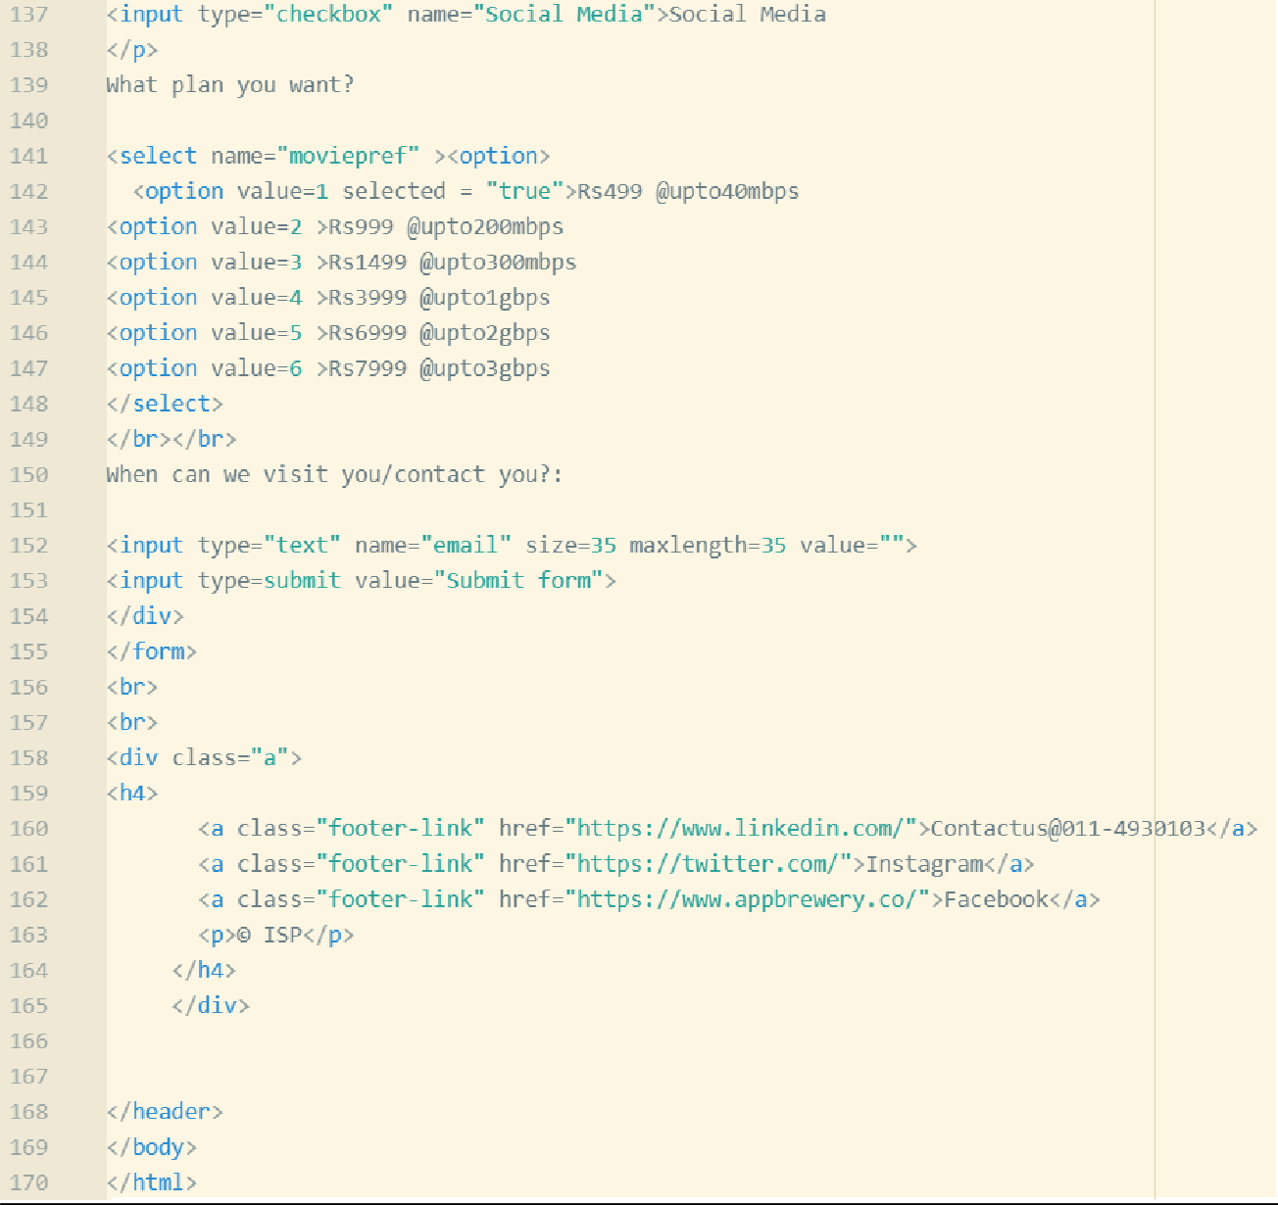

**OUTPUT**

